━━━━━━━━━━━━━━━━━━━━━━━━━━━━━━━━━━━━━━━━
RailVision Analytics — CCO Commercial Strategy Report FY2025–2026
━━━━━━━━━━━━━━━━━━━━━━━━━━━━━━━━━━━━━━━━
April 04, 2026
CONFIDENTIAL

Table of Contents

1. Executive Summary
2. Revenue & ARR Status
3. Customer Acquisition
4. Pipeline & Deals
5. Contract Execution & Gainshare Model
6. Go-To-Market Strategy
7. Partnership & Channel Strategy
8. Competitive Positioning
9. Key Commercial Risks
10. CCO Strategic Recommendations — Top 5 Priorities
11. Data Confidence Flags
12. Closing Statement — Chief Strategy Officer

Executive Summary
RailVision Analytics is a pre-recurring-revenue AI-powered railroad optimization company operating in the North American shortline rail market. This report provides a comprehensive commercial intelligence briefing covering revenue pipeline, customer acquisition, go-to-market execution, partnership strategy, competitive positioning, and strategic risks. It represents the CCO's unvarnished assessment of where the company stands commercially — and what must happen next.
The commercial picture is defined by a single structural reality: RailVision has a compelling product, a validated value proposition, and a $20M+ identified pipeline — but everything converges on the successful validation of one pilot. The Genesee & Wyoming Railroad (GWRR) 90-day pilot across 3 properties is not merely a customer engagement; it is the foundational proof event that unlocks the entire commercial roadmap, the $3M strategic fundraise, and every partnership conversation currently in motion.
**Critical Dependency:** The GWRR pilot validation is the single most important commercial event in the company's history. Failure or delay cascades directly into fundraise collapse, pipeline stall, and partnership erosion.

Key Commercial Highlights
Metric | Value
**12-Month ARR Target** | **$2.5M**
**Total Identified Pipeline** | **$20M+** across 5 named accounts
**Primary Revenue Model** | Gainshare — 30% of verified fuel savings, zero upfront cost
**Active Pilot** | Genesee & Wyoming — 3 properties, 90-day validation in progress
**Signed Term Sheet** | OmniTrax — pilot underway
**Priority Partnership** | Wabtec — fills their 650+ shortline coverage gap
**Critical Dependency** | GWRR pilot validation — unlocks fundraise, pipeline, and partnerships

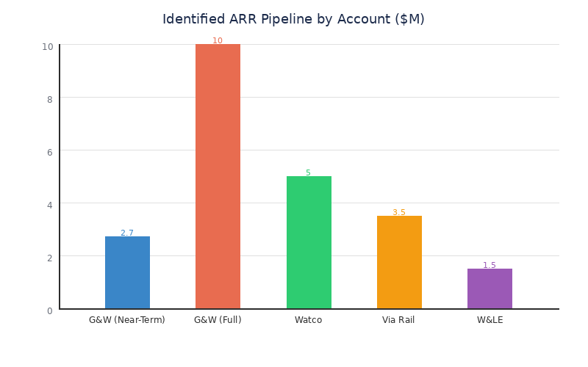

The commercial strategy for the next 6–12 months is organized around five imperatives: Validate the GWRR pilot, Convert OmniTrax to revenue, Scale the first repeatable sales motion, Partner strategically with Wabtec, and Discipline projections for investor credibility.
──────────────────────────────────────────────────────────────────────
Bottom line from the CCO: The $2.5M ARR target is achievable — but it is not inevitable. It requires flawless pilot execution, rapid OmniTrax conversion, and at least 3–5 additional property deployments before Q4 2026. There is no margin for error on the GWRR timeline.
────────────────────────────────────────────────────────────

Revenue & ARR Status

Current State
RailVision Analytics is in a pre-recurring-revenue stage, actively conducting pilot validation with its first customers. The company has not yet recognized recurring revenue under its gainshare model, though the economic framework — 30% of verified fuel savings with zero upfront customer cost — has been contractually established with GWRR and OmniTrax.

ARR Targets & Market Sizing
Metric | Value
**12-Month ARR Target** | **$2.5M**
North American Shortline TAM | $9.2M ARR
Broader Shortline Addressable Market | $300–375M (from $600–750M fuel spend, 650 railroads)
North American Shortline ARR Potential | $7.2–10.8M
Class I Market (Long-Term) | $113–142M ARR potential
Global Market (Total) | ~$2.5B USD
Exit Valuation Target | $50M–$100M

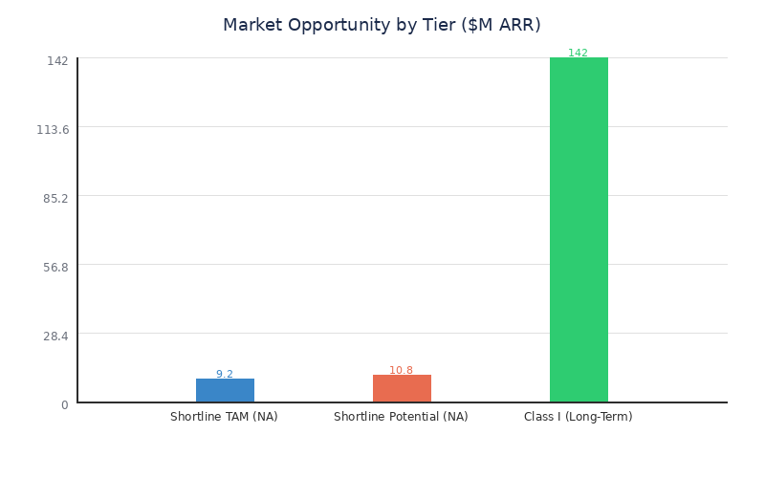

**Important caveat:** Class I and Global market figures are aspirational, long-term projections. Near-term commercial planning should be grounded exclusively in the North American shortline TAM of $9.2M ARR.

ARR Pipeline by Account
Account | ARR Potential | Status
**Genesee & Wyoming (G&W)** | **$10M (full), $2.7M (near-term)** | **Active pilot — 3 properties, 90-day validation**
Watco | $5M | Prospect — 45 railroads
Via Rail | $3.5M | Prospect — largest passenger railroad in Canada
Wheeling & Lake Erie | $1.5M | Prospect — Major Class II
**Total Identified Pipeline** | **$20M+** | **Mixed stages**

Revenue Model Economics
Revenue Metric | Value
Gainshare Rate | 30% of verified fuel savings
Fuel Savings — Model Verified | 8%
Fuel Savings — Average Live | 7%
Fuel Savings — Max Live (Human-Operated) | Up to 15%
Fuel Savings — Max Simulation (Machine-Operated) | Up to 25%
Alternative Model | Flat subscription option available

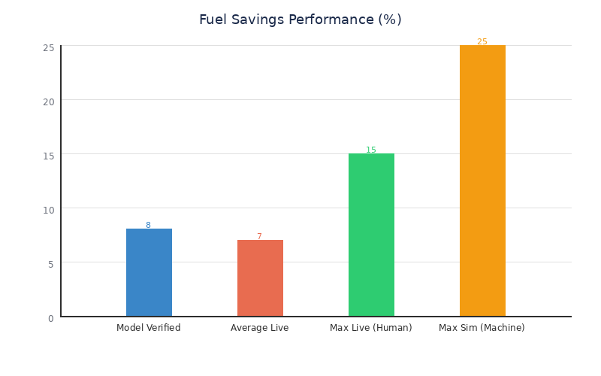

──────────────────────────────────────────────────────────────────────

CCO Assessment
**The $2.5M 12-month target is achievable if and only if the GWRR pilot validates on schedule and 3–5 additional properties convert before Q4 2026.** G&W represents >50% of near-term ARR, creating concentration risk that requires immediate mitigation through parallel pipeline development.
────────────────────────────────────────────────────────────

Customer Acquisition

Current Customer Base
RailVision's customer base is in its earliest formation stage with three named accounts at varying levels of engagement.
Customer | Type | Status | Detail
**Genesee & Wyoming (GWRR)** | Shortline Holding Co. | **Active Pilot** | 3 properties in 90-day validation; 112 total properties, ~2,000 customers, 13,000+ track-miles
**OmniTrax** | Shortline Holding Co. | **Term Sheet Signed** | Pilot underway
**Vermont Rail System** | Regional | Validation Data | 400+ miles of track; fuel savings data used for proof

The GWRR relationship is the crown jewel. With 112 properties, approximately 2,000 customers, and over 13,000 track-miles, a successful pilot-to-production conversion at GWRR alone could generate $10M in full-deployment ARR. However, the current engagement is limited to 3 properties — the gap between $2.7M near-term and $10M full potential should not be conflated in board discussions.

Active Prospects
Prospect | Segment | ARR Potential | Notes
**Watco** | Shortline (45 RRs) | $5M | Major multi-property shortline operator
**Via Rail** | Passenger | $3.5M | Largest passenger railroad in Canada
**Wheeling & Lake Erie** | Class II Regional | $1.5M | Major Class II railroad

All three prospects are in early-stage prospecting with no confirmed active engagement beyond initial conversations. The CCO assessment is that none of these accounts will convert to pilot without the GWRR proof point in hand.

Customer Segmentation
- Class III Shortlines (600–650 railroads): Primary beachhead market. Conservative, cost-conscious, chronically underserved by technology vendors.
- Class II Regionals (~20 railroads): Larger operations with higher fuel spend per railroad. More sophisticated buyers but still underserved.
- Passenger Railroads (Select targets): Via Rail represents the entry point. Different operating characteristics but strong fuel optimization use case.
- Conservative Railroad Buyers (Industry-wide archetype): Risk-averse, skeptical of technology, deeply relationship-driven.

Sales Cycle Compression
**Industry norm:** 2+ years for technology adoption in railroad operations.
**RailVision model:** 90 days from contract to live, revenue-generating deployment.
This 8x compression is enabled by: (1) zero upfront cost eliminates procurement delays, (2) tablet-based deployment eliminates hardware timelines, and (3) the pilot itself IS the sales process. This compression is a genuine competitive advantage, but it only works when the initial relationship exists.
────────────────────────────────────────────────────────────

Pipeline & Deals

Active Deal Pipeline
Deal | Stage | Timeline | Value | Key Milestone
**GWRR Pilot (3 properties)** | **Active Pilot** | **90-day validation in progress** | **$2.7M near-term ARR** | Documented fuel savings required
**OmniTrax** | **Term Sheet Signed** | **Pilot underway** | **TBD** | Term sheet to pilot conversion
GWRR Expansion (112 properties) | Dependent on Pilot | Post-validation | $10M full potential | Requires 3-property proof
Watco | Prospecting | TBD | $5M | 45 railroads — no engagement confirmed
Via Rail | Prospecting | TBD | $3.5M | Passenger segment entry
Wheeling & Lake Erie | Prospecting | TBD | $1.5M | Class II beachhead

Pipeline Summary by Stage
Stage | Total Potential ARR
**Active Pilot / Term Sheet** | **~$2.7M–$3.5M**
Expansion (Contingent on Pilot) | ~$10M
Prospecting (Early-Stage) | ~$10M
**Total Identified** | **$20M+**

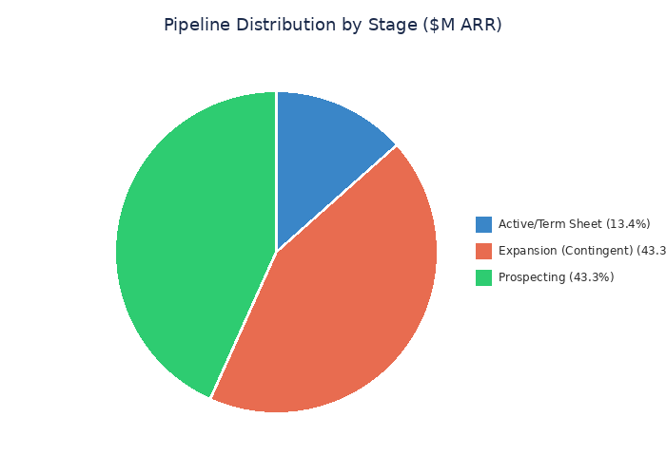

Only ~13% of identified pipeline is in active engagement. The remaining 87% is either contingent on pilot success or in early-stage prospecting.

Deal Dependency Map
Every deal in the pipeline has a dependency relationship with the GWRR pilot:
- GWRR Expansion ($10M): Directly dependent — will not proceed without 3-property validation
- OmniTrax (TBD): Partially dependent — term sheet signed independently, but conversion accelerated by GWRR proof
- Watco ($5M): Indirectly dependent — conservative buyer requires peer reference
- Via Rail ($3.5M): Indirectly dependent — new segment entry requires proven credibility
- Wheeling & Lake Erie ($1.5M): Indirectly dependent — Class II buyer requires shortline proof
**The GWRR pilot is not a $2.7M decision — it is a $20M+ pipeline decision.** Every conversation, partnership, and fundraise traces back to this single validation event.
──────────────────────────────────────────────────────────────────────

CCO Assessment
**Pipeline is top-heavy and early-stage.** Honest framing for board and investor communications: *"$2.7M in near-term contracted pipeline with $20M+ identified opportunity across 5 named accounts."*
────────────────────────────────────────────────────────────

Contract Execution & Gainshare Model

The Gainshare Framework
RailVision's gainshare structure eliminates the single largest barrier to technology adoption in the railroad industry: upfront capital expenditure risk.
Element | Detail
**Revenue Model** | 30% of verified fuel savings (gainshare) or flat subscription
**Upfront Cost to Customer** | **$0 — zero capital outlay**
**Fuel Savings (Verified)** | 8% (model), 7% avg (live), 15% max (live human), 25% max (simulation)
**Deployment Method** | Tablet-based, software-first, no hardware, locomotive-agnostic
**PTC Requirement** | None — advisory mode operates independently
**Pilot Duration** | 60–90 day corridor pilot
**Deployment Timeline** | 90 days from contract to live deployment

Four Structural Advantages
- Zero customer risk — Customers pay nothing unless they save money. This eliminates the #1 objection in railroad technology sales. The procurement committee is bypassed. The CFO has no line item to reject.
- Self-proving deployment — The 90-day pilot IS the sales process AND the product validation. No separate evaluation period. This collapses a 2+ year sales cycle into a single 90-day window.
- Aligned incentives — RailVision makes more money when customers save more money. Every percentage point of fuel savings improvement directly increases revenue. This alignment builds trust with an inherently skeptical buyer base.
- Asymmetric switching costs — Entry cost is near-zero (tablet + bracket). But once operational data is embedded and crew behaviors have adapted, switching back means accepting higher fuel costs. Easy to enter, expensive to leave.

Concerns & Model Risks

Gainshare Revenue Variability
Fuel savings fluctuate based on terrain profiles, crew compliance rates, weather conditions, commodity mix, and operational tempo. A railroad saving 12% in summer on flat terrain may save only 5% in winter on grades.
**CCO Recommendation:** Implement a **hybrid model — gainshare with a minimum subscription floor** set at 60–70% of projected minimum savings.

Verification Disputes
As deployments scale, fuel savings verification will become a friction point. Different railroads will have different baseline calculation methods and data quality standards.
**CCO Recommendation:** Establish an **algorithmic verification methodology** with third-party audit capability before signing production contracts beyond initial pilots.
──────────────────────────────────────────────────────────────────────
The gainshare model is RailVision's single greatest commercial asset. It must be protected from dilution in partnership negotiations and strengthened with hybrid floor mechanisms before scaling beyond 10+ properties.
────────────────────────────────────────────────────────────

Go-To-Market Strategy

GTM Playbook — The Four-Step Commercial Motion
- LEAD with "Shortline-Proof ROI" — Zero upfront cost, pay only when you save
- HOOK with the live LTOC demonstration — Real-time train location, speed limits, pacing advisories, and ETAs
- PROVE with a 60–90 day corridor pilot — Deploy, measure, document savings with hard data
- CLOSE by converting the pilot to a multi-year gainshare production contract
This playbook has been executed successfully with GWRR and OmniTrax. The challenge is that it has only been executed by one person.

Sales Channels
Channel | Status | Notes
**Direct (CEO-Led)** | **Primary & Only** | Jamie O'Rourke's 20-year railroad relationships drive all deals
Partner Channels | In Development | Wabtec, Loram, Holland, Railroad Software, Railhead identified
Industry Events / ASLRRA | Active | Shortline industry association engagement

Sales Team Assessment
- Jamie O'Rourke (CEO): Primary commercial relationship owner. 20-year railroad veteran. Responsible for 100% of deal origination.
- Dev Jain (CTO): Technical demonstrations, product validation. 7+ years rail experience. Critical for Hook and Prove phases.
- Formal Sales Team: DOES NOT EXIST. No dedicated sales hires, no SDRs, no account executives. First hire planned in $3M funding allocation.

What's Working
- Zero-upfront gainshare eliminates the #1 objection — Railroad CFOs cannot say no to something that costs nothing
- 90-day deployment vs. multi-year hardware installs — Speed-to-value is a genuine differentiator
- Jamie's personal relationships opened every door — GWRR, OmniTrax, Vermont Rail are all relationship-originated
- LTOC demo creates immediate "aha moment" — Operators see their railroad in real-time and immediately understand value

What's Not Working
- Single-threaded sales dependency on CEO — Most critical GTM vulnerability. All momentum stops if Jamie is unavailable. Does not scale.
- No repeatable sales playbook — Jamie's approach is intuitive, relationship-driven, and undocumented. A new hire cannot replicate what doesn't exist on paper.
- No dedicated sales hires — Blocked by funding. $3M round includes first sales hire, but that round depends on GWRR pilot.
- Long timeline without Jamie relationships — For prospects outside Jamie's network, sales cycle reverts to industry norm of 2+ years.
- Conservative buyer psychology persists — Even with zero upfront cost, operators default to "do nothing."
──────────────────────────────────────────────────────────────────────
**CCO GTM Verdict:** The playbook works. The model works. The demo works. What doesn't work is the delivery vehicle — a single human being. The #1 commercial priority after GWRR validation is documenting the sales playbook and hiring a closer who can execute independently.
────────────────────────────────────────────────────────────

Partnership & Channel Strategy

Tier 1 Strategic Partners
Partner | Strategic Value | Status | ARR Impact
**Wabtec** | Fills 650+ shortline gap. Brand credibility. Global sales network. Trip Optimizer complement | **Priority conversation** | Accelerates NA shortline penetration
**Alstom** | North American freight entry. Mastria integration. 70+ countries. Autonomous rail alignment | Medium-term (Q3/Q4 2025) | $52M international ARR opportunity
**Progress Rail (CAT)** | Bundle with locomotive sales. Fortune 100 credibility. Global expansion | Medium-term | Every loco sale = deployment opportunity

Wabtec — The Priority Partner
Wabtec's Trip Optimizer dominates Class I with 6,000+ installations but has zero presence in 650+ shortlines. Trip Optimizer's hardware-heavy, PTC-dependent architecture is unsuitable for Class II/III. RailVision fills this gap perfectly.
The value proposition to Wabtec: "We give you 650 railroads you cannot serve today, without cannibalizing Trip Optimizer in Class I."

Alstom — The International Bridge
Alstom's Mastria platform and 70+ country presence makes it the natural international expansion partner. The $52M international ARR opportunity is real but long-dated. Conversations should begin Q3/Q4 2025 after North American proof.

Progress Rail (CAT) — The Bundling Play
A bundled offering — "every locomotive comes with EcoRail" — creates deployment at the scale of hardware sales. Fortune 100 credibility is an added benefit for investor and customer confidence.

Tier 2 Distribution Partners
Partner | Value | Status
**Railroad Software** | 200+ railroad customers, 40+ years expertise | Identified
**Railhead** | 60+ locations, 800+ shortline customers, PE-backed | Identified
**Loram** | 32 countries, track maintenance contracts across Class I + regionals | Active conversation
**Holland Company** | Family-owned, 100+ year history, shortline relationships | Evaluation

Holland-Loram Consortium
An emerging strategic opportunity combining Holland's century-old shortline relationships and Loram's global track maintenance network:
- Shared investment risk across multiple parties
- Combined relationship networks spanning 800+ railroads
- Complementary data assets from track maintenance operations
- Cross-border alignment for Canadian and international expansion
**CCO Recommendation:** Advance Holland-Loram as a parallel track to Wabtec. Structure as investment + co-sell agreement, NOT acquisition pathway.
──────────────────────────────────────────────────────────────────────
Strategic principle: Complete GWRR pilot validation BEFORE entering substantive commercial terms with any partner. Negotiating from proven technology is categorically different from negotiating from promise.
────────────────────────────────────────────────────────────

Competitive Positioning

RailVision (EcoRail) vs. Wabtec (Trip Optimizer)
Dimension | RailVision (EcoRail) | Wabtec (Trip Optimizer)
**Market Focus** | Shortline (Class II/III) + Passenger | Class I only
**Approach** | Software-first, tablet-based | Hardware-heavy, locomotive-integrated
**Deployment Time** | 90 days | Multi-year
**Hardware Required** | Bracket + tablet only | Full locomotive hardware retrofit
**Locomotive Compatibility** | Any locomotive | Specific models only
**Fuel Savings** | 7% avg live, up to 25% (sim) | 5–17%
**Installed Base** | Pilot stage | 6,000+ locomotives
**PTC Required** | No | Yes
**Passenger + Freight** | Both | Freight only
**Affordable for Class II/III** | Yes (zero upfront) | No (too expensive)
**Upfront Cost** | $0 (gainshare) | Significant CapEx

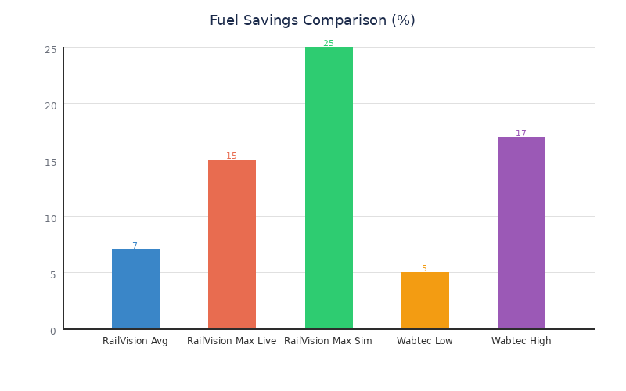

Position Statement
**"RailVision is the only deployed, validated software product serving the shortline and EMS-unequipped Class I market — a $30M+ ARR opportunity in North America that is currently unserved by any competitor."**
No competitor offers a software-only, zero-upfront, locomotive-agnostic fuel optimization solution for shortlines. RailVision is not competing for an existing market — it is creating one.

Where to Compete vs. Where NOT to Compete
Compete aggressively:
- Class III Shortlines (600–650 railroads) — Uncontested space
- Class II Regionals (~20 railroads) — Low competition
- Passenger Rail — Wabtec does not serve passenger
- EMS-Unequipped Class I Locomotives — Complement, not compete
Do NOT compete:
- Class I EMS-Equipped Fleets — Wabtec entrenched, switching costs of $25–50M+ per carrier
**Strategic Warning:** Do NOT position against Trip Optimizer head-to-head in Class I. Class I ARR projections ($113–142M) should be **removed or clearly marked as long-term aspirational** in all board and investor documents.

Competitive Moat (4 Pillars)
- Zero-upfront gainshare model — Eliminates customer financial risk
- 90-day deployment speed — 8x faster than hardware competitors
- Jamie O'Rourke's 20-year relationships — Non-replicable short-term
- Locomotive-agnostic, software-only architecture — Any railroad, any locomotive
The moat is real but time-limited. Wabtec could build a software-only shortline product in 18–24 months. The window of opportunity is now through Q4 2026.
────────────────────────────────────────────────────────────

Key Commercial Risks

Critical Risks (Red)
Risk | Impact | Mitigation
**GWRR pilot failure or delay** | Entire pipeline, fundraise, and partnerships collapse | Tight metrics framework. Weekly monitoring. Go/no-go at Day 45
**Single-threaded CEO sales dependency** | Key-person risk. All momentum stops if Jamie unavailable | First sales hire in $3M plan. Document playbook NOW
**Revenue concentration on G&W** | >50% of near-term ARR. Loss = loss of commercial viability | Accelerate Watco, W&LE, Via Rail in parallel

GWRR Pilot — The Existential Risk
If the 90-day validation fails to produce documented savings across all three properties, the consequences cascade:
- The $3M fundraise loses its primary proof point and likely stalls
- The GWRR expansion from 3 to 112 properties does not proceed
- Watco, Via Rail, and W&LE lose their peer validation reference
- Wabtec, Alstom, and Progress Rail partnership conversations lose credibility
- The $20M+ pipeline effectively resets to zero
──────────────────────────────────────────────────────────────────────

Elevated Risks (Yellow)
Risk | Impact | Mitigation
**Gainshare revenue variability** | Unpredictable revenue from fluctuating savings | Hybrid model: gainshare + minimum subscription floor
**Conservative buyer psychology** | Railroads default to "do nothing" | Peer validation via GWRR reference account
**Class I market overreach** | Damages investor credibility | Strip from near-term projections
**Partnership negotiation from weakness** | Unfavorable terms if negotiating pre-validation | Prove pilot FIRST
**Fuel savings verification disputes** | No audit standard exists | Establish algorithmic verification methodology

──────────────────────────────────────────────────────────────────────

Structural Strengths (Green)
- Zero-upfront model eliminates customer financial risk
- 90-day deployment = fast proof-of-value
- No hardware dependency = locomotive-agnostic scalability
- Jamie's 20-year relationships are non-replicable (short-term)
- Canadian SR&ED tax credits provide engineering cost advantage
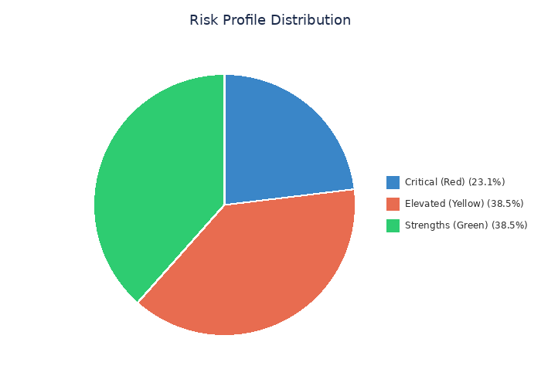

──────────────────────────────────────────────────────────────────────
**CCO Risk Summary:** The risk profile is concentrated, not distributed. Three critical risks dominate — and all three trace back to the GWRR pilot. This is either a strength (one event resolves multiple risks) or a fragility (one failure triggers multiple cascades). The difference is execution.
────────────────────────────────────────────────────────────

CCO Strategic Recommendations — Top 5 Priorities
The following five priorities represent the CCO's recommended commercial action plan for the next 6–12 months. They are sequenced intentionally — each builds on the one before it.
──────────────────────────────────────────────────────────────────────

Priority 1: VALIDATE — Close the GWRR Pilot with Board-Grade Proof
Timeline: Immediate — 90-day validation window
- Complete 90-day validation across all 3 GWRR properties with documented, independently verifiable fuel savings
- Produce board-grade case study package: fuel savings %, advisory compliance rate, exception reduction, operator satisfaction
- Establish Day 45 go/no-go checkpoint with clear threshold metrics
- Assign weekly metric review cadence with CTO oversight
**This is the single most important commercial event in the company's history.** The CCO recommends 80%+ of executive bandwidth be allocated here until validation is complete.
──────────────────────────────────────────────────────────────────────

Priority 2: CONVERT — Turn OmniTrax Term Sheet into Revenue
Timeline: Parallel with GWRR — next 90 days
- Move from signed term sheet to active pilot deployment immediately
- Establish independent fuel savings baseline for OmniTrax properties
- Target production contract conversion within 120 days of pilot start
Two paying customers is categorically different from one. One customer is an experiment; two customers is a pattern.
──────────────────────────────────────────────────────────────────────

Priority 3: SCALE — Build the First Repeatable Sales Motion
Timeline: Months 3–9 (begin documentation now, hire post-funding)
- Document Jamie's sales playbook — messaging, LTOC demo script, pilot proposal template, objection handling
- Hire 1 sales closer with railroad industry relationships ($3M funding allocation)
- Target: 15+ properties deployed by Q4 2026
- Success metric: At least one deal closed by a non-founder within 12 months
Playbook documentation should begin immediately — before the hire, before funding closes.
──────────────────────────────────────────────────────────────────────

Priority 4: PARTNER — Advance Wabtec to Structured Conversation
Timeline: Months 4–8 (post-GWRR validation)
- Do NOT approach prematurely — complete GWRR validation first
- Structure as co-sell / distribution agreement, NOT acquisition or exclusivity
- Preserve gainshare model economics — do not allow flattening into per-unit licensing
- Keep Loram and Holland advancing as combined investment + co-sell structure
──────────────────────────────────────────────────────────────────────

Priority 5: DISCIPLINE — Clean Projections for Investor Credibility
Timeline: Immediate and ongoing
- Remove or gate Class I revenue ($113–142M) from near-term projections
- Present shortline-only projections as the 12–24 month plan ($7.2–10.8M NAM potential)
- Position Class I as "Phase 3 — Accessible via partnership"
- Distinguish confirmed engagement ($2.7M) from identified opportunity ($20M+)
**The fastest way to lose investor trust is to present aspirational numbers as near-term targets to an audience that knows the railroad industry.**
──────────────────────────────────────────────────────────────────────

Priority Sequencing Summary
Priority | Action | Timeline | Dependency
**1. VALIDATE** | GWRR pilot — board-grade proof | Immediate (90 days) | None — foundation
**2. CONVERT** | OmniTrax → revenue | Parallel (90–120 days) | Independent, reinforced by P1
**3. SCALE** | Playbook + first hire | Months 3–9 | Requires $3M funding (P1 dependent)
**4. PARTNER** | Wabtec structured conversation | Months 4–8 | Requires P1 completion
**5. DISCIPLINE** | Clean investor projections | Immediate + ongoing | None — begin now

────────────────────────────────────────────────────────────

Data Confidence Flags
Transparency in data confidence is essential for board-grade reporting. The following identifies the confidence level of every key data point used in this report.

Confidence Assessment Matrix
Data Point | Confidence | Note
ARR pipeline by account ($20M+) | ✅ **Confirmed** | Strategic facts — high confidence, multiple sources
Fuel savings (7% avg, 15% live max, 25% sim) | ✅ **Confirmed** | Product effectiveness data from live deployments
GWRR pilot — 3 properties, 90-day timeline | ✅ **Confirmed** | Multiple source documents
OmniTrax term sheet signed | ✅ **Confirmed** | Strategic event logged
Gainshare model — 30% of verified savings | ✅ **Confirmed** | Multiple sources, contractual documentation
Market sizing — NAM shortline TAM ($9.2M) | ✅ **Confirmed** | Derived from industry data
Wabtec competitive positioning | ✅ **Confirmed** | Public data + industry analysis
Current cash position / burn rate | ⚠️ **Not available** | CFO data required — critical gap
Formal sales team structure | ⚠️ **Does not exist** | CEO-led only
Win rate / conversion metrics | ⚠️ **Not measurable** | Too early-stage
GWRR pilot current progress | ⚠️ **Not confirmed** | Needs operational update
Watco engagement level | ⚠️ **Prospecting only** | No confirmed conversations
Via Rail engagement level | ⚠️ **Prospecting only** | No confirmed conversations
W&LE engagement level | ⚠️ **Prospecting only** | No confirmed conversations
OmniTrax ARR potential | ⚠️ **TBD** | Term sheet signed, ARR not quantified
Holland-Loram consortium | ⚠️ **Emerging** | Conceptual stage, no formal terms

Data Gaps Requiring Resolution
- Cash position and monthly burn rate — Required from CFO (Raphael)
- GWRR pilot Day X status — Required from CTO/field operations
- OmniTrax ARR quantification — Required from CCO/CEO
- Prospect engagement confirmation — Watco, Via Rail, W&LE need status verification
──────────────────────────────────────────────────────────────────────
*All confirmed data points are sourced from RailVision strategic knowledge base, product documentation, and executive briefings. No data has been fabricated or inflated.*
────────────────────────────────────────────────────────────

Closing Statement — Chief Strategy Officer
**"This report is the commercial truth. The $2.5M ARR target is achievable but contingent on a single pilot. The pipeline is real but early. The partnerships are powerful but must be timed correctly. Every recommendation in this document points to one truth: prove the GWRR pilot, then everything accelerates."**
>
— **Michael, Chief Strategy Officer**
──────────────────────────────────────────────────────────────────────

Final Board-Level Summary
RailVision Analytics stands at an inflection point. The commercial fundamentals are strong: a validated product with documented fuel savings, a revenue model that eliminates customer risk, a $20M+ identified pipeline across named accounts, and strategic partnership opportunities with three global rail technology leaders.
But none of that matters without execution on the GWRR pilot. This single 90-day validation window is the gateway to everything: recurring revenue, Series A credibility, partnership leverage, and market leadership in a segment no competitor currently serves.
The CCO and CSO are aligned: the next 90 days define the next 3 years.
──────────────────────────────────────────────────────────────────────
Document Classification: CONFIDENTIAL — Executive Leadership Only
Prepared by: Mary, Chief Commercial Officer
Synthesized by: Michael, Chief Strategy Officer
Date: June 2025
Next Review: Post-GWRR Pilot Day 45 Checkpoint

