━━━━━━━━━━━━━━━━━━━━━━━━━━━━━━━━━━━━━━━━
RailVision × Holland Co-Sell Partnership — Strategic Assessment & Execution Plan
━━━━━━━━━━━━━━━━━━━━━━━━━━━━━━━━━━━━━━━━
March 23, 2026
CONFIDENTIAL

Table of Contents

1. Executive Summary
2. Partnership Rationale & Strategic Fit
3. Partnership Model & Commercial Terms
4. Joint Go-To-Market Plan — First 90 Days
5. Success Metrics & KPI Framework
6. Six-Month Execution Roadmap
7. Risk Assessment & Mitigation Framework
8. Next Steps & Recommendations

Executive Summary
RailVision stands at an inflection point. The decision to pursue Holland as a non-exclusive co-sell partner represents the single highest-leverage commercial move available in Q1 2026 — unlocking embedded shortline relationships, accelerating pipeline development, and de-risking the path to $750K ARR by year-end. This document provides the strategic rationale, commercial framework, execution roadmap, and risk assessment required for a confident go/no-go decision.
The core recommendation is unambiguous: proceed with Holland as a referral + co-sell partner under strict guardrails — no reseller rights, no white-labeling, no exclusivity. RailVision retains full control of the customer relationship, pricing, SOW execution, and all data rights. Holland earns referral fees (10–15% of first-year NRR) or fixed success fees per signed deal, incentivizing introductions without ceding margin or brand equity.
The strategic imperative: RailVision must convert its technology advantage into contracted revenue within the next 180 days. Holland's field-level access to 25+ shortline and regional railroad operators provides the fastest credible path to **3 signed POCs and 1 production contract** within 90 days of partnership launch.
The six-month execution plan outlined herein bridges the Holland partnership into a broader commercial engine — targeting $400K+ ARR by June 2026, with a clear decision framework for fundraising, strategic sale, or continued scaling based on demonstrated traction.

Summary of Key Targets
Metric | 30-Day Target | 90-Day Target | 180-Day Target
**POCs Signed** | 1 | ≥3 | 5+
**Production Contracts** | 0 | ≥1 | 3+
**Active Crew Usage (POC)** | Baseline | ≥70% | ≥80%
**ARR (Cumulative)** | — | $100–150K | $400K+
**Qualified Pipeline** | 6 intros | ≥5 deals | 10+ deals
**Documented Fuel Savings** | Baseline data | 5–10% target | Published case studies

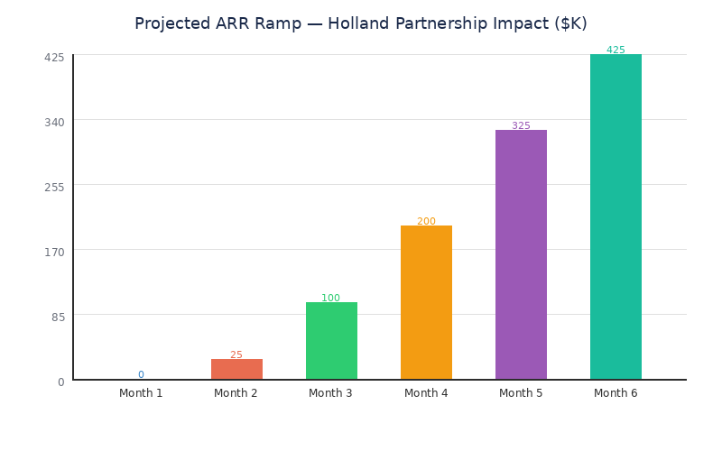

The balance of this document details the strategic fit assessment, commercial terms, joint GTM plan, success metrics, full six-month roadmap, and risk mitigation framework. Each section is designed to be actionable — providing decision-ready analysis rather than abstract strategy.
────────────────────────────────────────────────────────────

Partnership Rationale & Strategic Fit

Why Holland — And Why Now
RailVision's core challenge is not technology — it is distribution. The product delivers measurable fuel savings (5–10%), improved schedule adherence, and crew-friendly efficiency tooling. But shortline and regional railroads are notoriously relationship-driven markets where vendor trust is earned through years of field presence, not product demos. Holland occupies precisely this position: embedded, trusted, and operationally present across the shortline ecosystem.
Four factors make Holland the right partner at the right time:
- Access & Trust: Holland maintains active maintenance and service contracts with dozens of shortline operators. Their field technicians are on-site regularly, known by name to operations managers and locomotive engineers. This is the kind of access that would take RailVision 18–24 months to build independently.
- Credibility with Crews: Engineer adoption is the single biggest risk to any RailVision deployment. Holland's field staff are already trusted by the people who will use our product. Their endorsement — or even neutral introduction — dramatically reduces the "who are these people?" barrier that kills early-stage pilots.
- Complementary Footprint: RailVision is tablet-first, low-capex, and designed for rapid deployment. Holland can bundle our solution into existing service visits without requiring locomotive modifications or extended downtime. This is a critical advantage over competitors like Trip Optimizer (Wabtec), which require significant hardware installation.
- De-Risked Pilots: Joint introductions mean faster scheduling, shared onsite enablement, and a built-in escalation path if operational issues arise during proof-of-concept deployments.
──────────────────────────────────────────────────────────────────────

Strategic Fit Assessment
The following scorecard evaluates Holland across the dimensions that matter most for a co-sell partnership:
Fit Dimension | Rating (1–5) | Evidence / Rationale
**Shortline Coverage** | 5 | Active relationships with 25+ target logos; routine site presence
**C-Suite Access** | 4 | Known to ops leadership; some CEO-level relationships via long-term contracts
**Field Staff Quality** | 4 | Technically competent; trusted by crews; capable of coaching/enablement
**Brand Alignment** | 4 | Practical, operator-focused positioning; no conflicting technology agenda
**Commercial Flexibility** | 3 | Willing to discuss referral/success-fee models; exclusivity remains a negotiation risk
**Data Sensitivity** | 3 | No history of data-centric partnerships; requires clear contractual guardrails
**Competitive Risk** | 2 | Low probability of building competing product; moderate risk of partnering with a rival

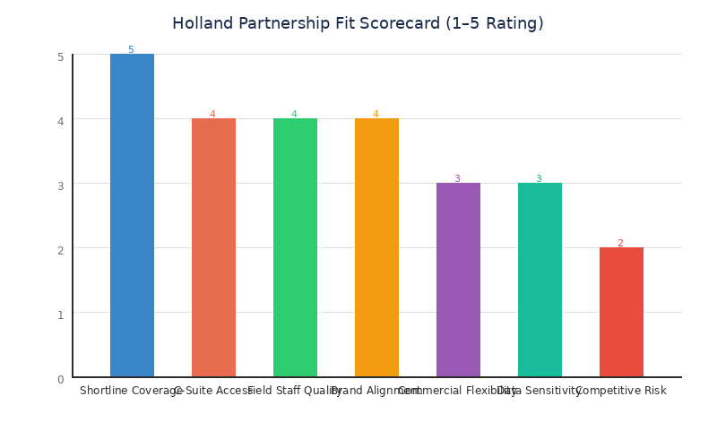

What Happens If We Don't Partner
The non-go scenario is not neutral — it carries real cost. Without Holland (or a comparable channel partner), RailVision must build shortline relationships from scratch, relying on cold outreach, conference networking, and the slow accumulation of references. Based on 2023–2024 sales cycle data, this implies:
- Average time-to-first-meeting: 6–8 weeks (vs. 1–2 weeks with Holland intro)
- Average time-to-signed-POC: 4–6 months (vs. 6–8 weeks with co-sell support)
- Pipeline conversion rate: ~12% direct vs. ~25% estimated with warm introduction
In a company with limited runway, this time differential is existential. Every month of delayed pipeline is a month of cash burn without revenue offset. The Holland partnership is not a growth optimization — it is a survival accelerant.
────────────────────────────────────────────────────────────

Partnership Model & Commercial Terms

Structural Guardrails
The partnership framework is designed around a single principle: RailVision retains the customer relationship, the commercial control, and the data rights — without exception. Holland provides access, introductions, and field enablement. They are a force multiplier, not a gatekeeper.
The following non-negotiable guardrails define the partnership boundaries:
Guardrail | Specification | Rationale
**Partnership Type** | Referral + co-sell only | Prevents Holland from controlling customer communication or pricing
**Territory** | North America shortlines & regionals | Focused scope; avoids overlap with Class I direct sales
**Exclusivity** | Explicitly non-exclusive | Preserves RailVision's right to pursue any account independently
**Customer Relationship** | RailVision holds SOW, pricing, and renewals | Ensures long-term account control and upsell path
**Data Rights** | RailVision receives all usage, trip, and performance data | Critical for product improvement, analytics, and competitive moat
**Branding** | Co-branded field materials; RailVision logo primary on product/UI | Protects brand equity; avoids white-label confusion
**Invoicing** | RailVision invoices customer directly | Holland never takes title or sets price

**Red line**: If Holland insists on exclusivity, reseller control (they invoice), or any restriction on RailVision's data rights, the partnership does not proceed. These are non-negotiable.
──────────────────────────────────────────────────────────────────────

Commercial Economics
Two compensation models are proposed, selectable on a per-deal basis depending on Holland's level of involvement:

Option A: Referral Fee Model
Component | Terms
Fee | 10–15% of first-year net revenue (NRR)
Trigger | Paid upon customer cash receipt
Duration | First-year only; no trailing commission on renewals
Conditions | Holland must provide qualified introduction that leads to signed SOW

Option B: Co-Sell Success Fee Model
Component | Terms
Base Fee | Fixed success fee per signed SOW (amount TBD by deal size)
Milestone Bonus | Additional payout after 90-day adoption target met (≥70% crew usage)
Revenue Share | None — RailVision retains 100% of customer revenue
Conditions | Holland participates in joint selling activities and field enablement

Sales SPIFs for Holland Field Teams
To drive grassroots engagement from Holland's account executives and field representatives, modest SPIFs are proposed:
Activity | SPIF Amount
Qualified POC introduction | $500 per POC
Closed-won deal (>$50K) | $2,000 per deal
Crew adoption milestone (≥70% active use) | $1,000 bonus

──────────────────────────────────────────────────────────────────────

Ancillary Services
Holland may provide paid field services under a separate SOW with the railroad customer. These include installation assistance, crew coaching, and change management support. Scope must be coordinated in a joint plan to ensure messaging alignment and avoid scope creep. RailVision does not take a cut of Holland's services revenue, and Holland does not take a cut of RailVision's subscription revenue. Clean separation of economics reduces friction and aligns incentives.
This structure ensures Holland is motivated to drive introductions and support adoption, while RailVision maintains the strategic assets — customer relationship, pricing power, data access, and brand control — that underpin long-term enterprise value.
────────────────────────────────────────────────────────────

Joint Go-To-Market Plan — First 90 Days
The first 90 days are structured as a high-velocity proving period. The goal is unambiguous: 3 signed POCs, 1 production contract, and statistically significant fuel/time savings with high crew acceptance. If these gates are not met, the partnership pauses for renegotiation or termination.

Phase 1: Account Mapping & Pipeline Build (Weeks 1–2)
The immediate priority is translating Holland's relationship network into a prioritized, actionable target list. This is not a passive exercise — it requires joint working sessions where Holland's field leaders and RailVision's sales team map specific accounts, decision-makers, and introduction paths.
Deliverable | Owner | Deadline | Success Criteria
25-logo target list with fleet size, freight mix, decision maker, relationship owner | Holland + RailVision Sales | Week 1 | List reviewed and prioritized by both teams
6 joint executive calls scheduled | Holland Channel Lead | Week 1 | Calendar holds confirmed; deal hypotheses defined
POC kit finalized (baseline plan, SOW template, pricing examples) | RailVision Product + Sales | Week 2 | Signed off by CSO; ready for customer delivery
Data-sharing mechanics validated | RailVision Engineering | Week 2 | Secure transfer mechanism tested; anonymization standard confirmed

Target Account Prioritization Signals
Not all shortlines are equal. The 25-logo target list should be prioritized using the following signals:
- Fuel exposure: High diesel cost sensitivity (fuel as % of operating expense >25%)
- Throttle variability: Routes with frequent acceleration/deceleration cycles (e.g., energy, aggregates freight)
- On-time pressure: Customers facing schedule adherence penalties or service-level agreements
- Safety culture: Operations leadership receptive to technology-enabled safety improvements
- Pilot willingness: History of piloting new tools on select routes before system-wide rollout
──────────────────────────────────────────────────────────────────────

Phase 2: Enablement & POC Preparation (Weeks 2–4)
Holland's field staff are the front line of crew adoption. Their ability to position RailVision correctly — as an engineer-first efficiency companion, not surveillance or autopilot — will make or break pilot success.
Activity | Description | Deadline
**Adoption Playbook Training** | Train 10+ Holland field staff on crew-first messaging, ride-along coaching protocols, scorecards, and feedback loops | Week 3
**Engineer 1-Pager** | Co-develop a single-page document for locomotive engineers: what RailVision is, what it isn't, how data is used, and personal benefits | Week 2
**Messaging Rubric Distribution** | Distribute approved talk tracks; review/approve all external materials before use | Week 3
**Baseline Measurement Plan** | Define fuel consumption, schedule adherence, and throttle/brake usage baselines for each POC site | Week 2

Messaging Guardrails (Critical)
**DO say**: "Helps you run smoother, reduce rework, cut wasted fuel, and arrive more predictably."
**DON'T say**: "Autopilot," "surveillance," "replace engineers," or anything implying loss of craft.
**Transparency principle**: Always explain what data is collected, why, and how it improves schedules and fuel — before deployment begins.
──────────────────────────────────────────────────────────────────────

Phase 3: Execution & Pipeline Cadence (Weeks 4–12)
Once POCs are launched, the operating rhythm shifts to weekly execution cadence:
- Weekly (30 min): Joint pipeline and deal operations review — stage progression, blocker removal, shared tracker updates
- Monthly: Enablement refresh, content updates, new account introductions
- Quarterly (QBR): Full scorecard review vs. targets; renew, adjust, or exit decision
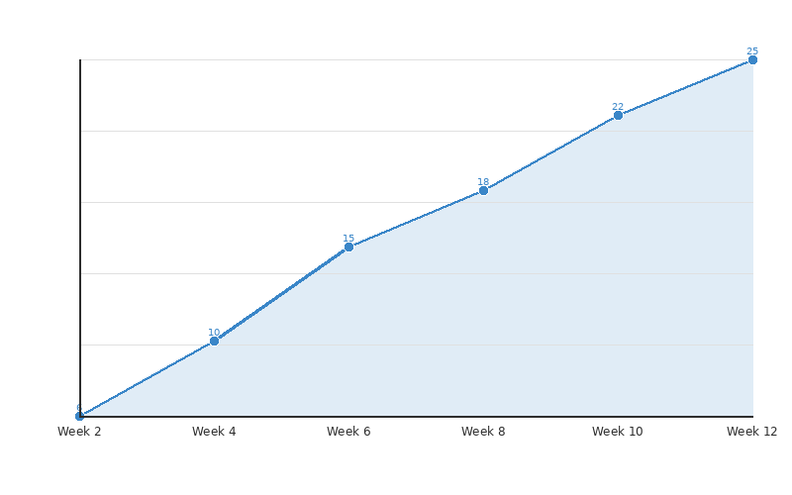

Chart note: Y-axis represents cumulative qualified pipeline activities (intros + meetings + POC proposals). Target is 25 touchpoints by Day 90, converting to ≥3 signed POCs.

90-Day Exit Gate
At Day 90, a formal review determines whether the partnership continues, adjusts, or terminates:
Outcome | Criteria | Action
**GO — Accelerate** | ≥3 POCs signed, ≥1 production contract, pipeline ≥5 qualified deals | Expand account mapping; increase SPIF budget; begin QBR cadence
**ADJUST** | 2 POCs signed, pipeline active but below target | Identify blockers; revise account list; extend evaluation by 45 days
**NO-GO — Pause** | <2 POCs signed or data rights not honored | Pause partnership; conduct post-mortem; evaluate alternative channels

────────────────────────────────────────────────────────────

Success Metrics & KPI Framework
Measuring partnership performance requires a balanced scorecard that spans commercial traction, product adoption, operational execution, and validated impact. Vanity metrics — meetings held, emails sent, logos contacted — are excluded. Every metric below has a clear threshold that maps to the 90-day and 180-day gate decisions.

Commercial Metrics
These metrics track the partnership's revenue contribution and pipeline health:
KPI | 90-Day Target | 180-Day Target | Measurement Method
POCs Signed | ≥3 | 5+ | Executed SOW count
Production Contracts | ≥1 | 3+ | Executed multi-property contracts
New ARR (Holland-sourced) | $100–150K | $300–400K | CRM attribution; Holland-introduced deals only
Qualified Pipeline Value | $500K+ | $1.5M+ | Stage 2+ opportunities in joint tracker
Average Deal Size | $50K+ | $75K+ | Contract value / deal count
Sales Cycle Length | <60 days | <45 days | First intro to signed SOW

Adoption Metrics
Crew adoption is the leading indicator of deployment success. If engineers reject the tool, fuel savings never materialize and renewals collapse.
KPI | Target | Red Flag Threshold
Active Crew Usage (POC) | ≥70% | <50% triggers intervention
Engineer NPS | Positive (>0) | Negative NPS triggers messaging review
Opt-Out Rate | <10% | >20% triggers deployment pause
Time-to-First-Train | ≤14 days from SOW | >21 days triggers implementation review
Training Completion Rate | 100% of assigned engineers | <80% triggers Holland enablement escalation

Operational & Impact Metrics
These metrics validate that the product delivers its promised value — the foundation of every renewal, expansion, and case study.
KPI | Target | Validation Standard
Documented Fuel Savings | 5–10% | Methodology documented; confidence intervals reported
Schedule Adherence Improvement | Measurable positive delta | Before/after comparison with statistical significance
Case Studies Published | 2 anonymized case snaps | Customer-approved; usable in demand generation
Pilot Runbook Execution | 100% of steps completed | Implementation lead sign-off per property

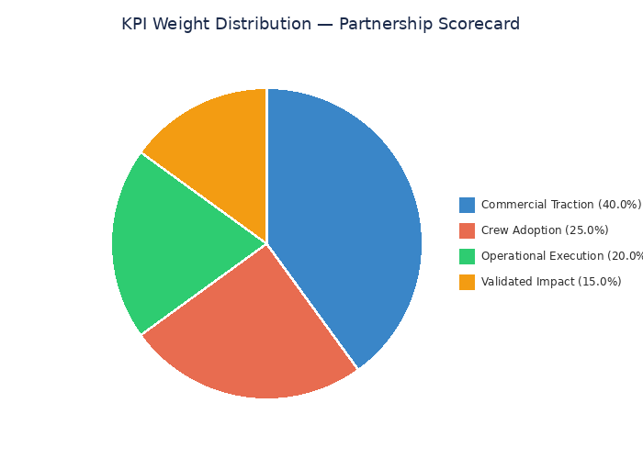

Scorecard Governance
The KPI framework is not a passive dashboard — it drives active decision-making:
- Weekly: Sales and pipeline metrics reviewed in joint 30-minute call. Any metric trending below 70% of target triggers a named action item with a 7-day resolution deadline.
- Monthly: Adoption and operational metrics reviewed in enablement session. Training gaps, messaging drift, or deployment delays are escalated to partnership leads.
- Quarterly (QBR): Full scorecard review with executive sponsors from both organizations. Formal go/adjust/no-go determination based on cumulative performance against all four metric categories.
The scorecard is owned by the RailVision CSO (lead) with RailVision Sales (co-lead) and the Holland Channel Lead as the three accountable parties. No metric is measured without a named owner and a defined response protocol for underperformance.
────────────────────────────────────────────────────────────

Six-Month Execution Roadmap
The Holland partnership does not exist in isolation — it is the commercial engine within a broader six-month survival plan that determines RailVision's trajectory. This roadmap integrates the Holland co-sell activities with parallel customer development, product deployment, and capital strategy.

Month-by-Month Execution Plan
Month | Focus Area | Key Deliverables | ARR Target
**Month 1 (Jan)** | Triage & Reset | Post-mortem complete; org changes executed; Holland memo sent; kickoff scheduled | $0
**Month 2 (Feb)** | GWRR Do-or-Die + Holland Launch | GWRR pilot agreement signed; Holland account mapping complete; 6 exec intros scheduled | $25K
**Month 3 (Mar)** | Deployment Discipline | GWRR Property #1 live; 2–3 Holland-sourced POCs launched; baseline data collection underway | $100K
**Month 4 (Apr)** | Validation & Expansion | GWRR Properties #2–3 deployed; first fuel savings report (6%+ target); Holland POC results emerging | $200K
**Month 5 (May)** | Sales Engine Activation | GWRR case study live; outbound campaign launched; Vermont Rail closed; OmniTrax pilot signed | $325K
**Month 6 (Jun)** | Funding Decision Point | $400K+ ARR confirmed; investment materials prepared; parallel fundraising/acquisition tracks evaluated | $425K

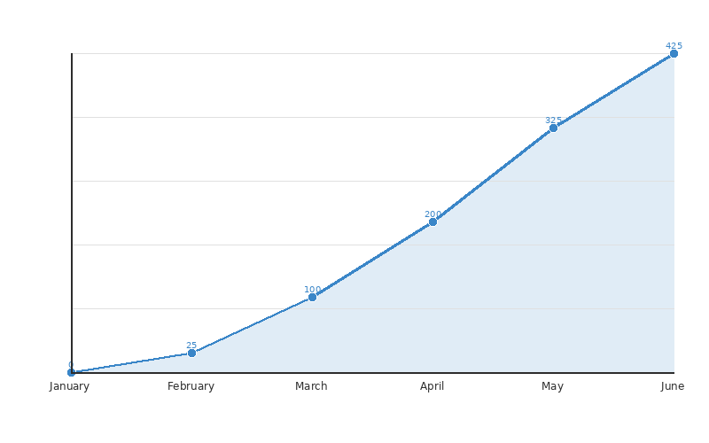

──────────────────────────────────────────────────────────────────────

Critical Path Dependencies
The roadmap contains several serial dependencies where failure at one stage cascades into subsequent months. These must be monitored with extreme vigilance:
- GWRR Pilot Agreement (Month 2) → Without a signed GWRR agreement, the Month 4 fuel savings report and Month 5 case study cannot exist. GWRR is the proof point that unlocks the entire pipeline. If GWRR does not sign by end of February, Plan B activates: redirect all resources to Holland-sourced POCs as the primary validation path.
- Holland Account Mapping (Month 1–2) → The 25-logo target list and 6 scheduled exec intros are prerequisites for the Week 4–12 pipeline cadence. If Holland cannot deliver introductions within the first 30 days, the partnership's value proposition is fundamentally undermined.
- Crew Adoption in POCs (Month 3–4) → If active crew usage falls below 50% in any POC, the deployment must pause for intervention. Low adoption means no fuel savings data, no case study, and no expansion conversation. The adoption playbook and Holland field training are the primary risk controls.
──────────────────────────────────────────────────────────────────────

Resource Allocation
RailVision is operating in survival mode. Resource allocation must be ruthlessly prioritized:
Role | Allocation | Responsibility
**CEO (Jamie O'Rourke)** | 30% of time | Executive air cover for GWRR and top Holland-sourced deals
**CSO (Michael)** | 50% of time | Holland partnership lead; scorecard governance; board communication
**Head of Sales** | 80% of time | Pipeline management; joint deal reviews; pricing/SOW execution
**Implementation Lead** (New Hire) | 100% | GWRR deployment; POC execution; pilot runbook management
**Dev Jain (Product/Engineering)** | 40% on deployment | Engineer training; on-site visits; product issue resolution
**Sales Specialist** (New Hire) | 100% | Shortline-focused outbound; Holland co-sell support

Month 6 Decision Framework
At the end of June 2026, RailVision's leadership and board must make a definitive strategic decision based on demonstrated performance:
Scenario | Criteria | Recommended Action
**Strong Momentum** | $400K+ ARR, 3+ production customers, growing pipeline | Raise $2–3M bridge round; target acquisition at higher valuation in 12–18 months
**Moderate Traction** | $200–300K ARR, execution challenges but product-market fit evident | Consider strategic sale at $15–20M; approach Wabtec, Progress Rail, Alstom
**Insufficient Progress** | <$200K ARR, limited customer traction | Prepare for acqui-hire or structured wind-down

────────────────────────────────────────────────────────────

Risk Assessment & Mitigation Framework
Every partnership introduces new risk vectors. The Holland co-sell arrangement is no exception. The following risk matrix evaluates the probability, impact, and mitigation strategy for each identified threat — organized by severity.

Risk Matrix
Risk | Probability | Impact | Severity | Mitigation Strategy
**Holland demands exclusivity** | Medium | Critical | 🔴 High | Non-negotiable red line; walk away if pressed. Alternative channel partners exist.
**Data rights friction** | Medium | Critical | 🔴 High | Data clause embedded in MSA/SOW before first deal; secure transfer mechanism; anonymization standard.
**Messaging drift ("autopilot" claims)** | High | High | 🔴 High | Shared talk tracks; mandatory review/approval of all external materials; crew-first coaching certification.
**Slow sell-through / intro delays** | Medium | High | 🟠 Medium-High | 90-day quota with exit clause; named-account plan with exec air cover from both sides.
**Channel conflict / loss of customer intimacy** | Medium | Medium | 🟠 Medium | Co-sell only model (never reseller); RailVision controls SOW/pricing; joint QBRs maintain visibility.
**Incumbent pushback (Trip Optimizer/Wabtec)** | High | Medium | 🟠 Medium | Lead with low-capex, fast time-to-value positioning; frame as "first step" efficiency vs. heavy install.
**Holland field staff underperformance** | Medium | Medium | 🟡 Medium | Training certification requirement; quarterly skill refresh; SPIF incentives tied to adoption outcomes.
**Crew rejection of RailVision tool** | Low-Med | High | 🟡 Medium | Pre-deployment messaging; engineer 1-pager; ride-along coaching; opt-out rate monitoring (<10%).
**Holland partners with competitor** | Low | High | 🟡 Medium | Non-exclusive means we can't prevent this; mitigate by delivering superior results and field support.
**Contractual / legal delays** | Low | Medium | 🟢 Low | Prepare template MSA and SOW in advance; pre-clear terms with legal before kickoff.

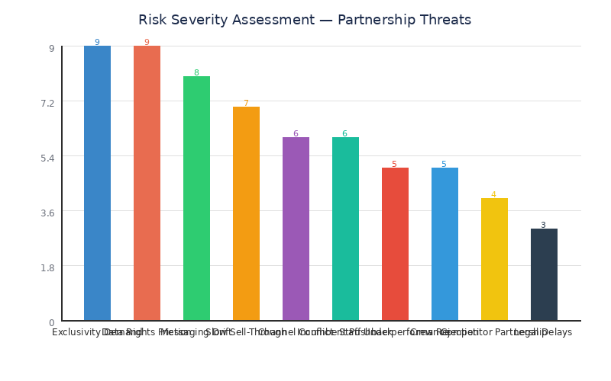

──────────────────────────────────────────────────────────────────────

Escalation Protocol
Not all risks can be prevented — but every risk must have a defined response. The following escalation protocol ensures that emerging issues are caught early and addressed decisively:
Tier 1 — Field-Level Issues (Response: 48 hours)
- Messaging inconsistencies observed during ride-alongs
- Individual crew member complaints or opt-outs
- Minor scheduling delays in POC deployment
- Owner: RailVision Implementation Lead + Holland Field Manager
Tier 2 — Partnership-Level Issues (Response: 7 days)
- Intro pipeline falls below 50% of monthly target
- Data-sharing mechanism fails or access is delayed
- Holland field staff fail training certification
- Owner: RailVision CSO + Holland Channel Lead
Tier 3 — Strategic Issues (Response: Immediate executive session)
- Holland requests exclusivity or reseller rights mid-partnership
- Customer data is mishandled or exposed
- Holland begins promoting a competing product
- Owner: RailVision CEO + Holland Executive Sponsor
──────────────────────────────────────────────────────────────────────

Competitive Positioning: RailVision vs. Trip Optimizer
The most likely competitive response to Holland-sourced deals will come from Wabtec's Trip Optimizer, the incumbent energy management system for larger railroads. Understanding and pre-empting this objection is essential for Holland's field teams:
Dimension | RailVision | Trip Optimizer (Wabtec)
**Deployment Model** | Tablet-first; no locomotive modification | Requires PTC hardware integration
**Install Time** | <14 days from SOW | 8–16 weeks typical
**Capex Requirement** | Low (software + tablet) | High ($50K–150K per locomotive)
**Target Market** | Shortlines & regionals | Class I railroads
**Crew Experience** | Advisory; engineer retains full control | Semi-autonomous; reduces engineer discretion
**Data Ownership** | Customer + RailVision | Wabtec retains significant data rights

The positioning message for every Holland-sourced conversation: "RailVision is the fast, low-risk first step to fuel efficiency — no locomotive surgery, no six-figure investment, and your engineers stay in control."
────────────────────────────────────────────────────────────

Next Steps & Recommendations

Immediate Actions (This Week)
The following actions must be completed within 7 calendar days of memo approval. Each item has a named owner and a binary completion criterion — no ambiguity, no partial credit.
Action Item | Owner | Deadline | Done Criteria
Send partnership memo + redline terms to Holland counterpart | CSO (Michael) | Day 1 | Email sent with attached term sheet
Schedule Holland kickoff meeting to draft named-account map | CSO + Sales Lead | Within 7 days | Calendar invite confirmed with Holland channel lead
Initiate legal review of template MSA / SOW with data rights clause | CSO + Legal | Within 7 days | Legal confirms review timeline ≤10 business days
Confirm data-sharing mechanics and security review scope | Engineering Lead | Within 7 days | Security review checklist created; Holland IT contact identified
Brief Jamie O'Rourke on partnership strategy for executive air cover | CSO | Within 3 days | CEO alignment confirmed; talking points for Holland exec call prepared

──────────────────────────────────────────────────────────────────────

Week 2 Deliverables
Deliverable | Owner | Completion Standard
POC Kit v1 (baseline plan, SOW template, value-based pricing examples) | Sales + Product | Reviewed and approved by CSO; ready for customer presentation
Adoption Playbook v1 (messaging rubrics, coaching protocols, scorecards) | Product + CS | Tested with internal team; formatted for Holland field training
Engineer 1-Pager (co-developed with Holland input) | Product + Holland | Single-page PDF; plain language; addresses "what it is / isn't / how data is used"
Security & data-sharing path validation | Engineering | Secure transfer mechanism tested end-to-end; anonymization standard documented

──────────────────────────────────────────────────────────────────────

Strategic Recommendations
Based on the analysis in this document, the CSO office makes the following five recommendations to the executive team:
1. Approve the Holland partnership under the defined guardrails. The referral + co-sell model with non-exclusive, non-reseller terms preserves RailVision's strategic assets while unlocking Holland's distribution network. The risk-reward profile is strongly favorable given current runway constraints.
2. Treat the 90-day gate as a hard commitment, not a soft target. If the partnership does not deliver ≥3 signed POCs and honored data rights by Day 90, the exit clause must be exercised. Sunk cost thinking in a cash-constrained environment is fatal.
3. Invest disproportionately in crew adoption enablement. Engineer acceptance is the highest-variance factor in every deployment. The adoption playbook, Holland field training, and messaging guardrails are not "nice to haves" — they are the difference between a reference customer and a churn event.
4. Run GWRR and Holland tracks in parallel, not sequentially. The six-month plan requires both engines producing results. GWRR provides the anchor case study; Holland provides pipeline breadth. Neither alone is sufficient to hit the $400K+ ARR target.
5. Prepare the Month 6 decision framework now — not in June. The fundraising, strategic sale, and wind-down scenarios should be pre-negotiated with the board so that the June decision is a selection, not a scramble. Investment materials should begin drafting in Month 4, not Month 6.
──────────────────────────────────────────────────────────────────────
**Final word**: RailVision has a **180-day window** to prove that its technology can convert into contracted, recurring revenue at a pace that justifies continued investment. The Holland partnership is the highest-probability accelerant available. Execute with discipline, measure with rigor, and be willing to pivot fast if the data says otherwise.
──────────────────────────────────────────────────────────────────────
Document prepared by the Office of the Chief Strategy Officer, RailVision
Classification: Internal — Executive Distribution
Version: 1.0 — December 2025

