AIKARTHYA FOUNDATION
SkillUp Programme • Monitoring & Evaluation
Program Facilitator Performance Analysis
Sandhya Yadav — Field Activity Review
PF | Sandhya Yadav (Active) | Window | 15-Jun to 25-Jun-2026
Schools | 5 (assigned 16-Jun-2026) | Source | Production database (live)
UUID | fba08bb6-…-4aa6b43c229e | Prepared by | Akash Das

1. Attendance Analysis
Attendance is counted from the first check-in: 15-Jun-2026, 11:37 IST. Each school has one registered geofence point (300 m) and there is one office point (Aikarthya Head Office). A check-in is an office visit or school visit by the point it matched. Where a check-out is away from a point, the day is validated by whether an observation was recorded that day.
Date | Check-in point | Check-out |  | Field validation
15-Jun | Head Office (office) | 16-Jun 10:01 (next day) |  | Office; check-out off-point
16-Jun | No registered point | 17-Jun 09:40 (next day) |  | No observation — UNVERIFIED
17-Jun | Head Office (office) | 18-Jun 09:05 (next day) |  | Office; check-out off-point
18-Jun | Grace Model (school) | 18-Jun 17:39 (same day) |  | 6 observations at Grace — verified
19-Jun | Central Public (school) | 19-Jun 16:26 (same day) |  | 5 observations at Central — verified
20-Jun | Scholars' Model (school) | 20-Jun 16:03 (same day) |  | 6 observations at Scholars' — verified
22-Jun | Adarsh (matched secondary pt) | 22-Jun 18:40 (same day) |  | 6 observations at Adarsh — verified
23-Jun | Head Office (office) | 24-Jun 09:08 (next day) |  | Office; check-out off-point
24-Jun | Head Office (office) | 25-Jun 11:14 (next day) |  | Office; check-out off-point
25-Jun | Head Office (office) | 25-Jun 17:32 (same day) |  | Office; check-out off-point
Metric |  |  | Value
Total attendance days (distinct check-ins) |  |  | 10
School-visit days |  |  | 4 — 18, 19, 20, 22 Jun
Office-visit days |  |  | 5 — 15, 17, 23, 24, 25 Jun
Unverified day (no point, no observation) |  |  | 1 — 16 Jun
Days with an off-registered-point check-out |  |  | 10 of 10
Missed same-day check-outs (closed next day) |  |  | 5 — 15, 16, 17, 23, 24 Jun
Leaves filed / holidays in window |  |  | 0 / 0 (no gaps; Sun 21-Jun excl.)

2. Observation Analysis (submitted observations only)
Counts below use the 23 submitted observations only — 3 unsubmitted drafts are excluded as they may be abandoned. All are Cycle 1 (baseline). Observation visits are counted by observation date.
Metric | Value
Submitted observations | 23
Observation-visit days | 4
Average observations per visit day | 5.75
Distinct teachers observed | 23
Average total score | 69.8 / 100 (range 52–92)
Schools observed | 4 of 5 — Ahad High School: 0 observations

Submitted observations by date
Obs date | Submitted | Avg score | School
18-Jun | 6 | 75.8 | Grace Model
19-Jun | 5 | 70.6 | Central Public
20-Jun | 6 | 61.3 | Scholars' Model
22-Jun | 6 | 71.7 | Adarsh Vidyalaya (primary)
Note: observation work is tight and same-day — every school-visit day produced a full set of observations entered on the day, with no week-late backdating. Average scores (69.8) sit comfortably in the baseline band.

3. Reporting Pipeline Analysis
Every submitted observation creates a report job: queued → generating → M&E review → PF review → released (shared). The target is governed by an SLA (Service-Level Agreement) of 72 hours — the window from observation submission within which the report should be reviewed and shared with the school. Here the full loop is closed: every report was generated and shared, none overdue.
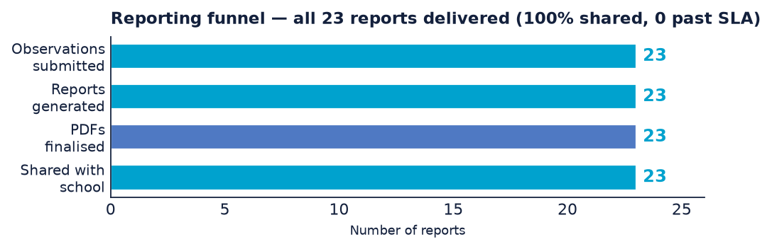
Stage | Result
Reports generated (AI draft) | 23 of 23 submitted (100%)
Reports finalised (PDF) | 23
Reports shared with school | 23 (100%)
Awaiting PF review / share | 0
Open reports past the 72-hour SLA | 0

By real date — observations vs. generation vs. sharing
Report-generation and share dates differ from observation dates, so each column below is keyed to the date that event actually occurred.
Date | Obs submitted | Reports generated | Reports shared
18-Jun | 6 | — | —
19-Jun | 5 | — | —
20-Jun | 6 | — | —
21-Jun | — | 1 | —
22-Jun | 6 | 11 | —
23-Jun | — | 1 | 10
24-Jun | — | 2 | 5
25-Jun | — | 8 | 8
Total | 23 | 23 | 23
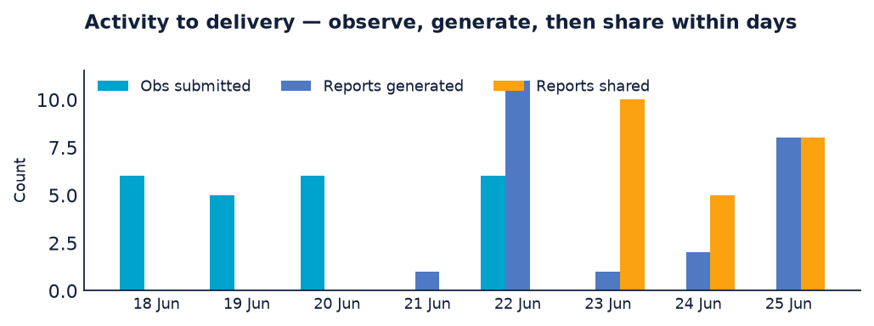

4. Session-Conducted Analysis
Sandhya has 7 submitted offline sessions covering all 5 schools — an orientation in each school plus two Cycle-1 sessions in the review window (5 further drafts are excluded). Session coverage is complete:
Date | School | Topic | Detail
04-Jun | Grace Model | Orientation | 90 min · eng 3/5 · 15 present
06-Jun | Ahad High School | Orientation | 105 min · leader present · 10 present
08-Jun | Central Public | Orientation | Submitted (attendance not marked present)
09-Jun | Adarsh (primary) | Orientation | 180 min · leader present · eng 4/5 · 15 present
10-Jun | Scholars' Model | Orientation | eng 3/5 · 16 present
19-Jun | Central Public | Orientation | In-window · 15 present
22-Jun | Adarsh (primary) | Culture building — rules to habits | 65 min · leader present · eng 3/5
Strength: unlike the observation gap, no school is missing a session — all five were oriented, and two received a follow-up Cycle-1 session. The one data nick is the 08-Jun Central session, where attendance was logged but no teacher marked present.

5. Data Quality & Validity (submitted observations only)
Completeness across the 23 submitted observations. The graded core — the full 34-indicator rubric and the glow/grow narrative — is complete on every submitted observation, as are subject, grade and duration. The gaps are the scheduling date and partial photo evidence.
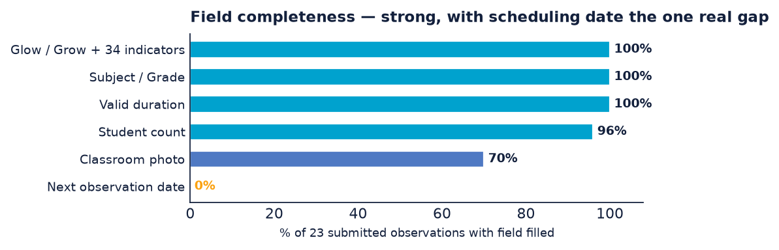
Field | Filled | Assessment
Next observation date | 0 / 23 | Forward observation schedule undefined
Classroom photo | 16 / 23 | Evidence trail missing on ~30%
Student count | 22 / 23 | Near-complete
Valid duration | 23 / 23 | No reversed or zero durations
Subject / Grade / Topic | 23 / 23 | Complete
Glow / Grow narrative + 34-indicator scores | 23 / 23 | Complete

6. Overall Performance Assessment (critical)
A loop-closing performer — strong where it counts, with discipline gaps to tighten. Sandhya does the thing that actually creates programme value: she does not just observe, she delivers. All 23 reports were generated and shared with schools, none past SLA — so every teacher she observed has received feedback they can act on. That is the single most important outcome of the role, and on it she is performing at the top of the cohort. Her observation scores (avg 69.8) and complete session coverage across all 5 schools reinforce a picture of a facilitator who closes loops rather than leaving work half-done.
The critical caveats are about discipline and completeness, not delivery. (1) Check-out discipline is poor: every one of 10 days closed away from a registered point, so the system cannot confirm she remained at the school for the full visit. (2) Coverage has a hole: Ahad High School was oriented but received zero classroom observations, and 16-Jun is an unverified field day. (3) The forward schedule is undefined: next-observation-date is blank on all 23, so Cycle 2 has no booked dates; photo evidence is present on only ~70%. None of these undo the delivery, but they are the difference between strong and exemplary.
Dimension | Rating | Basis
Report sharing within SLA | Excellent | 23 / 23 shared; 0 overdue
Report generation / finalisation | Excellent | 23 / 23 finalised
Session conduct & coverage | Strong | 7 sessions; all 5 schools
Observation volume | Strong | 23 obs, avg 69.8; same-day entry
Observation coverage | Partial | 4 of 5 schools; Ahad uncovered
Attendance / check-out discipline | Weak | 0 / 10 on-point; 1 unverified day
Baseline data integrity | Adequate | Core complete; no next dates; 70% photo

7. Consequences if the Gaps Are Not Corrected
- Attendance / payroll trust: with all 10 days closing off the registered point, the records cannot prove time-on-site. If attendance is ever tied to stipend or compliance, off-point check-outs invite disputes and audit exposure even when the field work was genuine.
- Incomplete evidence trail: missing photos on ~30% and the unverified 16-Jun day weaken the proof Aikarthya can show funders and schools that the visit happened as recorded.
- Baseline measurability: growth is endline − baseline; the strong scores only convert to a credible impact number if the baseline visit is fully evidenced and the follow-up is scheduled.

8. Recommendations
- Hold her sharing discipline up as the cohort model: 23/23 shared within SLA is the standard other PFs should be measured against.
- Fix check-out at the registered point: all 10 days were off-point — the one systemic discipline gap.
- Schedule Ahad High School observations and review the 16-Jun unverified day.
- Make next-observation-date mandatory at submission to lock the Cycle-2 schedule, and attach a classroom photo on the remaining ~30%.
Prepared for the Aikarthya Founder & M&E team from live production data on 25-Jun-2026, cross-referenced with the SkillUp programme framework. Internal analysis — confidential.

