資一1 - 柯昱佑 - 7號 - 任課老師:黃文瑤
題目 :
佑佑拉霸機
說明 :
出現3個7，獲得 下注金額*100
出現2個7，獲得 下注金額*50
出現1個7，獲得 下注金額*1.5
出現3個8，獲得 下注金額*8
出現3個6，獲得 下注金額*6
出現3個0，只能拿回 下注金額的一半
N = 1、2、3、4、5、9
出現3個N，獲得 下注金額*4
X = 1、2、3、4、5、6、8、9
出現2個N，獲得 下注金額*1.5
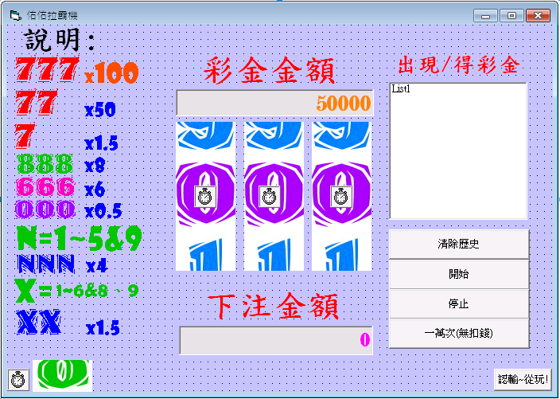
表單 :
程式 :
Dim money As Double  Dim Win(9) As Integer  Dim NTimer As Integer | 金錢盒  0~9(出現計次)  Timer跑完後計次
Private Sub Form_Load()  money = 50000  End Sub | 初始金額50000
Private Sub Command1_Click()  If money >= money2 And money2 >= 0 Then  money = money - money2  Timer1.Interval = 1  Timer2.Interval = 1  Timer3.Interval = 1  NTimer = 0  Timer4.Enabled = True  Command1.Enabled = False  Command2.Enabled = True  money2.Locked = True  For i = 0 To 9  Win(i) = 0  Next i  Else  MsgBox "彩金不足OR下注金額錯誤", , "彩金不足OR下注金額錯誤"  End If  End Sub | -當符合  下注金額<=彩金餘額時  才會執行  -Timer時間間隔設為1  (原為0)  -Timer跑完次數先歸0  -外圈計時器開始執行  -按鈕1，關閉  -按鈕2，開啟  -鎖住下注金額修改  -使0~9出現次數歸0
Private Sub Command2_Click()  Timer1.Interval = 101  Timer2.Interval = 101  Timer3.Interval = 101  End Sub | -Timer時間設為101  (因為計時器，設定 為Interval>100，立即歸0)
Private Sub Command3_Click()  money = 50000  money1 = 50000  List1.Clear  End Sub | -金錢盒值回到50000  -顯示金額回到50000  -清除list1
Private Sub Command5_Click()  List1.Clear  End Sub | -清除list1

Private Sub Command6_Click()  Randomize  If money >= money2 And money2 >= 0 Then  For yo = 1 To 10000  x = Int(Rnd * 10)  y = Int(Rnd * 10)  z = Int(Rnd * 10)  RP(0).Picture = P(x).Picture  RP(1).Picture = P(y).Picture  RP(2).Picture = P(z).Picture  For j = 0 To 9  Win(j) = 0  If RP(0).Picture = P(j).Picture Then Win(j) = Win(j) + 1  If RP(1).Picture = P(j).Picture Then Win(j) = Win(j) + 1  If RP(2).Picture = P(j).Picture Then Win(j) = Win(j) + 1  Next j  For i = 0 To 9  If Win(i) = 1 And i = 7 Then  money = money + (money2 * 1.5)  List1.AddItem i & " " & money - money1  money1 = money  Else  If Win(i) = 2 Then  If i = 7 Then money = money + (money2 * 50)  If i = 1 Or i = 2 Or i = 3 Or i = 4 Or i = 5 Or i = 6 Or i = 8 Or i = 9 Then  money = money + (money2 * 1.5)  End If  If i = 0 Then money = money * 1 + money2 * 1  List1.AddItem i & i & " " & money - money1  money1 = money  Else  If Win(i) = 3 Then  If i = 7 Then money = money + (money2 * 100)  If i = 8 Then money = money + (money2 * 8)  If i = 6 Then money = money + (money2 * 6)  If i = 0 Then money = money + (money2 * 0.5)  If i = 1 Or i = 2 Or i = 3 Or i = 4 Or i = 5 Or i = 9 Then  money = money + (money2 * 4)  End If  List1.AddItem i & i & i & " " & money - money1  money1 = money  End If  End If  End If  Next i  Next yo  Else  MsgBox "彩金不足OR下注金額錯誤", , "彩金不足OR下注金額錯誤"  End If  End Sub | -符合即執行  -迴圈一萬次  -X、Y、Z  -亂數  -(0~9)  -(圖片亂數)  -迴圈判斷  -出現歸0  -對應某數  -某數出現  次數+1  -迴圈判斷  -出現1次同  數字7  下注金額  *1.5倍  其餘=無  -出現2次同  數字7  下注金額*50  其餘數字  (除0外)  下注金額*1.5  -出現3次同  數字7，*100  數字8，*8  數字6，*6  數字0賠*0.5  數字1~5、9  *4  -金錢盒與  彩金餘額同步

Private Sub Timer1_Timer()  Randomize  x = Int(Rnd * 10)  RP(0).Picture = P(x).Picture  Timer1.Interval = Timer1.Interval + x  If Timer1.Interval > 100 Then  Timer1.Interval = 0  NTimer = NTimer + 1  For i = 0 To 9  If RP(0).Picture = P(i).Picture Then  Win(i) = Win(i) + 1  End If  Next i  End If  End Sub | -亂數(0~9)  圖片亂數變動  -Timer時間逐加  當大於100  Timer 歸0-停止  Timer跑完次數+1  -迴圈判斷  當某圖值對應某數  某數出現次數+1
Private Sub Timer2_Timer()  Randomize  x = Int(Rnd * 10)  RP(1).Picture = P(x).Picture  Timer2.Interval = Timer2.Interval + x  If Timer2.Interval > 100 Then  Timer2.Interval = 0  NTimer = NTimer + 1  For i = 0 To 9  If RP(1).Picture = P(i).Picture Then  Win(i) = Win(i) + 1  End If  Next i  End If  End Sub | -亂數(0~9)  圖片亂數變動  -Timer時間逐加  當大於100  Timer 歸0-停止  Timer跑完次數+1  -迴圈判斷  當某圖值對應某數  某數出現次數+1
Private Sub Timer3_Timer()  Randomize  x = Int(Rnd * 10)  RP(2).Picture = P(x).Picture  Timer3.Interval = Timer3.Interval + x  If Timer3.Interval > 100 Then  Timer3.Interval = 0  NTimer = NTimer + 1  For i = 0 To 9  If RP(2).Picture = P(i).Picture Then  Win(i) = Win(i) + 1  End If  Next i  End If  End Sub | -亂數(0~9)  圖片亂數變動  -Timer時間逐加  當大於100  Timer 歸0-停止  Timer跑完次數+1  -迴圈判斷  當某圖值對應某數  某數出現次數+1

Private Sub Timer4_Timer()  money1 = money  If NTimer = 3 Then  Command1.Enabled = True  Command2.Enabled = False  money2.Locked = True  For i = 0 To 9  If Win(i) = 1 And i = 7 Then  money = money + (money2 * 1.5)  List1.AddItem i & " " & money - money1  money1 = money  Timer4.Enabled = False  Else  If Win(i) = 2 Then  If i = 7 Then money = money + (money2 * 50)  If i = 1 Or i = 2 Or i = 3 Or i = 4 Or i = 5 Or i = 6 Or i = 8 Or i = 9 Then  money = money + (money2 * 1.5)  End If  List1.AddItem i & i & " " & money - money1  money1 = money  Timer4.Enabled = False  Else  If Win(i) = 3 Then  If i = 7 Then money = money + (money2 * 100)  If i = 8 Then money = money + (money2 * 8)  If i = 6 Then money = money + (money2 * 6)  If i = 0 Then money = money + (money2 * 0.5)  If i = 1 Or i = 2 Or i = 3 Or i = 4 Or i = 5 Or i = 9 Then  money = money + (money2 * 4)  End If  List1.AddItem i & i & i & " " & money - money1  money1 = money  Timer4.Enabled = False  End If  End If  End If  Next i  End If  End Sub | -時時判斷  -金額同步  -當3個都跑完  -按鈕1開  -按鈕2關  -開啟下注修改  -迴圈判斷  -出現1次同  數字7  下注金額  *1.5倍  其餘=無  -關閉外部計時  -出現2次同  數字7  下注金額*50  其餘數字  (除0外)  下注金額*1.5  -關閉外部計時  -出現3次同  數字7，*100  數字8，*8  數字6，*6  數字0賠*0.5  數字1~5、9  *4  -關閉外部計時

執行結果 :
按下按鈕1，並扣除下注金額，執行過程，視覺看起來像在動 ；執行完畢按鈕改變
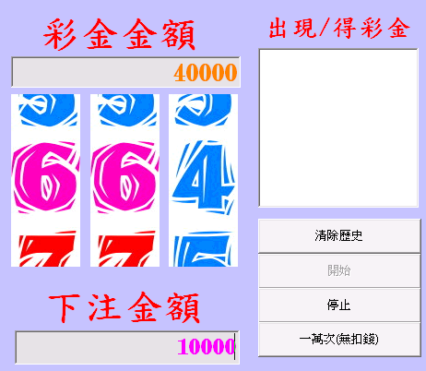
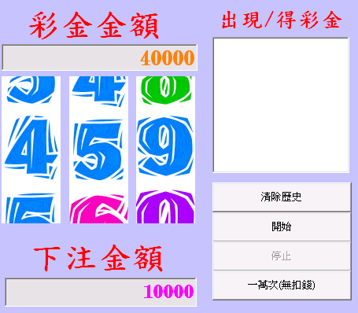
以一萬為下注金額的獲得金額，部分執行結果
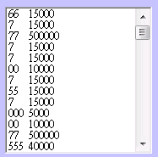

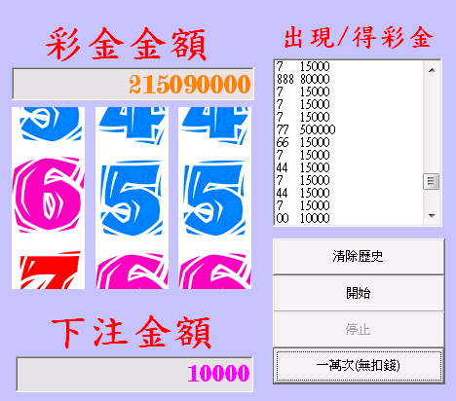
一萬次
按下從玩

