Overview of Financial Markets

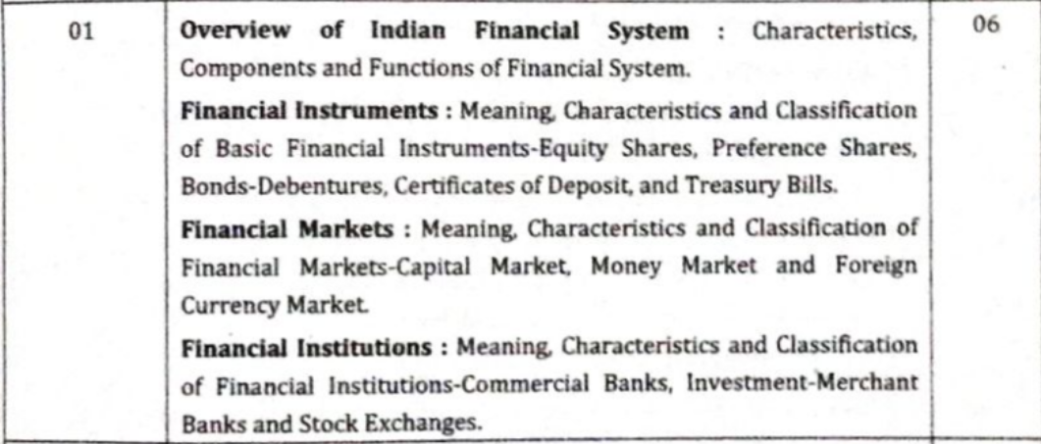

Ratios

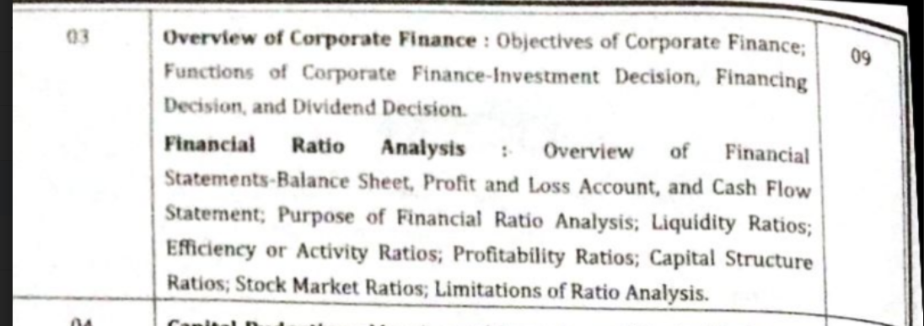

Dividend Policy

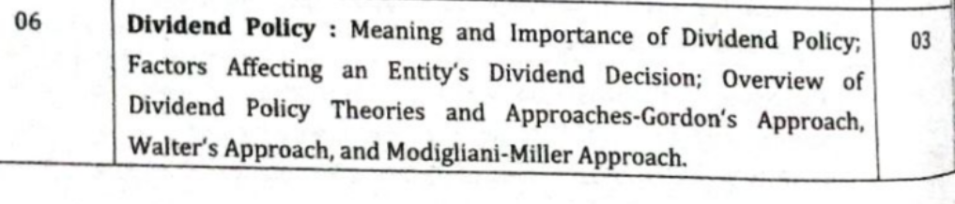

**Dividend Policy**

A dividend is a distribution of profits by a corporation to its shareholders.

A dividend policy is a financial decision that involves deciding on the dividend payout ratio, the frequency of dividends and should they pay dividends at all or not. It is drafted by the company's board of directors and acts as a guideline for distributing dividends to the investors.

Company can choose to give a part of earnings to shareholders and use the balance for reinvestment.

Dividend policy has the parameters for payment of dividends to shareholders such as frequency, amount, timing of dividend and depends on the financial position of the company.

Importance of Dividend Policy: BFII

1. Build Shareholders Trust: A well communicated dividend policy of the company helps to build trust with its shareholders, as the policy helps to establish consistency between shareholders expectations and actual payout.
2. Future Profits: Dividend policy signals the expectations of future profits of the company. For example, company making stable dividend payments, raises dividend payout signals that company expects growth in profits in future.
3. Influences stock price and value: Dividend payout is an important consideration for valuation of companies, hence a change in dividend policy influence the share price.
4. Influence Institutional Investors: Balanced dividend policy sends strong signals about the company’s capital allocation policy and help attract institutional investors.

Types of Dividend Policy :

1. Constant DP : The company decides a fixed amount of dividend for the shareholders. In this policy the dividend amount does not change periodically.
2. Constant Payout Policy : The company pays a fixed percentage of profit as dividends. The dividend amount grows or declines with change in profits.
3. Irregular DP : The company does not have fixed amount/schedule for dividend payout.
4. No Dividend Policy : Company has policy to retain all the profits for reinvestment and does not pay any dividends.

Factors Affecting Dividend Decision :

1. Legal Rules : Companies have to follow the guidelines given by the government.

2. Liquidity Position : greater the cash position and liquidity of a company, the greater its ability to pay a dividend.

The internal rate of return (IRR) is a metric used in financial analysis to estimate the profitability of potential investments.

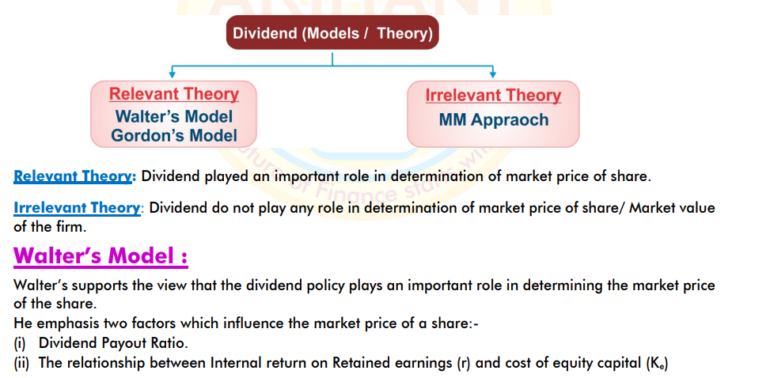

Limitations :

* No external financing
* Assumes constant rate of return and cost of capital

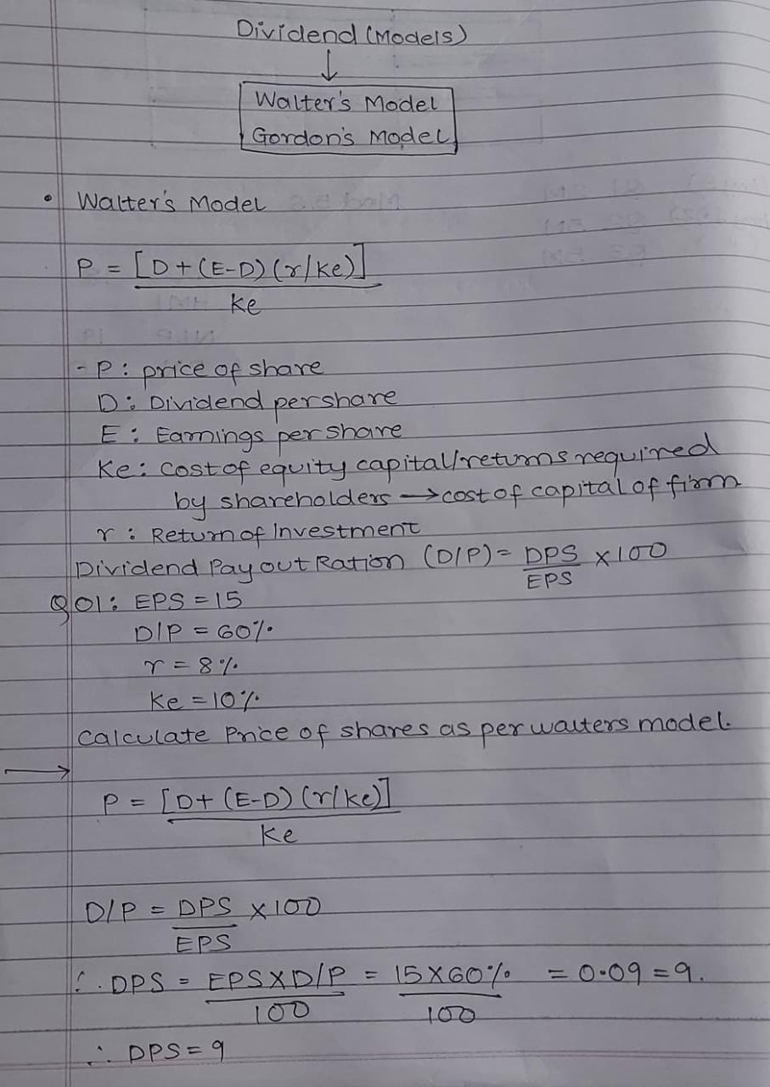

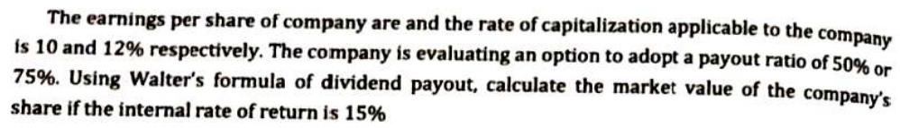

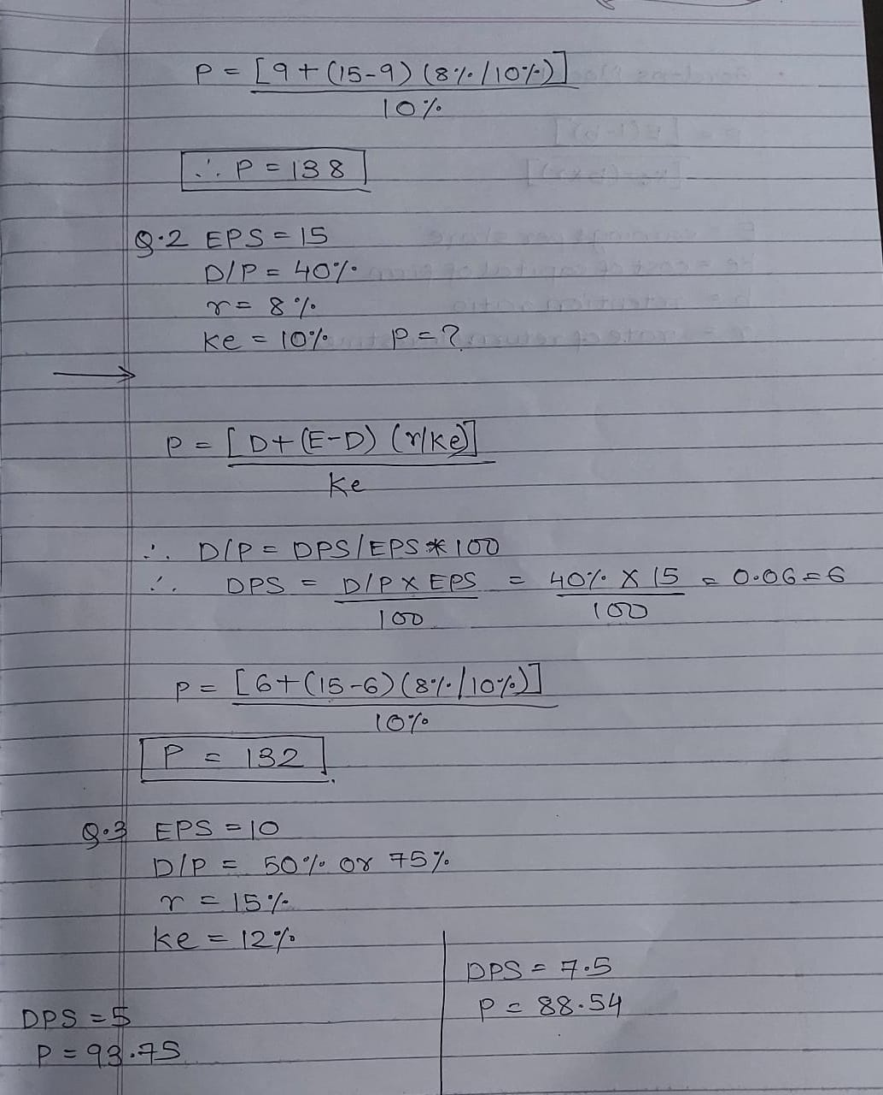

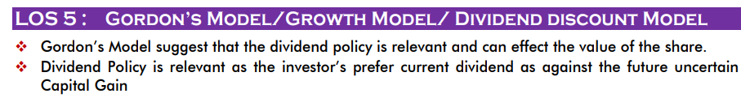

Assumptions :

* Capital greater than growth rate
* Constant retentions
* Perpetual earnings
* Internal financing



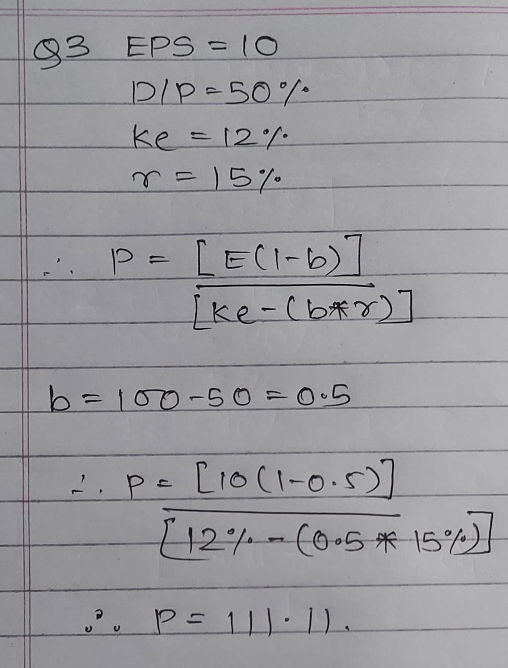

**Overview of Financial System**

Liquidity refers to how easily an investment can be sold for cash. T-bills and stocks are considered to be highly liquid since they can usually be sold at any time at the prevailing market price.

**Financial System :**

The financial system can be defined as an ecosystem that allows the exchange of funds between lenders, investors and borrowers. It operates at national and global levels. The financial sector of a country is responsible or transfer and supply of funds in an economy.

When we deposit our surplus funds to the bank, the bank pools savings of many such depositors and lends it to businesses or other household borrowers. The bank also gives interest to the depositors for depositing the money and charges interest from the borrowers for the user of money.

A country with well-developed financial system also invariably has strong and stable economy.

Features :

* It acts as a linkage between savers and borrowers.
* It is applicable at firm level, regional level, national level and international level.
* It plays a vital role in economic development of a country.
* It encourages both savings and investment.

**Financial System**

*Financial Markets Financial Instruments Financial Institutions*

**Financial Markets :**

It is a type of a marketplace that provides an avenue for the sale and purchase of assets such as bonds, stocks, foreign exchange and derivatives. The market makes it easy for buyers and sellers to trade their financial holdings. For example, imagine an individual that maintains a savings account. The bank can use their money and give it as loan to other borrowers with an interest rate. The depositors money increases over time based on its interest rate. Therefore, the bank serves as a financial market that benefits both the depositors and the borrowers.

Types of Financial Markets :

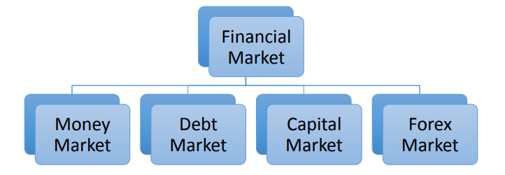

* Money Market : It refers to a section of the financial market where financial instruments with high liquidity and short-term maturities are traded. It is usually less than 1 year. It is used by investors for investment of excess funds available for short term and by borrowers for meeting their short-term funding requirements.

Eg : T-Bills, Commercial Paper, Trade Credit, Bills of Exchange.

* Debt Market: It is where investors buy and sell debt securities, mostly in the form of bonds. It is a long-term source of fund. Debt Market in India is one of the largest in Asia. The issuer or participants include banks, financial institutions, mutual funds, insurance companies etc. It gives fixed and regular returns.
* Capital Market: It is a market where buyers and sellers engage in trade of financial securities like bonds, stocks, etc. The buying/selling is undertaken by participants such as individuals and institutions. It is a long-term source of finance. It consists of primary markets and secondary markets. Primary markets deal with trade of new issues of stocks and other securities, whereas secondary market deals with the exchange of existing or previously-issued securities.
* Forex Market : The foreign exchange market is a global decentralized market for the trading of currencies. It includes all aspects of buying, selling and exchanging currencies. The payments are in foreign currency. Exchange Rates – One Currency in terms of other. (E.g. 1 US Dollar = 76.41 Indian Rupee.

Money Market Instruments :

1. Certificates of Deposit

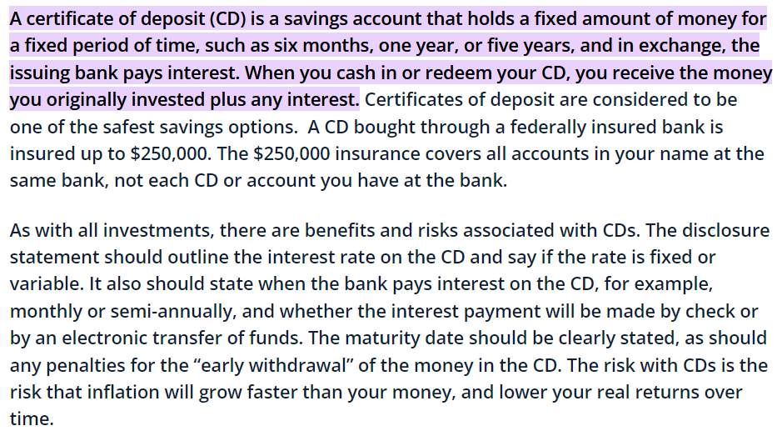

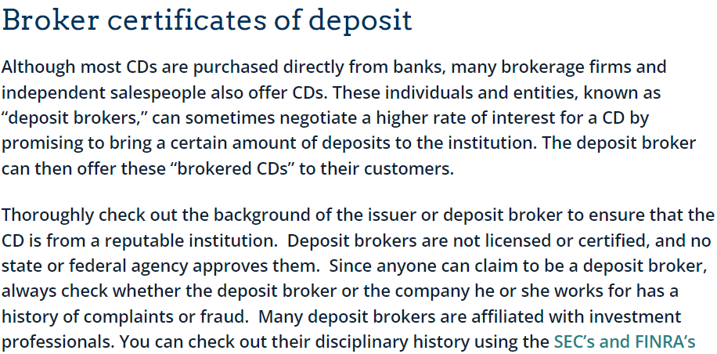

2. Treasury Bills

When the government goes to the financial market to raise money, it does so by issuing two types of debt instruments — treasury bills and government bonds. Treasury bills are issued when the government needs money for a short period. These bills are issued only by the central government, and the interest on them is determined by market forces. It has a maximum maturity period of 364 days. At present, it is issued in three maturities – 91 days – 182 days and 364 days. It was first issued in India in 1917. It has advantage of other market instruments because of the zero-risk weightage associated with them.

3. Commercial Bills

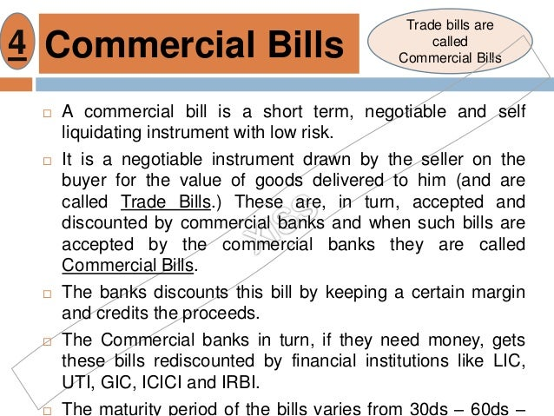

**Investment Banking**

It is a special segment of banking operation that helps individuals or organisations to raise capital and provide financial consultancy services to them.

Working :

Think of company ABC buying another company XYZ. ABC is not sure how much company XYZ is really worth and what will be the long-term benefits in terms of revenues, costs, etc. In this scenario, the investment bank will go through the process of due diligence to determine the value of the company, settle the deal by helping ABC prepare necessary documents and advising it on the appropriate timing of the deal.

Here the investment bank works on the buy side and some other investment banks may be working on the sell side to help XYZ. The bigger the deal size, the more commission the bank will earn. Bank of America, Barclays Capital, Citigroup Investment Banking, Deutsche Bank, and JP Morgan are some of the largest investment banks in India.

It manages portfolios for high-net-worth client and corporates. It provides financial advice to investors.

Services:

1. Fund Raising Services:

- IPO (Initial Public Offerings)

- FPO (Follow-on Public Offering)

- QIP (Qualified Institutional Placements)

2. Advisory Services

- Private Client Services

- Sales and Trading

- Infrastructure Advisory

**Reserve Bank Of India :**

It is the central bank of India. It uses monetary policy to create financial stability in India. It was established on 1st April 1935. It was privately owned and was later nationalised in year 1949. The central office was initially established in Calcutta and moved to Mumbai in 1937.

Structure of RBI :

The overall direction of RBI lies with the 21-member central board of directors. They are appointed/nominated for a period of four years. RBI has a head office in Mumbai and other 22 regional offices.

Function of RBI :

* Bank of Issue
* Banker to Government
* Bankers’ Bank and Lender of the last resort
* Controller of credit
* Custodian of foreign reserves
* Promotional functions

**Equity Market** : It is a place where stocks and shares of companies are traded.

**What is a share/stock?**

A type of security that signifies ownership in a corporation and represents a claim on part of the corporation’s assets and earning.

Types of Stock

1. Common Stock

It gives shareholders voting rights. The dividends received varies.

2. Preferred Stock

It does not give shareholders voting rights. It has a higher claim on assets and earning compared to common shares. They receive fixed dividends.

**Market Capitalisation** = No of shares outstanding * Market Price.

**What is a Stock Exchange ?**

The stock exchange in India serves as a market where financial instruments like stocks, bonds and commodities are traded.

**Ratios**



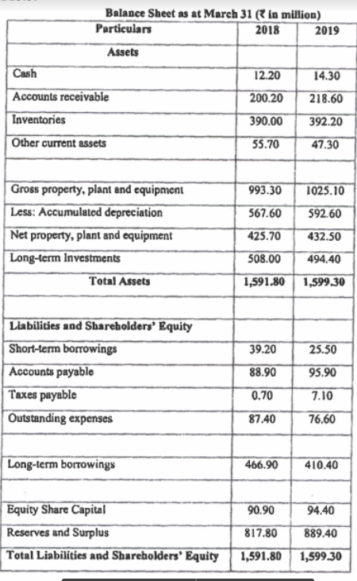

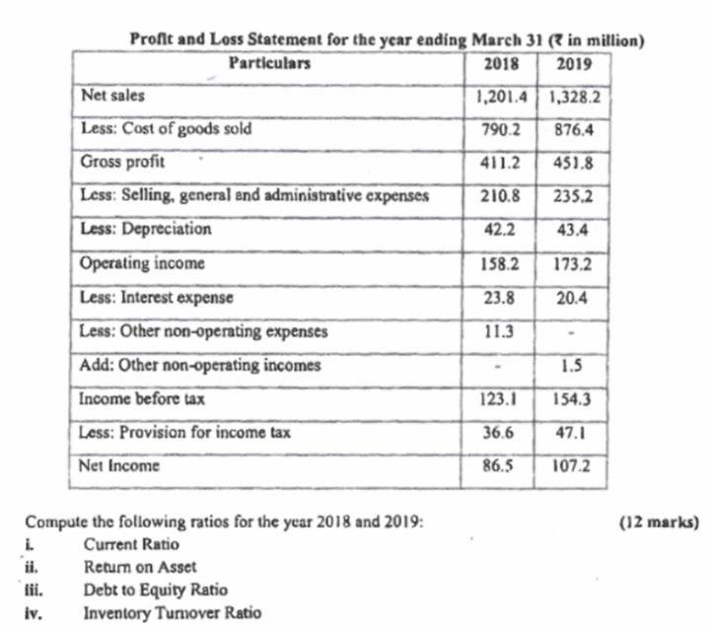

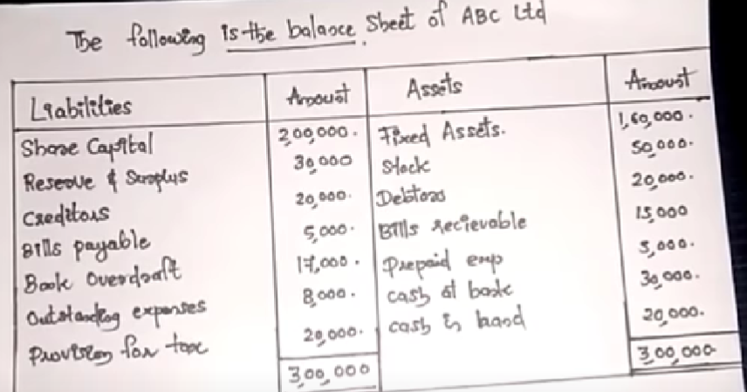

f

MCQs :

Notes are a long-term promissory notes with maturities ranging from 5 to 30 years.

The focal point of financial management in a firm is the creation of value for shareholders.

Profit maximisation and Wealth maximization are the two versions of goals of the financial management of the firm.

Which of the following is a not money market security?

A National Savings Certificates

B Treasury bill

C Certificate of deposit

D Commercial paper

Q Which of the following is not considered as capital market security? – 6-Month Treasury Bill

Equity Market is the financial market for Residual Claim

Classification of financial markets by the maturity of claims are – Money Market and Capital market

An important financial institution that assists in the initial sale of securities in the primary market is the – Investment Bank

Intermediaries who link buyers and sellers by buying and selling securities at stated prices are called. A. investment bankers.

PBIT : Profit Before Interest and Tax

Tangible Assets : Cash, Inventory, Vehicles, Equipment, Buildings, Investments

Intangible Assets : Account Receivable, Pre-Praid Expenses, Patents, Goodwill.

NOPAT : Net Operating Profit After Tax   
Acid Test Ratio is also known as Quick Ration.

Current Liabilites : Accounts Payable, Short-Term Debt, Dividends, Notes Payable, Income Taxes

Accounts receivable is also known as Sundry debtors.

Current Assets : Cash, Bank, Short Term, Investment (marketable securities), prepaid expenses, Inventory, Debtors

EBDT : Earnings Before Depreciation and Tax

EBT : Earnings Before Tax

EAT : After Tax

Current Ration = Current Assets/Current Liabilities

Ideal – 2:1