国信资金强弱报告

撰写者: 单昳Brian

时间: 2020年8月

目录

流程图 3

回测流程 4

结果 6

# 流程图

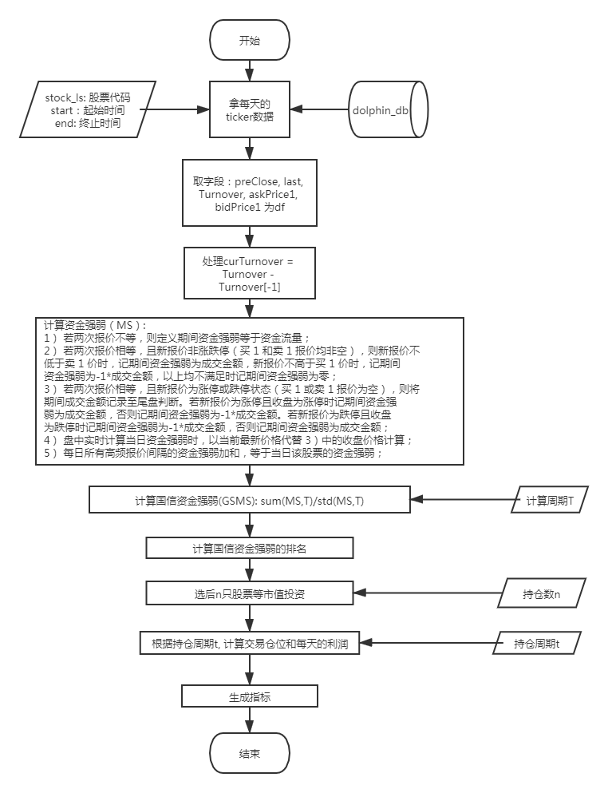

# 回测流程

1. Train的周期为:

|  |  |  |  |
| --- | --- | --- | --- |
| 开始 | 2016.01.01 | 2017.01.01 | 2018.01.01 |
| 结束 | 2018.01.01 | 2019.01.01 | 2020.01.01 |

1. Test的周期为:

|  |  |
| --- | --- |
| 开始 | 2020.01.01 |
| 结束 | 2020.07.01 |

1. 参数：

|  |  |
| --- | --- |
| hold_number (n) 持股数 | 16只ETF:1,2,3,4,5  HS300: 1,2,3,4,5,6,7,8,9,10,11,12,13,14,15 |
| period (t)  计算GSMS的周期 | 20,25,30,35,40 |
| hold_period  持仓周期 | 20, 25, 30, 35, 40, 45, 50, 55, 60 |

1. 从各类别里挑选的流动性最好的16只ETF为

510050 - 上证50

159995 - 国证半导体芯片

512090 - MSCI中国A股国际通

515050 - 中证5G通信主题

512290 - 生物医药

515000 - 科技龙头

515700 - 新能源汽车产业

512800 - 中证银行

159928 - 中证主要消费

512660 - 中证军工

512400 - 中证申万有色金属

510880 - 柏瑞红利

159976 - 粤港湾大湾区创新

511010 - 上证5年期国债

510900 - 恒生H股

518880 - 黄金

1. HS300: 使用的是2020.07.22的权重:

000001,000002,000063,000066,000069,000100,000157,000166,

000333,000338,000425,000538,000568,000596,000625,000627,000651,

000656,000661,000671,000703,000708,000709,000723,000725,000728,

000768,000776,000783,000786,000858,000860,000876,000895,000938,

000961,000963,000977,001979,002001,002007,002008,002024,002027,

002032,002044,002050,002120,002129,002142,002146,002153,002157,

002179,002202,002230,002236,002241,002252,002271,002304,002311,

002352,002371,002410,002415,002422,002456,002460,002463,002466,

002468,002475,002493,002508,002555,002558,002594,002601,002602,

002607,002624,002673,002714,002736,002739,002773,002841,002916,

002938,002939,002945,002958,003816,300003,300014,300015,300033,

300059,300122,300124,300136,300142,300144,300347,300408,300413,

300433,300498,300601,300628,600000,600004,600009,600010,600011,

600015,600016,600018,600019,600025,600027,600028,600029,600030,

600031,600036,600038,600048,600050,600061,600066,600068,600085,

600089,600104,600109,600111,600115,600118,600170,600176,600177,

600183,600188,600196,600208,600219,600221,600233,600271,600276,

600297,600299,600309,600332,600340,600346,600352,600362,600369,

600372,600383,600390,600398,600406,600436,600438,600482,600487,

600489,600498,600516,600519,600522,600547,600570,600583,600585,

600588,600606,600637,600655,600660,600674,600690,600703,600705,

600741,600745,600760,600795,600809,600837,600848,600867,600886,

600887,600893,600900,600919,600926,600928,600958,600968,600977,

600989,600998,600999,601006,601009,601012,601018,601021,601066,

601077,601088,601100,601108,601111,601117,601138,601155,601162,

601166,601169,601186,601198,601211,601212,601216,601225,601229,

601231,601236,601238,601288,601298,601318,601319,601328,601336,

601360,601377,601390,601398,601555,601577,601600,601601,601607,

601618,601628,601633,601658,601668,601669,601688,601698,601727,

601766,601788,601800,601808,601816,601818,601828,601838,601857,

601877,601878,601881,601888,601898,601899,601901,601916,601919,

601933,601939,601985,601988,601989,601992,601997,601998,603019,

603156,603160,603259,603260,603288,603369,603501,603658,603799,

603833,603899,603986,603993

1. 手续费标准:

|  |  |
| --- | --- |
| 手续费乘数 | 3 |
| 深交所ETF（除国债） | 0.487/10000 (交易额) |
| 上交所ETF（除国债） | 0.45/10000 (交易额) |
| 国债ETF | 0 |
| 股票 | 2/1000 （不乘乘数） |

1. 流程

* 跑Train集的3段时间的所有参数。
* 生成Train集的3段时间共同的优质参数组，存为para_summary.csv
* 用para_summary.csv里的参数，跑Test集
* 根据指标，图像，删除para_summary的不满意参数，生成final_params.csv
* 用final_params.csv重跑2016.01.01-2020.07.01区间，生成图像和所有数据，检查是否有错。

# 结果

基本是16年很有效，17年平，18-20年因子失效

* 16只ETF:



* 2,20,50

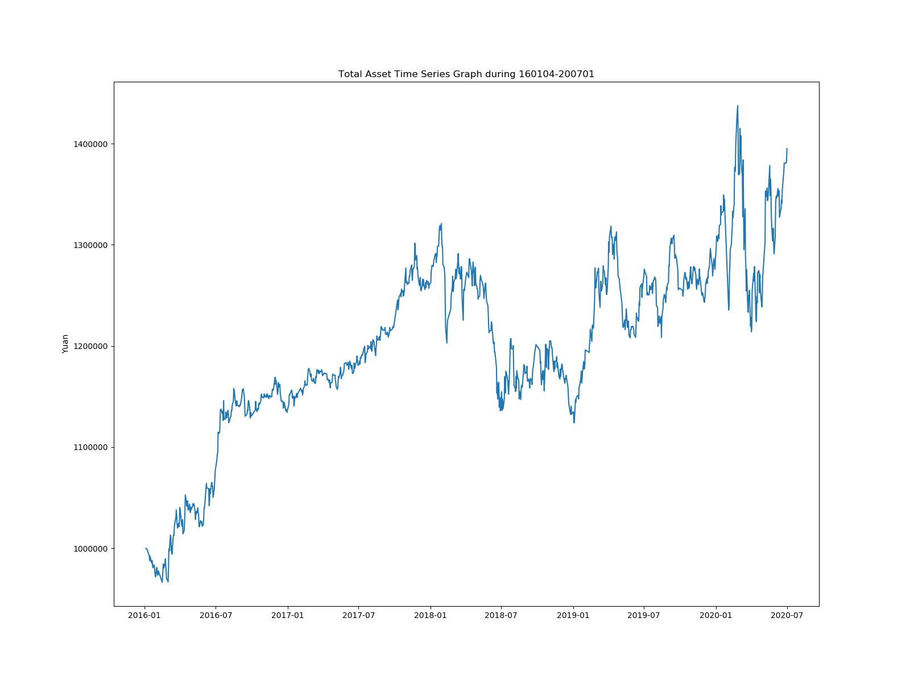

* HS300:

由于测试集数据结果比较糟糕，就没有跑整体的结果。

