


Software Safety Requirements and Architecture

Lane Assistance
Document Version: [Version]
Template Version 1.0, Released on 2017-06-21



Document history
Date | Version | Editor | Description
2018-06-14 | 1.0 | Markus Isaksson | First attempt

Table of Contents

Document history
Table of Contents
Purpose
Inputs to the Software Requirements and Architecture Document
Technical safety requirements
Refined Architecture Diagram from the Technical Safety Concept
Software Requirements
Refined Architecture Diagram

Purpose

The Software Safety Requirements and Architecture document refines the Technical Safety Concept by adding all details needed by a software engineer to develop the program. This may include variable names, signal paths, protocols and mechanisms. The granularity of the architecture is refined to describe software elements/units within components.

Inputs to the Software Requirements and Architecture Document

Technical safety requirements
Technical Safety Requirements related to Functional Safety Requirement 01-01 are:
ID | Technical Safety Requirement | ASIL | Fault Tolerant Time Interval | Architecture Allocation | Safe State
Technical  Safety  Requirement  01 | The LDW safety component shall ensure that the amplitude of the LDW_Torque_Request sent to the ‘Final Torque’ component is below Max_Torque_Amplitude. | C | 50 ms | LDW Safety | Lane Assistance is turned off
Technical  Safety  Requirement  02 | When a failure is detected by the ‘LDW Safety’ component, this shall be indicated in the LDW_Torque_Request signal. | C | 50 ms | LDW Safety | Lane Assistance is turned off
Technical  Safety  Requirement  03 | When the ‘Final Torque’ component receives a LDW_Torque_Request signal indicating a failure, then it shall set LA_Final_Torque to zero. | C | 50 ms | Final Torque | Lane Assistance is turned off
Technical  Safety  Requirement  04 | The validity and integrity of the data transmission for ‘LDW_Torque_Request’ signal shall be ensured. | C | 50 ms | Data Transmission Integrity Check | Lane Assistance is turned off
Technical  Safety  Requirement  05 | When a failure is detected by the ‘LDW Safety’ component,this shall be indicated in the LDW_Error_Status signal. | C | 50 ms | LDW Safety | Lane Assistance is turned off
Technical  Safety  Requirement  06 | When the ‘LA Malfunction Warning’ component receives a LDW_Error_Status signal indicating a failure, then it shall draw a symbol on the Car Display indicating that the LA item is turned of due to a malfunction. | QM | 50 ms | LA Malfunction Warning | Lane Assistance is turned off
Technical  Safety  Requirement  07 | Memory test shall be conducted at start up of the EPS ECU to check for any faults in memory. | A | Ignition cycle | Memory Test | Lane Assistance is turned off

Refined Architecture Diagram from the Technical Safety Concept

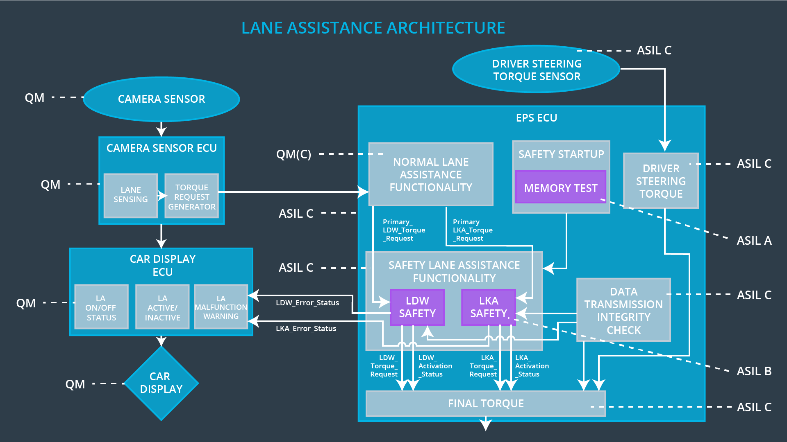

Software Requirements

Lane Departure Warning (LDW) Amplitude Malfunction Software Requirements:

ID | Technical Safety Requirement | ASIL | Fault Tolerant Time Interval | Allocation to Architecture | Safe State
Technical  Safety  Requirement  01 | The LDW safety component shall ensure that the amplitude of the LDW_Torque_Request sent to the ‘Final Torque’ component is below Max_Torque_Amplitude. | C | 50 ms | LDW Safety | Lane Assistance is turned off

ID | Software Safety Requirement | ASIL | Allocation Software Elements | Safe State
Software  Safety  Requirement  01-01 | The input signal “Primary_LDW_Torq_Req” shall be read and pre-processed to determine the torque request coming from the “Basic/Main LAFunctionality” SW Component. Signal “processed_LDW_Torq_Req” shall be generated at the end of the processing. | C | LDW_SAFETY_INPUT_PROCESSING | N/A
Software Safety Requirement 01-02 | In case the “processed_LDW_Torq_Req” signal has a value greater than “Max_Torque_Amplitude_LDW” (maximum allowed safe torque), the torque signal “limited_LDW_Torq_Req” shall be set to 0, else “limited_LDW_Torq_Req” shall take the value of “processed_LDW_Torq_Req”. | C | TORQUE_LIMITER | “limited_LDW_Torq_Req” = 0 (Nm=Newton-meter)
Software Safety Requirement 01-03 | The “limited_LDW_Torq_Req” shall be transformed into a signal “LDW_Torq_Req” which is suitable to be transmitted outside of the LDW Safety component (“LDW Safety”) to the “Final EPS Torque”component. Also see SofSafReq04-01 and SofSafReq04-02 | C | LDW_SAFETY_OUTPUT_GENERATOR | LDW_Torq_Req= 0 (Nm)

ID | Technical Safety Requirement | ASIL | Fault Tolerant Time Interval | Allocation to Architecture | Safe State
Technical  Safety  Requirement  02 | When a failure is detected by the ‘LDW Safety’ component, this shall be indicated in the LDW_Torque_Request signal. | C | 50 ms | LDW Safety | Lane Assistance is turned off

ID | Software Safety Requirement | ASIL | Allocation Software Elements | Safe State
Software Safety Requirement02-01 | The limited_LDW_Torq_Req signal shall have a boolean field Torq_Failure indicating failures. | C | TORQUE_LIMITER | N/A
Software Safety Requirement02-02 | When Torque_Limiter actively limits the “limited_LDW_Torq_Req” to 0, then the Torq_Failure shall be set to True, otherwise it shall be set to False.  Also see SofSafReq01-02. | C | TORQUE_LIMITER | N/A
Software Safety Requirement 02-03 | The “limited_LDW_Torq_Req” shall be transformed into a signal “LDW_Torq_Req” which is suitable to be transmitted outside of the LDW Safety component (“LDW Safety”) to the “Final EPS Torque”component. Also see SofSafReq04-01 and SofSafReq04-02 | C | LDW_SAFETY_OUTPUT_GENERATOR | N/A

ID | Technical Safety Requirement | ASIL | Fault Tolerant Time Interval | Allocation to Architecture | Safe State
Technical  Safety  Requirement  03 | When the ‘Final Torque’ component receives a LDW_Torque_Request signal indicating a failure, then it shall set LA_Final_Torque to zero. | C | 50 ms | Final Torque | Lane Assistance is turned off

ID | Software Safety Requirement | ASIL | Allocation Software Elements | Safe State
Software Safety Requirement 03-01 | When the ‘Final Torque’ component receives a “LDW_Torq_Req” signal where the Torq_Failure value is True, then it shall set the Final_Torque to 0 until end of power cycle. | C | FINAL_EPS_TORQUE_GENERATOR | Final_Torque set to 0

ID | Technical Safety Requirement | ASIL | Fault Tolerant Time Interval | Allocation to Architecture | Safe State
Technical  Safety  Requirement  04 | The validity and integrity of the data transmission for LDW_Torque_Request signal shall be ensured | C | 50 ms | Data Transmission Integrity Check | Lane Assistance is turned off

ID | Software Safety Requirement | ASIL | Allocation Software Elements | Safe State
Software Safety Requirement 04-01 | Any data to be transmitted outside of the LDW Safety component (“LDW Safety”) including "LDW_Torque_Req" and “activation_status” (see SofSafReq03-02) shall be protected by an End2End(E2E) protection mechanism | C | E2ECalc | LDW_Torq_Req= 0 (Nm)
Software Safety Requirement 04-02 | The E2E protection protocol shall contain and attach the control data: alive counter (SQC) and CRC to the data to be transmitted. | C | E2ECalc | LDW_Torq_Req= 0 (Nm)

ID | Technical Safety Requirement | ASIL | Fault Tolerant Time Interval | Allocation to Architecture | Safe State
Technical  Safety  Requirement  05 | When a failure is detected by the ‘LDW Safety’ component,this shall be indicated in the LDW_Error_Status signal. | C | 50 ms | LDW Safety | Lane Assistance is turned off

ID | Software Safety Requirement | ASIL | Allocation Software Elements | Safe State
Software Safety Requirement 05-01 | When Torque_Limiter actively limits the “limited_LDW_Torq_Req” to 0, then the LDW_Error_Status signal be set to “LDW_Torq_Failure”.  Also see SofSafReq01-02. | C | TORQUE_LIMITER | N/A

ID | Technical Safety Requirement | ASIL | Fault Tolerant Time Interval | Allocation to Architecture | Safe State
Technical  Safety  Requirement  06 | When the ‘LA Malfunction Warning’ component receives a LDW_Error_Status signal indicating a failure, then it shall draw a symbol on the Car Display indicating that the LA item is turned of due to a malfunction. | QM | 50 ms | LA Malfunction Warning | Lane Assistance is turned off

ID | Software Safety Requirement | ASIL | Allocation Software Elements | Safe State
Software Safety Requirement 06-01 | When the ‘LA Malfunction Warning’ component receives a LDW_Error_Status signal having the value “LDW_Torq_Failure” or “LDW_Memory_Failure”, then it shall draw both the LA_OFF and the LA_Malfunction symbol on the display. | QM | CAR_DISPLAY_ECU - LA Malfunction Warning | N/A

ID | Technical Safety Requirement | ASIL | Fault Tolerant Time Interval | Allocation to Architecture | Safe State
Technical  Safety  Requirement  07 | Memory test shall be conducted at start up of the EPS ECU to check for any faults in memory. | A | Ignition cycle | Memory Test | Lane Assistance is turned off

ID | Software Safety Requirement | ASIL | Allocation Software Elements | Safe State
Software Safety Requirement 07-01 | A CRC verification check over the software code in the Flash memory shall be done every time the ignition is switched from off to on to check for any corruption of content. | A | MEMORYTEST | Activation_status = 0
Software Safety Requirement 07-02 | Standard RAM tests to check the data bus, address bus and device integrity shall be done every time the ignition is switched from off to on (E.g.walking 1s test, RAM pattern test. Refer RAM and processor vendor recommendations ) | A | MEMORYTEST | Activation_status = 0
Software Safety Requirement 07-03 | The test result of the RAM or Flash memory shall be indicated to the LDW_Safety component via the “test_status” signal | A | MEMORYTEST | Activation_status = 0
Software Safety Requirement 07-04 | In case any fault is indicated via the “test_status” signal the INPUT_LDW_PROCESSING shall set an error on error_status_input (=1) | A | LDW_SAFETY_INPUT_PROCESSING | Activation_status = 0
Software Safety Requirement 07-05 | When the error_status_input indicates an error, the activation status shall be set to False and the LDW_Error_Status signal set to “LDW_Memory_Failure”. |  | LDW_SAFETY_ACTIVATION
Software Safety Requirement 07-06 | When the ‘Final Torque’ component receives a activation status with value False, then it shall set the Final_Torque to 0 until end of power cycle. | C | FINAL_EPS_TORQUE_GENERATOR | Final_Torque set to 0

Refined Architecture Diagram

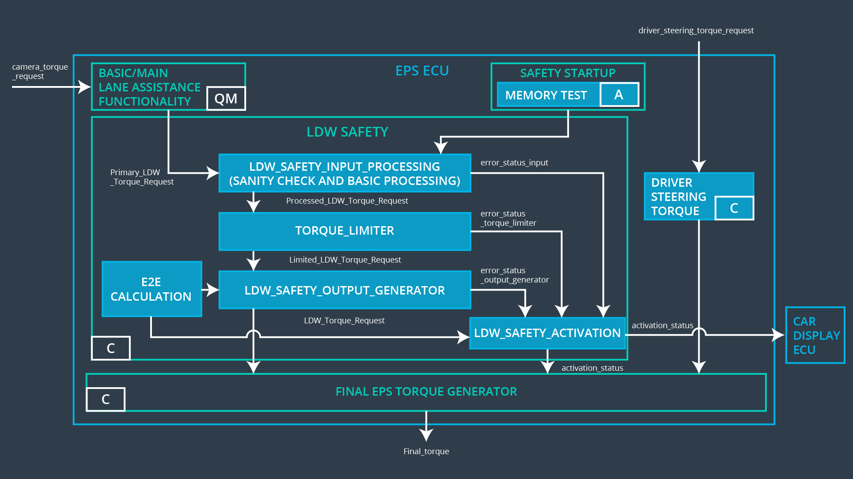
This figure is not completely accurate to the final architecture (but considered good enough for this exercise). In particular the error handling is done differently, except for the memory test.

