


Functional Safety Concept Lane Assistance
Document Version: [Version]
Template Version 1.0, Released on 2017-06-21



Document history
Date | Version | Editor | Description
2018-06-12 | 1.0 | Markus Isaksson | First attempt

Table of Contents
Document history
Table of Contents
Purpose of the Functional Safety Concept
Inputs to the Functional Safety Analysis
Safety goals from the Hazard Analysis and Risk Assessment
Preliminary Architecture
Description of architecture elements
Functional Safety Concept
Functional Safety Analysis
Functional Safety Requirements
Refinement of the System Architecture
Allocation of Functional Safety Requirements to Architecture Elements
Warning and Degradation Concept

Purpose of the Functional Safety Concept
The functional safety concept refines the Safety Goals from the Hazards Analysis and Risk Assessment into functional safety requirements. These requirements are then allocated to relevant parts of the system architecture. The allocation might involve expanding the system architecture with new element blocks.

Inputs to the Functional Safety Concept

Safety goals from the Hazard Analysis and Risk Assessment
ID | Safety Goal
Safety_Goal_01 | The oscillating steering torque from the lane departure warning function shall be limited.
Safety_Goal_02 | The lane keeping assistance function shall be time limited and the additional steering torque shall end after a given time interval so that the driver cannot misuse the system for autonomous driving.
Safety_Goal_03 | The steering torque from the lane keeping assistance function shall be limited.
Safety_Goal_04 | The lane keeping assistance function shall not interfere when the torque applied on the steering wheel by the driver suggests that the lane change is intentional.

Preliminary Architecture

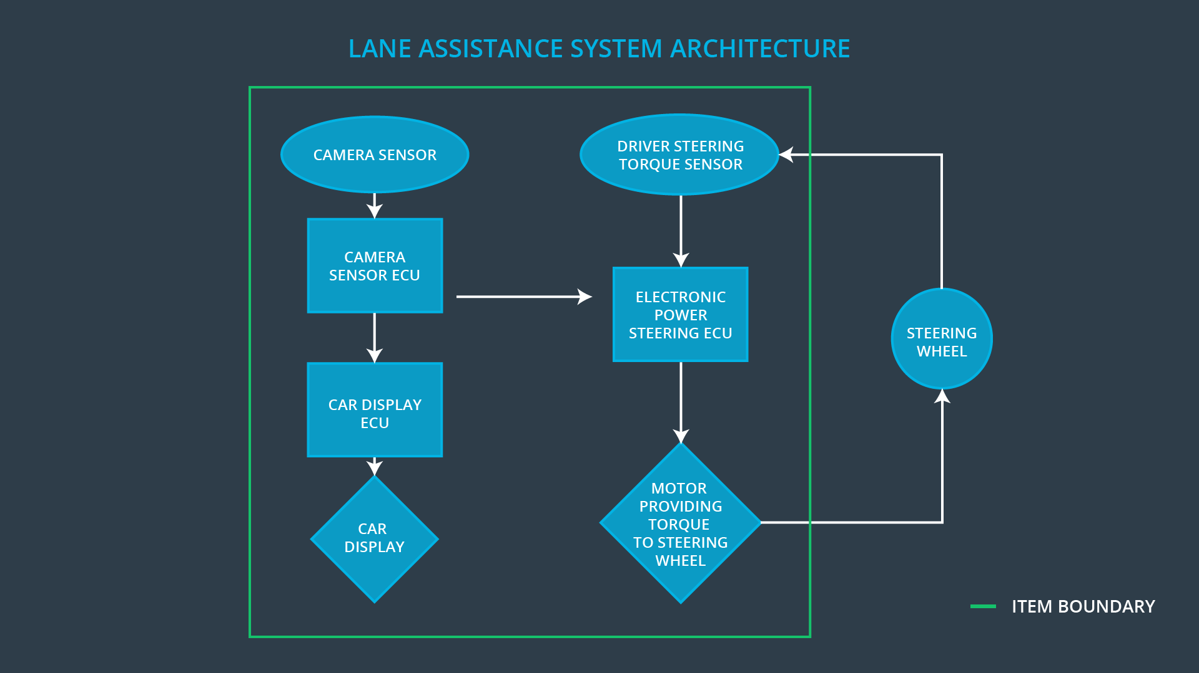

Description of architecture elements

Element | Description
Camera Sensor | Forward looking camera capturing images of the road ahead of ego vehicle.
Camera Sensor ECU | Detecting lane lines in the Camera Sensor images and determines when the vehicle leaves the lane by mistake. Implements the Lane Departure Warning and Lane Keeping Assistance functions. Sends messages to the Electronic Power Steering ECU requesting torque input on the steering wheel. Sends status messages to the Car Display ECU.
Car Display | Display mounted in the vehicle dashboard to present information to the driver.
Car Display ECU | Create the images displayed on the Car Display. The status messages from the Camera Sensor ECU is shown as symbols and/or text.
Driver Steering Torque Sensor | Measures the torque applied on the steering wheel by the driver.
Electronic Power Steering ECU | Controls the torque applied on the steering wheel by this item.
Motor | Steering wheel torque actuator.

Functional Safety Concept
The functional safety concept consists of:
- Functional safety analysis
- Functional safety requirements
- Functional safety architecture
- Warning and degradation concept

Functional Safety Analysis

Malfunction ID | Main Function of the Item Related to Safety Goal Violations | Guidewords (NO, WRONG, EARLY, LATE, MORE, LESS) | Resulting Malfunction
Malfunction_01 | Lane Departure Warning (LDW) function shall apply an oscillating steering torque to provide the driver a haptic feedback | The lane departure warning is giving MORE torque than what is safe | The lane departure warning function applies an oscillating torque with very high torque amplitude (above limit)
Malfunction_02 | Lane Departure Warning (LDW) function shall apply an oscillating steering torque to provide the driver a haptic feedback | The lane departure warning is giving MORE torque than what is safe | The lane departure warning function applies an oscillating torque with very high torque frequency (above limit)
Malfunction_03 | Lane Keeping Assistance (LKA) function shall apply the steering torque when active in order to stay in ego lane | The lane keeping assistance has NO time limit | The lane keeping assistance function is not limited in time duration which leads to misuse as an autonomous driving function.
Malfunction_04 | Lane Keeping Assistance (LKA) function shall apply the steering torque when active in order to stay in ego lane | The lane keeping assistance is giving MORE torque than what is safe | The lane keeping assistance function applies a very high torque (above limit)
Malfunction_05 | Lane Keeping Assistance (LKA) function shall apply the steering torque when active in order to stay in ego lane | The lane keeping assistance has NO input from the driver steering torque sensor | The lane keeping assistance function does not consider driver steering torque when deciding if a lane change is intentional.

Functional Safety Requirements

Lane Departure Warning (LDW) Requirements:
ID | Functional Safety Requirement | ASIL | Fault Tolerant Time Interval | Safe State
Functional  Safety  Requirement  01-01 | The electronic power steering ECU shall ensure that the lane departure oscillating torque amplitude is below Max_Torque_Amplitude | C | 50 ms | Lane Assistance is turned off
Functional  Safety  Requirement  01-02 | The electronic power steering ECU shall ensure that the lane departure oscillating torque frequency is below Max_Torque_Frequency | C | 50 ms | Lane Assistance is turned off

Lane Departure Warning (LDW) Verification and Validation Acceptance Criteria:
ID | Validation Acceptance  Criteria and Method | Verification Acceptance  Criteria and Method
Functional  Safety  Requirement  01-01 | Validate that the Max_Torque_Amplitude not is too high to affect the controllability of the vehicle, still adequate to be clearly noticed by the driver. | Verify by fault injection in the Camera Sensor ECU and measure that no torque is applied on the steering wheel after FTTI.
Functional  Safety  Requirement  01-02 | Validate that the Max_Torque_Frequency not is too high to affect controllability of the vehicle, still adequate to be clearly noticed by the driver. | Verify by fault injection in the Camera Sensor ECU and measure that no torque is applied on the steering wheel after FTTI.

Lane Keeping Assistance (LKA) Requirements:
ID | Functional Safety Requirement | ASIL | Fault Tolerant Time Interval | Safe State
Functional  Safety  Requirement  02-01 | The electronic power steering ECU shall ensure that the lane keeping assistance torque is applied for only Max_Duration. | B | 500 ms | LKA is deactivated
Functional  Safety  Requirement  02-02 | The electronic power steering ECU shall ensure that the lane keeping assistance torque is below Max_Lane_Keep_Torque. | B | 50 ms | Lane Assistance is turned off
Functional  Safety  Requirement  02-03 | The electronic power steering ECU shall ensure that the lane keeping assistance applies no torque when the driver steering torque exceeds Max_Drifting_Torque. | A | 50 ms | LKA is deactivated

Lane Keeping Assistance (LKA) Verification and Validation Acceptance Criteria:
ID | Validation Acceptance  Criteria and Method | Verification Acceptance  Criteria and Method
Functional  Safety  Requirement  02-01 | Validate that the Max_Duration actually dissuades drivers from taking their hands off the wheel, still is adequate to correct unintentional lane changes. | Verify by fault injection in the Camera Sensor ECU and measure that no torque is applied on the steering wheel after Max_Duration + FTTI.
Functional  Safety  Requirement  02-02 | Validate that the Max_Lane_Keep_Torque not is too high to affect the controllability of the vehicle, still adequate to correct the direction of the vehicle on curvy roads at high speed. | Verify by fault injection in the Camera Sensor ECU and measure that no torque is applied on the steering wheel after FTTI.
Functional  Safety  Requirement  02-03 | Validate that Max_Drifting_Torque is less than typical steering torques applied by driver during collision avoidance. | Verify by applying a driver steering torque of Max_Drifting_Torque and by fault injection in the Camera Sensor ECU, then measure that this item applies no torque on the steering wheel after FTTI.

Refinement of the System Architecture

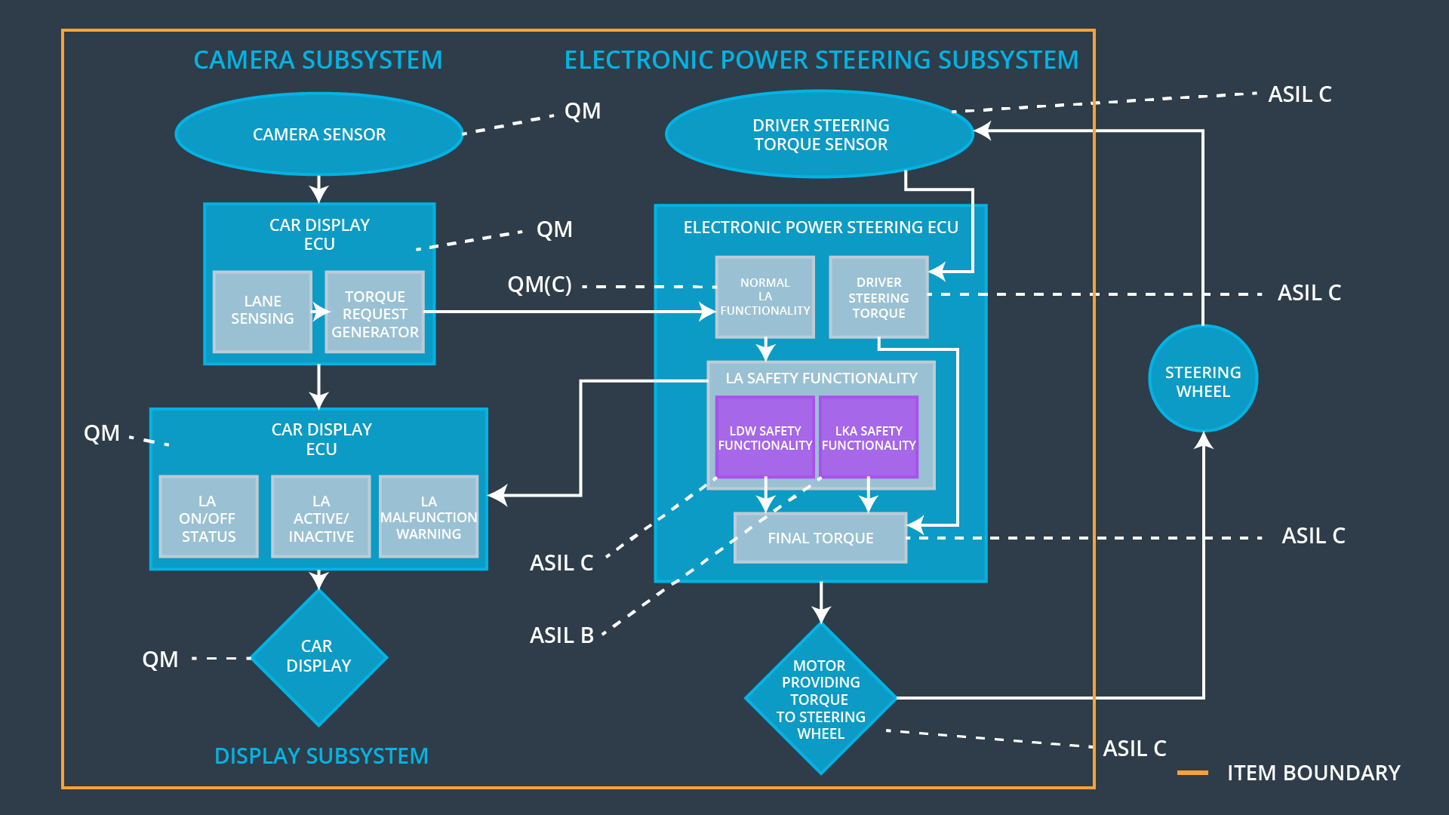

Allocation of Functional Safety Requirements to Architecture Elements

ID | Functional Safety Requirement | Electronic Power Steering ECU | Camera ECU | Car Display ECU
Functional  Safety  Requirement  01-01 | The electronic power steering ECU shall ensure that the lane departure oscillating torque amplitude is below Max_Torque_Amplitude | x
Functional  Safety  Requirement  01-02 | The electronic power steering ECU shall ensure that the lane departure oscillating torque frequency is below Max_Torque_Frequency | x
Functional  Safety  Requirement  02-01 | The electronic power steering ECU shall ensure that the lane keeping assistance torque is applied for only Max_Duration. | x
Functional  Safety  Requirement  02-02 | The electronic power steering ECU shall ensure that the lane keeping assistance torque is below Max_Lane_Keep_Torque. | x
Functional  Safety  Requirement  02-03 | The electronic power steering ECU shall ensure that the lane keeping assistance applies no torque when the driver steering torque exceeds Max_Drifting_Torque. | x

Warning and Degradation Concept

ID | Degradation Mode | Trigger for Degradation Mode | Safe State invoked? | Driver Warning
WDC-01 | Lane Assistance turned off until the vehicle is restarted. | Malfunction_01  Malfunction_02  Malfunction_04 | Yes | Activate a warning symbol on Car Display indicating that the Lane Assistance item has been turned off.
WDC-02 | LKA is deactivated for a duration of LKA_Deactivation_Period. | Malfunction_03 | Yes | 1. Activate a warning symbol on the Car Display indicating that LKA is deactivated.  2. Sound an alarm signal.
WDC-03 | LKA is deactivated for a duration of LKA_Deactivation_Period, measured from the most recent triggering. | Malfunction_05 | Yes | Activate a warning symbol on the Car Display indicating that LKA is deactivated.

