**Name : Akash Babu Misal**

**PRN: 21520005**

**Class:** Final Year (Computer Science and Engineering)

**Course Name: Cryptography and Network Security**  **Lab**

**Assignment No – 5**

Aim- To encrypt given plain text using DES algorithm.

Theory:

DES is a block cipher and encrypts data in blocks of size of 64 bits each, which means 64 bits of plain text go as the input to DES, which produces 64 bits of ciphertext. The same algorithm and key are used for encryption and decryption, with minor differences. The key length is 56 bits.

Code:

#include <bits/stdc++.h>

using namespace std;

string hexToBin(string s)

{

    unordered_map<char, string> mp;

    mp['0'] = "0000";

    mp['1'] = "0001";

    mp['2'] = "0010";

    mp['3'] = "0011";

    mp['4'] = "0100";

    mp['5'] = "0101";

    mp['6'] = "0110";

    mp['7'] = "0111";

    mp['8'] = "1000";

    mp['9'] = "1001";

    mp['A'] = "1010";

    mp['B'] = "1011";

    mp['C'] = "1100";

    mp['D'] = "1101";

    mp['E'] = "1110";

    mp['F'] = "1111";

    stringstream bin;

    for (int i = 0; i < s.size(); i++)

    {

        bin << mp[s[i]];

    }

    return bin.str();

}

string binToHex(string s)

{

    unordered_map<string, string> mp;

    mp["0000"] = "0";

    mp["0001"] = "1";

    mp["0010"] = "2";

    mp["0011"] = "3";

    mp["0100"] = "4";

    mp["0101"] = "5";

    mp["0110"] = "6";

    mp["0111"] = "7";

    mp["1000"] = "8";

    mp["1001"] = "9";

    mp["1010"] = "A";

    mp["1011"] = "B";

    mp["1100"] = "C";

    mp["1101"] = "D";

    mp["1110"] = "E";

    mp["1111"] = "F";

    stringstream hex;

    for (int i = 0; i < s.length(); i += 4)

    {

        string ch = s.substr(i, 4);

        hex << mp[ch];

    }

    return hex.str();

}

string permute(string k, int *arr, int n)

{

    stringstream per;

    for (int i = 0; i < n; i++)

    {

        per << k[arr[i] - 1];

    }

    return per.str();

}

string shiftLeft(string k, int shifts)

{

    string s = "";

    for (int i = 0; i < shifts; i++)

    {

        for (int j = 1; j < 28; j++)

        {

            s += k[j];

        }

        s += k[0];

        k = s;

        s = "";

    }

    return k;

}

string XOR(string a, string b)

{

    stringstream ans;

    for (int i = 0; i < a.size(); i++)

    {

        if (a[i] == b[i])

        {

            ans << "0";

        }

        else

        {

            ans << "1";

        }

    }

    return ans.str();

}

string encrypt(string plain, vector<string> rkb, vector<string> rk)

{

    // Hexadecimal to binary

    plain = hexToBin(plain);

    // Initial Permutation Table

    int initial_perm[64] = {58, 50, 42, 34, 26, 18, 10, 2,

                            60, 52, 44, 36, 28, 20, 12, 4,

                            62, 54, 46, 38, 30, 22, 14, 6,

                            64, 56, 48, 40, 32, 24, 16, 8,

                            57, 49, 41, 33, 25, 17, 9, 1,

                            59, 51, 43, 35, 27, 19, 11, 3,

                            61, 53, 45, 37, 29, 21, 13, 5,

                            63, 55, 47, 39, 31, 23, 15, 7};

    // Initial Permutation

    plain = permute(plain, initial_perm, 64);

    cout << "After initial permutation: " << binToHex(plain) << endl;

    // Splitting

    string left = plain.substr(0, 32);

    string right = plain.substr(32, 32);

    cout << "After splitting: L0=" << binToHex(left)

         << " R0=" << binToHex(right) << endl;

    // Expansion D-box Table

    int exp_d[48] = {32, 1, 2, 3, 4, 5, 4, 5,

                     6, 7, 8, 9, 8, 9, 10, 11,

                     12, 13, 12, 13, 14, 15, 16, 17,

                     16, 17, 18, 19, 20, 21, 20, 21,

                     22, 23, 24, 25, 24, 25, 26, 27,

                     28, 29, 28, 29, 30, 31, 32, 1};

    // S-box Table

    int s[8][4][16] = {{14, 4, 13, 1, 2, 15, 11, 8, 3, 10, 6, 12, 5, 9, 0, 7,

                        0, 15, 7, 4, 14, 2, 13, 1, 10, 6, 12, 11, 9, 5, 3, 8,

                        4, 1, 14, 8, 13, 6, 2, 11, 15, 12, 9, 7, 3, 10, 5, 0,

                        15, 12, 8, 2, 4, 9, 1, 7, 5, 11, 3, 14, 10, 0, 6, 13},

                       {15, 1, 8, 14, 6, 11, 3, 4, 9, 7, 2, 13, 12, 0, 5, 10,

                        3, 13, 4, 7, 15, 2, 8, 14, 12, 0, 1, 10, 6, 9, 11, 5,

                        0, 14, 7, 11, 10, 4, 13, 1, 5, 8, 12, 6, 9, 3, 2, 15,

                        13, 8, 10, 1, 3, 15, 4, 2, 11, 6, 7, 12, 0, 5, 14, 9},

                       {10, 0, 9, 14, 6, 3, 15, 5, 1, 13, 12, 7, 11, 4, 2, 8,

                        13, 7, 0, 9, 3, 4, 6, 10, 2, 8, 5, 14, 12, 11, 15, 1,

                        13, 6, 4, 9, 8, 15, 3, 0, 11, 1, 2, 12, 5, 10, 14, 7,

                        1, 10, 13, 0, 6, 9, 8, 7, 4, 15, 14, 3, 11, 5, 2, 12},

                       {7, 13, 14, 3, 0, 6, 9, 10, 1, 2, 8, 5, 11, 12, 4, 15,

                        13, 8, 11, 5, 6, 15, 0, 3, 4, 7, 2, 12, 1, 10, 14, 9,

                        10, 6, 9, 0, 12, 11, 7, 13, 15, 1, 3, 14, 5, 2, 8, 4,

                        3, 15, 0, 6, 10, 1, 13, 8, 9, 4, 5, 11, 12, 7, 2, 14},

                       {2, 12, 4, 1, 7, 10, 11, 6, 8, 5, 3, 15, 13, 0, 14, 9,

                        14, 11, 2, 12, 4, 7, 13, 1, 5, 0, 15, 10, 3, 9, 8, 6,

                        4, 2, 1, 11, 10, 13, 7, 8, 15, 9, 12, 5, 6, 3, 0, 14,

                        11, 8, 12, 7, 1, 14, 2, 13, 6, 15, 0, 9, 10, 4, 5, 3},

                       {12, 1, 10, 15, 9, 2, 6, 8, 0, 13, 3, 4, 14, 7, 5, 11,

                        10, 15, 4, 2, 7, 12, 9, 5, 6, 1, 13, 14, 0, 11, 3, 8,

                        9, 14, 15, 5, 2, 8, 12, 3, 7, 0, 4, 10, 1, 13, 11, 6,

                        4, 3, 2, 12, 9, 5, 15, 10, 11, 14, 1, 7, 6, 0, 8, 13},

                       {4, 11, 2, 14, 15, 0, 8, 13, 3, 12, 9, 7, 5, 10, 6, 1,

                        13, 0, 11, 7, 4, 9, 1, 10, 14, 3, 5, 12, 2, 15, 8, 6,

                        1, 4, 11, 13, 12, 3, 7, 14, 10, 15, 6, 8, 0, 5, 9, 2,

                        6, 11, 13, 8, 1, 4, 10, 7, 9, 5, 0, 15, 14, 2, 3, 12},

                       {13, 2, 8, 4, 6, 15, 11, 1, 10, 9, 3, 14, 5, 0, 12, 7,

                        1, 15, 13, 8, 10, 3, 7, 4, 12, 5, 6, 11, 0, 14, 9, 2,

                        7, 11, 4, 1, 9, 12, 14, 2, 0, 6, 10, 13, 15, 3, 5, 8,

                        2, 1, 14, 7, 4, 10, 8, 13, 15, 12, 9, 0, 3, 5, 6, 11}};

    // Straight Permutation Table

    int per[32] = {16, 7, 20, 21,

                   29, 12, 28, 17,

                   1, 15, 23, 26,

                   5, 18, 31, 10,

                   2, 8, 24, 14,

                   32, 27, 3, 9,

                   19, 13, 30, 6,

                   22, 11, 4, 25};

    cout << endl;

    for (int i = 0; i < 16; i++)

    {

        // Expansion D-box

        string right_expanded = permute(right, exp_d, 48);

        // XOR RoundKey[i] and right_expanded

        string x = XOR(rkb[i], right_expanded);

        // S-boxes

        string op = "";

        for (int i = 0; i < 8; i++)

        {

            int row = 2 * int(x[i * 6] - '0') + int(x[i * 6 + 5] - '0');

            int col = 8 * int(x[i * 6 + 1] - '0') + 4 * int(x[i * 6 + 2] - '0') + 2 * int(x[i * 6 + 3] - '0') + int(x[i * 6 + 4] - '0');

            int val = s[i][row][col];

            op += char(val / 8 + '0');

            val = val % 8;

            op += char(val / 4 + '0');

            val = val % 4;

            op += char(val / 2 + '0');

            val = val % 2;

            op += char(val + '0');

        }

        // Straight D-box

        op = permute(op, per, 32);

        // XOR left and op

        x = XOR(op, left);

        left = x;

        // Swapper

        if (i != 15)

        {

            swap(left, right);

        }

        cout << "Round " << i + 1 << " " << binToHex(left) << " "

             << binToHex(right) << " " << rk[i] << endl;

    }

    // Combination

    string combine = left + right;

    // Final Permutation Table

    int final_perm[64] = {40, 8, 48, 16, 56, 24, 64, 32,

                          39, 7, 47, 15, 55, 23, 63, 31,

                          38, 6, 46, 14, 54, 22, 62, 30,

                          37, 5, 45, 13, 53, 21, 61, 29,

                          36, 4, 44, 12, 52, 20, 60, 28,

                          35, 3, 43, 11, 51, 19, 59, 27,

                          34, 2, 42, 10, 50, 18, 58, 26,

                          33, 1, 41, 9, 49, 17, 57, 25};

    // Final Permutation

    string cipher = binToHex(permute(combine, final_perm, 64));

    return cipher;

}

int main()

{

    string plain, key;

    // plain = "This is a test text";

    // key = "this is a test";

    // Key Generation

    cout << "Enter the plain text: ";

    getline(cin, plain);

    cout << "Enter the key: ";

    getline(cin, key);

    // Hex to binary

    key = hexToBin(key);

    // Parity bit drop table

    int keyp[56] = {57, 49, 41, 33, 25, 17, 9,

                    1, 58, 50, 42, 34, 26, 18,

                    10, 2, 59, 51, 43, 35, 27,

                    19, 11, 3, 60, 52, 44, 36,

                    63, 55, 47, 39, 31, 23, 15,

                    7, 62, 54, 46, 38, 30, 22,

                    14, 6, 61, 53, 45, 37, 29,

                    21, 13, 5, 28, 20, 12, 4};

    // getting 56 bit key from 64 bit using the parity bits

    key = permute(key, keyp, 56); // key without parity

    // Number of bit shifts

    int shift_table[16] = {1, 1, 2, 2,

                           2, 2, 2, 2,

                           1, 2, 2, 2,

                           2, 2, 2, 1};

    // Key- Compression Table

    int key_comp[48] = {14, 17, 11, 24, 1, 5,

                        3, 28, 15, 6, 21, 10,

                        23, 19, 12, 4, 26, 8,

                        16, 7, 27, 20, 13, 2,

                        41, 52, 31, 37, 47, 55,

                        30, 40, 51, 45, 33, 48,

                        44, 49, 39, 56, 34, 53,

                        46, 42, 50, 36, 29, 32};

    // Splitting

    string left = key.substr(0, 28);

    string right = key.substr(28, 28);

    vector<string> rkb; // rkb for RoundKeys in binary

    vector<string> rk;  // rk for RoundKeys in hexadecimal

    for (int i = 0; i < 16; i++)

    {

        // Shifting

        left = shiftLeft(left, shift_table[i]);

        right = shiftLeft(right, shift_table[i]);

        // Combining

        string combine = left + right;

        // Key Compression

        string RoundKey = permute(combine, key_comp, 48);

        rkb.push_back(RoundKey);

        rk.push_back(binToHex(RoundKey));

    }

    cout << "\nEncryption:\n\n";

    string cipher = encrypt(plain, rkb, rk);

    cout << "\nCipher Text: " << cipher << endl;

    cout << "\nDecryption\n\n";

    reverse(rkb.begin(), rkb.end());

    reverse(rk.begin(), rk.end());

    string text = encrypt(cipher, rkb, rk);

    cout << "\nPlain Text: " << text << endl;

}

Output –

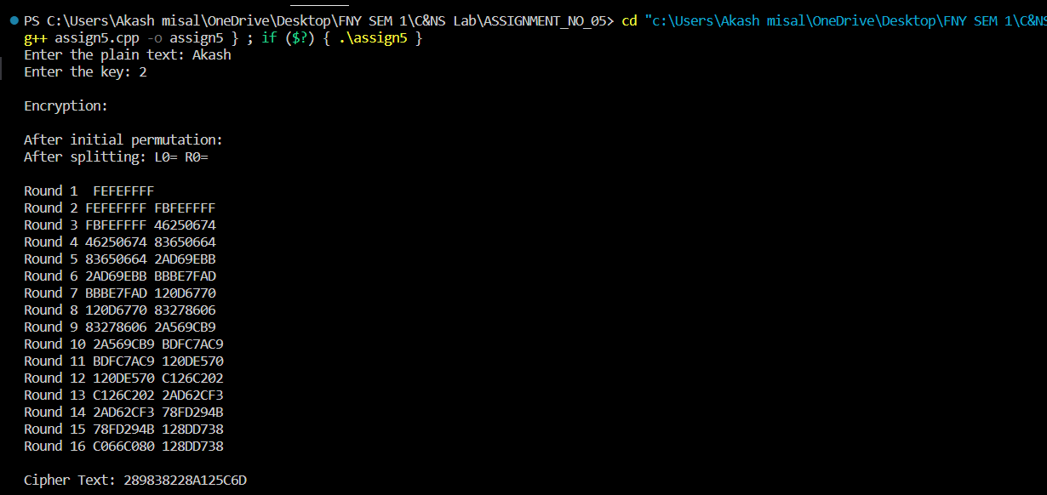

**Conclusion:**

The DES algorithm is a classic symmetric-key encryption technique that demonstrates the principles of permutation and substitution to secure data. This experiment allows us to understand the encryption process of DES, including key generation, Feistel network operations, and permutation. While DES has been largely replaced by more secure encryption algorithms due to its relatively short key length, it remains an important historical cipher with a well-defined structure.