1. MAPbI₃
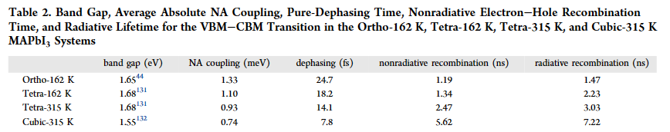
Ref. J. Am. Chem. Soc. 2022, 144, 19137-19149
https://doi.org/10.1021/jacs.2c08627

2. MAPbI₃ (including nuclear quantum effects)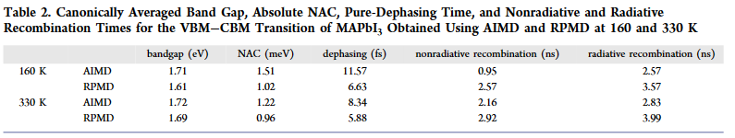 Ref. J. Am. Chem. Soc. 2023, 145, 14112−14123
https://doi.org/10.1021/jacs.3c04412

3. MAPbBr₃
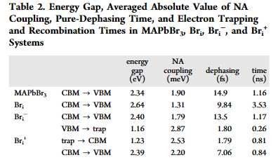
Ref. J. Phys. Chem. Lett. 2022, 13, 4193−4199
https://pubs.acs.org/doi/10.1021/acs.jpclett.2c00965
4. FAPbI₃
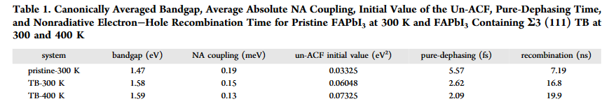
Ref. J. Phys. Chem. Lett. 2021, 12, 8575−8582
https://doi.org/10.1021/acs.jpclett.1c02653

5. CsPbI₃
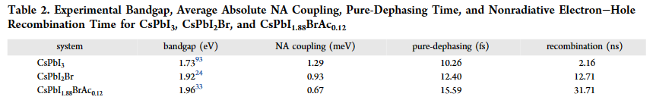
Ref. J. Phys. Chem. Lett. 2022, 13, 11375−11382
https://doi.org/10.1021/acs.jpclett.2c03072

6. CsPbBr₃
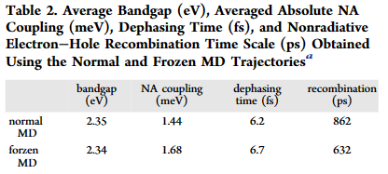
Ref. J. Phys. Chem. Lett. 2022, 13, 3016−3022
https://doi.org/10.1021/acs.jpclett.2c00532

