Reducing Energy Consumption in Large Language Model Inference using Distributed Model Partitioning

Table of Contents
1. Abstract 2
2. Introduction 2
3. Methodology 3
3.1 Problem Formulation 3
3.2 System Model / Architecture 4
3.3 Data Description 5
3.4 Data Preprocessing 5
3.5 Proposed Method / Algorithm 5
3.6 Baseline Methods 6
3.7 Implementation Details 6
3.8 Experimental Setup 6
3.9 Evaluation Metrics 7
3.10 Validation Strategy 7
3.11 Workflow / Pipeline 7
3.12 Assumptions 9
3.13 Limitations 9
3.14 Expected Academic Contribution 9
4. Literature Review 10
4.1 Similar Applications 10
4.2 Related Research 10
4.3 Gap Analysis 12
5. Key References 14

Abstract
The massive growth of LLMs has resulted in significant increases in both computation and energy requirements for executing AI inference tasks which have traditionally been executed on High End GPUs, consuming enormous amounts of power. This paper proposes Kubernetes-based AI Inference (KAI) -- an Energy Aware Distributed Inference Framework built on top of Kubernetes designed to run large scale transformer models across clusters of many, small, resource constrained machines. While traditional inference systems are designed to achieve high throughput using very powerful hardware, this system is designed to achieve lower energy use while generating exactly the same outputs from the models as those generated on the much larger hardware platforms. This system provides a unified architecture that will support both single node optimizations and multi-node executions. This system includes Dynamic Energy-Aware Scheduling to schedule workloads according to available power; Real-Time Power Monitoring to monitor how much power is being used during each step of the process; Adaptive Workload Partitioning based on Heterogeneous Hardware Capabilities to partition the workload into sub-workloads that best match the capabilities of each machine's hardware. Further, to increase efficiency, this system includes Hybrid Parallelism Engine providing Pipeline and Tensor Parallelism. Also Compute Capacity, Network Latency. Finally, this system includes a new KV Cache Optimization Mechanism providing Mixed Precision Storage to reduce memory usage while preserving Output Fidelity. Furthermore, this system utilizes Closed Loop Energy Feedback Controller to Continuously Monitor System Metrics and Dynamically Adjust Execution Parameters such as Batch Size, Precision, and Power Limits to Minimize Energy Use per Token. Also provided in this system is Speculative Decoding and Fault Tolerant Mechanisms to Improve Performance and Reliability in Distributed Environments.

Introduction
The use of Large Language Models (LLM's) has led to an extraordinary increase in the computing and energy demands for performing AI inference operations. Typically, these demanding workloads have been performed using expensive, high-performance GPUs located in the cloud; however, the amount of power consumed by these processors is tremendous. Consequently, with the increasing cost and availability of low-cost commodity hardware and heterogeneous edge devices being used for various applications, these platforms are becoming unable to meet the memory requirements, process requirements, and inferencing throughput requirements for today’s modern LLM’s.
Proposed Solution: To resolve the issues presented above, this paper presents Kubernetes-based AI Inference (KAI) - An Energy-Aware Distributed Inference Framework utilizing Kubernetes. KAI is specifically designed to enable efficient execution of large-scale transformer models across multiple small-resource-constrained machines. Notably, unlike other inference frameworks focused solely on achieving higher throughput rates on high-performance platforms, KAI was developed to produce identical output results at much reduced levels of energy utilization. Furthermore, KAI provides a single architecture that can support optimizations for both single-node executions and scalable multi-node deployments.
Architecture and Core Innovations: At the foundation of KAI is a strong control plane combined with an execution plane. KAI utilizes a number of advanced optimizations to dynamically mitigate resource bottlenecks within its execution. Dynamic Resource Bottleneck Mitigation Using Adaptive Workload Partitioning: Subtasks that best match the unique capabilities of each piece of heterogeneous hardware are utilized to partition workload.
Optimized Hybrid Parallelism & Model Placement Engine: A hybrid parallelism engine (using pipeline and tensor parallelism) in combination with an intelligent model placement engine that considers factors such as memory, compute capability, and network latency when selecting where to place individual components of a model. Using Mixed Precision KV Cache.
Storage Mechanism: A new storage optimization mechanism called mixed precision KV cache is employed to minimize memory usage without sacrificing output fidelity.
Closed-Loop Energy Feedback Controller: Real-time telemetry data collected from the system including but not limited to; power usage and latency, is continuously monitored. This telemetry data is then used to dynamically adjust key parameters involved in the execution process such as batch size, precision level and maximum allowable power usage.
KAI is primarily intended to develop a scalable and highly distributable inference architecture capable of reducing the total energy consumption and operational costs associated with running inference processes using high-end GPU-based systems. Experimental studies demonstrate that KAI achieves a reduction in total energy consumption by more than 50% in comparison to equivalent high-end GPU-based systems while producing identical response times and acceptable latency. Therefore, this study provides a practical approach for conducting environmentally friendly computations on low-cost hardware and establishes a standard reference point for evaluating future energy-efficient distributed inference architectures.

Methodology

Problem Formulation
Low-cost Hardware (i.e. Commodity Devices) are becoming increasingly unable to support the Computational Requirements of Large Language Models because of their memory requirements, processing power needs, and need for Inference Throughput Stability. Most Solutions have focused on using Expensive Cloud-Based High-End GPUs, which can severely degrade Model Quality by Compressing it Aggressively, or simply don't adapt well enough to Heterogeneous Edge Environments or Laboratory Clusters. This Project will provide a Distributed Inference Framework that supports Low-Cost Hardware and Optimizes Key Performance Factors (Energy Consumption, Latency, Fairness). Specifically, the Research Focus is on Ensuring Memory Feasibility at the Node Level, Meeting Deadlines/Latencies, and Maintaining an Acceptable Response Quality. Therefore, the Study Aims to Design Scalable Distributed Inference Architectures that Support Clustering with Low-Cost Hardware, Reduce Overall Energy Consumption/Operational Costs Compared to Traditional High-End GPU Setups, Preserve Acceptable Latency and Output Quality, and Integrate Adaptive Scheduling Mechanisms with Resource Allocation Strategies that Ensure Fairness.

System Model / Architecture
The System Architecture was organized in to two main planes; the Control Plane and the Execution Plane. The Control Plane contains the gateway, scheduler, monitor, and Tuning Controller that were able to process incoming requests, allocate resources, observe the system, and optimize it adaptively. The Execution Plane contained distributed Chunk Workers that would host segment portions of the model that could be computed. The entire process started with an initial client request made to the Gateway where Tokenization and Routing occurred. Once this happened, the request went to the Scheduler who would determine how best to place tasks on each available worker. After that, Chunk Worker(s) executed layer-wise forward passes of the model and once complete, would aggregate the results to sample tokens and create the final response. Feedback from monitoring was constantly collected to make changes to the system based upon metrics (power consumption, latency, resource utilization). In addition to being layered (Control/Execution), the system was divided into several Function Modules including the Gateway for controlling how requests enter and exit the inference process, Model Partitioner for determining which layers of the model should run on which workers, Scheduler for determining how tasks map to execution nodes, Monitor for gathering Telemetry Data related to Power Usage, Latency and Queue Depth, and finally the Controller for making updates to system policies via Adaptive Optimization Mechanisms.
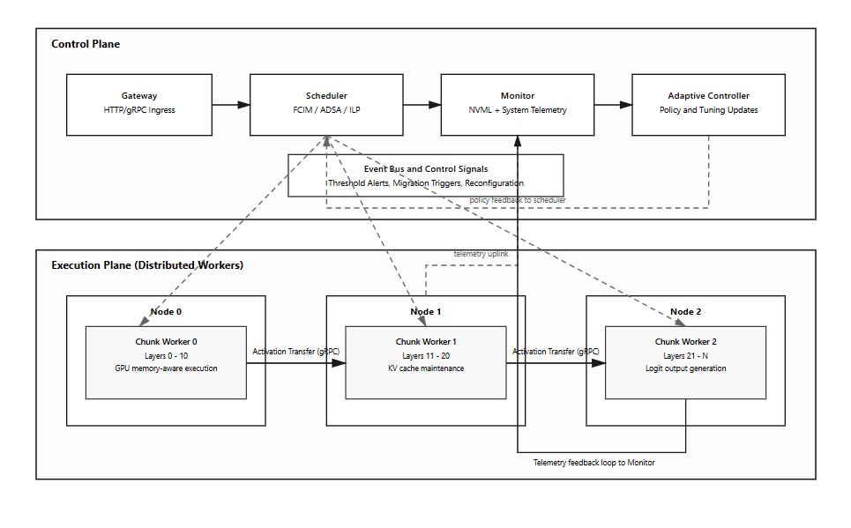
Figure 01: System architecture

Data Description
The research will use a variety of sources of data, which includes publically available large language models (LMS) for inference testing, common evaluation benchmarks/prompts/datasets, and real-time telemetry data that is collected when the system runs. There are also a number of characteristics that the data will have. For example, it will be possible to vary the length of prompts entered into the system (short/long), in addition to varying the bounds on how much the system generates in terms of outputs based on fixed limits. Also, there will be time-based telemetry data collected while the system is running to capture metrics related to KPIs, including, but limited to, power consumption, latency, throughput, and memory usage. In order to allow for complete analysis of the results, a variety of feature types will be collected. This includes features at the request level, including request length, output generated by the LMS, and temperature setting; resources level, including memory capacity of GPU(s), computational load on GPU(s), and rate of utilization of each GPU; network level, including delay in transmitting data over the network and overhead due to communications; and at the outcome level, including total latency of all responses received back from the LMS, total amount of work completed by the system in a given timeframe (throughput), and total amount of energy consumed by the system.

Data Preprocessing
The steps that will occur in the Data Preprocessing Pipeline are:
Cleaning: Removing incomplete telemetry readings; remove experimental run failures from the record set and synchronize timestamp values from each module.
Normalization: Normalize latency and throughput measures by scaling them so they can be compared. Convert power consumption values to measure relative to device capacity. Normalize all measured variables to have similar ranges to enable optimizing the variables.
Feature Engineering: Compute new (derived) metric(s): Energy efficiency; Fairness among workers at the distributed layer; Indicators for bottleneck pressures within queues and the system as a whole.
Data Splitting: Partition the processed data with a data split method to create Training Set; Validation Set; Test Set. Create separate sets to evaluate policies on unseen workload data and utilize time-based data splits when evaluating sequentially captured telemetry.

Proposed Method / Algorithm
In order to provide efficient distribution of inferences as well as balance out performance and resource constraints; multiple algorithmic elements have been developed to help accomplish that. Elements include a fair and cost-effective worker selection strategy, a dynamic task ordering methodology to allow for optimal assignment (to select the best order for tasks), and optionally an optimization solver when there are many variables in terms of resources and time constraints. When exact optimization becomes too costly to compute, we plan to employ heuristics-based fallback to ensure that the overall system remains as efficient as possible. For every incoming request our process will operate in an iterative manner; first we will extract features from the workload, next we will rank the candidate workers using their feasibility and performance characteristics. We will then assign model layer segments to the worker(s) based upon the amount of capacity they currently possess. Following this step, we will execute a distributed forward pass through the network. Throughout and after executing these steps we collect telemetry data and update our scheduling policy as needed once we detect any type of bottleneck or inefficiency.

Baseline Methods
To assess the effectiveness of the proposed system, it is compared to three baseline configurations: A) a single GPU-based inference approach; B) an optimized single machine-based runtime (optimized for either one or multiple GPUs); C) a distributed system without the proposed scheduling/energy efficiency features. Baseline systems were chosen as representative examples of current practices utilized by industry and academia. Thus, through comparison of the proposed system's results (costs, latencies, etc.) relative to the baseline systems' results, the authors can assure that any differences observed are significant and relevant and provide evidence for the benefits associated with the use of the proposed system.

Implementation Details
The new system will use a current, flexible, open-source software architecture that uses python as the main source code language. Core Machine Learning (ML) functions will be developed using pytorch and transformers. Inter-component communications will utilize gRPC and protocol buffers so there are no overheads from the messages being passed. Distributed Orchestration will be managed using kubernetes to allow for deployments across multiple machines or locally to test/prototype in a multithreaded (multi-process) environment. Interactive visualizations and monitoring of the systems performance will be created using streamlit and plotly for users to analyze metrics. A phased prototyping methodology will be used for development. Phase one will create a functional prototype utilizing a single node; phase two will develop a distributed multi-node version of the prototype. The final phase will include the addition of adaptive scheduling and optimization tools. Hardware-wise, the system can run on commodity gpu's in a heterogeneous configuration with moderate ram and ssd storage.

Experimental Setup
The design of this experiment includes an array of controlled elements (variables), procedural protocols for conducting experiments, and a repeatable testing environment. Variables to be tested include; Batch Size, Precision Mode, Scheduling Policy, Number of Workers/Model Chunks as each one will have a unique effect on System Performance. Experimental Procedures begin with Baseline Systems being executed, then the Proposed System will be executed using same Workload Conditions to allow for comparative analysis. Each Variable will be changed individually so that each can be evaluated for its separate effects and to obtain Statistical Reliability of Results and to minimize Variance of Results, Multiple Runs of the Experiment will be completed. Consistency and Reproducibility of Testing Environment will be maintained by documenting details about Hardware Configuration, Using Repeatable Execution Scripts, and Having Fixed Benchmark Prompt Sets that are used throughout all Experimental Runs.

Evaluation Metrics
The proposed systems will be evaluated using multiple metrics for measuring both the performance and efficiency of the system. The proposed systems will be measured using two types of latency measures; Time-To-First-Token (TTFT) which represents how long it takes for the first token to generate from the input sentence and Per-Token Generation Time (PTGT) which represents how long it takes for each additional token after the first one to be generated. Throughput will be represented in terms of Tokens Per Second (TPS). Three energy related metrics will also be used to evaluate the proposed systems. They are Total Energy Consumption (TEC), in watt hours (Wh); An Energy Efficiency Ratio (EER) to determine the computational performance compared to the amount of energy used; A Fairness Index to determine if the resources are being fairly distributed among the worker(s); Cost per Inference Run to provide an economical perspective of the proposal; Output Quality Consistency to make sure that no optimization compromises reliable responses. The metrics were chosen because they represent both a performance metric and a sustainable metric for evaluating the proposed systems.

Validation Strategy
Validation will be done using holdout testing (with new test prompts), as well as cross scenario evaluation (to evaluate how the system performs at each of the multiple workloads). The Tuning Strategy will start with a Grid Search through all possible initial parameters, followed by a Bayesian Optimization, or Heuristic Refinement approach, to allow for an efficient method of optimizing. After tuning is complete, we will perform Robustness Testing, Under Stress Conditions to determine if our system remains stable and continues to run properly even when loaded heavily.

Workflow / Pipeline
The flow of the end-to-end system starts by obtaining a user request that will be tokenized (broken into individual words) and have its profile extracted for information regarding the work load. Once the workload has been identified through the profiling process, an appropriate scheduling strategy can be determined and computational resources may be allocated according to that decision. The system will execute distributed inferences on each of the worker nodes and the partial results will be aggregated to provide the final response. Telemetry data will be continuously recorded during execution and the control policy will be adjusted as needed based upon observations made about the system's performance. Overall, the system flow is :
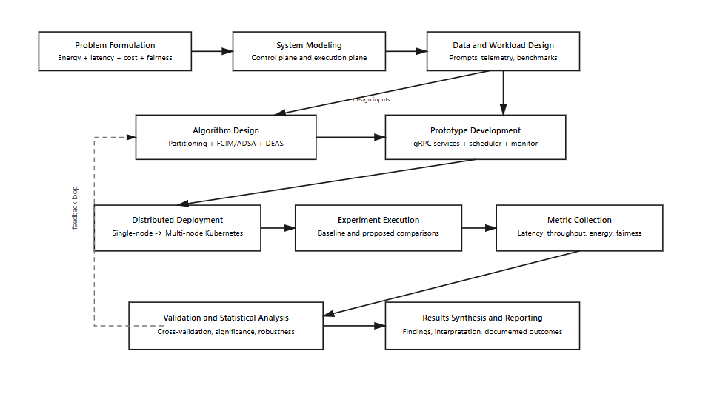
Figure 02: Flowchart of the proposed system
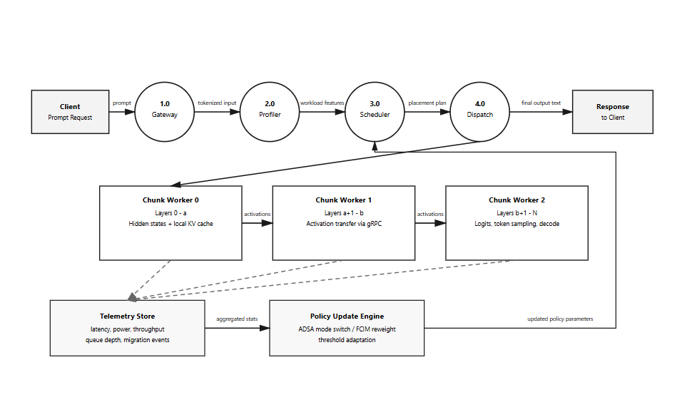
Figure 03: Proposed pipeline

Assumptions
The research in this paper assumes that, using reliable profiling tools, the performance of different types of nodes (i.e., compute nodes) can be accurately characterized. This paper also assumes that the cost of communicating from one node to another will be known and manageable as part of the overall design of a computing system. Further, the authors assume that the benchmark application workloads chosen for testing represent typical usage patterns. In addition, the authors assume that any adverse impact on quality resulting from optimizations made to the applications will remain at acceptable levels for practical purposes. Finally, the authors assume that sufficient monitoring data is available to enable both the detection of potential problems and the implementation of appropriate corrective actions by the adaptive control mechanism during the execution of an application.

Limitations
While this proposed system has many advantages it also has a number of disadvantages that could limit its ability to be scalable or perform well under certain conditions. Due to architecture and coordination costs there are likely to be limits on how scalable the first prototype will be for large numbers of cluster nodes. There may be an issue with network consistency (across all distributed nodes) as to whether the experimental results will be replicable. As well, depending upon the size of the system and how much data needs to be processed by each node, exact methods for optimizing may become too computationally intensive to use in practice. Commodity hardware differences may create problems when trying to ensure that comparative testing across nodes occurs fairly and consistently. Lastly, the initial development milestone does include complete production level fault-tolerant capabilities.

Expected Academic Contribution
This research will help create an applied methodology for energy aware distributed inference (for example on mobile or embedded devices) of large language models. Additionally, it should be able to create a reproducible and standardized evaluation platform for distributed inference systems which are able to evaluate multiple aspects (such as latency, fairness and energy consumption). Finally, the results from this research can give insight into how different adaptive scheduling algorithms (in terms of their ability to dynamically distribute tasks across nodes based upon available resources and performance) perform within a cluster of heterogeneous computing devices.

Literature Review

Similar Applications
The proposed system fits into a wide variety of existing distributed inference, and LLM serving architectures. Tensor-parallelism was first introduced with Megatron-LM using all-reduce collective communication methods. It is an early approach toward model parallelism, though, it has been primarily used for large-scale model training {Li et al., 2024; Dash, 2025; Dash et al., 2023}. Therefore, it does not have many characteristics required for efficient inference, such as low power consumption or a small footprint {Wu et al., 2023; Miao et al., 2023}. vLLM is an example of a lightweight inference engine optimized for running on a single GPU using paged attention. It reduces memory fragmentation, optimizes KV cache access, and uses both sparse and dense representations {Kwon et al., 2023; Wu et al., 2023; Yao et al., 2024; He et al., 2025}. However, vLLM is not scalable beyond one node {Wu et al., 2023; Kwon et al., 2023}. Petals is an example of a decentralized peer-to-peer inference system similar to how BitTorrent distributes content among peers. This system allows for collaboration during computing tasks, eliminating the need for central orchestration {Borzunov et al., 2022; Miao et al., 2023; Jiang et al., 2023}. While Petals is also a decentralized system similar to the proposed system, its architecture is very different (i.e., structured cluster vs unstructured decentralized). Ollama is a simple and easy to deploy single machine inference system that uses quantized models. Since it represents a simple baseline for lightweight inference engines, it can be considered as a baseline for lightweight distributed inference systems. FlexGen is another example of an inference system, however, it is focused on performing high throughput inference on a single GPU using CPU and disk offload techniques. Similar to vLLM, FlexGen shares similar goals of minimizing memory usage; however, unlike vLLM and Ollama, FlexGen is capable of scaling over multiple nodes. AlpaServe is an example of a high-level parallelization strategy applied across three major dimensions: tensor (data), data (tensor), and pipeline. The flexible nature of this scheduling strategy will provide guidance when implementing the hybrid parallelism strategy {Wu et al., 2023; Xu et al., 2025; Miao et al., 2023; Jiang et al., 2023}. Ray Serve is an example of a general purpose distributed serving framework that uses actor-based execution and dynamic scheduling. As such, it can serve as a reference point for designing orchestration and scheduling strategies for future distributed inference systems {Kwon et al., 2023; Xu et al., 2025; Miao et al., 2023; Sun et al., 2024}.

Related Research
The body of literature from which this study is derived includes a number of significant areas: edge and cloud-edge scheduling for large language model inference; strategies for large-scale parallelism; techniques for optimizing KV caches and memory; and energy-aware AI system design {Miao et al., 2023; Jiang et al., 2023; Dash, 2025; Gundla & Atthuluri, 2025}. In terms of edge and cloud-edge scheduling, prior research has focused on efficient worker selection, and the use of adaptive scheduling methods to order tasks dynamically in response to deadlines {Wu et al., 2023; Miao et al., 2023; Jiang et al., 2023; Sun et al., 2024; Jin et al., 2024}, as well as on using adaptive partitioning to distribute segments of the model based on the heterogeneous capabilities of different types of devices, as opposed to statically partitioned strategies {Jiang et al., 2023; Gundla & Atthuluri, 2025}. Additionally, there are studies examining how cloud-edge systems may employ active inference to perform task offload decisions based on beliefs regarding changing workloads, as opposed to employing reinforcement learning to select among possible offload options {Miao et al., 2023; Jiang et al., 2023; He et al., 2025}. Furthermore, the authors note that existing infrastructure aware scheduling frameworks seek to develop solutions that optimize multiple objectives simultaneously, and include heuristics or fallbacks for when those optimizations are not feasible due to resource limitations within a given environment {Wu et al., 2023; Miao et al., 2023; Jiang et al., 2023; Yao et al., 2024; Sun et al., 2024; Gundla & Atthuluri, 2025}.
With respect to large-scale parallelism and the scaling of LLM service delivery, there are demonstrations (e.g., Tensor-Parallel Inference) that indicate that it is feasible to execute inference tasks in a distributed manner even in highly resource-constrained environments {Xu et al., 2025; Jiang et al., 2023; Li et al., 2024; Zhang et al., 2025; Dash et al., 2023; Gundla & Atthuluri, 2025}. There also exist pipeline parallelism frameworks that improve throughput by providing structure to both the partitioning of tasks among workers and their scheduling {Xu et al., 2025; Jiang et al., 2023; Yang et al., 2025; Li et al., 2024; Dash et al., 2023; Gundla & Atthuluri, 2025}. Finally, there exist large-scale systems (such as DeepSpeed), that implement additional memory and communications optimizations (e.g., ZeRO-style optimizations) that enable the execution of models with tens of hundreds of billions of parameters. Collectively, these bodies of research demonstrate the potential for both hybrid forms of parallelism and system-wide optimization to scale inference performance {Xu et al., 2025; Jiang et al., 2023; Yang et al., 2025; Li et al., 2024; Dash et al., 2023; He et al., 2025; Chen, 2024}.
Research into optimization of KV cache management and the memory hierarchy seeks to mitigate memory bottlenecks that occur during inference {Wu et al., 2023; Kwon et al., 2023; Miao et al., 2023; Jiang et al., 2023; Song et al., 2024; Sun et al., 2024; Jin et al., 2024; He et al., 2025}. As an example, research into KV cache quantization indicates that selectively retaining precision can result in substantial reductions in memory usage without compromising output quality {Miao et al., 2023; Jiang et al., 2023; Song et al., 2024}. Research into dynamic KV placement across heterogeneous tiers of memory seeks to reduce bandwidth pressure and improve overall throughput {Wu et al., 2023; Miao et al., 2023; Jiang et al., 2023; Jin et al., 2024; He et al., 2025}. Finally, other researchers have combined batching, quantization, and search-based scheduling methods to create additional optimization techniques that can be used in edge environments to increase efficiency. Decoding level optimizations have been proposed to further reduce synchronization overhead and improve memory reuse patterns {Wu et al., 2023; Miao et al., 2023; Jiang et al., 2023; Yao et al., 2024; Song et al., 2024; Sun et al., 2024; Jin et al., 2024; He et al., 2025}.
Finally, studies focused on energy and sustainability issues associated with large language models seek to identify and address the increasingly important issue of the environmental impact of large language model systems {Miao et al., 2023; Jiang et al., 2023; Dash, 2025}. Research into lifecycle energy models quantifies the entire computational cost of AI systems and highlights that inference time energy consumption and memory bound decoding stages are dominant contributors to total energy consumption {Jiang et al., 2023; Li et al., 2024; Dash, 2025}. Additionally, other research has proposed composite efficiency metrics that consider runtime energy consumption, memory utilization, and carbon emissions. Overall, these findings reinforce the need for sustainable AI system designs {Miao et al., 2023; Jiang et al., 2023; Li et al., 2024; Dash, 2025}.

Gap Analysis
An analysis of the academic contribution that KAI will make as an Energy-Aware Distributed Inference System based upon a Kubernetes environment; compared to several other systems presented in the provided source material including vLLM, Petals, FlexGen, and AlpaServe will be necessary. Each of these three systems has been developed as alternatives to a single aspect of how vLLM operates. Therefore, when analyzing how KAI compares to each of them (as described below), we are essentially identifying areas where KAI fills the gap.
Feature / Framework | vLLM | Petals | FlexGen | AlpaServe | KAI (Proposed)
Primary Architecture | Lightweight inference engine. | Decentralized peer-to-peer system. | High-throughput inference system. | High-level parallelization strategy. | Distributed structured cluster on Kubernetes.
Scalability | Not scalable beyond one node. | Scales via peer collaboration without central orchestration. | Capable of scaling over multiple nodes. | Scales across tensor, data, and pipeline dimensions. | Scalable multi-node execution with dynamic partitioning.
Hardware Focus | Optimized for single GPU. | Collaborative peer hardware. | Single GPU with CPU/disk offload techniques. | General parallelization environments. | Small, resource-constrained, heterogeneous commodity devices.
Memory / Cache Strategy | Paged attention; optimized KV cache access. | Decentralized distribution. | Offloads to CPU and disk to minimize memory usage. | Not explicitly detailed as a core focus. | Mixed Precision KV Cache Optimization.
Energy & Feedback Control | None explicitly identified. | None explicitly identified. | None explicitly identified. | Flexible scheduling strategy. | Closed Loop Energy Feedback Controller to minimize energy per token.
The identified gaps in current research include:
GAP 1: The lack of distributed inference as well as a structured energy-aware architecture for inference. Petals allows for decentralizing the model distribution, however, does not offer a structured architecture for distributing the models nor a central orchestrator. On the other hand, KAI provides an architecture based upon Kubernetes which is structured into clusters. Additionally, none of the previous architectures included a closed-loop energy feedback controller to monitor and adjust parameters (e.g., batch size, power limitations) at runtime to optimize energy usage.
GAP 2: Single Node Optimization vs. Scalability of Engines and High-End GPU Based Architectures. Highly optimized engines such as vLLM have excellent memory management due to paged attention; however, these engines are unable to be scaled beyond one node. Moreover, most traditional engines use high-end GPUs which are very expensive. KAI will bridge this gap by providing a scalable architecture which was specifically designed to operate on low cost, constrained commodity hardware.
GAP 3: The rigid nature of workload partitioning across different types of devices. AlpaServe has provided good guidance toward hybrid parallelism techniques (i.e., tensor, data and pipeline); however, AlpaServe is a generic purpose scheduling technique. FlexGen supports multi-node scaling; however, FlexGen's support is highly dependent on CPU/Disk offloading to manage memory. KAI improves upon both AlpaServe and FlexGen by providing adaptive workload partitioning where each workload can be dynamically mapped to the best fitting capability of the various edge devices or laboratory clusters.
GAP 4: Achieving optimal balance of energy efficiency versus output fidelity. Currently, all models suffer from either consuming excessive power on high-end platforms or degrading their model quality through heavy compression to fit within the confines of smaller platforms. KAI will address GAP 4 by utilizing mixed precision storage for kv-cache optimization to reduce memory footprint while maintaining the strictest level of output fidelity.

Key References
- Edge-LLM inference with cost-aware layer allocation and adaptive scheduling. (n.d.). IEEE Xplore. https://ieeexplore.ieee.org/document/11392787
- Narayanan, D., Harlap, A., Phanishayee, A., Seshadri, V., Devanur, N., Ganger, G. R., Gibbons, P. B., & Zaharia, M. (2019). PipeDream: Generalized pipeline parallelism for DNN training. Proceedings of the ACM Symposium on Operating Systems Principles. https://doi.org/10.1145/3341301.3359646
- Rasley, J., Rajbhandari, S., Ruwase, O., & He, Y. (2020). DeepSpeed: System optimizations enable training deep learning models with over 100 billion parameters. Proceedings of the ACM SIGKDD Conference. https://doi.org/10.1145/3394486.3406703
- Exploring KV cache quantization in multimodal large language model inference. (n.d.). IEEE Xplore. https://ieeexplore.ieee.org/document/11304543
- Accelerating LLM inference via dynamic KV cache placement in heterogeneous memory system. (n.d.). IEEE Xplore. https://ieeexplore.ieee.org/document/11206428
- FlashDecoding++Next: High throughput LLM inference with latency and memory optimization. (n.d.). IEEE Xplore. https://ieeexplore.ieee.org/document/11062854
- Accelerating quantization-aware vector search for fast retrieval in prompt engineering. (2026). IEEE Computer Society Digital Library. https://www.computer.org/csdl/journal/tc/2026/03/11303310/2cwBPdFTVUk
- The energy cost of artificial intelligence lifecycle in communication networks. (n.d.). IEEE Xplore. http://ieeexplore.ieee.org/document/11298182
- Energy cost modelling for optimizing large language model inference on hardware accelerators. (n.d.). IEEE Xplore. https://ieeexplore.ieee.org/document/10737844
- GreenAI: A comparative analysis of environmental efficiency in LLM-generated code. (n.d.). IEEE Xplore. https://ieeexplore.ieee.org/document/11366639
- Strubell, E., Ganesh, A., & McCallum, A. (2019). Energy and policy considerations for deep learning in NLP. Proceedings of the Annual Meeting of the Association for Computational Linguistics. https://www.researchgate.net/publication/335778882
- Efficient LLMs training and inference: An introduction. (n.d.). IEEE Xplore. https://ieeexplore.ieee.org/document/10756602
- Minimizing response latency in LLM-based agent systems: A comprehensive survey. (n.d.). IEEE Xplore. https://ieeexplore.ieee.org/document/11394729
- Borzunov, A., Baranchuk, D., Dettmers, T., Ryabinin, M., Belkada, Y., Chumachenko, A., Samygin, P., & Raffel, C. (2022). Petals: Collaborative inference and fine-tuning of large models. arXiv. https://doi.org/10.48550/arxiv.2209.01188
- Dash, A. (2025). Distributed training frameworks for large language models: Architectures, challenges, and innovations. Journal of Computer Science and Technology Studies. https://doi.org/10.32996/jcsts.2025.7.5.15
- Dash, S., Lyngaas, I., Yin, J., Wang, X., Egele, R., Cong, G., Wang, F., & Balaprakash, P. (2023). Optimizing distributed training on Frontier for large language models. arXiv. https://doi.org/10.48550/arxiv.2312.12705
- He, Y., Xu, M., Wu, J., Hu, J., Shen, M., Chen, L., Xu, C., Qu, L., & Ye, K. (2025). BanaServe: Unified KV cache and dynamic module migration for balancing disaggregated LLM serving in AI infrastructure. arXiv. https://doi.org/10.48550/arxiv.2510.13223
- Jiang, Y., Yan, R., Yao, X., Zhou, Y., Chen, B., & Yuan, B. (2023). HexGen: Generative inference of large language model over heterogeneous environment.
- Kwon, W., Li, Z., Zhuang, S., Sheng, Y., Zheng, L., Yu, C., Gonzalez, J., Zhang, H., & Stoica, I. (2023). Efficient memory management for large language model serving with PagedAttention. Proceedings of the 29th Symposium on Operating Systems Principles. https://doi.org/10.1145/3600006.3613165
- Li, Q., Zhang, B., Ye, L., Zhang, Y., Wu, W., Sun, Y., & Xie, Y. (2024). Flash communication: Reducing tensor parallelization bottleneck for fast large language model inference. arXiv. https://doi.org/10.48550/arxiv.2412.04964
- Miao, X., Oliaro, G., Zhang, Z., Cheng, X., Jin, H., Chen, T., & Jia, Z. (2023). Towards efficient generative large language model serving: A survey from algorithms to systems. ACM Computing Surveys, 58, 1–37. https://doi.org/10.1145/3754448
- Sun, B., Huang, Z., Zhao, H., Xiao, W., Zhang, X., Li, Y., & Lin, W. (2024). Llumnix: Dynamic scheduling for large language model serving. arXiv. https://doi.org/10.48550/arxiv.2406.03243
- Wu, B., Zhong, Y., Zhang, Z., Huang, G., Liu, X., & Jin, X. (2023). Fast distributed inference serving for large language models. arXiv. https://doi.org/10.48550/arxiv.2305.05920
- Xu, L., Suresh, K., Anthony, Q., Alnaasan, N., & Panda, D. (2025). Characterizing communication patterns in distributed large language model inference. 2025 IEEE Symposium on High-Performance Interconnects (HOTI), 1–11. https://doi.org/10.1109/hoti66940.2025.00025
- Yao, Y., Jin, H., Shah, A., Han, S., Hu, Z., Ran, Y., Stripelis, D., Xu, Z., Avestimehr, S., & He, C. (2024). ScaleLLM: A resource-frugal LLM serving framework by optimizing end-to-end efficiency. arXiv. https://doi.org/10.48550/arxiv.2408.00008
- Chen, Q. (2024). Research on inference and training acceleration of large language model. Proceedings of the 2024 7th International Conference on Computer Information Science and Artificial Intelligence. https://doi.org/10.1145/3703187.3703238
- Gundla, N., & Atthuluri, S. (2025). Multi-node inference architectures for low-latency LLM serving. 2025 International Conference on Advanced Computing Technologies (ICoACT), 1–6. https://doi.org/10.1109/icoact63339.2025.11004706
- Jin, H., Lai, R., Ruan, C., Wang, Y., Mowry, T., Miao, X., Jia, Z., & Chen, T. (2024). A system for microserving of LLMs. arXiv. https://doi.org/10.48550/arxiv.2412.12488
- Song, M., Tang, X., Hou, F., Li, J., Wei, W., Xiao, R., Si, H., Jiang, D., Yin, S., Hu, Y., & Long, G. (2024). Tackling the dynamicity in a production LLM serving system with SOTA optimizations via hybrid prefill/decode/verify scheduling on efficient meta-kernels. arXiv. https://doi.org/10.48550/arxiv.2412.18106
- Yang, H., Tian, Y., Yang, Z., Wang, Z., Zhou, C., & Li, D. (2025). Research on model parallelism and data parallelism optimization methods in large language model–based recommendation systems. 2025 7th International Conference on Artificial Intelligence Technologies and Applications (ICAITA), 324–329. https://doi.org/10.1109/icaita67588.2025.11137951
- Zhang, M., Mishra, M., Zhou, Z., Brandon, W., Wang, J., Kim, Y., Ragan-Kelley, J., Song, S., Athiwaratkun, B., & Dao, T. (2025). Ladder-residual: Parallelism-aware architecture for accelerating large model inference with communication overlapping. arXiv. https://doi.org/10.48550/arxiv.2501.06589

