**Computer Graphics**

**Assignment #02**

**Submitted By:**

**Misbah iqbal**

**Registration No:**

**17-CP-55**

**Session:**

**CP 2K17**

**University of Engineering & Technology, Taxila**

**Task 1**

**Create a webpage and add String Functionality**

**stringFunctionality.php**

<!DOCTYPE html>

<html>

<head>

<meta name="viewport" content="width=device-width, initial-scale=1">

<style>

body {

font-family: Arial, Helvetica, sans-serif;

margin-right:700px;

}

* {box-sizing: border-box;}

input[type=text],textarea {

width: 100%;

padding: 12px;

border: 1px solid #ccc;

border-radius: 4px;

box-sizing: border-box;

margin-top: 6px;

margin-bottom: 16px;

resize: vertical;

}

input[type=submit] {

background-color: #4CAF50;

color: white;

padding: 12px 20px;

border: none;

border-radius: 4px;

cursor: pointer;

}

input[type=submit]:hover {

background-color: #45a049;

}

.container {

border-radius: 5px;

background-color: #f2f2f2;

padding: 20px;

}

</style>

</head>

<body>

<h3>String Functionality</h3>

<div class="container">

<form action="/stringFunctionality.php" method="post">

<label for="fname">First Name</label>

<input type ="text" id="fname" name="firstname" placeholder="First Name">

<label for="lname">Last Name</label>

<input type="text" id="lname" name="lastname" placeholder="Last Name">

<label for="subject">Subject</label>

<textarea id="subject" name="subject" placeholder="Write something.." style="height:200px"></textarea>

<input type="submit" name="sub" value="Submit">

</form>

</div>

<?php

if(isset($_POST["sub"]))

{

$fname = $_POST['firstname'];

$lname = $_POST['lastname'];

$box = $_POST['subject'];

//strpos

echo "<h4>String Position-strpos</h4>";

$Pos = strpos($fname, "a");

echo "The position of a in first name :". $Pos."<br/>";

//str_replace

echo "<h4>String Replace-str_replace</h4>";

$updated = str_replace("roll", "registration", $box);

echo "Before replace: ". $box . "<br />";

echo "After replace: ". $updated. "<br/>" ;

//substr_replace

echo "<h4>Sub String Replace-substr_replace</h4>";

$sp = substr_replace($updated, "omega section", -1);

echo "Original String: $updated <br />";

echo "updated: $sp <br />";

//strtoupper

echo "<h4>String Capitalization-strtoupper,strtolower</h4>";

$upperCase = strtoupper($fname);

echo "Old string - $fname <br />";

echo "UpperCase - $upperCase <br/>";

//strtolower

$lowerCase = strtolower($lname);

echo "Old string - $lname <br />";

echo "LowerCase - $lowerCase <br/>";

//explode

echo "<h4>String Explode-explode</h4>";

$Chunks = explode(" ", $updated);

echo "original = $updated <br />";

for($i = 0; $i < count($Chunks); $i++){

echo "Piece $i = $Chunks[$i] <br />";

}

//implode

echo "<h4>String Implode-implode</h4>";

$pieces = array("CP","2k17");

$join = implode("-", $Chunks);

echo "Glued with dash = $join <br />";

}

?>

</body>

</html>

## Output:

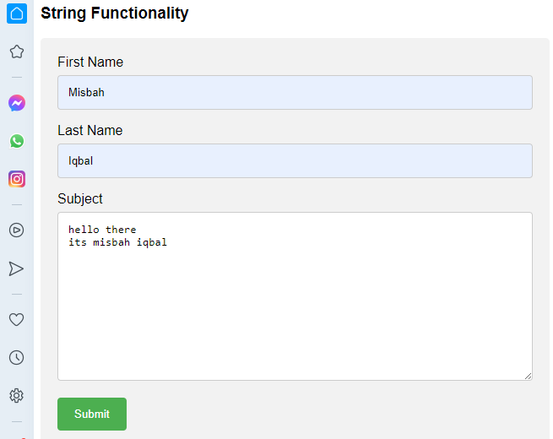

# **Task 2 & 3**

# Create a webpage and print number of views and last visit:

## Session_cookies.php

<?php

$duration = 60 * 60 * 24 * 60 + time();

setcookie('uname', date("G:i - m/d/y"), $duration);

?>

<html>

<head>

<style>

body {

font-family: Arial, Helvetica, sans-serif;

margin-left:450px;

margin-right:550px;

margin-top:30px;

padding: 0px;

text-align: left;

}

* {box-sizing: border-box}

input[type=text], input[type=password] {

width: 100%;

padding: 15px;

margin: 5px 0px 22px 0;

display: inline-block;

border: none;

background: #f1f1f1;

}

input[type=text]:focus, input[type=password]:focus {

background-color: #ddd;

outline: none;

}

hr {

border: 1px solid #f1f1f1;

margin-bottom: 25px;

}

/* Set a style for all buttons */

button {

background-color: #4CAF50;

color: white;

padding: 14px 20px;

margin: 8px 0;

border: none;

cursor: pointer;

width: 100%;

opacity: 0.9;

}

button:hover {

opacity:1;

}

.cancelbtn {

padding: 14px 20px;

background-color: #f44336;

}

.cancelbtn, .signupbtn {

float: left;

width: 50%;

}

.container {

padding: 16px;

}

.clearfix::after {

content: "";

clear: both;

display: table;

}

@media screen and (max-width: 300px) {

.cancelbtn, .signupbtn {

width: 100%;

}

}

</style>

</head>

<body>

<form action="/session.php" method="post" style="border:1px solid #ccc">

<div class="container">

<h1>Login</h1>

<p>Please fill in this form</p>

<hr>

<label for="email"><b>Email</b></label>

<input type="text" placeholder="Enter Email" name="email" required>

<label for="psw"><b>Password</b></label>

<input type="password" placeholder="Enter Password" name="psw" required>

<label>

<input type="checkbox" checked="checked" name="remember" style="margin-bottom:15px"> Remember me

</label>

<div class="clearfix">

<button type="button" class="cancelbtn">Cancel</button>

<button type="submit" name="sub" class="signupbtn">Login</button>

</div>

</div>

</form>

<?php

session_start();

if(isset($_POST["sub"]))

{

$uname = $_POST['email'];

}

if(isset($_SESSION['uname']))

$_SESSION['uname'] = $_SESSION['uname']+ 1;

else

$_SESSION['uname'] = 1;

echo "views = ". $_SESSION['uname']."<br/>";

echo "last visit: " . $_COOKIE['uname'];

?>

</body>

</html>

## Output:

