

The University of Azad Jammu &
Kashmir, Muzaffarabad

Bank Account Management System

1st Semester Project

Course Code: HU-1101
Course Title: Programming Fundamentals
Submitted to: Engr. Awais Rathore
Submitted by: Misbah Khurshid
Roll No: 2025-SE-10

Bank Account Management

System Using C++

Introduction:
In today’s digital era, banks and financial institutions need efficient systems to manage customer accounts and transactions. Manual record keeping is time-consuming, error-prone, and difficult to manage, especially when multiple transactions are involved. Many small systems still rely on basic methods that lack automation and accuracy.
To overcome these problems, this Bank Account Management System has been developed using the C++ programming language. This console-based system allows users to create bank accounts, perform deposits and withdrawals, and check account types based on balance. The system is simple, interactive, and suitable for beginners to understand basic banking operations.
The main purpose of this project is to provide a structured and automated solution for managing bank transactions while demonstrating core programming concepts.

Objectives of the System:
- To provide a simple banking system using C++.
- To allow users to create a new bank account or use an existing one.
- To perform deposit and withdrawal transactions efficiently.
- To classify account type based on account balance.
- To track the total number of transactions.
- To demonstrate practical use of programming fundamentals.

Core Features:

1. Welcome & Start Menu:
When the program starts, a welcome message is displayed. The user is asked whether they want to perform a transaction or exit the program.
Options: Yes → Continue to banking system.
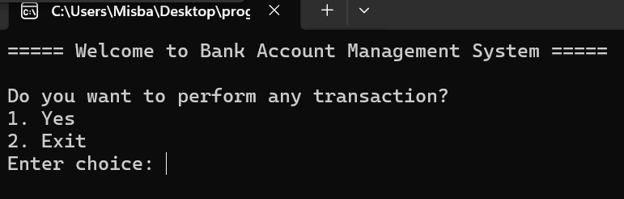

Exit → Program terminates with a thank-you message.
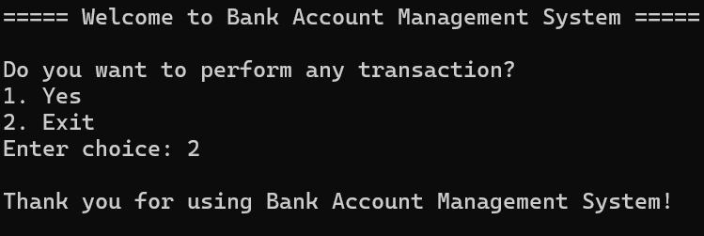

2. Account Verification:
The system asks the user whether they already have a bank account.
Options:
Existing Account → User enters current balance.
New Account → User creates a new account by entering personal details.
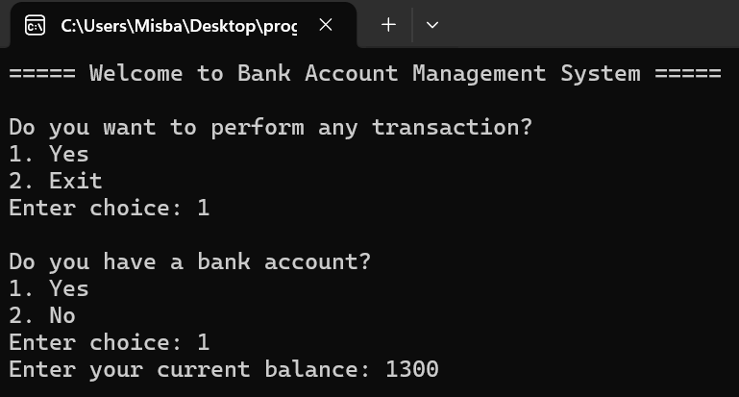
This step is performed only once, ensuring better user experience.

3. Account Creation:
If the user selects “No account”, the system allows them:
- Enter Name
- Enter Account Name
- Enter Initial Deposit
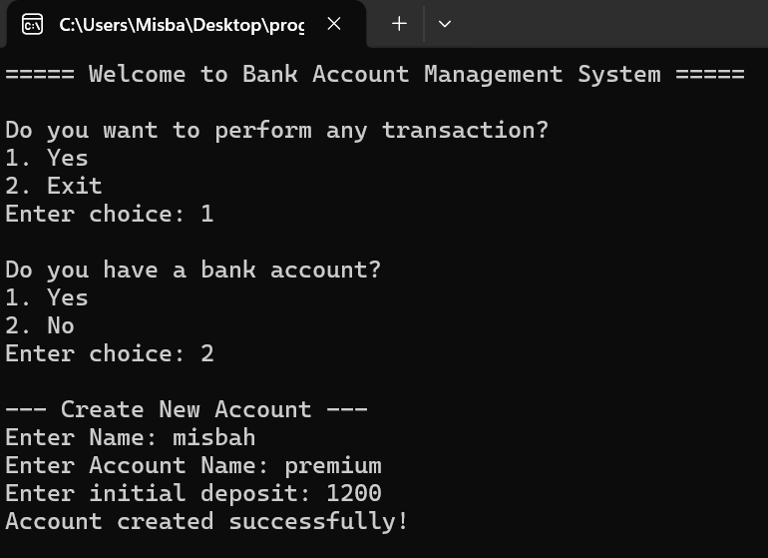
After successful input, the account is created and ready for transactions.

4. Transaction Menu:
After account setup, the user can perform multiple transactions using a menu:
- Deposit Money
- Withdraw Money

This menu repeats until the user chooses to stop.
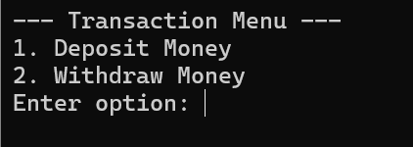

5. Deposit Operation:
The deposit function allows the user to:
- Enter deposit amount.
- Add amount to current balance.
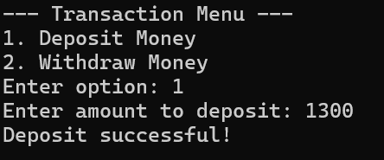
- Increase transaction count.

6. Withdraw Operation:
The withdrawal function allows the user to:
- Enter withdrawal amount.
- Check for sufficient balance.
- Deduct amount from balance.
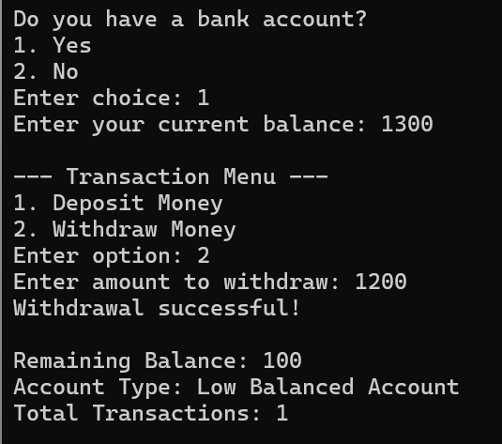
- Update transaction count.

7. Account Type Classification:
The system automatically displays the account type based on balance:
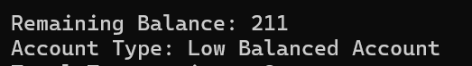
- Low Balanced Account →Balance<10,000

- Saving Account → Balance ≤ 30,000


- Premium Account → Balance ≤ 70,000


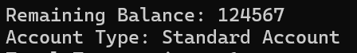
- Standard Account → Balance > 70,000

8. Transaction Count:
The system keeps track of how many transactions the user performs during the session and displays the total count.
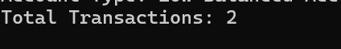

9. Repeat Transactions:
After each transaction, the user is asked whether they want to perform another transaction.
- If yes, the transaction menu appears again.

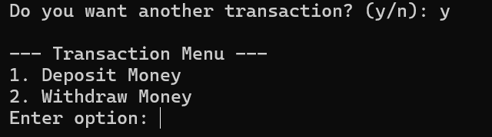

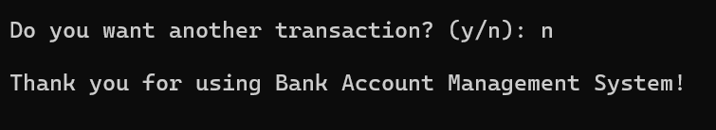
- If no, the program exits safely.

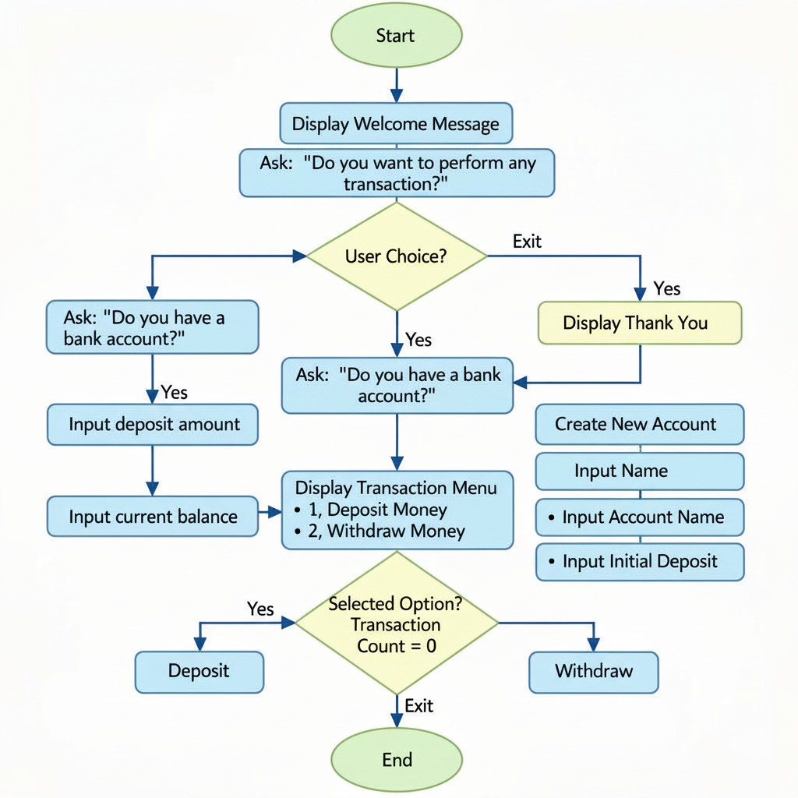
Flow Chart:

Core Programming Concepts Used:

1. Functions:
Functions are used to divide the program into logical parts such as:
- createAccount()
- depositMoney()
- withdrawMoney()
- showAccountType()
This improves readability and reusability.

2. Arrays:
Character arrays are used to store:
- User name
- Account name

3. Conditional Statements:
if , else if, and else statements are used for:
- Menu selection
- Balance checking
- Account type classification

4. Switch Statement:
switch-case is used to handle transaction options efficiently.

5. Loops:
do-while loop is used to:
- Allow multiple transactions.
- Improve user interaction.

6. Pass by Reference:
Reference variables are used to update balance and transaction count directly.

Output:
The system provides clear console-based output such as:
- Welcome and exit messages.
- Account creation confirmation.
- Successful deposit and withdrawal messages.
- Remaining balance display.
- Account type information.
- Total transaction count.

Advantages of the System:
- Easy to understand and user-friendly.
- Eliminates manual calculations.
- Accurate transaction handling.
- Modular and well-structured code.
- Ideal for beginners learning C++.
- Demonstrates real-world banking logic.

Limitations:

- Data is not stored permanently (no file handling).
- Single user at a time.
- Console-based interface.
- Limited security features.
- These limitations can be improved in future versions.

Conclusion:
The Bank Account Management System is a simple yet effective console-based application developed in C++. It automates basic banking operations such as account creation, deposits, withdrawals, and account type classification. This project successfully demonstrates the use of core programming concepts including functions, loops, conditional statements, arrays, and switch cases. It is a strong beginner-level project that reflects real-world problem solving using programming fundamentals.

