ANEUSO Application Screenshots
Generated: 2026-06-21 21:26
Screens captured from the Flutter app UI (390×844 phone layout). Each image shows one screen with its name as caption.
Here are all 53 screens in your app, grouped by folder:

Here are all 53 screens in your app, grouped by folder:

auth/ (3)
File | Screen
login_screen.dart | Login
register_screen.dart | Register
otp_verification_screen.dart | OTP Verification

common/ (4 + subfolders)
File | Screen
dashboard_screen.dart | Dashboard (home for all roles)
profile_screen.dart | Profile
notification_inbox_screen.dart | Notifications Inbox
live_tracking_screen.dart | Live Tracking
common/jobs/ (2) | jobs_list_screen.dart | Jobs Portal (list) | | job_detail_screen.dart | Job Detail |
common/tutorials/ (5) | tutorials_home_screen.dart | Tutorials Home | | topics_list_screen.dart | Topics List | | topic_detail_screen.dart | Topic Detail | | video_detail_screen.dart | Video Detail | | video_player_screen.dart | Video Player |

admin/ (18)
File | Screen
branch_list_screen.dart | Branch Management
branch_stats_screen.dart | Branch Stats
company_list_screen.dart | Company Management
public_garbage_reports_screen.dart | Public Garbage Reports
GarbageMissionDetailsScreen.dart | Garbage Mission Details
AdminCleanupDashboard.dart | Cleanup Operations Dashboard
MissionAssignmentScreen.dart | Mission Assignment
CleanupFinalizationScreen.dart | Cleanup Finalization
admin_products_screen.dart | Product Management
product_form_screen.dart | Add/Edit Product
admin_offers_screen.dart | Admin Offers
offer_form_screen.dart | Add/Edit Offer
admin_deals_screen.dart | Global Deals
admin_pickups_screen.dart | All App Pickups
admin_driver_ratings_screen.dart | Driver Ratings (admin)
admin_broadcast_screen.dart | Send Notification

citizen/ (12)
File | Screen
products_screen.dart | Browse Products
cart_screen.dart | My Cart
checkout_screen.dart | Checkout
orders_screen.dart | My Orders
order_detail_screen.dart | Order Detail
order_success_screen.dart | Order Success
report_garbage_screen.dart | Report Garbage
CleanupCampaignsScreen.dart | Active Campaigns
CampaignDetailScreen.dart | Campaign Detail
special_offers_screen.dart | Special Offers
offer_details_screen.dart | Offer Details

driver/ (4)
File | Screen
DailyTasksScreen.dart | Daily Tasks
ConfirmPickupsScreen.dart | Confirm Pickups
DriverMissionScreen.dart | Cleanup Missions
driver_my_ratings_screen.dart | My Ratings

industry/ (6)
File | Screen
schedule_pickup.dart | Schedule Pickup
ServiceHistoryScreen.dart | Service History
industry_pickup_detail_screen.dart | Pickup Detail
create_deal_screen.dart | Industry Deals
view_deals_screen.dart | View Deals
industry_three_bin_training_screen.dart | 3-Bin Training

chat/ (2)
File | Screen
messages_hub_screen.dart | Messages Hub
chat_thread_screen.dart | Chat Thread

jobs/ — moved to common/jobs/ (listed above)

Total: 53 screens
Folder path: lib/presentation/screens/
If you want, I can also list the route names from main.dart (e.g. /login, /profile, /citizen/mycart) next to each screen.
Total: 53 screens
Folder path: lib/presentation/screens/
If you want, I can also list the route names from main.dart (e.g. /login, /profile, /citizen/mycart) next to each screen

Here’s a full map of what triggers notifications in your app today.
Notifications are stored in the database and shown in the app under Dashboard → Notifications. Some also relay to Supabase for real-time alerts.

Shop / orders
Event | Who gets notified
Citizen places order (cart checkout) | Citizen — “Order Confirmed”
Same checkout | All admins — “New Order Received”
Admin marks order as shipped | Citizen — “Order Shipped”

Products / inventory
Event | Who gets notified
Product stock updated and falls below 10 | All admins — “Low Stock Alert”

Industry deals (bids)
Event | Who gets notified
Industry posts a new deal | All admins — “New Deal Posted”
Admin approves or rejects a deal | Industry user — “Deal Approved” / “Deal Rejected”

Waste pickups (industry ↔ driver)
Event | Who gets notified
Industry schedules a pickup | Industry, Driver, All admins
Admin assigns driver to pickup | Driver, Industry
Driver completes pickup | Industry, All admins
Driver reports an issue on pickup | All admins — “Pickup Issue Reported”
2 hours before scheduled pickup (scheduler) | Driver — “Pickup Reminder”
Industry rates driver | Driver — “New Rating Received”
Rating is 3 stars or less | All admins — “Low Rating Alert”

Garbage reports / cleanup campaigns (citizens)
Event | Who gets notified
Report status updated | Citizen — “Garbage Report Update”
Admin marks truck dispatched (status 204) | Citizen — “Cleanup Truck Dispatched”
Report approved & funding started | Citizen — status update
Admin assigns driver to cleanup | Driver — “New Cleanup Mission”; Citizen — “Driver Assigned”
Driver starts route | Citizen + All admins — “Driver En Route”
Driver arrives on site | Citizen + All admins — “Driver Arrived”
Driver finishes & submits photos | All admins — “Garbage Collected”
Admin marks area cleaned | Citizen — “Cleanup Complete!”; Driver — “Mission Finalized”

Account approvals (admin)
Event | Who gets notified
Admin approves industry account | Industry — “Account Approved”
Admin approves driver account | Driver — “Driver Account Approved”

Manual admin broadcast
Event | Who gets notified
Admin uses Send Alert (broadcast screen) | Chosen group: all users, industry, drivers, citizens, or admins

1. Login
Login
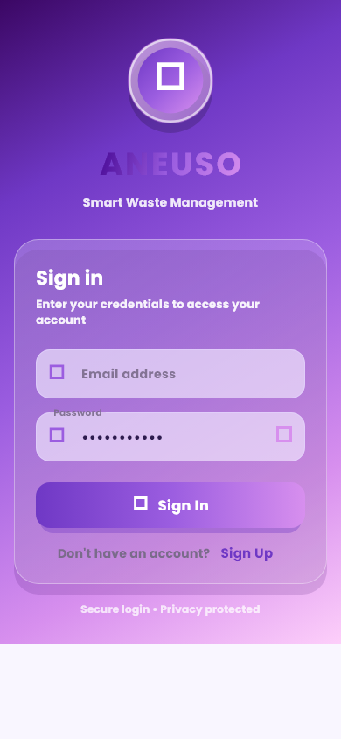

2. Register
Register
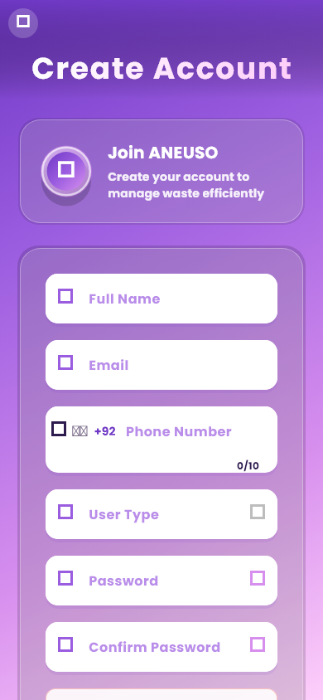

3. Otp Verification
Otp Verification
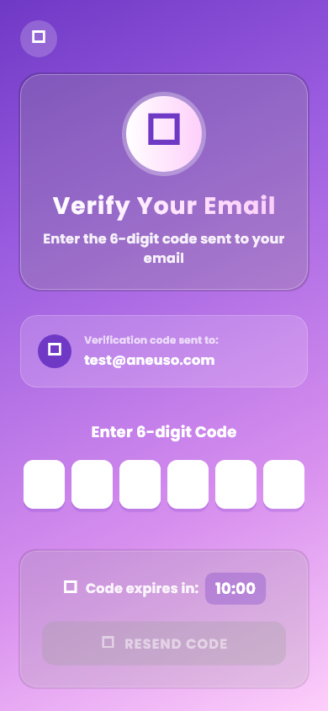

4. Profile
Profile
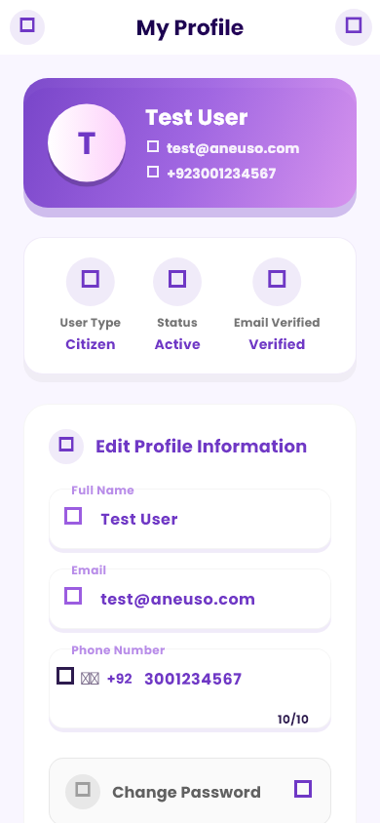

5. Dashboard Admin
Dashboard Admin
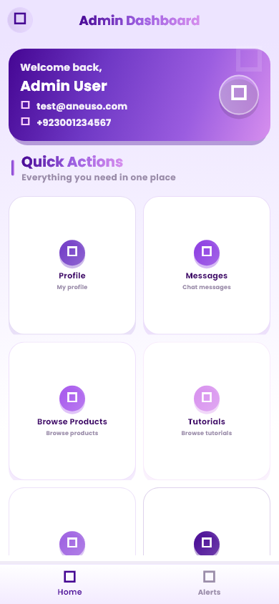

6. Dashboard Industry
Dashboard Industry
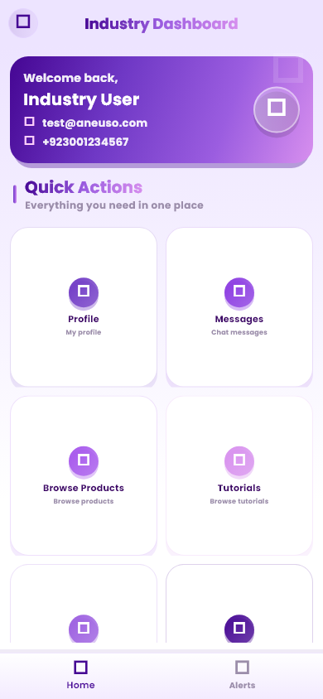

7. Dashboard Driver
Dashboard Driver
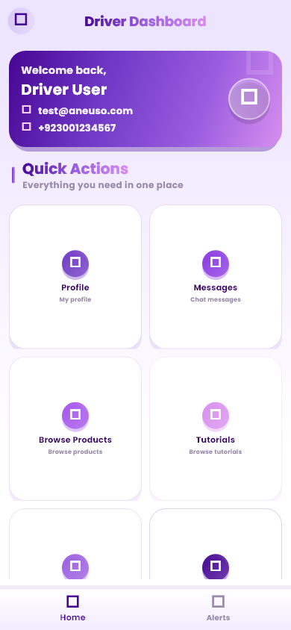

8. Dashboard Citizen
Dashboard Citizen
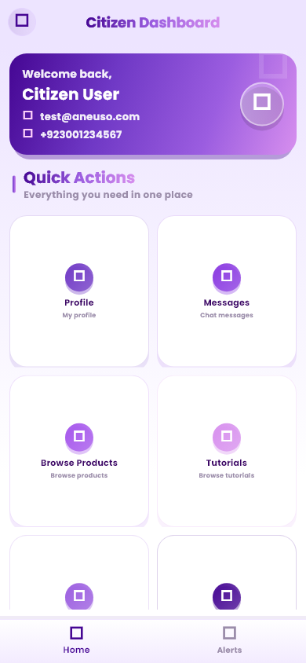

9. Products
Products
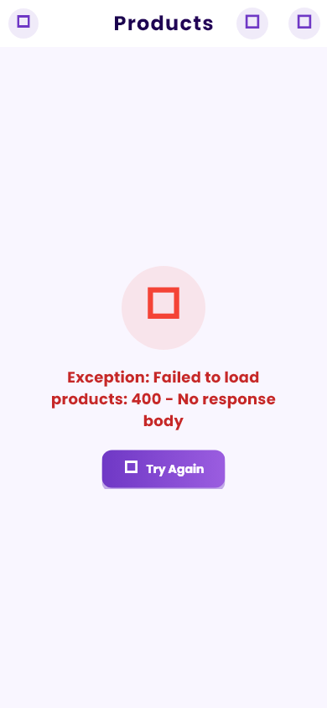

10. Cart
Cart
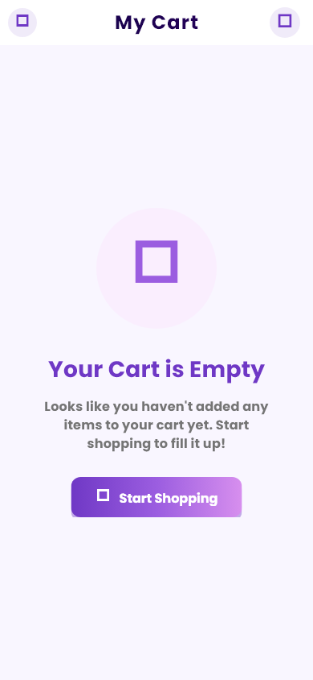

11. Orders
Orders
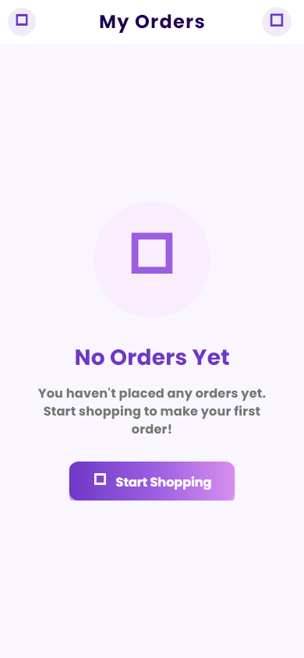

12. Report Garbage
Report Garbage
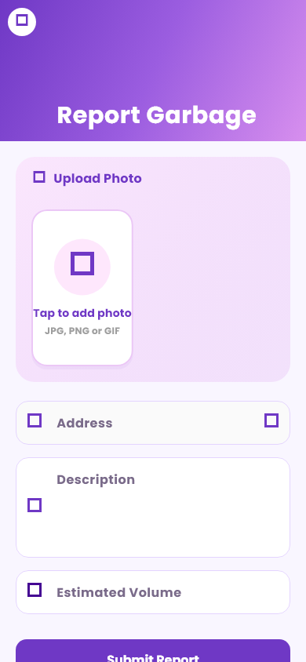

13. Cleanup Campaigns
Cleanup Campaigns
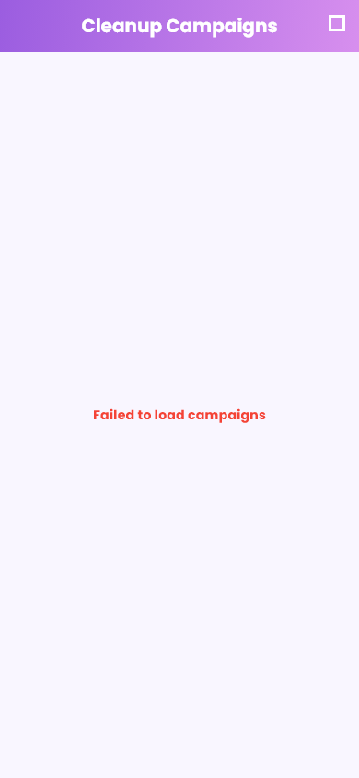

14. Schedule Pickup
Schedule Pickup
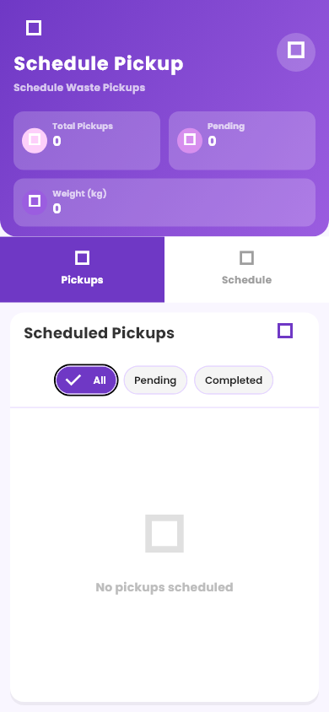

15. Create Deal
Create Deal
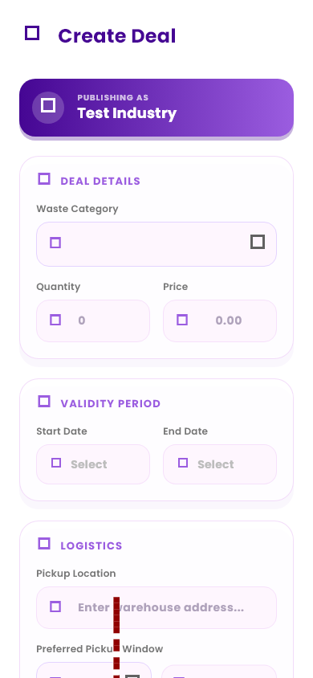

16. Service History
Service History
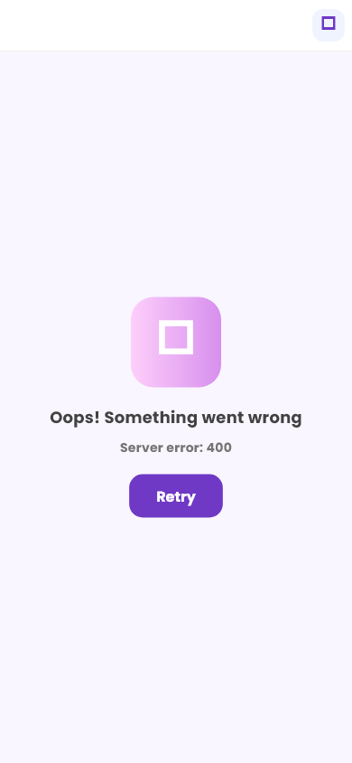

17. Three Bin Training
Three Bin Training
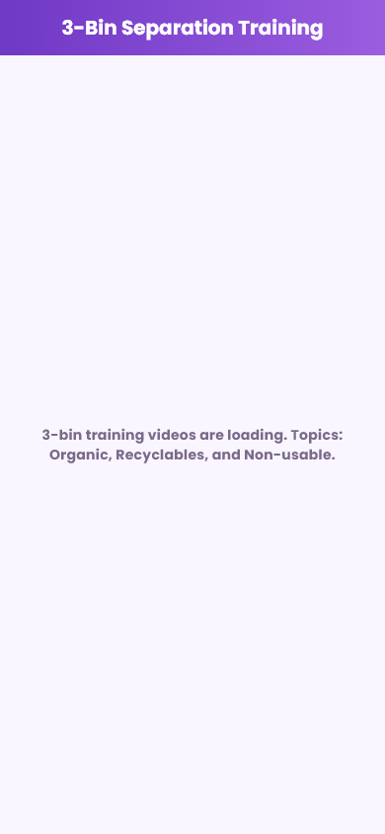

18. Driver Daily Tasks
Driver Daily Tasks
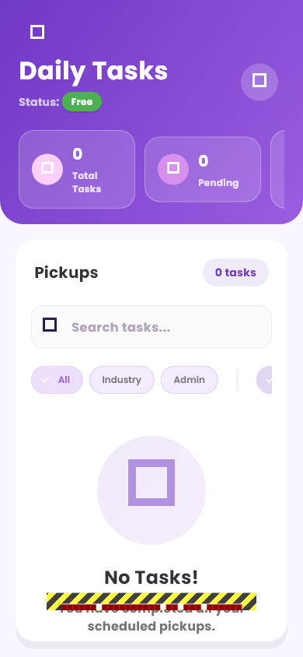

19. Confirm Pickups
Confirm Pickups
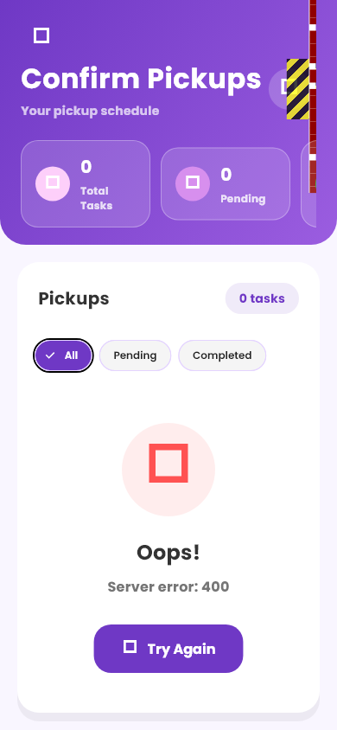

20. Driver Missions
Driver Missions
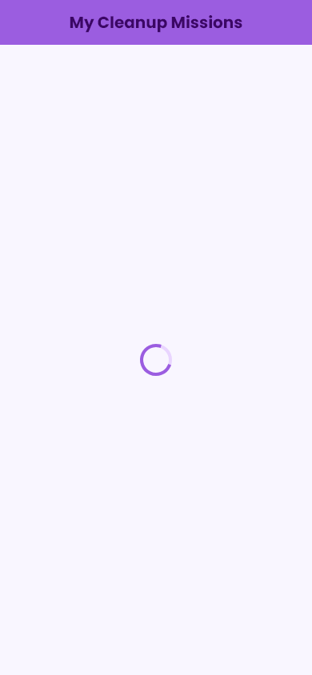

21. Driver My Ratings
Driver My Ratings
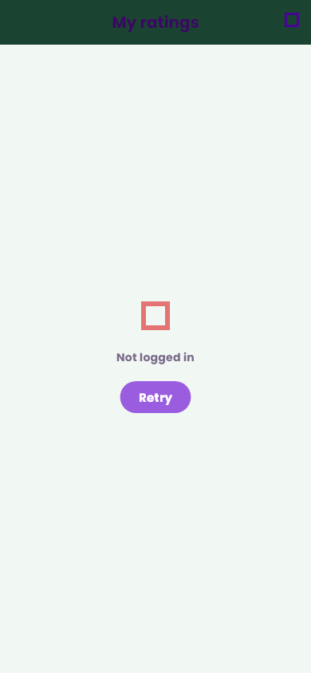

22. Companies
Companies
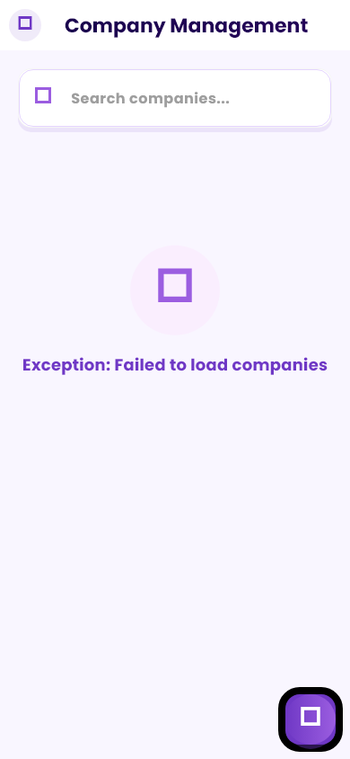

23. Branches
Branches
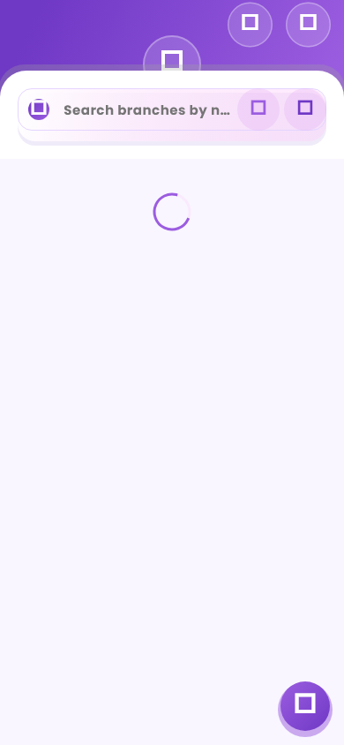

24. Branch Stats
Branch Stats
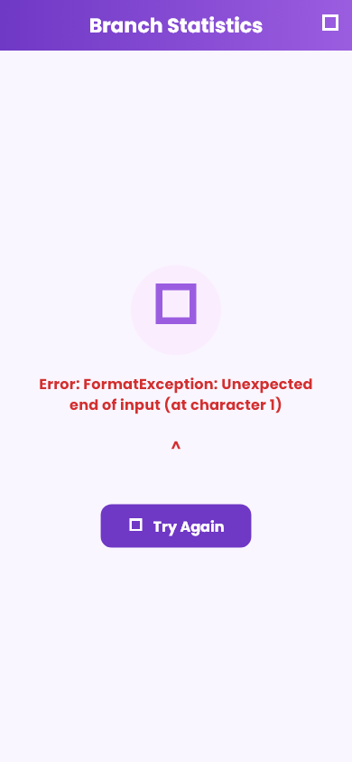

25. Admin Products
Admin Products
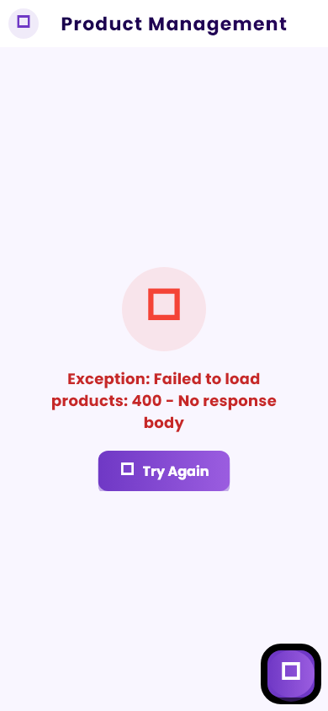

26. Admin Product Form
Admin Product Form
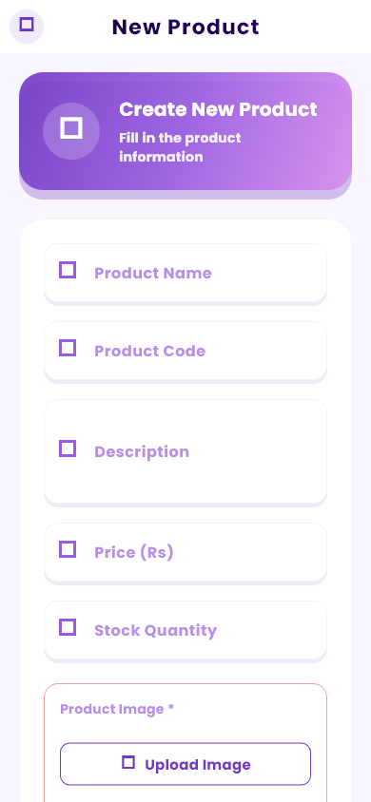

27. Admin Deals
Admin Deals
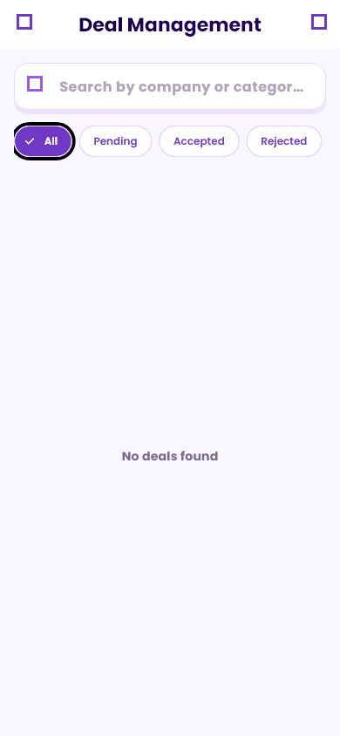

28. Admin Pickups
Admin Pickups
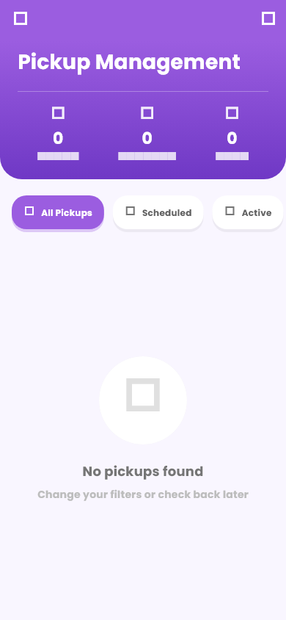

29. Admin Broadcast
Admin Broadcast
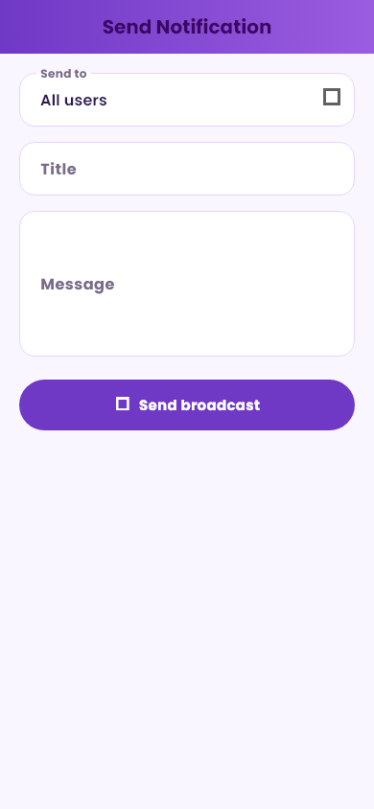

30. Admin Driver Ratings
Admin Driver Ratings
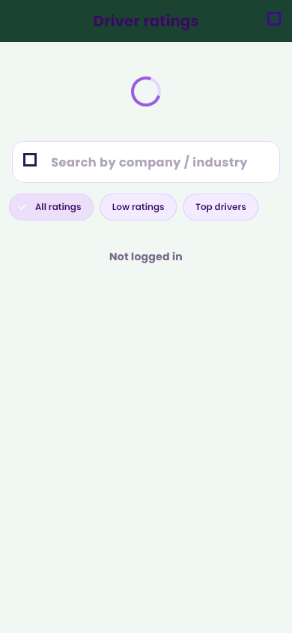

31. Admin Cleanup Dashboard
Admin Cleanup Dashboard
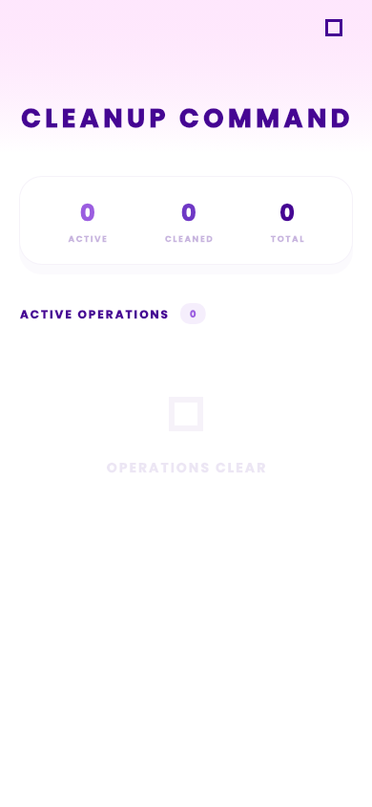

32. Public Garbage Reports
Public Garbage Reports
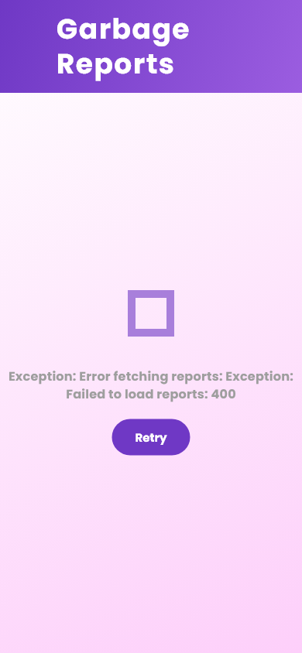

33. Messages Hub
Messages Hub
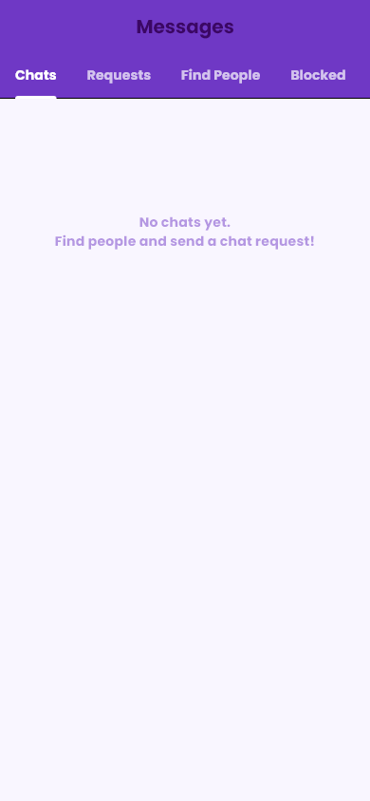

34. Jobs List
Jobs List


35. Tutorials Topics
Tutorials Topics
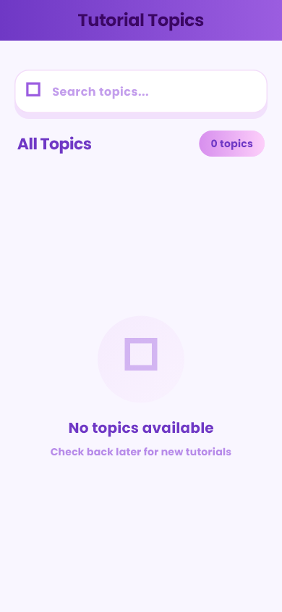

36. Tutorials Home
Tutorials Home
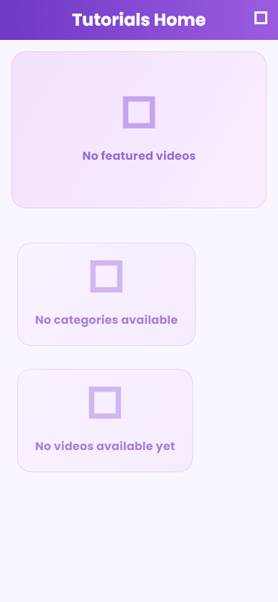

37. Notifications
Notifications
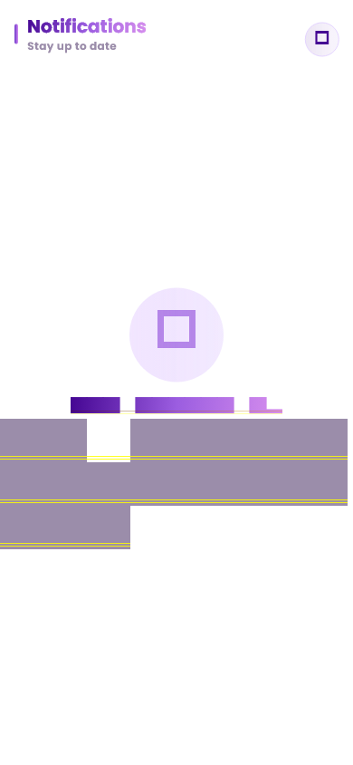

38. Live Tracking
Live Tracking
