**Data Mining**

**Lab 4**

**the pre-processing:**

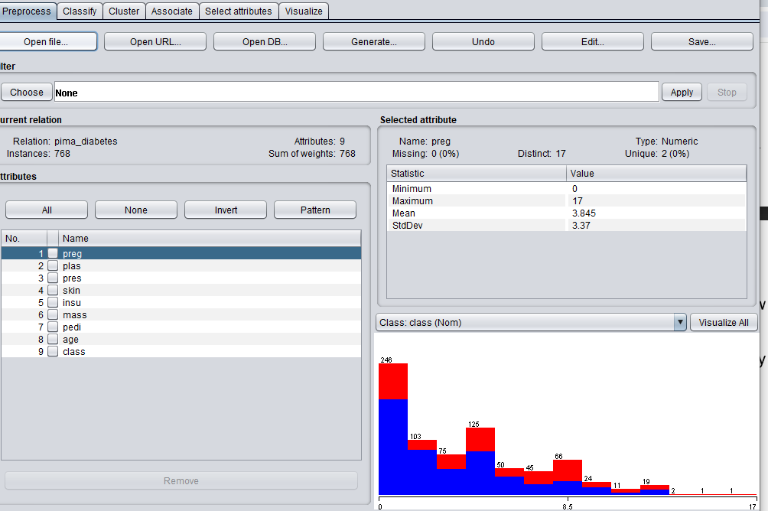

1. The Size of the training set is 768.
2. There are 9 attributes in the training set.
3. 268 instances are positive and 500 are negative.
4. The attribute that best separates the data is ‘plas’ and ‘age’.

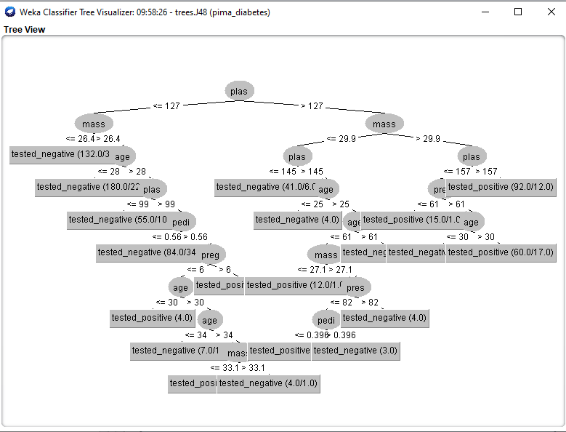

* **Load and analyse data:**

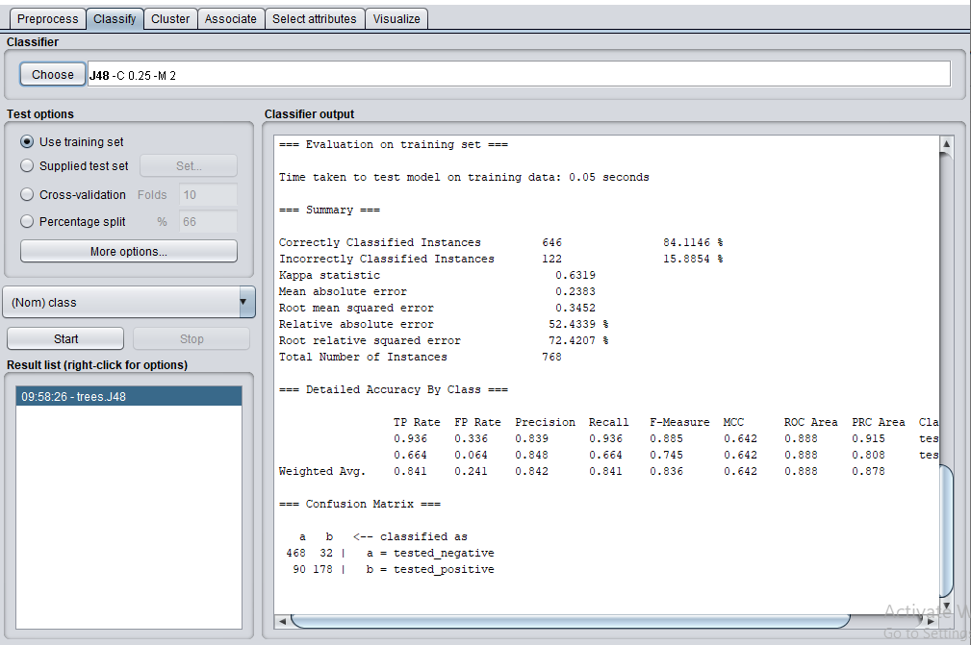

**Classification accuracy:**

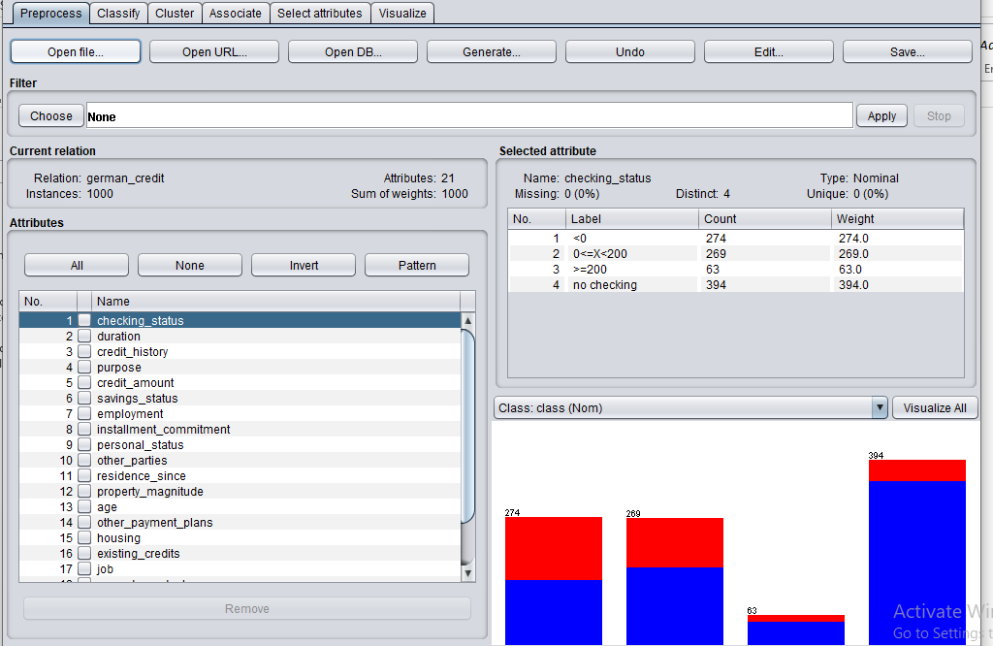

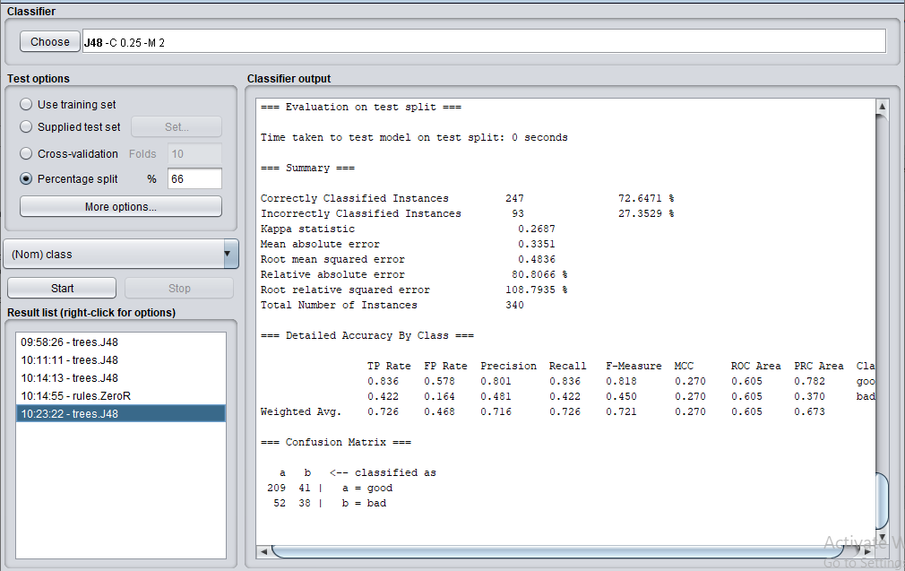

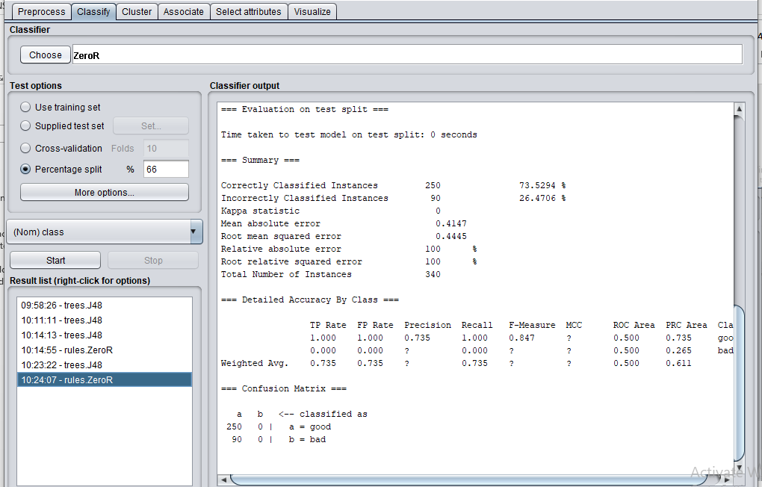

The zeror classifier is better than J48 as it have correctly classified instances

**OneR classifier:**

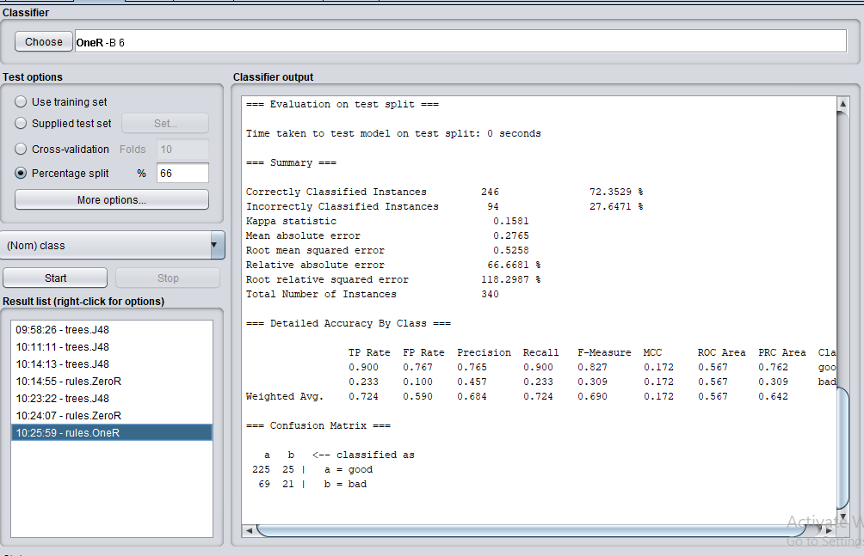

**JRip Classifier:**

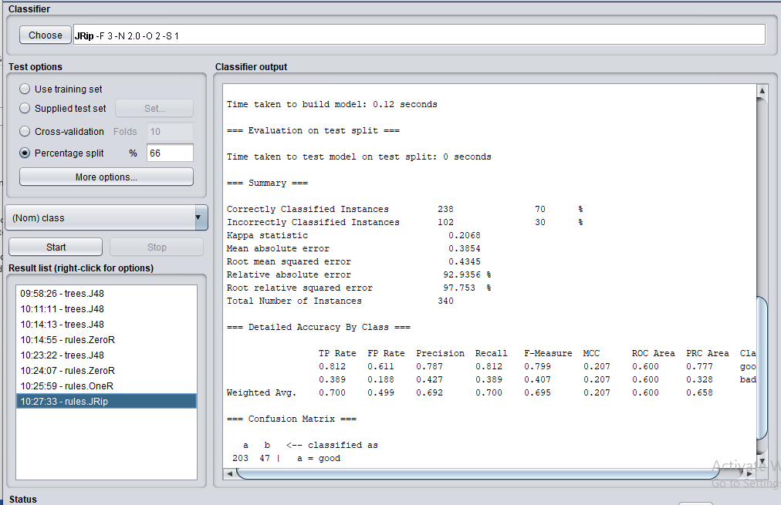

The result with OneR is the same as that of J48 but the result with JRip is less than J48, ZeroR and OneR.

