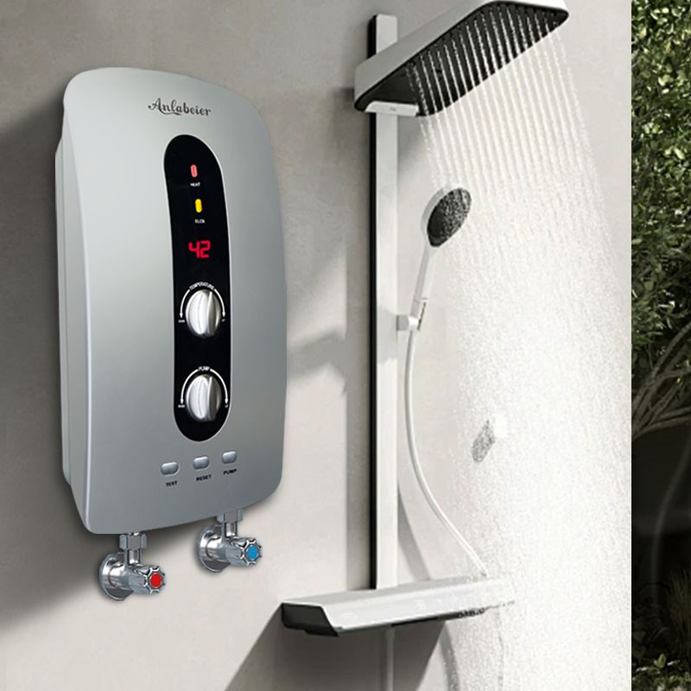
Digital temperature Heatar
Digital temperature Heatar
Price: 18,499
Key Features:
- Instant heating technology
- LED temperature indicator
- Anti-dry heating protection
- Suitable for low water pressure homes
- Long-lasting ABS outer body
Frame Colors: Classic Black, Golden Frame,
Wooden Brown, Matte White
Technical Specifications
Mounting | Wall-mounted
Heating Element | Pure Copper
Water Pressure | 0.02–0.6 Mpa
Power | 3000W
Voltage | 220-240V
Warranty | 2-3 Years

