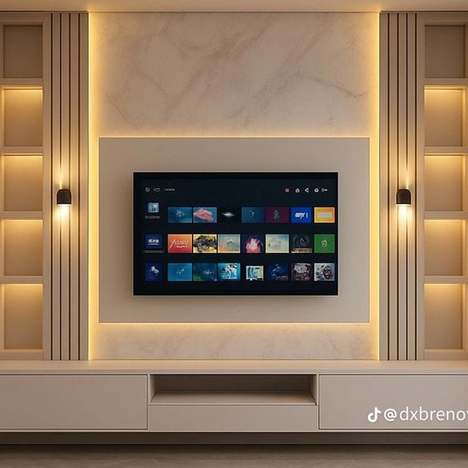
Smart Frame LED TV

Smart Frame LED TV
Price: Rs 89,999
Key Features:
- Art Mode (Digital Painting Display)
- Ultra Slim Body (2.5cm)
- 4k Ultra HD Resolution
- AI Picture Enhancement
Available Sizes: 43", 50", 55", 65"
Frame Colors: Classic Black, Golden Frame,
Wooden Brown, Matte White
Technical Specifications
Resolution | 3840×2160 (4K UHD)
Refresh Rate | 60Hz
HDMI | 3 | USB: 2
RAM | 2GB | Storage: 16GB
Bluetooth | 5.0
Warranty | 1 Year

