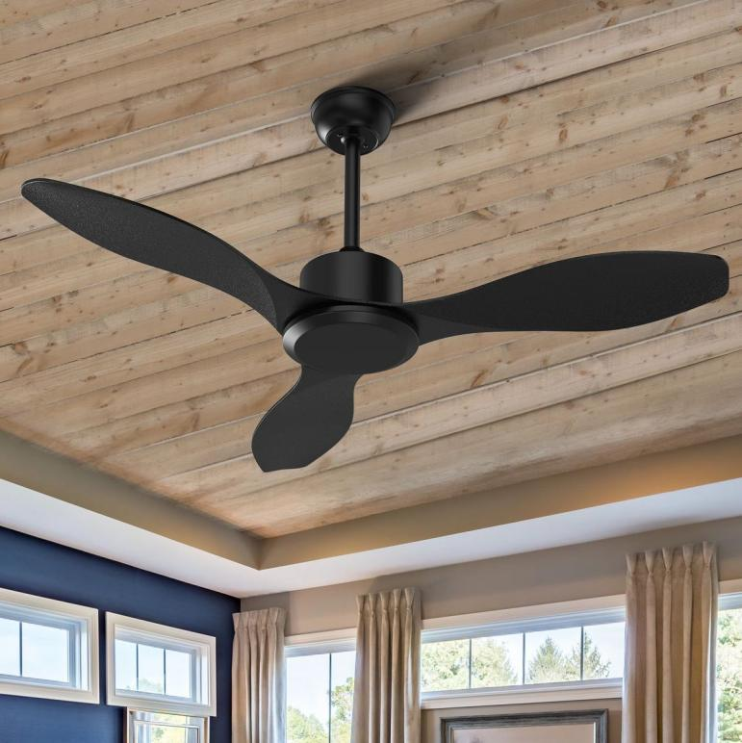
Wooden Blade Ceiling Fan
Wooden Blade Ceiling Fan
Price: 9,500
Key Features:
- Brushless energy-saving motor
- Ultra-quiet operation
- Decorative premium finish
- Low voltage start
- Remote control with 5 speed modes
Frame Colors: Classic Black, Golden Frame,
Wooden Brown, Matte White
Technical Specifications
Sweep Size | 48" / 56"
Motor | BLDC / Copper
RPM | 350–380
Power | 32W (BLDC) / 60W
Voltage | 140–260V
Warranty | 2-3 Years

