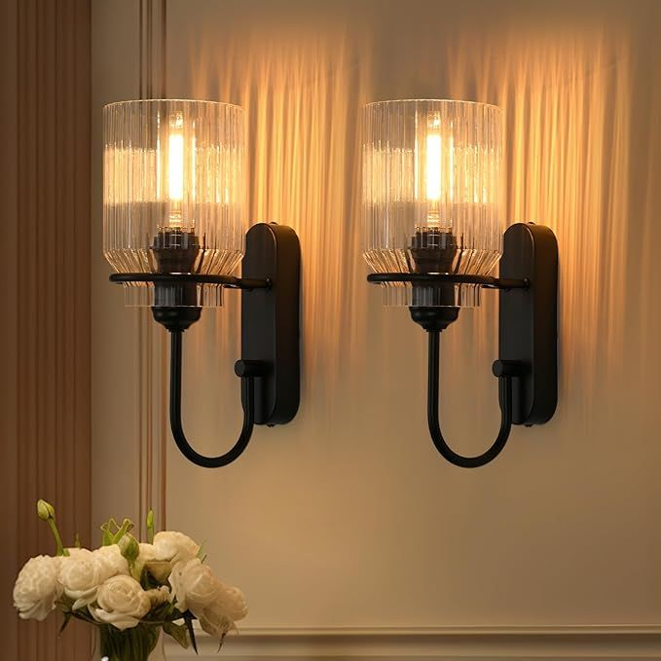
Modern Dual Glow Wall Light
Modern Dual Wall Light
Price: 6,499
Key Features:
- Art Elegant modern design suitable for outdoor walls
- Ultra Rain-proof and weather-resistant
- 4k Energy-efficient LED light
- AI Long-lasting durability
- Easy installation
Frame Colors: Classic Black, Golden Frame,
Wooden Brown, Matte White
Technical Specifications
Power 10W LED | 10W LED
Material | Aluminum & Glass
Color Temperature | 3000K Warm White
Voltage | 220-240V
IP Rating | IP65
Dimensions | 25cm x 15cm x 10cm

