Session-1

2.
Create a new Python file named hello_instagram.py in VS Code and write code to print 'Hello, Instagram World!' to the terminal.
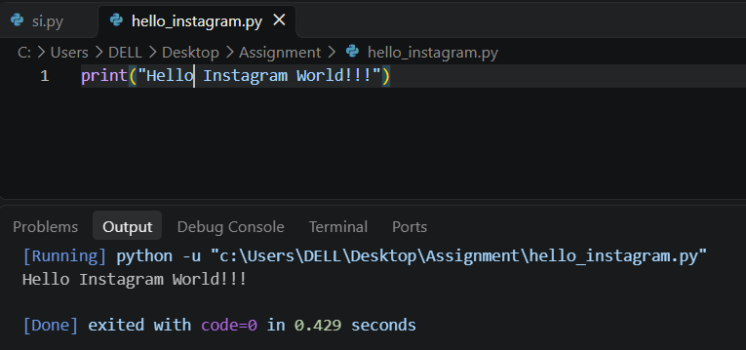
3.
Write a Python script called app_use_cases.py that prints three real-life apps you use daily and, for each, prints one way Python could be used in their backend or data analysis.
Code :
print("1. Instagram")
print("Python can be used to recommend posts and analyze user activity.")

print("\n2. Zomato")
print("Python can be used to analyze food orders and predict delivery times.")

print("\n3. Spotify")
print("Python can be used to recommend songs based on listening history.")
4.
Modify your hello_instagram.py script to print the Python version currently running your script.<br><br><em><strong>Hint:</strong> Use the sys module and sys.version.</em>
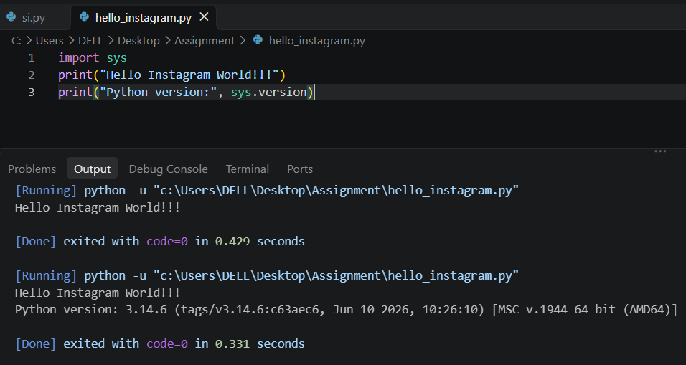

5.
Explain the difference between how Python executes code versus how C or Java executes code, using your own words and a simple example for each.
- Python: Python code is executed by the Python interpreter. Python uses bytecode internally, which is executed by the Python Virtual Machine (PVM).
- C: C code is compiled into machine code by a compiler before execution.
- Java: Java code is compiled into bytecode by the Java compiler, and the JVM (Java Virtual Machine) executes it.
1. Python Example
print("Hello World")
Execution: Write the code in a .py file and run it using the Python interpreter.
2. C Example
#include <stdio.h>

int main() {
printf("Hello World");
return 0;
}
Execution: First, compile the code using a C compiler, then run the generated executable file.
3. Java Example
class Hello {
public static void main(String[] args) {
System.out.println("Hello World");
}
}
Execution: Save the file as Hello.java, compile it using javac Hello.java, and run it using java Hello.

