Session-2

Question 1
Create variables to store details of a Flipkart product: product_name, price, is_available, and rating. Print each variable and its data type using the type() function.
Program
product_name = "Wireless Mouse"
price = 599.99
is_available = True
rating = 4.3

print(product_name, type(product_name))
print(price, type(price))
print(is_available, type(is_available))
print(rating, type(rating))
Sample Output
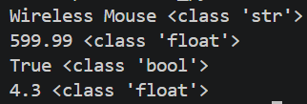

Question 2
Declare variables for a Zomato restaurant: restaurant_name, cuisine_type, average_cost, and is_open_now. Follow Python variable naming rules and print their values.
Program
restaurant_name = "Spice Garden"
cuisine_type = "North Indian"
average_cost = 450
is_open_now = True

print("Restaurant Name:", restaurant_name)
print("Cuisine Type:", cuisine_type)
print("Average Cost:", average_cost)
print("Open Now:", is_open_now)
Sample Output
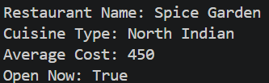

Question 3
Build a small snippet that creates three variables representing a Spotify playlist: playlist_title, number_of_songs, and is_public. Use the id() function to print the memory address of each variable.
Program
playlist_title = "Chill Vibes"
number_of_songs = 25
is_public = True

print("Address of playlist_title:", id(playlist_title))
print("Address of number_of_songs:", id(number_of_songs))
print("Address of is_public:", id(is_public))
Sample Output
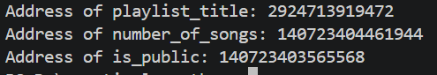

Question 4
Given the following variables for a YouTube video: title, views, likes, is_premium, identify which are primitive and which are non-primitive data types, and explain your reasoning in comments.
Program
title = "Python Tutorial for Beginners"
views = 1500000
likes = 85000
is_premium = False

# title -> str (text). A str is a basic, single value that stores
# text, so it is treated as a primitive data type.
# views -> int (whole number). Primitive, it stores one simple number.
# likes -> int (whole number). Primitive, it stores one simple number.
# is_premium -> bool (True or False). Primitive, it stores one
# simple True/False value.
#
# None of these variables is non-primitive. Non-primitive types
# such as list, tuple, set and dict can hold many values together,
# and none of these four variables does that.

print(type(title))
print(type(views))
print(type(likes))
print(type(is_premium))
Sample Output
