Session-3

Question 1
Write a Python script that asks the user for their name and favorite food using input(), then prints a welcome message like 'Hello Priya, your favorite food is Pizza!' using print().
Program
name = input("Enter your name: ")
food = input("Enter your favorite food: ")
print(f"Hello {name}, your favorite food is {food}!")
Output
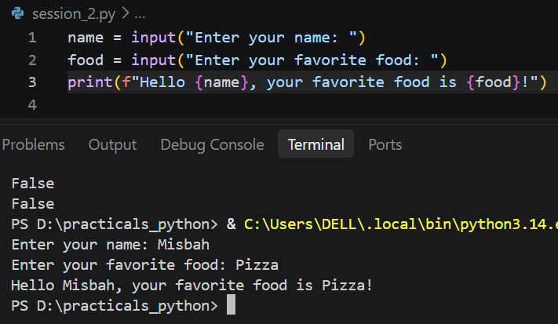

Question 2
Create a small program that takes two numbers as input (use input()), converts them to integers using int(), and prints their sum, difference, product, and quotient using print().
Hint: Remember to convert the input strings to integers before performing arithmetic operations.
Program
a = int(input("Enter first number: "))
b = int(input("Enter second number: "))

print("Sum:", a + b)
print("Difference:", a - b)
print("Product:", a * b)
if b != 0:
print("Quotient:", a / b)
else:
print("Quotient: cannot divide by zero")
Output
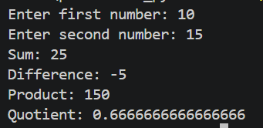

Question 3
Build a Zomato-style bill calculator: take the price of a food item and quantity as input, convert them to float and int, calculate the total bill, and display it with a message like 'Your total bill is ₹350.50'.
Program
price = float(input("Enter the price of the item (₹): "))
quantity = int(input("Enter the quantity: "))

total = price * quantity
print(f"Your total bill is ₹{total:.2f}")
Output
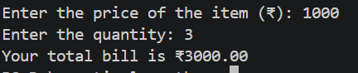

Question 4
Write a script that asks the user for their Instagram follower count, converts it to an integer, and prints the count in a formatted string like 'You have 1,500 followers'. Use escape characters to add a new line and tab before the output.
Hint: Use '\n' for new line and '\t' for tab in your print statement.
Program
followers = int(input("Enter your Instagram follower count: "))
print(f"\n\tYou have {followers:,} followers")
Output
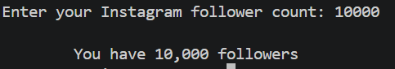

Question 5
Create a basic calculator program that takes two numbers and an operator (+, -, *, /) as input, performs the correct operation using typecasting, and prints the result. If the user enters an invalid operator, print an error message.
Program
num1 = float(input("Enter first number: "))
num2 = float(input("Enter second number: "))
op = input("Enter an operator (+, -, *, /): ")

if op == "+":
print("Result:", num1 + num2)
elif op == "-":
print("Result:", num1 - num2)
elif op == "*":
print("Result:", num1 * num2)
elif op == "/":
if num2 != 0:
print("Result:", num1 / num2)
else:
print("Error: division by zero is not allowed")
else:
print("Error: invalid operator. Please use +, -, * or /")
Output
