Step 1: Create database in Mongodb

You can watch any youtube video to download and install the mongodb

https://www.youtube.com/watch?v=KYIOJrE3zjk

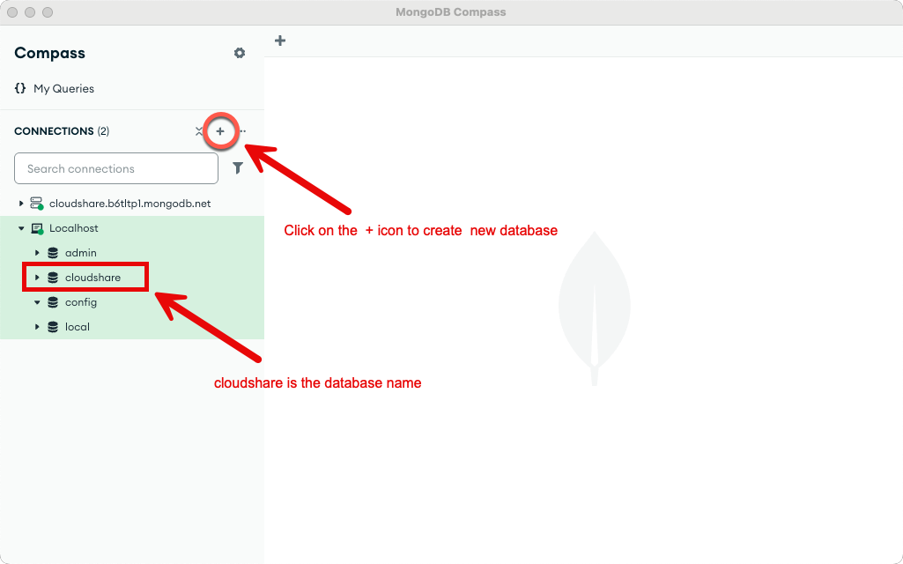

Step 2: Create a account in Clerk

Step 3: Create a new application

Step 4: Copy the CLERK_PUBLISHABLE_KEY, Frontend API URL, JWKS URL, Webhook Signing Secret

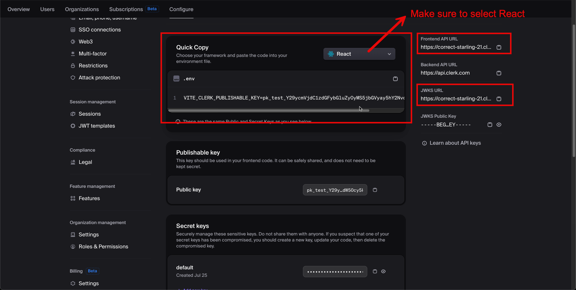

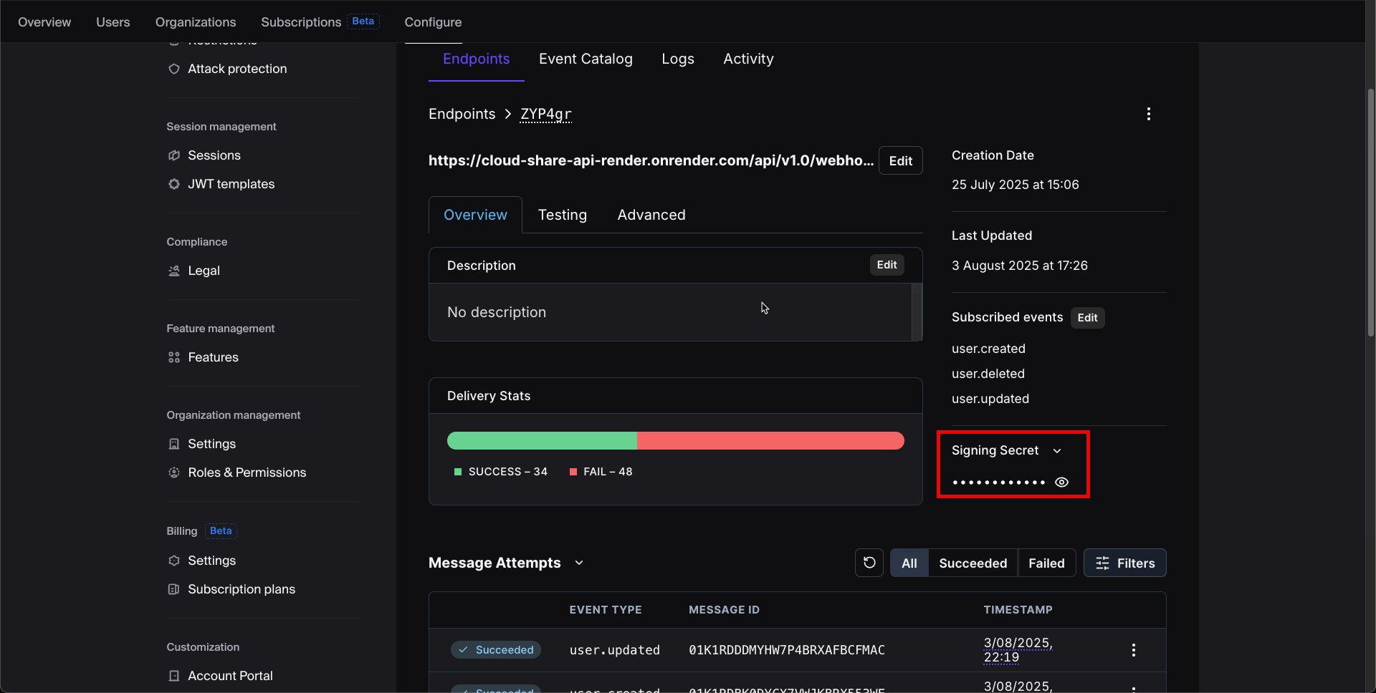

Step 5: Create a razor pay account and login to the razorpay account. Click on the profile settings. Create API keys and Note down the Key Id and Secret key
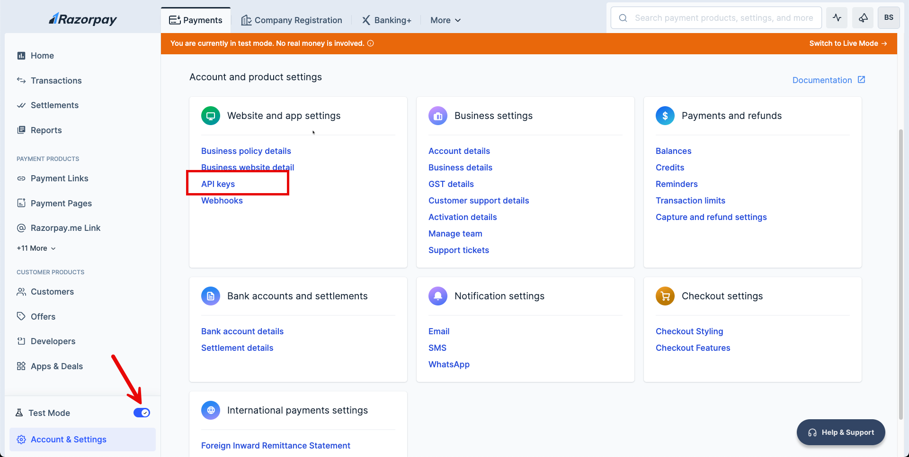

Step 6: Download the project and extract it. Open the backend api (cloudshareapi) in Intellij IDEA

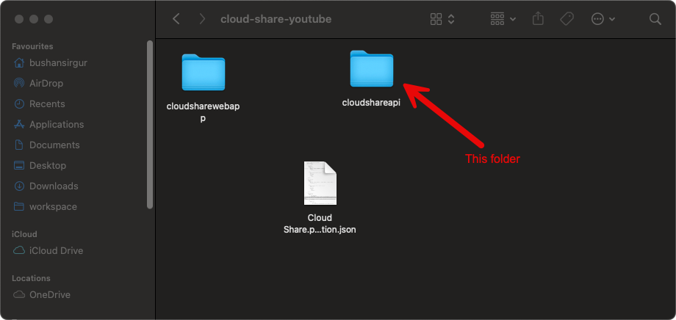

Step 7: Open application properties file and change the details as follows

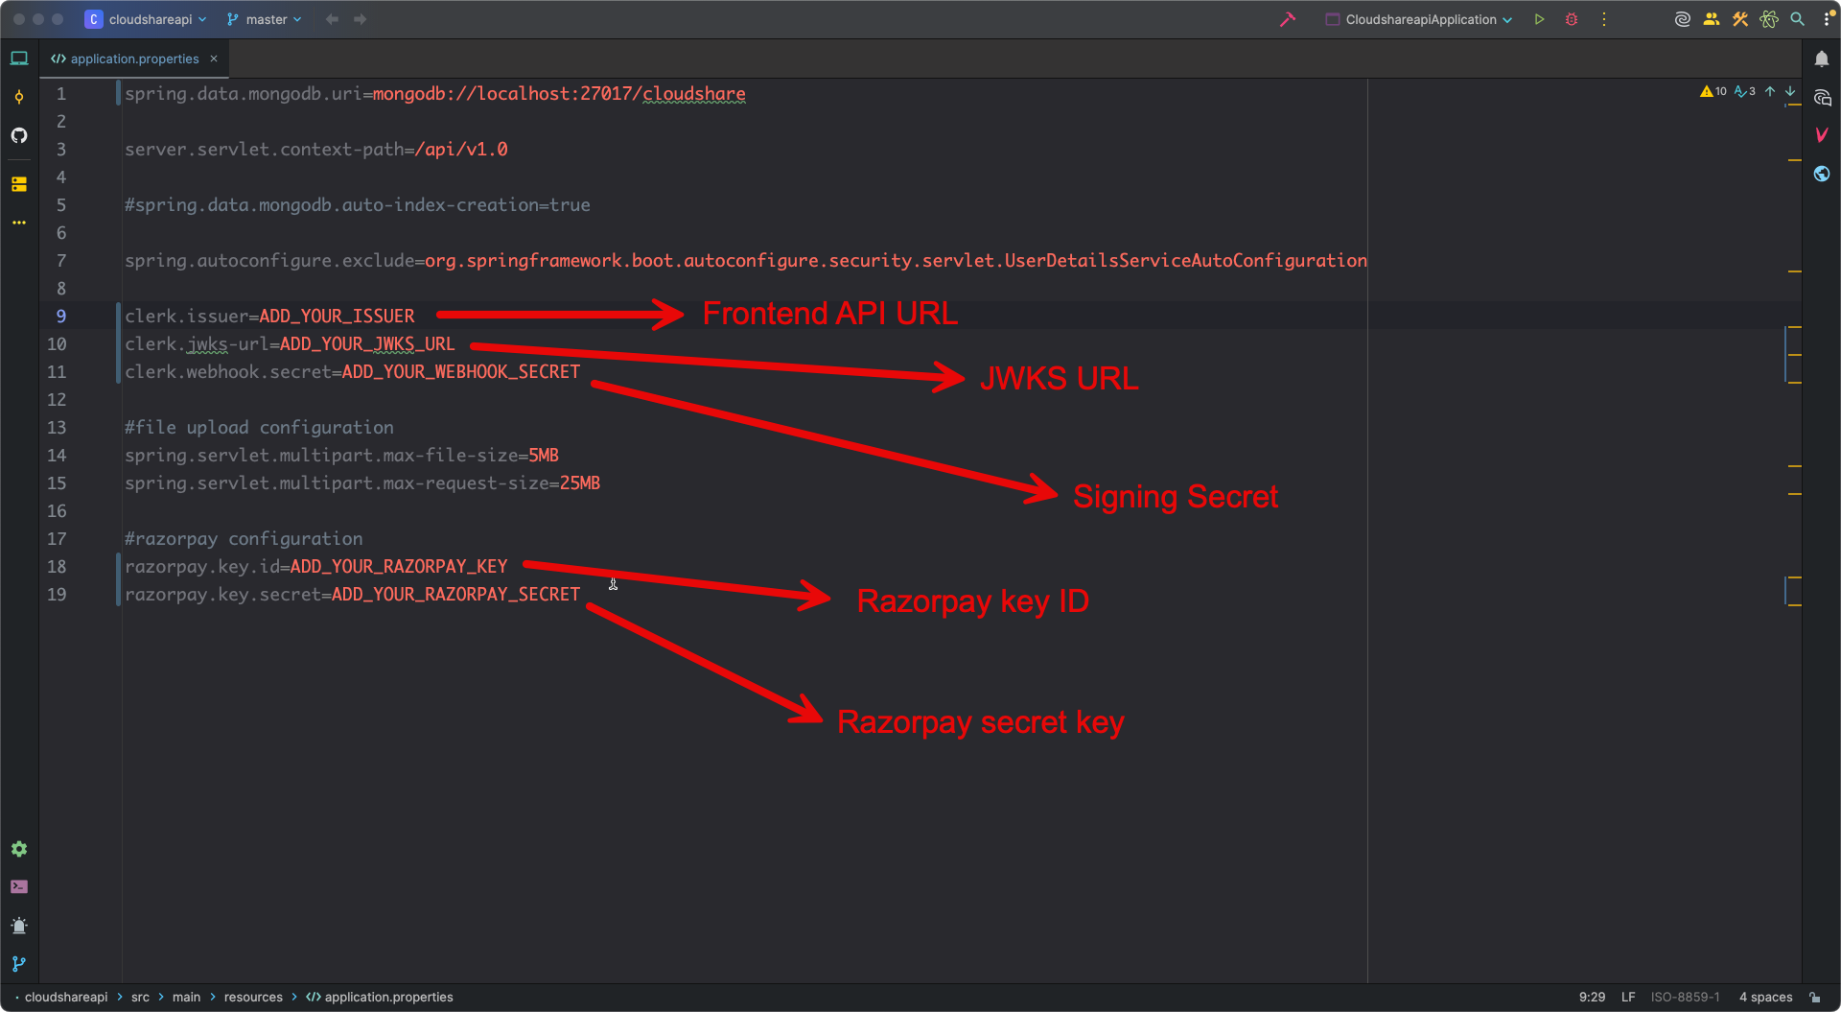

Step 8: Open CloudshareapiApplication java class and run the application

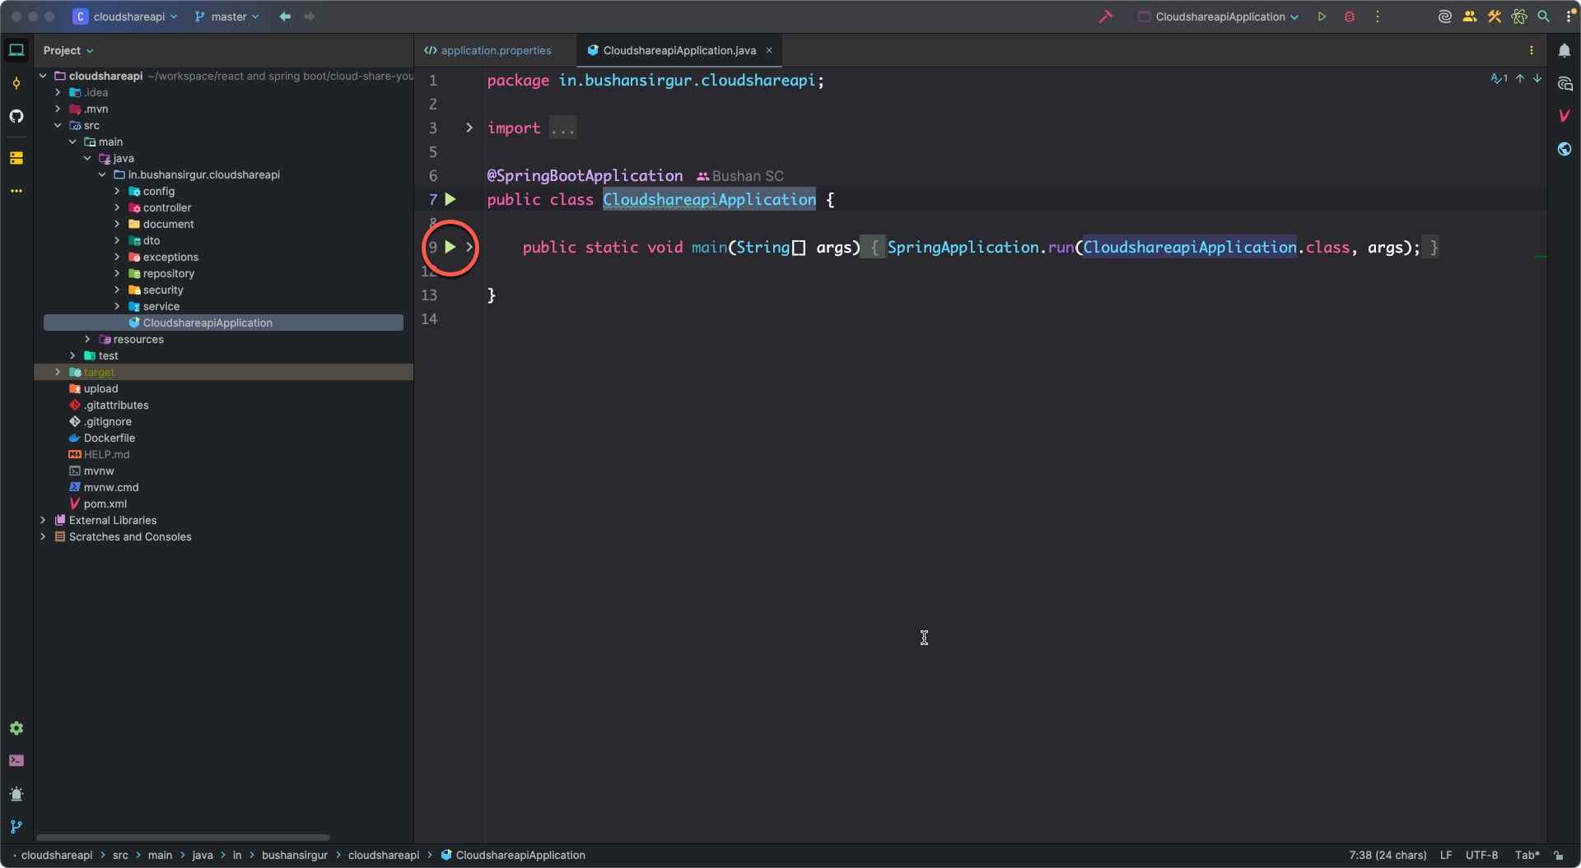

Step 9: Open the frontend application (cloudsharewebapp) in Visual studio code or Webstorm. Open .env file and change the details

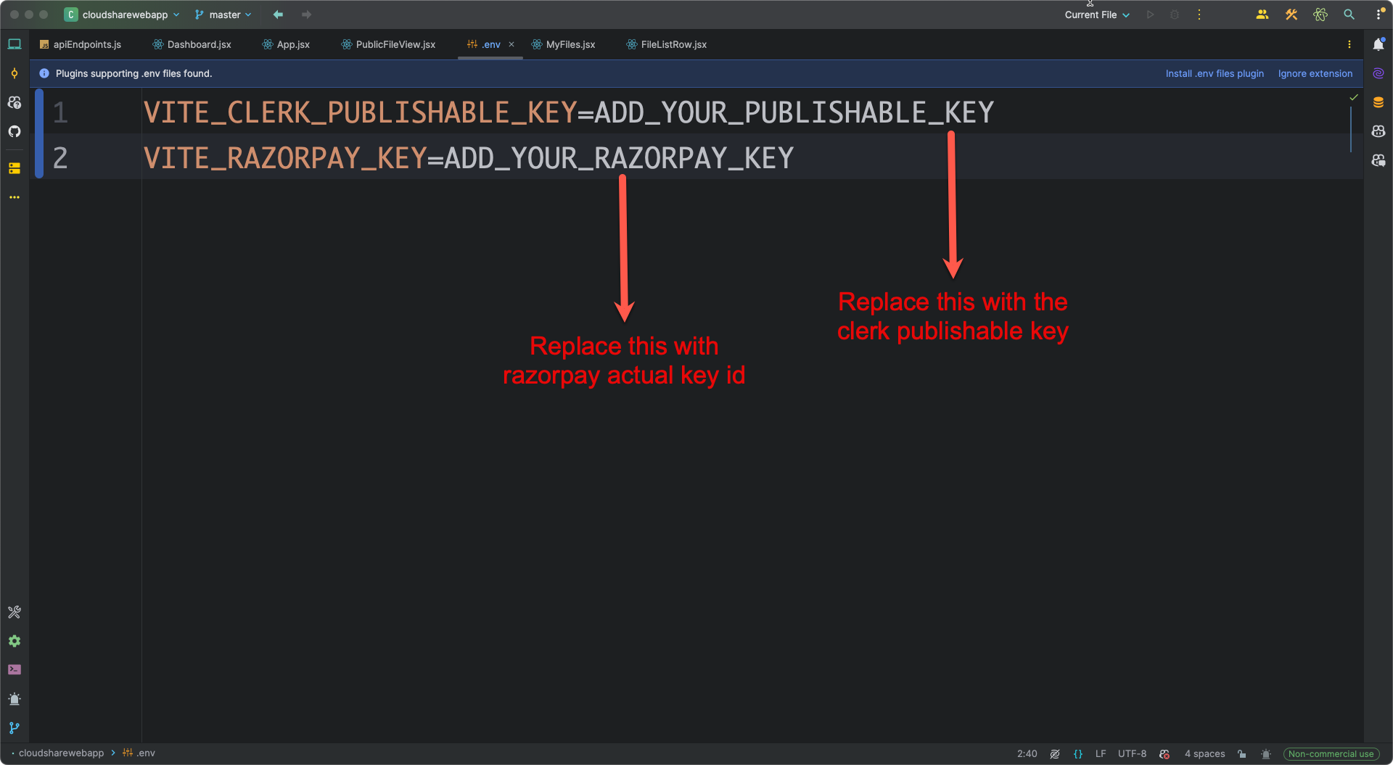

Step 10: Open terminal and go to the root of the directory execute the following command

npm install

Step 11: Run the frontend application

npm run dev

