Demonstrate Christian’s Method for Synchronizing Clocks – 16 Marks
1. Introduction
In a distributed system, every computer has its own local clock. These clocks may run at slightly different speeds due to clock drift, so the time shown by different computers may not be the same.
Clock synchronization is the process of making the clocks of different computers show approximately the same time.
Christian’s algorithm is a clock synchronization method in which a client synchronizes its clock with an accurate time server.

2. Basic Idea
Christian’s method works as follows:
- A computer is selected as the time server.
- The client sends a request asking for the current time.
- The server checks its clock and sends its current time to the client.
- The client calculates the round-trip time (RTT).
- The client assumes that the message takes approximately the same time in both directions.
- Therefore, the communication delay is estimated as RTT/2.
- The client adds this delay to the server's time and adjusts its clock.
Important assumption
The method assumes that the request and reply experience approximately equal network delays.

3. Neat Diagram of Christian’s Algorithm
Draw this diagram in the exam:
Request → Server gives time → Calculate delay → Add delay → Adjust clock

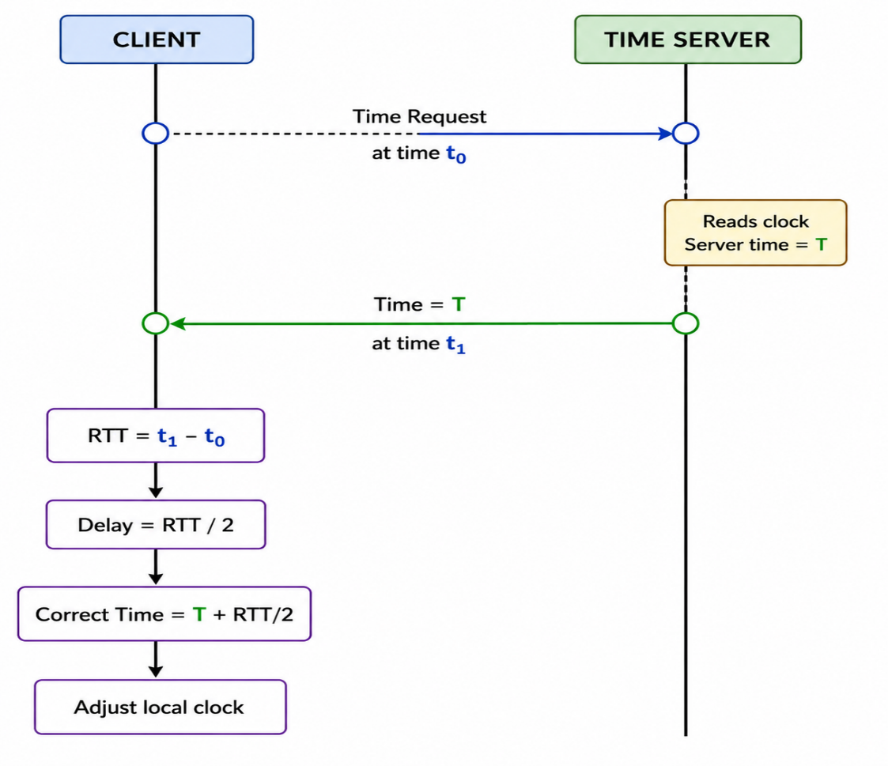

4. Steps of Christian’s Algorithm
Step 1: Select the Time Server
One computer is selected as the time server.
The time server should have a reasonably accurate clock.

Step 2: Client Sends a Request
The client sends a message to the time server asking for the current time.
The client records the time at which the request is sent.
Let:
t₀ = time at which the client sends the request
Client ────────────────> Time Server
Time Request

Step 3: Server Records Its Time
When the server receives the request, it reads its local clock.
Let:
T = time shown by the server
The server sends this time back to the client.
Client <──────────────── Time Server
T

Step 4: Client Receives the Reply
When the client receives the reply, it records the time.
Let:
t₁ = time at which the client receives the reply
Now the client can calculate the Round Trip Time (RTT).
Formula:
RTT = t₁ − t₀

Step 5: Calculate Network Delay
Christian’s algorithm assumes that the request and reply take approximately equal time.
Therefore:
Network Delay = RTT / 2

Step 6: Calculate the Correct Time
The estimated correct time at the client is:
Correct Time = T + RTT/2
Where:
- T = time received from the server
- RTT = round-trip time
- RTT/2 = estimated one-way network delay

Step 7: Adjust the Client Clock
The client compares the calculated correct time with its current clock.
- If the client clock is behind, it advances the clock.
- If the client clock is ahead, it adjusts the clock appropriately.
Thus, the client becomes approximately synchronized with the time server.

5. Numerical Example
Consider the following situation:
- Client sends request at 10:00:05
- Server sends its time as 10:00:10
- Client receives the reply at 10:00:09
Step 1: Calculate RTT
RTT = t₁ − t₀
RTT = 10:00:09 − 10:00:05
RTT = 4 seconds

Step 2: Calculate Network Delay
Delay = RTT / 2
Delay = 4 / 2 = 2 seconds

Step 3: Calculate Correct Time
Correct Time = Server Time + Delay
= 10:00:10 + 2 seconds
= 10:00:12
Therefore, the client should adjust its clock to approximately:
10:00:12

6. Working Diagram with Numerical Example
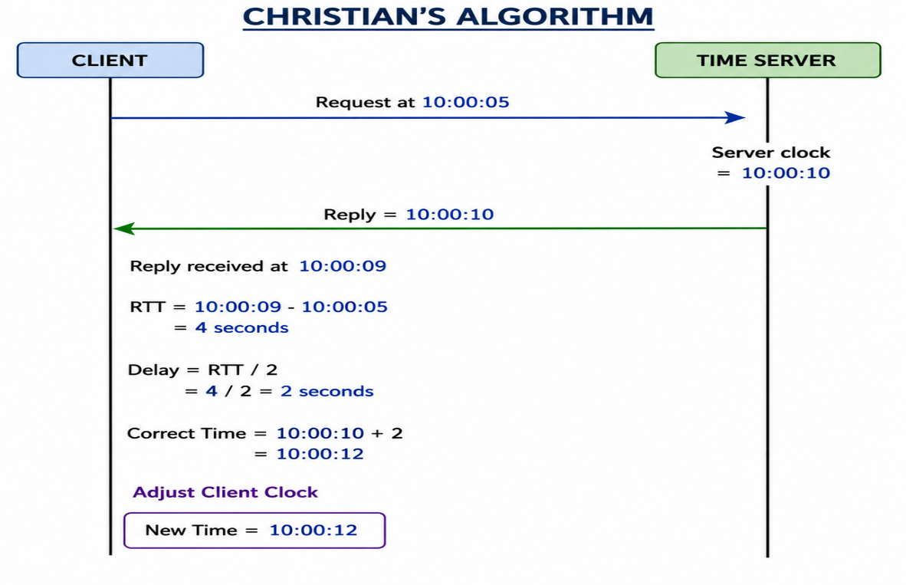

7. Pseudocode
Christian's Algorithm
1. Client records t₀.
2. Client sends a time request to the server.
3. Server reads its clock T.
4. Server sends T to the client.
5. Client records t₁.
6. Calculate RTT = t₁ − t₀.
7. Calculate delay = RTT / 2.
8. Calculate correct time = T + delay.
9. Adjust the client clock to the correct time.

8. Advantages
- Simple and easy to implement.
- Uses a time server to provide a common reference time.
- Takes network communication delay into account.
- Provides reasonably accurate synchronization when network delay is small.
- Easy to understand and suitable for many distributed applications.

9. Limitations
- It depends on the time server.
- If the time server fails, synchronization may be affected.
- It assumes that message delays are approximately equal in both directions.
- Network congestion can cause inaccurate synchronization.
- Variable network delays reduce the accuracy of the algorithm.
- A heavily used time server can become a bottleneck.

10. Conclusion
Christian’s algorithm is a simple and effective method for clock synchronization in distributed systems. It uses a time server as the reference and estimates the network delay as half of the round-trip time. The client then adds this delay to the server's time and adjusts its local clock.
2)Elaborate Logical Time and Logical Clocks
1. Introduction
In a distributed system, there is no single global clock shared by all computers. Each process has its own physical clock, and these clocks may not show exactly the same time.
Therefore, it is difficult to determine which event happened before another event by using physical time alone.
To solve this problem, distributed systems use logical time and logical clocks.
- Logical time represents the ordering of events in a distributed system.
- Logical clock is a mechanism used to assign numbers (timestamps) to events so that their ordering can be determined.

2. Logical Time
Definition
Logical time is a numerical representation used to determine the relative ordering of events in a distributed system.
It does not represent actual clock time such as 10:00 AM. Instead, it tells us whether one event occurred before, after, or concurrently with another event.
Example
Consider three processes:
Here:
Event A → Event B → Event C
So, logical time helps us represent this ordering even if the physical clocks of P1, P2, and P3 are different.

3. Need for Logical Time
Logical time is required because:
- There is no global clock in a distributed system.
- Physical clocks may have different values.
- Network message delays are unpredictable.
- It is difficult to identify the order of events using physical time.
- It helps identify causal relationships between events.
- It helps maintain proper message ordering.
- It is useful in distributed mutual exclusion, deadlock detection, distributed databases, and debugging.

4. Logical Clock
Definition
A logical clock is a software-based clock used in distributed systems to assign a timestamp to each event.
The timestamp does not represent the actual time. It represents the logical ordering of events.
The main objective is:
If event A causally occurs before event B, the timestamp of A must be smaller than the timestamp of B.
This relationship is represented as:
A→B
Then,
C(A)<C(B)​
where C(A) and C(B) are the logical clock values of events A and B.

5. Happened-Before Relationship
The happened-before relation, denoted by →, was introduced by Leslie Lamport.
It defines the causal ordering of events in a distributed system.
Rules
Rule 1: Events within the same process
If event A occurs before event B in the same process:
A→B
Example:
P1:

A ───────> B
Therefore:
A→B

Rule 2: Message transmission
If a process sends a message and another process receives it:
Send(m)→Receive(m)

Example:
P1 P2
│ │
│── Send(m) ──────────────>│
│ │
│ Receive(m)
The sending event always happens before the receiving event.

Rule 3: Transitivity
If:
A→B and B→C then: A→C​
This is called the transitive property.

6. Logical Clock Rules
The most common logical clock is the Lamport logical clock.
Each process maintains a counter.
Rule 1 – Before every event
Before executing an event, the process increments its logical clock:
Ci​=Ci​+1

Rule 2 – Sending a message
When a process sends a message, it attaches its current logical clock value to the message.
Message = (m, timestamp)

Rule 3 – Receiving a message
When a process receives a message with timestamp T, it updates its clock as:
Cj​=max(Cj​,T)+1
This ensures that the receiving event has a timestamp greater than the sending event.

7. Diagram of Logical Clock
LOGICAL CLOCKS
LOGICAL CLOCKS

P1 P2
│ │
C1=1 C2=1
│ │
│─── m (timestamp=2) ────>│
│ │
C1=2 max(1,2)+1
│ │
│ C2=3
│ │
▼ ▼
Send(m) Receive(m)

Explanation
- P1's clock becomes 2.
- P1 sends message m with timestamp 2.
- P2 receives the message.
- P2's old clock is 1.
- P2 calculates:
C2​=max(1,2)+1=3
Therefore:
Send(m) timestamp = 2
Receive(m) timestamp = 3
Hence:
2<3
So the logical clock correctly represents the causal ordering.

8. Example of Logical Time
Consider three processes:
P1 P2 P3
│ │ │
│ │ │
(1) (1) (1)
│ │ │
│─── m1 (2) ─────────> │ │
│ │ │
│ (3) │
│ │─── m2 (4) ── ───>│
│ │ │
│ │ (5)
▼ ▼ ▼
Step-by-step
Initially:
P1 = 0
P2 = 0
P3 = 0
P1 performs an event:
P1=1
P1 performs another event and sends m1:
P1=2
The message contains timestamp 2.
P2 receives it:
P2=max(0,2)+1=3
P2 sends another message:
P2=4
P3 receives it:
P3=max(0,4)+1=5
Therefore:
P1(2)→P2(3)→P2(4)→P3(5)​
The logical timestamps represent the causal order of events.

9. Types of Logical Clocks
There are two important categories of logical clocks:
1. Lamport Logical Clock
- Uses a single integer timestamp.
- Provides a partial ordering of events.
- Simple and efficient.
- Does not completely identify concurrent events.
2. Vector Clock
- Uses a vector of timestamps.
- Each process maintains a vector.
- Provides more information about causal relationships.
- Can identify whether two events are concurrent.
Comparison
Feature | Lamport Clock | Vector Clock
Timestamp | Single integer | Vector
Complexity | Simple | More complex
Causality | Represents causal order | Represents causal order more precisely
Detect concurrency | Cannot reliably detect it | Can detect it
Storage | Low | Higher

10. Advantages of Logical Clocks
- Provides ordering of events without requiring a global clock.
- Helps identify causal relationships.
- Works effectively in asynchronous distributed systems.
- Useful for message ordering.
- Helps in distributed mutual exclusion.
- Useful in distributed debugging and event tracking.
- Does not depend on synchronized physical clocks.

11. Limitations
- Logical clocks do not represent actual physical time.
- Lamport clocks cannot determine all concurrent events.
- Maintaining vector clocks requires more storage.
- Logical timestamps depend on communication and event relationships.
- They cannot directly tell the actual elapsed time between two events.

12. Applications
Logical clocks are used in:
- Distributed mutual exclusion
- Distributed databases
- Distributed deadlock detection
- Message ordering
- Distributed debugging
- Replication systems
- Causal consistency
- Event ordering

3)Elaborate Any Two Logical Clock Categories in Distributed Systems with an Example
1. Introduction
In a distributed system, several processes execute independently on different computers. There is no common physical clock that can accurately determine the order of events occurring in all processes.
Therefore, logical clocks are used to assign a logical timestamp to each event. They help determine the ordering and causal relationship between events in a distributed system.
The two important categories of logical clocks are:
- Lamport Logical Clock
- Vector Clock

2. Lamport Logical Clock
Definition
A Lamport Logical Clock is a logical clock that assigns a single integer value to each event in a distributed system.
It was introduced by Leslie Lamport.
Its main purpose is to determine the ordering of events based on their causal relationship.
If event A happens before event B, then:
L(A) < L(B)
where L(A) and L(B) are the Lamport timestamps of events A and B.

3. Rules of Lamport Logical Clock
Each process maintains a counter.
Rule 1: Local Event
Before performing an event, the process increments its clock by 1.
C = C + 1
Rule 2: Sending a Message
Before sending a message, the sender increments its clock and attaches the timestamp to the message.
Message = (Message, Timestamp)
Rule 3: Receiving a Message
When a process receives a message with timestamp T, it updates its clock as:
C = max(C, T) + 1
This ensures that the receive event always gets a larger timestamp than the send event.

- Diagram of Lamport Logical Clock

PROCESS P1 PROCESS P2
│ │
│ │
Event A │
Clock = 1 │
│ │
│ │
Event B │
Clock = 2 │
│ │
│ │
│──── Message (2) ───────────>│
│ │
│ │ Receive
│ │
│ │ max(1,2)+1
│ │ = 3
│ │
▼ ▼
Explanation
- P1 performs Event A → clock becomes 1.
- P1 performs Event B → clock becomes 2.
- P1 sends a message with timestamp 2.
- P2 receives the message.
- P2's previous clock value is 1.
- P2 calculates:
max(1,2) + 1 = 3
Therefore:
Send event = 2
Receive event = 3
Hence, the send event occurred before the receive event.

- Example of Lamport Clock
Consider two processes P1 and P2.
P1 P2
│ │
│ Event A │
│ L = 1 │
│ │
│ Event B │
│ L = 2 │
│ │
│────── m(2) ─────────────────>│
│ │
│ │ Event C
│ │ L = 3
│ │
│ │ Event D
│ │ L = 4
▼ ▼
The ordering is:
A → B → C → D
Therefore:
1 < 2 < 3 < 4
Thus, Lamport clocks help to maintain the logical ordering of events.

6. Advantages of Lamport Clock
- It is simple and easy to implement.
- It requires only one integer counter for each process.
- It requires less memory.
- It helps maintain the ordering of events.
- It is useful in distributed mutual exclusion.
- It can be used for message ordering.

7. Limitation of Lamport Clock
The major limitation is that Lamport clocks cannot accurately identify concurrent events.
If:
L(A) < L(B)
we cannot always say that A caused B.
Therefore, Lamport clocks provide less information about causal relationships.
To overcome this limitation, Vector Clocks are used.

8. Vector Clock
Definition
A Vector Clock is a logical clock that uses a vector of integers instead of a single integer.
If there are n processes, each process maintains an n-element vector.
For example, for three processes:
P1, P2, P3
the vector contains three values:
[P1, P2, P3]
Each position represents the number of events known from that process.

9. Rules of Vector Clock
Rule 1: Local Event
When a process performs an event, it increments its own position.
Initially:
P1 = [0,0,0]
After one event at P1:
P1 = [1,0,0]

Rule 2: Sending a Message
Before sending a message, the process increments its own component and attaches the complete vector to the message.
Example:
P1 = [2,0,0]
The message contains:
Message = [2,0,0]

Rule 3: Receiving a Message
When a process receives a message, it takes the maximum value of each corresponding position and then increments its own position.
For example:
Receiver = [0,1,0]
Message = [2,0,0]
First take maximum:
max([0,1,0], [2,0,0])
↓
[2,1,0]
The receiver's own position is already represented in the maximum operation, so the resulting vector is:
[2,1,0]

10. Diagram of Vector Clock

PROCESS P1 PROCESS P2
│ │
│ [1,0] │ [0,0]
│ │
│ [2,0] │
│ │
│──── Message [2,0] ─────────>│
│ │
│ │ Receive
│ │
│ │ Current = [0,0]
│ │ Message = [2,0]
│ │
│ │ max = [2,0]
│ │
│ │ Increment P2
│ │
│ │ [2,1]
▼ ▼

11. Example of Vector Clock
Consider three processes:
P1, P2 and P3
Initially:
P1 = [0,0,0]
P2 = [0,0,0]
P3 = [0,0,0]
Step 1: Event at P1
P1 = [1,0,0]
Step 2: Another event at P1
P1 = [2,0,0]
Step 3: P1 sends a message to P2
The message carries:
[2,0,0]
Step 4: P2 receives the message
P2 currently has:
[0,0,0]
Compare the vectors:
max([0,0,0], [2,0,0])
Result:
[2,0,0]
Now P2 increments its own position:
P2 = [2,1,0]
This means P2 knows about the two events that occurred at P1 and has performed one event itself.

12. Detecting Concurrent Events
One major advantage of Vector Clocks is that they can identify concurrent events.
Suppose:
Event A = [2,1]
Event B = [1,2]
Compare them:
A = [2,1]
B = [1,2]
- A is greater than B in the first position.
- B is greater than A in the second position.
Therefore, neither vector is completely smaller than the other.
Hence:
A || B
This means A and B are concurrent events.
Simple meaning
Concurrent events are events that occur independently, where neither event has caused the other.

13. Advantages of Vector Clock
- It provides more accurate causal information.
- It can detect concurrent events.
- It helps identify the relationship between distributed events.
- It is useful for causal consistency.
- It is useful in replicated and distributed databases.
- It helps in conflict detection.

14. Limitations of Vector Clock
- It requires more memory than Lamport clocks.
- The size of the vector increases as the number of processes increases.
- It has higher communication overhead.
- It is more complex to implement than Lamport clocks.

15. Lamport Clock vs Vector Clock
Feature | Lamport Clock | Vector Clock
Timestamp | Single integer | Vector of integers
Example | 5 | [2,1,0]
Complexity | Simple | More complex
Memory | Less | More
Causal ordering | Yes | Yes
Detect concurrency | No | Yes
Communication overhead | Low | Higher
Main purpose | Event ordering | Causality and concurrency

16. Applications
Logical clocks are used in:
- Distributed databases
- Distributed mutual exclusion
- Message ordering
- Replicated databases
- Distributed debugging
- Causal consistency
- Conflict detection
- Distributed event tracking

17. Conclusion
Lamport and Vector clocks are important logical clock mechanisms used in distributed systems.
Lamport Clock uses a single integer to determine the logical ordering of events. It is simple and requires less memory.
Vector Clock uses a vector of integers to provide detailed information about causal relationships and can also identify concurrent events.
4)Algorithm Using Multicast and Logical Clocks for Mutual Exclusion
1. Introduction
In a distributed system, several processes may request access to the same critical section at the same time.
Mutual exclusion ensures that only one process enters the critical section at a time.
The Ricart–Agrawala algorithm is a distributed mutual exclusion algorithm that uses:
- Logical clocks to order requests.
- Multicast to send requests to all other processes.
- Reply messages to give permission to enter the critical section.

2. Basic Idea
Suppose there are three processes:
P1
/ \
/ \
▼ ▼
P2 ◄──► P3
If P1 wants to enter the critical section, it:
- Increases its logical clock.
- Multicasts a REQUEST message to P2 and P3.
- P2 and P3 compare the timestamp of P1's request with their own requests.
- They send REPLY to P1 if P1's request has priority.
- P1 waits for replies from all other processes.
- After receiving all replies, P1 enters the critical section.
- After leaving, P1 sends replies to any waiting processes.

3. Algorithm
Step 1: Requesting the Critical Section
When process Pi wants to enter the critical section:
LCi = LCi + 1
It creates a request:
REQUEST(timestamp, process_id)
Then it multicasts the request to every other process.
Diagram
REQUEST(5,P1)
┌──────────────────► P2
│
│
P1
│
└──────────────────► P3

P1 wants Critical Section
Logical Clock = 5

4. Step 2: Receiving a Request
When another process receives the REQUEST:
- It updates its logical clock.
- It compares the received request with its own request.
- Requests are ordered using:
(timestamp, process ID)
The request with the smaller timestamp gets priority.
For example:
P1 → REQUEST(5,P1)
P2 → REQUEST(8,P2)

Since 5 < 8,

P1 gets priority.

5. Step 3: Sending REPLY
If the receiving process is not inside the critical section and the received request has higher priority, it immediately sends:
REPLY
Example:
REQUEST
┌───────────────► P2
│ │
│ │ REPLY
│ ▼
P1 ◄───────────────┘

REQUEST
┌───────────────► P3
│ │
│ │ REPLY
│ ▼
P1 ◄───────────────┘

6. Step 4: Entering the Critical Section
P1 does not enter immediately after sending the request.
It waits until it receives REPLY from every other process.
For three processes:
P1 waits for:

REPLY from P2 ✓
REPLY from P3 ✓
After receiving both replies:
┌─────────────────────┐
│ CRITICAL SECTION │
│ P1 │
└─────────────────────┘
Therefore, P1 can safely access the shared resource.

7. Step 5: Leaving the Critical Section
After completing its work, P1 leaves the critical section.
If some other process has requested access while P1 was inside the critical section, P1 sends the required REPLY to that waiting process.
P1
│
│ leaves CS
▼
Send pending REPLY
│
▼
Next process enters

8. Complete Diagram
This is the main diagram you can draw in the exam:
DISTRIBUTED MUTUAL EXCLUSION

P1 P2
│ │
│ REQUEST(5,P1) │
├─────────────────────────►│
│ │
│ │
│ REQUEST(5,P1) │
├────────────────────────────────► P3
│ │ │
│ │ │
│◄──────── REPLY ──────────┤ │
│ │ │
│◄────────────────────── REPLY ─────┤
│ │
▼ │
┌───────────────┐ │
│ CRITICAL │ │
│ SECTION │ │
│ P1 │ │
└───────┬───────┘ │
│ │
│ Leave Critical Section │
▼ │
Send pending replies

9. Role of Multicast
Multicast is used to send the REQUEST message from one process to all other processes.
For example:
REQUEST
┌─────┴─────┐
▼ ▼
P2 P3
▲ ▲
└─────┬─────┘
P1
So, multicast makes sure that all processes know about the request.

10. Role of Logical Clocks
Logical clocks are used to decide the order of requests.
Example:
P1 → REQUEST(5,P1)
P2 → REQUEST(8,P2)
Since:
5 < 8
P1's request is considered earlier and gets priority.
Thus:
Logical clock = determines the order of requests.
Multicast = distributes the request to all processes.
REPLY = gives permission to enter the critical section.

11. Advantages
- No central coordinator is required.
- Logical clocks provide an ordering of requests.
- Multicast informs all processes about a request.
- Ensures mutual exclusion.
- Provides fair access according to request order.
12. Disadvantages
- Many messages are exchanged.
- If a process fails, other processes may wait for its reply.
- Network delay can increase waiting time.
5.same question in unit 1(Design the Procedure for Causality in an Asynchronous Execution with a Suitable Example)

