AI-Driven Vertical Farming: An Intelligent System for Optimized Crop Growth Using TabNet and Self-Supervised Visual Diagnosis
Misbha Arif, Ahsan Raza Shah, Arooba Wasim
Department of Computer Engineering, COMSATS University Islamabad, Islamabad, Pakistan
Supervisor: Dr. Mohsin Riaz | Co-Supervisor: Mr. Tayyab Rasul

Abstract—While vertical farming is a promising solution to the escalating global food security crisis in a scalable and weather-dependent manner, most available vertical farming systems are either manually controlled or limitedly automated with simple reactive rules which are incapable of adapting to the needs of crops and growth stages. Vertical farming is a scalable solution to the food security challenge that can grow food in a weather independent manner, but most vertical farming systems available in the market are either manually operated or limitedly automated with simple reactive rules which are not capable to adapt to the requirement of the crops and the growth stages. In this paper, an AI-based vertical farming system for the integration of distributed embedded sensing, cloud connectivity, and two machine learning models into a single closed-loop system is presented, designed, implemented, and evaluated. The data from each microcontroller is transmitted to a Raspberry Pi 5 via separate UART links, with each individual microcontroller continuously measuring and reporting temperature, humidity, soil NPK/pH, light, air-quality and water-level data within its respective growing tray. A set-point control loop based on proportional-integral actuators is used to implement a TabNet model trained on the Crop Recommendation Dataset which sets the optimal environmental conditions for a given crop. Simultaneously, a self-supervised visual diagnosis pipeline based on SimCLR contrastive pretraining and K-Means clustering with MobileNetV3-Small fine-tuning produces diagnostic images of leaves into seven plant-health classes with a 84.95% test accuracy and macro-average F1-score of 0.8482. A rule-based sensor gate (70:30 ratio) is incorporated with the visual prediction to resolve visually ambiguous nutrient-deficiency cases. The data from all sensors, the AI output and the operator settings are synchronized via Firebase Realtime Database to a React Web dashboard. The full prototype confirms the ability of low-cost embedded hardware and self-supervised edge AI to implement a predictive, diagnostic vertical farming system without manual labelling or expensive commercial vertical farms.
Index Terms—vertical farming, TabNet, self-supervised learning, SimCLR, MobileNetV3, IoT, precision agriculture, edge AI.
I. INTRODUCTION
The world population is projected to grow to 9.7 billion by 2050, necessitating a 70% rise in food production as arable land, fresh water, and reliable growing season become ever more limited due to climate change and the growth of urban areas [1]. Vertical farming overcomes this by growing crops inside in stacked trays, which are grown in controlled environments with no dependence on weather conditions, lessen land use, recycle water, and allow for crops to be grown in places that would not normally be used for farming in a rooftop or repurposed warehouse, for example. The complexity of providing a range of temperature, humidity, CO₂ and light that is specific to the crop, in addition to the considerable energy required for artificial lighting and climate control, however, makes it hard to run vertical farms efficiently. Most commercial deployments are in the form of either manual-supervised farms (labor-intensive, slow to respond) or rule-based automated farms (reactive to threshold violation but unable to predict needs or adapt to growth stages of a crop) [3]. AI fills this gap by predicting the environmental needs before the plant becomes stressed, and by visually detecting plant stress that a human operator may miss. In this paper, an end-to-end AI-based vertical farming prototype is presented that combines (i) a distributed embedded sensing layer, (ii) a TabNet-based environmental prediction model and (iii) a fully self-supervised visual plant-health diagnosis pipeline, all connected via a cloud-based database and live web dashboard. This system, implemented entirely with publicly available datasets, inexpensive hardware and open-source tools, is the first to demonstrate a system that learns online, monitors the system with an IoT interface, and then takes control of its physical actuators.
II. RELATED WORK
Three categories of existing controlled environment agriculture (CEA) solutions are considered. The simplest IoT monitoring systems gather and display sensor data without giving predictive or diagnostic intelligence [4]. In most cases, machine learning-based systems rely on classical regressors or gradient-boosted trees (such as XGBoost [5] or LightGBM [6]) to predict yield or condition from tabular sensor data, while usually not incorporating a vision-based health diagnostic. Individually, computer-vision plant-disease classifiers achieved high accuracy with CNN backbones like VGG [8], ResNet [9] and EfficientNet [10] when the images were fully manually labeled and tested offline, but these classifiers are rarely trained and tested in complex lighting conditions such as purple LED grow lights on edge hardware. TabNet [11] was chosen to perform the environmental-prediction task as it is sequentially attentive, meaning that it has built-in interpretability on which sensor features influence the prediction for each step, while maintaining competitive performance with gradient boosting for tabular data. For the visual pipeline, SimCLR [12] was selected because it has shown to be a good self-supervised model that avoids the prohibitive cost of manually labeling thousands of leaf images, and then the model's representations were divided into pseudo-labels for supervised fine-tuning which has not been used in conjunction with TabNet-driven actuation in a single deployed vertical farming system.

III. SYSTEM ARCHITECTURE
A. Hardware Architecture
The system architecture is a two independent growing trays with each tray using its own ESP32 microcontroller to read data from a DHT22 temperature/humidity sensor, an NPK 7-in-1 soil sensor (nitrogen, phosphorus, potassium, pH, moisture, soil temperature, conductivity) via RS-485, an air-quality sensor MQ-135, a digital light sensor BH1750, and a water-level sensor, which control fan, pump, heater and LED actuators. The individual ESP32s in each tray are connected to a dedicated UART line with the central Raspberry Pi 5, so that if one tray's microcontroller fails or resets, then the other tray remains unaffected. The plant-health diagnosis pipeline uses a visual-monitoring channel that is provided by a camera module connected to the Raspberry Pi 5. The overall hardware block diagram is shown in Fig.1.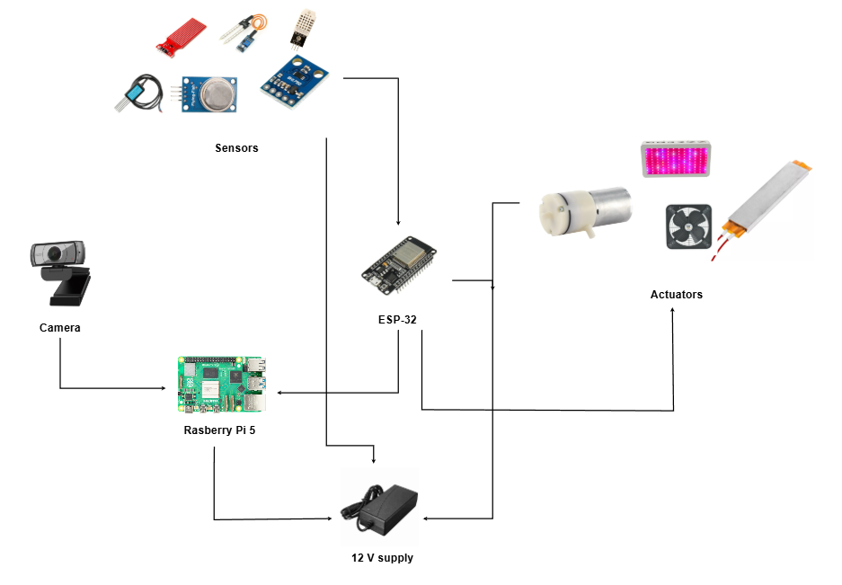
Fig. 1. Hardware block diagram of the two-tray AI-driven vertical farming system.
B. Software Architecture
The software stack is structured in four levels (Fig. 2): The embedded layer is two separate firmware instances for the ESP32. Two concurrently-run system-managed Python services reside on the edge-AI layer, which is implemented on the Raspberry Pi 5: pi_tabnet.py for the prediction of the environment and the control of the actuators, and pi_cnn.py for capturing images from the camera, pre-processing them, and performing CNN inference; these two services are fed into a sensor-fusion stage to yield the final diagnosis. The cloud layer, which is the Firebase Realtime Database, is shared memory between the embedded and edge and presentation layers, and is used to propagate updates to subscribed clients. The presentation layer is a web dashboard deployed on Vercel that shows the live values of the sensors, recommendations from AI, and the status of the actuators to the operator.
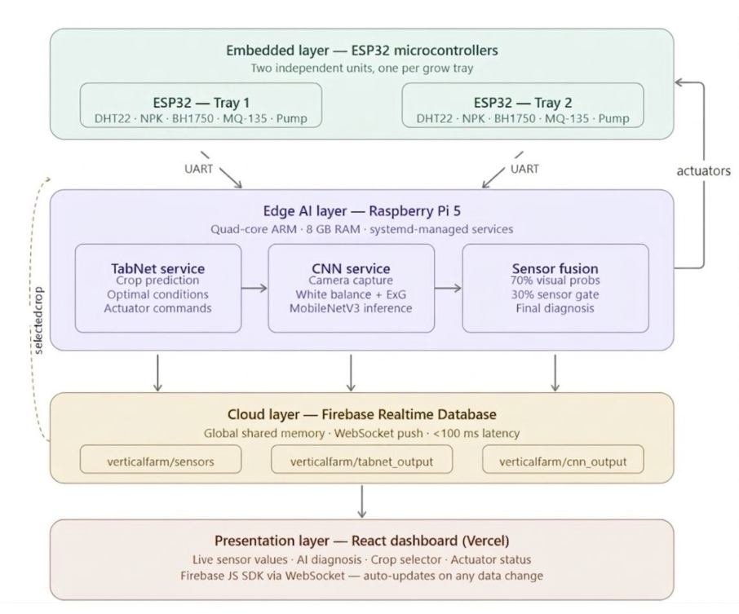
Fig. 2. Four-layer software architecture: embedded, edge-AI, cloud, and presentation.
C. Design Considerations
Modularity, scalability and graceful degradation are principles of the architecture. Each module can be developed, tested, or replaced without impacting the others.You are able to develop and test or replace each module separately from the other modules. No changes to any existing modules are necessary to add a third tray: just add a new ESP32, a new Firebase path, and a new UART thread. The camera doesn't work, and sensor data will be used for diagnosis; Firebase is unreachable and the Pi services will run from the local cache; if a service fails, the Pi restarts it within 2 seconds.
IV. METHODOLOGY
A. TabNet Environmental Prediction
A TabNet model was trained on the Crop Recommendation Dataset [13] to predict the set-point of the environment: temperature, humidity, soil moisture, nutrient and an operator selected crop. TabNet's sequential attention mechanism picks the most relevant input features at every decision step, while still being competitive with gradient-boosted alternatives, and offers interpretable predictions. The output of drive fan, grow-light intensity and irrigation is controlled by a proportional-integral feedback loop which continuously reduces the gap between the measured and target conditions.
B. Self-Supervised Visual Plant-Health Diagnosis
A self-supervised approach was used to avoid manually labelling thousands of leaf images in a three-stage pipeline. The first step was to pretrain a SimCLR contrastive model on 10,686 images of unlabeled leaves from the PlantVillage dataset, yielding 576-dimensional feature embeddings that reflect the visual similarity between the images. Secondly, this embedding space was divided into 7 clusters (using K-Means algorithm), each cluster given a semantic label after manual inspection of the cluster level (not the image level) data. Although the symptoms of stress on plants are continuous and overlap, clustering quality was validated using a Calinski-Harabasz Index of 1065.54, a Silhouette Score of 0.1836, and a Davies-Bouldin Index of 1.8673. This raw clustered set was highly unbalanced, with anywhere between 746 and 2714 images in each cluster (Fig. 3), which would cause a classifier to overlook minority classes like pH Imbalance. The data set was then upsampled to 737 images per class and stratified split into train/validation/test sets, 589/73/75 images. Then, a CNN with MobileNetV3-Small was fine-tuned on the balanced set using multi-head output and a Weighted Random Sampler, with a focus on achieving the best possible accuracy-to-latency ratio on an edge CPU compared to other deeper networks like ResNet or EfficientNet.
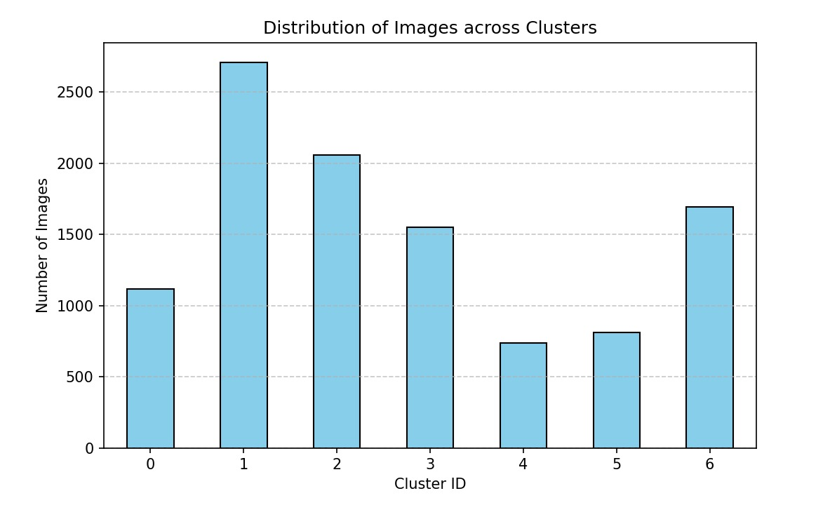
Fig. 3. Distribution of pseudo-labeled images across the seven K-Means clusters prior to balancing.
C. Purple-Light Image Preprocessing
Farm grow lights are not white light like PlantVillage images, thus, before performing inference, two preprocessing steps were performed: grey-world white-balance correction (red ×1.45, green ×0.35, blue ×1.30), to restore the natural leaf colour, and HSV dual-mask segmentation, to separate the leaf from the background, before resizing to 224×224 and ImageNet normalization..
D. Sensor-Fusion Decision Gating
The final diagnosis is the weighted average of the CNN's softmax output and a sensor-gate based on live NPK, pH and temperature measurements with a fixed weight: final_probs = 0.70 × neural_probs + 0.30 × sensor_gate. This fusion is especially well for early nutrient deficiencies that are not easily detected visually, when there is direct evidence of this deficiency from the sensor, which the visual model fails to classify correctly.
V. RESULTS AND DISCUSSION
A. CNN Classification Performance
The best validation accuracy of the MobileNetV3-Small classifier was obtained for the seven plant-health categories with a final test accuracy of 87.28% and a macro-average F1-score of 0.8482 (Table I). Nitrogen Deficiency was the most challenging class (F1 = 0.7626) due to the fact that other chlorosis-causing classes are visually similar to Nitrogen Deficiency, while the most reliably detected class was Phosphorus Deficiency (F1 = 0.9146, 100% recall on the 75 test images of the class)..
TABLE I
PER-CLASS TEST-SET CLASSIFICATION REPORT
Class | Precision | Recall | F1
Healthy | 0.7791 | 0.8933 | 0.8323
Water Stress | 0.8889 | 0.8533 | 0.8707
Nitrogen Def. | 0.8281 | 0.7067 | 0.7626
Phosphorus Def. | 0.8427 | 1.0000 | 0.9146
Potassium Def. | 0.8714 | 0.8133 | 0.8414
Temperature Stress | 0.9265 | 0.8400 | 0.8811
pH Imbalance | 0.8289 | 0.8400 | 0.8344
Macro Avg. | 0.8522 | 0.8495 | 0.8482

B. Confusion Matrix Analysis
The confusion matrix (Fig. 4) displays also a more or less pronounced diagonal structure, indicating a balanced performance without a bias towards any of the seven classes. The most common misclassifications are that both Nitrogen and Phosphorus Deficiency have chlorotic symptoms that appear in early stages (7 images) – this is where the sensor-fusion gate comes into play to distinguish between the states of Nitrogen and Phosphorus based on direct measurement. The remaining Six misclassifications were for cases of mild heat lesions, when visual signs of heat lesion were not yet apparent, which were covered by the Temperature Stress class using direct DHT22 temperature measurements at the time of inference.
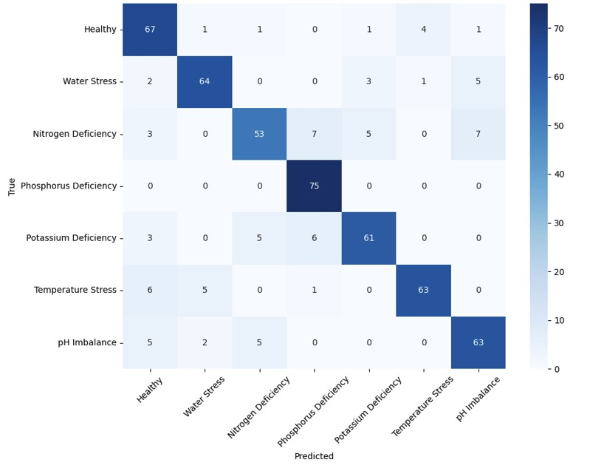
Fig. 4. Confusion matrix for the MobileNetV3-Small classifier on the held-out test set (75 images/class).
C. System-Level Performance
The CNN infers comfortably within the visual-monitoring cycle of 30 seconds, end-to-end, on the CPU of the Raspberry Pi 5. During long tests, no more than 0.5% of packets were lost in the soil sensor link and updates from Firebase to the dashboard were almost instantaneous. The difference between the accuracy on the validation set (87.28%) and the test set (84.95%) is within the typical range of generalization bounds and suggests that there is not much overfitting, which is supported by the balanced nature of the data, the use of a Weighted Random Sampler, data augmentation, and a two-stage fine-tuning schedule that starts with a frozen backbone for the initial epochs. The ability to learn a full training set of labeled images from zero, from a contrastive self-supervision approach and from clustering alone, is a significant advantage for this system, with a 3–8% gap compared to fully supervised PlantVillage baselines with similar MobileNetV3 backbones which generally report 88–93% accuracy under controlled studio imagery [7]-[10].
VI. CONCLUSION AND FUTURE WORK
This paper presented a fully integrated, closed-loop AI-driven vertical farming prototype that couples distributed embedded sensing, TabNet-based environmental prediction, and a self-supervised visual plant-health diagnosis pipeline through a cloud-synchronized dashboard. The system demonstrates that affordable embedded hardware, combined with self-supervised learning, can produce a working predictive and diagnostic vertical-farming system without manual image annotation or costly commercial infrastructure, achieving 84.95% plant-health classification accuracy and sub-100 ms data propagation across all layers.
Future work includes growth-stage-aware environmental recommendations, manual review of cluster-boundary pseudo-labels to further reduce label noise, migration to ESP-NOW wireless communication for scaling beyond five trays, dedicated NDIR CO₂ sensing, reinforcement-learning-based closed-loop yield optimization, per-tray multi-crop support, automated nutrient dosing, and time-series yield forecasting.
REFERENCES
[1] United Nations, "The 17 Sustainable Development Goals," [Online]. Available: un.org/sustainabledevelopment (accessed May 2025).
[2] S. Wolfert, L. Ge, C. Verdouw, and M. J. Bogaardt, "Big Data in Smart Farming – A Review," Agricultural Systems, vol. 153, 2017.
[3] K. A. Shafi, M. A. Ansari, and M. Zahoor, "IoT-Based Smart Agriculture Monitoring System," Int. J. Adv. Comput. Sci. Appl., vol. 12, no. 4, 2021.
[4] Espressif Systems, "ESP32 Technical Reference Manual," [Online] (accessed Feb. 2025).
[5] T. Chen and C. Guestrin, "XGBoost: A Scalable Tree Boosting System," Proc. ACM SIGKDD KDD, 2016.
[6] G. Ke et al., "LightGBM: A Highly Efficient Gradient Boosting Decision Tree," Adv. Neural Inf. Process. Syst. (NeurIPS), 2017.
[7] D. P. Hughes and M. Salathé, "An Open Access Repository of Images on Plant Health to Enable the Development of Mobile Disease Diagnostics," arXiv:1511.08060, 2015.
[8] K. Simonyan and A. Zisserman, "Very Deep Convolutional Networks for Large-Scale Image Recognition," ICLR, 2015.
[9] K. He, X. Zhang, S. Ren, and J. Sun, "Deep Residual Learning for Image Recognition," Proc. IEEE CVPR, 2016.
[10] M. Tan and Q. V. Le, "EfficientNet: Rethinking Model Scaling for Convolutional Neural Networks," Proc. ICML, 2019.
[11] S. O. Arik and T. Pfister, "TabNet: Attentive Interpretable Tabular Learning," Proc. AAAI Conf. Artif. Intell., vol. 35, 2021.
[12] T. Chen, S. Kornblith, M. Norouzi, and G. Hinton, "A Simple Framework for Contrastive Learning of Visual Representations," Proc. ICML, 2020.
[13] Kaggle, "Crop Recommendation Dataset," [Online]. Available: kaggle.com/datasets/atharvaingle/crop-recommendation-dataset (accessed Jan. 2025).

