**Question 2**

The k-means algorithm does *not* always yield the same solution for the clustering problem. In the images below you can see that with different initializations (filled points), the results are different, too:

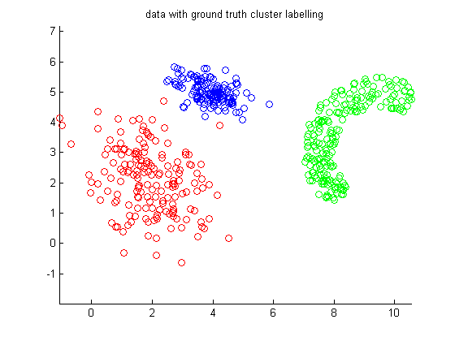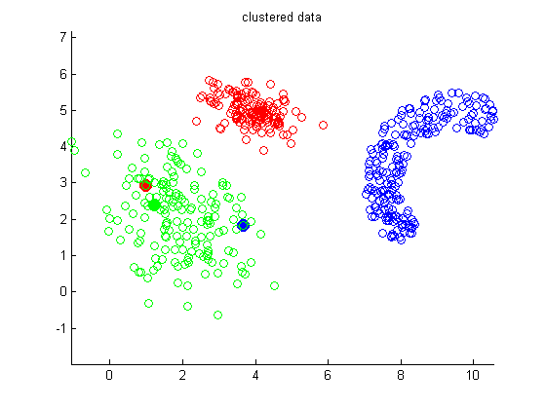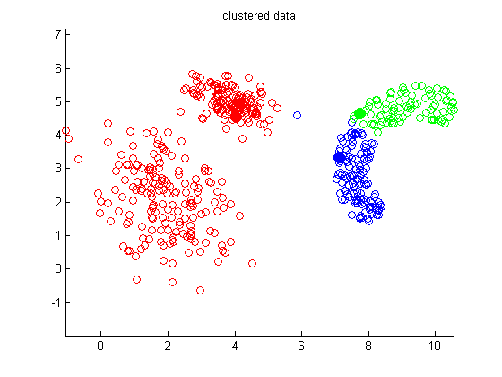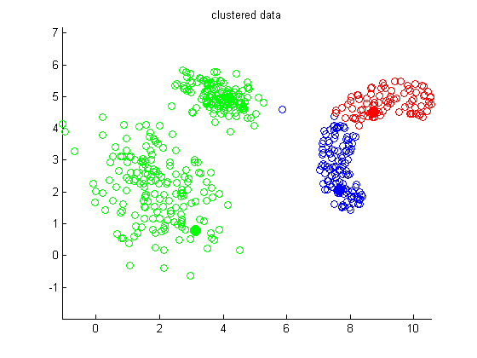

***Ground truth***

The reason for this effect can be explained by considering the distortion function that measures the sum of quared distances between the training samples and the corresponding cluster centroids: The function is not convex and by minimizing it we can therefore happen to land in a local but not global minimum.

**Question 3**

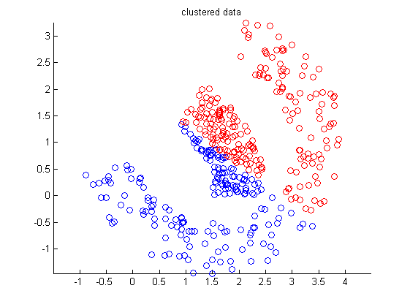As we immediatly see, the clustering is not the desired one if we compare the ground truth result with the one k-means gave us:

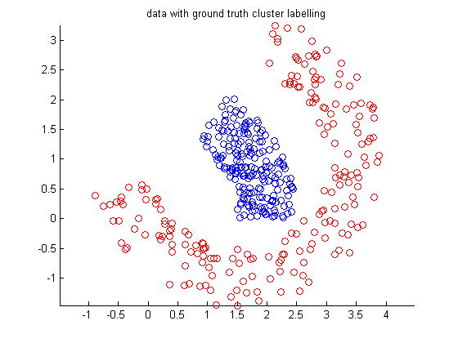

k-means

Ground truth

The ground truth result will never be obtained by the k-means clustering algorithm because it does not correspond to a solution that (globally or locally) minimizes the distances between the data points and their cluster centroids.

If we look e.g. at a red point at the lower left and one at the upper top, we see that in between them there are some blue points. But since k-means uses an averaging process of the positions of the data set, such an image cannot be the output of our algorithm.