# Arduino Uno – Analog Input Simulation

This document includes a simple Arduino Uno simulation in Tinkercad to test the analog-to-digital converter (ADC) functionality.

## 1. Version A: Values ≥ 512 printed to Serial Monitor

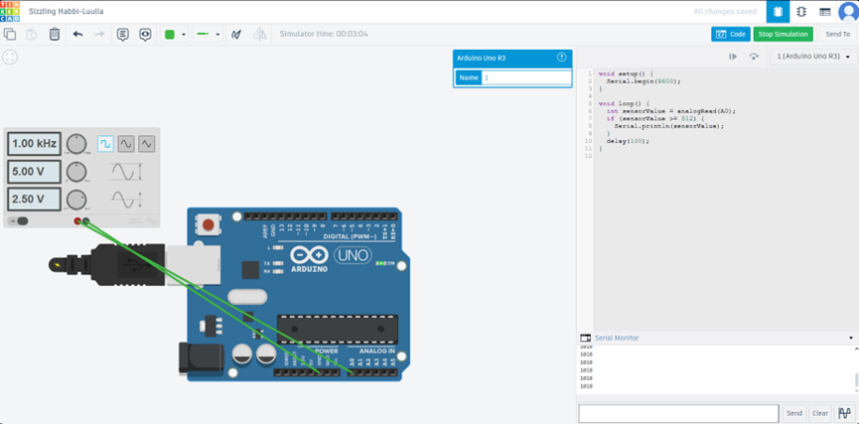

Only analog values higher than or equal to 512 were transmitted over Serial.

## 2. Version B: Full ADC range (0–1023)

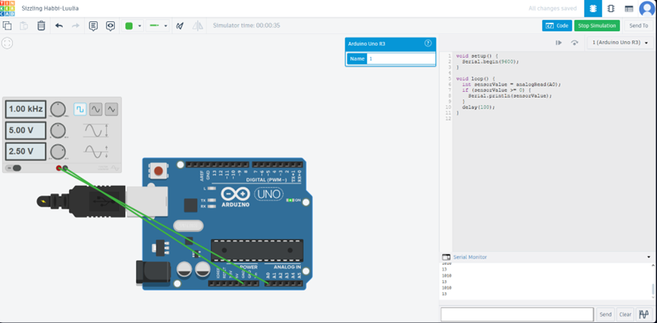

All values across the 10-bit ADC range were printed to the Serial Monitor.

## 3. Circuit Schematic

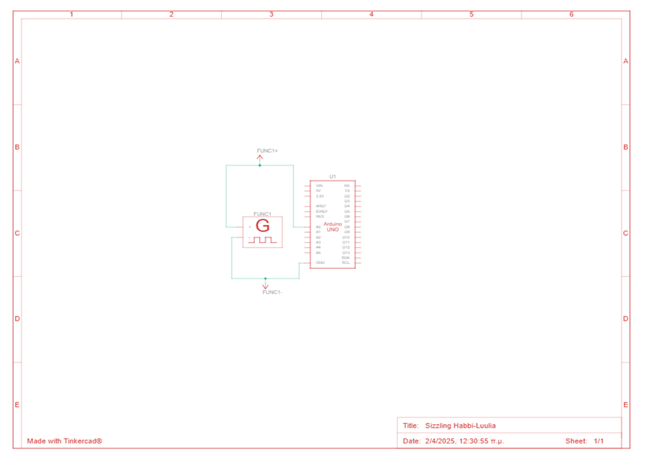

Generated using Tinkercad, showing connection between analog signal source and pin A0 of Arduino Uno.