use insurance;

SELECT*FROM car

WHERE (price<12000)OR(price>15000);

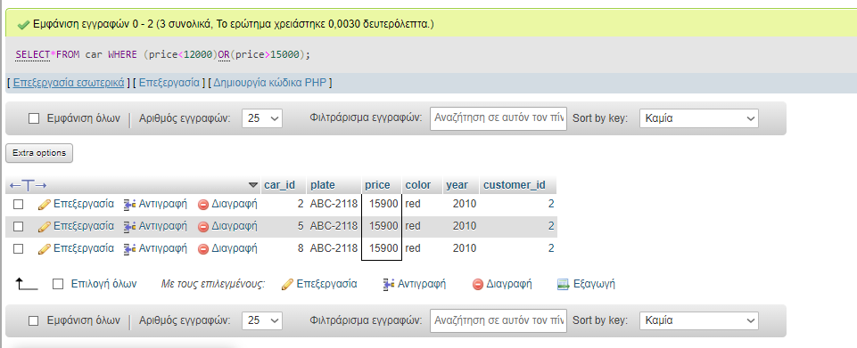

use insurance;

SELECT SUM(price), AVG(price) FROM car;

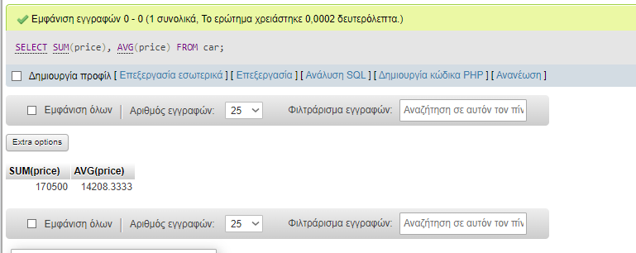

use insurance;

SELECT MIN(price), MAX(price) FROM car;



use insurance;

SELECT MIN(price), MAX(price) FROM car;

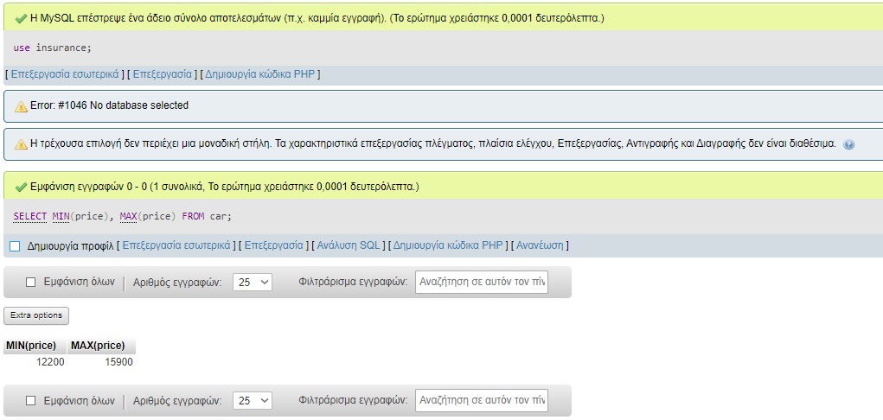

use insurance;

SELECT COUNT(color)

FROM car

WHERE color IN('red','silver');



use insurance;

SELECT first_name,last_name,age

FROM customer

WHERE age>30;

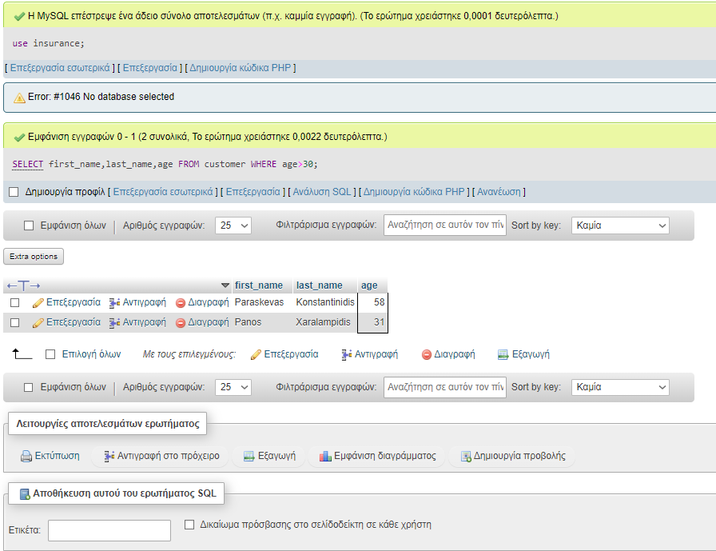

use insurance;

SELECT customer_id,first_name,last_name

FROM customer

WHERE last_name LIKE '_a%';

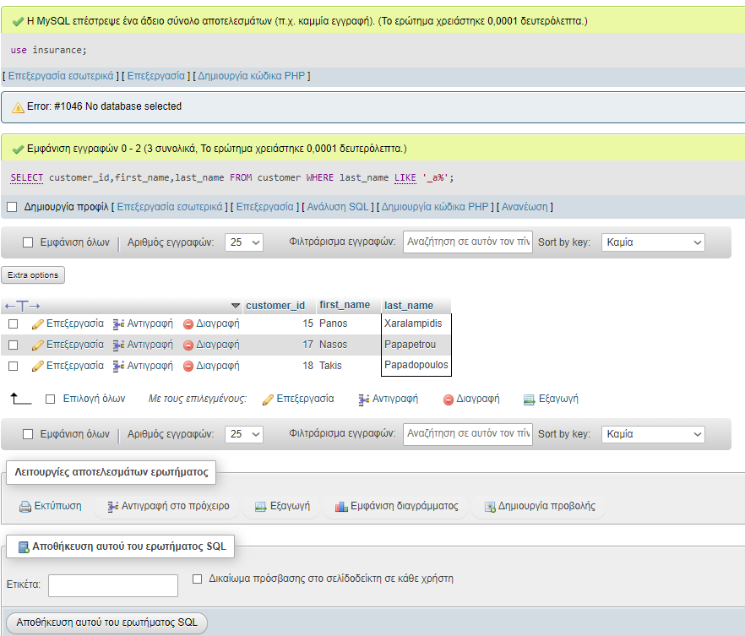

use insurance;

SELECT first_name,last_name

FROM customer

WHERE last_name LIKE 'Di%ou';

