FreeCol UI mod
Everything that changed, with before and after
Fork: mischadeq/freecol, branch colony-overview
Based on FreeCol 1.2.0 (upstream commit 73926ac17)
12 October 2026
Mischa de Queljoe, with Claude

Contents
1. Summary: what changed in one page, how it was built, how it fits together
2. Colony Overview: the main report, before and after
3. Supply-aware warnings: shortages that trade routes cover, and start-of-turn messages
4. Logistics report with map: every trade route on one page
5. Goods Overview: every good across every colony
6. Unit Overview: every unit and what it is doing
7. Unit groups: armies and wagon trains, marching together or rushing
8. What has been tested: and what still needs a look in play
9. Files changed: and what is next

1. Summary
FreeCol plays well, but its interface makes it hard to run a growing empire. You could not see what each colony was specialised in, wagon logistics had to be managed one wagon at a time, and there was no way to move troops as an army. This mod adds four overview reports, supply-aware warnings, and unit groups, all on the player's side of the game.
Nothing in the game rules changes. The server, the AI, save games and multiplayer are untouched: every new feature only reads the game or gives the same orders a player could give by hand. FreeCol's own mod system cannot load Java code, so this lives in the source of a forked FreeCol rather than in a mod folder.
Feature | Where to find it | What it gives you
Colony Overview | Report menu, Shift+F6 | One row per colony: main products, needs, stock, warehouse, current build. Sortable.
Supply-aware warnings | Colony Overview colours, start of turn | Shortages that a trade route covers in time stay quiet; broken supply lines raise a message.
Logistics | Report menu, Shift+F7 | Every trade route with a map, its stops, deliveries and carriers.
Goods Overview | Report menu, Shift+F8 | Every good across every colony: stock, change per turn, totals.
Unit Overview | Report menu, Shift+F10 | Every unit outside the colonies, with filters such as Idle.
Unit groups | Orders menu, Shift+G and Shift+R | Armies and wagon trains: one order for all, marching together or rushing.

How it was built
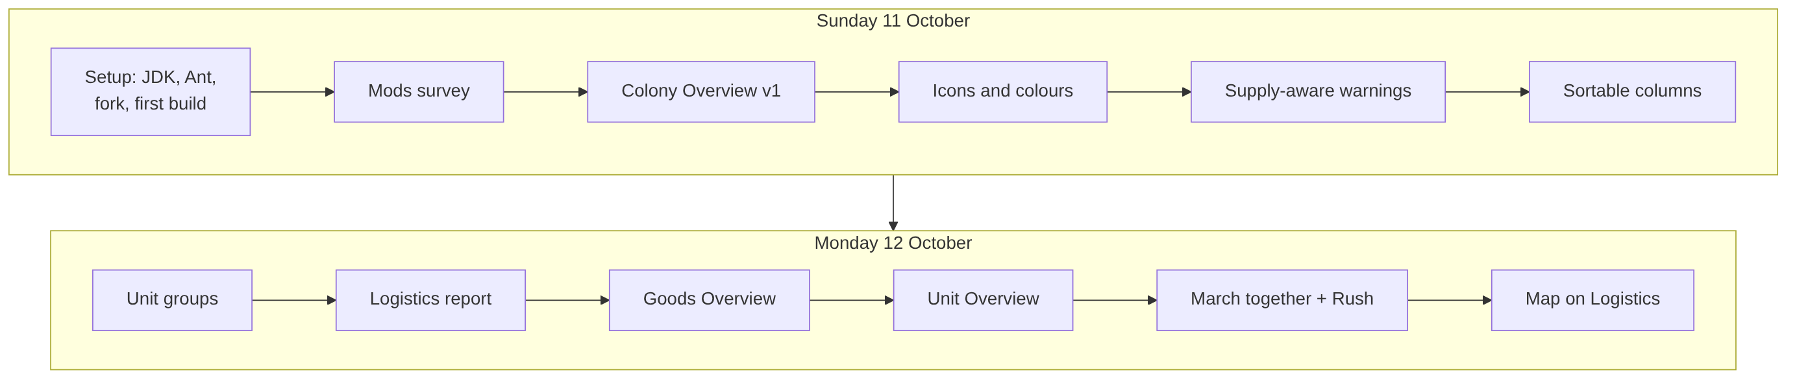
Figure 1. The order in which the features were built.

How the pieces fit together
All new code sits in the game client. The reports read the game model; the group orders turn into the ordinary orders the game already understands.
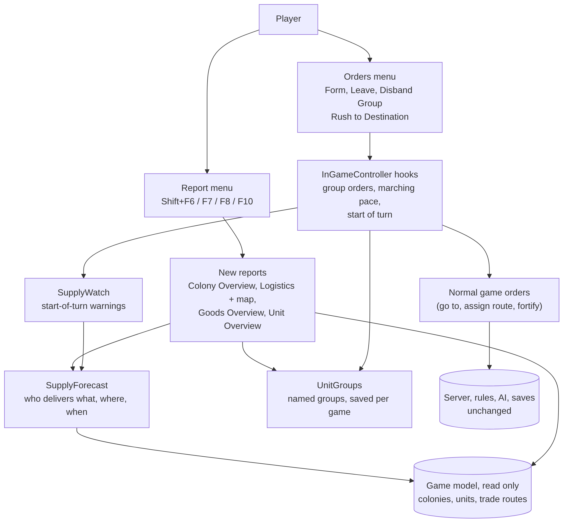
Figure 2. Architecture of the mod.

2. Colony Overview
The problem. The game's Colony Advisor comes in two versions. The compact one is a dense grid with a column per good and colour codes for ten statuses; the classic one is rows of icons per colony. Both hold the data, but neither tells you what a colony is for.
BEFORE: Colony Advisor, compact version
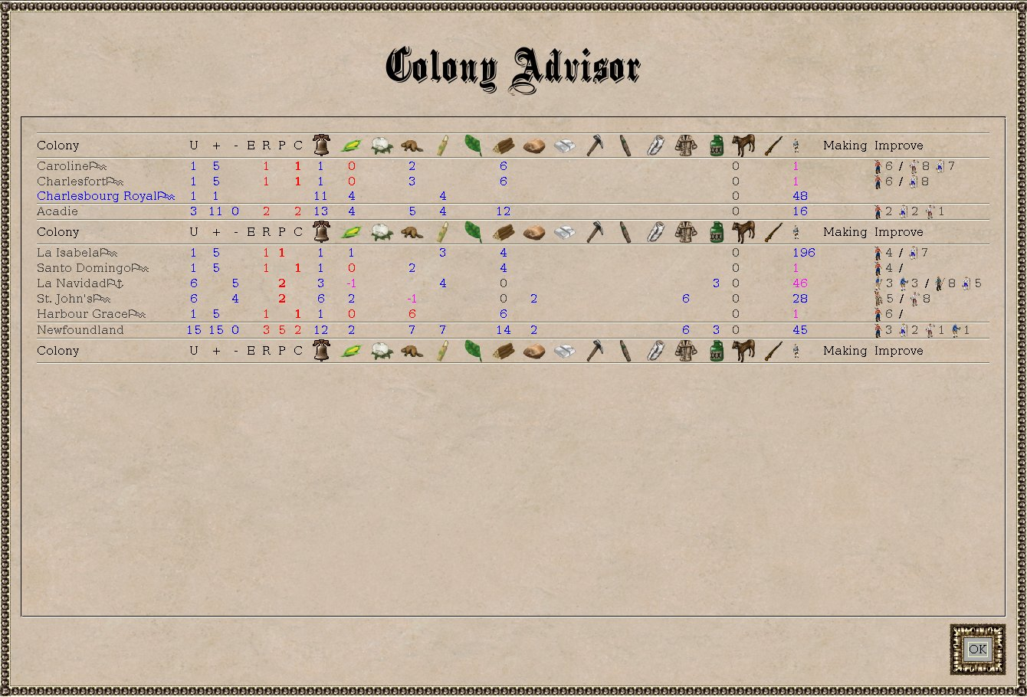
Figure 3. The original compact Colony Advisor: one column per goods type, numbers coloured by status.
BEFORE: Colony Advisor, classic version
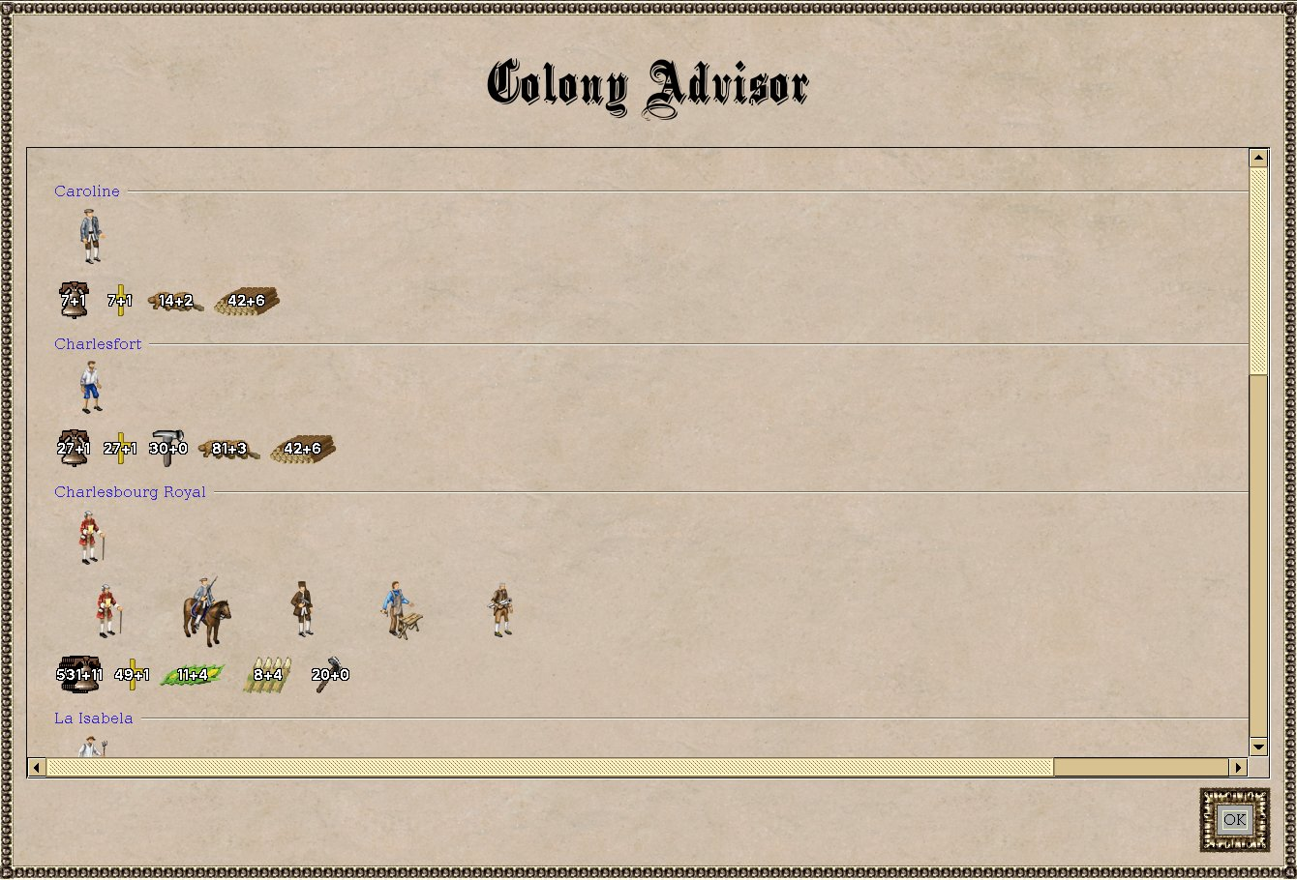
Figure 4. The original classic Colony Advisor: units, goods and buildings as rows of icons per colony.

What changed
A new report, Colony Overview (Report menu, Shift+F6), next to the existing Colony Advisor, which is left as it was. One row per colony:
- Mainly produces: the three goods with the highest net production per turn. The main product is named, the other two show icon and amount.
- Needs: goods running out (with turns left) and inputs the buildings could use more of.
- In stock: the three largest stockpiles; red when goods will be wasted next turn, magenta when nearly full.
- Cap.: warehouse capacity.
- Building: what is under construction and turns left. Red only when nothing is being built, magenta while waiting for goods.
- Sorting: click a column header to sort, click again to reverse. "Mainly produces" groups colonies by specialisation.
- Tooltips: every number explains itself in a sentence. Colony names open the colony.
AFTER: first version, as seen on your machine
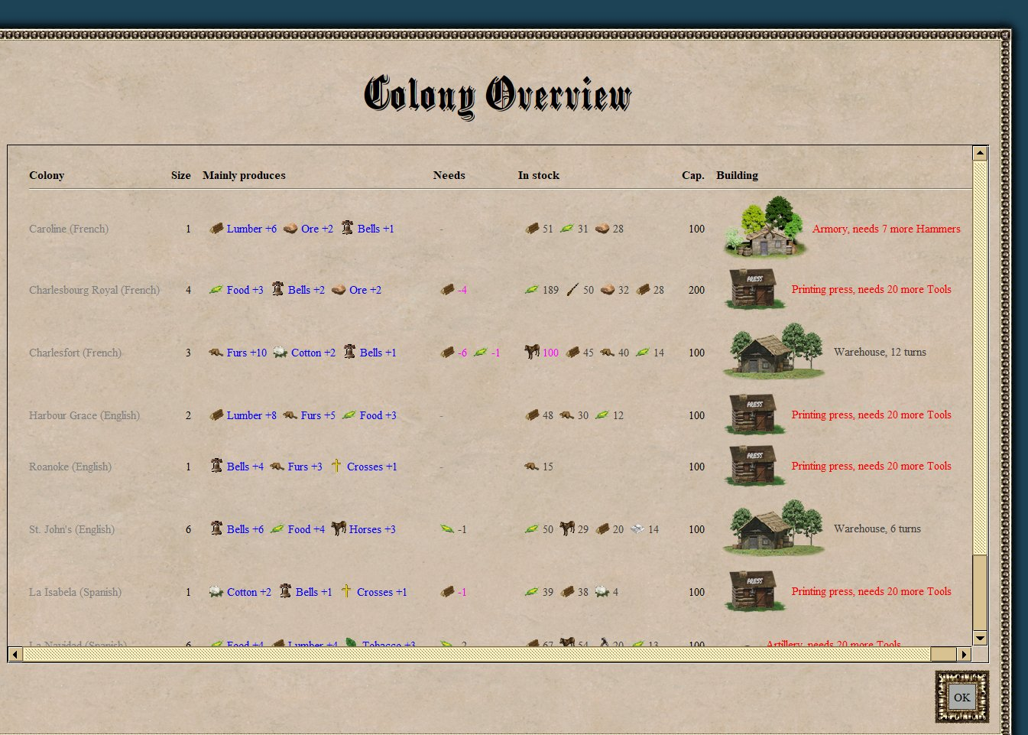
Figure 5. Your screenshot of the first version (debug mode lists AI colonies in gray). Building icons were too large and caused a horizontal scrollbar.
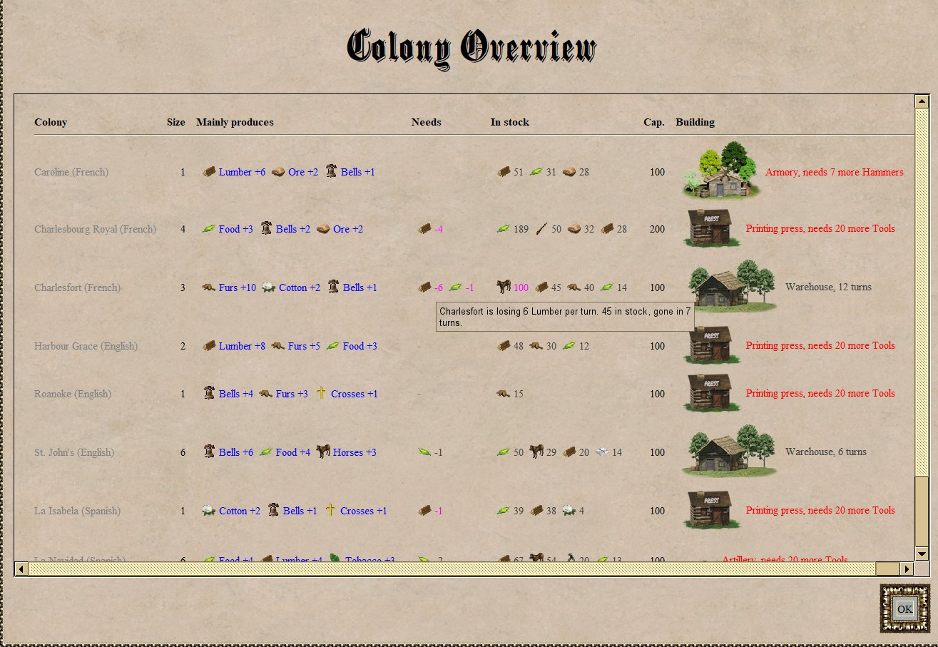
Figure 6. Your screenshot of a tooltip: "Charlesfort is losing 6 Lumber per turn. 45 in stock, gone in 7 turns."
AFTER: current version
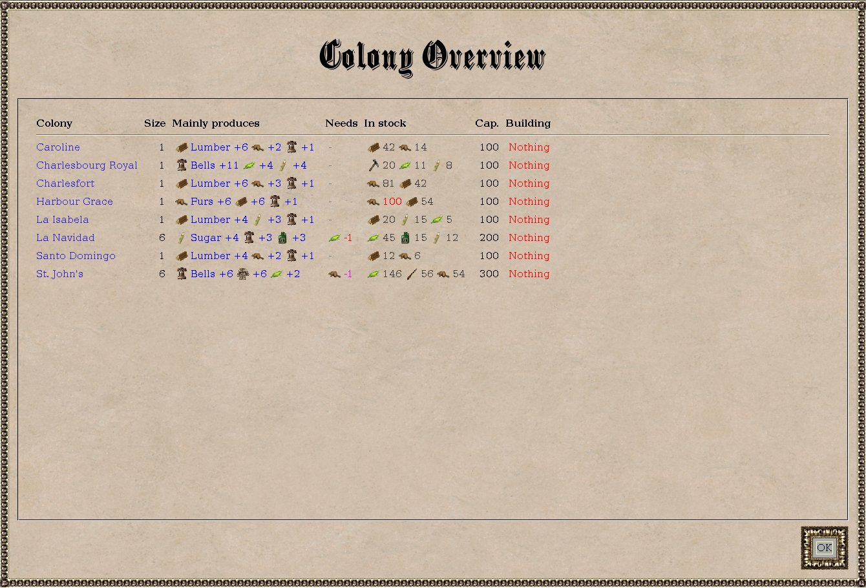
Figure 7. Current version: small even rows, no scrollbar, red only where nothing is being built.
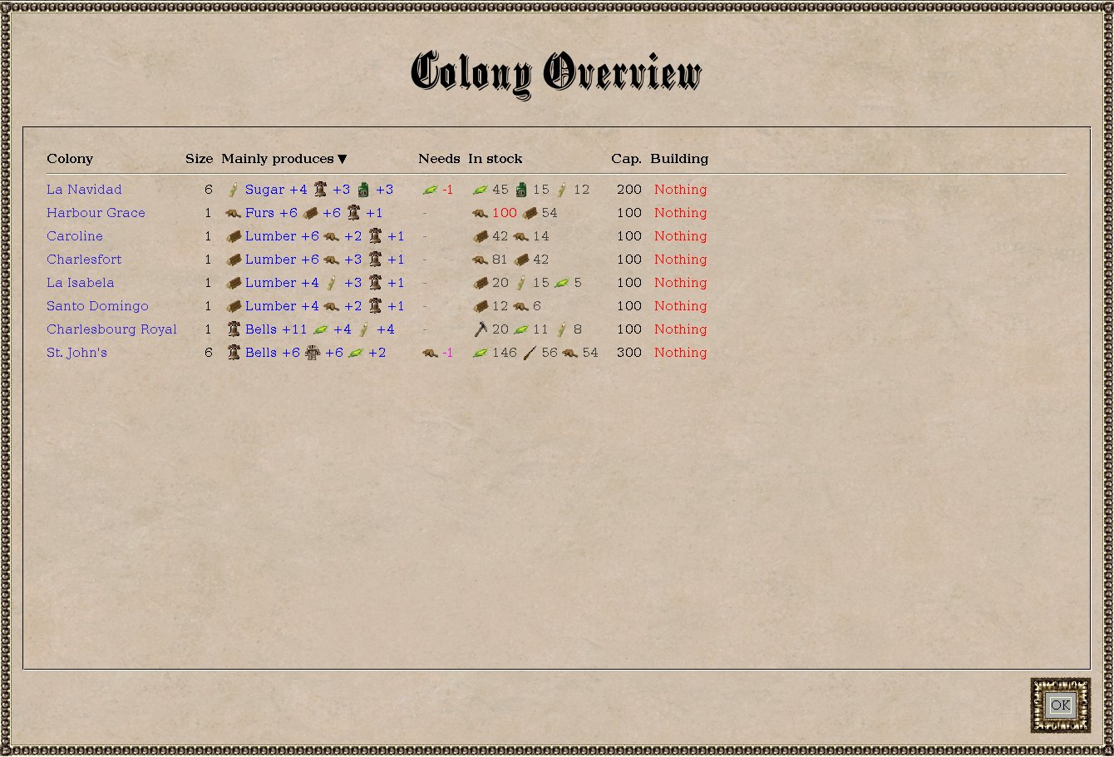
Figure 8. Sorted by "Mainly produces" (arrow on the header): colonies with the same main product end up together.

Changes along the way
Change | Why
Fixed-size building icons | The original icons varied in size and made rows uneven and the table too wide.
Red only for "Nothing" | With half the rows red the colour stopped meaning anything (your decision).
Only the main product named | Keeps the table inside the window; the other names are in the tooltips.
Needs as icons only | Your decision: there are few enough goods to recognise.
Food kept in "Mainly produces" | Your decision, marked in ideas.md for reconsideration.
Debug listing of AI colonies | In debug mode the report also shows other nations' colonies, so there is data to test with.

3. Supply-aware warnings
Your idea. A colony running out of lumber should not raise alarm when a wagon on a trade route will bring lumber in time. It should raise alarm as soon as that stops being true: the wagon is taken off the route, delayed, or has nothing to bring.
BEFORE: no equivalent
The game had no notion of a supply line. The compact advisor coloured a shortage red or magenta whether or not a delivery was on its way, and nothing warned you when a route stopped working.

What changed
- SupplyForecast follows every wagon train and ship along its trade route from where it is now, and works out which goods it unloads at which colony after how many turns.
- Colony Overview, Needs: green when a route resupplies in time; red when a route should deliver but will not. The tooltip names the carrier, the route and the arrival time.
- Colony Overview, Building: "Tools arriving in 3 turns" instead of "needs 20 more Tools" when enough is on its way.
- SupplyWatch adds a message at the start of your turn when a supply line breaks. Each message appears once, when the situation changes.
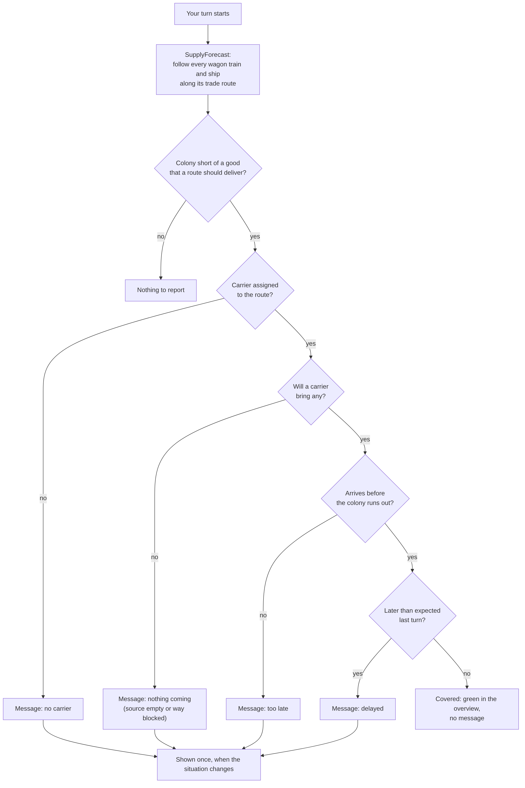
Figure 9. How the start-of-turn check decides whether to warn.
AFTER: messages produced in a real game
No screenshot of a message on screen was captured, but in an automated game the start-of-turn check produced these two messages after a turn ended:
"St. John's relies on trade route Test run for Lumber, but none of its carriers will bring any: the source has nothing to spare, or the way is blocked. St. John's has 24 left."
"Charlesbourg Royal relies on trade route Back haul for Lumber, but no wagon train or ship is assigned to that route any more. Charlesbourg Royal has 38 left."
The other two kinds of message, "too late" and "delayed", read like this:
- "Jamestown runs out of Lumber in 3 turns (30 left), but the next delivery will be too late: Dutch Wagon Train on trade route Lumber run needs 5 turns."
- "The delivery of Lumber to Jamestown is delayed. Dutch Wagon Train on trade route Lumber run now needs 3 turns, 1 turn more than expected."

4. Logistics report with map
The problem. Running a road network of wagons meant opening each wagon to see where it was going. The game's Trade Routes panel lists route names only, and the Cargo Report shows carriers as icons per location.
BEFORE: Trade Routes panel
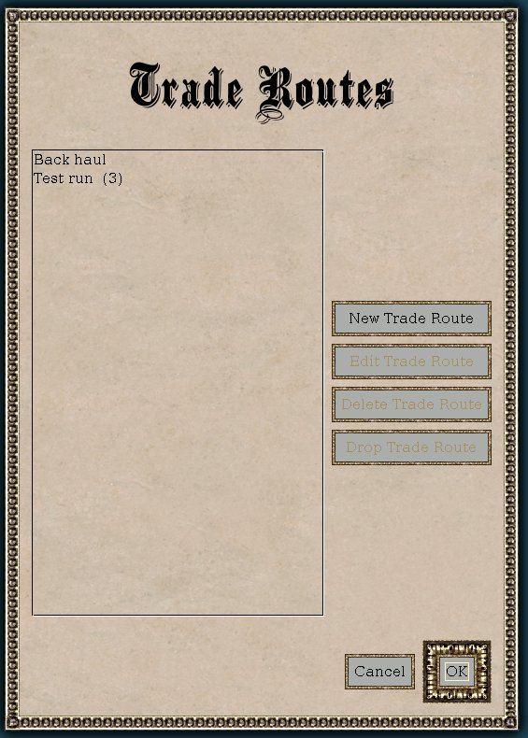
Figure 10. The original Trade Routes panel: a list of route names and buttons.
BEFORE: Cargo Report
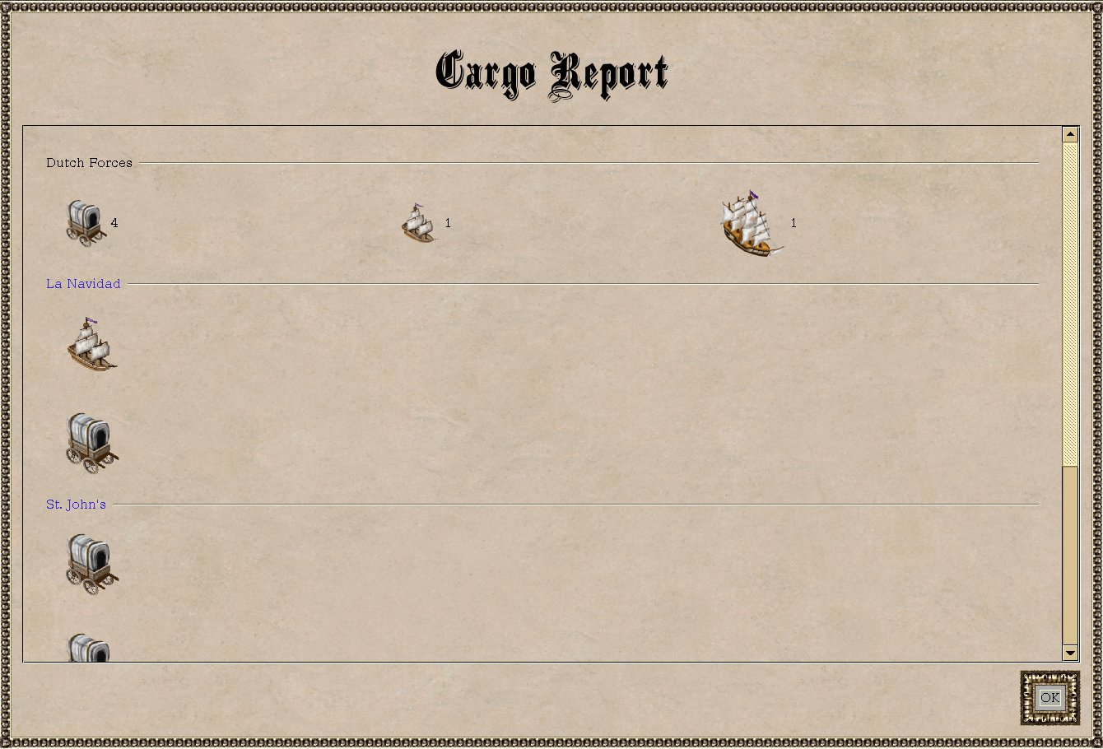
Figure 11. The original Cargo Report: carriers as icons per location, no routes, no destinations.

What changed
A new Logistics report (Report menu, Shift+F7):
- Map strip zoomed to the area the routes cover. Each route in its own colour as a dashed line through its stops, with an arrow for the direction. Each carrier as a circle at its real position with its path to the next stop, the goods it carries and the turns to get there. Hover for details; click to look at that spot on the main map.
- Per route: the stops and what each loads; what the route delivers to which colony and when (green in time, red too late or nothing coming); the carriers with their group, position, cargo and next deliveries. A route without carriers says so in red.
- Spare carriers: wagon trains and ships without a route are listed at the bottom.
AFTER: Logistics report
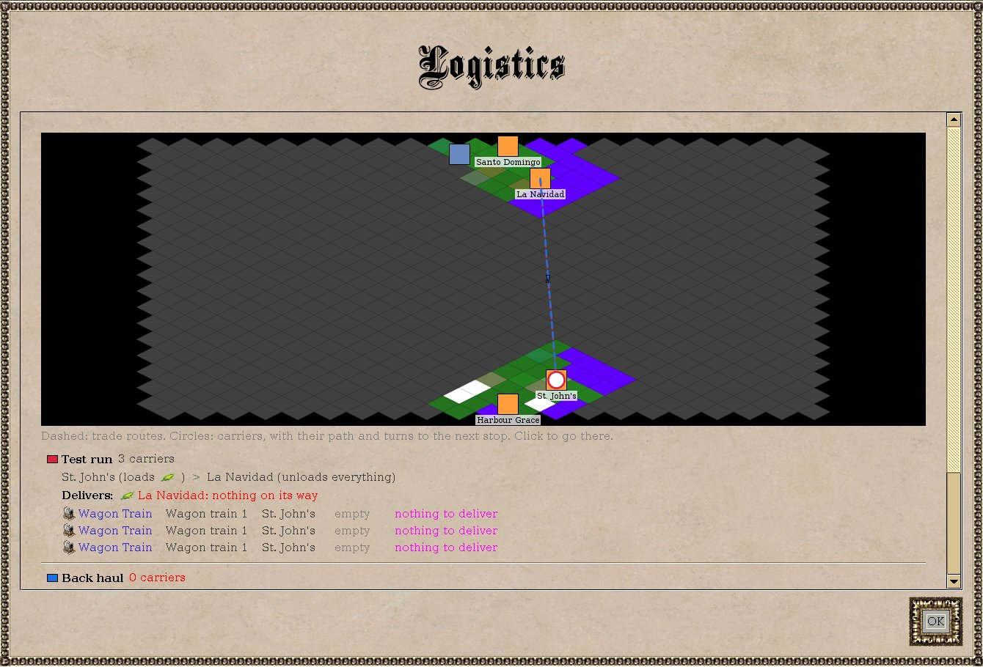
Figure 12. The Logistics report from the automated test game. The test colonies were taken over from AI nations, so most of the map is unexplored (gray). "Test run" has three wagons waiting at St. John's; "Back haul" has none and is flagged in red.

5. Goods Overview
The problem. To find out where your cloth or tools are, you had to open colonies one by one. The Production Report needs you to pick goods from drop-down lists first.
BEFORE: Production Report
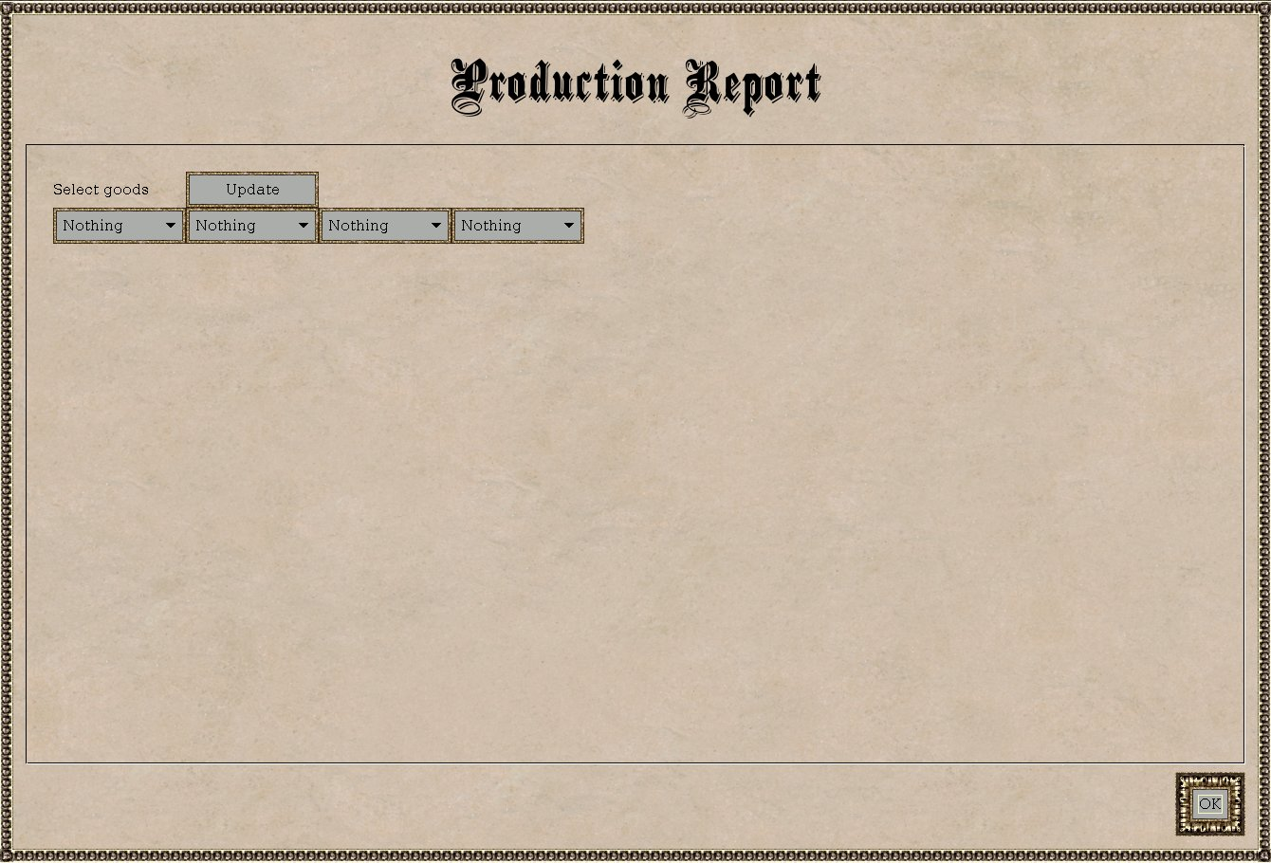
Figure 13. The original Production Report: empty until you choose goods one at a time.

What changed
A new Goods Overview (Report menu, Shift+F8): one row per good, one column per colony, with the empire total and the net change per turn in front. Each cell shows stock and change per turn. Red means overflow next turn or nearly gone; magenta means draining or nearly full. Colony names open the colony.
AFTER: Goods Overview
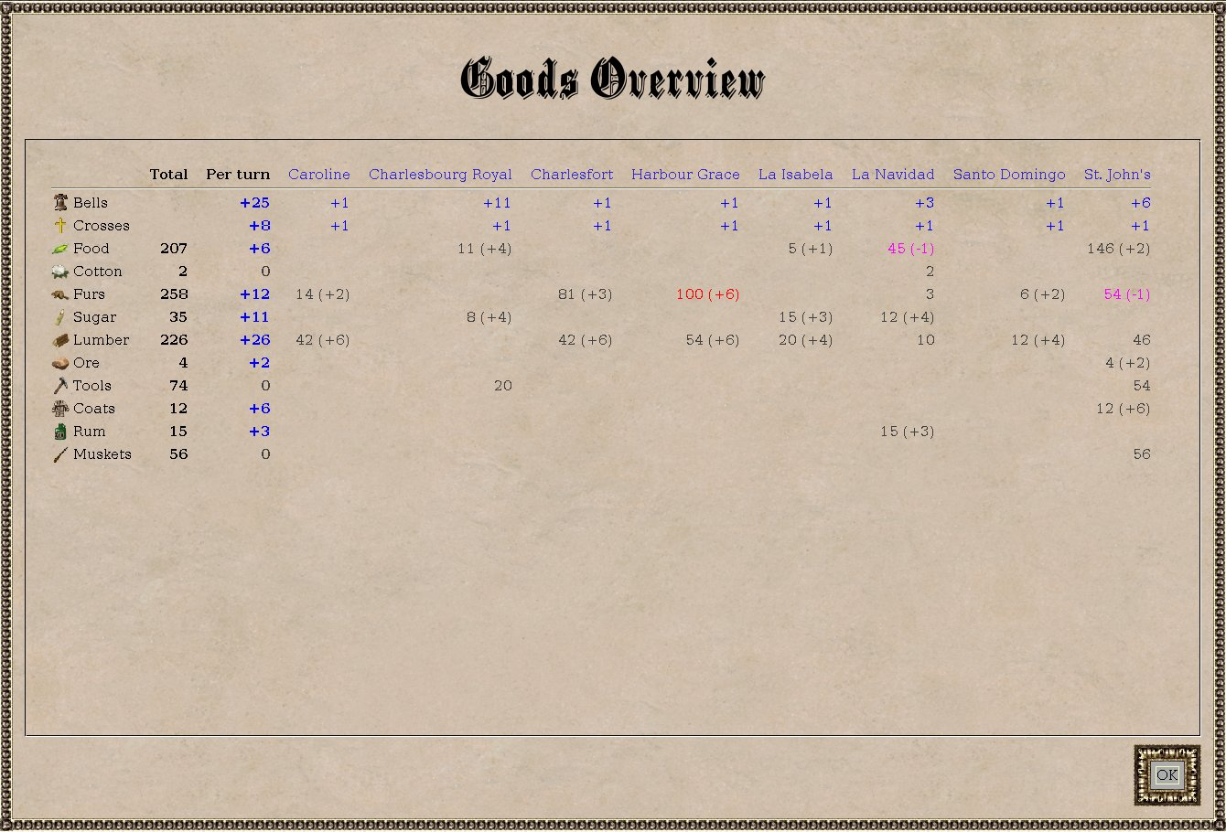
Figure 14. The Goods Overview: lumber and food draining in some colonies (magenta), totals per good on the left.

6. Unit Overview
The problem. The Military Advisor counts unit types per colony, but does not tell you what each unit is doing or which ones are idle.
BEFORE: Military Advisor
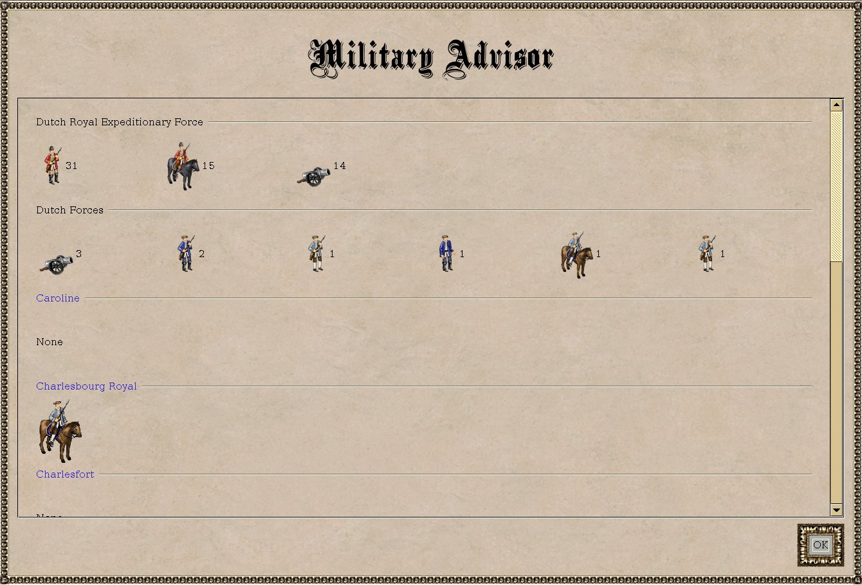
Figure 15. The original Military Advisor: unit counts per location.

What changed
A new Unit Overview (Report menu, Shift+F10) lists every unit that is not working inside a colony: its group, where it is, what it is doing (marching to X in N turns, trade route, fortified, sentry, idle) and moves left. Filters: All, Idle, Soldiers, Wagon trains, Ships, In a group. Click a unit to select it on the map.
AFTER: Unit Overview
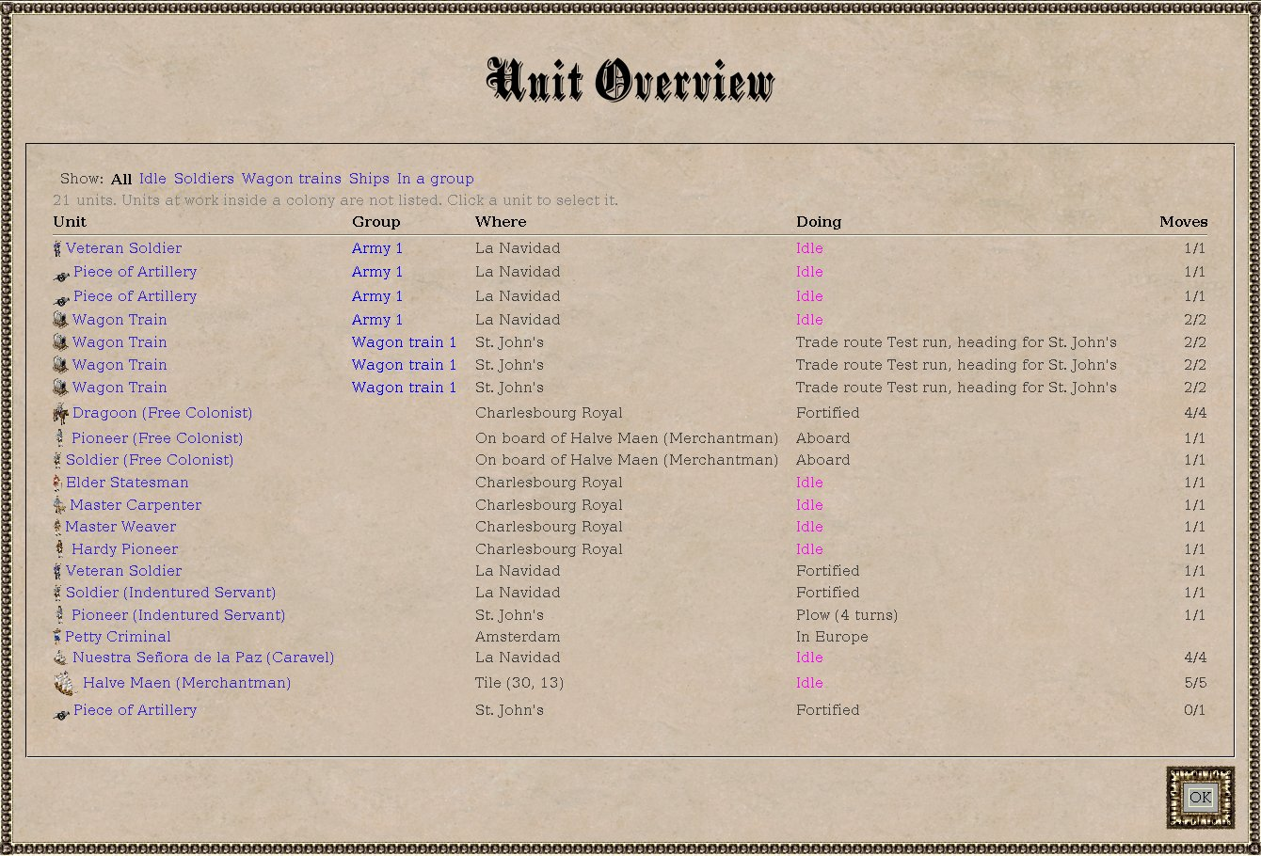
Figure 16. All units, grouped units first.
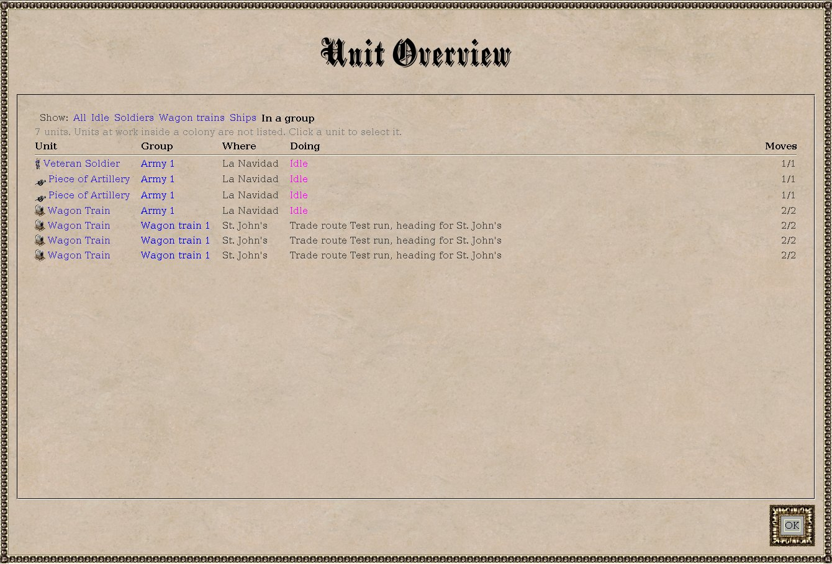
Figure 17. Filtered to "In a group": an army and a wagon train.

7. Unit groups: armies and wagon trains
The problem. Every unit had to be ordered separately. Moving an army of soldiers and artillery, or running four wagons on one route, meant repeating the same order for each.
BEFORE: no equivalent
The game has no way to group units. The only shortcut was selecting units one by one on a tile.

What changed
- Form Group (Shift+G): all your units on the active unit's tile that travel the same way (land or sea) form a named group, such as "Army 1" or "Wagon train 1".
- One order for all: go to a tile or colony, assign a trade route (carriers only), fortify, sentry. Arrow-key steps are followed for plain moves only, never for attacks or boarding.
- March together (default): the slowest member moves first each turn and the faster ones go no further than its tile, so an army escorts its artillery.
- Rush to Destination (Shift+R): your addition. Every member goes at full speed and the fastest arrive first. The next normal go-to order makes them march together again.
- Leave Group, Disband Group: take one unit out, or dissolve the group.
- Visible: the info panel shows the group and its size; the Unit Overview and Logistics reports show it per unit.
- Kept: groups are saved per game in your FreeCol user data folder, so they survive saving and loading. They live on your machine only.
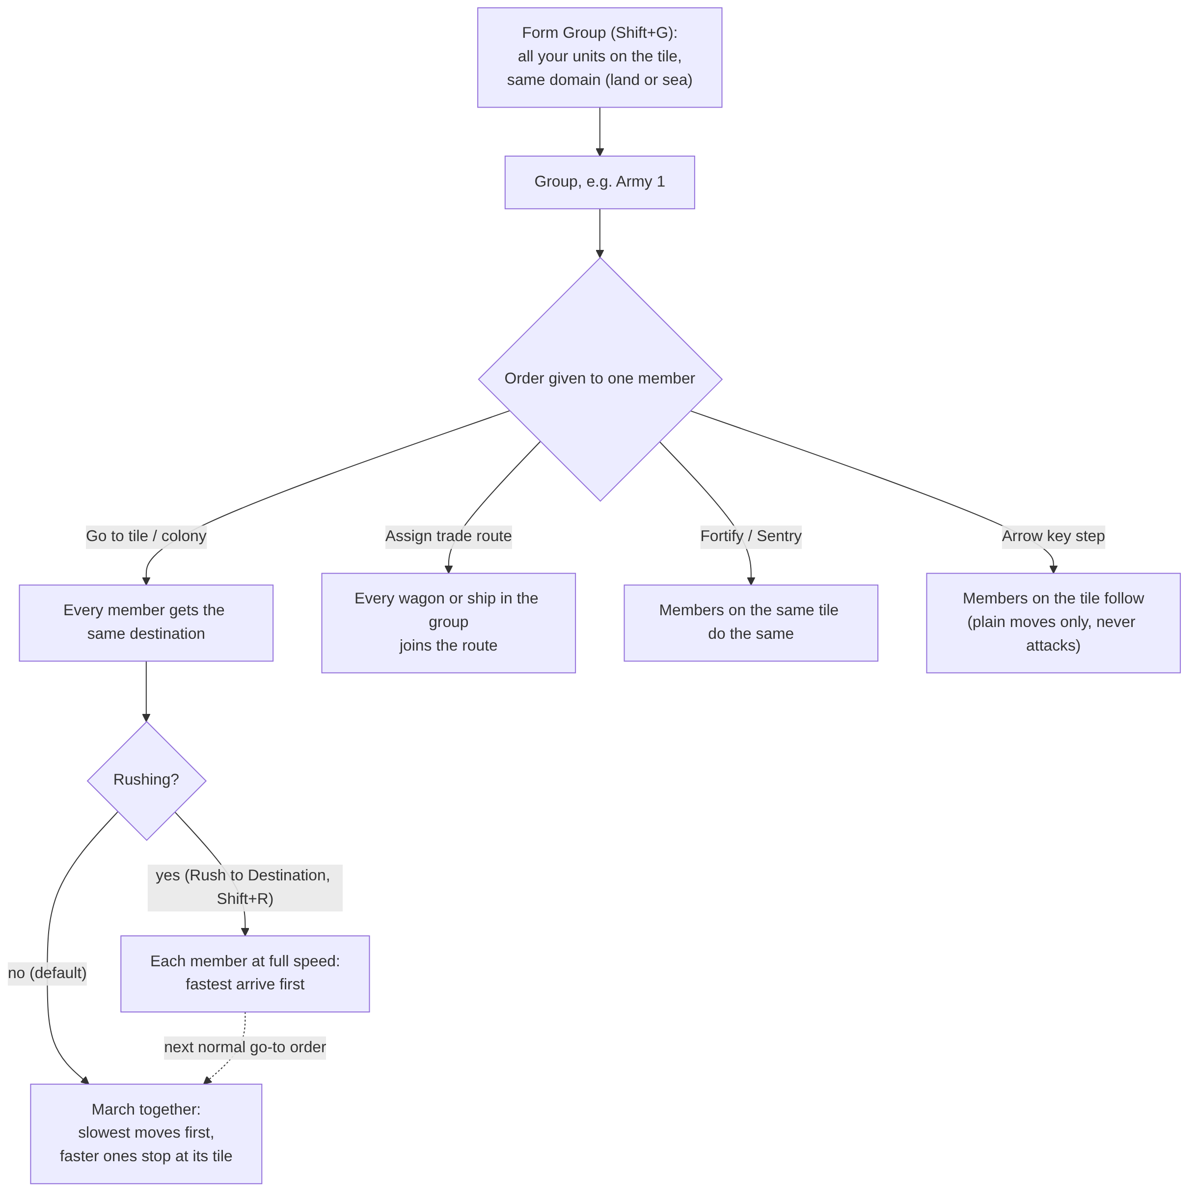
Figure 18. How an order given to one member reaches the group.
AFTER: Orders menu and info panel
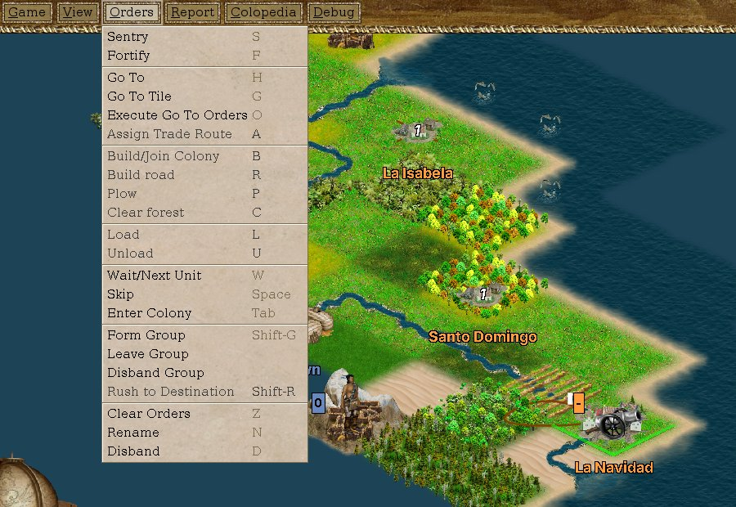
Figure 19. The Orders menu with Form Group, Leave Group, Disband Group and Rush to Destination.
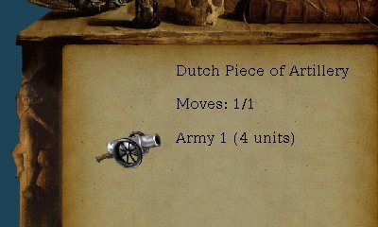
Figure 20. The info panel shows the selected unit's group: "Army 1 (4 units)".

8. What has been tested
Three kinds of checks were used:
- Unit tests: SupplyForecastTest (6 tests: no route, no carrier, nothing coming, delivery in time and late, goods already aboard, the turn-by-turn watch) and UnitGroupsTest (forming, moving between groups, saving and loading, lost units, leaving, disbanding). All pass, as do the game's own TradeRouteTest and UnitTest.
- Automated game runs: the real game in a virtual screen, 50 AI turns, colonies taken over in debug mode, wagons and soldiers added, every report opened and screenshotted. Most screenshots in this document come from these runs.
- Your own runs: the first version of the Colony Overview (figures 5 and 6).
Feature | Confirmed | Still to check in play
Colony Overview | Rendering, sorting, fits the window | All seven sort columns
Supply warnings | Unit tests; messages produced in a real game | Messages on screen; green "covered" colour
Logistics + map | Rendering, map fills the strip | A carrier on its way; hover; click
Goods Overview | Rendering with several colonies | Many colonies (sideways scroll)
Unit Overview | Rendering, filters | Clicking a unit
Unit groups | Group go-to and route orders; march together on the first move; info panel; menu | Form/Leave/Disband dialogs; several turns of marching; Rush moving units ahead

The full checklist is under "To be tested" in claude_docs/ideas.md.

Known limits
- Supply arrival times are estimates: the forecast assumes carriers visit every stop in order, while the game lets them skip stops with nothing to do.
- "Delayed" compares with last turn's expectation, kept in memory only; after loading a save the first turn cannot report a delay.
- A carrier that spends a turn loading counts as one turn delayed. A threshold can be added if this is noisy.
- Form Group takes every unit on the tile; picking a subset is not possible yet.
- Groups are stored on your machine, not in the save file.

9. Files changed
27 files, 4,421 lines added, 1 removed, compared with upstream FreeCol. Everything is in the client and the English texts; no server or rules file is touched.
File | Kind | Purpose
client/control/SupplyForecast.java | new | Forecast of trade route deliveries
client/control/SupplyWatch.java | new | Start-of-turn supply warnings
client/control/UnitGroups.java | new | Named groups, saved per game
client/control/InGameController.java | changed | Group orders, marching pace, Rush, turn-start hook
gui/panel/report/OverviewReportPanel.java | new | Shared building blocks of the reports
gui/panel/report/ReportColonyOverviewPanel.java | new | Colony Overview
gui/panel/report/ReportLogisticsPanel.java | new | Logistics report
gui/panel/report/LogisticsMap.java | new | Map on the Logistics report
gui/panel/report/ReportGoodsOverviewPanel.java | new | Goods Overview
gui/panel/report/ReportUnitOverviewPanel.java | new | Unit Overview
gui/action/Report*Action.java (4) | new | Menu entries for the reports
gui/action/Form/Leave/Disband/RushGroupAction.java | new | Menu entries for groups
gui/action/ActionManager.java, gui/menu/InGameMenuBar.java | changed | Register the menu entries
gui/GUI.java, SwingGUI.java, Widgets.java | changed | Open the new reports
gui/panel/InfoPanel.java | changed | Show the group of the selected unit
data/strings/FreeColMessages.properties | changed | All English texts
test/.../SupplyForecastTest.java, UnitGroupsTest.java | new | Unit tests

What is next
From the ideas list: choosing which units join a group, showing groups on the map, suggested trade routes from the overview, a better trade route editor, turn message filtering, and map overlays.

