Time Series Analysis with R Part 1, Lecture 5

Michèle Fille

Table of contents

# Lecture 5 – Time Series Fundamentals

## 5.1 Introduction

### Exercise 5.1. Introduction

#### Exercise 5.1: Predictor Variables

Read the following case. List the possible predictor variables that might be useful, assuming that the relevant data are available.

Case: Car Fleet Company

A large car fleet company asks us to help them forecast vehicle resale values. They purchase new vehicles, lease them out for three years, and then sell them. Better forecasts of vehicle sales values would mean better control of profits; understanding what affects resale values may allow leasing and sales policies to be developed in order to maximize profits. The resale values are being forecast by a group of specialists. Unfortunately, they see any statistical model as a threat to their jobs, and are uncooperative in providing information. Nevertheless, the company provides a large amount of data on previous vehicles and their eventual resale values.

* *Model or make of the car*
* *Odometer reading (how many km)*
* *Conditions of the cars*
* *Leaser - Company the car was leased to*
* *Colour of car*
* *Date of sale/purchase*

### Self-Study 5.1. Introduction

#### Self-Study 5.1: Steps of Forecasting

For the case described in Exercise 5.1, describe the five steps of forecasting in the context of this project.

***1. Business Understanding and Problem Definition***

* *The main stakeholders should be defined.*
* *Everyone has been questioned about which way he or she can benefit from the new system.*

*In case of the fleet company probably the group of specialists was not recognized as stakeholders which led to complications in gathering relevant information and later in finding an appropriate statistical approach and deployment of the new forecasting method.*

***2. Data Understanding: Information Gathering and Exploratory Analysis.***

* *Data set of past sales should be obtained, including surrounding information such as the way data were gathered, possible outliers and incorrect records, special values in the data.*
* *Expertise knowledge should be obtained from people responsible for the sales such as seasonal price fluctuations, if there is dependency of the price on the situation in economy, also finding other possible factors which can influence the price.*
* *Graphs which show dependency of the sale price on different predictor variables should be considered.*
* *Dependency of the sale price on month of the year should be plot.*

***3. Data Preparation***

* *Possible outliers and inconsistent information should be found (for example very small, zero or even negative prices).*

***4. Choosing and fitting models***

* *A model to start from (for example a linear model) and predictor variables which most likely affect the forecasts should be chosen.*

***5. Evaluating a forecasting model***

* *Predicting performance of the models must be evaluated.*
* *The model should be changed (for example by transforming parameters, adding or removing predictor variables) and it’s performance evaluated.*

*This should be done iteratively wit step 4 a few times until a satisfactory model is found.*

***6. Deploying a Forecasting Model***

* *The appropriate software should be deployed to the company and relevant people should be educated how to use this software.*
* *Forecasting accuracy should be checked against new sales. If necessary the model should be updated and then the deployed software.*

## 5.2 Time Series in R

### Exercise 5.2. Time Series in R

#### Exercise 5.2: Exploring tsibble Objects

1. Explore the following 3 time series. (The data sets are all contained in the package tsibbledata.)

* Use ? or help() to find out about the data in each series.
* What is the time interval of each series?
* Use autoplot() to produce a time plot of each series.
* For the last plot, modify the axis labels and title.

#install.packages("tsibbledata")  
  
library(tsibbledata)  
library(tsibble)  
library(ggplot2)  
library(dplyr)  
library(fpp3) # needed for autoplot for tsibble

* Bricks from aus_production

head(aus_production)

# A tsibble: 6 x 7 [1Q]  
 Quarter Beer Tobacco Bricks Cement Electricity Gas  
 <qtr> <dbl> <dbl> <dbl> <dbl> <dbl> <dbl>  
1 1956 Q1 284 5225 189 465 3923 5  
2 1956 Q2 213 5178 204 532 4436 6  
3 1956 Q3 227 5297 208 561 4806 7  
4 1956 Q4 308 5681 197 570 4418 6  
5 1957 Q1 262 5577 187 529 4339 5  
6 1957 Q2 228 5651 214 604 4811 7

help("aus_production")  
  
interval(aus_production)

<Interval[0]>

# The time interval is quarterly BUT help says half-hourly (?)  
  
aus_production |> autoplot(Bricks)

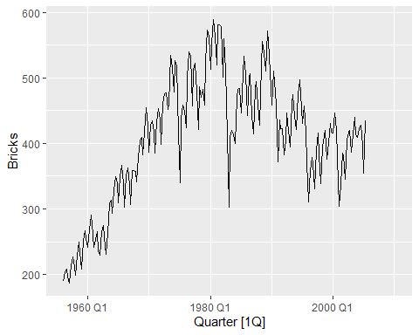

# An upward trend is apparent until 1980, after which the number of bricks being produced starts to decline. A seasonal pattern is evident in this data. Some sharp drops in some quarters can also be seen.

* Lynx from pelt

head(pelt)

# A tsibble: 6 x 3 [1Y]  
 Year Hare Lynx  
 <dbl> <dbl> <dbl>  
1 1845 19580 30090  
2 1846 19600 45150  
3 1847 19610 49150  
4 1848 11990 39520  
5 1849 28040 21230  
6 1850 58000 8420

help("pelt")  
  
interval(pelt)

<Interval[0]>

# Interval is yearly. Looking closer at the data, we can see that the index is a Date variable. It also appears that observations occur only on trading days, creating lots of implicit missing values.  
  
pelt |> autoplot(Lynx)

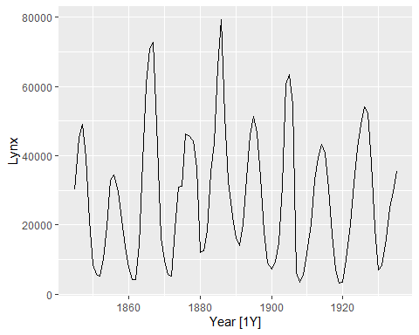

# Canadian lynx trappings are cyclic, as the extent of peak trappings   
# is unpredictable, and the spacing between the peaks is irregular but approximately 10 years.

* Close from gafa_stock.

head(gafa_stock)

# A tsibble: 6 x 8 [!]  
# Key: Symbol [1]  
 Symbol Date Open High Low Close Adj_Close Volume  
 <chr> <date> <dbl> <dbl> <dbl> <dbl> <dbl> <dbl>  
1 AAPL 2014-01-02 79.4 79.6 78.9 79.0 67.0 58671200  
2 AAPL 2014-01-03 79.0 79.1 77.2 77.3 65.5 98116900  
3 AAPL 2014-01-06 76.8 78.1 76.2 77.7 65.9 103152700  
4 AAPL 2014-01-07 77.8 78.0 76.8 77.1 65.4 79302300  
5 AAPL 2014-01-08 77.0 77.9 77.0 77.6 65.8 64632400  
6 AAPL 2014-01-09 78.1 78.1 76.5 76.6 65.0 69787200

help("gafa_stock")  
  
interval(gafa_stock)

<Interval[0]>

# The time interval is daily (irregular)  
  
gafa_stock |> autoplot(Close)

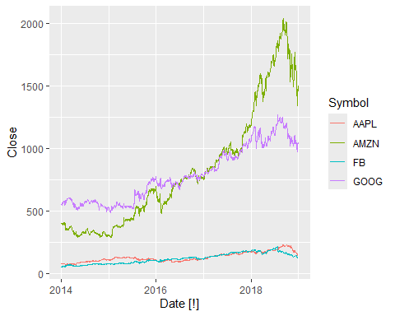

# Stock prices for these technology stocks have risen for most of the series, until mid-late 2018.  
# The four stocks are on different scales, so they are not directly comparable. A plot with faceting would be better.  
  
gafa_stock |>  
 ggplot(aes(x=Date, y=Close, group=Symbol)) +  
 geom_line(aes(col=Symbol)) +  
 facet_grid(Symbol ~ ., scales='free')

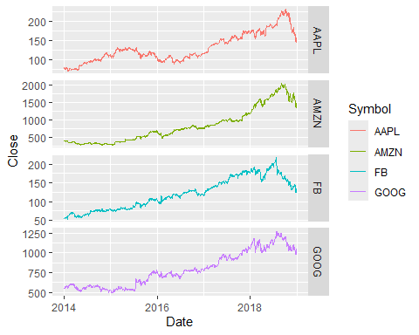

# The downturn in the second half of 2018 is now very clear, with Facebook taking a big drop (about 20%) in the middle of the year. The stocks tend to move roughly together, as you would expect with companies in the same industry.

2. Use filter() to find what days corresponded to the peak closing price for each of the four stocks in gafa_stock from package tsibbledata.

gafa_stock |>  
 group_by(Symbol) |>  
 filter(Close == max(Close)) |>  
 ungroup() |>  
 select(Symbol, Date, Close)

# A tsibble: 4 x 3 [!]  
# Key: Symbol [4]  
 Symbol Date Close  
 <chr> <date> <dbl>  
1 AAPL 2018-10-03 232.  
2 AMZN 2018-09-04 2040.  
3 FB 2018-07-25 218.  
4 GOOG 2018-07-26 1268.

### Self-Study 5.2. Time Series in R

#### Self-Study 5.2: Creating tsibble Objects

1. The USgas package contains data on the demand for natural gas in the US.

* Install the USgas package.

#install.packages("USgas")  
library(USgas)

* Create a tsibble from us_total with year as the index and state as the key.

head(us_total)

year state y  
1 1997 Alabama 324158  
2 1998 Alabama 329134  
3 1999 Alabama 337270  
4 2000 Alabama 353614  
5 2001 Alabama 332693  
6 2002 Alabama 379343

help(us_total) # y = yearly total natural gas consumption in a million cubic feet by state or US aggregate  
  
us_tsibble <- us_total %>%   
 as_tsibble(index=year,   
 key=state)

* Plot the annual natural gas consumption by state for the New England area (comprising the states of Maine, Vermont, New Hampshire, Massachusetts, Connecticut and Rhode Island).

us_tsibble %>%  
 filter(state %in% c("Maine", "Vermont", "New Hampshire", "Massachusetts",  
 "Connecticut", "Rhode Island")) %>%  
 autoplot(y/1e3) +  
 labs(y = "billion cubic feet")

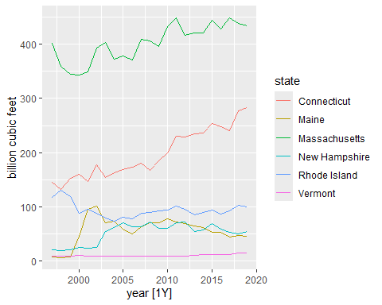

2. Download tourism.xlsx from GitHub and read it into R using readxl::read_excel().

* Create a tsibble which is identical to the tourism tsibble from the tsibble package.

library(readxl)  
  
my_tourism <- readxl::read_excel("tourism.xlsx") %>%   
 mutate(Quarter = yearquarter(Quarter)) %>%   
 as_tsibble(  
 index = Quarter,  
 key = c(Region, State, Purpose, Trips)  
 )

head(my_tourism)

# A tsibble: 6 x 5 [1Q]  
# Key: Region, State, Purpose, Trips [6]  
 Quarter Region State Purpose Trips  
 <qtr> <chr> <chr> <chr> <dbl>  
1 2010 Q1 Adelaide South Australia Business 68.7  
2 2005 Q2 Adelaide South Australia Business 73.3  
3 2013 Q2 Adelaide South Australia Business 101.   
4 2001 Q4 Adelaide South Australia Business 101.   
5 2013 Q1 Adelaide South Australia Business 102.   
6 2006 Q4 Adelaide South Australia Business 107.

head(tourism)

# A tsibble: 6 x 5 [1Q]  
# Key: Region, State, Purpose [1]  
 Quarter Region State Purpose Trips  
 <qtr> <chr> <chr> <chr> <dbl>  
1 1998 Q1 Adelaide South Australia Business 135.  
2 1998 Q2 Adelaide South Australia Business 110.  
3 1998 Q3 Adelaide South Australia Business 166.  
4 1998 Q4 Adelaide South Australia Business 127.  
5 1999 Q1 Adelaide South Australia Business 137.  
6 1999 Q2 Adelaide South Australia Business 200.

* Find what combination of Region and Purpose had the maximum number of overnight trips on average.

my_tourism %>%   
 as_tibble() %>%   
 summarise(Trips = mean(Trips), .by=c(Region, Purpose)) %>%   
 filter(Trips == max(Trips))

# A tibble: 1 × 3  
 Region Purpose Trips  
 <chr> <chr> <dbl>  
1 Sydney Visiting 747.

* Create a new tsibble which combines the Purposes and Regions, and just has total trips by State.

state_tourism <- my_tourism %>%   
 group_by(State) %>%   
 summarise(Trips = sum(Trips)) %>%   
 ungroup()  
  
head(state_tourism)

# A tsibble: 6 x 3 [1Q]  
# Key: State [1]  
 State Quarter Trips  
 <chr> <qtr> <dbl>  
1 ACT 1998 Q1 551.  
2 ACT 1998 Q2 416.  
3 ACT 1998 Q3 436.  
4 ACT 1998 Q4 450.  
5 ACT 1999 Q1 379.  
6 ACT 1999 Q2 558.

## 5.3 Visualizing Time Series

### Exercise 5.3. Visualizing Time Series

#### Exercise 5.3: Time Plots, Seasonal Plots and ACF Plots

1. The aus_arrivals data set comprises quarterly international arrivals to Australia from Japan, New Zealand, UK and the US.

* Use autoplot(), gg_season() and gg_subseries() to compare the differences between the arrivals from these four countries.

head(aus_arrivals)

# A tsibble: 6 x 3 [1Q]  
# Key: Origin [1]  
 Quarter Origin Arrivals  
 <qtr> <chr> <int>  
1 1981 Q1 Japan 14763  
2 1981 Q2 Japan 9321  
3 1981 Q3 Japan 10166  
4 1981 Q4 Japan 19509  
5 1982 Q1 Japan 17117  
6 1982 Q2 Japan 10617

aus_arrivals %>%   
 autoplot(Arrivals)

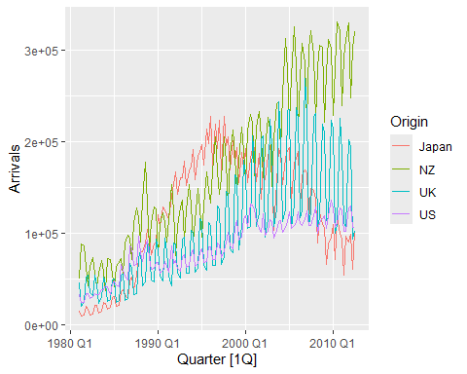

# Generally the number of arrivals to Australia is increasing over the entire series, with the exception of Japanese visitors which begin to decline after 1995. The series appear to have a seasonal pattern which varies proportionately to the number of arrivals. Interestingly, the number of visitors from NZ peaks sharply in 1988. The seasonal pattern from Japan appears to change substantially.

aus_arrivals %>%   
 gg_season(Arrivals, labels = "both")

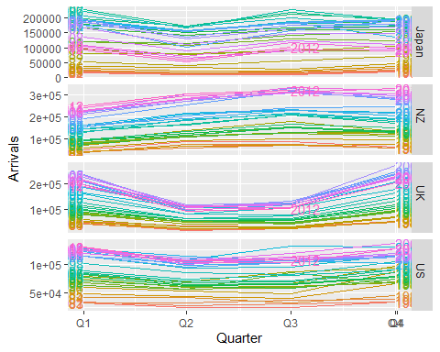

# The seasonal pattern of arrivals appears to vary between each country. In particular, arrivals from the UK appears to be lowest in Q2 and Q3, and increase substantially for Q4 and Q1. Whereas for NZ visitors, the lowest period of arrivals is in Q1, and highest in Q3. Similar variations can be seen for Japan and US.

aus_arrivals %>%   
 gg_subseries(Arrivals)

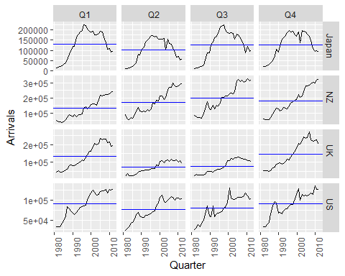

# The subseries plot reveals more interesting features. It is evident that whilst the UK arrivals is increasing, most of this increase is seasonal. More arrivals are coming during Q1 and Q4, whilst the increase in Q2 and Q3 is less extreme. The growth in arrivals from NZ and US appears fairly similar across all quarters. There exists an unusual spike in arrivals from the US in 1992 Q3.

* Can you identify any unusual observations?
  + *2000 Q3: Spikes from the US (Sydney Olympics arrivals)*
  + *2001 Q3-Q4 are unusual for US (9/11 effect)*
  + *1991 Q3 is unusual for the US (Gulf war effect?)*

2. The following time plots and ACF plots correspond to four different time series. Your task is to match each time plot in the first row with one of the ACF plots in the second row.

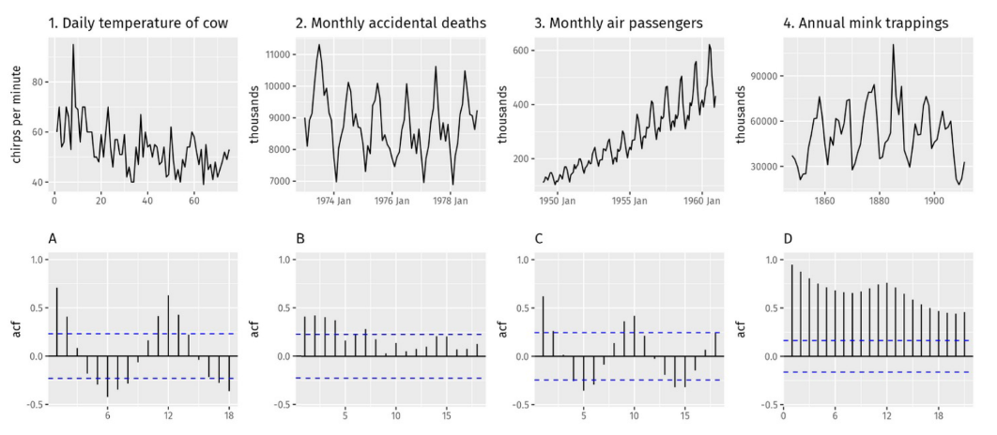

1-B, 2-A, 3-D, 4-C

## Self-Study 5.3. Visualizing Time Series

#### Self-Study 5.3: Time Plots and White Noise

1. Download the file tute1.csv from GitHub, open it in Excel (or some other spreadsheet application), and review its contents. You will find four columns of information. Columns B through D each contain a quarterly series, labelled Sales, AdBudget and GDP. Sales contains the quarterly sales for a small company over the period 1981-2005. AdBudget is the advertising budget and GDP is the gross domestic product. All series have been adjusted for inflation.

* Read the data into R and store it in the variable tute1.

tute1 <- readr::read_csv("tute1.csv")  
  
head(tute1)

# A tibble: 6 × 4  
 Quarter Sales AdBudget GDP  
 <date> <dbl> <dbl> <dbl>  
1 1981-03-01 1020. 659. 252.  
2 1981-06-01 889. 589 291.  
3 1981-09-01 795 512. 291.  
4 1981-12-01 1004. 614. 292.  
5 1982-03-01 1058. 647. 279.  
6 1982-06-01 944. 602 254

* View the data set and convert it to time series.

View(tute1)  
  
mytimeseries <- tute1 %>%   
 mutate(Quarter = yearquarter(Quarter)) %>%   
 as_tsibble(index = Quarter)

* Construct time plots of each of the three series.
  + Hint: Consider using pivot_longer() and facet_grid().

mytimeseries %>%   
 pivot_longer(-Quarter, names_to="Key", values_to="Value") %>%   
 ggplot(aes(x = Quarter, y = Value, colour = Key)) +  
 geom_line() +  
 facet_grid(vars(Key), scales = "free_y")

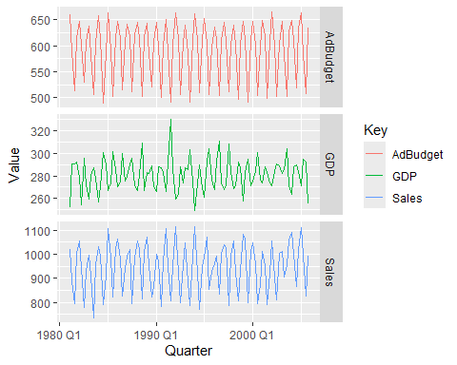

# Without faceting:  
mytimeseries %>%   
 pivot_longer(-Quarter, names_to="Key", values_to="Value") %>%   
 ggplot(aes(x = Quarter, y = Value, colour = Key)) +  
 geom_line()

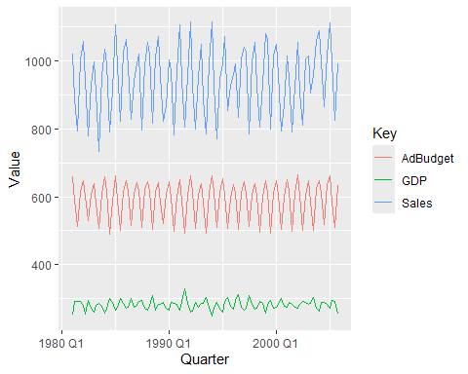

2. The aus_livestock data contains the monthly total number of pigs slaughtered in Victoria, Australia, from Jul 1972 to Dec 2018.

head(aus_livestock)

# A tsibble: 6 x 4 [1M]  
# Key: Animal, State [1]  
 Month Animal State Count  
 <mth> <fct> <fct> <dbl>  
1 1976 Jul Bulls, bullocks and steers Australian Capital Territory 2300  
2 1976 Aug Bulls, bullocks and steers Australian Capital Territory 2100  
3 1976 Sep Bulls, bullocks and steers Australian Capital Territory 2100  
4 1976 Okt Bulls, bullocks and steers Australian Capital Territory 1900  
5 1976 Nov Bulls, bullocks and steers Australian Capital Territory 2100  
6 1976 Dez Bulls, bullocks and steers Australian Capital Territory 1800

* Use filter() to extract pig slaughters in Victoria between 1990 and 1995.
  + Hint: Use the dplyr function between() to access the years between 1990 and 1995.
  + Hint: The column Month is a time object of class yearmonth. You can access the year in a yearmonth object x by year(x).

vic_pigs <- aus_livestock %>%   
 filter(Animal == "Pigs",   
 State == "Victoria",   
 between(year(Month), 1990, 1995))  
head(vic_pigs)

# A tsibble: 6 x 4 [1M]  
# Key: Animal, State [1]  
 Month Animal State Count  
 <mth> <fct> <fct> <dbl>  
1 1990 Jan Pigs Victoria 76000  
2 1990 Feb Pigs Victoria 78100  
3 1990 Mär Pigs Victoria 77600  
4 1990 Apr Pigs Victoria 84100  
5 1990 Mai Pigs Victoria 98000  
6 1990 Jun Pigs Victoria 89100

* Use autoplot() and ACF() for this data.

vic_pigs %>%   
 autoplot(Count)

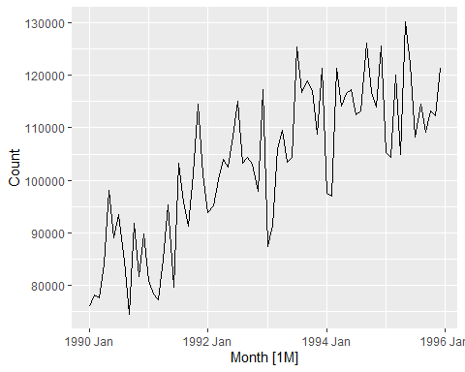

# Although the values appear to vary erratically between months, a general upward trend is evident between 1990 and 1995. In contrast, a white noise plot does not exhibit any trend.

* How do they differ from white noise?

vic_pigs %>%   
 ACF(Count) %>%   
 autoplot()

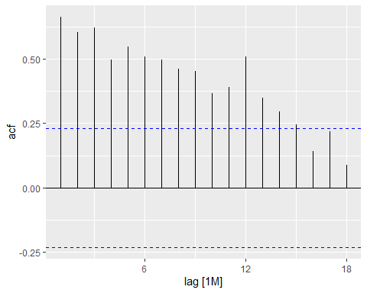

# The first 14 lags are significant, as the ACF slowly decays. This suggests that the data contains a trend. A white noise ACF plot would not usually contain any significant lags. The large spike at lag 12 suggests there is some seasonality in the data.

* If a longer period of data is used, what difference does it make to the ACF?

aus_livestock |>  
 filter(Animal == "Pigs", State == "Victoria") |>  
 ACF(Count) |>  
 autoplot()

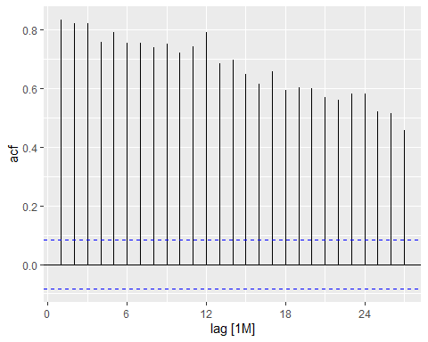

# The longer series has much larger autocorrelations, plus clear evidence of seasonality at the seasonal lags of 12, 24, ....