1.

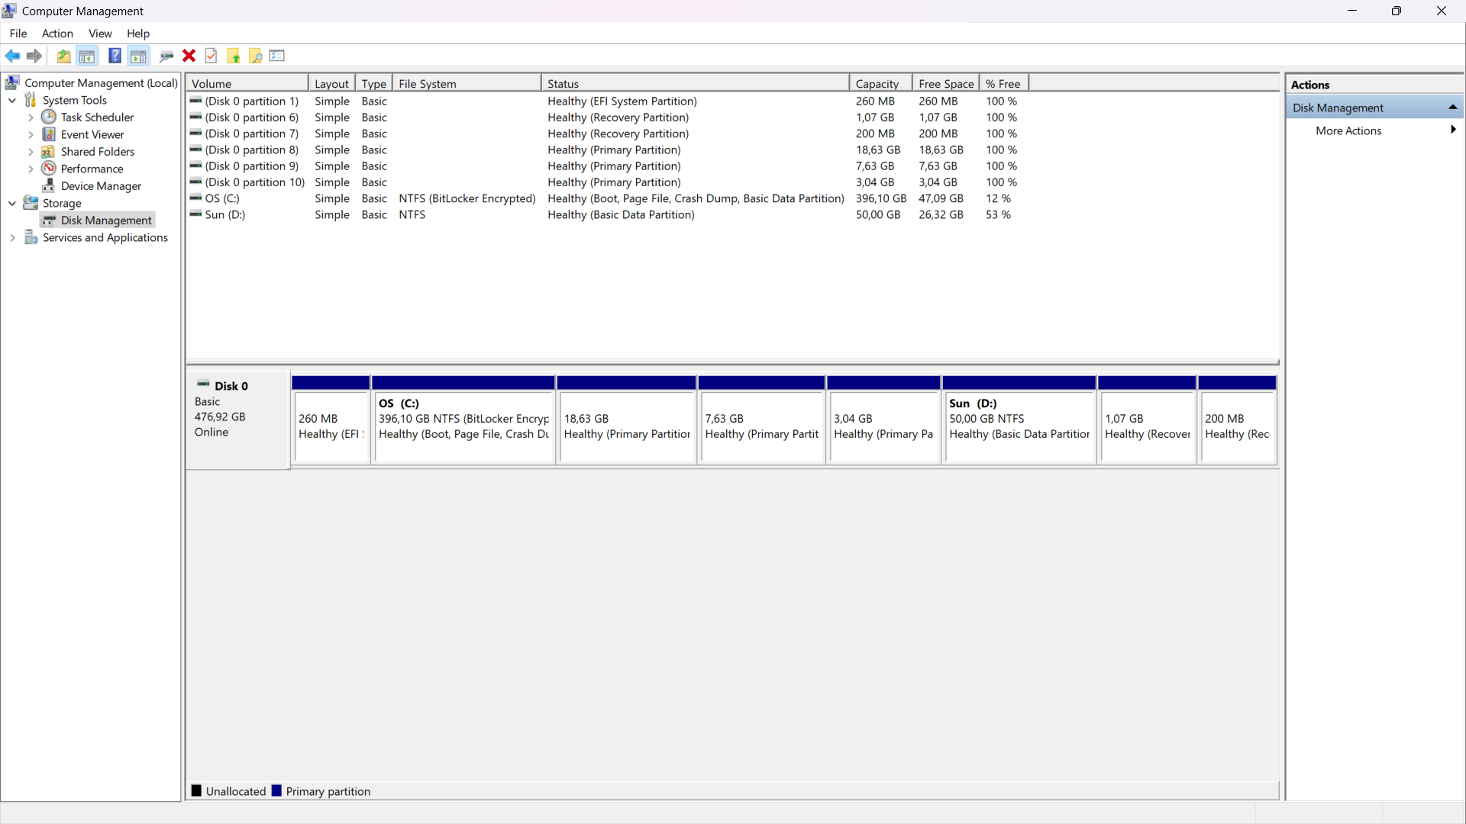

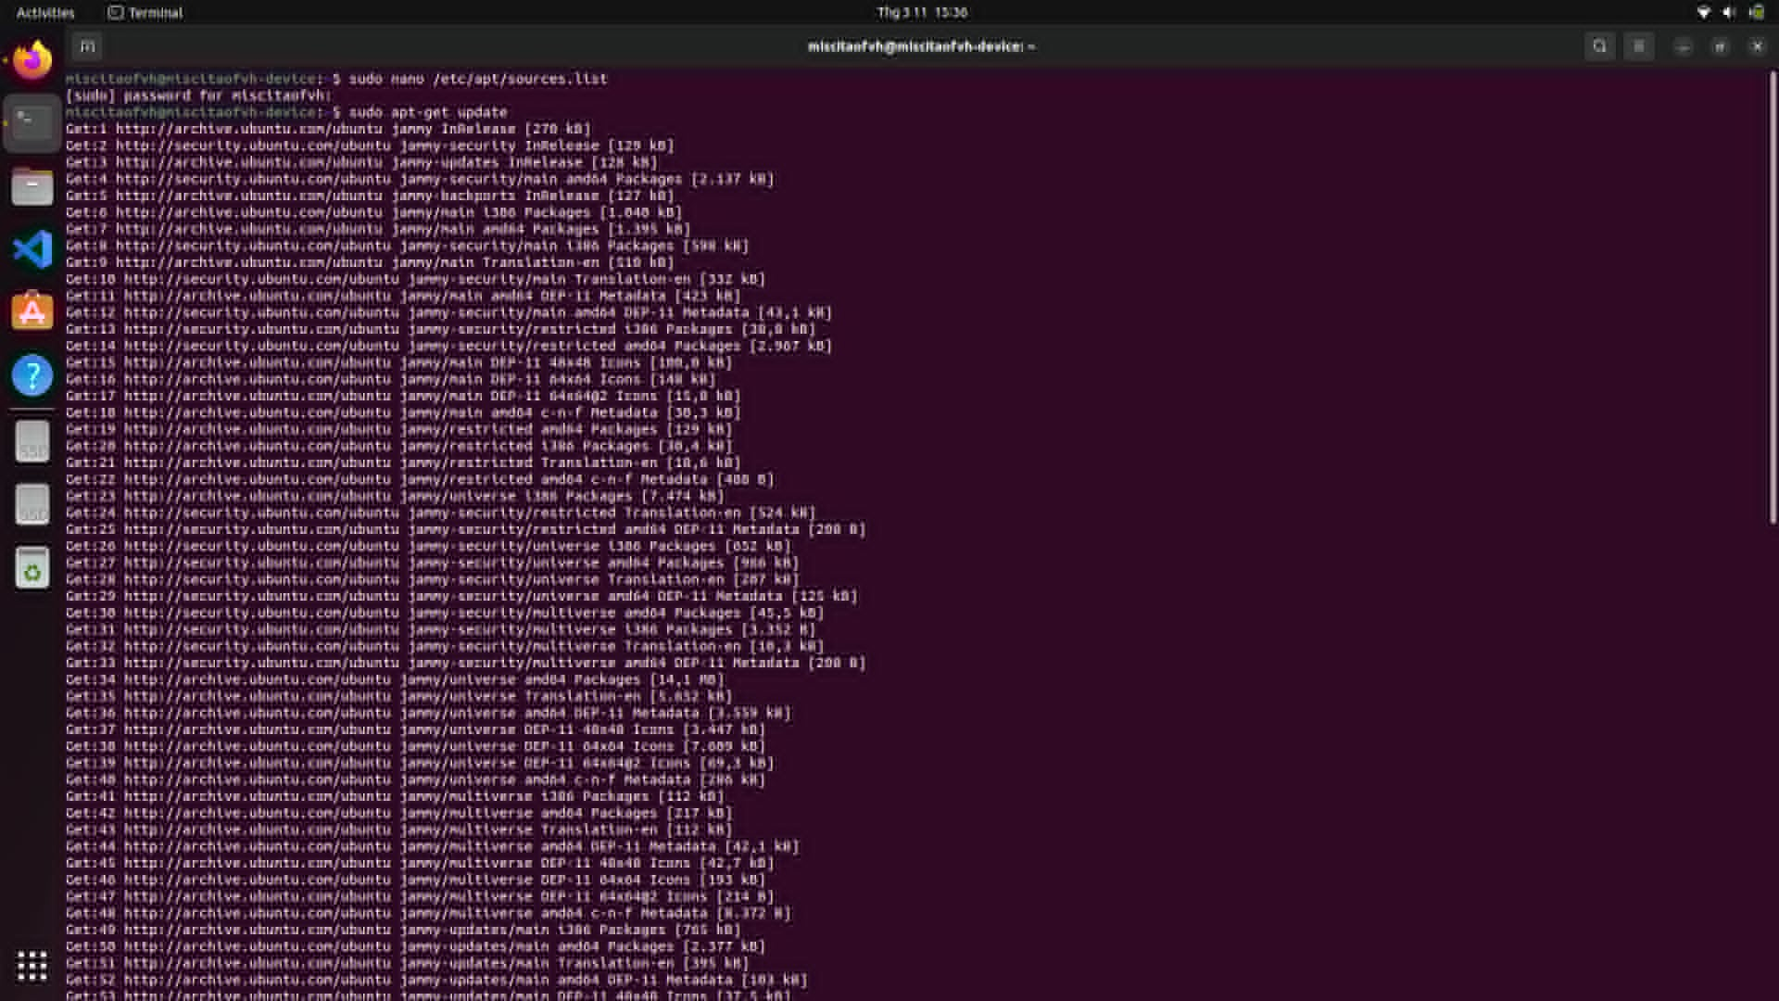

2.

