Họ tên: Nguyễn Văn Hưng

MSSV: 23520569

1. **Gcc**

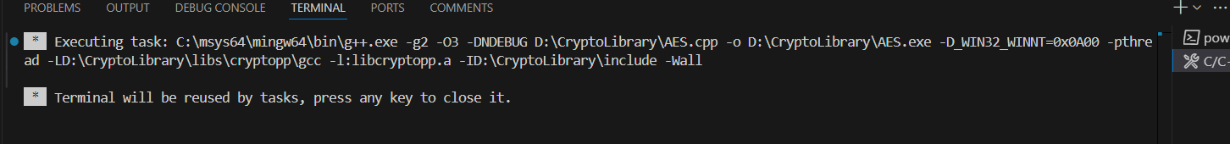



1. **Clang**

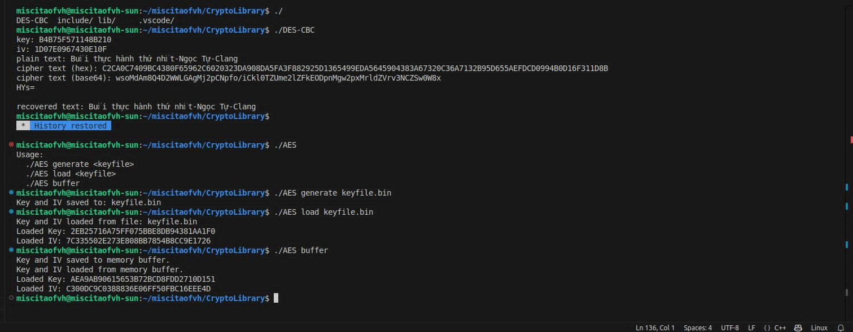

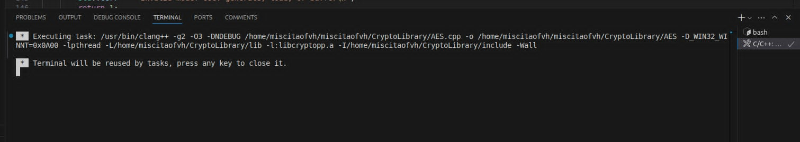

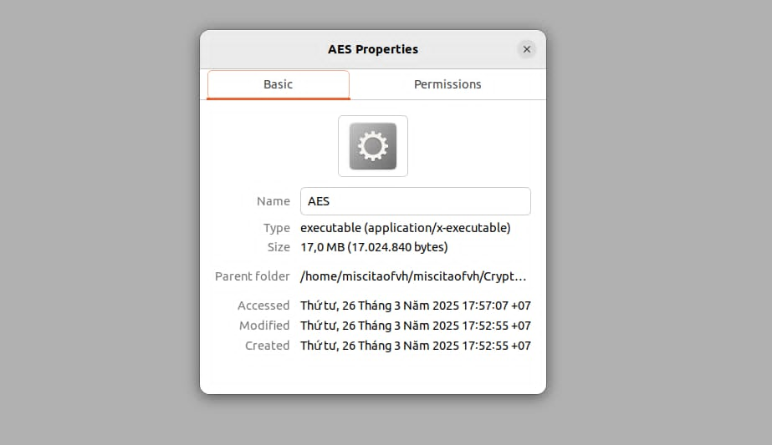

1. **Msvc**

