Week 5 Tic-Tac-PyNum
Shawn T Storm
Colorado State University Global
CSC 484: Advanced Topics in Software Development with Python
Prof. Cooper
Program Overview:
This project is a two-player-style Tic-Tac-Toe game where the user plays against the computer. The human player uses X, while the computer, represented as WOPR, automatically plays O. The game board is stored as a 3x3 NumPy array, and each button on the graphical interface corresponds to a specific [row, column] position in that array. This allows the program to meet the NumPy requirements of the assignment while giving the user a point-and-click interface instead of requiring row and column values to be typed manually.
The program also uses object-oriented programming concepts from this module. A general [Player] class is used as the parent class, while [HumanPlayer] and [WOPRPlayer] inherit from it. Both player types use the same [choose_move()] method, but each handles that method differently. The human player's move comes from the square selected on the screen, while WOPR examines the current NumPy board and chooses its own move. This provides a practical example of both inheritance and polymorphism within the same program.
The visual design intentionally borrows elements from the 1983 film WarGames, which centered on computers, programming, early computer security, and the fictional WOPR system. The startup message, Dr. Falken reference, game-selection screen, and the Thermo-Nuclear War option are included as a light reference to the movie rather than as part of the game logic itself (Badham, 1983). The interface also uses an older Windows-style appearance and a board inspired by the look of classic Minesweeper, giving the program a nostalgic theme while keeping the actual controls simple and functional.

PseudoCode:
BEGIN PROGRAM

IMPORT NumPy
IMPORT Tkinter

CREATE Player parent class
STORE player symbol

DEFINE choose_move()
This method will be handled differently by each child class

CREATE HumanPlayer class that inherits from Player

DEFINE choose_move(board, row, column)
IF selected board position is empty
RETURN selected row and column
ELSE
RETURN invalid move

CREATE WOPRPlayer class that inherits from Player

DEFINE choose_move(board)

CREATE list of all empty board positions

CHECK each empty position
TEMPORARILY place O in position

IF WOPR would win
REMOVE temporary move
RETURN that position

REMOVE temporary move

CHECK each empty position again
TEMPORARILY place X in position

IF human player would win
REMOVE temporary move
RETURN that position to block player

REMOVE temporary move

IF center position is empty
RETURN center position

CHECK opposite corner opportunities
IF human occupies one corner
AND opposite corner is empty
RETURN opposite corner

CREATE list of corner positions

FOR each corner
IF corner is empty
RETURN that corner

CREATE list of edge positions

FOR each edge
IF edge is empty
RETURN that edge

RETURN first remaining empty position

CREATE TicTacToeGame class

DEFINE initialization

CREATE main Tkinter window

CREATE HumanPlayer using X
CREATE WOPRPlayer using O

CREATE 3x3 NumPy array filled with blank spaces

SET current player to HumanPlayer

SET consecutive draw counter to 0

CREATE list for GUI buttons

DISPLAY startup screen

DEFINE startup screen

CLEAR current window

DISPLAY WOPR title

DISPLAY:
"Hello, Dr. Falken."

DISPLAY:
"Would you like to play a game?"

DISPLAY Tic-Tac-Toe option

DISPLAY Thermo-Nuclear War option
SHOW red line through option

DISPLAY Exit option

DEFINE Thermo-Nuclear War selection

DISPLAY warning message:

"This game is no longer playable as it is a
zero-sum game with no discernible winner."

DEFINE start new Tic-Tac-Toe game

CLEAR current window

RESET NumPy board to blank 3x3 array

SET current player to HumanPlayer

CREATE status message

CREATE 3 rows and 3 columns of large buttons

FOR each row from 0 through 2
FOR each column from 0 through 2

CREATE button for that position

CONNECT button to:
handle_human_move(row, column)

STORE button in button list

DISPLAY current status:
"Dr. Falken, select a square."

DEFINE handle_human_move(row, column)

IF current player is not HumanPlayer
RETURN

ASK HumanPlayer to choose selected move

IF selected NumPy position is already occupied
DISPLAY:
"That square is already occupied."
RETURN

PLACE X in NumPy board[row, column]

UPDATE matching GUI button to show X

DISABLE selected button

DISPLAY:
"Selected position: [row, column]"

CHECK whether X has won

IF X has won
RESET consecutive draw counter to 0
DISPLAY human victory message
END current game
RETURN

CHECK whether board is a draw

IF draw
HANDLE draw
RETURN

SET current player to WOPRPlayer

DISPLAY:
"WOPR is considering its move..."

SCHEDULE WOPR move after short delay

DEFINE handle_wopr_move()

ASK WOPRPlayer to choose move using current NumPy board

RECEIVE row and column

PLACE O in NumPy board[row, column]

UPDATE matching GUI button to show O

DISABLE selected button

DISPLAY:
"WOPR selected position: [row, column]"

CHECK whether O has won

IF O has won
RESET consecutive draw counter to 0
DISPLAY WOPR victory message
END current game
RETURN

CHECK whether board is a draw

IF draw
HANDLE draw
RETURN

SET current player back to HumanPlayer

DISPLAY:
"Dr. Falken, select a square."

DEFINE check_winner(player_symbol)

FOR each row in NumPy board
GET all values in row

IF every value equals player_symbol
RETURN True

FOR each column in NumPy board
GET all values in column

IF every value equals player_symbol
RETURN True

CREATE first diagonal using:
board[0,0]
board[1,1]
board[2,2]

IF every value in first diagonal equals player_symbol
RETURN True

CREATE second diagonal using:
board[0,2]
board[1,1]
board[2,0]

IF every value in second diagonal equals player_symbol
RETURN True

RETURN False

DEFINE check_draw()

IF no blank spaces remain in NumPy board
AND X has not won
AND O has not won

RETURN True

ELSE
RETURN False

DEFINE handle_draw()

ADD 1 to consecutive draw counter

IF consecutive draw counter is less than 3

DISPLAY draw message

OFFER option to play again

ELSE

START WOPR analysis sequence

DEFINE WOPR analysis sequence

CLEAR game board

DISPLAY WOPR analysis screen

CREATE list of analysis messages:

"ANALYZING GAME HISTORY..."

"GAME 1: DRAW"
"GAME 2: DRAW"
"GAME 3: DRAW"

"REVIEWING POSSIBLE OUTCOMES..."

"TESTING STRATEGIES..."

"SEARCHING FOR WINNING PATH..."

"NO DECISIVE PATH FOUND..."

"CONCLUSION:"

"Dr. Falken, this game is much like Thermo-Nuclear War..."

"There is no winner."

SET current analysis line to first line

CALL function to display lines one at a time

DEFINE display next analysis line

IF another line remains

DISPLAY current line

IF line is blank
USE short delay

ELSE IF line contains "ANALYZING"
USE longer delay

ELSE IF line contains "CONCLUSION"
USE longer delay

ELSE IF line contains "Dr. Falken"
USE longer delay

ELSE IF line equals "There is no winner."
USE longest delay

ELSE
USE normal delay

MOVE to next line

SCHEDULE display of next line

ELSE

DISPLAY button:
"Return to Game Menu"

DEFINE return to menu

RESET consecutive draw counter

DISPLAY startup screen

DEFINE exit program

CLOSE application

CREATE TicTacToeGame object

START Tkinter main event loop

END PROGRAM

Program Code:
"""
CSC 484 - Module 5
Tic-Tac-Toe with NumPy, Inheritance, and Polymorphism

This program uses:
1. NumPy to store and evaluate a 3x3 tic-tac-toe board.
2. Tkinter to create a point-and-click graphical user interface.
3. Inheritance through a shared Player parent class.
4. Polymorphism because HumanPlayer and WOPRPlayer both implement
choose_move() differently.
5. A main application class to keep the game state and GUI together.

The game intentionally favors readable coursework over highly compressed code.
A few sections take a longer, very explicit route so the logic is easy to
follow and still leaves room for later refactoring as more Python is learned.
"""

# -----------------------------------------------------------------------------
# SECTION 1 - IMPORTS
# -----------------------------------------------------------------------------
import tkinter as tk
from tkinter import messagebox
import numpy as np

# -----------------------------------------------------------------------------
# SECTION 2 - PLAYER CLASSES: INHERITANCE AND POLYMORPHISM
# -----------------------------------------------------------------------------
class Player:
"""Parent class containing information shared by every player type."""

def __init__(self, name, symbol):
self.name = name
self.symbol = symbol

def choose_move(self, board, row=None, column=None):
"""Subclasses provide their own version of how a move is selected."""
raise NotImplementedError("Subclasses must define choose_move().")

class HumanPlayer(Player):
"""Represents Dr. Falken, who chooses a move by clicking the GUI."""

def choose_move(self, board, row=None, column=None):
# The human move already comes from a GUI click. This method simply
# validates the selected NumPy position and returns it if it is legal.
if row is None or column is None:
return None

if board[row, column] == " ":
return row, column

return None

class WOPRPlayer(Player):
"""Represents the computer opponent and selects its own NumPy position."""

def choose_move(self, board, row=None, column=None):
# WOPR follows a simple strategy rather than choosing a random square.
# The steps are intentionally written out so each decision is visible.

# Step 1: If WOPR can win immediately, take that move.
winning_move = self.find_winning_move(board, self.symbol)
if winning_move is not None:
return winning_move

# Step 2: If the human can win next turn, block that square.
blocking_move = self.find_winning_move(board, "X")
if blocking_move is not None:
return blocking_move

# Step 3: Prefer the center when it is available.
if board[1, 1] == " ":
return 1, 1

# Step 4: If the human owns a corner and the opposite corner is open,
# WOPR takes the opposite corner. This helps reduce simple fork setups.
opposite_corner_pairs = [
((0, 0), (2, 2)),
((2, 2), (0, 0)),
((0, 2), (2, 0)),
((2, 0), (0, 2))
]

for human_corner, opposite_corner in opposite_corner_pairs:
human_row, human_column = human_corner
opposite_row, opposite_column = opposite_corner

if board[human_row, human_column] == "X":
if board[opposite_row, opposite_column] == " ":
return opposite_row, opposite_column

# Step 5: Try each corner in a fixed order.
corners = [(0, 0), (0, 2), (2, 0), (2, 2)]

for corner in corners:
corner_row, corner_column = corner
if board[corner_row, corner_column] == " ":
return corner_row, corner_column

# Step 6: If no corner is open, try the edge squares.
edges = [(0, 1), (1, 0), (1, 2), (2, 1)]

for edge in edges:
edge_row, edge_column = edge
if board[edge_row, edge_column] == " ":
return edge_row, edge_column

# If no squares remain, there is no legal move.
return None

def find_winning_move(self, board, symbol):
"""Return a move that makes three in a row, or None if none exists."""

# We test each empty square by temporarily placing the supplied symbol.
# A tighter implementation could reduce some repetition, but the longer
# version makes the trial-and-restore process straightforward to trace.
for row in range(3):
for column in range(3):
if board[row, column] == " ":
board[row, column] = symbol

if self.board_has_winner(board, symbol):
board[row, column] = " "
return row, column

board[row, column] = " "

return None

def board_has_winner(self, board, symbol):
"""Small helper used only while WOPR evaluates possible moves."""

for row in range(3):
if np.all(board[row, :] == symbol):
return True

for column in range(3):
if np.all(board[:, column] == symbol):
return True

first_diagonal = np.array([
board[0, 0],
board[1, 1],
board[2, 2]
])

if np.all(first_diagonal == symbol):
return True

second_diagonal = np.array([
board[0, 2],
board[1, 1],
board[2, 0]
])

if np.all(second_diagonal == symbol):
return True

return False

# -----------------------------------------------------------------------------
# SECTION 3 - MAIN APPLICATION CLASS
# -----------------------------------------------------------------------------
class WOPRTicTacToe:
"""Controls the WOPR-style Tic-Tac-Toe game and Tkinter interface."""

def __init__(self, root):
"""Set up the main window, players, and first program state."""

self.root = root
self.root.title("WOPR Tic-Tac-Toe")
self.root.geometry("560x610")
self.root.resizable(False, False)

self.win95_gray = "#C0C0C0"
self.root.configure(bg=self.win95_gray)

# The assignment's game board is a real 3x3 NumPy array.
self.board = np.full((3, 3), " ", dtype="<U1")

# The two subclasses inherit name and symbol from Player, but each has
# its own choose_move() behavior. This is the polymorphism example.
self.human_player = HumanPlayer("Dr. Falken", "X")
self.wopr_player = WOPRPlayer("WOPR", "O")

# Dr. Falken always begins each round. WOPR is always Player O.
self.current_player = self.human_player

self.consecutive_draws = 0
self.game_over = False
self.wopr_thinking = False

self.square_buttons = [[None for _ in range(3)] for _ in range(3)]
self.main_frame = None

self.create_menu_bar()
self.show_start_screen()

# -------------------------------------------------------------------------
# SECTION 4 - WINDOWS 95 STYLE MENU AND STARTUP SCREEN
# -------------------------------------------------------------------------
def create_menu_bar(self):
"""Create a small Windows 95-style menu at the top of the window."""

menu_bar = tk.Menu(self.root)

file_menu = tk.Menu(menu_bar, tearoff=0)
file_menu.add_command(label="Exit", command=self.root.destroy)
menu_bar.add_cascade(label="File", menu=file_menu)

game_menu = tk.Menu(menu_bar, tearoff=0)
game_menu.add_command(label="New Tic-Tac-Toe Game", command=self.start_new_game)
game_menu.add_command(label="Return to Game Menu", command=self.show_start_screen)
menu_bar.add_cascade(label="Game", menu=game_menu)

help_menu = tk.Menu(menu_bar, tearoff=0)
help_menu.add_command(label="About", command=self.show_about_message)
menu_bar.add_cascade(label="Help", menu=help_menu)

self.root.config(menu=menu_bar)

def clear_main_frame(self):
"""Remove the current screen before drawing a different one."""

if self.main_frame is not None:
self.main_frame.destroy()

self.main_frame = tk.Frame(self.root, bg=self.win95_gray)
self.main_frame.pack(fill="both", expand=True, padx=12, pady=12)

def show_start_screen(self):
"""Display the WOPR opening screen and game choices."""

self.clear_main_frame()

terminal_frame = tk.Frame(
self.main_frame,
bg="black",
bd=4,
relief="sunken"
)
terminal_frame.pack(fill="both", expand=True, padx=18, pady=18)

title_label = tk.Label(
terminal_frame,
text="WOPR GAME SYSTEM",
bg="black",
fg="#00FF66",
font=("Courier", 18, "bold")
)
title_label.pack(pady=(40, 30))

hello_label = tk.Label(
terminal_frame,
text="Hello, Dr. Falken.",
bg="black",
fg="#00FF66",
font=("Courier", 14)
)
hello_label.pack(pady=8)

question_label = tk.Label(
terminal_frame,
text="Would you like to play a game?",
bg="black",
fg="#00FF66",
font=("Courier", 14)
)
question_label.pack(pady=(0, 30))

tic_tac_toe_button = tk.Button(
terminal_frame,
text="TIC-TAC-TOE",
command=self.start_new_game,
width=24,
bg=self.win95_gray,
activebackground="#D4D0C8",
relief="raised",
bd=4,
font=("Arial", 10, "bold")
)
tic_tac_toe_button.pack(pady=10)

thermo_button = tk.Button(
terminal_frame,
text="THERMO-NUCLEAR WAR",
command=self.show_thermonuclear_warning,
width=24,
bg=self.win95_gray,
fg="red",
activebackground="#D4D0C8",
relief="raised",
bd=4,
font=("Arial", 10, "bold", "overstrike")
)
thermo_button.pack(pady=10)

exit_button = tk.Button(
terminal_frame,
text="EXIT",
command=self.root.destroy,
width=12,
bg=self.win95_gray,
relief="raised",
bd=4
)
exit_button.pack(pady=(30, 10))

def show_thermonuclear_warning(self):
"""Show the warning attached to the crossed-out game choice."""

messagebox.showwarning(
"WOPR Warning",
"This game is no longer playable as it is a 0 sum game with no discernable winner."
)

def show_about_message(self):
"""Display a short description of the program."""

messagebox.showinfo(
"About WOPR Tic-Tac-Toe",
"CSC 484 Module 5\n\n"
"A point-and-click Tic-Tac-Toe game using NumPy, inheritance, "
"and polymorphism."
)

# -------------------------------------------------------------------------
# SECTION 5 - BUILDING AND RESETTING THE GAME BOARD
# -------------------------------------------------------------------------
def start_new_game(self):
"""Create a fresh NumPy board and draw a new 3x3 GUI game board."""

self.board = np.full((3, 3), " ", dtype="<U1")
self.current_player = self.human_player
self.game_over = False
self.wopr_thinking = False

self.clear_main_frame()

game_title = tk.Label(
self.main_frame,
text="WOPR TIC-TAC-TOE",
bg=self.win95_gray,
font=("Arial", 18, "bold")
)
game_title.pack(pady=(10, 5))

self.status_label = tk.Label(
self.main_frame,
text="Dr. Falken (X): Select a square",
bg=self.win95_gray,
font=("Arial", 11, "bold"),
relief="sunken",
bd=2,
anchor="w",
padx=8
)
self.status_label.pack(fill="x", padx=20, pady=(5, 15))

board_frame = tk.Frame(self.main_frame, bg=self.win95_gray)
board_frame.pack(pady=5)

for row in range(3):
for column in range(3):
square_button = tk.Button(
board_frame,
text="",
width=7,
height=3,
bg=self.win95_gray,
activebackground="#D4D0C8",
relief="raised",
bd=6,
font=("Arial", 26, "bold"),
command=lambda r=row, c=column: self.handle_human_click(r, c)
)

square_button.grid(row=row, column=column, padx=2, pady=2)
self.square_buttons[row][column] = square_button

self.coordinate_label = tk.Label(
self.main_frame,
text="Selected position: [--, --]",
bg=self.win95_gray,
font=("Courier", 11)
)
self.coordinate_label.pack(pady=(14, 4))

control_frame = tk.Frame(self.main_frame, bg=self.win95_gray)
control_frame.pack(pady=12)

new_game_button = tk.Button(
control_frame,
text="New Game",
command=self.start_new_game,
width=12,
relief="raised",
bd=4,
bg=self.win95_gray
)
new_game_button.grid(row=0, column=0, padx=8)

menu_button = tk.Button(
control_frame,
text="Game Menu",
command=self.show_start_screen,
width=12,
relief="raised",
bd=4,
bg=self.win95_gray
)
menu_button.grid(row=0, column=1, padx=8)

exit_button = tk.Button(
control_frame,
text="Exit",
command=self.root.destroy,
width=12,
relief="raised",
bd=4,
bg=self.win95_gray
)
exit_button.grid(row=0, column=2, padx=8)

# -------------------------------------------------------------------------
# SECTION 6 - HUMAN AND WOPR MOVES
# -------------------------------------------------------------------------
def handle_human_click(self, row, column):
"""Process Dr. Falken's GUI click and then give WOPR its turn."""

if self.game_over or self.wopr_thinking:
return

# The HumanPlayer subclass handles the human version of choose_move().
selected_move = self.human_player.choose_move(self.board, row, column)

if selected_move is None:
self.status_label.config(
text=f"Square [{row}, {column}] is already occupied. Choose another square."
)
return

selected_row, selected_column = selected_move
self.apply_move(self.human_player, selected_row, selected_column)

if self.check_for_winner(self.human_player.symbol):
self.finish_with_winner(self.human_player)
return

if self.check_for_draw():
self.finish_with_draw()
return

# Prevent another click while WOPR is selecting its response.
self.wopr_thinking = True
self.status_label.config(text="WOPR (O): Evaluating board...")
self.disable_open_squares()

# after() creates a short pause so the computer move feels deliberate
# and keeps the interface responsive while we wait.
self.root.after(650, self.make_wopr_move)

def make_wopr_move(self):
"""Ask the WOPRPlayer subclass to choose and perform its move."""

if self.game_over:
return

# Same method name as HumanPlayer, different behavior. WOPR receives
# the board and determines its own row and column automatically.
selected_move = self.wopr_player.choose_move(self.board)

if selected_move is None:
# This should normally mean the board is full, but the explicit
# check makes the program safer and easier to follow.
if self.check_for_draw():
self.finish_with_draw()
return

selected_row, selected_column = selected_move
self.apply_move(self.wopr_player, selected_row, selected_column)

if self.check_for_winner(self.wopr_player.symbol):
self.finish_with_winner(self.wopr_player)
return

if self.check_for_draw():
self.finish_with_draw()
return

self.wopr_thinking = False
self.enable_open_squares()
self.status_label.config(text="Dr. Falken (X): Select a square")

def apply_move(self, player, row, column):
"""Store one player's move in NumPy and update the matching GUI button."""

self.board[row, column] = player.symbol

self.square_buttons[row][column].config(
text=player.symbol,
relief="sunken",
state="disabled",
disabledforeground="black"
)

self.coordinate_label.config(
text=f"{player.name} selected position: [{row}, {column}]"
)

# -------------------------------------------------------------------------
# SECTION 7 - WIN AND DRAW CHECKS USING NUMPY
# -------------------------------------------------------------------------
def check_for_winner(self, symbol):
"""Return True when the supplied symbol has three matching squares."""

# Check the three horizontal rows.
for row in range(3):
row_values = self.board[row, :]

if np.all(row_values == symbol):
return True

# Check the three vertical columns.
for column in range(3):
column_values = self.board[:, column]

if np.all(column_values == symbol):
return True

# The diagonal checks intentionally spell out the coordinates rather
# than using the shorter np.diag() approach. It is still correct, but
# it leaves an obvious future refactoring opportunity.
first_diagonal = np.array([
self.board[0, 0],
self.board[1, 1],
self.board[2, 2]
])

if np.all(first_diagonal == symbol):
return True

second_diagonal = np.array([
self.board[0, 2],
self.board[1, 1],
self.board[2, 0]
])

if np.all(second_diagonal == symbol):
return True

return False

def check_for_draw(self):
"""Return True only when every NumPy square is filled without a win."""

board_is_full = np.all(self.board != " ")

if board_is_full:
return True
else:
return False

# -------------------------------------------------------------------------
# SECTION 8 - NORMAL GAME ENDINGS AND BUTTON CONTROL
# -------------------------------------------------------------------------
def finish_with_winner(self, player):
"""Stop the round, announce the winner, and reset the draw streak."""

self.game_over = True
self.wopr_thinking = False
self.consecutive_draws = 0
self.disable_all_squares()

if player is self.human_player:
winner_message = "Dr. Falken wins."
else:
winner_message = "WOPR wins."

self.status_label.config(text=winner_message)
messagebox.showinfo("Game Complete", winner_message)

def finish_with_draw(self):
"""Handle a draw and start the WOPR analysis after three in a row."""

self.game_over = True
self.wopr_thinking = False
self.consecutive_draws = self.consecutive_draws + 1

self.status_label.config(
text=f"Draw. Consecutive draws: {self.consecutive_draws}"
)
self.disable_all_squares()

if self.consecutive_draws < 3:
messagebox.showinfo(
"Draw",
f"The game is a draw.\n\nConsecutive draws: {self.consecutive_draws}"
)
self.start_new_game()
else:
self.root.after(700, self.start_wopr_analysis)

def disable_all_squares(self):
"""Disable every square after a round ends."""

for row in range(3):
for column in range(3):
self.square_buttons[row][column].config(state="disabled")

def disable_open_squares(self):
"""Temporarily disable open squares while WOPR is thinking."""

for row in range(3):
for column in range(3):
if self.board[row, column] == " ":
self.square_buttons[row][column].config(state="disabled")

def enable_open_squares(self):
"""Re-enable only squares that are still empty after WOPR's turn."""

for row in range(3):
for column in range(3):
if self.board[row, column] == " ":
self.square_buttons[row][column].config(state="normal")

# -------------------------------------------------------------------------
# SECTION 9 - THREE-DRAW WOPR ANALYSIS SEQUENCE
# -------------------------------------------------------------------------
def start_wopr_analysis(self):
"""Display a deliberately simple line-by-line WOPR learning sequence."""

self.clear_main_frame()

analysis_frame = tk.Frame(
self.main_frame,
bg="black",
bd=4,
relief="sunken"
)
analysis_frame.pack(fill="both", expand=True, padx=10, pady=10)

analysis_title = tk.Label(
analysis_frame,
text="WOPR STRATEGIC GAME ANALYSIS",
bg="black",
fg="#00FF66",
font=("Courier", 14, "bold")
)
analysis_title.pack(pady=(16, 8))

self.analysis_text = tk.Text(
analysis_frame,
width=58,
height=24,
bg="black",
fg="#00FF66",
insertbackground="#00FF66",
font=("Courier", 10),
relief="flat",
wrap="word"
)
self.analysis_text.pack(padx=14, pady=8)
self.analysis_text.config(state="disabled")

self.analysis_lines = [
"ACCESSING RECENT GAME HISTORY...",
"GAME 1 RESULT: DRAW",
"GAME 2 RESULT: DRAW",
"GAME 3 RESULT: DRAW",
"",
"BEGINNING STRATEGIC REVIEW...",
"REPLAYING HUMAN OPENING MOVES...",
"REPLAYING WOPR RESPONSE PATTERNS...",
"TESTING CENTER CONTROL...",
"RESULT: NO FORCED WIN FOUND",
"TESTING CORNER CONTROL...",
"RESULT: NO FORCED WIN FOUND",
"TESTING EDGE CONTROL...",
"RESULT: NO FORCED WIN FOUND",
"",
"COMPARING RESPONSE PATTERNS...",
"CHECKING OFFENSIVE PATHS...",
"CHECKING DEFENSIVE PATHS...",
"CHECKING BLOCKING PATHS...",
"CHECKING REPEATED OUTCOMES...",
"",
"NO DECISIVE ADVANTAGE DETECTED.",
"NO RELIABLE WINNING PATH DETECTED.",
"",
"CONCLUSION:",
"Dr. Falken, this game is much like Thermo-Nuclear War...",
"There is no winner."
]

self.analysis_line_number = 0
self.write_next_analysis_line()

def write_next_analysis_line(self):
"""Write one analysis line, then schedule the next line."""

if self.analysis_line_number < len(self.analysis_lines):
line_to_write = self.analysis_lines[self.analysis_line_number]

self.analysis_text.config(state="normal")
self.analysis_text.insert("end", line_to_write + "\n")
self.analysis_text.see("end")
self.analysis_text.config(state="disabled")

self.analysis_line_number = self.analysis_line_number + 1

# This could be replaced by a timing dictionary or a more general
# animation helper. The longer if/elif version remains readable
# and shows exactly why different lines pause for different times.
if line_to_write == "":
delay = 250
elif "ACCESSING" in line_to_write:
delay = 700
elif "BEGINNING" in line_to_write:
delay = 700
elif "REPLAYING" in line_to_write:
delay = 600
elif "CONCLUSION" in line_to_write:
delay = 900
elif "Dr. Falken" in line_to_write:
delay = 1000
elif line_to_write == "There is no winner.":
delay = 1200
else:
delay = 550

self.root.after(delay, self.write_next_analysis_line)
else:
self.show_analysis_return_button()

def show_analysis_return_button(self):
"""Add the final return button after the analysis crawl finishes."""

return_button = tk.Button(
self.main_frame,
text="Return to Game Menu",
command=self.return_from_analysis,
width=22,
bg=self.win95_gray,
relief="raised",
bd=4
)
return_button.pack(pady=(0, 10))

def return_from_analysis(self):
"""Reset the draw streak and return to the startup screen."""

self.consecutive_draws = 0
self.show_start_screen()

# -----------------------------------------------------------------------------
# SECTION 10 - PROGRAM START
# -----------------------------------------------------------------------------
if __name__ == "__main__":
root = tk.Tk()
app = WOPRTicTacToe(root)
root.mainloop()

Screenshots:
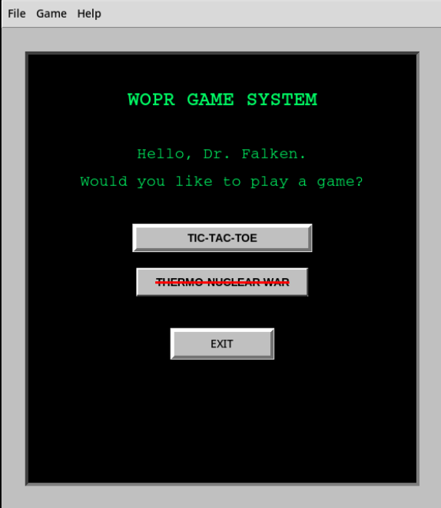
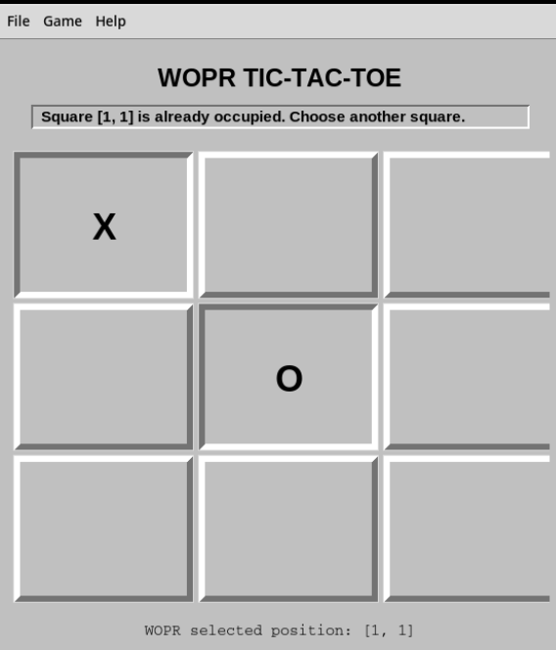

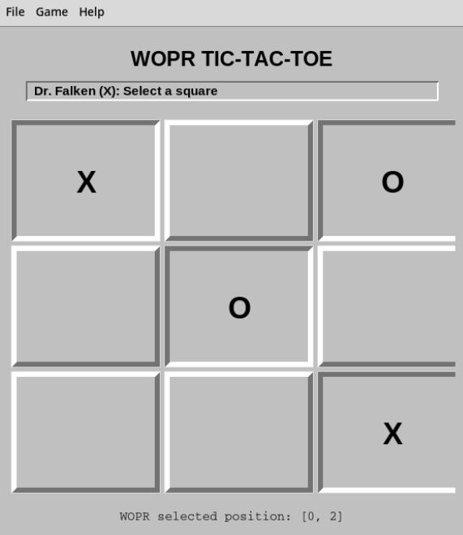
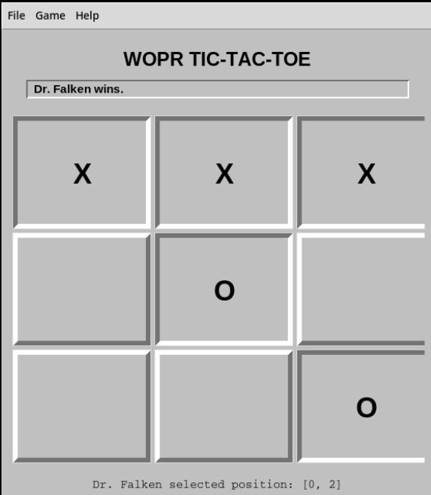
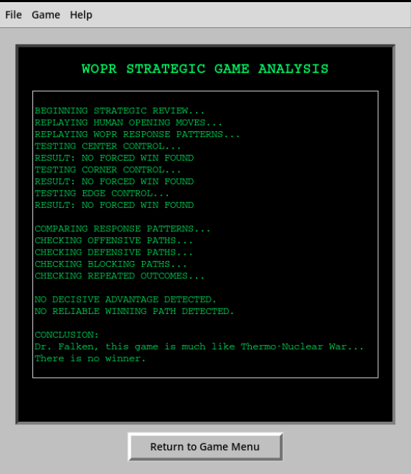

GitHub Link:
https://github.com/miscney1/CSC484_Week5_Tic-Tac-Toe

