Why OWS Should Endorse A Constitutional Amendment to end corporate personhood
- A Constitutional Amendment to end corporate personhood will reverse the Supreme Court’s insideous Citizens United decision, ending the absurd legal fiction that corporations are persons.
- The General Assembly’s OWS Declaration of the Occupation of New York City states that a democratic government derives its just power from the people, not from corporations.
- In the the ABC/Washington Post poll –
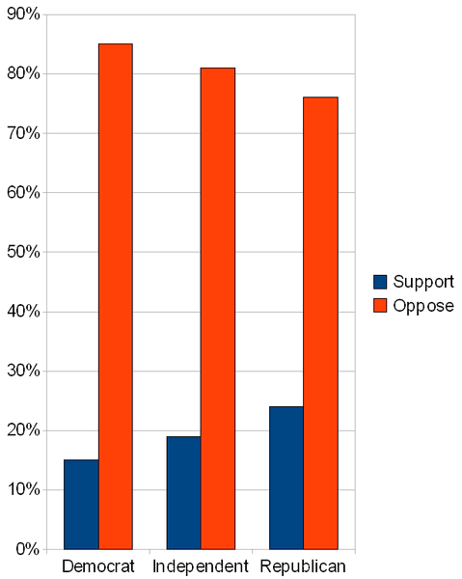
Ver 5.2
85% of Democrats oppose Citizens United.
83%
^{of Americans}
81% of independents oppose Citizens United.
76% of Republicans oppose Citizens United.
Dem
86%
Ind
81%
Rep
76%
So if OWS endorses this amendment,
OWS will gain immediate widespread
support across the political spectrum !
Starting with 83% support means that we
begin our quest – requiring no efforts or
time wasted “educating” or “convincing”
- In the the PFAW Poll -
85% of voters say that corporations have
too much influence over the political system today.
77% think Congress should support an amendment
to limit the amount corporations can spend on elections.
74% say that they would be more likely to vote
for a candidate for Congress who pledged to support
a Constitutional Amendment limiting corporate spending in elections.

No other OWS goal or demand starts with this kind of overwhelming support.

- The Prohibition movement started as a disjointed effort by conservative teetotalers who thought the consumption of alcohol was immoral. They remained a minority until they sought support from the liberals - many of whom considered alcohol partially responsible for spousal and child abuse. Together, they decided to concentrate on one issue nationally - a constitutional amendment. They pressured all politicians to sign a pledge to support the amendment. Any who did not, they defeated easily at the ballot box. Within just 17 months they were successful in getting ¾ of the state legislatures to ratify the constitutional amendment into law. Eight other amendments took less than a year to pass and the 26th, granting 18-year-olds the right to vote, took less than 4 months.
- A Constitutional Amendment to end corporate personhood will be relatively easy to pass using the unified approach in the Prohibition amendment model– and taking advantage of the pre-existing 83% support.
- A Constitutional Amendment to end corporate personhood will immediately overturn court decisions like Citizens United that have handed our political system and our politicians over to the rich organizations.
- A Constitutional Amendment to end corporate personhood will enable additional, powerful campaign finance laws that will get big and anonymous money out of politics, sapping the power of the plutocracy to control the peoples’ elections, the peoples’ government and the people. Then we can elect representatives that can accurately represent the people.

Government of the people, by the people, for the people

To sum up, when OWS endorses a Constitutional Amendment to end corporate personhood,
OWS will get instant, massive support from the left, the right and the center.
The amendment will sap corrosive corporate power
We the People . . .
and enable us to elect representatives only beholden to

Join us at the Restore Democracy Working Group http://www.nycga.net/groups/restore-democracy/
See the entire plan and supporting evidence at http://bit.ly/vK2pGI .
If you agree this is a great foundational step for OWS to take, please share this link among your email lists and across all social media - and support its adoption by the OWS GA!

DEMOCRACY IS FOR SALE ONLY IF YOUR INACTION ALLOWS IT !

