The OWS Restore Democracy Plan to eliminate Corporate Personhood: ver 4.2
There are a lot of great, complicated ideas being generated at OWS – mostly with strong
pro constituencies AND strong anti constituencies. Most will be very difficult to achieve until we
get big money out of politics first and level the political playing field for the working classes. Thus, we should make OWS’s first and fundamental goal the passage of a constitutional amendment that
‘corporations are not people’
which will overturn the Citizens United, the Supreme Court decision - with polling proving
CU is opposed by 83% of Americans.
Imagine the momentum we’d get coming out of the gate with a proposal supported by such an overwhelming majority! How many other issues have this kind of built-in support?

Please oppose the GA adopting any “demands.” They will sap OWS’s energy and alienate broad segments of the public. You have seen how often we, inside OWS, can be turned off by someone advocating a position that we disagree with – dead locked on issues – this goal is virtually a freebie for OWS. Not legalize marijuana. Not tax reform. Not the Patriot act. Not electoral reform.
Simplicity and virtual national unanimity! Let’s use what we know and be smart and start with the only popular/achievable/empowering goal that is already so strongly supported. Also - and this is a critical benefit to OWS - by pursuing this constitutional amendment first, it will prove to the skeptics that we are a serious movement and will help us open their minds to our other ideas!

Meanwhile, OWS Working Groups can create a comprehensive, internally consistent, progressive platform that we will enact as soon as corporate money is drained from the corrupt political system.

Join the Restore Democracy Working Group at http://www.nycga.net/groups/restore-democracy
Plan details with supporting documentation found at: http://bit.ly/vK2pGI
Spread the word: Forward the above link to email lists/social media; post in Web forums andin comments
Please contact Rick at OWS@EcoHearth.com to offer help.

Virtually
Corporations are NOT people & money is NOT speech.
Public option & universal health care – medicare for all.
Corporations must pay a minimum tax of at least 20%.
Bush tax cuts for over $250,000 must end.
Capital gains must be taxed as income.
Stop oil company subsidies.
Eliminate recent restraints on collective bargaining.
Eliminate recent changes to restrict voting.
Impliment election & electoral reform.
Restore Glass-Steagal and banking regulations and regulators
Stop privatization of government & prisons & military.
Tax exported jobs.
Tax extra for ultra-fast stock trades ( > 1/day )
End the wars and cut the military budget.
Create an FDR type WPA & CCC & a TVA for wind farms.
Hire & train returning vets.
Arrest and try the war criminals and bank/investment criminals.
Stop using the Patriot Act to spy on Americans.
Eliminate the filibuster……………………………………

all of our

goals -

All have ONE fundamental enemy – and we must do something – quickly– to begin to disarm it. This fundamental enemy is the 5 to 4 Supreme Court decision – “Citizens United” that allows unlimited anonymous corporate money to pervert our political system – converting our nation from –
of the people, by the people for the people into of the people, by the corporations for the rich.

Because this decision was made by the Supreme Court, no law can change this as part of our legal and economic and political system. This is why our only route to reversing CU and laying the cornerstone to solve all of the above problems is to disarm our real enemy – POLITICAL GRAFT in the form of MASSIVE and ANONYMOUS campaign contributions – by passing a Constitutional

Amendment to reverse CU: “Corporations and organizations are NOT people”
This effort is not trivial – but is simply a matter of numbers – as this amendment history proves:

THE SUCCESS STORY OF THE AMENDING PROCESS
The Prohibition movement started as a disjointed effort by conservative teetotalers who thought the consumption of alcohol was immoral. They ransacked saloons and garnered press coverage here and there for a few years. Then they began to gain support from the liberals because many considered alcohol partially responsible for spousal and child abuse, among other social ills. This odd alliance, after many years of failing to influence change consistently across jurisdictions, decided to concentrate on one issue nationally—a constitutional amendment. They pressured all politicians on every level to sign a pledge to support the amendment. Any who did not, they defeated easily at the ballot box since they controlled a huge number of liberal, and conservative and independent swing votes in every election. By being a single-issue constituency attacking from all sides of the political spectrum, they very quickly amassed enough votes (2/3) to pass the amendment in Congress. And, using the same tactics, within just 17 months they were successful in getting ¾ of the state legislatures to ratify the constitutional amendment into law. (Other amendments were ratified even faster: Eight—the 7th, 12th, 13th, 15th, 17th, 20th, 21st and 26th—took less than a year. The 26th, granting 18-year-olds the right to vote, took just three months and 8 days.)

The good news - the very good news - is that the overwhelming majority of all Americas oppose Citizens United - as shown in this ABC/Washington Post Poll:
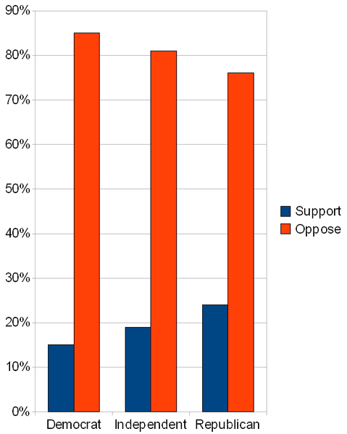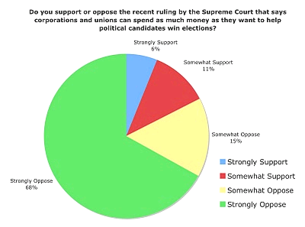

Oppose CU Total
68% + 15% = 83%
D
86%
I
81%
R
76%
83%
^{of Americans}
Thus a super-majority (83%) of all Americans – even 56% of the Tea Party - all agree !
In the the PFAW Poll -
85% of voters say that corporations have too much influence over the political system today.
77% think Congress should support an amendment to limit the amount corporations can spend on elections.
74% say that they would be more likely to vote for a candidate for Congress who pledged to support
a Constitutional Amendment limiting corporate spending in elections.
Do you see the parallels to the prohibition amendment process – where both sides got together to succeed? We don’t have to persuade Americans to accept or understand our position –
we only have to persuade them to ACT based on their own position.
Achieving this goal will make virtually every other goal – from our list - or yours - much easier to achieve – by disarming our greatest mutual enemy – A POLITICAL SYSTEM CORRUPTED BY MASSIVE & ANONYMOUS CAMPAIGN CONTRIBUTIONS AND GREED.

Ohio won. Arizona won. Maine won. Mississippi won. Using their tactics, and the tactics of the NRA, AARP and TP, who all represent minorities that have succeeded in using their voting blocks to achieve their minority goals - plus the Prohibition Amendment tactics: bringing all sides together –
is a sure path for us to succeed at this one MAJORITY task - getting money out of politics - that will enable us to reach all of our other goals to improve our nation.

The straightforwardness and pre-existing support for this goal cannot hide the massive
co-ordinated grassroots effort required. We need to leverage our momentum and start now!

The key to success is NUMBERS –
We start with the support of 83% of Americans - ARE YOU WITH US???

DEMOCRACY IS FOR SALE ONLY IF YOUR INACTION ALLOWS IT !

