Misgana Okbagaber
University of Washington

Clinical Decision Making and Pattern Recognition in Health Care

Introduction
Healthcare organizations process large amounts of patient data every day. Clinical decision-making and pattern recognition use AI and data analytics to identify health risks, support healthcare professionals, and improve Treatment, Payment, and Operations (TPO). These technologies help improve patient care while reducing costs and increasing efficiency.

Current Trends in Healthcare AI
Healthcare organizations are increasingly using artificial intelligence, machine learning, predictive analytics, and generative AI to improve patient care, clinical documentation, coding, and workflow. Although advanced AI is growing, many organizations still prefer rule-based decision support systems because they are more transparent, explainable, and easier to validate.

Opportunities and Challenges
Clinical decision support can improve efficiency by identifying high-risk patients, reducing documentation time, improving consistency, and supporting payment integrity. However, AI also faces challenges, including the need for accurate patient data, protection of patient privacy, HIPAA compliance, and ensuring that AI supports—not replaces—healthcare professionals' clinical judgment.

Proof of Concept Application
A web-based application was developed using Python and Streamlit to demonstrate clinical decision support for Treatment, Payment, and Operations. Users enter patient information, and the system calculates a clinical risk score and generates a dashboard with:
- Clinical Risk Assessment
- Clinical Reasoning Summary
- Payment Integrity Review
- Documentation Quality Review
- ICD-10 Category Suggestions
- Operations Recommendations
- Exportable Clinical Case Report
The application uses a transparent rule-based reasoning engine to provide consistent, explainable results without relying on external AI services, demonstrating how healthcare analytics can support clinical decision-making.
Figure 1. Screenshot of the Cotiviti Clinical Intelligence Platform proof of concept.
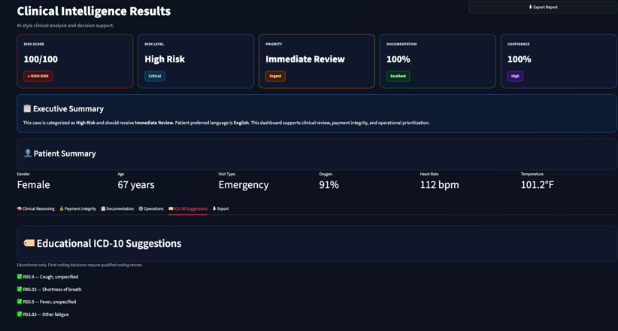

Strategic Opportunities for Cotiviti

This proof of concept shows how a single clinical intelligence platform can support Treatment, Payment, and Operations (TPO) in one system. It combines clinical risk assessment, documentation review, payment integrity, and operational recommendations to improve efficiency and reduce manual work. For Cotiviti, similar technologies could help identify documentation gaps, prioritize high-risk cases, improve communication, and integrate future features such as electronic health records, predictive analytics, multilingual support, and large language models while maintaining patient privacy and regulatory compliance.

Conclusion
Artificial intelligence is improving healthcare by helping organize, review, and analyze clinical information. Transparent clinical decision support systems remain valuable because they provide clear and consistent recommendations that healthcare professionals can understand and verify. The proof-of-concept application developed for this project demonstrates how software engineering and healthcare analytics can improve clinical review, documentation quality, payment integrity, and healthcare operations. As healthcare becomes more data-driven, these technologies

References
American Medical Association. (2024). Current Procedural Terminology (CPT®). https://www.ama-assn.org/
Centers for Medicare & Medicaid Services. (2024). Medical review and documentation requirements. https://www.cms.gov/
HealthIT.gov. (2024). Clinical decision support. https://www.healthit.gov/
World Health Organization. (2021). Ethics and governance of artificial intelligence for health. https://www.who.int/publications/i/item/9789240029200

