Form No. SP-04 Rev # 0
SALZER ELECTRONICS LIMITED -II-HOSUR PLANT
THORAPPALLI ROAD,PERANDAPALLI POST,
GST No:33AAECS3411L1Z3
DELIVERY CHALLANP
Returnablen!

To  SALZER ELECTRONICS LIMITED-II CHINNAMADAMPALAYAM  COIMBATORE  TAMIL NADU GST No:33AAECS3411L1ZJ | DC No :HP/GN23/0274  Dc Date : 26/03/2024  Party Dc  Party DcDate : 26/03/2024

010Purpose : LAPTOP SERVICE Returndate : 06/04/2024
WThrough a BY HAND DI Person Responsible For Return : prakashfl
flOke have Despatched to you the f011owing. Please acknowledge the receiptU!

S.No ItemCode Description
1 LAPTOP LAPTOP
2
3
4
5
6
7
8
Qty Unit Amount
1.000 NOS 15000.000

Total Value 15000.000
For SALZER ELECTRONICS LIMITED -II-HOSUR PLANT

T. /f---¹-4--


Recommended By
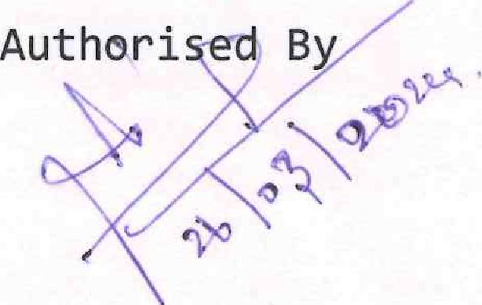
Authori ed By
Party's Signature Prepared By
ot,

