project for the subject PGR – Computer Graphics
3D game using OpenGL
Authors: Tomas Kimer, xkimer00
Tomas Sychra, xsychr03
David Sabata, xsabat01

Assignment

- Implementation of a 3D game using OpenGL and GLSL
- Goal of the game: drive an RC car model through given checkpoints on the track in the shortest time
- The basis of the scene is always a static room (e.g. only lights are lit otherwise)
- Free movement around the room (possibility of returning to the track - the return point is determined by the last checkpoint passed)
- A single level (depending on time, maybe more)
- A single car (depending on time, maybe more)
- Lighting: multiple lights, shadows (shadow bodies, stencil shadows)
- Materials: at least 5+ materials
- Textures: for important uses of parallax mapping, otherwise bump mapping or generated
- Sophisticated physics (you can use a library)
- Postprocessing: bloom, toning

Technologies used

- Programmed in C++ and GLSL
- OpenGL, SDL, GLEE, GLM library
- 3Ds model loading library
- Bullet Physics library
- Programming environment: Microsoft Visual Studio 2010
- Modeling software: Autodesk 3ds Max 2012
- GPU debugging tool: AMD Development Kit
- Graphics software: GIMP

Sources used

Effects:
- Textura: chair2.bmp - http://www.flickr.com/photos/zooboing/4498648030/
- Model auta: car.3ds, wheel.3ds - http://www.3dmodelfree.com/models//28823-0.htm
- Bump Mapping (studium): http://www.swiftless.com/tutorials/glsl/8_bump_mapping.html
- Parallax Mapping (studium): http://www.dhpoware.com/demos/glslParallaxNormalMapping.html
- Blinn-Phong(studium): http://www.opengl.org/sdk/docs/tutorials/ClockworkCoders/lighting.php
- Point-Light(studium): http://www.lighthouse3d.com/tutorials/glsl-tutorial/point-light-per-pixel/
- Perlin Noise(studium): http://staffwww.itn.liu.se/~stegu/simplexnoise/simplexnoise.pdf
Shadow bodies:
- http://nehe.gamedev.net/tutorial/shadows/16010/
- http://www.angelfire.com/games5/duktroa/RealTimeShadowTutorial.htm
Physics:
- Bullet 2.79 Physics SDK Manual: http://code.google.com/p/bullet/downloads/detail?name=bullet-2.79-rev2440.zip
- Vehicle Simulation With Bullet: http://tinyurl.com/ydfb7lm
- Wiki and forums on the Bullet library website: http://bulletphysics.org/
Other:
- Car tracking camera – True Axis Physics SDK, source files for DemoCars: http://trueaxis.com/physics/downloadDemosSource.html

The most important results achieved

- Realistic classroom display

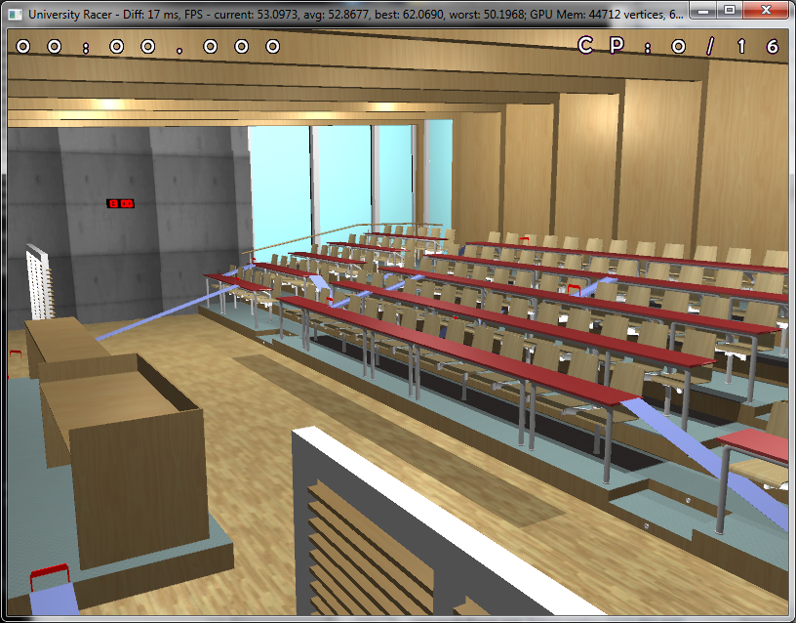
Figure 1: Classroom with all four lights on
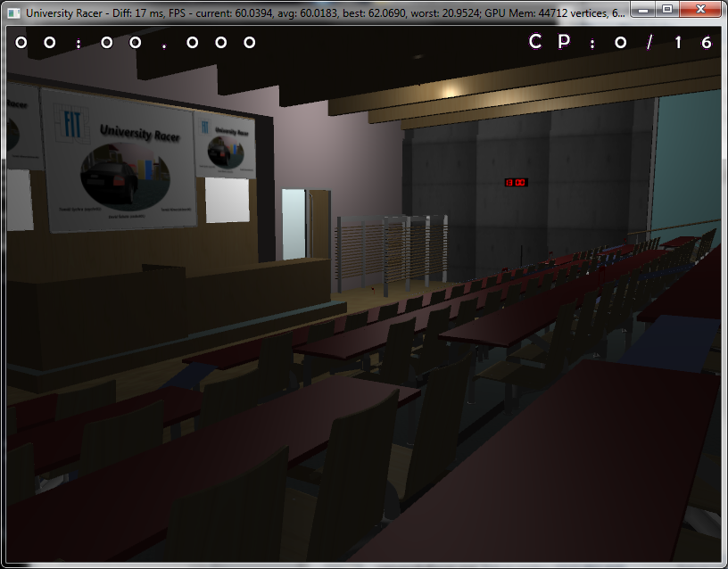
Figure 2: Classroom with only one light on

- A tuned toy car driving around the classroom

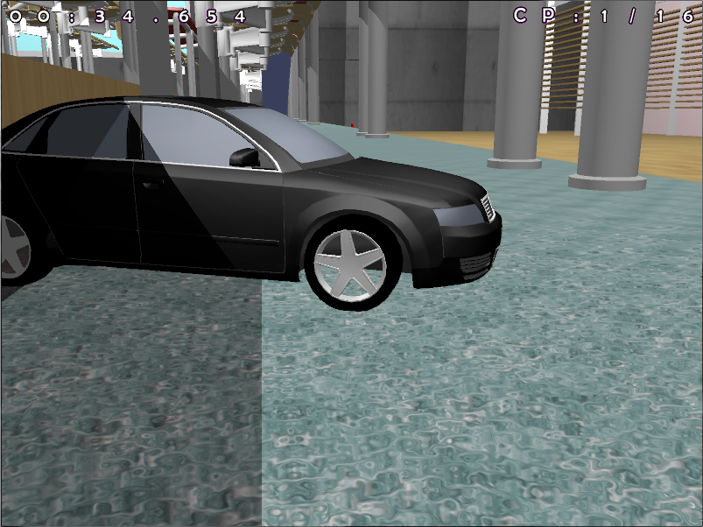
Figure 3: Detail of the car and carpet
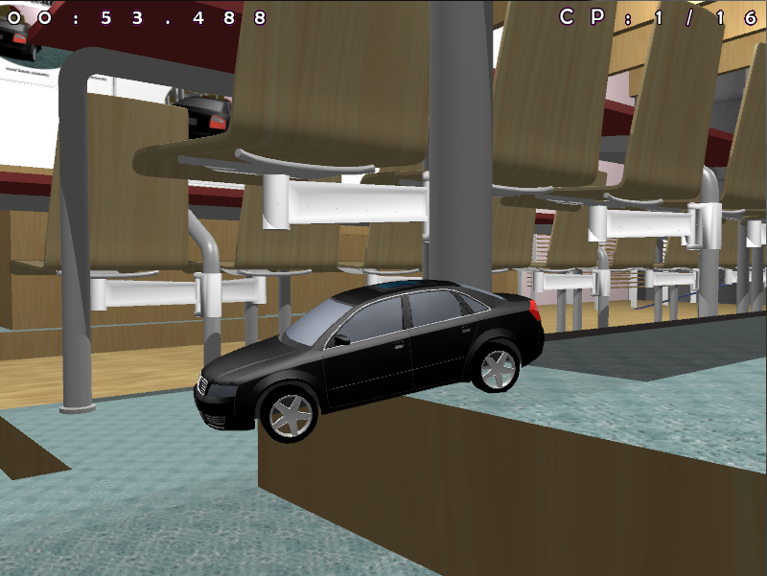
Figure 4: Car collision with a staircase in a classroom
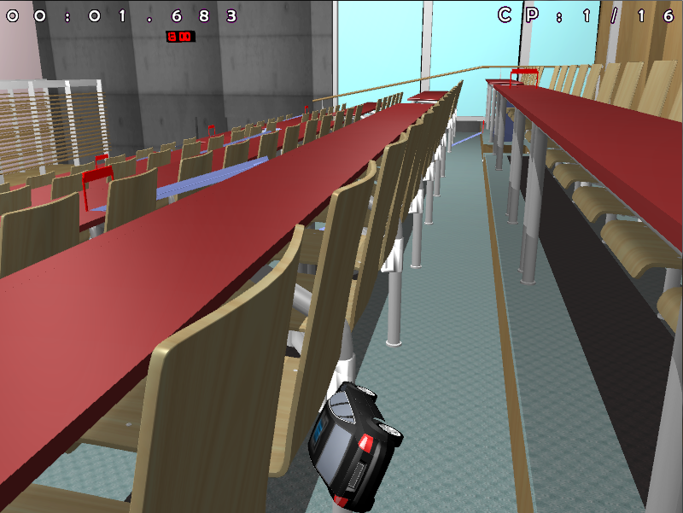
Figure 5: Car crash

- Functional simple game system

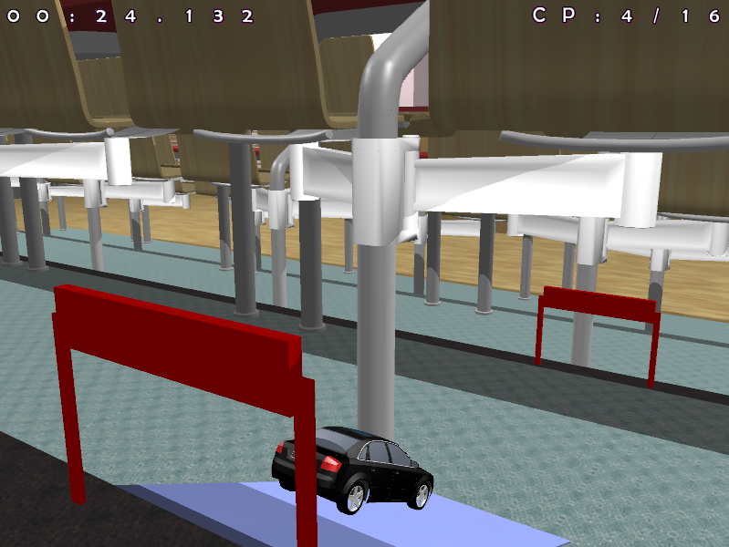
Figure 6: Passing the fourth checkpoint and measuring time
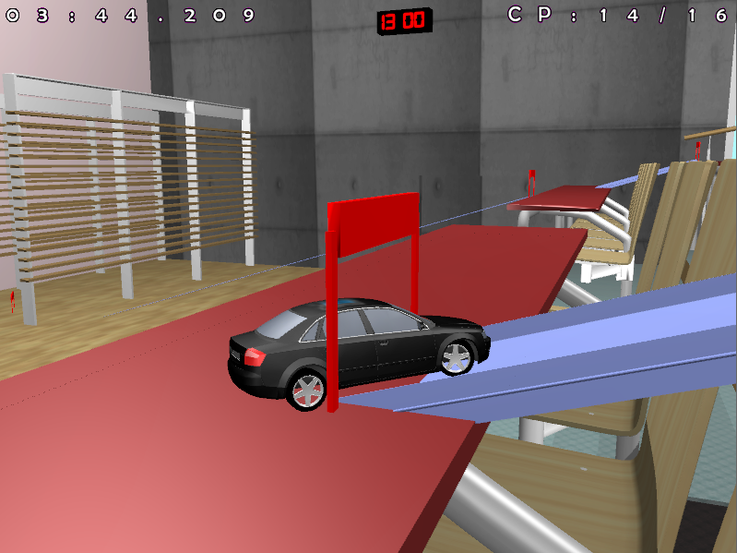
Figure 7: Passing the fourteenth checkpoint and approaching the connecting area

Controlling the created program

- Drive forward – up arrow
- Braking/reversing – down arrow
- Turning – right/left arrow
- R key – restart game
- Enter key – return to last checkpoint
- F key – lock/unlock camera from car
- Space key – handbrake
- If the camera is unlocked from following the car, then:
  - W, A, S, D keys – camera control
- M key – lock the mouse to the application (then you can “look around” using mouse movement)
- 1-4 keys – turn individual lights on and off
- F5 key – turn off rough surface generation on benches (perlin noise)
- F6 key – turn off shadows
- TAB key – switch between wireframe model with collision body highlighting and classic display

Division of work in the team

David Sabata:
- object-oriented application design
- scene loading and display
- shadows using shadow bodies
- model creation and editing
Tomas Sychra:
- shader programming
- texture creation, model texturing
- track design and creation
Tomas Kimer:
- physics
- gameplay
- port and customization of the car tracking camera

What was the most difficult?

Tomas Sychra:
- inability to properly debug shaders in GLSL on GPU
- understanding and correct implementation of perlin noise
- texture creation and selection (to make the result as close to reality as possible)
David Sabata:
- implementation of shadow bodies for arbitrary geometry
- optimization of scene rendering
Tomas Kimer:
- correct mapping of the collision model to the car
- tuning the driving model

Experience gained from solving the project

- Deeper understanding of OpenGL
- Working with the Git versioning system
- Using profiling to optimize performance
- Connecting a more advanced graphics application to a game system
- Working with a complex physics library and incorporating it into a game project
- Overall working as a team on a larger game project - the need for a good initial design and using a versioning system

Assessment

- Technical design: 75% (analysis, problem decomposition, selection of appropriate means, ...)
  - We designed a simple, yet functional and extensible game engine. However, since our experience with OpenGL was rather limited, there is still room for further optimizations after completion, especially in the rendering itself.
- Programming: 65% (quality and readability of the code, reliability of the run, generality of the solution, reusability, …)
  - With the exception of the scene definition (which is hardcoded in the code), the application is fully object-oriented and sufficiently general for further expansion possibilities. The shader source codes are minimally structured and may be less readable, but always in the interest of increasing performance.
- Appearance of the created solution: 90% (credibility of the display, aesthetic quality, GUI insight, …)
  - The only weak element is the GUI. The rest of the scene is rendered as realistically as the performance allows at the current level of optimization.
- Resource utilization: 50% (use of existing code and data, use of literature, …)
  - In addition to using the OpenGL, SDL, GLM and Bullet Physics libraries, we were inspired by code snippets and sample solutions. We studied literature mainly electronic, in the form of tutorials and manuals.
- Time management: 80% (even completion of parts of the project, degree of haste, missing parts of the solution, …)
  - The distribution of work over time was even, we started soon after the project assignment and completed the main parts of the application on time. Towards the end, we were forced to focus on optimizations, at the expense of other functions.
- Team collaboration: 100% (communication, adherence to agreements, mutual reliance, evenness, …)
  - Communication was seamless, we versioned the code using Git, we met regularly in CVT, we believe that the distribution of work was even.
- Overall impression: 90% (laboriousness, acquired skills, usefulness, choice of assignment, anything, …)
  - We are satisfied with the assignment and the resulting impression even exceeded our expectations. Still, we would have liked more time and further expanded the functionality. However, other study obligations did not allow us to do so.

Recommendations for future project awards

We highly appreciate the possibility of specifying the assignment yourself and the necessity of consultation before starting work. We were also pleased with the looser form of documentation, which led us to think about the project from a slightly different perspective. Given the nature of most assignments, we would have liked more in-depth information about OpenGL in the lectures. Lighting models and shadows are relatively easy to find, but the structure of the application and practical knowledge with optimization are difficult to find.
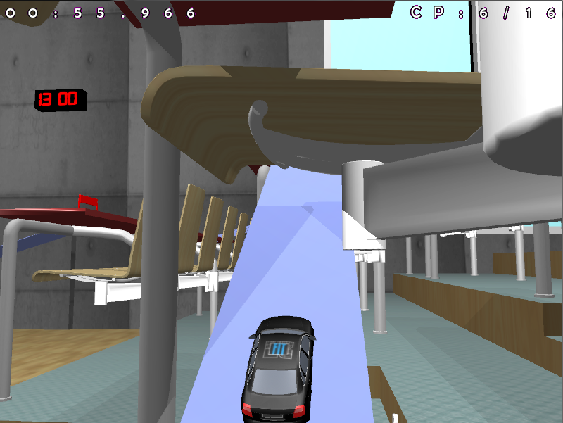
Figure 8: FIT

