# Department of Computing

**CS213: Advanced Programming**

**Class: BSCS – 5C**

# Lab 3: Getting started with R and building our first R application

**CLO3: Develop applications and tools using various frameworks**

**Date: September 29, 2017**

# Time: Friday (14:00 – 17:00)

# Instructor: Shamyl Bin Mansoor

# 

# Lab 3: Getting started with R and building our first R application

**Github link: https://github.com/mishaalijaz/AP-lab-3**

**Graph 1:**

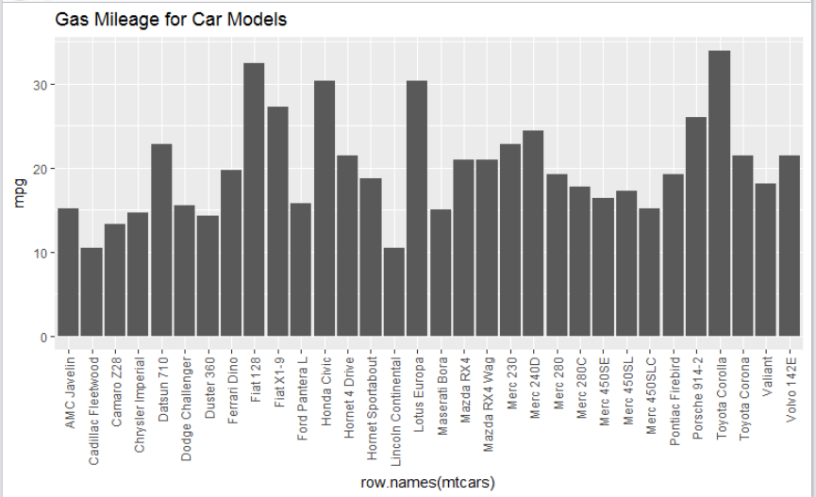

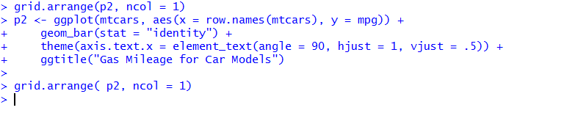

**Graph 2:**

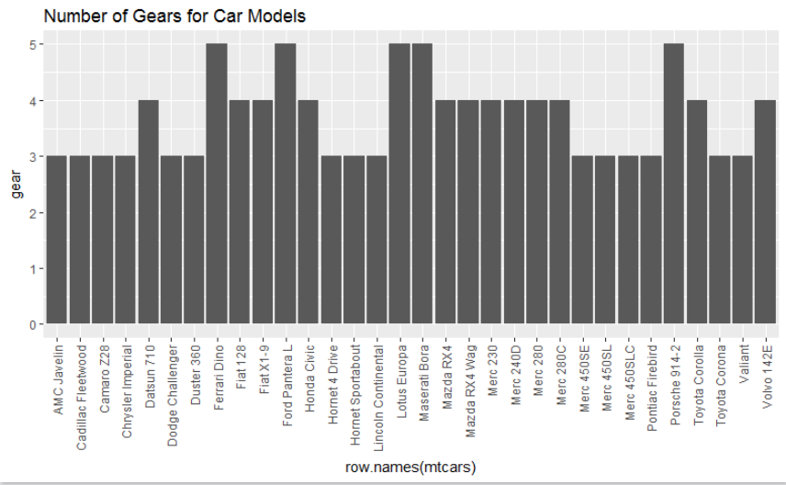

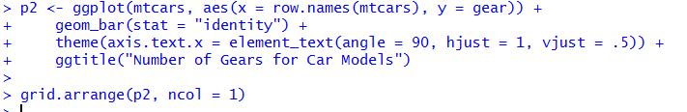

**Graph 3:**

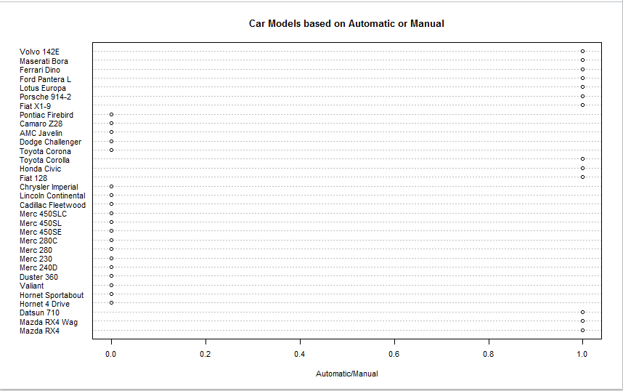

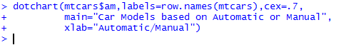

**Graph 4:**

