**Effects of spatially heterogeneous lakeside development on nearshore biotic communities in a large, deep, oligotrophic lake (Siberia)**

Michael F. Meyer1*

Stephanie E. Hampton2

Tedy Ozersky3

Kara H. Woo2

Kirill Shchapov3

Daniel D. Snow4

Emma J. Rosi5

Maxim A. Timofeyev6

Yulia M. Zaitseva7

Dmitry Yu. Karnaukhov6

Nina A. Bondarenko7

Aaron Galloway8

Julie Schram8

1. School of the Environment, Washington State University, Pullman, WA, USA

2. Center for Environmental Research, Education, and Outreach, Washington State University,

Pullman, WA, USA

3. Large Lakes Observatory, University of Minnesota - Duluth, Duluth, MN, USA

4. School of Natural Resources, University of Nebraska-Lincoln, Lincoln, NE, USA

5. Cary Institute of Ecosystem Studies, Millbrook, NY, USA

6. Biological Research Institute, Irkutsk State University, Irkutsk, Irkutsk Oblast, Russia

7. Limnological Institute SB RAS, Irkutsk, Irkutsk Oblast, Russia

8. Oregon Institute of Marine Biology, University of Oregon, Charleston, OR, USA

*corresponding author: michael.f.meyer@wsu.edu

**Keywords**: Lake Baikal, sewage, PPCP, foodwebs, community ecology, human disturbance

**Abstract (244/250 words)**

Sewage released from lakeside development is a pervasive and frequently high impact human disturbance, with effects most immediately observed among littoral biota. Less urban, large, deep, oligotrophic lakes present unique opportunity to study lakeside development’s environmental effects because the nearshore area contains a small proportion of the lake’s overall volume yet also provides a large share of resources for the lake’s biota. Lake Baikal, the world’s most voluminous and biodiverse lake, has been suspected of localized sewage pollution, and nearshore benthic communities appear to be responding. To test the extent and degree of human disturbance in Lake Baikal, we surveyed a 40-km transect of the southwestern shore for sewage indicators, including pharmaceutical and personal care products (PPCPs) and microplastics. To measure community and foodweb responses, periphyton and macroinvertebrate abundance were assessed at each littoral site. PPCPs, including caffeine (up to 60 ng/L), acetaminophen (up to 40 ng/L), and associated metabolites (up to 20 ng/L), were detected in the nearshore water column, and concentrations were directly proportional with increasing population intensity. Among biotic samples, mollusc as well as diatom abundance were inversely associated with lakeside development. Periphyton and macroinvertebrate stable isotopes and fatty acid samples suggested that while community composition had altered among sites, the foodweb structure remained consistent. For Lake Baikal, these results are especially timely and important, considering that increasing tourism to the area (~300,000 tourists annually) in tandem with inadequate wastewater management may increase risk of environmental degradation.

**Introduction**

Human disturbances have been well documented in disrupting a suite of biological processes, ranging from physiological (e.g., Sokolova & Lannig, 2008) and behavioral (e.g., Longcore & Rich, 2004) to population (e.g., Crouse et al., 1987) and community dynamics (e.g., Ellis et al., 2011). Because human population tends to be concentrated in residential hubs, human disturbance, and therefore proximal organismal responses to that disturbance, can also be concentrated spatially and temporally, creating a “hot spot” disturbance landscape (Harper et al., 2005). For example, constructing a boat dock within a lake can abruptly render habitats unusable for fish spawning (Scheuerell & Schindler, 2004). Similarly, variable toxicant concentrations may threaten disparate ontogenetic stages and ecological communities depending on how spatially and temporally co-located toxicants and biological processes are (Ginn et al., 2007). The potential for simultaneous episodic and human disturbances may likewise amplify ecological responses if disturbances co-occur with sensitive biological processes (Franklin et al., 2000; Lake, 2000). As of result of complex heterogeneity of human disturbance, abiotic environments, and biological systems, understanding how a specific disturbance as well as spatio-temporally coupled disturbances disrupt ecological processes necessitates a strong response signal relative the noise of natural systems (Carpenter et al., 2001).

Ecosystems located along an edge, such as the nearshore area in lakes, present opportunity to study heterogeneous disturbance as inhabiting biota directly interface with two abutting systems. Because these systems inherently integrate autochthonous and allochthonous processes, ecological communities along a perimeter are forced to respond to environmental processes on both sides of their boundary. In the case of lakes, the nearshore area intrinsically incorporates nutrients from terrestrial subsidies as well as intra-lake cycling (Carpenter et al., 2005). Consequently, because human settlements tend to border the land-water interface, littoral organisms’ close proximity makes them susceptible to areas and moments of terrestrial inputs, such as sewage release (Carpenter et al., 2005) or construction of a boat dock (Scheuerell & Schindler, 2004). Although the disturbance may be directly localized on nearshore biota, the particular disturbance may propagate to offshore biota, as pelagic organisms frequently rely on high littoral productivity for feeding or breeding (Vadeboncoeur et al., 2008). As a net result, increased understanding in how edge ecological communities respond to transboundary disturbance can offer insight into how a given disturbance may alter proximal as well as coupled distal communities.

The release of treated and untreated wastewater into aquatic ecosystems is an example of a globally frequent and high impact human disturbance that can introduce pollutants and reshape aquatic ecological communities (Scheffer et al., 2001). Nutrients are among the primary pollutants within sewage byproducts (Smith et al., 1999). Although often concentrated within sewage, nutrients can originate from disparate anthropogenic and environmental sources and obfuscate clear sewage signals. For example, increased alder presence in terrestrial plant communities has been associated with increased nutrient concentrations and nearshore periphyton production in proximal lake environments (Moran et al., 2012). Geological processes, such as melting permafrost, have likewise been shown to contribute high nutrient loadings to bog environments that can eventually lead to changes in primary production and decomposition (Turetsky et al., 2010). Similar to geological and biological processes, non-sewage-associated anthropogenic nutrient pollution, such as agricultural runoff, can add high nutrient concentrations to soil and aquatic systems (Powers et al., 2016). Regardless of the nutrients’ source, biological responses to even slight nutrient increases can further confound sewage signals. Benthic primary producers in the nearshore, especially those in oligotrophic lakes, can assimilate dissolved anthropogenic solutes, such as nutrients, quickly from the water column (e.g., hours), such that deviation in typical water concentrations is not observed (Andersson & Brunberg, 2006).

As a result of nutrients’ multiple potential sources, pharmaceuticals and personal care products (PPCPs) have garnered increasing attention for their usefulness as sewage indicators (Rosi-Marshall & Royer, 2012). Research by Kolpin et al. (2002) is often the most cited (5,062 Web of Science citations as of 07 June 2019) study of continental scale PPCP concentrations and demonstrated that areas with dense populations tend to be PPCP hotspots, although lower concentrations can still be detected in less urban locations. At finer spatial and temporal scales, PPCP concentrations have been used to identify hotspots and hot moments of septic discharge within suburban residential areas (Yang et al., 2016). In addition to PPCPs identifying areas and moments of sewage pollution, they have also demonstrated robustness in defining gradients of sewage pollution with concentrations being directly proportional to the magnitude of population density and inversely proportional to distance from a densely populated area (Bendz et al., 2005).

Like PPCPs, microplastics have shown promise in detecting sewage pollution even in low densities (Li et al., 2018). Like PPCPs, microplastic densities have been used to define human pollution gradients in aquatic environments (Klein et al., 2015). However, because microplastics can originate from various sources of human pollution, they can sometimes also confound sewage signals with other human activities, such as agriculture (Koelmans et al., 2019). Unlike PPCPs, microplastics have mainly been studied in marine and lentic environments (Wagner et al., 2014). In lake environments, microplastics have been useful in identifying hotspots of human pollution with microplastic densities increasing in response to mixing patterns (Free et al., 2014).

Beyond identifying sewage pollution, PPCP and microplastic concentrations can also be useful to study how biotic communities many differ with varying levels of sewage pollution. While benthic primary producers can assimilate nutrients quickly from the water column (Rosenberger et al., 2008; Hampton et al., 2011), PPCPs can remain within the water column with concentrations directly proportional to magnitude of human population and inversely proportional to distance from a population hub (Bendz et al., 2005). Population magnitude and proximity have also been suspected to correlate with increased filamentous algal taxa, which more effectively remove nutrients than other algae, such as diatoms (Rosenberger et al., 2008). These differences in filamentous and diatomaceous algal abundances can be even more stark if macroinvertebrate communities shift to consume more filamentous algae or detritus (Rosenberger et al., 2008). Aside from difficulty consuming filamentous algae, there may be tradeoffs in nutritional quality, as filamentous algae tends to contain lower quality essential fatty acids in comparison diatoms (Kelly & Scheibling, 2012). While associations between nearshore algal communities may correlate with increased sewage pollution, increased filamentous algae, like nutrients, may also be a product of non-sewage sources, such as agricultural runoff (Beman et al., 2005). Pairing co-located sewage indicator data, such as PPCPs and microplastics, with nearshore community composition and structure data, such as species abundance, stables isotopes, and fatty acids, would (1) identify hotspots of explicit sewage pollution and (2) facilitate whether observed community changes are associated with sewage pollution.

To address ecological community responses to sewage pollution using micropollutants as sewage indicators, we surveyed a 40-km shoreline in Lake Baikal, a remote, large, deep, oligotrophic lake, with discrete population hubs for indicators of sewage pollution and metrics of benthic community composition and structure. Located in the heart of Siberia, Lake Baikal is the oldest, most voluminous, and deepest freshwater lake in the world (Hampton et al., 2018), with the majority of Baikal’s biota occuring in the littoral zone (Kozhova & Izmesteva, 1998). While the majority of Lake Baikal’s shoreline lacks human development, pockets of lakeside development have emerged with suspected environmental responses within the nearshore (Timoshkin et al., 2016). While Lake Baikal’s pelagic zone is generally ultra-oligotrophic (Ministry of Natural Resources and Ecology of the Russian Federation, 2014), nearshore areas proximal to lakeside settlements have reportedly higher filamentous algae abundance as well as markedly decreased gastropod abundance (Timoshkin et al., 2016). Research by Timoshkin et al. (2016, 2018) asserted that inadequate wastewater management in lakeside settlements was the main driver of nearshore ecological alterations, but lacked data to conclusively associate nearshore biological responses with sewage pollution.

Given the potential for minute sewage pollution to be eliciting ecological responses in Lake Baikal’s littoral zone, we hypothesized that (1) sewage indicators, such as PPCP concentrations and microplastic densities, would increase with increasing population density and proximity of lakeside development; (2) an increasing sewage signal would be directly proportional to filamentous algal community composition; and (3) with an increasing filamentous algae abundance, the littoral food web would restructure to include more macroinvertebrates capable of consuming filamentous algae as well as detritus in place of diatom-consuming macroinvertebrates. In doing so, this study leverages highly specific indicators of sewage pollution with co-located biological measurements, thereby explicitly defining areas of sewage pollution and highlighting the marked heterogeneity in the nearshore area.

**Methods**

*1. Site description*

The vast majority of Lake Baikal’s 2,000-km shoreline lacks lakeside development (Timoshkin et al., 2016). Our study focused on a 40-km transect of Baikal’s southwestern shoreline, where rudimentary wastewater management techniques are employed interspersed with areas of uninhabited shoreline (Timoshkin et al., 2018). The largest settlement, Listvyanaka, is primarily a tourist town with approximately 1,963 permanent residents (IrkutskStat, 2012), although tourism can contribute significantly to the town’s population (Timoshkin et al., 2016). Listvyanka, however, does experience high fluxes in tourists with approximately 400,000 tourists over the course of the year (Timoshkin et al., 2016). Listvyanka also serves as the main transportation hub to other settlements within Lake Baikal. Within our 40-km transect, two of those villages include Bolshie Koti and Bol’shoe Goloustnoe. Bolshie Koti consists of approximately 56 permanent residents (IrkutskStat, 2012). Bol’shie Koti also contains two field research stations for Irkutsk State University and the Russian Academy of Sciences Limnological Institute (Timoshkin et al., 2018). Bolshoe Golustnoe is also a tourist village, consisting of approximately 600 residents (IrkutskStat, 2012).

Along our 40-km transect, we conducted sampling at 14 littoral and 3 pelagic locations. Littoral locations were meant to capture a range of sites with immediate shoreline development. Pelagic sites were all 2 to 5 kilometers offshore from each of the proximally developed sites (Figure 1; Table 1). We attempted to choose specific sites at each location that represented a gradient moving away from centers of high population, with distance between dictated by accessibility. Sampling sites were chosen to be the same depth (~1.25 m) across all sites and locations, such that sites sometimes differed in their distance from shore (Table 1). At each site, air temperature was measured with a mercury thermometer and photographs were taken of the substrate and the shoreline.

Because lakeside developments are highly clustered, hydrologic connectivity between sites could create sewage gradients. In order to account for sewage gradients, we created a metric of population intensity for each littoral site. Our population intensity metric is meant to capture that sewage pollution should be directly related to increasing magnitude of human activity and inversely related with distance from human activity (sensu Bendz et al., 2005). For each littoral site with proximal lakeside development, we calculated the population density (population/km2). We then scaled population density by length of shoreline at the developed site. This scaling accounts for opportunity of sewage pollution to pass into the lake. Each littoral site was assigned the scaled population density metric of the nearest developed site. In order to capture how sewage pollution may attenuate over space, all scaled population densities were normalized by distance from the nearest developed location. Our population intensity metric can be described by the equation , where Ij is the population intensity at site j, Pi is the population at developed site i, Ai is the area of developed site i in km2, Li is the shoreline length at developed site i in km, and D is the distance from developed site i to j in km.

*2. Water samples*

At both pelagic and littoral sites, water samples were collected for nutrient, chlorophyll, microplastic, and pharmaceutical and personal care product (PPCP) analysis. Each water sample collection procedure is described below.

*2a. Nutrients*

Water samples for nutrient analyses were collected in approximately 150 mL glass jars that had been rinsed three times with water from the sampling location. Samples were collected in duplicates and immediately frozen at -20C. Samples were stored in the dark at -20C until processing at the Siberian Branch of the Russian Academy of Sciences.

*2b. Chlorophyll a*

Water samples were collected in 1.5 L plastic bottles from a depth of 0.75 m. Within 12 h of collection, three subsamples were collected by passing up to 150 mL through 25 mm cellulose nitrate filter. Filters were then placed in a 35 mm petri dish and then frozen in the dark until processing.

Chlorophyll samples were processed in a manner similar to that of Parson (1963) and Lorenzen (1967). Filtered GF/Fs were ground in 90% acetone, in which chlorophyll extraction was allowed to proceed overnight. Samples were then centrifuged for 15-20 minutes. Once particulates settled, absorbance of the chlorophyll extract was then measured in a spectrophotometer at 630, 645, 665, and 750 nm. Concentrations were then calculated using the formula: ; where A is the absorbance value of a particular wavelength, V1 is the volume of the filtered water, and V2 is the volume of extract. Concentrations are reported as mg/L.

*2c. PPCPs*

Water samples were collected in a 250 mL amber glass bottle that was rinsed with an organic solvent and then three times with sample water prior to collections. Following collection, samples were refrigerated and kept in the dark until solid phase extraction (SPE).

Within 12 h of collection, samples were filtered directly from the amber glass bottle using a 25 mm GF/F, and then passed through SPE cartridges (Waters Corporation, Milford, MA). Gloves and face masks were worn to prevent contamination. Prior to filtration, SPE cartridges were primed with at least 5 mL of either methanol or acetone and then washed with at least 5 mL of sample water. Rate of SPE occurred at approximately 1 drop per second. Extraction proceeded until water could no longer pass through the SPE cartridge or until all collected water was filtered. Upon completion, cartridges were removed and immediately stored in whirlpacks. SPE cartridges were processed for PPCPs in a manner as described in Lee et al., (2016).

2d. *Microplastics*

At each location, three 1.5 L clear plastic bottles were washed thoroughly with sample water before each collection. Samples were collected from the midpoint depth for each site. Once collected, bottles were sealed with a plastic cap until processing.

For processing, each bottle was vacuum filtered with a 47 mm GF/F. During filtration aluminum foil was used to cover the filtration funnel to prevent contamination. Upon completion, GF/Fs were allowed to dry under vacuum pressure and then stored in 50 mm petri dishes. Following filtration of all three replicates, filtrate was collected and then re-filtered as a control for contamination.

Microplastic counting involved visual inspection of the entire GF/F according to guidelines proposed in Van Cauwenberghe et al. (2015). Visual enumeration was conducted under a stereoscope, and microplastics were classified into one of three categorie: fibers, fragments, or beads. For all categories, plastics were defined as observed objects with artificial colors and no visible organelles or cellular components. Fibers were defined as smooth, long plastics with consistent diameters. Fragments were defined as plastics with irregularly sharp or jagged edges. Beads were defined as perfectly spherical plastics. Suspected microplastics that were clear were not counted. During enumeration, GF/Fs remained in the petri dish to prevent contamination. Results are reported as average microplastics per liter.

3. Benthic biological samples

3a. Benthic algal collection

At each littoral site, we randomly selected three rocks representative of substrate. A plastic stencil was used to scrape a standardized 14.5 cm2 patch for periphyton counts. Samples for periphyton counts were stored in plastic scintillation vials and preserved with Lugol’s. Remaining periphyton from the site were collected in composite and then split evenly for fatty acid and stable isotope analysis.

Periphyton taxonomic identification and enumeration was performed by subsampling 10 μL aliquots from each plastic scintillation vial. For each aliquot, cells, filaments, and colonies were counted for each taxonomic group until at least 300 cells were counts. Taxa were classified in broad categories roughly consistent with Baikal algal taxonomy (Izhboldina, 2007). Taxonomic groupings were course so as to capture overarching patterns in diatom and filamentous algae abundance. As a result, diatoms were considered one group. Filamentous algae consisted of either *Ulothrix*, a regularly occurring Baikal filamentous alga (Kozhov, 1963; Osipova et al., 2009), or *Spirogyra*, a recently cosmopolitan filamentous alga (Timoshkin et al., 2016).

3b. Benthic invertebrate collection

At each littoral site, three kick-net samples were collected for assessment of benthic community composition and abundance. Using a D-net, we collected macroinvertebrates by flipping over 1-3 rocks, and then sweeping five times in a left-to-right motion of approximately 1 m in length. After the series of sweeps, the catch was rinsed into a plastic bucket. For each replicate, bucket contents were concentrated using a 64 μm net and placed in glass jars with vodka for preservation and refrigerated at 4C. Vodka was replaced with ~80% ethanol upon return, and samples were stored in a refrigerator.

Separate collections were conducted for invertebrate fatty acid and stable isotope analyses. Invertebrates were collected using a D-net in a similar fashion as the community enumeration. Additional invertebrates were also collected by hand. Collected organisms were then live-sorted, identified to species, and frozen in composite at -20C.

Invertebrate taxonomic identification and enumeration were performed under a stereoscope. All well preserved invertebrates were identified to species with the exception of juveniles (Taakhteev, 2015 for amphipods; Sitnikova, 2012 for molluscs).

3c. Food Web characterization

*Stable Isotope Analysis*

Stable Isotope analysis occurred at the University of Minnesota - Duluth….

*Fatty acid analysis*

Fatty acid extractions generally involved three phases: (1) 100% chloroform extraction, (2) chloroform-methanol extraction, and (3) fatty acid methylation. Fatty acid extraction methods are adapted from similar methods developed in Schram et al. (2018).

Samples were first freeze-dried in eppendorf tubes at -20C overnight, then ground and weighed. Following freeze-drying, samples were transferred to 10 mL glass centrifuge vials, and 2 mL of 100% chloroform was added to each under nitrogen gas. Samples were allowed to sit in chloroform overnight at -80C.

Following overnight chloroform extraction, samples underwent a chloroform-methanol extraction three times. To each sample, we added 1 mL cooled 100% methanol, 1 mL chloroform:methanol solution (2:1), and 0.8 mL 0.9% NaCl solution. Samples were inverted three times and then sonicated on ice for 10 minutes. Following sonication, samples were vortexed for 1 minute, and then centrifuged for 5 minutes (3,000 rpm) at 4C. Using a double pipette technique, the lower organic layer was extracted and kept under nitrogen. Following the third extraction, samples were allowed to evaporate under nitrogen flow, and then resuspended in 1.5 mL chloroform and stored at -20C overnight.

Following resuspension in chloroform, 1 mL of chloroform extract was transferred to a glass centrifuge tube with a glass syringe. As a standard, 4 μL of 19 C was added along with 1 mL of toluene and 2 mL of 1% sulfuric acid-methanol. The vial was closed under nitrogen gas and then incubated in 50C water bath for 16 hours. After incubation, samples were removed from bath, allowed to reach room temperature, and then stored on ice. We then performed a potassium carbonate-hexane extraction twice. To each sample, we added 2 mL of 2% potassium bicarbonate and 5 mL of 100% hexane, inverting the capped vial so as to mix the solution. Samples were then centrifuged for 3 minutes (1,500 rpm) at 4C. The upper hexane layer was then removed and placed in a vial to evaporate under nitrogen flow. Once almost evaporated, 1 mL of 100% hexane was added, and then sample was stored in a glass amber autosampler vial for GC/MS quantification. GC/MS quantification was performed in a similar method as described in Schram et al. (2018).

4. Statistical Analyses

All water sample parameters were assessed for correlation with population intensity by using a generalized linear model with population intensity as a predictor of each parameter.

Periphyton and invertebrate community percent contributions were assessed visually via NMDS produced with bray-curtis dissimilarity of species abundance. In order to identify a number of clusters for ordination, k-means hierarchical clustering was performed with both the periphyton and invertebrate community abundance data, and then sites were assigned to clusters. Differences between clusters were evaluated using PERMANOVA with benthic community composition as a response to ordinated cluster.

Fatty acid relatives compositions was assessed via NMDS with bray-curtis dissimilarity for all taxa and sites (Figure S3). Because taxonomic fatty acid profiles varied greater than inter-site differences, fatty acid relative compositions were evaluated by comparing relative mean, variance, and mean:variance ratios across all sites for each taxa (sensu Rheubert et al., *Under review*). In doing so, we aimed to understand which fatty acid relative abundances varied most intensely among all sites. Our analyses identified that 18:3ω3, 18:4ω3, 20:5ω3, and 22:6ω3 varied most intensely across sites. The higher intersite variance was hypothesized to be caused by differences in periphyton community composition. 18:3ω3 and 18:4ω3 have been previously associated with filamentous algae, such as Baikalian *Ulothrix* (Osipova et al., 2009), whereas 20:5ω3 and 22:6ω3 have previously been associated with diatoms (Taipale et al., 2013). In order to assess relative filamentous:diatom signals (i.e., (18:3ω3% + 18:4ω3%)/(20:5ω3% + 22:6ω3%)) as a function of potential sewage pollution, we regressed filamentous:diatom fatty acid signals against human intensity metrics.

All analyses were conducted within the R statistical environment (R Core Team, 2019). All data are publicly available from the Dryad data repository (DOI), and all R scripts are available from the github repository of this project’s Open Science Framework account (DOI).

**Results**

*Water samples*

Both nitrate (p-value = 0.27), ammonium (p-value = 0.16), and chlorophyll a (p-value = 0.48) were were not significantly correlated with population intensity (Figure 1). Phosphate concentrations, however, were significantly correlated with population intensity (p-value = 0.01; Figure 2).

Within the littoral zone, PPCPs detected included caffeine, 1,7-dimethylxanthine, cotinine, and acetaminophen (Table 2). Total PPCP concentrations were significantly correlated with population intensity (p-value = 0.037; Figure 2).

Within the littoral and pelagic areas, microplastics were detected. Bead microplastics were only detected in the nearshore area with the highest population intensity. Fibers were most abundant across all sites (average = 3.6 microplastics/L), followed by fragments (average = 1.4 microplastics/L) and beads (average = 0.09 microplastics/L). Total microplastic densities were were not significantly correlated with of population intensity (p-value = 0.56; Figure 2), although more types of microplastics were generally observed near areas with higher population intensity, such as Listvyanka (LI).

*Benthic biological samples*

*Periphyton*

Major taxonomic groupings of periphyton consisted of diatoms, *Tetrasporales*, *Spirogyra*, and *Ulothrix*. K-means cluster analysis of periphyton abundance demonstrated 2 major groupings would capture most variance, and visual inspection of periphyton community NMDS suggested categorical delineations of population intensity as a potential grouping variable (Figure 3). PERMANOVA results demonstrated that periphyton communities with moderate/low population intensity metric were significantly different from sites with high population intensity metrics (p-value = 0.033).

*Macroinvertebrates*

Among all adult macroinvertebrate species, several were cross-correlated and were removed so as to not include redundant variance. Uncorrelated taxonomic groupings included four amphipod genera: *Eulimnogammarus*, *Poekilogammarus*, *Cryptoropus*, and *Pallasea*; two mollusc families: Planorbidae and Valvatidae; flatworms; caddisflies; and leeches. K-means cluster analysis of macroinvertebrate community composition demonstrated 3 major groupings would capture most variance, and visual inspection of NMDS suggested categorical sortings of population intensity as a potential grouping characteristic (Figure 4). PERMANOVA results suggested that macroinvertebrate communities with moderate/low population intensity metrics were significantly different from sites with high population intensities (p-value = 0.001).

*Food web characterization*

*Stable isotopes*

Among periphyton and amphipod samples, 13C values ranged from -19.5 to -9.5%, suggesting terrestrial carbon inputs (Figure 5). Among grazer δ15N values, no grazer groups deviated greater than 3.4% δ15N, suggesting that all were within the same trophic level (Post, 2002).

When evaluating 13C and δ15N concentrations as a function of population intensity, δ15N significantly increased with an increasing population intensity metric only for grazer samples (p-value = 0.008; Figure 1, Figure 5). Periphyton δ15N signatures did not significantly increase with increasing population intensity (p-value = 0.7, Figure 1). In contrast, 13C concentrations did not change as a function of population intensity for either periphyton or macroinvertebrates.

*Fatty acids*

Among both periphyton and grazers, C18:3ω3, C18:4ω3, C20:5ω3, and C22:6ω3 mean, variance, and mean-to-variance ratios were highest across all sites. A full description of essential fatty acid percentage profiles across all species and sites is detailed in Table SXX. For periphyton, the ratio of C18:3ω3 and C18:4ω3 in comparison to C20:5ω3and C22:6ω3 significantly increased with an increasing PPCP concentration (p-value = 0.05, Figure 6) but not with an increasing population intensity (p-value = 0.17). Amphipods’ fatty acid ratios were not significantly correlated with either increasing population intensity or increasing PPCP concentrations.

**Discussion**

We quantified magnitude of sewage pollution within the nearshore area of Lake Baikal and correlated sewage pollution metrics with population intensity and biological community data. Our combined results are concordant with our hypotheses and suggest that even in remote, lakes, such as Lake Baikal, trace sewage pollution can be detected and associated with differences in nearshore community composition and food web dynamics. The use of consistently associated molecular indicators for quantifying sewage pollution as well as biological responses likewise demonstrates how easily trends may be masked by course metrics, such as chlorophyll a or nutrient concentrations. These combined results are important for Lake Baikal’s developing infrastructure, given the increasing tourism to several of the settlements where we sampled, as well as for understanding how heterogeneous human disturbance in disparate systems can lead to changes in community composition and structure.

Perhaps the most notable result from this study was that sewage pollution can be both detected in Lake Baikal’s nearshore area and associated with magnitude of lakeside development. While several studies have detected and quantified PPCP concentrations in aquatic systems (e.g., Kolpin et al., 2002; Focazio et al., 2008; Rosi-Marshall et al., 2013), lakes have remained less represented within the PPCP literature in comparison to lotic systems (Meyer et al., *Under review*). With longer hydraulic residence times, PPCP distributions in lentic systems may differ from lotic environments, as pollutants within lakes may be more prone accumulate within the nearshore before diffusing to undetectable concentrations. Our results suggest that PPCP distributions appear to concentrate within the nearshore and are undetectable offshore. This result remains consistent with pelagic lake monitoring programs’ insensitivity to detect localized hot spots of nearshore sewage pollution, despite nearshore areas responding to sewage pollution earlier than the pelagic (Hampton et al., 2011).

In contrast to Lake Baikal’s PPCP concentrations, microplastics were not associated with population intensities. Like PPCPs, microplastics have been used to identify sewage pollution in similarly large lakes, like Lake Khuvsgul, where concentrations tend to be higher in areas of longer hydraulic residence times (Free et al., 2014). Unlike PPCPs’ relative short half-lives though, microplastics offer time-integrated understanding of human disturbance by degrading slowly or remaining recalcitrant to decay (Brandon et al., 2016). As a result, microplastic concentrations in Baikal may be poor proxies for capturing the temporal variability of short-term human populations, but may be useful to detecting offshore sewage signals as microplastics diffuse from the nearshore to the pelagic.

In conjunction with detecting and quantifying magnitude of sewage pollution, our data also suggest that increased filamentous periphyton as well as decreased mollusc and caddisfly abundance tend to be associated with increasing sewage indicators. Previous studies investigating Baikal’s periphyton composition noted that areas proximal to human development often had increased filamentous algae (Timoshkin et al., 2015; 2016; 2018). Even though Lake Baikal’s southwestern shore often experiences increased *Ulothrix* blooms in late August (Kozhov, 1963), our data corroborate Timoshkin’s surveys (Timoshkin et al., 2016) that *Spirogyra* as well as *Ulothrix* abundance is greatest near areas of lakeside development. While not observed at the same magnitude as results reported in Timoshkin et al. (2016), our results support the general conclusion that Baikalian molluscs tend to be more susceptible to sewage pollution. These differences in community composition may be explained by a suite of conjectures, including molluscs having low tolerance for increased PPCP concentrations, especially caffeine and its metabolites (Hollingsworth et al., 2002), molluscs not being able to consume filamentous algae (Lucia & Russo, 1989), or filamentous algae not offering the proper nutritional yield for molluscs (Pernet et al., 2007).

With filamentous algae and molluscs as the main community compositional shifts, food web structure remained consistent. Stable isotope analysis suggested that foodweb structure did not change with an increasing sewage signal. Similarly, fatty acid compositions did not to vary significantly between sites, whereas periphyton fatty acid compositions at sites with higher sewage pollution were more associated with C18 than C20 and C22 fatty acids. This pattern is likely the result of *Ulothrix* and *Spirogyra* being characterized by C18 fatty acid signatures, and diatoms being characterized by C20 and C22 fatty acid signatures (Taipale et al., 2013; Osipova et al., 2009). Given the variation in periphyton fatty acid composition and lack of variation in grazing amphipods, our results suggest that amphipods are able to maintain a consistent fatty acid signature through two potential mechanisms. First, amphipods may selectively consume diatoms as opposed to filamentous algae. As a result, grazing pressure on diatoms would increase, and diatom relative abundance could decrease both from increased grazing and lacked efficiency at removing nutrients from the water column. Second, amphipods may indeed consume filamentous algae, and then invest energy to convert C18 fatty acids to C20 and C22 fatty acids. Consequently, amphipods would need to catabolize new fatty acids, but may prove necessary to surviving Baikal’s cold temperatures. Regardless of the exact mechanism, our data support the hypothesis that an increasing sewage pollution would alter community trophic interactions, which could arise through increased grazing pressure on diatoms or inclusion of filamentous algae in amphipod grazing.

Together, the combined results of our study corroborate previous studies suggesting sewage pollution and its ecological consequences in Lake Baikal’s nearshore area. Unlike previous studies, though, we use molecular techniques to quantify magnitudes of sewage pollution, so as to relate sewage pollution data with co-located biological communities. In doing so, we were able to identify how heterogeneous human settlements can create gradients of human disturbance that produce gradients in community composition and food web dynamics. Moving forward, these results open avenues for future research including complex interactive effects between human disturbance and a warming climate.

*Significance in the context of a warming Lake Baikal*

As a result of being the most ancient lake, Lake Baikal remains a biodiversity hotspot (Hampton et al., 2018), where the majority of endemic species tend to be cryophilic stenotherms (Moore et al., 2009). Within increasing lake temperatures worldwide (O’Reilley et al., 2015), it is unclear how these cold-water adapted species will respond to a warming ambient environment in conjunction with increased human disturbance. In our study, we demonstrated that littoral amphipods were prevalent throughout the entirety of human disturbance gradients. Several abundant winter-breeding amphipod species, such as *Eulimnogammarus verucossus*, are known to be more sensitive to increased warming than summer-breeding amphipods (Jakob et al., 2015), with winter-breeding species migrating to cooler depths when temperatures increase (Timofeyev et al., 2008) and males demonstrating a more robust proteomic thermal responses than females (Bedulina et al., 2016). The combined \amphipod molecular and behavioral responses to temperature could offer potential hypotheses into how summer-breeding, and particularly female summer-breeding, amphipods may be prime littoral community members to study tandem effects of increasing temperatures and human disturbance. Predicting such responses may also lead to deeper insights in how littoral communities may restructure, especially as Lake Baikal continues to warm and tourism to the area continues to increase.

**Works Cited**

Andersson, E., and A.K. Brunberg. 2006. Inorganic nutrient acquisition in a shallow clearwater lake – dominance of benthic microbiota. Aquatic Sciences **68**: 172–180. doi:10.1007/s00027-006-0805-x

Bedulina, D., M. F. Meyer, A. Gurkov, E. Kondratjeva, B. Baduev, R. Gusdorf, and M. A. Timofeyev. 2017. Intersexual differences of heat shock response between two amphipods ( *Eulimnogammarus verrucosus* and *Eulimnogammarus cyaneus* ) in Lake Baikal. PeerJ **5**: e2864. doi:10.7717/peerj.2864

Beman, J. M., K. R. Arrigo, and P. A. Matson. 2005. Agricultural runoff fuels large phytoplankton blooms in vulnerable areas of the ocean. Nature **434**: 211.

Bendz, D., N. A. Paxéus, T. R. Ginn, and F. J. Loge. 2005. Occurrence and fate of pharmaceutically active compounds in the environment, a case study: Höje River in Sweden. Journal of Hazardous Materials **122**: 195–204. doi:10.1016/j.jhazmat.2005.03.012

Brandon, J., M. Goldstein, and M. D. Ohman. 2016. Long-term aging and degradation of microplastic particles: comparing in situ oceanic and experimental weathering patterns. Marine pollution bulletin **110**: 299–308.

Carpenter, S., B. Walker, J. M. Anderies, and N. Abel. 2001. From Metaphor to Measurement: Resilience of What to What? Ecosystems **4**: 765–781. doi:10.1007/s10021-001-0045-9

Carpenter, S. R., J. J. Cole, M. L. Pace, and others. 2005. Ecosystem subsidies: terrestrial support of aquatic food webs from 13C addition to contrasting lakes. Ecology **86**: 2737–2750.

Crouse, D. T., L. B. Crowder, and H. Caswell. 1987. A Stage-Based Population Model for Loggerhead Sea Turtles and Implications for Conservation. Ecology **68**: 1412–1423. doi:10.2307/1939225

Ellis, B. K., J. A. Stanford, D. Goodman, and others. 2011. Long-term effects of a trophic cascade in a large lake ecosystem. Proceedings of the National Academy of Sciences **108**: 1070–1075. doi:10.1073/pnas.1013006108

Focazio, M. J., D. W. Kolpin, K. K. Barnes, E. T. Furlong, M. T. Meyer, S. D. Zaugg, L. B. Barber, and M. E. Thurman. 2008. A national reconnaissance for pharmaceuticals and other organic wastewater contaminants in the United States - II) Untreated drinking water sources. SCIENCE OF THE TOTAL ENVIRONMENT **402**: 201–216. doi:10.1016/j.scitotenv.2008.02.021

Free, C. M., O. P. Jensen, S. A. Mason, M. Eriksen, N. J. Williamson, and B. Boldgiv. 2014. High-levels of microplastic pollution in a large, remote, mountain lake. Marine Pollution Bulletin **85**: 156–163. doi:10.1016/j.marpolbul.2014.06.001

Franklin, J. F., D. Lindenmayer, J. A. MacMahon, A. McKee, J. Magnuson, D. A. Perry, R. Waide, and D. Foster. 2000. Threads of continuity. Conservation in Practice **1**: 8–17.

Ginn, T. R., F. J. Loge, and T. D. Scheibe. 2007. Explaining“ Noise” as Environmental Variations in Population Dynamics. Computing in Science & Engineering **9**: 40–49.

Hampton, S. E., S. McGowan, T. Ozersky, and others. 2018. Recent ecological change in ancient lakes: Ecological change in ancient lakes. Limnology and Oceanography. doi:10.1002/lno.10938

Hampton, S. E., S. C. Fradkin, P. R. Leavitt, and E. E. Rosenberger. 2011. Disproportionate importance of nearshore habitat for the food web of a deep oligotrophic lake. Marine and Freshwater Research **62**: 350. doi:10.1071/MF10229

Harper, K. A., S. E. McDonald, P. J. Burton, and others. 2005. Edge Influence on Forest Structure and Composition in Fragmented Landscapes. Conservation Biology **19**: 768–782.

Hollingsworth, R. G., J. W. Armstrong, and E. Campbell. 2002. Pest control: caffeine as a repellent for slugs and snails. nature **417**: 915.

Jakob, L., D. V. Axenov-Gribanov, A. N. Gurkov, and others. 2016. Lake Baikal amphipods under climate change: thermal constraints and ecological consequences J. Benstead [ed.]. Ecosphere **7**. doi:10.1002/ecs2.1308

Kelly, J. R., and R. E. Scheibling. 2012. Fatty acids as dietary tracers in benthic food webs. Marine Ecology Progress Series **446**: 1–22.

Klein, S., E. Worch, and T. P. Knepper. 2015. Occurrence and spatial distribution of microplastics in river shore sediments of the Rhine-Main area in Germany. Environmental science & technology **49**: 6070–6076.

Kolpin, D. W., E. T. Furlong, M. T. Meyer, E. M. Thurman, S. D. Zaugg, L. B. Barber, and H. T. Buxton. 2002. Pharmaceuticals, Hormones, and Other Organic Wastewater Contaminants in U.S. Streams, 1999−2000: A National Reconnaissance. Environmental Science & Technology **36**: 1202–1211. doi:10.1021/es011055j

Lake, P. S. 2000. Disturbance, patchiness, and diversity in streams. Journal of the north american Benthological society **19**: 573–592.

Lee, S. S., A. M. Paspalof, D. D. Snow, E. K. Richmond, E. J. Rosi-Marshall, and J. J. Kelly. 2016. Occurrence and Potential Biological Effects of Amphetamine on Stream Communities. Environmental Science & Technology **50**: 9727–9735. doi:10.1021/acs.est.6b03717

Li, X., L. Chen, Q. Mei, B. Dong, X. Dai, G. Ding, and E. Y. Zeng. 2018. Microplastics in sewage sludge from the wastewater treatment plants in China. Water research **142**: 75–85.

Longcore, T., and C. Rich. 2004. Ecological Light Pollution. Frontiers in Ecology and the Environment **2**: 191. doi:10.2307/3868314

Lorenzen, C. J. 1967. DETERMINATION OF CHLOROPHYLL AND PHEO-PIGMENTS: SPECTROPHOTOMETRIC EQUATIONS1. Limnology and oceanography **12**: 343–346.

Mazzella, L., and G. F. Russo. 1989. Grazing effect of two Gibbula species (Mollusca, Archaeogastropoda) on the epiphytic community of Posidonia oceanica leaves. Aquatic Botany **35**: 357–373.

Ministry of Natural Resources and Ecology of the Russian Federation. 2014. On the State of Lake Baikal and Measures for Its Protection in 2013: Government Report.

Moore, M. V., S. E. Hampton, L. R. Izmest’Eva, E. A. Silow, E. V. Peshkova, and B. K. Pavlov. 2009. Climate change and the world’s “sacred sea”—Lake Baikal, Siberia. BioScience **59**: 405–417.

Moran, P. W., S. E. Cox, S. S. Embrey, R. L. Huffman, T. D. Olsen, and S. C. Fradkin. 2012. Sources and Sinks of Nitrogen and Phosphorus in a Deep, Oligotrophic Lake, Lake Crescent, Olympic National Park, Washington. US Geological Survey.

O’Reilly, C. M., S. Sharma, D. K. Gray, and others. 2015. Rapid and highly variable warming of lake surface waters around the globe: GLOBAL LAKE SURFACE WARMING. Geophysical Research Letters **42**: 10,773–10,781. doi:10.1002/2015GL066235

Osipova, S., L. Dudareva, N. Bondarenko, A. Nasarova, N. Sokolova, L. Obolkina, O. Glyzina, and O. Timoshkin. 2009. Temporal variation in fatty acid composition of Ulothrix zonata (Chlorophyta) from ice and benthic communities of Lake Baikal. Phycologia **48**: 130–135.

Pernet, F., R. Tremblay, L. Comeau, and H. Guderley. 2007. Temperature adaptation in two bivalve species from different thermal habitats: energetics and remodelling of membrane lipids. Journal of Experimental Biology **210**: 2999–3014.

Powers, S. M., T. W. Bruulsema, T. P. Burt, and others. 2016. Long-term accumulation and transport of anthropogenic phosphorus in three river basins. Nature Geoscience **9**: 353.

Rosenberger, E. E., S. E. Hampton, S. C. Fradkin, and B. P. Kennedy. 2008. Effects of shoreline development on the nearshore environment in large deep oligotrophic lakes. Freshwater Biology **53**: 1673–1691. doi:10.1111/j.1365-2427.2008.01990.x

Rosi-Marshall, E. J., and T. V. Royer. 2012. Pharmaceutical Compounds and Ecosystem Function: An Emerging Research Challenge for Aquatic Ecologists. Ecosystems **15**: 867–880. doi:10.1007/s10021-012-9553-z

Rosi-Marshall, E. J., D. W. Kincaid, H. A. Bechtold, T. V. Royer, M. Rojas, and J. J. Kelly. 2013. Pharmaceuticals suppress algal growth and microbial respiration and alter bacterial communities in stream biofilms. Ecological Applications **23**: 583–593.

Scheffer, M., S. Carpenter, J. A. Foley, C. Folke, and B. Walker. 2001. Catastrophic shifts in ecosystems. Nature **413**: 591.

Scheuerell, M. D., and D. E. Schindler. 2004. Changes in the Spatial Distribution of Fishes in Lakes Along a Residential Development Gradient. Ecosystems **7**: 98–106. doi:10.1007/s10021-003-0214-0

Smith, V. H., G. D. Tilman, and J. C. Nekola. 1999. Eutrophication: impacts of excess nutrient inputs on freshwater, marine, and terrestrial ecosystems. Environmental Pollution **100**: 179–196. doi:10.1016/S0269-7491(99)00091-3

Sokolova, I., and G. Lannig. 2008. Interactive effects of metal pollution and temperature on metabolism in aquatic ectotherms: implications of global climate change. Climate Research 37: 181–201. doi:10.3354/cr00764

Taipale, S., U. Strandberg, E. Peltomaa, A. Galloway, A. Ojala, and M. Brett. 2013. Fatty acid composition as biomarkers of freshwater microalgae: analysis of 37 strains of microalgae in 22 genera and in seven classes. Aquatic Microbial Ecology **71**: 165–178. doi:10.3354/ame01671

Timofeyev, M., and Z. Shatilina. 2007. Different Preference Reactions of Three Lake Baikal Endemic Amphipods to Temperature and Oxygen Are Correlated with Symbiotic Life. Crustaceana **80**: 129–138.

Timoshkin, O. A., M. V. Moore, N. N. Kulikova, and others. 2018. Groundwater contamination by sewage causes benthic algal outbreaks in the littoral zone of Lake Baikal (East Siberia). Journal of Great Lakes Research. doi:10.1016/j.jglr.2018.01.008

Timoshkin, O. A., D. P. Samsonov, M. Yamamuro, and others. 2016. Rapid ecological change in the coastal zone of Lake Baikal (East Siberia): Is the site of the world’s greatest freshwater biodiversity in danger? Journal of Great Lakes Research. doi:10.1016/j.jglr.2016.02.011

Turetsky, M. R., R. K. Wieder, C. J. Williams, and D. H. Vitt. 2000. Organic matter accumulation, peat chemistry, and permafrost melting in peatlands of boreal Alberta. Écoscience 7: 115–122. doi:10.1080/11956860.2000.11682608

Vadeboncoeur, Y., G. Peterson, M. J. Vander Zanden, and J. Kalff. 2008. Benthic algal production across lake size gradients: interactions among morphometry, nutrients, and light. Ecology **89**: 2542–2552.

Van Cauwenberghe, L., L. Devriese, F. Galgani, J. Robbens, and C. R. Janssen. 2015. Microplastics in sediments: a review of techniques, occurrence and effects. Marine environmental research **111**: 5–17.

Wagner, M., C. Scherer, D. Alvarez-Muñoz, and others. 2014. Microplastics in freshwater ecosystems: what we know and what we need to know. Environmental Sciences Europe **26**:1.

Weithmann, N., J. N. Möller, M. G. Löder, S. Piehl, C. Laforsch, and R. Freitag. 2018. Organic fertilizer as a vehicle for the entry of microplastic into the environment. Science Advances **4**: eaap8060.

Yang, Y.-Y., G. S. Toor, P. C. Wilson, and C. F. Williams. 2016. Septic systems as hot-spots of pollutants in the environment: Fate and mass balance of micropollutants in septic drainfields. Science of The Total Environment **566-567**: 1535–1544. doi:10.1016/j.scitotenv.2016.06.043

**Acknowledgments**

We would like to thank the faculty, students, staff, and mariners of the Irkutsk State University’s Biological Research Institute Biostation for their expert field, taxonomic, and laboratory support; Marianne Moore and Bart De Stasio for helpful advice; the researchers and students of the Siberian Branch of the Russian Academy of Sciences Limnological Institute for expert taxonomic and expert assistance; Stephen M. Powers, Stephanie G. Labou, Stephen L. Katz, Brian P. Lannouette, John R. Loffredo, Alex K. Fremier, Erica J. Crespi, Daniel L. Preston, and Jim J. Elser for offering insights throughout the development of this project. Funding was

provided by the National Science Foundation (NSF-DEB-1136637) to S.E.H., a Fulbright Fellowship to M.F.M., a NSF Graduate Research Fellowship to M.F.M. (NSF-DGE-1347973), and the Russian Ministry of Education and Science Research Project (No. GR 01201461929; 1354-2014/51).

|  |  |  |  |  |  |  |  |  |
| --- | --- | --- | --- | --- | --- | --- | --- | --- |
| Table 1: Site Description of all sampled locations. All locations are littoral except for three pelagic locations labelled as “OS” | | | | | | | | |
| Site | Latitude | Longitude | Depth (m) | Distance to shore (m) | Air Temperature (C) | Surface Temperature (C) | Midpoint Temperature (C) | Bottom Temperature (C) |
| BK-1 | 51.90316 | 105.074 | 0.7 | 10 | 18 | 14 | 13 | 13 |
| BK-2 | 51.90365 | 105.069 | 0.9 | 17.5 | 19 | 13 | 13 | 13 |
| BK-3 | 51.90536 | 105.0957 | 0.8 | 10 | 18 | 14 | 14 | 14 |
| BGO-1 | 52.02693 | 105.401 | 0.9 | 18 | 20 | 13 | 13 | 13 |
| BGO-2 | 52.0197 | 105.3771 | 1.1 | 14 | 19 | 14 | 14 | 14 |
| BGO-3 | 52.02649 | 105.4358 | 0.7 | 21 | 18 | 16 | 16 | 16 |
| OS-1 | 51.98559 | 105.4724 | 900 | NA | 15 | NA | NA | NA |
| KD-1 | 51.92646 | 105.245 | 0.8 | 20.75 | 23 | NA | NA | NA |
| KD-2 | 51.91807 | 105.2146 | 0.9 | 14.5 | 23 | 16 | 15 | 15 |
| MS-1 | 51.89863 | 105.1502 | 0.6 | 10.5 | 21 | 17 | 16 | 16 |
| SM-1 | 51.87152 | 104.9801 | 0.9 | 11.5 | 21 | 15 | 15 | 15 |
| LI-1 | 51.86825 | 104.8304 | 0.6 | 8.9 | 19 | 14 | 14 | 14 |
| LI-2 | 51.84626 | 104.8736 | 0.8 | 9.4 | 21 | 15 | 15 | 15 |
| LI-3 | 51.85407 | 104.8622 | 0.7 | 9.25 | 19.5 | 15 | 14 | 14 |
| EM-1 | 51.86005 | 104.94 | 0.7 | 15.5 | 24.5 | 14 | 14 | 14 |
| OS-2 | 51.8553 | 104.8148 | 1300 | NA | 21 | NA | NA | NA |
| OS-3 | 51.85911 | 105.0769 | 1400 | 5000 | NA | 14.5 | NA | NA |

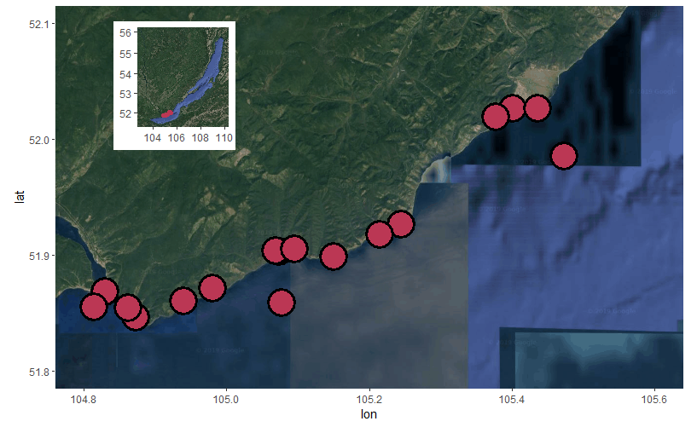

Figure 1: Map of all sampling locations.

|  |  |  |  |  |  |  |  |  |  |  |  |  |
| --- | --- | --- | --- | --- | --- | --- | --- | --- | --- | --- | --- | --- |
| Table 2: Average sewage indicator concentrations and densities per sampling location | | | | | | | | | | | | |
| Site | NH4+  (mg/L) | NO3-  (mg/L) | PO43-  (mg/L) | Caffeine  (ng/L) | Acetaminophen (ng/L) | Paraxanthine (ng/L) | Cotinine (ng/L) | Total  PPCP  (ng/L) | Microplastic  Density  (mp/L) | Fragment  Density  (mp/L) | Fiber  Density (mp/L) | Bead Density (mp/L) |
| BK-1 | 0.003 | 0.085 | 0.054 | 0.011 | 0.001 | 0.002 | 0 | 0.014 | 7.61904 | 2.61904 | 5 | 0 |
| BK-2 | 0.003 | 0.085 | 0.052 | 0.007 | 0.001 | 0 | 0 | 0.008 | 4.04761 | 2.85714 | 1.19047 | 0 |
| BK-3 | 0.068 | 0.09 | 0.045 | 0.003 | 0.001 | 0 | 0 | 0.004 | 6.19047 | 3.09523 | 3.09523 | 0 |
| BGO-1 | 0.0145 | 0.085 | 0.044 | 0 | 0.002 | 0 | 0 | 0.002 | 3.57142 | 1.19047 | 2.38095 | 0 |
| BGO-2 | 0.001 | 0.08 | 0.0385 | 0 | 0.001 | 0 | 0 | 0.001 | 5.71428 | 0.95238 | 4.76190 | 0 |
| BGO-3 | 0.001 | 0.09 | 0.044 | 0.005 | 0.003 | 0 | 0 | 0.008 | 2.85714 | 1.26984 | 1.58730 | 0 |
| OS-1 | 0.001 | 0.085 | 0.061 | 0 | 0.001 | 0 | 0.001 | 0.002 | 9.52381 | 2.38095 | 7.14285 | 0 |
| KD-1 | 0.0035 | 0.065 | 0.0375 | 0.003 | 0.001 | 0 | 0 | 0.004 | 5.47619 | 0.23809 | 5.23809 | 0 |
| KD-2 | 0.001 | 0.1 | 0.0445 | 0.001 | 0.001 | 0 | 0 | 0.002 | 4.04761 | 0.71428 | 3.33333 | 0 |
| MS-1 | 0.001 | 0.09 | 0.061 | 0.064 | 0.035 | 0.015 | 0 | 0.114 | 3.57142 | 0.71428 | 2.85714 | 0 |
| SM-1 | 0.001 | 0.085 | 0.1475 | 0.042 | 0.012 | 0.005 | 0 | 0.059 | 4.52381 | 0 | 4.52381 | 0 |
| LI-1 | 0.004 | 0.08 | 0.0385 | 0.05 | 0.04 | 0.006 | 0.002 | 0.098 | 6.19047 | 3.80952 | 1.66666 | 0.71428 |
| LI-2 | 0.091 | 0.095 | 0.0775 | 0.001 | 0.007 | 0 | 0 | 0.008 | 4.52381 | 1.42857 | 3.09523 | 0 |
| LI-3 | 0.0035 | 0.08 | 0.077 | 0.027 | 0.002 | 0.002 | 0.003 | 0.034 | 4.28571 | 1.19047 | 2.38095 | 0.71428 |
| EM-1 | 0.1125 | 0.185 | 0.092 | 0.029 | 0.014 | 0.002 | 0 | 0.045 | 5.47619 | 0 | 5.47619 | 0 |
| OS-2 | 0.001 | 0.08 | 0.078 | 0.033 | 0.001 | 0.004 | 0.003 | 0.041 | 3.57142 | 0.23809 | 3.33333 | 0 |

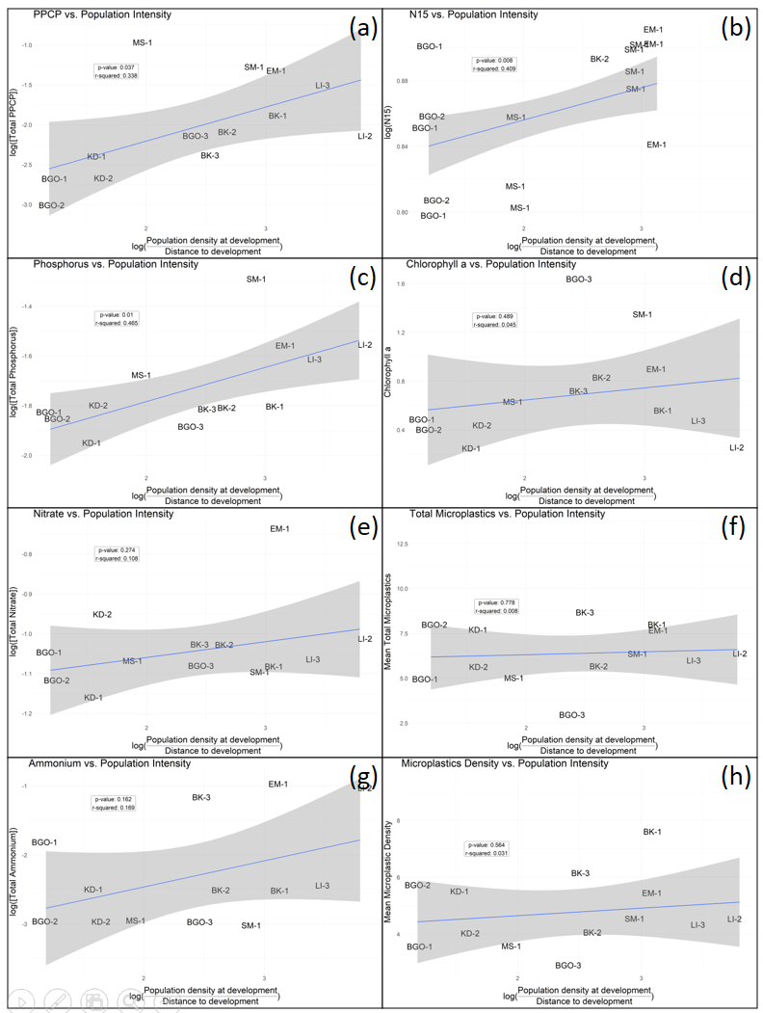

Figure 2: Linear models of each water column and sewage indicator as a function of population intensity. PPCPs (a), phosphorus (c), and N15 (b) produced significant models. Chlorophyll a (d), Nitrate (e), Ammonium (g), Total Microplastics (f), and Microplastic Density (h) did not produce significant models.

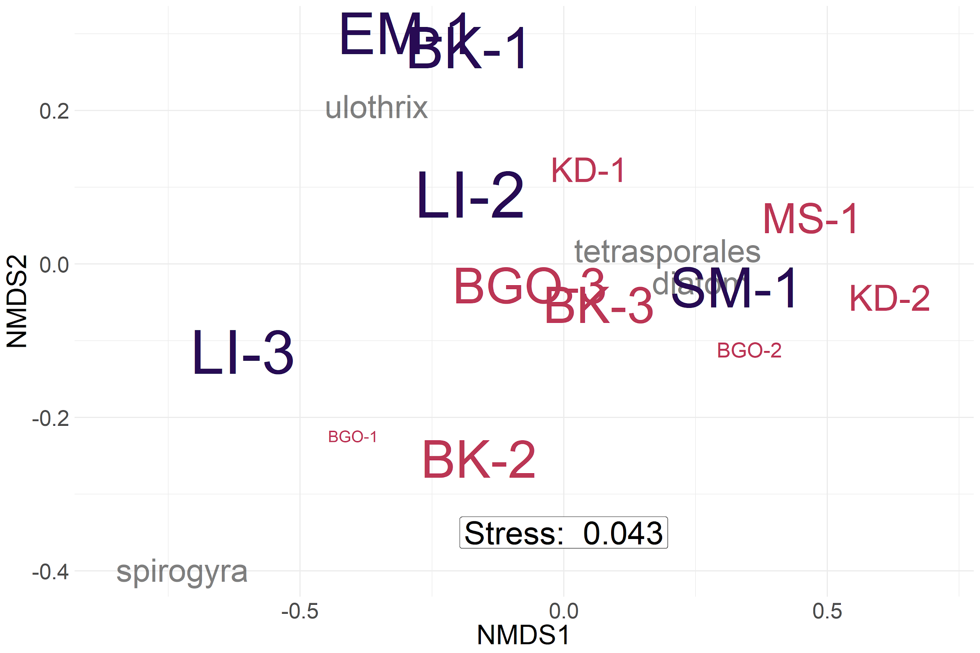

Figure 3: Periphyton abundance NMDS with bray-curtis dissimilarity. Labels are sized by log10 population intensity and colored by sites with high (purple) and moderate/low (pink) population intensities. PERMANOVA confirmed the two groups to be significantly different (p-value = 0.033). Sites with a higher population intensity metric tended to be more associated with filamentous algal groupings.

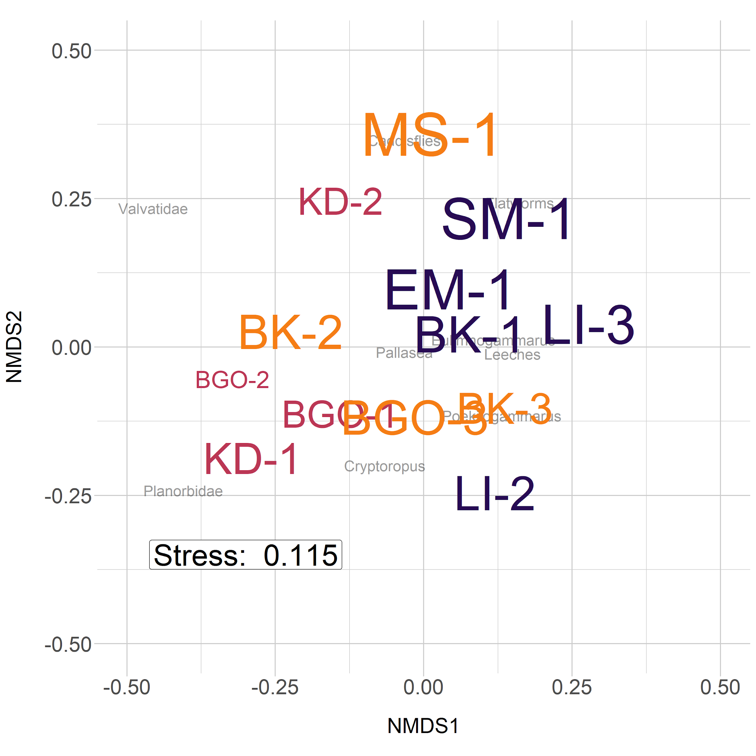

Figure 4: NMDS of macroinveretebrate abundance with bray-curtis dissimilarity. Three major groups included sites with low (pink), moderate (yellow), and high (purple) population intensities. PERMANOVA analysis confirmed this as a significant difference (p-value = 0.002).

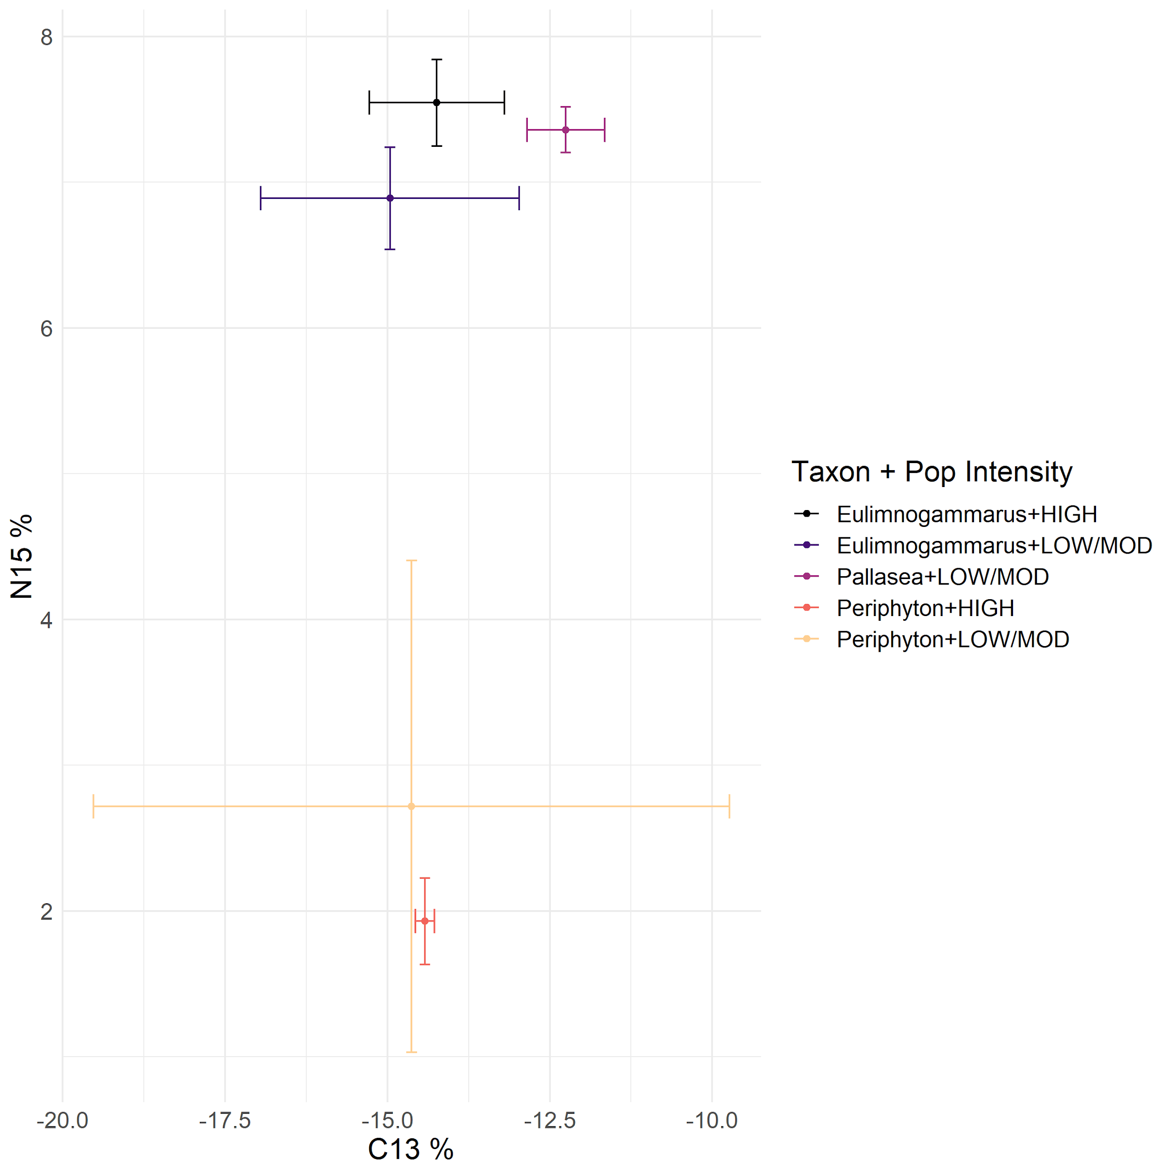

Figure 5: Biplot of mean and standard deviation C13 and N15 stable isotope values for littoral amphipods and periphyton, grouped by proximal population intensity. In general, periphyton did not differ in C13 or N15 signatures with increasing population intensity, whereas *Eulimnogammarus* amphipods increased N15 signatures with increasing population intensity. *Pallasea* signatures differed from *Eulimnogammarus* most likely because Pallasea tends to remain in the nearshore area, whereas *Eulimnogammarus* will regularly migrate the deeper zones (Taakhteev & Didorenko, 2015).

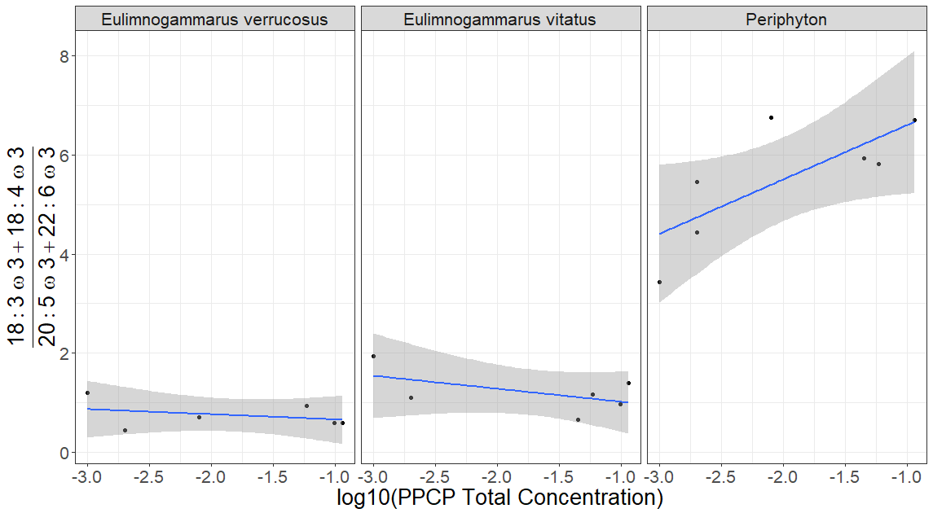

Figure 6: Filamentous:Diatom fatty acid ratios as a function of PPCP concentration. While grazing amphipod ratios remain relatively constant over a range of PPCP concentrations, periphyton tend to be more correlated with an increasing sewage signal (p-value = 0.05).