**Effects of spatially heterogeneous lakeside development on nearshore biotic communities in a large, deep, oligotrophic lake (Siberia)**

Michael F. Meyer1*

Stephanie E. Hampton2

Tedy Ozersky3

Kara H. Woo2

Kirill Shchapov3

Daniel D. Snow4

Emma J. Rosi5

Maxim A. Timofeyev6

Yulia M. Zaitseva7

Dmitry Yu. Karnaukhov6

Nina A. Bondarenko7

Aaron Galloway8

Julie Schram8

Matthew R. Brousil2

1. School of the Environment, Washington State University, Pullman, WA, USA

2. Center for Environmental Research, Education, and Outreach, Washington State University,

Pullman, WA, USA

3. Large Lakes Observatory, University of Minnesota - Duluth, Duluth, MN, USA

4. School of Natural Resources, University of Nebraska-Lincoln, Lincoln, NE, USA

5. Cary Institute of Ecosystem Studies, Millbrook, NY, USA

6. Biological Research Institute, Irkutsk State University, Irkutsk, Irkutsk Oblast, Russia

7. Limnological Institute SB RAS, Irkutsk, Irkutsk Oblast, Russia

8. Oregon Institute of Marine Biology, University of Oregon, Charleston, OR, USA

*corresponding author: michael.f.meyer@wsu.edu

**Keywords**: Lake Baikal, sewage, PPCP, food webs, community ecology, human disturbance

**Abstract (224/250 words)**

Clustered anthropogenic activity along lakeshores can create hot spots of disturbance and corresponding ecological responses. Sewage released from such lakeside development is a type of heterogeneous, pervasive, and frequently high impact disturbance with effects most immediately observed among littoral biota. Lake Baikal, the world’s most ancient, voluminous, and biodiverse lake, has been suspected of localized sewage pollution from adjacent lakeside settlements, and nearshore benthic communities appear to be responding. To test the spatial extent and magnitude of sewage release into Lake Baikal, we surveyed a 40-km transect of the southwestern shore for sewage-specific indicators, including pharmaceuticals and personal care products (PPCPs) and microplastics. To examine community responses, periphyton and macroinvertebrate abundance as well as trophic interactions were assessed at each littoral site. At all sites PPCPs including caffeine (up to 60 ng/L) and acetaminophen (up to 40 ng/L) were detected in the nearshore water column, and concentrations were related to the size of and distance from the nearest southern human settlement. Similarly, mollusc and diatom abundances decreased with increasing lakeside development. Periphyton and macroinvertebrate stable isotope analysis and essential fatty acid compositions suggested that despite differences in community composition among sites, the food web structure remained consistent. For Lake Baikal, these results are especially timely, especially considering the potential environmental consequences from growing tourism hot spots (~300,000 tourists annually) in tandem with developing wastewater management.

**Introduction**

Human disturbances across ecosystems disrupt a suite of biological processes, ranging from physiological (Sokolova and Lannig 2008) and behavioral (Longcore and Rich 2004) to population (Crouse et al. 1987) and community dynamics (Ellis et al. 2011). When human populations are concentrated in localized areas, human disturbance, and therefore organismal responses to that disturbance, can also be concentrated spatially, creating a “hot spot” disturbance landscape (Harper et al. 2005). For example, constructing a boat dock within a lake can abruptly reduce usability of fish spawning habitat (Scheuerell and Schindler 2004). Similarly, toxicants from human activities such as aluminum production, may threaten various ontogenetic stages and ecological communities depending on the co-location of toxicants and biological processes (Ginn et al. 2007). Further, multiple simultaneous disturbances, whether considered anthropogenic or “natural,” may amplify ecological responses if disturbances co-occur with sensitive biota (Franklin et al. 2000; Lake 2000). Given the heterogeneity of human disturbances, abiotic environments, and biological systems, heterogeneity of a specific disturbance as well as between co-occurring disturbances can produce a range of ecological responses (Carpenter et al. 2001).

Lakeside human settlements tend to be near to the land-water interface, and littoral organisms’ close proximity to the shoreline makes them susceptible to human disturbances such as sewage release (Carpenter et al. 2005; Rosenberger et al. 2008). Although the direct impacts of disturbance may be localized on nearshore biota, the disturbance may propagate to offshore communities, as pelagic organisms frequently rely on high littoral productivity for feeding or breeding (Vadeboncoeur et al. 2008; Hampton et al. 2011). As a result of connectivity between pelagic and littoral processes, increased understanding of how edge ecological communities respond to disturbance can also offer insights to whole ecosystem processes.

The release of treated and untreated wastewater into aquatic ecosystems is an example of a globally frequent and high impact human disturbance that can introduce pollutants and reshape aquatic ecological communities (Meyer et al. 2019). Nutrients are among the primary pollutants within sewage byproducts (Smith et al. 1999). Although often concentrated within sewage, nutrient inputs can also originate from disparate anthropogenic and environmental sources, thereby obfuscating sewage signals. For example, agricultural runoff can add high nutrient concentrations to soil and aquatic systems (Powers et al. 2016). Geological processes, such as melting permafrost, can likewise contribute high nutrient loadings to bogs that can eventually lead to changes in primary production and decomposition (Turetsky et al. 2000). Similar to geological and anthropogenic processes, changes in terrestrial plant communities, such as increased alder presence, has been associated with increased nutrient concentrations and nearshore periphyton production in adjacent lake environments (Moran et al. 2012). Regardless of the nutrients’ source, biological responses to even slight nutrient increases can further confound sewage signals. Benthic primary producers in nearshore water, especially those in oligotrophic lakes, can assimilate dissolved anthropogenic solutes, such as nutrients, quickly from the water column (e.g., hours), such that deviation in typical water concentrations is not observed (Hadwen and Bunn 2005).

Because nutrients alone may not allow identification of a pollutants’ source, pharmaceuticals and personal care products (PPCPs) have garnered increasing attention for their usefulness as sewage indicators (Rosi-Marshall and Royer 2012). Study of sub-continental and continental scale PPCP concentrations demonstrated that areas with dense human populations tend to be PPCP hot spots, yet lower concentrations can still be detected in less urban locations (Kolpin et al. 2002; Focazio et al. 2008; Yang et al. 2018). At finer scales, PPCP concentrations have been used to identify hot spots of septic discharge within suburban residential areas (Yang et al. 2016). In addition to identifying areas and moments of sewage pollution, PPCPs have also demonstrated robustness in defining gradients of sewage pollution in river systems, with concentrations being directly proportional to population density and inversely proportional to distance from a densely populated area (Bendz et al. 2005). The varying degradation time of PPCPs can make them useful for different purposes. For example, gemfibrozil has an environmental half life of 120-288 days (Araujo et al. 2011) and can indicate pollution that may have occurred within a relatively long time frame, whereas relatively short-lived PPCPs, such as caffeine (t0.5 = 3.5-13 days; (Benotti and Brownawell 2009)), can provide finer scaled temporal monitoring.

Microplastics (plastic debris up to 5 mm in size; (Barnes et al. 2009)) also have been used to detect sewage pollution (Li et al. 2018) along gradients of increasing human (Klein et al. 2015). They are typically very resistant to degradation (Barnes et al. 2009), providing a signal over a longer time frame than many PPCPs and nutrients in sewage. Their usefulness as indicators, however, has several distinct limitations. First, similar to nutrients, microplastics can originate from various sources of human pollution, such that the signal provided by microplastics can sometimes be confounded with other human activities, such as agriculture (Koelmans et al. 2019). Second, while microplastics have been useful in identifying presence of human pollution in lake environments, their densities may be more correlated with intra-lake currents and wave action more than lakeside human activity (Free et al. 2014).

In addition to identifying presence of sewage pollution, PPCP and microplastic concentrations can also be useful to delineate gradients of human disturbance along which biotic community response may be examined. Bendz et al. (2005) noted PPCPs concentrations decreased downstream of the input source in a river. Yang et al. (2016) similarly demonstrated how leachate from septic systems can create PPCP hotspots in soils, with certain PPCPs advecting in groundwater transport and others sorbing to colloidal particles. By defining sewage gradients using PPCPs, their concentrations can be correlated with changes in primary producer and consumer guilds, such as increased filamentous algal taxa relative to diatoms. Increased filamentous algae relative to other taxa has been frequently observed in areas suspected of sewage pollution (Rosenberger et al. 2008; Hampton et al. 2011), likely due to benthic filamentous algae efficiently removing nutrients from the water column (Hadwen and Bunn 2005; Andersson and Brunberg 2006). With a changing resource base, grazing macroinvertebrate communities may likewise shift to include more detritivores or species that are capable of consuming filamentous algae (Rosenberger et al. 2008). In addition to the physical difficulty grazers may experience in consuming filamentous algae, there also may be tradeoffs in nutritional quality, as filamentous algae tend to contain a different mixture of essential fatty acids in comparison to diatoms (Kelly and Scheibling 2012). With this potential for nutritional change, sewage pollution into the nearshore area of lakes may not only alter community composition but also restructure interactions between community members.

To investigate ecological community responses to sewage pollution using micropollutants as sewage indicators, we surveyed a 40-km shoreline in Lake Baikal with discrete population centers for indicators of sewage pollution and metrics of benthic community composition and structure. Located in Siberia, Lake Baikal is the oldest, most voluminous, and deepest freshwater lake in the world (Hampton et al. 2018), with the majority of Baikal’s biota occurring in the littoral zone (Kozhova and Izmest’eva 1998). Despite much of Lake Baikal’s shoreline lacking human development and Baikal’s watershed being largely roadless and unpopulated (Moore et al. 2009), pockets of lakeside development have have been recently associated with filamentous algal blooms (Timoshkin et al. 2016). While Lake Baikal’s pelagic zone is generally ultra-oligotrophic (Ministry of Natural Resources and Ecology of the Russian Federation 2014), nearshore areas abutting lakeside settlements have demonstrated signs of eutrophication (Timoshkin et al. 2016). Timoshkin et al. (2016, 2018) present a compelling case that inadequacies in wastewater management for lakeside settlements has been the main driver of nearshore ecological alterations, motivating further research that might identify the extent to which sewage is altering nearshore communities.

Having evolved under ultra-oligotrophic conditions over 25 million years (Kozhov 1963), Baikal’s biota present excellent opportunity to study how nearshore communities respond to highly localized human disturbance. Even though Lake Baikal’s remoteness and high volume should mitigate risks of sewage pollution, nearshore biotic communities proximal to adjacent lakeside development may respond most markedly as pollutants diffuse into the lake. Given the potential to observe community-level responses to sewage pollution within Lake Baikal in the nearshore area, we hypothesized that (1) sewage indicators, such as PPCP concentrations and microplastic densities, would increase with increasing population density and proximity of lakeside development; (2) an increasing sewage signal would be directly proportional to filamentous algal community composition; and (3) with an increasing filamentous algae abundance, the littoral food web would restructure to include more macroinvertebrates capable of consuming filamentous algae as well as detritus in place of diatom-consuming macroinvertebrates. In doing so, this study pairs highly specific sewage indicators to identify pollution hot spots with co-located biological measurements, thereby explicitly defining areas of sewage pollution.

**Methods**

*1. Site description*

The vast majority of Lake Baikal’s 2,000-km shoreline lacks lakeside development (Timoshkin et al. 2016). Our study focused on a 40-km transect of Baikal’s southwestern shoreline, where rudimentary wastewater management techniques are employed in pockets of lakeside development (Timoshkin et al. 2018). The largest settlement, Listvyanka, is primarily a tourist town with approximately 1,963 permanent residents (IrkutskStat, 2012), although tourism can contribute significantly to the town’s population (Timoshkin et al., 2016). Listvyanka experiences high fluxes in tourists with approximately 300,000 tourists over the course of the year (Timoshkin et al., 2016). Listvyanka also serves as the main transportation hub to other settlements within Lake Baikal. Within our 40-km transect, two of those villages include Bolshie Koty and Bol’shoe Goloustnoe. Bolshie Koty consists of approximately 56 permanent residents (IrkutskStat, 2012). Bolshie Koty also is home to two field research stations, for Irkutsk State University and the Russian Academy of Sciences Limnological Institute (Timoshkin et al., 2018). Bolshoe Goloustnoe is also a tourist village, with approximately 600 permanent residents (IrkutskStat, 2012).

Along our 40-km transect, we sampled 14 littoral and 3 pelagic locations. Littoral locations were meant to capture a range of sites with varying degrees of adjacent shoreline development – from “developed” to “undeveloped.” Pelagic sites were located 2 to 5 km offshore from each of the developed sites (Figure 1; Table 1). We attempted to choose specific sites at each location that represented a gradient moving away from population centers, with distance between sites dictated by accessibility. Littoral sampling sites were chosen to be the same depth (~1.25 m) across all sites and locations, such that sites sometimes differed in their distance from shore (Table 1). At each site, air temperature was measured with a mercury thermometer and photographs were taken of the substrate and the shoreline.

Because certain littoral sampling sites are clustered around a population center, hydrologic connectivity between sites could create sewage gradients. In order to account for the effect of sewage gradients, we created a distance-weighted population density metric for each littoral site. The distance-weighted population metric reflects the idea that sewage pollution should be positively related to increasing magnitude of human density and inversely related with distance from densely populated areas (sensu Bendz et al., 2005). For each littoral site, we first calculated the population density (population/km2) of the closest southern lakeside development, recognizing that the most southern site would be eliminated from analysis. While a north-to-south wind and associated current typically dominate for this area, late-summer winds and associated currents tend to flow south-to-north although not with the velocity and regularity of autumn winds (Shimaraev et al., 1994). Population data were collected from 2012 census data (IrkutskStat, 2012); development area was determined using area calculation from Google Earth (Table S1). Because sewage pollution may be diluted in instances where the majority of lakeside development is not arranged along the shoreline, we scaled population density directly by length of shoreline at the closest developed site. Each sampled littoral site was then assigned the scaled population density metric of the nearest southern developed site. In order to capture how sewage pollution may attenuate over space, all scaled population densities were normalized by distance from the nearest southern developed location. In summary, we calculated our distance-weighted population metric by the equation , where Ij is the distance-weighted population at site j, Pi is the population at developed site i, Ai is the area of developed site i in km2, Li is the shoreline length at developed site i in km, and D is the distance from developed site i to j in km.

*2. Water samples*

At both pelagic and littoral sites, water samples were collected for nutrient, chlorophyll, microplastic, and pharmaceutical and personal care product (PPCP) analysis. Each water sample collection procedure is described below.

*2a. Nutrients*

Water samples for nutrient analyses were collected in approximately 150 mL glass jars that had been rinsed three times with water from the sampling location. Samples were collected in duplicates and immediately frozen at -20°C. Samples were stored in the dark at -20°C until processing at the Siberian Branch of the Russian Academy of Sciences.

For each water sample, nitrate, ammonium, phosphate, and total phosphorus concentrations were measured. For ammonium and nitrate concentrations, samples were analyzed with a spectrophotometer following the addition of Nessler’s reagent and disulfuric acid respectively. Phosphate concentration was measured with a spectrophotometer following the addition of persulfate. Total phosphorus was derived from the molecular mass of phosphate concentration. Concentrations are reported in mg/L.

*2b. Chlorophyll a*

Water samples were collected in 1.5 L plastic bottles from a depth of approximately 0.75 m. Within 12 h of collection, three subsamples were collected by passing up to 150 mL through 25 mm cellulose nitrate filter. Filters were then placed in a 35 mm petri dish and frozen in the dark until processing.

Chlorophyll samples were processed in a manner similar to that of Parson (1963) and Lorenzen (1967). Filtered GF/Fs were ground in 90% acetone, in which chlorophyll extraction was allowed to proceed overnight. Samples were centrifuged for 15-20 minutes. Once particulates settled, absorbance of the chlorophyll extract was measured in a spectrophotometer at 630, 645, 665, and 750 nm. Concentrations were calculated using the formula: ; where A is the absorbance value of a particular wavelength, V1 is the volume of the filtered water, and V2 is the volume of extract. Concentrations are reported as mg/L.

*2c. PPCPs*

Water samples were collected in a 250 mL amber glass bottle that was rinsed with an organic solvent and then three times with sample water prior to collections. Following collection, samples were refrigerated and kept in the dark until solid phase extraction (SPE).

Within 12 h of collection, samples were filtered directly from the amber glass bottle using a 25 mm GF/F, and then passed through SPE cartridges (Waters Corporation, Milford, MA). Lab personnel wore gloves and face masks to minimize contamination. Prior to filtration, SPE cartridges were primed with at least 5 mL of either methanol or acetone and then washed with at least 5 mL of sample water. Rate of SPE occurred at approximately 1 drop per second. Extraction proceeded until water could no longer pass through the SPE cartridge or until all collected water was filtered. Upon completion, cartridges were removed and immediately stored in whirlpacks. SPE cartridges were processed for PPCPs following methods of Lee et al. (2016).

2d. *Microplastics*

At each location, three 1.5 L clear plastic bottles were washed thoroughly with sample water before each collection. Samples were collected from the midpoint depth for each site. Once collected, bottles were sealed with a plastic cap until processing.

For processing, each sample was vacuum filtered with a 47 mm GF/F. During filtration, aluminum foil was used to cover the filtration funnel to prevent contamination. Upon completion, filters were allowed to dry under vacuum pressure and then stored in 50 mm petri dishes. Following filtration of all three replicates, filtrate was collected and then re-filtered as a control for contamination.

Microplastic counting involved visual inspection of the entire GF/F according to guidelines proposed in Van Cauwenberghe et al. (2015). Visual enumeration was conducted under a stereoscope, and microplastics were classified into one of three categories: fibers, fragments, or beads. For all categories, plastics were defined as observed objects with apparently artificial colors and no visible organelles or cellular components. Fibers were defined as smooth, long plastics with consistent diameters. Fragments were defined as plastics with irregularly sharp or jagged edges. Beads were defined as spherical plastics. During enumeration, GF/Fs remained in the petri dish to minimize potential for contamination. Results are reported as the average number of microplastics per liter.

*3. Benthic biological samples*

At each littoral site, periphyton and macroinvertebrates were collected for relative abundance estimates and food web analysis. Each biological sample collection and processing procedure is described below.

*3a. Benthic algal collection*

At each littoral site, we haphazardly selected three rocks representative of substrate. A plastic stencil was used to scrape a standardized 14.5 cm2 patch for periphyton samples. Samples were stored in plastic scintillation vials and preserved with Lugol’s solution. Remaining periphyton from the site were collected in composite for fatty acid and stable isotope analysis to enable food web characterization (described below).

Periphyton taxonomic identification and enumeration was performed by subsampling 10 μL aliquots from each plastic scintillation vial. For each aliquot, cells, filaments, and colonies were counted for each taxonomic group until at least 300 cells were identified. Taxa were classified in broad categories consistent with Baikal algal taxonomy (Izhboldina, 2007). Taxonomic groupings were coarse so as to capture overarching patterns in diatom relative to filamentous algae abundance. As a result, diatoms were considered one group. Filamentous algae were considered at finer resolution due to the distinctions in their occurrences described by Timoshkin et al. (2016). Samples contained *Ulothrix*, a regularly occurring Baikal filamentous alga (Kozhov 1963; Osipova et al. 2009), and *Spirogyra*, a recently cosmopolitan filamentous alga (Timoshkin et al., 2016).

*3b. Benthic invertebrate collection*

At each littoral site, three kick-net samples were collected for assessment of benthic community composition and abundance. Using a D-net, we collected macroinvertebrates by flipping over 1-3 rocks, and then sweeping five times in a left-to-right motion of approximately 1 m in length. After the series of sweeps, the catch was rinsed into a plastic bucket. For each replicate, bucket contents were concentrated using a 64 μm net and placed in glass jars with vodka (~40% ethanol) for preservation and refrigerated at 4°C aboard the research vessel. Vodka was replaced with ~80% ethanol upon return to the lab, and samples were stored at ~4°C.

Separate collections were conducted for invertebrate fatty acid and stable isotope analyses. Invertebrates were collected using a D-net in a similar fashion as the community enumeration. Additional invertebrates were also collected by hand. Collected organisms were then live-sorted, identified to species, and frozen at -20°C.

Invertebrate taxonomic identification and enumeration were performed under a stereoscope. All well preserved invertebrates were identified to species with the exception of juveniles (Taakhteev, 2015 for amphipods; Sitnikova, 2012 for molluscs; Table 2).

*3c. Food web characterization*

To characterize littoral food webs, we analyzed carbon and nitrogen stables isotopes as well as fatty acid profiles for periphyton and macroinvertebrates. Stable isotopes have been used extensively to examine food web structure and dynamics, indirectly indicating food web associations (see review (Layman et al. 2012)). More sensitive diet tracers, such as fatty acids, have demonstrated robust potential to identify trophic relationships because fatty acid signatures are largely consistent within a species (Iverson et al. 2004; Galloway and Winder 2015). Fatty acid analysis, therefore, can be used to infer species-level resource consumption, when fatty acid profiles of both resources and consumers are known. Ideally, combining fatty acid profiles with stable isotope data can present a more cohesive food web analysis (Boecklen et al. 2011).

*Stable isotope analysis*

Prior to isotopic analysis, periphyton and macroinvertebrate samples were freeze dried for ~48 h (or until dry). Measurements of δ15N and δ13C were performed on an elemental analyzer-isotope ratio mass spectrometer (EA-IRMS; Finnigan DELTAplus XP, Thermo Scientific). The EA-IRMS was calibrated against certified reference materials including L-glutamic acid (NIST SRM 8574), low organic soil and sorghum flour (standards B-2153 and B-2159 from Elemental Micro-analysis Ltd., Okehampton, UK) and in-house standards (acetanilide and caffeine).

*Fatty acid analysis*

Fatty acid extractions generally involved three phases: (1) 100% chloroform extraction, (2) chloroform-methanol extraction, and (3) fatty acid methylation. Fatty acid extraction methods were adapted from similar methods developed in Schram et al. (2018).

Samples were first freeze-dried in Eppendorf tubes at -20°C overnight, then ground and weighed. Following freeze-drying, samples were transferred to 10 mL glass centrifuge vials, and 2 mL of 100% chloroform was added to each under nitrogen gas. Samples were allowed to sit in chloroform overnight at -80°C.

Following overnight chloroform extraction, samples underwent a chloroform-methanol extraction three times. To each sample, we added 1 mL cooled 100% methanol, 1 mL chloroform:methanol solution (2:1), and 0.8 mL 0.9% NaCl solution. Samples were inverted three times and sonicated on ice for 10 minutes. Next, samples were vortexed for 1 minute, and centrifuged for 5 minutes (3,000 rpm) at 4°C. Using a double pipette technique, the lower organic layer was extracted and kept under nitrogen. After the third extraction, samples were allowed to evaporate under nitrogen flow, and resuspended in 1.5 mL chloroform and stored at -20°C overnight.

Once resuspended in chloroform, 1 mL of chloroform extract was transferred to a glass centrifuge tube with a glass syringe. As a standard, 4 μL of 19-carbon fatty acid was added along with 1 mL of toluene and 2 mL of 1% sulfuric acid-methanol. The vial was closed under nitrogen gas and then incubated in 50°C water bath for 16 hours. After incubation, samples were removed from the bath, allowed to reach room temperature and stored on ice. Next, we performed a potassium carbonate-hexane extraction twice. To each sample, we added 2 mL of 2% potassium bicarbonate and 5 mL of 100% hexane, inverting the capped vial so as to mix the solution. Samples were centrifuged for 3 minutes (1,500 rpm) at 4°C. The upper hexane layer was then removed and placed in a vial to evaporate under nitrogen flow. Once almost evaporated, 1 mL of 100% hexane was added and stored in a glass amber autosampler vial for GC/MS quantification. GC/MS quantification was performed in a similar method as described in Schram et al. (2018).

*4. Statistical analyses*

Total phosphorus, nitrate, ammonium, microplastic abundance and density, total PPCP concentration, and δN15 in macroinvertebrate tissues were log-transformed and regressed against log-transformed distance-weighted population using a linear model. Residuals were assessed for normality and homogeneity of variance.

Periphyton and macroinvertebrate abundance data were each analyzed with a consistent multivariate routine. First, cross-correlated taxa were identified, and the taxon with less abundance was removed so as to ensure species abundances were independent. Second, community compositions for both periphyton and macroinvertebrates were visualized using non-metric multidimensional scaling (NMDS) with a Bray-Curtis similarity metric. Like other ordination techniques (e.g., Principal Component Analysis), NMDS condenses complexity of multi-dimensional data, such that when data are plotted, more similar data points (sampled locations, in our case) are spatially closer together. Visual inspection of the NMDS plot identified groupings of sampled locations based off PPCP concentrations and distance-weighted population. Third, to determine an optimal number of groups for the sampled locations, k-means clustering was performed. K-means clustering is a non-hierarchical clustering method that iterates through increasing numbers of clusters (K) and assigns sites to the closest cluster’s centroid (i.e., mean) (Johnson and Wichern 2007). After adding an additional cluster, the within-group-sum-of-squares (WSS) was calculated, and the optimal number of clusters was selected when WSS decreased most markedly. Finally, when an optimal number of groups was determined, sites were assigned to a cluster and then differences between clusters were assessed using a permutational multivariate analysis of variance (PERMANOVA, (Anderson 2001)) with 999 permutations. Unlike traditional multivariate analyses of variance (MANOVA), PERMANOVA does not require assumptions of multivariate normality (Anderson 2001).

Fatty acid data were analyzed in a manner similar to periphyton and macroinvertebrate abundance data. First, complete fatty acid profiles were visualized by performing NMDS with Bray-Curtis similarity for all organisms (Figure S1). This technique broadly demonstrated that inter-specific variation in fatty acid composition was greater than intraspecific variation. This same pattern was observed for all fatty acids quantified as well as solely essential fatty acids (EFAs; Figure S2). EFAs are a subgroup of polyunsaturated fatty acids (PUFAs) that are prone to accumulating within organisms (see Kelly & Scheibling, 2012). Among the eight common EFAs used with an ecological focus (Taipale et al. 2013), 18:3ω3, 18:4ω3, 20:5ω3, and 22:6ω3 had the highest coefficient of variation between sites. Because these four EFAs demonstrated the greatest variation between sites, our analyses focused on how their relative abundances related to PPCP concentrations and distance-weighted populations. The fatty acids 18:3ω3 and 18:4ω3 have been previously associated with filamentous algae, such as Baikalian *Ulothrix* (Osipova et al. 2009), whereas 20:5ω3 and 22:6ω3 have previously been associated with diatoms (Taipale et al. 2013). Comparing the ratio of (18:3ω3% + 18:4ω3%)/(20:5ω3% + 22:6ω3%) could therefore function as proxy for filamentous:diatom abundance and potentially offer insights into feeding patterns for the grazers. To evaluate how this ratio may be related with sewage pollution, we regressed filamentous:diatom fatty acid signals (i.e., (18:3ω3% + 18:4ω3%)/(20:5ω3% + 22:6ω3%)) against log-transformed PPCP concentrations using a linear model.

All analyses were conducted within the R statistical environment (R Core Team 2019), using the tidyr (Wickham and Henry 2019), dplyr (Wickham et al. 2019), ggplot2 (Wickham 2016), and vegan (Oksanen et al. 2019) packages. All data are publicly available from the Dryad data repository (DOI), and all R scripts are available from the GitHub repository of this project’s Open Science Framework account (DOI).

**Results**

*1. Water samples*

Nitrate (p = 0.27), ammonium (p = 0.16), and chlorophyll a (p = 0.48) were not significantly correlated with distance-weighted population (Figure 2). Phosphate (p = 0.01) and total PPCP (p = 0.037) concentrations, however, were significantly correlated with distance-weighted population (p = 0.01; Figure 2). Within the littoral zone, PPCPs detected included caffeine, 1,7-dimethylxanthine (main human metabolite of caffeine), cotinine (main human metabolite of nicotine), and acetaminophen (Table 3).

Microplastics were detected in both the littoral and pelagic zones. Bead microplastics were only detected in Listvyanka. Fibers were the most abundant type of microplastics across all sites (average = 3.6 microplastics/L), followed by fragments (average = 1.4 microplastics/L) and beads (average = 0.09 microplastics/L). Total microplastic densities were not significantly correlated with distance-weighted population (p = 0.56; Figure 2), although more types of microplastics were generally observed near areas with higher distance-weighted population values, such as Listvyanka.

*2. Benthic biological samples*

*2a. Periphyton*

Major taxonomic groupings of periphyton consisted of diatoms, *Tetrasporales*, *Spirogyra*, and *Ulothrix*. K-means cluster analysis of periphyton abundance demonstrated three major groupings would capture most variance, and visual inspection of periphyton community NMDS suggested groupings were related to distance-weighted population values (Figure 3). PERMANOVA results demonstrated that periphyton communities were significantly different based on distance-weighted population values (p = 0.023).

*2b. Macroinvertebrates*

Uncorrelated taxonomic groupings included four amphipod genera: *Eulimnogammarus*, *Poekilogammarus*, *Cryptoropus*, and *Pallasea*; two mollusc families: Planorbidae and Valvatidae; flatworms; caddisflies; and leeches (summarized in Table 2). K-means cluster analysis of macroinvertebrate community composition demonstrated 3 major groupings would capture most variance, and visual inspection of NMDS suggested clusters related to distance-weighted population (Figure 4). PERMANOVA results supported the hypothesis that macroinvertebrate communities significantly differed along a gradient of distance-weighted populations (p = 0.001).

*3. Food web characterization*

*3a. Stable isotopes*

Among periphyton and amphipod samples, 13C values ranged from -19.5 to -9.5%, suggesting terrestrial origin for benthic carbon (Figure 5; Post, 2002). Among grazer δ15N values, no grazer groups deviated more than 3.4% δ15N, suggesting that all were within the same trophic level (Post 2002).

When evaluating 13C and δ15N concentrations in relation to distance-weighted population, δ15N significantly increased with distance-weighted population only for grazers (p = 0.008; Figure 2, Figure 5). Periphyton δ15N signatures did not significantly increase with distance-weighted population (p = 0.7). In contrast, 13C concentrations were not related with distance-weighted population for either periphyton or macroinvertebrates.

*3b. Fatty acids*

For both periphyton and grazers, our analyses focused mainly on the essential fatty acids (EFAs) 18:3ω3, 18:4ω3, 20:5ω3, and 22:6ω3. The EFAs 18:3ω3 and 18:4ω3 are commonly associated with filamentous algae (Taipale et al. 2013), whereas 20:5ω3, and 22:6ω3 are more associated with diatoms (Taipale et al. 2013). All EFAs are polyunsaturated fatty acids (PUFAs), which are critical to maintaining cellular membrane fluidity especially in cold environments (Nichols et al. 1993). Additionally, EFAs are largely synthesized by primary producers, each species of which usually has a consistent EFA signature (Taipale et al., 2013) although temperature-related deviations can occur (Flaim et al., 2014; Anesi et al., 2016). Consumers, however, can acquire EFAs by grazing (Daalsgard et al., 2003) or upgrading EFAs at their own energetic expense (Sargent et al., 1988; Daalsgard et al., 2003). By comparing the most abundant EFAs in both periphyton and amphipods, results of our analysis might imply changes in trophic interactions. For periphyton, the ratio of C18:3ω3 and C18:4ω3 in comparison to C20:5ω3 and C22:6ω3 significantly increased with an increasing PPCP concentration (p = 0.05, Figure 6) but not with an increasing distance-weighted population (p = 0.17). Amphipods’ fatty acid ratios were not significantly related with either increasing distance-weighted population or increasing PPCP concentrations.

**Discussion**

Concordant with our expectations, sewage pollution indicators in the nearshore of Lake Baikal were associated with size of and distance from human settlements, and Baikal’s nearshore communities appear to be responding. Total PPCP, phosphorus, and macroinvertebrate δN15 concentrations tended to increase with distance-weighted population. Similarly, nearshore communities with stronger sewage signals tended to contain lower fractions of molluscs and caddisflies and higher filamentous algae presence. In contrast, amphipods remained prevalent throughout all littoral sampling locations. Despite these changes in community composition, fatty acid results did not support our hypothesis that food web interactions would restructure.

Perhaps the most notable result from this study was that sewage pollution can be both detected in Lake Baikal’s nearshore area and associated with size of and proximity to lakeside development. The influence of these localized settlements is even more noteworthy considering that Baikal’s shoreline is largely void of lakeside development (Moore et al., 2009). While several studies have quantified PPCP concentrations in aquatic systems (e.g., Kolpin et al., 2002; Focazio et al., 2008; Rosi-Marshall et al., 2013), lakes have remained less represented within the PPCP literature in comparison to lotic systems (Meyer et al., 2019). With longer hydraulic residence times, PPCP distributions in lentic systems may differ from lotic environments, as pollutants within lakes may be more prone to accumulate within the nearshore before diffusing to undetectable concentrations. Our results suggest that PPCPs concentrate within the nearshore and are undetectable offshore. This result is especially important, considering how Baikal and many other lakes focus monitoring efforts based on pelagic measurement (Ministry, 2014). Despite Lake Baikal’s widely ultraoligotrophic status, nearshore sampling holds promise to identify localized disturbances long before a pelagic response may become detectable (Hampton et al., 2011).

In contrast to Lake Baikal’s PPCP concentrations, microplastics were not associated with distance-weighted population and may be a poor proxy for sewage pollution in Baikal. Microplastics, though, have been used to identify sewage pollution in similarly large lakes, like Lake Hovsgol (Free et al., 2014). Unlike PPCPs’ relatively short half-lives though, microplastics suggest accumulated pollution by degrading slowly or remaining recalcitrant to decay (Brandon et al., 2016). As a result, microplastic concentrations in Baikal, as quantified by our methods, may be poor proxies for capturing the temporal variability of short-term human populations, but may be useful in detecting offshore sewage signals as microplastics diffuse from the nearshore to the pelagic. It is worth noting that since the time of our field sampling, evidence has accumulated that our methods likely dramatically underestimated microplastic abundance (Wang & Wang, 2018; Brandon et al., 2019). While we focus here on microplastics as an indicator of human disturbance, microplastics are increasingly shown to disrupt food web dynamics by altering grazing patterns (ref) and providing carbon substrate for microbial growth (ref). Together these growing uncertainties suggest that microplastic pollution in Baikal and elsewhere deserves increased attention.

Along the shoreline, increasing sewage indicators tended to be associated with more filamentous periphyton as well as decreased mollusc and caddisfly. Previous studies investigating Baikal’s periphyton composition noted that areas adjacent to human development often had increased filamentous algae (Timoshkin et al., 2015; 2016; 2018). Even though Timoshkin et al., (2015, 2016, 2018) present a convincing argument, Lake Baikal’s southwestern shore often experiences increased *Ulothrix* blooms in late August (Kozhov, 1963), potentially confounding sewage signals with annually occurring phenomenon. Our data corroborate Timoshkin’s surveys (Timoshkin et al., 2016) that *Spirogyra* as well as *Ulothrix* abundance is greatest near areas of high lakeside development. While not observed at the same magnitude as reported in Timoshkin et al. (2016), our results also support those authors’ general conclusion that Baikalian molluscs tend to be more susceptible to sewage pollution. Decreased mollusc abundance may have several causes, including molluscs having low tolerance for increased PPCP concentrations, especially caffeine and its metabolites (Hollingsworth et al., 2002), molluscs not being able to consume filamentous algae (Lucia & Russo, 1989), filamentous algae not offering the proper nutritional yield for molluscs (Pernet et al., 2007), or certain contaminants within the sewage being particularly toxic to molluscs (Timoshkin et al., 2016).

With respect to how food webs would restructure with a changing community composition, our data suggest a nuanced food web response to increasing sewage signal. Periphyton essential fatty acid profiles from sites with higher sewage pollution had higher levels of 18:3ω3 and 18:4ω3 relative to C20:5ω3 and C22:6ω3 fatty acids. Because fatty acid profiles tend to be indicative of algal species (Iverson et al., 2004; 2008; Kelley & Scheibling, 2012; Galloway & Winder, 2015), this pattern likely reflects the higher abundance of green algae relative to diatoms. (Taipale et al., 2013; Osipova et al., 2009). Stable isotopes, however, suggested no differences in periphyton δN15% with increasing distance-weighted population (Figure 5). In contrast to periphyton, amphipod fatty acid profiles did not differ between sites (Figure 6), whereas δN15% increased slightly yet significantly with increasing distance-weighted population. The differing periphyton and amphipod δN15% signatures in relation to distance-weighted population may relate to amphipods having longer cellular turnover rates (e.g., weeks, McIntyre & Flecker, 2006) relative to periphyton (e.g., days; Swarnikannu & Hoagland, 1989). This insight implies that amphipods may be long-term indicators of sewage pollution into Baikal, whereas periphyton offers a more instantaneous sewage signal.

Given the intersite variation in periphyton’s fatty acids yet intersite consistency in amphipods’ fatty acids, our results suggest that amphipods are able to maintain a consistent fatty acid signature through three potential mechanisms. First, amphipods may selectively consume diatoms as opposed to filamentous algae. As a result, grazing pressure on diatoms would increase, and diatom relative abundance could decrease both from increased grazing and lesser efficiency at removing nutrients from the water column relative to filamentous taxa. Second, amphipods may indeed consume filamentous algae, and then invest energy to convert C18 fatty acids to C20 and C22 fatty acids. Consequently, amphipods would need to catabolize fatty acids necessary to survive in Baikal’s cold temperatures. Third, amphipod fatty acid turnover could lag behind periphyton, much like how amphipods demonstrated increasing δN15% signature whereas periphyton δN15% remained consistent across all sites. Regardless of the exact mechanism, our data support the hypothesis that increasing sewage pollution would alter community trophic interactions, which suggests a net energetic cost through amphipods’ increased grazing pressure on diatoms or consumption of filamentous algae.

Together, our results corroborate previous studies by suggesting sewage pollution is occurring in Lake Baikal’s nearshore area, with ecological consequences. Unlike previous studies, though, our results demonstrate how patchy hot spots of lakeside development can create gradients of human disturbance. While PPCP hot spots as well as gradients have been observed in lotic (Bendz et al., 2005) and subsurface (Yang et al., 2016) systems, PPCP gradients within lacustrine environments are less well understood (Meyer et al., 2019). In the case of Lake Baikal, internal mixing from currents and wave action (Shimaraev et al., 1998) likely created the PPCP gradient we observed. While ecological responses to thermal gradients created by hydrodynamics has been well studied in Lake Baikal (Kozhov, 1963), the potential for Baikal’s physical processes, and lentic systems’ globally, to influence pollutant concentrations presents a new frontier in understanding heterogeneity of human disturbance. Large lakes, such as Baikal and other Great Lakes of the world, may have complex internal physical processes creating heterogeneities, such as Poincaré waves or Langmuir circulation, whereas smaller lakes may be more influenced by traveling surface waves (Wetzel, 2001). Given lacustrine physical processes’ potential to influence contaminant distributions and ecological communities, our results highlight how nuanced physical, chemical, and biological measurements may be necessary to define heterogeneous disturbances and ecological responses.

*Future research trajectories in the context of a changing climate*

Ancient Lake Baikal remains a biodiversity hot spot (Hampton et al., 2018), where the majority of endemic species tend to be cryophilic stenotherms (Kozhova & Izmesteva, 1998). With increasing lake temperatures (O’Reilly et al., 2015) and less consistent ice coverage (Sharma et al. 2019) worldwide, it is unclear how cold-water adapted species will respond to a warming ambient environment in conjunction with human disturbance. In our study, we demonstrated that littoral amphipods were prevalent throughout the entirety of human disturbance gradients, which are likely products of physical limnological processes. These same physical processes are also influenced by climate forcings, such as temperature and wind. In the case of Baikal, endemic amphipods are well adapted to intense hydrodynamics (Jakob et al., 2015), yet they have shown acute sensitivity to temperature (Bedulina et al., 2016) as well as toxicants (Timofeyev et al., 2008). The extent to which a changing climate may result in altered hydrodynamics is uncertain, but potential exists for altered current and mixing patterns to warm water and transport solutes unexpectedly. Beyond Baikal, a changing climate creates potential for altered lake hydrodynamics globally. Changes in intra-lake transport may be consequential for understanding heterogeneity, suggesting need for intensive study of individual systems’ disturbances and ecological responses and extensive comparison of lakes between regions.

**Works Cited**

Andersson, E., and A.K. Brunberg. 2006. Inorganic nutrient acquisition in a shallow clearwater lake – dominance of benthic microbiota. Aquatic Sciences **68**: 172–180. doi:10.1007/s00027-006-0805-x

Bedulina, D., M. F. Meyer, A. Gurkov, E. Kondratjeva, B. Baduev, R. Gusdorf, and M. A. Timofeyev. 2017. Intersexual differences of heat shock response between two amphipods ( *Eulimnogammarus verrucosus* and *Eulimnogammarus cyaneus* ) in Lake Baikal. PeerJ **5**: e2864. doi:10.7717/peerj.2864

Beman, J. M., K. R. Arrigo, and P. A. Matson. 2005. Agricultural runoff fuels large phytoplankton blooms in vulnerable areas of the ocean. Nature **434**: 211.

Bendz, D., N. A. Paxéus, T. R. Ginn, and F. J. Loge. 2005. Occurrence and fate of pharmaceutically active compounds in the environment, a case study: Höje River in Sweden. Journal of Hazardous Materials **122**: 195–204. doi:10.1016/j.jhazmat.2005.03.012

Brandon, J., M. Goldstein, and M. D. Ohman. 2016. Long-term aging and degradation of microplastic particles: comparing in situ oceanic and experimental weathering patterns. Marine pollution bulletin **110**: 299–308.

Carpenter, S., B. Walker, J. M. Anderies, and N. Abel. 2001. From Metaphor to Measurement: Resilience of What to What? Ecosystems **4**: 765–781. doi:10.1007/s10021-001-0045-9

Carpenter, S. R., J. J. Cole, M. L. Pace, and others. 2005. Ecosystem subsidies: terrestrial support of aquatic food webs from 13C addition to contrasting lakes. Ecology **86**: 2737–2750.

Crouse, D. T., L. B. Crowder, and H. Caswell. 1987. A Stage-Based Population Model for Loggerhead Sea Turtles and Implications for Conservation. Ecology **68**: 1412–1423. doi:10.2307/1939225

Ellis, B. K., J. A. Stanford, D. Goodman, and others. 2011. Long-term effects of a trophic cascade in a large lake ecosystem. Proceedings of the National Academy of Sciences **108**: 1070–1075. doi:10.1073/pnas.1013006108

Focazio, M. J., D. W. Kolpin, K. K. Barnes, E. T. Furlong, M. T. Meyer, S. D. Zaugg, L. B. Barber, and M. E. Thurman. 2008. A national reconnaissance for pharmaceuticals and other organic wastewater contaminants in the United States - II) Untreated drinking water sources. SCIENCE OF THE TOTAL ENVIRONMENT **402**: 201–216. doi:10.1016/j.scitotenv.2008.02.021

Free, C. M., O. P. Jensen, S. A. Mason, M. Eriksen, N. J. Williamson, and B. Boldgiv. 2014. High-levels of microplastic pollution in a large, remote, mountain lake. Marine Pollution Bulletin **85**: 156–163. doi:10.1016/j.marpolbul.2014.06.001

Franklin, J. F., D. Lindenmayer, J. A. MacMahon, A. McKee, J. Magnuson, D. A. Perry, R. Waide, and D. Foster. 2000. Threads of continuity. Conservation in Practice **1**: 8–17.

Ginn, T. R., F. J. Loge, and T. D. Scheibe. 2007. Explaining“ Noise” as Environmental Variations in Population Dynamics. Computing in Science & Engineering **9**: 40–49.

Hampton, S. E., S. McGowan, T. Ozersky, and others. 2018. Recent ecological change in ancient lakes: Ecological change in ancient lakes. Limnology and Oceanography. doi:10.1002/lno.10938

Hampton, S. E., S. C. Fradkin, P. R. Leavitt, and E. E. Rosenberger. 2011. Disproportionate importance of nearshore habitat for the food web of a deep oligotrophic lake. Marine and Freshwater Research **62**: 350. doi:10.1071/MF10229

Harper, K. A., S. E. McDonald, P. J. Burton, and others. 2005. Edge Influence on Forest Structure and Composition in Fragmented Landscapes. Conservation Biology **19**: 768–782.

Hollingsworth, R. G., J. W. Armstrong, and E. Campbell. 2002. Pest control: caffeine as a repellent for slugs and snails. nature **417**: 915.

Jakob, L., D. V. Axenov-Gribanov, A. N. Gurkov, and others. 2016. Lake Baikal amphipods under climate change: thermal constraints and ecological consequences J. Benstead [ed.]. Ecosphere **7**. doi:10.1002/ecs2.1308

Kelly, J. R., and R. E. Scheibling. 2012. Fatty acids as dietary tracers in benthic food webs. Marine Ecology Progress Series **446**: 1–22.

Klein, S., E. Worch, and T. P. Knepper. 2015. Occurrence and spatial distribution of microplastics in river shore sediments of the Rhine-Main area in Germany. Environmental science & technology **49**: 6070–6076.

Kolpin, D. W., E. T. Furlong, M. T. Meyer, E. M. Thurman, S. D. Zaugg, L. B. Barber, and H. T. Buxton. 2002. Pharmaceuticals, Hormones, and Other Organic Wastewater Contaminants in U.S. Streams, 1999−2000: A National Reconnaissance. Environmental Science & Technology **36**: 1202–1211. doi:10.1021/es011055j

Lake, P. S. 2000. Disturbance, patchiness, and diversity in streams. Journal of the north american Benthological society **19**: 573–592.

Lee, S. S., A. M. Paspalof, D. D. Snow, E. K. Richmond, E. J. Rosi-Marshall, and J. J. Kelly. 2016. Occurrence and Potential Biological Effects of Amphetamine on Stream Communities. Environmental Science & Technology **50**: 9727–9735. doi:10.1021/acs.est.6b03717

Li, X., L. Chen, Q. Mei, B. Dong, X. Dai, G. Ding, and E. Y. Zeng. 2018. Microplastics in sewage sludge from the wastewater treatment plants in China. Water research **142**: 75–85.

Longcore, T., and C. Rich. 2004. Ecological Light Pollution. Frontiers in Ecology and the Environment **2**: 191. doi:10.2307/3868314

Lorenzen, C. J. 1967. DETERMINATION OF CHLOROPHYLL AND PHEO-PIGMENTS: SPECTROPHOTOMETRIC EQUATIONS1. Limnology and oceanography **12**: 343–346.

Mazzella, L., and G. F. Russo. 1989. Grazing effect of two Gibbula species (Mollusca, Archaeogastropoda) on the epiphytic community of Posidonia oceanica leaves. Aquatic Botany **35**: 357–373.

Ministry of Natural Resources and Ecology of the Russian Federation. 2014. On the State of Lake Baikal and Measures for Its Protection in 2013: Government Report.

Moore, M. V., S. E. Hampton, L. R. Izmest’Eva, E. A. Silow, E. V. Peshkova, and B. K. Pavlov. 2009. Climate change and the world’s “sacred sea”—Lake Baikal, Siberia. BioScience **59**: 405–417.

Moran, P. W., S. E. Cox, S. S. Embrey, R. L. Huffman, T. D. Olsen, and S. C. Fradkin. 2012. Sources and Sinks of Nitrogen and Phosphorus in a Deep, Oligotrophic Lake, Lake Crescent, Olympic National Park, Washington. US Geological Survey.

O’Reilly, C. M., S. Sharma, D. K. Gray, and others. 2015. Rapid and highly variable warming of lake surface waters around the globe: GLOBAL LAKE SURFACE WARMING. Geophysical Research Letters **42**: 10,773–10,781. doi:10.1002/2015GL066235

Osipova, S., L. Dudareva, N. Bondarenko, A. Nasarova, N. Sokolova, L. Obolkina, O. Glyzina, and O. Timoshkin. 2009. Temporal variation in fatty acid composition of Ulothrix zonata (Chlorophyta) from ice and benthic communities of Lake Baikal. Phycologia **48**: 130–135.

Pernet, F., R. Tremblay, L. Comeau, and H. Guderley. 2007. Temperature adaptation in two bivalve species from different thermal habitats: energetics and remodelling of membrane lipids. Journal of Experimental Biology **210**: 2999–3014.

Powers, S. M., T. W. Bruulsema, T. P. Burt, and others. 2016. Long-term accumulation and transport of anthropogenic phosphorus in three river basins. Nature Geoscience **9**: 353.

Rosenberger, E. E., S. E. Hampton, S. C. Fradkin, and B. P. Kennedy. 2008. Effects of shoreline development on the nearshore environment in large deep oligotrophic lakes. Freshwater Biology **53**: 1673–1691. doi:10.1111/j.1365-2427.2008.01990.x

Rosi-Marshall, E. J., and T. V. Royer. 2012. Pharmaceutical Compounds and Ecosystem Function: An Emerging Research Challenge for Aquatic Ecologists. Ecosystems **15**: 867–880. doi:10.1007/s10021-012-9553-z

Rosi-Marshall, E. J., D. W. Kincaid, H. A. Bechtold, T. V. Royer, M. Rojas, and J. J. Kelly. 2013. Pharmaceuticals suppress algal growth and microbial respiration and alter bacterial communities in stream biofilms. Ecological Applications **23**: 583–593.

Scheffer, M., S. Carpenter, J. A. Foley, C. Folke, and B. Walker. 2001. Catastrophic shifts in ecosystems. Nature **413**: 591.

Scheuerell, M. D., and D. E. Schindler. 2004. Changes in the Spatial Distribution of Fishes in Lakes Along a Residential Development Gradient. Ecosystems **7**: 98–106. doi:10.1007/s10021-003-0214-0

Smith, V. H., G. D. Tilman, and J. C. Nekola. 1999. Eutrophication: impacts of excess nutrient inputs on freshwater, marine, and terrestrial ecosystems. Environmental Pollution **100**: 179–196. doi:10.1016/S0269-7491(99)00091-3

Sokolova, I., and G. Lannig. 2008. Interactive effects of metal pollution and temperature on metabolism in aquatic ectotherms: implications of global climate change. Climate Research 37: 181–201. doi:10.3354/cr00764

Taipale, S., U. Strandberg, E. Peltomaa, A. Galloway, A. Ojala, and M. Brett. 2013. Fatty acid composition as biomarkers of freshwater microalgae: analysis of 37 strains of microalgae in 22 genera and in seven classes. Aquatic Microbial Ecology **71**: 165–178. doi:10.3354/ame01671

Timofeyev, M., and Z. Shatilina. 2007. Different Preference Reactions of Three Lake Baikal Endemic Amphipods to Temperature and Oxygen Are Correlated with Symbiotic Life. Crustaceana **80**: 129–138.

Timoshkin, O. A., M. V. Moore, N. N. Kulikova, and others. 2018. Groundwater contamination by sewage causes benthic algal outbreaks in the littoral zone of Lake Baikal (East Siberia). Journal of Great Lakes Research. doi:10.1016/j.jglr.2018.01.008

Timoshkin, O. A., D. P. Samsonov, M. Yamamuro, and others. 2016. Rapid ecological change in the coastal zone of Lake Baikal (East Siberia): Is the site of the world’s greatest freshwater biodiversity in danger? Journal of Great Lakes Research. doi:10.1016/j.jglr.2016.02.011

Turetsky, M. R., R. K. Wieder, C. J. Williams, and D. H. Vitt. 2000. Organic matter accumulation, peat chemistry, and permafrost melting in peatlands of boreal Alberta. Écoscience 7: 115–122. doi:10.1080/11956860.2000.11682608

Vadeboncoeur, Y., G. Peterson, M. J. Vander Zanden, and J. Kalff. 2008. Benthic algal production across lake size gradients: interactions among morphometry, nutrients, and light. Ecology **89**: 2542–2552.

Van Cauwenberghe, L., L. Devriese, F. Galgani, J. Robbens, and C. R. Janssen. 2015. Microplastics in sediments: a review of techniques, occurrence and effects. Marine environmental research **111**: 5–17.

Wagner, M., C. Scherer, D. Alvarez-Muñoz, and others. 2014. Microplastics in freshwater ecosystems: what we know and what we need to know. Environmental Sciences Europe **26**:1.

Weithmann, N., J. N. Möller, M. G. Löder, S. Piehl, C. Laforsch, and R. Freitag. 2018. Organic fertilizer as a vehicle for the entry of microplastic into the environment. Science Advances **4**: eaap8060.

Yang, Y.-Y., G. S. Toor, P. C. Wilson, and C. F. Williams. 2016. Septic systems as hot-spots of pollutants in the environment: Fate and mass balance of micropollutants in septic drainfields. Science of The Total Environment **566-567**: 1535–1544. doi:10.1016/j.scitotenv.2016.06.043

**Acknowledgments**

We would like to thank the faculty, students, staff, and mariners of the Irkutsk State University’s Biological Research Institute Biostation for their expert field, taxonomic, and laboratory support; Marianne Moore and Bart De Stasio for helpful advice; the researchers and students of the Siberian Branch of the Russian Academy of Sciences Limnological Institute for expert taxonomic and expert assistance; Stephen M. Powers, Stephanie G. Labou, Stephen L. Katz, Brian P. Lannouette, John R. Loffredo, Alex K. Fremier, Erica J. Crespi, Daniel L. Preston, and Jim J. Elser for offering insights throughout the development of this project. Funding was

provided by the National Science Foundation (NSF-DEB-1136637) to S.E.H., a Fulbright Fellowship to M.F.M., a NSF Graduate Research Fellowship to M.F.M. (NSF-DGE-1347973), and the Russian Ministry of Education and Science Research Project (No. GR 01201461929; 1354-2014/51). This work serves as one chapter of M.F.M.’s doctoral dissertation in Environmental and Natural Resource Sciences at Washington State University.

|  |  |  |  |  |  |  |  |  |  |
| --- | --- | --- | --- | --- | --- | --- | --- | --- | --- |
| Table 1: Site description of all sampled locations. All locations are littoral except for three pelagic locations labelled as “OS”. Because “OS” locations presented logistical challenges, certain temperature and distance from shore measurements were not collected at the same time as the samples. “Adjacent Population” refers to the number of people living in any human settlements directly adjacent to the sampling location. | | | | | | | | | |
| Site | Latitude | Longitude | Depth (m) | Distance to shore (m) | Air Temperature (C) | Surface Temperature (C) | Midpoint Temperature (C) | Bottom Temperature (C) | Adjacent Population |
| BK-1 | 51.90316 | 105.07404 | 0.7 | 10 | 18 | 14 | 13 | 13 | 56 |
| BK-2 | 51.90365 | 105.069 | 0.9 | 17.5 | 19 | 13 | 13 | 13 | 56 |
| BK-3 | 51.90536 | 105.0957 | 0.8 | 10 | 18 | 14 | 14 | 14 | 56 |
| BGO-1 | 52.02693 | 105.40102 | 0.9 | 18 | 20 | 13 | 13 | 13 | 0 |
| BGO-2 | 52.0197 | 105.37707 | 1.1 | 14 | 19 | 14 | 14 | 14 | 600 |
| BGO-3 | 52.02649 | 105.43577 | 0.7 | 21 | 18 | 16 | 16 | 16 | 600 |
| OS-1 | 51.98559 | 105.47237 | 900 | NA | 15 | NA | NA | NA | NA |
| KD-1 | 51.92646 | 105.24504 | 0.8 | 20.75 | 23 | NA | NA | NA | 0 |
| KD-2 | 51.91807 | 105.21456 | 0.9 | 14.5 | 23 | 16 | 15 | 15 | 0 |
| MS-1 | 51.89863 | 105.15017 | 0.6 | 10.5 | 21 | 17 | 16 | 16 | 0 |
| SM-1 | 51.87152 | 104.98006 | 0.9 | 11.5 | 21 | 15 | 15 | 15 | 0 |
| LI-1 | 51.86825 | 104.83042 | 0.6 | 8.9 | 19 | 14 | 14 | 14 | 2000 |
| LI-2 | 51.84626 | 104.87356 | 0.8 | 9.4 | 21 | 15 | 15 | 15 | 2000 |
| LI-3 | 51.85407 | 104.86216 | 0.7 | 9.25 | 19.5 | 15 | 14 | 14 | 2000 |
| EM-1 | 51.86005 | 104.93999 | 0.7 | 15.5 | 24.5 | 14 | 14 | 14 | 0 |
| OS-2 | 51.8553 | 104.8148 | 1300 | NA | 21 | NA | NA | NA | NA |
| OS-3 | 51.859108 | 105.0769 | 1400 | 5000 | NA | 14.5 | NA | NA | NA |

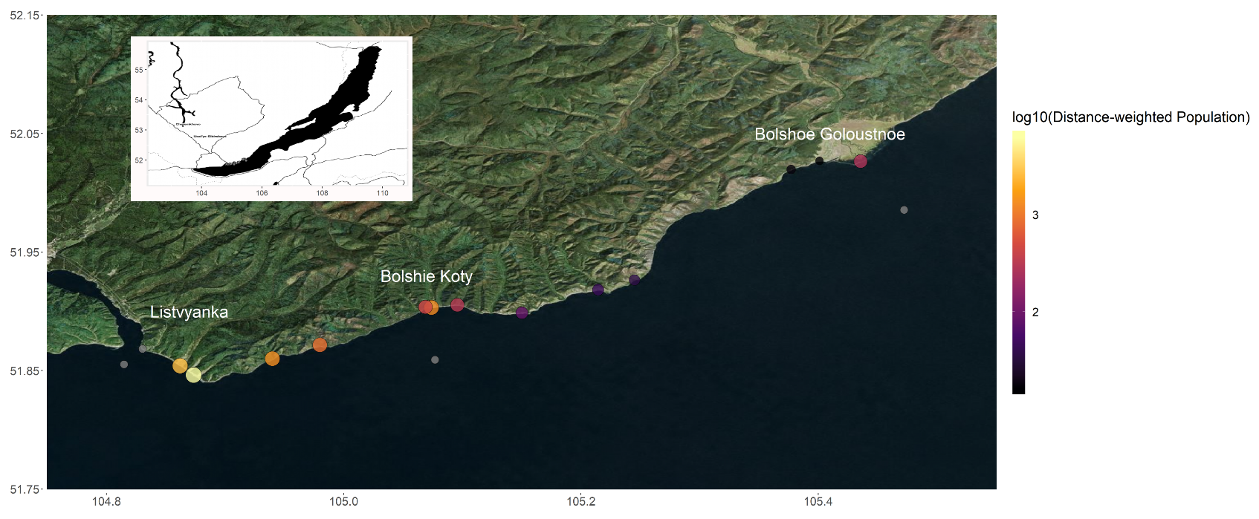

Figure 1: Map of all sampling locations with sites sized and colored by distance-weighted population. Grey sites are located where a distance-weighted population could not be calculated. The entire transect included three developed sites (i.e., Listvyanka, Bolshie Koty, Bolshoe Goloustnoe). Listvyanka contains approximately 2,000 permanent residents, although it experiences a transient tourist population of approximately 300,000 people annually. Bolshie Koty contains approximately 56 permanent residents, but the two local field stations and tourism can increase population by 200+ individuals in the summer. Bolshoe Goloustnoe has approximately 600 permanent residents and remains relatively consistent throughout the year. Three offshore samples were also collected to compare pelagic sewage signals to those in the littoral.

|  |  |  |
| --- | --- | --- |
| Table 2: Macroinvertebrate taxonomic groupings for abundance estimates. Amphipod taxa were defined as in Taakhteev & Didorenko, 2015; Mollusc taxa were defined as in Sitnikova, 2012. | | |
| **Amphipoda** | **Mollusca** | **Other** |
| *Brandtia latissima intermida* | Acroloxidae | Asellidae |
| *Brandtia latissima lata* | Baicaliidae | Caddisflies |
| *Brandtia latissima latior* | Benedictidate | Hirudinea |
| *Brandtia latissima latissima* | Maackia | Planaria |
| *Brandtia latissima lora* | Planorbidae |  |
| *Brandtia parasitica parasitica* | Valvatidae |  |
| *Cryptoropus inflatus* |  |  |
| *Cryptoropus pachytus* |  |  |
| *Cryptoropus rugosus* |  |  |
| *Eulimnogammarus capreolus* |  |  |
| *Eulimnogammarus cruentes* |  |  |
| *Eulimnogammarus cyaneus* |  |  |
| *Eulimnogammarus grandimanus* |  |  |
| *Eulimnogammarus maacki* |  |  |
| *Eulimnogammarus marituji* |  |  |
| *Eulimnogammarus verucossus* |  |  |
| *Eulimnogammarus viridis viridis* |  |  |
| *Eulimnogammarus vittatus* |  |  |
| *Hyallela cziarnianski* |  |  |
| *Pallasea brandtia brandita* |  |  |
| *Pallasea brandtii tenera* |  |  |
| *Pallasea cancelloides* |  |  |
| *Pallasea cancellus* |  |  |
| *Pallasea viridis* |  |  |
| *Poekilogammarus crassimus* |  |  |
| *Poekilogammarus ephippiatus* |  |  |
| *Poekilogammarus megonychus perpolitus* |  |  |
| *Poekilogammarus pictus* |  |  |

|  |  |  |  |  |  |  |  |  |  |
| --- | --- | --- | --- | --- | --- | --- | --- | --- | --- |
| Table 3: Average sewage indicator concentrations and densities per sampling location | | | | | | | | | |
| Site | NH4 mg/dm3 | NO3 mg/dm3 | PO4 mg/dm3 | Caffeine | Acetaminophen | Paraxanthine | Cotinine | Distance weighted population | Categorical distance weighted population |
| BK-1 | 0.003 | 0.085 | 0.054 | 0.011 | 0.001 | 0.002 | 0 | 1311.29 | High |
| BK-2 | 0.003 | 0.085 | 0.052 | 0.007 | 0.001 | 0 | 0 | 435.045 | Mod |
| BK-3 | 0.068 | 0.09 | 0.045 | 0.003 | 0.001 | 0 | 0 | 306.89 | Mod |
| BGO-1 | 0.0145 | 0.085 | 0.044 | 0 | 0.002 | 0 | 0 | 15.50 | Low |
| BGO-2 | 0.001 | 0.08 | 0.0385 | 0 | 0.001 | 0 | 0 | 16.44 | Low |
| BGO-3 | 0.001 | 0.09 | 0.044 | 0.005 | 0.003 | 0 | 0 | 264.55 | Mod |
| OS-1 | 0.001 | 0.085 | 0.061 | 0 | 0.001 | 0 | 0.001 | NA | NA |
| KD-1 | 0.0035 | 0.065 | 0.0375 | 0.003 | 0.001 | 0 | 0 | 34.80 | Low |
| KD-2 | 0.001 | 0.1 | 0.0445 | 0.001 | 0.001 | 0 | 0 | 43.51 | Low |
| MS-1 | 0.001 | 0.09 | 0.061 | 0.064 | 0.035 | 0.015 | 0 | 84.84 | Mod |
| SM-1 | 0.001 | 0.085 | 0.1475 | 0.042 | 0.012 | 0.005 | 0 | 868.42 | High |
| LI-1 | 0.004 | 0.08 | 0.0385 | 0.05 | 0.04 | 0.006 | 0.002 | NA | NA |
| LI-2 | 0.091 | 0.095 | 0.0775 | 0.001 | 0.007 | 0 | 0 | 6221.74 | High |
| LI-3 | 0.0035 | 0.08 | 0.077 | 0.027 | 0.002 | 0.002 | 0.003 | 2703.49 | High |
| EM-1 | 0.1125 | 0.185 | 0.092 | 0.029 | 0.014 | 0.002 | 0 | 1359.84 | High |
| OS-2 | 0.001 | 0.08 | 0.078 | 0.033 | 0.001 | 0.004 | 0.003 | NA | NA |
| OS-3 | 0.001 | 0.08 | 0.0795 | 0.001 | 0.001 | 0 | 0 | NA | NA |

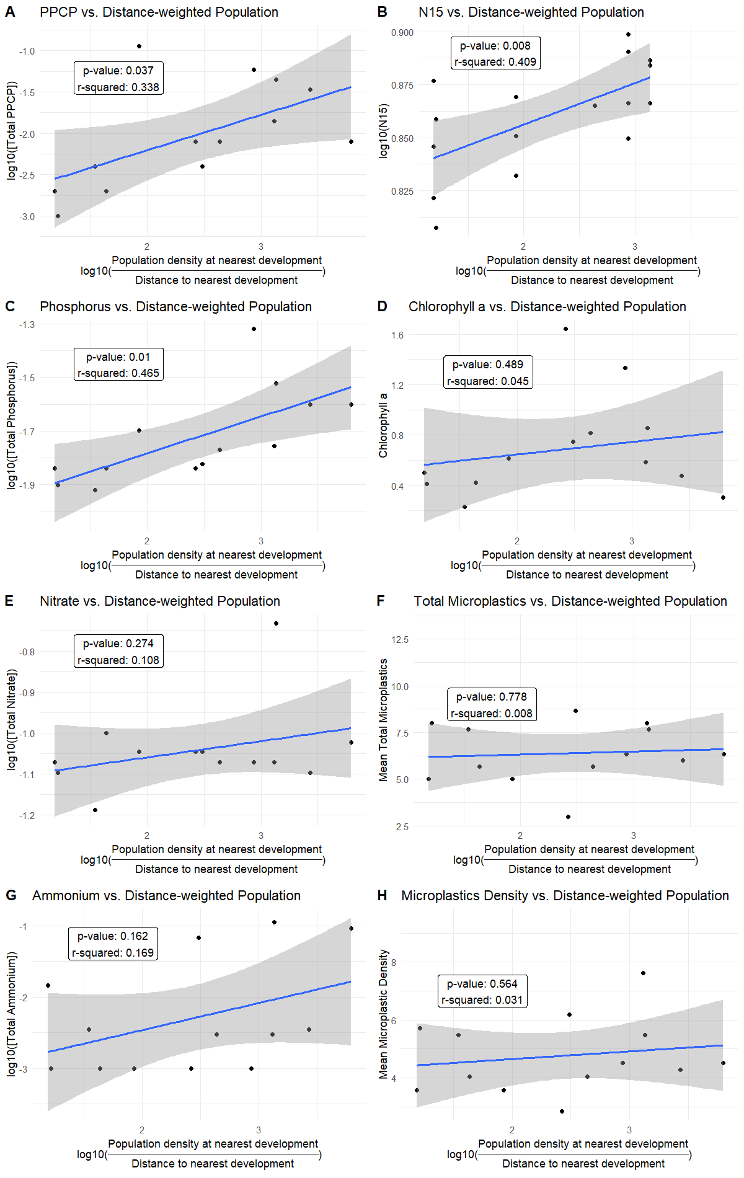

Figure 2: Linear models of total PPCP concentrations (A), N15 (B), phosphorus (C), Chlorophyll a (D), Nitrate (E), Total Microplastics (F), Ammonium (G), and Microplastic Density (H) regressed against log-transformed distance-weighted population. Total PPCP concentrations (A), N15 (B), and phosphorus (C) produced significant models. Chlorophyll a (D), Nitrate (E), Total Microplastics (F), Ammonium (G), and Microplastic Density (H) did not produce significant models.

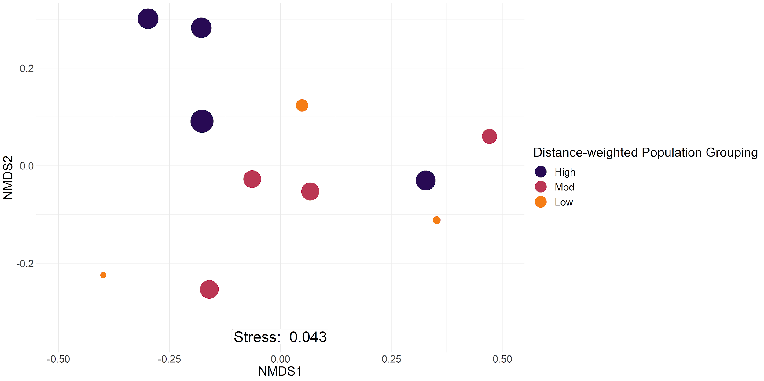

Figure 3: Periphyton abundance NMDS with bray-curtis dissimilarity. Labels are sized by log10 distance-weighted population and colored by sites with high (purple), moderate (pink), and low (orange) distance-weighted population values. PERMANOVA confirmed the three groups to be significantly different (p = 0.023). Sites with a higher distance-weighted population value tended to be more associated with filamentous algal groupings, whereas moderate and low values were more associated with diatom abundance.

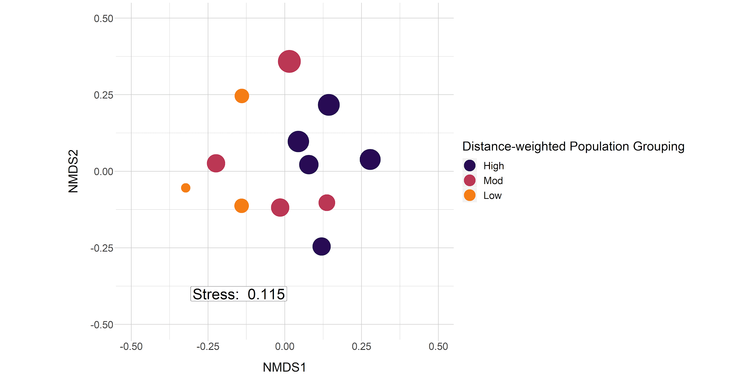

Figure 4: Macroinvertebrate abundance NMDS with bray-curtis dissimilarity. Sampling location labels are sized by log-transformed distance-weighted population with major groups including low (orange), moderate (pink), and high (purple) distance-weighted population. PERMANOVA confirmed the three groups to be significantly different (p = 0.002). Sites with a higher distance-weighted population values tended to be associated with amphipod and leech taxa (see Table 2), whereas sites with lesser distance-weighted population values were more associated with increased mollusc abundance (see Table 2).

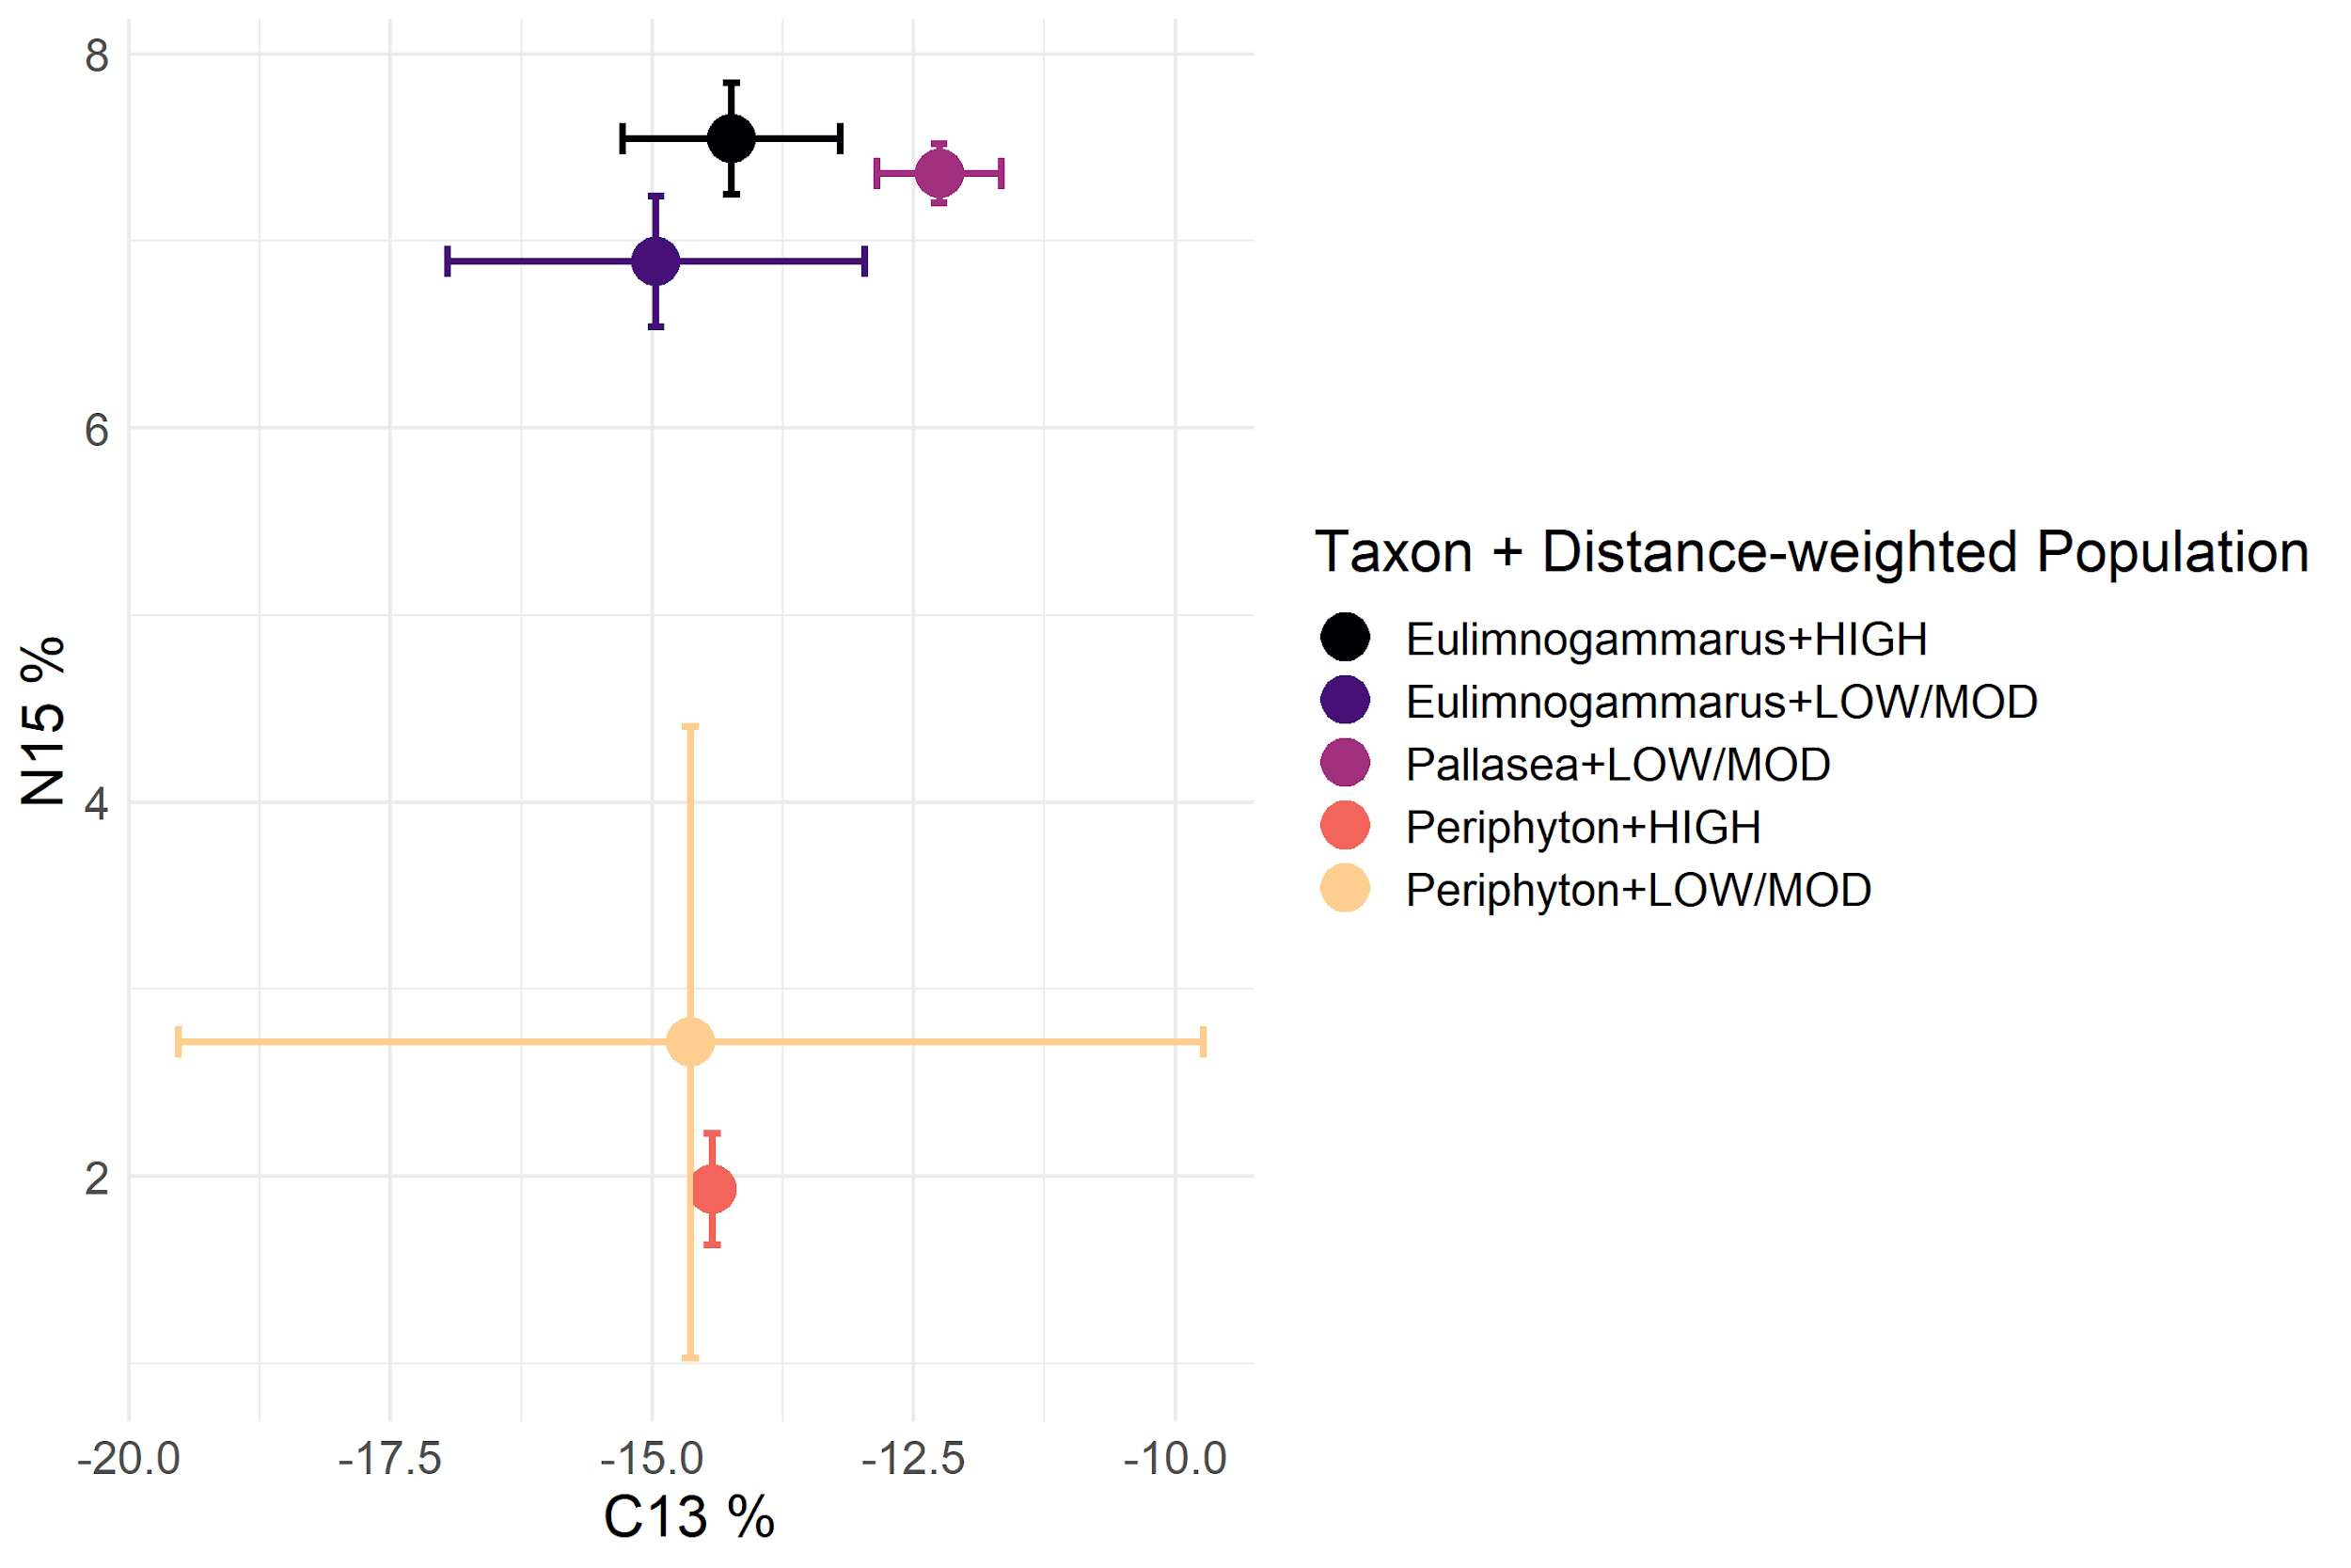

Figure 5: Biplot of mean and standard deviation C13 and N15 stable isotope values for littoral amphipods and periphyton, grouped by categorical distance-weighted population (Table 3). In general, periphyton did not differ in C13 or N15 signatures with increasing distance-weighted population, whereas *Eulimnogammarus* amphipods increased N15 signatures with increasing distance-weighted population. *Pallasea* signatures differed from *Eulimnogammarus* most likely because Pallasea tends to remain in the nearshore area, whereas *Eulimnogammarus* will regularly migrate the deeper zones (Taakhteev & Didorenko, 2015).

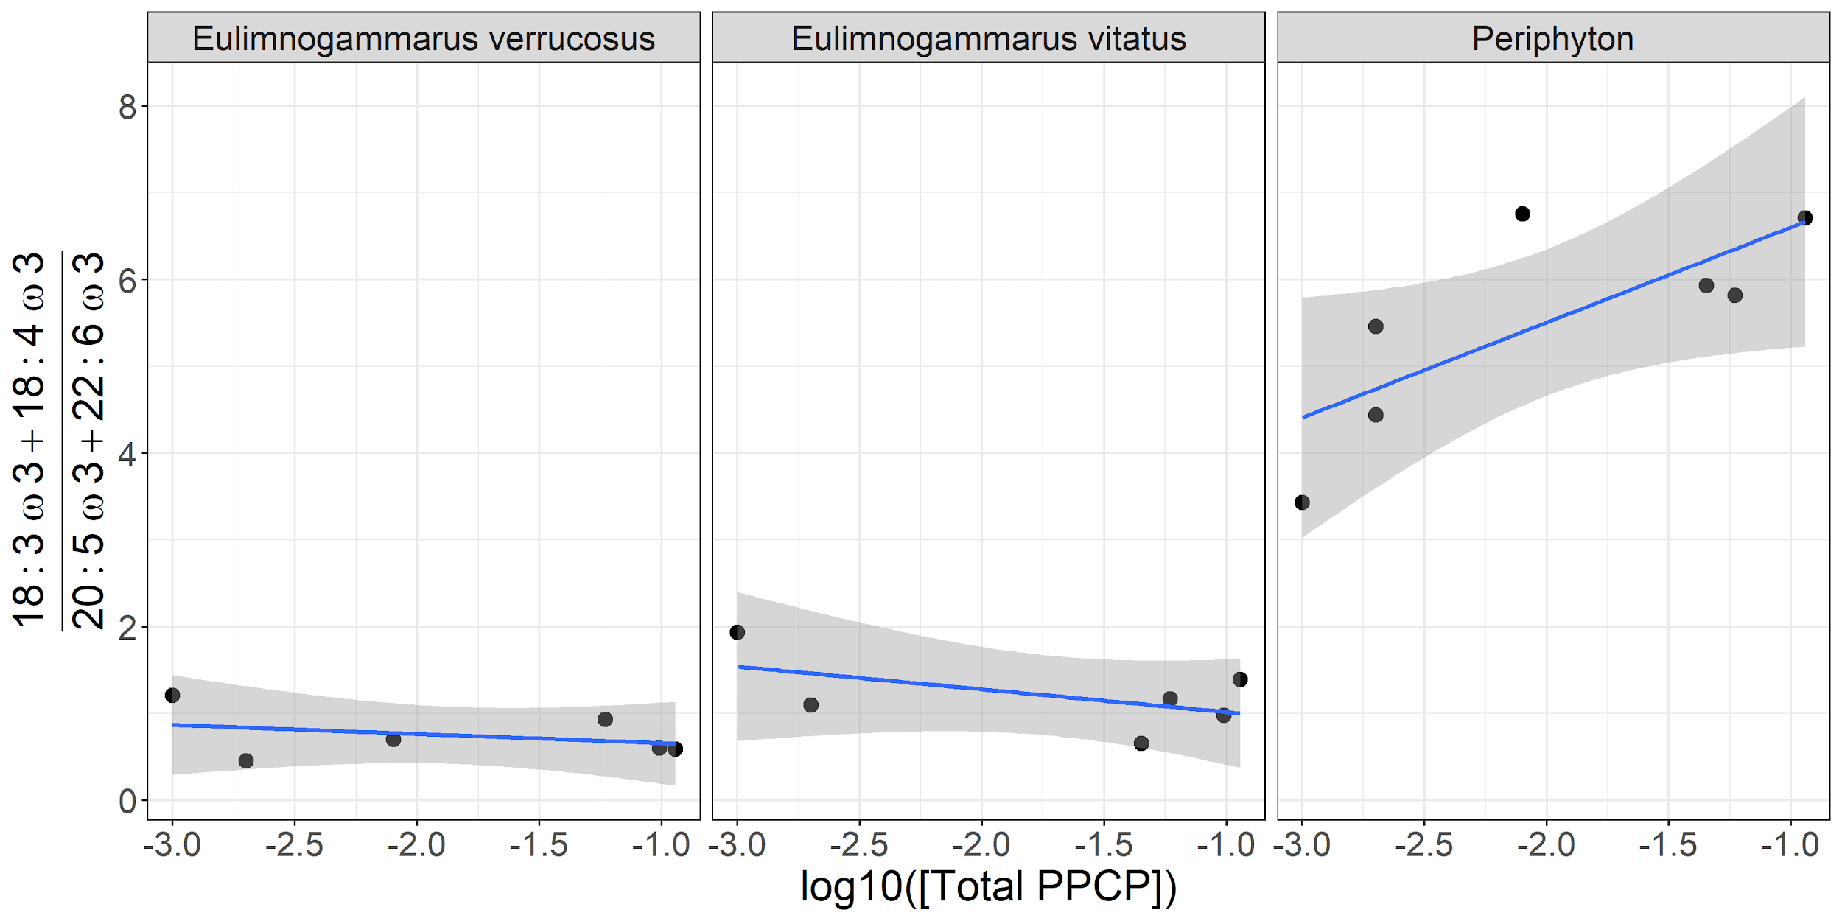

Figure 6: Ratio of 18:3ω3 and 18:4ω3 relative to 20:5ω3 and 20:6ω3 as a function of log -transformed total PPCP concentrations. The fatty acids 18:3ω3, 18:4ω3, 20:5ω3 and 20:6ω3 are all essential fatty acids (EFAs), which are prone to accumulate in organisms and mainly synthesized in primary producers. Because 18:3ω3 and 18:4ω3 are mainly found in filamentous algae whereas 20:5ω3 and 20:6ω3 tend to be associated with diatoms, our ratio also serves as a filamentous:diatom indicator. Periphyton ratios tend to increase with increasing total PPCP concentration, which corroborates our periphyton community abundance results (p = 0.05; Figure 3). Grazing amphipod ratios, however, remain relatively constant over a range of PPCP concentrations, implying two potential causes. First, amphipods could be selectively grazing to maintain a consistent ratio across sewage gradients. This potential cause would also imply that certain periphyton taxa, especially diatoms, would be experiencing increased grazing pressure at higher sewage concentrations. Second, amphipods could graze on filamentous algae and then expend their own energy to upgrade 18:3ω3 and 18:4ω3 to 20:5ω3 and 20:6ω3. In both of these scenarios, amphipods are able to maintain EFAs that are beneficial to living in cold environments despite necessary energetic trade-offs for remaining in areas with higher sewage concentrations.

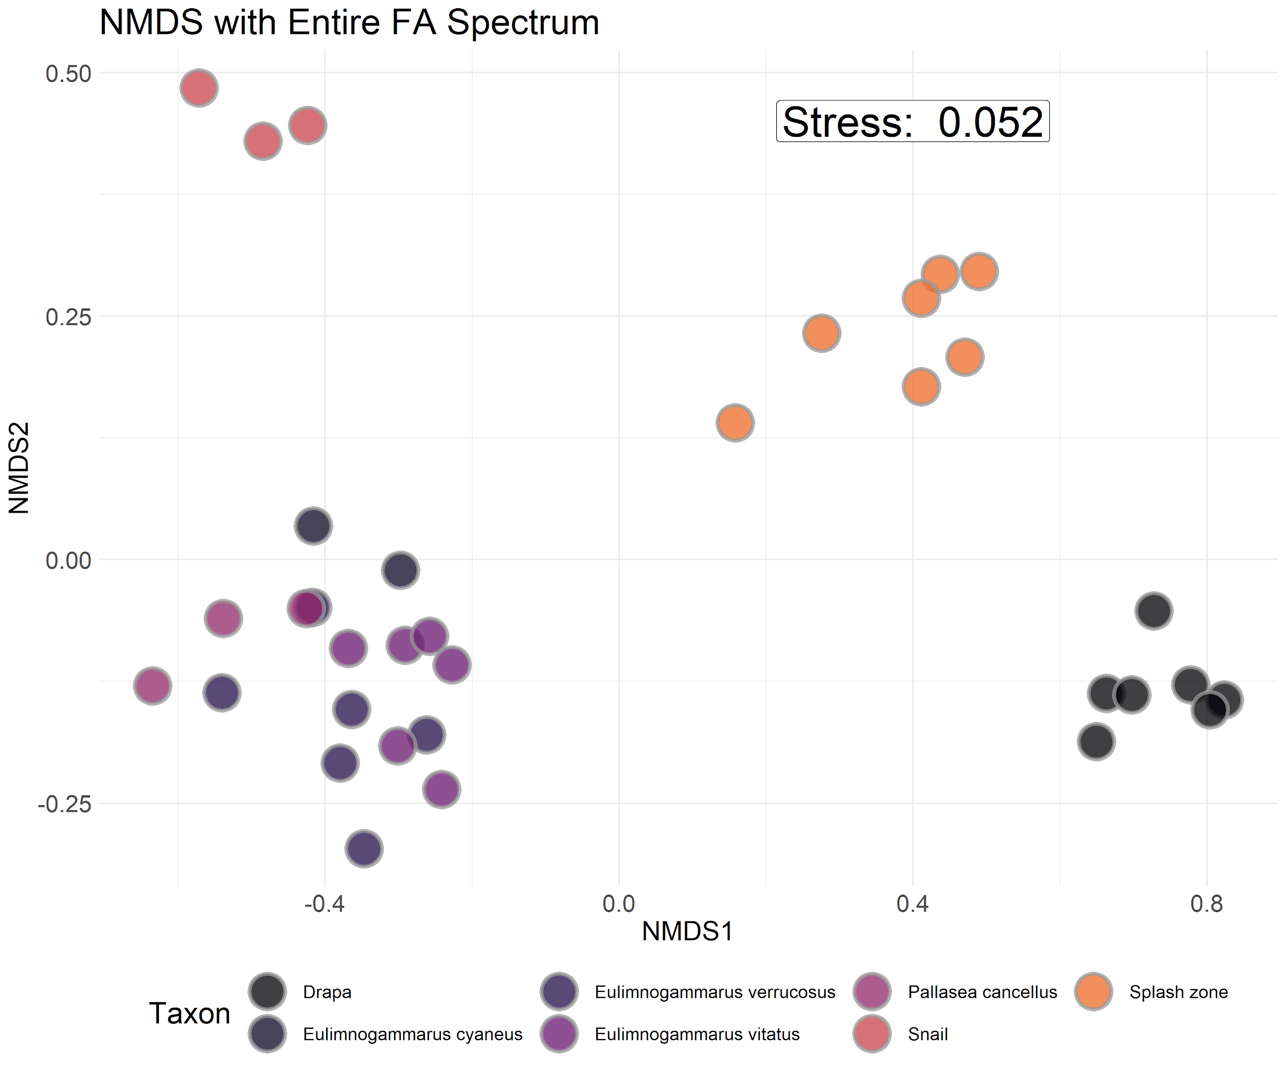

Figure S1: NMDS with bray-curtis dissimilarity of proportional fatty acid compositions for each macroinvertebrate and primary producer collected. Interspecific variation in fatty acid composition tended to be larger than intraspecific variation, implying that fatty acid signatures were largely species-specific and not environmentally driven.

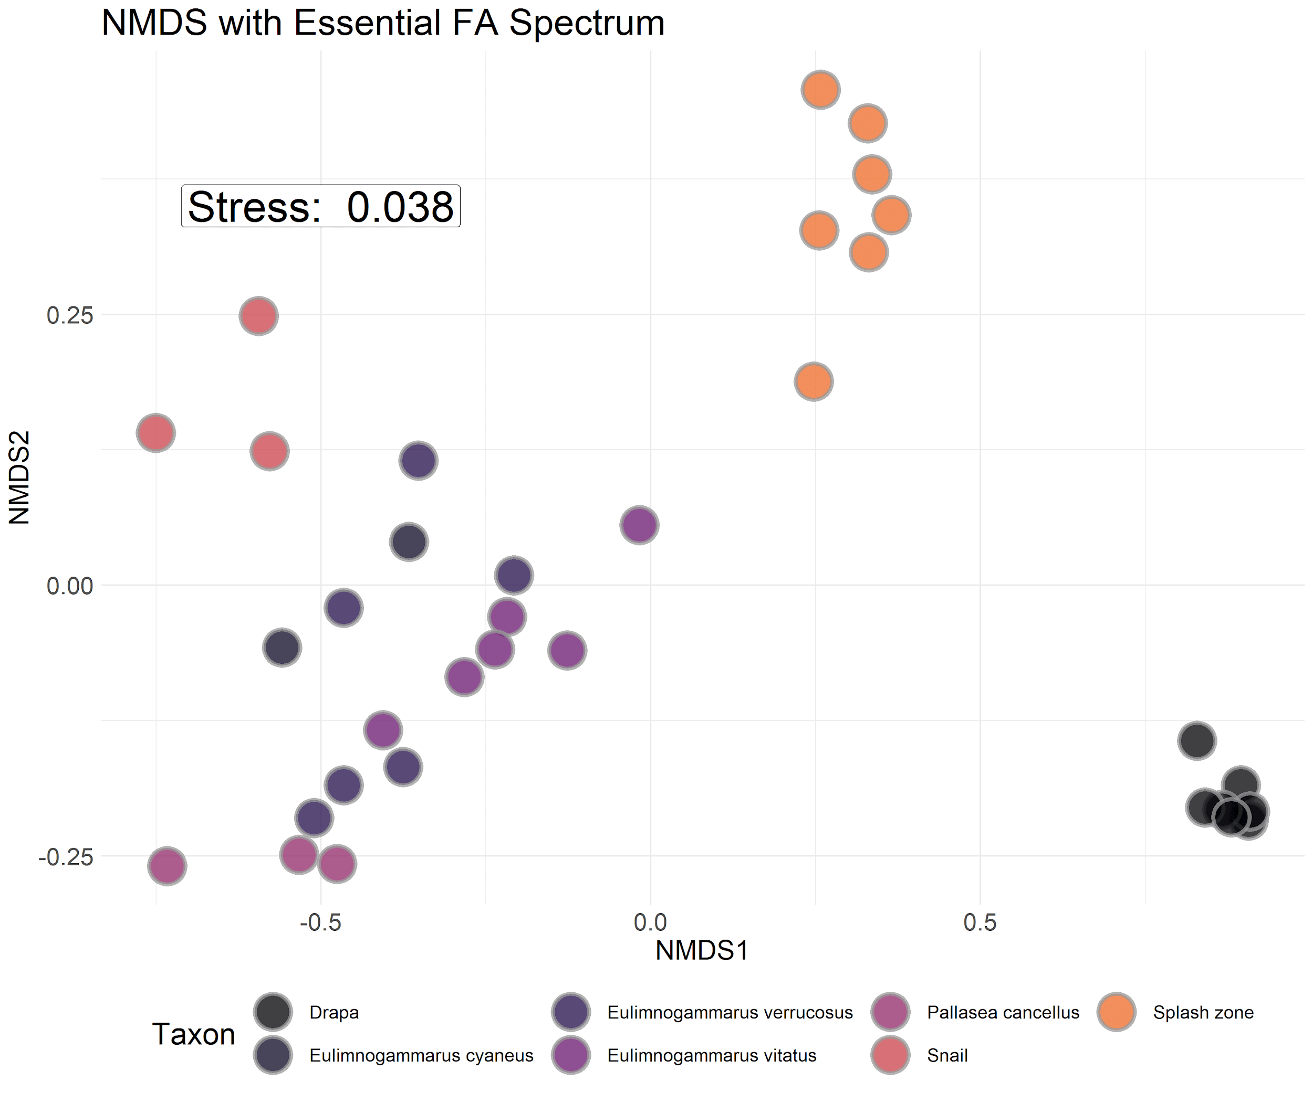

Figure S2: NMDS with bray-curtis dissimilarity of proportional essential fatty acid compositions for each macroinvertebrate and primary producer collected. Interspecific variation in fatty acid composition tended to be larger than intraspecific variation, implying that fatty acid signatures were largely species-specific and not environmentally driven.

|  |  |  |  |  |
| --- | --- | --- | --- | --- |
| Table S1: Metrics for calculating distance-weighted population. All landscape data were measured in google maps, and population data were collected from the 2012 census (IrkuStat, 2012). LI-1 has values of 0 for all variables because it was the southernmost site. | | | | |
| Site | Distance to southern developed site (km) | Population at southern developed site | Shoreline length of southern developed site (km) | Area of southern developed site (km2) |
| BK-1 | 0.22 | 80 | 1.19 | 0.33 |
| BGO-3 | 1.54 | 600 | 1.65 | 2.43 |
| BK-2 | 10.44 | 2000 | 4.61 | 2.03 |
| BK-3 | 0.94 | 80 | 1.19 | 0.33 |
| BGO-1 | 18.61 | 80 | 1.19 | 0.33 |
| BGO-2 | 17.54 | 80 | 1.19 | 0.33 |
| KD-1 | 8.29 | 80 | 1.19 | 0.33 |
| KD-2 | 6.63 | 80 | 1.19 | 0.33 |
| MS-1 | 3.4 | 80 | 1.19 | 0.33 |
| SM-1 | 5.23 | 2000 | 4.61 | 2.03 |
| OS-1 | NA | NA | NA | NA |
| OS-2 | NA | NA | NA | NA |
| EM-1 | 3.34 | 2000 | 4.61 | 2.03 |
| LI-1 | 0 | 0 | 0 | 0 |
| LI-2 | 0.73 | 2000 | 4.61 | 2.03 |
| LI-3 | 1.68 | 2000 | 4.61 | 2.03 |
| OS-3 | NA | NA | NA | NA |