**Effects of spatially heterogeneous lakeside development on nearshore biotic communities in a large, deep, oligotrophic lake (Lake Baikal, Siberia)**

Michael F. Meyer1*

Stephanie E. Hampton2

Tedy Ozersky3

Kara H. Woo2

Kirill Shchapov3

Daniel D. Snow4

Emma J. Rosi5

Maxim A. Timofeyev6

Yulia M. Zaitseva7

Dmitry Yu. Karnaukhov6

Nina A. Bondarenko7

Aaron Galloway8

Julie Schram8

Matthew R. Brousil2

1. School of the Environment, Washington State University, Pullman, WA, USA

2. Center for Environmental Research, Education, and Outreach, Washington State University,

Pullman, WA, USA

3. Large Lakes Observatory, University of Minnesota - Duluth, Duluth, MN, USA

4. School of Natural Resources, University of Nebraska-Lincoln, Lincoln, NE, USA

5. Cary Institute of Ecosystem Studies, Millbrook, NY, USA

6. Biological Research Institute, Irkutsk State University, Irkutsk, Irkutsk Oblast, Russia

7. Limnological Institute SB RAS, Irkutsk, Irkutsk Oblast, Russia

8. Oregon Institute of Marine Biology, University of Oregon, Charleston, OR, USA

*corresponding author: michael.f.meyer@wsu.edu

**Keywords**: Lake Baikal, sewage, PPCP, food webs, community ecology, human disturbance

**Abstract (224/250 words)**

Clustered anthropogenic activity along lakeshores can create hot spots of disturbance and corresponding ecological responses. Sewage released from such lakeside development is a type of heterogeneous, pervasive, and frequently high impact disturbance with effects most immediately observed among littoral biota. Lake Baikal, a large, ancient and oligotrophic lake, has been experiencing localized sewage pollution from lakeside settlements, and nearshore benthic communities appear to be responding. To test the spatial extent and magnitude of sewage release into Lake Baikal, we surveyed X sites along a 40-km transect of the southwestern shore for sewage indicators, including pharmaceuticals and personal care products (PPCPs) and microplastics. To examine benthic community responses, periphyton and macroinvertebrate abundance as well as trophic interactions were assessed at each littoral site. At all sites, PPCPs including caffeine (up to 60 ng/L) and acetaminophen (up to 40 ng/L) were detected in the nearshore water column, and concentrations were related to extent of lakeside development. Benthic invertebrate and periphyton communities also responded to lakeside development. Periphyton and macroinvertebrate stable isotope analysis and essential fatty acid compositions suggested that, despite differences in community composition among sites, the food web structure remained consistent along our study area. For Lake Baikal, these results are timely, especially considering the potential environmental consequences from growing tourism hot spots (~300,000 tourists annually) in tandem with developing wastewater management.

**Introduction**

Human disturbances can disrupt many biological processes, ranging from physiological (e.g., Sokolova and Lannig 2008) and behavioral (e.g., Longcore and Rich 2004) to population (e.g., Crouse et al. 1987) and community dynamics (e.g., Ellis et al. 2011). When human populations are concentrated in localized areas, human disturbance, and therefore ecological responses to that disturbance, can also be concentrated spatially, creating a “hot spot” disturbance landscape (Harper et al. 2005). For example, constructing a boat dock within a lake can abruptly reduce usability of fish spawning habitat (Scheuerell and Schindler 2004). Similarly, toxicants from human activities such as aluminum production, may threaten various ontogenetic stages and ecological communities depending on the co-location of toxicants and biological processes (Ginn et al. 2007). Further, multiple simultaneous disturbances, whether considered anthropogenic or “natural,” may amplify ecological responses if disturbances co-occur with sensitive biota (Franklin et al. 2000; Lake 2000). Given the heterogeneity of human disturbances, abiotic environments, and biological systems, heterogeneity of a specific disturbance as well as between co-occurring disturbances can produce a range of ecological responses (Carpenter et al. 2001).

Edges where ecosystems meet, such as the nearshore area in lakes, present an opportunity to study heterogeneous disturbance as the biota directly interface with two abutting systems. In the case of lakes, human settlements tend to be near to the land-water interface, and littoral organisms’ close proximity to the shoreline makes them susceptible to human disturbances such as sewage release (Carpenter et al. 2005; Rosenberger et al. 2008). Although the direct impacts of disturbance on nearshore biota may be localized, the effects of disturbance may also propagate to offshore communities, as pelagic organisms frequently rely on littoral regions for feeding or breeding (Vadeboncoeur et al. 2008; Hampton et al. 2011). As a result of connectivity between pelagic and littoral processes, increased understanding of how edge ecological communities respond to disturbance can also offer insights to whole ecosystem processes.

The release of treated and untreated wastewater into aquatic ecosystems is an example of a common human disturbance that can introduce pollutants and reshape aquatic ecological communities (Meyer et al. 2019). Nutrients are among the primary pollutants within sewage byproducts (Smith et al. 1999). Although often concentrated within sewage, nutrient inputs can also originate from disparate anthropogenic and environmental sources, thereby obfuscating sewage signals. For example, agricultural runoff can add high nutrient concentrations to soil and aquatic systems (Powers et al. 2016). Geological processes, such as melting permafrost, can likewise contribute high nutrient loadings to bogs that can eventually lead to changes in primary production and decomposition (Turetsky et al. 2000). Similar to geological and anthropogenic processes, changes in terrestrial plant communities, such as increased alder presence, has been associated with increased nutrient concentrations and nearshore periphyton production in adjacent lake environments (Moran et al. 2012). Regardless of the nutrients’ source, biological responses to even slight nutrient increases can further confound sewage signals. Benthic primary producers in nearshore water, especially those in oligotrophic lakes, can assimilate dissolved anthropogenic solutes, such as nutrients, quickly from the water column (e.g., hours), such that deviation in typical water concentrations is not observed (Hadwen and Bunn 2005).

Because nutrients alone may not allow identification of a pollutants’ source, pharmaceuticals and personal care products (PPCPs) have garnered increasing attention for their usefulness as sewage indicators (Rosi-Marshall and Royer 2012). Study of sub-continental and continental scale PPCP concentrations demonstrated that areas with dense human populations tend to be PPCP hot spots, yet lower concentrations can still be detected in less urban locations (Kolpin et al. 2002; Focazio et al. 2008; Yang et al. 2018). At finer scales, PPCP concentrations have been used to identify hot spots of septic discharge within suburban residential areas (Yang et al. 2016). In addition to identifying areas and periods of sewage pollution, PPCPs have also demonstrated robustness in defining gradients of sewage pollution in river systems, with concentrations being directly proportional to population density and inversely proportional to distance from a densely populated area (Bendz et al. 2005). The varying degradation times of different PPCPs can make them useful for monitoring pollution at varying time scales. For example, gemfibrozil has an environmental half life (t0.5) of 120-288 days (Araujo et al. 2011) and can indicate pollution that may have occurred within a relatively long time frame, whereas relatively short-lived PPCPs, such as caffeine (t0.5 = 3.5-13 days; (Benotti and Brownawell 2009)), can provide finer scaled temporal monitoring.

Microplastics (plastic debris up to 5 mm in size; (Barnes et al. 2009)) also have been used to detect sewage pollution (Li et al. 2018) along gradients of increasing human impact/ population density? (Klein et al. 2015). They are typically very resistant to degradation (Barnes et al. 2009), providing a signal over a longer time frame than many PPCPs and nutrients in sewage. Their usefulness as indicators, however, has several distinct limitations. First, similar to nutrients, microplastics can originate from various sources of human activity (Koelmans et al. 2019). Second, while microplastics have been useful in identifying presence of human pollution in lake environments, their densities may be more correlated with lake currents and wave action more than lakeside human activity (Free et al. 2014).

In addition to identifying presence of sewage pollution, PPCP and microplastic concentrations can also delineate gradients of human disturbance along which biotic community response may be examined. Bendz et al. (2005) noted PPCPs concentrations decreased downstream of the input source in a river. Yang et al. (2016) similarly demonstrated how leachate from septic systems can create PPCP hotspots in soils, with certain PPCPs advecting in groundwater transport and others sorbing to colloidal particles. By defining sewage gradients using PPCPs, their concentrations can be correlated with changes in primary producer and consumer guilds, such as increased filamentous algal taxa relative to diatoms. Increased filamentous algae relative to other taxa has been frequently observed in areas suspected of sewage pollution (Rosenberger et al. 2008; Hampton et al. 2011), likely due to benthic filamentous algae efficiently removing nutrients from the water column (Hadwen and Bunn 2005; Andersson and Brunberg 2006). With a changing resource base, grazing macroinvertebrate communities may likewise shift to include more detritivores or species that are capable of consuming filamentous algae (Rosenberger et al. 2008). In addition to the physical difficulty grazers may experience in consuming filamentous algae (Mazzella and Russo 1989), there also may be changes in nutritional quality, as filamentous algae tend to contain a different mixture of essential fatty acids in comparison to diatoms (Kelly and Scheibling 2012). With this potential for nutritional change, sewage pollution into the nearshore area of lakes may not only alter community composition but also restructure interactions between community members.

To investigate ecological community responses to sewage pollution, we surveyed a 40-km shoreline in Lake Baikal with discrete population centers for indicators of sewage pollution and metrics of benthic community composition and structure. Located in Siberia, Lake Baikal is the oldest, most voluminous, and deepest freshwater lake in the world (Hampton et al. 2018), with the majority of Baikal’s biota occurring in the littoral zone (Kozhova and Izmest’eva 1998). Despite much of Lake Baikal’s shoreline lacking human development and Baikal’s watershed being largely roadless and unpopulated (Moore et al. 2009), areas of lakeside development have have been recently associated with filamentous algal blooms (Timoshkin et al. 2016). While Lake Baikal’s pelagic zone is generally ultra-oligotrophic (Ministry of Natural Resources and Ecology of the Russian Federation 2014), nearshore areas abutting lakeside settlements have shown signs of eutrophication (Timoshkin et al. 2016). Timoshkin et al. (2016, 2018) present a compelling case that inadequacies in wastewater management for lakeside settlements has been the main driver of nearshore ecological alterations, motivating further research that might identify the extent to which sewage is altering nearshore communities.

Having evolved under ultra-oligotrophic conditions over 25 million years (Kozhov 1963), Baikal’s biota present excellent opportunity to study how nearshore communities respond to highly localized human disturbance. Even though Lake Baikal’s remoteness and high volume should mitigate risks of sewage pollution to the pelagic ecosystem, nearshore biotic communities may respond most strongly to pollutants entering the lake from lakeside development. Given the potential to observe community-level responses to sewage pollution within Lake Baikal in the nearshore area, we hypothesized that (1) sewage indicators, such as PPCP concentrations and microplastic densities, would increase with increasing population density and proximity of lakeside development; (2) an increasing sewage signal would correlate with increased dominance of filamentous benthic algae; and (3) increasing filamentous algae abundance will result in changes to the littoral food web, with changes in the relative proportions of different feeding guilds. In doing so, this study pairs highly specific sewage indicators to identify pollution hot spots with co-located biological measurements, thereby explicitly defining areas of sewage pollution.

**Methods**

*1. Site description*

The vast majority of Lake Baikal’s 2,000-km shoreline lacks lakeside development (Timoshkin et al. 2016). Our study focused on a 40-km transect of Baikal’s southwestern shoreline, which included three settlements of different size . The largest, Listvyanka, is primarily a tourist town with approximately 1,963 permanent residents, although tourism can contribute significantly to the town’s population with approximately 300,000 visitors over the course of the year ((IrkutskStat, 2012, Timoshkin et al., 2016). The other two settlements are the villages Bolshie Koty and Bol’shoe Goloustnoe. Bolshie Koty has 56 permanent residents () and also is home to two field research stations and several small hotels. Bolshoe Goloustnoe is has approximately 600 permanent residents and some tourist operations (IrkutskStat, 2012).

We sampled 14 littoral and 3 pelagic locations along our 40-km transect. Littoral locations were chosen to capture a range of sites with varying degrees of adjacent shoreline development – from “developed” (no human settlements and complete natural forest cover) to “undeveloped” (along the built-up waterfront of Listvyanka). Pelagic sites were located 2 to 5 km offshore from each of the developed sites (Figure 1; Table 1). We attempted to choose specific sites at each location that represented a gradient moving away from population centers, with distance between sites dictated by accessibility. Littoral sites were sampled at the same depth (~1.25 m) and therefore the sampling locations sometimes differed in their distance from shore (Table 1). At each site, air temperature was measured with a mercury thermometer and photographs were taken of the substrate and the shoreline.

Because certain littoral sampling sites are clustered around a population center, hydrologic connectivity between sites could create sewage gradients. In order to account for the effect of sewage gradients, we created a distance-weighted population density metric for each littoral site. The distance-weighted population metric reflects the idea that sewage pollution should be positively related to increasing magnitude of human density and inversely related with distance from densely populated areas (sensu Bendz et al., 2005). For each littoral site, we first calculated the population density (population/km2) of the closest southern lakeside development, recognizing that the most southern site would be eliminated from analysis. Measurements were recorded from the nearest southern developed site as summer winds and associated currents tend to flow south-to-north, although not with the velocity and regularity of autumn winds (Shimaraev et al., 1994). Population data were collected from 2012 census data (IrkutskStat, 2012); development area was determined using area calculation from Google Earth (Table S1). Because sewage pollution may be diluted in instances where the majority of lakeside development is not arranged along the shoreline, we scaled population density directly by length of shoreline at the closest developed site. Each sampled littoral site was then assigned the scaled population density metric of the nearest southern developed site. In order to capture how sewage pollution may attenuate over space, all scaled population densities were normalized by distance from the nearest southern developed location. In summary, we calculated our distance-weighted population metric by the equation , where Ij is the distance-weighted population at site j, Pi is the population at developed site i, Ai is the area of developed site i in km2, Li is the shoreline length at developed site i in km, and D is the distance from developed site i to j in km.

*2. Water samples*

At both pelagic and littoral sites, water samples were collected for nutrient, chlorophyll, microplastic, and pharmaceutical and personal care product (PPCP) analysis. Each water sample collection procedure is described below.

*2a. Nutrients*

Water samples for nutrient analyses were collected in approximately 150 mL glass jars that had been rinsed three times with water from the sampling location. Samples were collected in duplicates and immediately frozen at -20°C until processing at the Siberian Branch of the Russian Academy of Sciences.

For each water sample, nitrate, ammonium, phosphate, and total phosphorus concentrations were measured. For ammonium and nitrate concentrations, samples were analyzed with a spectrophotometer following the addition of Nessler’s reagent and disulfuric acid respectively. Phosphate concentration was measured with a spectrophotometer following the addition of persulfate. Concentrations are reported in mg/L.

*2b. Chlorophyll a*

Water samples were collected in 1.5 L plastic bottles from a depth of approximately 0.75 m. Within 12 h of collection, three subsamples were collected by passing up to 150 mL through 25 mm cellulose nitrate filter. Filters were then placed in a 35 mm petri dish and frozen in the dark until processing.

Chlorophyll samples were processed in a manner similar to that of Parson (1963) and Lorenzen (1967). Filtered GF/Fs were ground in 90% acetone, in which chlorophyll extraction was allowed to proceed overnight. Samples were centrifuged for 15-20 minutes. Once particulates settled, absorbance of the chlorophyll extract was measured in a spectrophotometer at 630, 645, 665, and 750 nm. Concentrations were calculated using the formula: ; where A is the absorbance value of a particular wavelength, V1 is the volume of the filtered water, and V2 is the volume of extract. Concentrations are reported as mg/L.

*2c. PPCPs*

Water samples were collected in 250 mL amber glass bottles that were rinsed with an organic solvent and then three times with sample water prior to collections. Following collection, samples were refrigerated and kept in the dark until solid phase extraction (SPE).

Within 12 h of collection, samples were filtered directly from the amber glass bottle using a 25 mm GF/F, and then passed through SPE cartridges (Waters Corporation, Milford, MA). Lab personnel wore gloves and face masks to minimize contamination. Prior to filtration, SPE cartridges were primed with at least 5 mL of either methanol or acetone and then washed with at least 5 mL of sample water. Rate of SPE occurred at approximately 1 drop per second. Extraction proceeded until water could no longer pass through the SPE cartridge or until all collected water was filtered. Cartridges were stored in whirlpacks until analysis for PPCPs following methods of Lee et al. (2016).

2d. *Microplastics*

At each location, samples were collected in triplicate using 1.5 L clear plastic bottles that were washed thoroughly with sample water before each collection. Samples were collected by hand from the midpoint depth for each site. Once collected, bottles were sealed with a plastic cap until processing.

For processing, each sample was vacuum filtered on to a 47 mm GF/F filter. During filtration, aluminum foil was used to cover the filtration funnel to prevent contamination. Upon completion, filters were allowed to dry under vacuum pressure and then stored in 50 mm petri dishes. Following filtration of all three replicates, filtrate was collected and then re-filtered as a control for contamination.

Microplastic counting involved visual inspection of the entire GF/F according to guidelines proposed in Van Cauwenberghe et al. (2015). Visual enumeration was conducted under a stereoscope, and microplastics were classified into one of three categories: fibers, fragments, or beads. For all categories, plastics were defined as observed objects with apparently artificial colors and no visible organelles or cellular components. Fibers were defined as smooth, long plastics with consistent diameters. Fragments were defined as plastics with irregularly sharp or jagged edges. Beads were defined as spherical plastics. During enumeration, GF/Fs remained in the petri dish to minimize potential for contamination from the air. Results are reported as the average number of microplastics per liter.

*3. Benthic biological samples*

At each littoral site, periphyton and macroinvertebrates were collected for relative abundance estimates and food web analysis.

*3a. Benthic algal collection*

At each littoral site, we haphazardly selected three rocks representative of local substrate. A plastic stencil was used to scrape a standardized 14.5 cm2 patch of periphyton from the upper surface of each rock. Samples were stored in plastic scintillation vials and preserved with Lugol’s solution. Remaining periphyton from the site were collected in composite for fatty acid and stable isotope analysis to enable food web characterization (described below).

Periphyton taxonomic identification and enumeration was performed by subsampling 10 μL aliquots from each preserved sample. For each aliquot, cells, filaments, and colonies were counted for each taxonomic group until at least 300 cells were identified. Taxa were classified in broad categories consistent with Baikal algal taxonomy (Izhboldina, 2007). Taxonomic groupings were coarse so as to capture overarching patterns in diatom relative to filamentous algae abundance. As a result, diatoms were considered one group. Filamentous algae were considered at finer resolution due to the distinctions in their occurrences described by Timoshkin et al. (2016). Samples contained *Ulothrix*, a regularly occurring Baikal filamentous alga (Kozhov 1963; Osipova et al. 2009), and *Spirogyra*, a recently cosmopolitan filamentous alga (Timoshkin et al., 2016).

*3b. Benthic invertebrate collection*

At each littoral site, three kick-net samples were collected for assessment of benthic community composition and abundance. Using a D-net, we collected macroinvertebrates by flipping over 1-3 rocks, and then sweeping five times in a left-to-right motion for approximately 1 m. After the series of sweeps, the catch was rinsed into a plastic bucket. For each replicate, bucket contents were concentrated using a 64 μm net and placed in glass jars with 40% ethanol (vodka; which was the only preservative available to us at the time) for preservation and refrigerated at 4°C aboard the research vessel. The 40% ethanol preservative was replaced with ~80% ethanol upon return to the lab (within how long?), and samples were stored at ~4°C.

Separate collections were conducted for invertebrate fatty acid and stable isotope analyses. Invertebrates were collected using a D-net in a similar fashion as the community enumeration. Additional invertebrates were also collected by hand. Collected organisms were then live-sorted, identified to species, and frozen at -20°C.

Invertebrate taxonomic identification and enumeration were performed under a stereoscope. All well preserved invertebrates were identified to species with the exception of juveniles (Taakhteev, 2015 for amphipods; Sitnikova, 2012 for molluscs; Table 2).

*3c. Food web characterization*

To characterize littoral food webs, we analyzed carbon and nitrogen stables isotopes as well as fatty acid profiles for periphyton and macroinvertebrates.

*Stable isotope analysis*

Prior to isotopic analysis, periphyton and macroinvertebrate samples were freeze dried for ~48 h (or until dry). Measurements of δ15N and δ13C were performed on an elemental analyzer-isotope ratio mass spectrometer (EA-IRMS; Finnigan DELTAplus XP, Thermo Scientific). The EA-IRMS was calibrated against certified reference materials including L-glutamic acid (NIST SRM 8574), low organic soil and sorghum flour (standards B-2153 and B-2159 from Elemental Micro-analysis Ltd., Okehampton, UK) and in-house standards (acetanilide and caffeine).

*Fatty acid analysis*

Fatty acid extractions generally involved three phases: (1) 100% chloroform extraction, (2) chloroform-methanol extraction, and (3) fatty acid methylation. Fatty acid extraction methods were adapted from similar methods developed in Schram et al. (2018).

Samples were first freeze-dried in Eppendorf tubes at -20°C overnight, then ground and weighed. Following freeze-drying, samples were transferred to 10 mL glass centrifuge vials, and 2 mL of 100% chloroform was added to each under nitrogen gas. Samples were allowed to sit in chloroform overnight at -80°C.

Following overnight chloroform extraction, samples underwent a chloroform-methanol extraction three times. To each sample, we added 1 mL cooled 100% methanol, 1 mL chloroform:methanol solution (2:1), and 0.8 mL 0.9% NaCl solution. Samples were inverted three times and sonicated on ice for 10 minutes. Next, samples were vortexed for 1 minute, and centrifuged for 5 minutes (3,000 rpm) at 4°C. Using a double pipette technique, the lower organic layer was extracted and kept under nitrogen. After the third extraction, samples were allowed to evaporate under nitrogen flow, and resuspended in 1.5 mL chloroform and stored at -20°C overnight.

Once resuspended in chloroform, 1 mL of chloroform extract was transferred to a glass centrifuge tube with a glass syringe. As a standard, 4 μL of 19-carbon fatty acid was added along with 1 mL of toluene and 2 mL of 1% sulfuric acid-methanol. The vial was closed under nitrogen gas and then incubated in 50°C water bath for 16 hours. After incubation, samples were removed from the bath, allowed to reach room temperature and stored on ice. Next, we performed a potassium carbonate-hexane extraction twice. To each sample, we added 2 mL of 2% potassium bicarbonate and 5 mL of 100% hexane, inverting the capped vial so as to mix the solution. Samples were centrifuged for 3 minutes (1,500 rpm) at 4°C. The upper hexane layer was then removed and placed in a vial to evaporate under nitrogen flow. Once almost evaporated, 1 mL of 100% hexane was added and stored in a glass amber autosampler vial for GC/MS quantification. GC/MS quantification was performed in a similar method as described in Schram et al. (2018).

*4. Statistical analyses*

Total phosphorus, nitrate, ammonium, microplastic abundance and density, total PPCP concentration, and δ15N in macroinvertebrate tissues were log-transformed and regressed against log-transformed distance-weighted population using a linear model. Residuals were assessed for normality and homogeneity of variance.

Periphyton and macroinvertebrate abundance data were each analyzed with a consistent multivariate routine. First, cross-correlated taxa were identified, and the taxon with less abundance was removed so as to ensure species abundances were independent. Second, community compositions for both periphyton and macroinvertebrates were visualized using non-metric multidimensional scaling (NMDS) with a Bray-Curtis similarity metric. Visual inspection of the NMDS plot identified groupings of sampled locations based off PPCP concentrations and distance-weighted population. Third, to determine an optimal number of groups for the sampled locations, k-means clustering was performed.. After adding an additional cluster, the within-group-sum-of-squares (WSS) was calculated, and the optimal number of clusters was selected when WSS decreased most markedly. Finally, when an optimal number of groups was determined, sites were assigned to a cluster and then differences between clusters were assessed using a permutational multivariate analysis of variance (PERMANOVA, (Anderson 2001)) with 999 permutations. Unlike traditional multivariate analyses of variance (MANOVA), PERMANOVA does not require assumptions of multivariate normality (Anderson 2001).

Fatty acid data were analyzed in a manner similar to periphyton and macroinvertebrate abundance data. First, complete fatty acid profiles were visualized by performing NMDS with Bray-Curtis similarity for all organisms (Figure S1). This technique broadly demonstrated that inter-specific variation in fatty acid composition was greater than intraspecific variation. The same pattern was observed for all fatty acids quantified as well as solely essential fatty acids (EFAs; Figure S2). EFAs are a subgroup of polyunsaturated fatty acids (PUFAs) that are prone to accumulating within organisms (see Kelly & Scheibling, 2012). Among the eight common EFAs used with an ecological focus (Taipale et al. 2013), 18:3ω3, 18:4ω3, 20:5ω3, and 22:6ω3 had the highest coefficient of variation between sites. Because these four EFAs demonstrated the greatest variation between sites, our analyses focused on how their relative abundances related to PPCP concentrations and distance-weighted populations. The fatty acids 18:3ω3 and 18:4ω3 have been previously associated with filamentous algae, such as Baikalian *Ulothrix* (Osipova et al. 2009), whereas 20:5ω3 and 22:6ω3 have previously been associated with diatoms (Taipale et al. 2013). Comparing the ratio of (18:3ω3% + 18:4ω3%)/(20:5ω3% + 22:6ω3%) could therefore function as proxy for filamentous:diatom abundance and potentially offer insights into feeding patterns for the grazers. To evaluate how this ratio may be related with sewage pollution, we regressed filamentous:diatom fatty acid signals (i.e., (18:3ω3% + 18:4ω3%)/(20:5ω3% + 22:6ω3%)) against log-transformed PPCP concentrations using a linear model.

All analyses were conducted within the R statistical environment (R Core Team 2019), using the tidyr (Wickham and Henry 2019), dplyr (Wickham et al. 2019), ggplot2 (Wickham 2016), and vegan (Oksanen et al. 2019) packages. All data are publicly available from the Dryad data repository (DOI), and all R scripts are available from the GitHub repository of this project’s Open Science Framework account (DOI).

**Results**

*1. Water samples*

Nitrate (p = 0.27), ammonium (p = 0.16), and chlorophyll a (p = 0.48) were not significantly correlated with distance-weighted population (Figure 2). Phosphate (p = 0.01) and total PPCP (p = 0.037) concentrations, however, were significantly correlated with distance-weighted population (p = 0.01; Figure 2). Within the littoral zone, detected PPCPs included caffeine, 1,7-dimethylxanthine (main human metabolite of caffeine), cotinine (main human metabolite of nicotine), and acetaminophen (Table 3).

Microplastics were detected in samples from both the littoral and pelagic sites. Bead microplastics were only detected at sites in Listvyanka. Fibers were the most abundant type of microplastics across all sites (average = 3.6 microplastics/L), followed by fragments (average = 1.4 microplastics/L) and beads (average = 0.09 microplastics/L). Total microplastic densities were not significantly correlated with distance-weighted population (p = 0.56; Figure 2), although more types of microplastics were generally observed near areas with higher distance-weighted population values, such as Listvyanka.

*2. Benthic biological samples*

*2a. Periphyton*

Major taxonomic groupings of periphyton consisted of diatoms, *Tetrasporales* spp*.*, *Spirogyra* spp., and *Ulothrix* spp. K-means cluster analysis of periphyton abundance demonstrated three groupings capture most variance, and visual inspection of periphyton community NMDS suggested groupings were related to distance-weighted population values (Figure 3). PERMANOVA results demonstrated that periphyton communities were significantly different based on distance-weighted population values (p = 0.023).

*2b. Macroinvertebrates*

Uncorrelated taxonomic groupings included four amphipod genera: *Eulimnogammarus*, *Poekilogammarus*, *Cryptoropus*, and *Pallasea*; two mollusc families: Planorbidae and Valvatidae; flatworms; caddisflies; and leeches (summarized in Table 2). K-means cluster analysis of macroinvertebrate community composition demonstrated 3 major groupings would capture most variance, and visual inspection of NMDS suggested clusters were related to distance-weighted population (Figure 4). PERMANOVA results supported the hypothesis that macroinvertebrate communities significantly differed along a gradient of distance-weighted populations (p = 0.001).

*3. Food web characterization: stable isotopes and fatty acids*

Among periphyton and amphipod samples, δ 13C values ranged from -19.5 to -9.5%, suggesting terrestrial origin for benthic carbon (Figure 5; Post, 2002). Among grazer δ15N values, no grazer groups deviated more than 3.4% δ15N, suggesting that all were within the same trophic level (Post 2002).

δ15N significantly increased with distance-weighted population only for grazers (p = 0.008; Figure 2, Figure 5). Periphyton δ15N signatures did not significantly increase with distance-weighted population (p = 0.7). In contrast, δ 13C concentrations were not related with distance-weighted population for either periphyton or macroinvertebrates.

For both periphyton and grazers, our analyses focused mainly on the essential fatty acids (EFAs) 18:3ω3, 18:4ω3, 20:5ω3, and 22:6ω3. The EFAs 18:3ω3 and 18:4ω3 are commonly associated with filamentous algae (Taipale et al. 2013), whereas 20:5ω3, and 22:6ω3 are more associated with diatoms (Taipale et al. 2013). All EFAs are polyunsaturated fatty acids (PUFAs), which are critical to maintaining cellular membrane fluidity especially in cold environments (Nichols et al. 1993). Additionally, EFAs are largely synthesized by primary producers, each species of which usually produces a consistent EFA signature (Taipale et al. 2013) although temperature-related deviations can occur (Flaim et al. 2014; Anesi et al. 2016). Consumers, however, can acquire EFAs by grazing (Dalsgaard et al. 2003) or upgrading EFAs at their own energetic expense (Sargent and Falk-Petersen 1988; Dalsgaard et al. 2003). For periphyton, the ratio of C18:3ω3 and C18:4ω3 in comparison to C20:5ω3 and C22:6ω3 significantly increased with an increasing PPCP concentration (p = 0.05, Figure 6) but not with an increasing distance-weighted population (p = 0.17). Amphipods’ fatty acid ratios were not significantly related with either increasing distance-weighted population or increasing PPCP concentrations.

**Discussion**

Concordant with our expectations, sewage pollution indicators in the nearshore of Lake Baikal were associated with size of and distance from human settlements. Nearshore biotic communities appear to be responding to… what? Sewage pollution? Human impacts?. Total PPCP, phosphorus, and macroinvertebrate δ15N concentrations increased with distance-weighted population. Similarly, nearshore biotic communities at sites with stronger sewage signals tended to contain lower fractions of molluscs and caddisflies and higher filamentous algae presence. In contrast, amphipods remained prevalent throughout all littoral sampling locations. Despite these changes in community composition, fatty acid results did not support our hypothesis that food web interactions would restructure in response to….

Perhaps the most notable result from this study was that sewage pollution can be detected in Lake Baikal’s nearshore area and is associated with size of and proximity to lakeside development. The detectable influence of these localized settlements on what? is noteworthy considering that Baikal’s shoreline, including our study area, is largely void of lakeside development (Moore et al. 2009). While several studies have quantified PPCP concentrations in aquatic systems (Kolpin et al. 2002; Focazio et al. 2008; Rosi et al. 2013), lakes have remained less represented within the PPCP literature in comparison to lotic systems (Meyer et al. 2019). With longer hydraulic residence times, PPCP distributions in lentic systems may differ from lotic environments, as pollutants within lakes may be more prone to accumulate within the nearshore before diffusing to undetectable concentrations offshore. Our results support this, showing patchy concentrations of PPCPs nearshore (in association with development), and undetectable concentrations at the offshore sites . This result is especially important, that monitoring efforts in many lakes are based on pelagic measurement (Ministry of Natural Resources and Ecology of the Russian Federation 2014). Despite Lake Baikal’s widely ultraoligotrophic status, nearshore sampling holds promise to identify localized disturbances long before a pelagic response may become detectable (Hampton et al. 2011).

In contrast to PPCP concentrations, microplastics at our sampling sites were not associated with distance-weighted population and may be a poor proxy for sewage pollution in Lake Baikal. Microplastics have been used to identify sewage pollution in other large lakes, like Lake Hovsgol (Free et al. 2014). Unlike PPCPs’, which have relatively short half-lives, microplastics indicate accumulated pollution because of their slow degradation time (Brandon et al. 2016). As a result, microplastic concentrations in Baikal, as quantified by our methods, may be poor proxies for capturing the temporal variability of short-term human populations, but may be useful in detecting offshore sewage signals as microplastics diffuse from the nearshore to the pelagic. It is worth noting that since the time of our field sampling, evidence has accumulated that our methods likely dramatically underestimated microplastic abundance (Wang and Wang 2018; Brandon et al. 2020). While we focus here on microplastics as an indicator of human disturbance, microplastics are increasingly shown to disrupt food web dynamics by altering grazing patterns (Green 2016) and providing carbon substrate for microbial growth (Romera-Castillo et al. 2018). Together these growing uncertainties suggest that microplastic pollution in Baikal and elsewhere deserves increased attention.

Along the shoreline, increasing sewage indicators tended to be associated with more filamentous periphyton as well as decreased mollusc and caddisfly relative abundances. Previous studies investigating Baikal’s periphyton composition noted that areas adjacent to human development often had increased abundance of filamentous algae such as Ulothrix and Spirogyra (Timoshkin et al. 2016, 2018). Lake Baikal’s southwestern shore historically experiences short *Ulothrix* blooms in late August (Kozhov 1963), potentially confounding sewage signals with an annually occurring phenomenon. Our data agree with results of Timoshkin et al. (2016) and show that relative abundance of filamentous algae is greatest near areas of high lakeside development. While not observed at the same magnitude as reported in Timoshkin et al. (2016), our results also support those authors’ general conclusion that Baikalian molluscs tend to be more susceptible to sewage pollution. Decreased mollusc abundance may have several causes, including molluscs having low tolerance for increased PPCP concentrations, especially caffeine and its metabolites (Hollingsworth et al. 2002), molluscs not being able to consume filamentous algae (Mazzella and Russo 1989), filamentous algae not offering the proper nutritional yield for molluscs (Lowe and Hunter 1988), or certain contaminants within the sewage being particularly toxic to molluscs (Timoshkin et al. 2016).

With respect to how food webs would restructure with a changing community composition, our data suggest a nuanced food web response to increasing sewage signal. Periphyton essential fatty acid profiles from sites with higher sewage pollution had higher levels of 18:3ω3 and 18:4ω3 relative to C20:5ω3 and C22:6ω3 fatty acids. Because fatty acid profiles tend to be indicative of algal species (Iverson et al. 2004; Taipale et al. 2013; Galloway and Winder 2015), this pattern likely reflects the higher abundance of green algae relative to diatoms. (Osipova et al. 2009; Taipale et al. 2013). Stable isotopes, however, suggested no differences in periphyton δ15N with increasing distance-weighted population (Figure 5). In contrast to periphyton, amphipod fatty acid profiles did not differ between sites (Figure 6), whereas δ15N increased slightly but significantly with increasing distance-weighted population. The differing pattern of periphyton and amphipod δ15N values in relation to distance-weighted population may relate to amphipods having longer cellular turnover rates (e.g., weeks;McIntyre and Flecker 2006) relative to periphyton (e.g., days; (Swamikannu and Hoagland 1989)). This insight implies that amphipods may be longer-term indicators of sewage pollution than periphyton in Baikal.

Given the intersite variation in the fatty acids composition of periphyton but not amphipods’, our results suggest that amphipods are able to maintain a consistent fatty acid signature through three potential mechanisms. First, amphipods may selectively consume diatoms as opposed to filamentous algae. As a result, grazing pressure on diatoms would increase, and diatom relative abundance could decrease both from increased grazing and lesser efficiency at removing nutrients from the water column relative to filamentous taxa. Second, amphipods may indeed consume filamentous algae, and then invest energy to convert C18 fatty acids to C20 and C22 fatty acids. Consequently, amphipods would need to catabolize fatty acids necessary to survive in Baikal’s cold temperatures. Third, amphipod fatty acid turnover could be longer than periphyton fatty acid turnover rates, much like how amphipods’ δN15% turnover rates were longer than those for periphyton. Regardless of the exact mechanism, our data support the hypothesis that increasing sewage pollution would alter community trophic interactions, which suggests a net energetic cost through amphipods’ increased grazing pressure on diatoms or consumption of filamentous algae.

Together, our results corroborate previous studies by showing detectable signals of sewage pollution in Lake Baikal’s nearshore area and identifying several potential ecological consequences of sewage pollution. Unlike previous studies, our results demonstrate how patchy hot spots of lakeside development can create gradients of human disturbance. While PPCP hot spots and gradients have been observed in lotic (Bendz et al. 2005) and subsurface (Yang et al. 2016) systems, PPCP gradients within lacustrine environments are less well understood (Meyer et al. 2019). In the case of Lake Baikal, internal mixing from currents and wave action (Shimaraev et al., 1994) likely created the PPCP gradient we observed. While ecological responses to thermal gradients created by hydrodynamics has been well studied in Lake Baikal (Kozhov 1963), the potential for Baikal’s physical processes, and lentic systems’ globally, to influence pollutant concentrations presents a new frontier in understanding heterogeneity of human disturbance. Large lakes, such as Baikal and other Great Lakes of the world, have complex internal physical processes creating heterogeneities, such as Poincaré waves or Langmuir circulation, whereas smaller lakes are more influenced by traveling surface waves (Wetzel 2001). Given lacustrine physical processes’ potential to influence contaminant distributions and ecological communities, our results highlight how nuanced physical, chemical, and biological measurements may be necessary to define heterogeneous disturbances and ecological responses.

*Future research trajectories in the context of a changing climate*

Ancient Lake Baikal remains a biodiversity hot spot (Hampton et al. 2018), where the majority of endemic species tend to be cryophilic stenotherms (Kozhova and Izmest’eva 1998)). With increasing lake temperatures (O’Reilly et al. 2015) and less consistent ice coverage (Sharma et al. 2019) worldwide, it is unclear how cold-water adapted species will respond to a warming ambient environment in conjunction with human disturbance. We demonstrated that littoral amphipods were prevalent throughout the entirety of human disturbance gradients, which are likely products of physical limnological processes. These same physical processes are also influenced by climate forcings, such as temperature and wind. In the case of Baikal, endemic amphipods are well adapted to intense hydrodynamics (Jakob et al. 2016), yet they have shown acute sensitivity to temperature (Bedulina et al. 2017) as well as toxicants (Timofeyev et al. 2008). The extent to which a changing climate may result in altered hydrodynamics is uncertain, but potential exists for altered current and mixing patterns to warm water and transport solutes unexpectedly. Beyond Baikal, a changing climate creates potential for altered lake hydrodynamics globally. Changes in intra-lake transport may be consequential for understanding heterogeneity, suggesting need for intensive study of individual systems’ disturbances and ecological responses and extensive comparison of lakes between regions.

**Works Cited**

Anderson, M. J. 2001. A new method for non-parametric multivariate analysis of variance. Austral Ecology **26**: 32–46. doi:10.1111/j.1442-9993.2001.01070.pp.x

Andersson, E., and A.-K. Brunberg. 2006. Inorganic nutrient acquisition in a shallow clearwater lake – dominance of benthic microbiota. Aquatic Sciences **68**: 172–180. doi:10.1007/s00027-006-0805-x

Anesi, A., U. Obertegger, G. Hansen, A. Sukenik, G. Flaim, and G. Guella. 2016. Comparative Analysis of Membrane Lipids in Psychrophilic and Mesophilic Freshwater Dinoflagellates. Front. Plant Sci. **7**. doi:10.3389/fpls.2016.00524

Araujo, L., N. Villa, N. Camargo, M. Bustos, T. García, and A. de J. Prieto. 2011. Persistence of gemfibrozil, naproxen and mefenamic acid in natural waters. Environ Chem Lett **9**: 13–18. doi:10.1007/s10311-009-0239-5

Barnes, D. K. A., F. Galgani, R. C. Thompson, and M. Barlaz. 2009. Accumulation and fragmentation of plastic debris in global environments. Philos Trans R Soc Lond B Biol Sci **364**: 1985–1998. doi:10.1098/rstb.2008.0205

Bedulina, D., M. F. Meyer, A. Gurkov, E. Kondratjeva, B. Baduev, R. Gusdorf, and M. A. Timofeyev. 2017. Intersexual differences of heat shock response between two amphipods ( *Eulimnogammarus verrucosus* and *Eulimnogammarus cyaneus* ) in Lake Baikal. PeerJ **5**: e2864. doi:10.7717/peerj.2864

Bendz, D., N. A. Paxéus, T. R. Ginn, and F. J. Loge. 2005. Occurrence and fate of pharmaceutically active compounds in the environment, a case study: Höje River in Sweden. Journal of Hazardous Materials **122**: 195–204. doi:10.1016/j.jhazmat.2005.03.012

Benotti, M. J., and B. J. Brownawell. 2009. Microbial degradation of pharmaceuticals in estuarine and coastal seawater. Environmental Pollution **157**: 994–1002. doi:10.1016/j.envpol.2008.10.009

Boecklen, W. J., C. T. Yarnes, B. A. Cook, and A. C. James. 2011. On the Use of Stable Isotopes in Trophic Ecology.

Brandon, J. A., A. Freibott, and L. M. Sala. 2020. Patterns of suspended and salp-ingested microplastic debris in the North Pacific investigated with epifluorescence microscopy. Limnology and Oceanography Letters **5**: 46–53. doi:10.1002/lol2.10127

Brandon, J., M. Goldstein, and M. D. Ohman. 2016. Long-term aging and degradation of microplastic particles: Comparing in situ oceanic and experimental weathering patterns. Marine Pollution Bulletin **110**: 299–308. doi:10.1016/j.marpolbul.2016.06.048

Carpenter, S. R., J. J. Cole, M. L. Pace, and others. 2005. Ecosystem Subsidies: Terrestrial Support of Aquatic Food Webs from 13c Addition to Contrasting Lakes. Ecology **86**: 2737–2750. doi:10.1890/04-1282

Carpenter, S., B. Walker, J. M. Anderies, and N. Abel. 2001. From Metaphor to Measurement: Resilience of What to What? Ecosystems **4**: 765–781. doi:10.1007/s10021-001-0045-9

Crouse, D. T., L. B. Crowder, and H. Caswell. 1987. A Stage-Based Population Model for Loggerhead Sea Turtles and Implications for Conservation. Ecology **68**: 1412–1423. doi:10.2307/1939225

Dalsgaard, J., M. St. John, G. Kattner, D. Müller-Navarra, and W. Hagen. 2003. Fatty acid trophic markers in the pelagic marine environment, p. 225–340. *In* Advances in Marine Biology. Elsevier.

Ellis, B. K., J. A. Stanford, D. Goodman, and others. 2011. Long-term effects of a trophic cascade in a large lake ecosystem. Proceedings of the National Academy of Sciences **108**: 1070–1075. doi:10.1073/pnas.1013006108

Flaim, G., U. Obertegger, A. Anesi, and G. Guella. 2014. Temperature-induced changes in lipid biomarkers and mycosporine-like amino acids in the psychrophilic dinoflagellate *Peridinium aciculiferum*. Freshw Biol **59**: 985–997. doi:10.1111/fwb.12321

Focazio, M. J., D. W. Kolpin, K. K. Barnes, E. T. Furlong, M. T. Meyer, S. D. Zaugg, L. B. Barber, and M. E. Thurman. 2008. A national reconnaissance for pharmaceuticals and other organic wastewater contaminants in the United States - II) Untreated drinking water sources. SCIENCE OF THE TOTAL ENVIRONMENT **402**: 201–216. doi:10.1016/j.scitotenv.2008.02.021

Franklin, J. F., D. Lindenmayer, J. A. MacMahon, A. McKee, J. Magnuson, D. A. Perry, R. Waide, and D. Foster. 2000. Threads of continuity. Conservation in Practice **1**: 8–17.

Free, C. M., O. P. Jensen, S. A. Mason, M. Eriksen, N. J. Williamson, and B. Boldgiv. 2014. High-levels of microplastic pollution in a large, remote, mountain lake. Marine Pollution Bulletin **85**: 156–163. doi:10.1016/j.marpolbul.2014.06.001

Galloway, A. W. E., and M. Winder. 2015. Partitioning the Relative Importance of Phylogeny and Environmental Conditions on Phytoplankton Fatty Acids. PLOS ONE **10**: e0130053. doi:10.1371/journal.pone.0130053

Ginn, T. R., F. J. Loge, and T. D. Scheibe. 2007. Explaining" Noise" as Environmental Variations in Population Dynamics. Computing in Science & Engineering **9**: 40–49.

Green, D. S. 2016. Effects of microplastics on European flat oysters, Ostrea edulis and their associated benthic communities. Environmental Pollution **216**: 95–103. doi:10.1016/j.envpol.2016.05.043

Hadwen, W. L., and S. E. Bunn. 2005. Food web responses to low-level nutrient and^ 1^ 5N-tracer additions in the littoral zone of an oligotrophic dune lake. Limnology and Oceanography **50**: 1096.

Hampton, S. E., S. C. Fradkin, P. R. Leavitt, and E. E. Rosenberger. 2011. Disproportionate importance of nearshore habitat for the food web of a deep oligotrophic lake. Marine and Freshwater Research **62**: 350. doi:10.1071/MF10229

Hampton, S. E., S. McGowan, T. Ozersky, and others. 2018. Recent ecological change in ancient lakes. Limnology and Oceanography **63**: 2277–2304. doi:10.1002/lno.10938

Harper, K. A., S. E. McDonald, P. J. Burton, and others. 2005. Edge Influence on Forest Structure and Composition in Fragmented Landscapes. Conservation Biology **19**: 768–782.

Hollingsworth, R. G., J. W. Armstrong, and E. Campbell. 2002. Caffeine as a repellent for slugs and snails. Nature **417**: 915–916. doi:10.1038/417915a

Iverson, S. J., C. Field, W. D. Bowen, and W. Blanchard. 2004. Quantitative Fatty Acid Signature Analysis: A New Method of Estimating Predator Diets. Ecological Monographs **74**: 211–235. doi:10.1890/02-4105

Jakob, L., D. V. Axenov-Gribanov, A. N. Gurkov, and others. 2016. Lake Baikal amphipods under climate change: thermal constraints and ecological consequences J. Benstead [ed.]. Ecosphere **7**. doi:10.1002/ecs2.1308

Johnson, R. A., and D. V. Wichern. 2007. Applied Multivariate Statistical Analysis, 6th ed. Prentice Hall.

Kelly, J. R., and R. E. Scheibling. 2012. Fatty acids as dietary tracers in benthic food webs. Marine Ecology Progress Series **446**: 1–22. doi:10.3354/meps09559

Klein, S., E. Worch, and T. P. Knepper. 2015. Occurrence and Spatial Distribution of Microplastics in River Shore Sediments of the Rhine-Main Area in Germany. Environ. Sci. Technol. **49**: 6070–6076. doi:10.1021/acs.est.5b00492

Koelmans, A. A., N. H. Mohamed Nor, E. Hermsen, M. Kooi, S. M. Mintenig, and J. De France. 2019. Microplastics in freshwaters and drinking water: Critical review and assessment of data quality. Water Research **155**: 410–422. doi:10.1016/j.watres.2019.02.054

Kolpin, D. W., E. T. Furlong, M. T. Meyer, E. M. Thurman, S. D. Zaugg, L. B. Barber, and H. T. Buxton. 2002. Pharmaceuticals, Hormones, and Other Organic Wastewater Contaminants in U.S. Streams, 1999−2000: A National Reconnaissance. Environmental Science & Technology **36**: 1202–1211. doi:10.1021/es011055j

Kozhov, M. M. 1963. Lake Baikal and its Life, Springer Science & Business Media.

Kozhova, O. M., and L. R. Izmest’eva. 1998. Lake Baikal: Evolution and Biodiversity, Backhuys Publishers.

Lake, P. S. 2000. Disturbance, patchiness, and diversity in streams. Journal of the north american Benthological society **19**: 573–592.

Layman, C. A., M. S. Araujo, R. Boucek, and others. 2012. Applying stable isotopes to examine food-web structure: an overview of analytical tools. Biological Reviews **87**: 545–562. doi:10.1111/j.1469-185X.2011.00208.x

Li, J., C. Green, A. Reynolds, H. Shi, and J. M. Rotchell. 2018. Microplastics in mussels sampled from coastal waters and supermarkets in the United Kingdom. Environmental Pollution **241**: 35–44. doi:10.1016/j.envpol.2018.05.038

Longcore, T., and C. Rich. 2004. Ecological Light Pollution. Frontiers in Ecology and the Environment **2**: 191. doi:10.2307/3868314

Lowe, R. L., and R. D. Hunter. 1988. Effect of Grazing by Physa integra on Periphyton Community Structure. Journal of the North American Benthological Society **7**: 29–36. doi:10.2307/1467828

Mazzella, L., and G. F. Russo. 1989. Grazing effect of two Gibbula species (Mollusca, Archaeogastropoda) on the epiphytic community of Posidonia oceanica leaves.

McIntyre, P. B., and A. S. Flecker. 2006. Rapid turnover of tissue nitrogen of primary consumers in tropical freshwaters. Oecologia **148**: 12–21. doi:10.1007/s00442-005-0354-3

Meyer, M. F., S. M. Powers, and S. E. Hampton. 2019. An Evidence Synthesis of Pharmaceuticals and Personal Care Products (PPCPs) in the Environment: Imbalances among Compounds, Sewage Treatment Techniques, and Ecosystem Types. Environ. Sci. Technol. **53**: 12961–12973. doi:10.1021/acs.est.9b02966

Ministry of Natural Resources and Ecology of the Russian Federation. 2014. On the State of Lake Baikal and Measures for Its Protection in 2013: Government Report.

Moore, M. V., S. E. Hampton, L. R. Izmest’eva, E. A. Silow, E. V. Peshkova, and B. K. Pavlov. 2009. Climate Change and the World’s “Sacred Sea”-Lake Baikal, Siberia. Bioscience **59**: 405–417. doi:10.1525/bio.2009.59.5.8

Moran, P. W., S. E. Cox, S. S. Embrey, R. L. Huffman, T. D. Olsen, and S. C. Fradkin. 2012. Sources and Sinks of Nitrogen and Phosphorus in a Deep, Oligotrophic Lake, Lake Crescent, Olympic National Park, Washington. US Geological Survey.

Nichols, D. S., P. D. Nichols, and T. A. McMeekin. 1993. Polyunsaturated fatty acids in Antarctic bacteria. Antartic science **5**: 149–160. doi:10.1017/S0954102093000215

Oksanen, J., F. G. Blanchet, M. Friendly, and others. 2019. vegan: Community Ecology Package,.

O’Reilly, C. M., S. Sharma, D. K. Gray, and others. 2015. Rapid and highly variable warming of lake surface waters around the globe: GLOBAL LAKE SURFACE WARMING. Geophysical Research Letters **42**: 10,773-10,781. doi:10.1002/2015GL066235

Osipova, S., L. Dudareva, N. Bondarenko, A. Nasarova, N. Sokolova, L. Obolkina, O. Glyzina, and O. Timoshkin. 2009. Temporal variation in fatty acid composition of Ulothrix zonata (Chlorophyta) from ice and benthic communities of Lake Baikal. Phycologia **48**: 130–135.

Post, D. M. 2002. Using Stable Isotopes to Estimate Trophic Position: Models, Methods, and Assumptions. Ecology **83**: 703–718. doi:10.1890/0012-9658(2002)083[0703:USITET]2.0.CO;2

Powers, S. M., T. W. Bruulsema, T. P. Burt, and others. 2016. Long-term accumulation and transport of anthropogenic phosphorus in three river basins. Nature Geoscience **9**: 353–356. doi:10.1038/ngeo2693

R Core Team. 2019. R: A Language and Environment for Statistical Computing,.

Romera-Castillo, C., M. Pinto, T. M. Langer, X. A. Álvarez-Salgado, and G. J. Herndl. 2018. Dissolved organic carbon leaching from plastics stimulates microbial activity in the ocean. Nat Commun **9**: 1–7. doi:10.1038/s41467-018-03798-5

Rosenberger, E. E., S. E. Hampton, S. C. Fradkin, and B. P. Kennedy. 2008. Effects of shoreline development on the nearshore environment in large deep oligotrophic lakes. Freshwater Biology **53**: 1673–1691. doi:10.1111/j.1365-2427.2008.01990.x

Rosi, E. J., D. W. Kincaid, H. A. Bechtold, T. V. Royer, M. Rojas, and J. J. Kelly. 2013. Pharmaceuticals suppress algal growth and microbial respiration and alter bacterial communities in stream biofilms. Ecological Applications **23**: 583–593.

Rosi-Marshall, E. J., and T. V. Royer. 2012. Pharmaceutical Compounds and Ecosystem Function: An Emerging Research Challenge for Aquatic Ecologists. Ecosystems **15**: 867–880. doi:10.1007/s10021-012-9553-z

Sargent, J. R., and S. Falk-Petersen. 1988. The lipid biochemistry of calanoid copepods. Hydrobiologia **167–168**: 101–114. doi:10.1007/BF00026297

Scheuerell, M. D., and D. E. Schindler. 2004. Changes in the Spatial Distribution of Fishes in Lakes Along a Residential Development Gradient. Ecosystems **7**: 98–106. doi:10.1007/s10021-003-0214-0

Sharma, S., K. Blagrave, J. J. Magnuson, and others. 2019. Widespread loss of lake ice around the Northern Hemisphere in a warming world. Nat. Clim. Chang. **9**: 227–231. doi:10.1038/s41558-018-0393-5

Smith, V. H., G. D. Tilman, and J. C. Nekola. 1999. Eutrophication: impacts of excess nutrient inputs on freshwater, marine, and terrestrial ecosystems. Environmental Pollution **100**: 179–196. doi:10.1016/S0269-7491(99)00091-3

Sokolova, I., and G. Lannig. 2008. Interactive effects of metal pollution and temperature on metabolism in aquatic ectotherms: implications of global climate change. Climate Research **37**: 181–201. doi:10.3354/cr00764

Swamikannu, X., and K. D. Hoagland. 1989. Effects of Snail Grazing on the Diversity and Structure of a Periphyton Community in a Eutrophic Pond. Can. J. Fish. Aquat. Sci. **46**: 1698–1704. doi:10.1139/f89-215

Taipale, S., U. Strandberg, E. Peltomaa, A. W. E. Galloway, A. Ojala, and M. T. Brett. 2013. Fatty acid composition as biomarkers of freshwater microalgae: analysis of 37 strains of microalgae in 22 genera and in seven classes. Aquatic Microbial Ecology **71**: 165–178. doi:10.3354/ame01671

Timofeyev, M. A., Z. M. Shatilina, D. S. Bedulina, M. V. Protopopova, V. V. Pavlichenko, O. I. Grabelnych, and A. V. Kolesnichenko. 2008. Evaluation of biochemical responses in Palearctic and Lake Baikal endemic amphipod species exposed to CdCl2. Ecotoxicology and Environmental Safety **70**: 99–105. doi:10.1016/j.ecoenv.2007.06.014

Timoshkin, O. A., M. V. Moore, N. N. Kulikova, and others. 2018. Groundwater contamination by sewage causes benthic algal outbreaks in the littoral zone of Lake Baikal (East Siberia). Journal of Great Lakes Research. doi:10.1016/j.jglr.2018.01.008

Timoshkin, O. A., D. P. Samsonov, M. Yamamuro, and others. 2016. Rapid ecological change in the coastal zone of Lake Baikal (East Siberia): Is the site of the world’s greatest freshwater biodiversity in danger? Journal of Great Lakes Research **42**: 487–497. doi:10.1016/j.jglr.2016.02.011

Turetsky, M. R., R. K. Wieder, C. J. Williams, and D. H. Vitt. 2000. Organic matter accumulation, peat chemistry, and permafrost melting in peatlands of boreal Alberta. Écoscience **7**: 115–122. doi:10.1080/11956860.2000.11682608

Vadeboncoeur, Y., G. Peterson, M. J. Vander Zanden, and J. Kalff. 2008. Benthic algal production across lake size gradients: interactions among morphometry, nutrients, and light. Ecology **89**: 2542–2552.

Wang, W., and J. Wang. 2018. Investigation of microplastics in aquatic environments: An overview of the methods used, from field sampling to laboratory analysis. TrAC Trends in Analytical Chemistry **108**: 195–202. doi:10.1016/j.trac.2018.08.026

Wetzel, R. G. 2001. Limnology : lake and river ecosystems, 3rd ed. Academic Press.

Wickham, H. 2016. ggplot2: Elegant Graphics for Data Analysis, Springer-Verlag.

Wickham, H., R. Francois, L. Henry, and K. Mueller. 2019. dplyr: A Grammar of Data Manipulation,.

Wickham, H., and L. Henry. 2019. tidyr: Easily Tidy Data with ‘spread()’ and ‘gather()’ Functions,.

Yang, Y., W. Song, H. Lin, W. Wang, L. Du, and W. Xing. 2018. Antibiotics and antibiotic resistance genes in global lakes: A review and meta-analysis. Environment International **116**: 60–73. doi:10.1016/j.envint.2018.04.011

Yang, Y.-Y., G. S. Toor, P. C. Wilson, and C. F. Williams. 2016. Septic systems as hot-spots of pollutants in the environment: Fate and mass balance of micropollutants in septic drainfields. Science of The Total Environment **566–567**: 1535–1544. doi:10.1016/j.scitotenv.2016.06.043

**Acknowledgments**

We would like to thank the faculty, students, staff, and mariners of the Irkutsk State University’s Biological Research Institute Biostation for their expert field, taxonomic, and laboratory support; Marianne Moore and Bart De Stasio for helpful advice; the researchers and students of the Siberian Branch of the Russian Academy of Sciences Limnological Institute for expert taxonomic and expert assistance; Stephen M. Powers, Stephanie G. Labou, Stephen L. Katz, Brian P. Lannouette, John R. Loffredo, Alex K. Fremier, Erica J. Crespi, Daniel L. Preston, and Jim J. Elser for offering insights throughout the development of this project. Funding was

provided by the National Science Foundation (NSF-DEB-1136637) to S.E.H., a Fulbright Fellowship to M.F.M., a NSF Graduate Research Fellowship to M.F.M. (NSF-DGE-1347973), and the Russian Ministry of Education and Science Research Project (No. GR 01201461929; 1354-2014/51). This work serves as one chapter of M.F.M.’s doctoral dissertation in Environmental and Natural Resource Sciences at Washington State University.

|  |  |  |  |  |  |  |  |  |  |
| --- | --- | --- | --- | --- | --- | --- | --- | --- | --- |
| Table 1: Site description of all sampled locations. All locations are littoral except for three pelagic locations labelled as “OS”. Because “OS” locations presented logistical challenges, certain temperature and distance from shore measurements were not collected at the same time as the samples. “Adjacent Population” refers to the number of people living in any human settlements directly adjacent to the sampling location. | | | | | | | | | |
| Site | Latitude | Longitude | Depth (m) | Distance to shore (m) | Air Temperature (C) | Surface Temperature (C) | Midpoint Temperature (C) | Bottom Temperature (C) | Adjacent Population |
| BK-1 | 51.90316 | 105.07404 | 0.7 | 10 | 18 | 14 | 13 | 13 | 56 |
| BK-2 | 51.90365 | 105.069 | 0.9 | 17.5 | 19 | 13 | 13 | 13 | 56 |
| BK-3 | 51.90536 | 105.0957 | 0.8 | 10 | 18 | 14 | 14 | 14 | 56 |
| BGO-1 | 52.02693 | 105.40102 | 0.9 | 18 | 20 | 13 | 13 | 13 | 0 |
| BGO-2 | 52.0197 | 105.37707 | 1.1 | 14 | 19 | 14 | 14 | 14 | 600 |
| BGO-3 | 52.02649 | 105.43577 | 0.7 | 21 | 18 | 16 | 16 | 16 | 600 |
| OS-1 | 51.98559 | 105.47237 | 900 | NA | 15 | NA | NA | NA | NA |
| KD-1 | 51.92646 | 105.24504 | 0.8 | 20.75 | 23 | NA | NA | NA | 0 |
| KD-2 | 51.91807 | 105.21456 | 0.9 | 14.5 | 23 | 16 | 15 | 15 | 0 |
| MS-1 | 51.89863 | 105.15017 | 0.6 | 10.5 | 21 | 17 | 16 | 16 | 0 |
| SM-1 | 51.87152 | 104.98006 | 0.9 | 11.5 | 21 | 15 | 15 | 15 | 0 |
| LI-1 | 51.86825 | 104.83042 | 0.6 | 8.9 | 19 | 14 | 14 | 14 | 2000 |
| LI-2 | 51.84626 | 104.87356 | 0.8 | 9.4 | 21 | 15 | 15 | 15 | 2000 |
| LI-3 | 51.85407 | 104.86216 | 0.7 | 9.25 | 19.5 | 15 | 14 | 14 | 2000 |
| EM-1 | 51.86005 | 104.93999 | 0.7 | 15.5 | 24.5 | 14 | 14 | 14 | 0 |
| OS-2 | 51.8553 | 104.8148 | 1300 | NA | 21 | NA | NA | NA | NA |
| OS-3 | 51.859108 | 105.0769 | 1400 | 5000 | NA | 14.5 | NA | NA | NA |

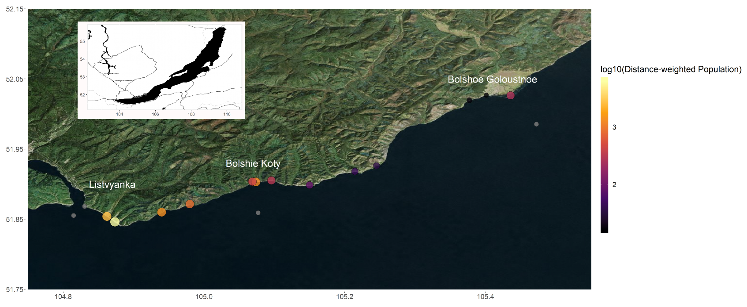

Figure 1: Map of all sampling locations with sites sized and colored by distance-weighted population. Grey sites are located where a distance-weighted population could not be calculated. The entire transect included three developed sites (i.e., Listvyanka, Bolshie Koty, Bolshoe Goloustnoe). Listvyanka contains approximately 2,000 permanent residents, although it experiences a transient tourist population of approximately 300,000 people annually. Bolshie Koty contains approximately 56 permanent residents, but the two local field stations and tourism can increase population by 200+ individuals in the summer. Bolshoe Goloustnoe has approximately 600 permanent residents and remains relatively consistent throughout the year. Three offshore samples were also collected to compare pelagic sewage signals to those in the littoral.

|  |  |  |
| --- | --- | --- |
| Table 2: Macroinvertebrate taxonomic groupings for abundance estimates. Amphipod taxa were defined as in Taakhteev & Didorenko, 2015; Mollusc taxa were defined as in Sitnikova, 2012. | | |
| **Amphipoda** | **Mollusca** | **Other** |
| *Brandtia latissima intermida* | Acroloxidae | Asellidae |
| *Brandtia latissima lata* | Baicaliidae | Caddisflies |
| *Brandtia latissima latior* | Benedictidate | Hirudinea |
| *Brandtia latissima latissima* | Maackia | Planaria |
| *Brandtia latissima lora* | Planorbidae |  |
| *Brandtia parasitica parasitica* | Valvatidae |  |
| *Cryptoropus inflatus* |  |  |
| *Cryptoropus pachytus* |  |  |
| *Cryptoropus rugosus* |  |  |
| *Eulimnogammarus capreolus* |  |  |
| *Eulimnogammarus cruentes* |  |  |
| *Eulimnogammarus cyaneus* |  |  |
| *Eulimnogammarus grandimanus* |  |  |
| *Eulimnogammarus maacki* |  |  |
| *Eulimnogammarus marituji* |  |  |
| *Eulimnogammarus verucossus* |  |  |
| *Eulimnogammarus viridis viridis* |  |  |
| *Eulimnogammarus vittatus* |  |  |
| *Hyallela cziarnianski* |  |  |
| *Pallasea brandtia brandita* |  |  |
| *Pallasea brandtii tenera* |  |  |
| *Pallasea cancelloides* |  |  |
| *Pallasea cancellus* |  |  |
| *Pallasea viridis* |  |  |
| *Poekilogammarus crassimus* |  |  |
| *Poekilogammarus ephippiatus* |  |  |
| *Poekilogammarus megonychus perpolitus* |  |  |
| *Poekilogammarus pictus* |  |  |

|  |  |  |  |  |  |  |  |  |  |
| --- | --- | --- | --- | --- | --- | --- | --- | --- | --- |
| Table 3: Average sewage indicator concentrations and densities per sampling location | | | | | | | | | |
| Site | NH4 mg/dm3 | NO3 mg/dm3 | PO4 mg/dm3 | Caffeine | Acetaminophen | Paraxanthine | Cotinine | Distance weighted population | Categorical distance weighted population |
| BK-1 | 0.003 | 0.085 | 0.054 | 0.011 | 0.001 | 0.002 | 0 | 1311.29 | High |
| BK-2 | 0.003 | 0.085 | 0.052 | 0.007 | 0.001 | 0 | 0 | 435.045 | Mod |
| BK-3 | 0.068 | 0.09 | 0.045 | 0.003 | 0.001 | 0 | 0 | 306.89 | Mod |
| BGO-1 | 0.0145 | 0.085 | 0.044 | 0 | 0.002 | 0 | 0 | 15.50 | Low |
| BGO-2 | 0.001 | 0.08 | 0.0385 | 0 | 0.001 | 0 | 0 | 16.44 | Low |
| BGO-3 | 0.001 | 0.09 | 0.044 | 0.005 | 0.003 | 0 | 0 | 264.55 | Mod |
| OS-1 | 0.001 | 0.085 | 0.061 | 0 | 0.001 | 0 | 0.001 | NA | NA |
| KD-1 | 0.0035 | 0.065 | 0.0375 | 0.003 | 0.001 | 0 | 0 | 34.80 | Low |
| KD-2 | 0.001 | 0.1 | 0.0445 | 0.001 | 0.001 | 0 | 0 | 43.51 | Low |
| MS-1 | 0.001 | 0.09 | 0.061 | 0.064 | 0.035 | 0.015 | 0 | 84.84 | Mod |
| SM-1 | 0.001 | 0.085 | 0.1475 | 0.042 | 0.012 | 0.005 | 0 | 868.42 | High |
| LI-1 | 0.004 | 0.08 | 0.0385 | 0.05 | 0.04 | 0.006 | 0.002 | NA | NA |
| LI-2 | 0.091 | 0.095 | 0.0775 | 0.001 | 0.007 | 0 | 0 | 6221.74 | High |
| LI-3 | 0.0035 | 0.08 | 0.077 | 0.027 | 0.002 | 0.002 | 0.003 | 2703.49 | High |
| EM-1 | 0.1125 | 0.185 | 0.092 | 0.029 | 0.014 | 0.002 | 0 | 1359.84 | High |
| OS-2 | 0.001 | 0.08 | 0.078 | 0.033 | 0.001 | 0.004 | 0.003 | NA | NA |
| OS-3 | 0.001 | 0.08 | 0.0795 | 0.001 | 0.001 | 0 | 0 | NA | NA |

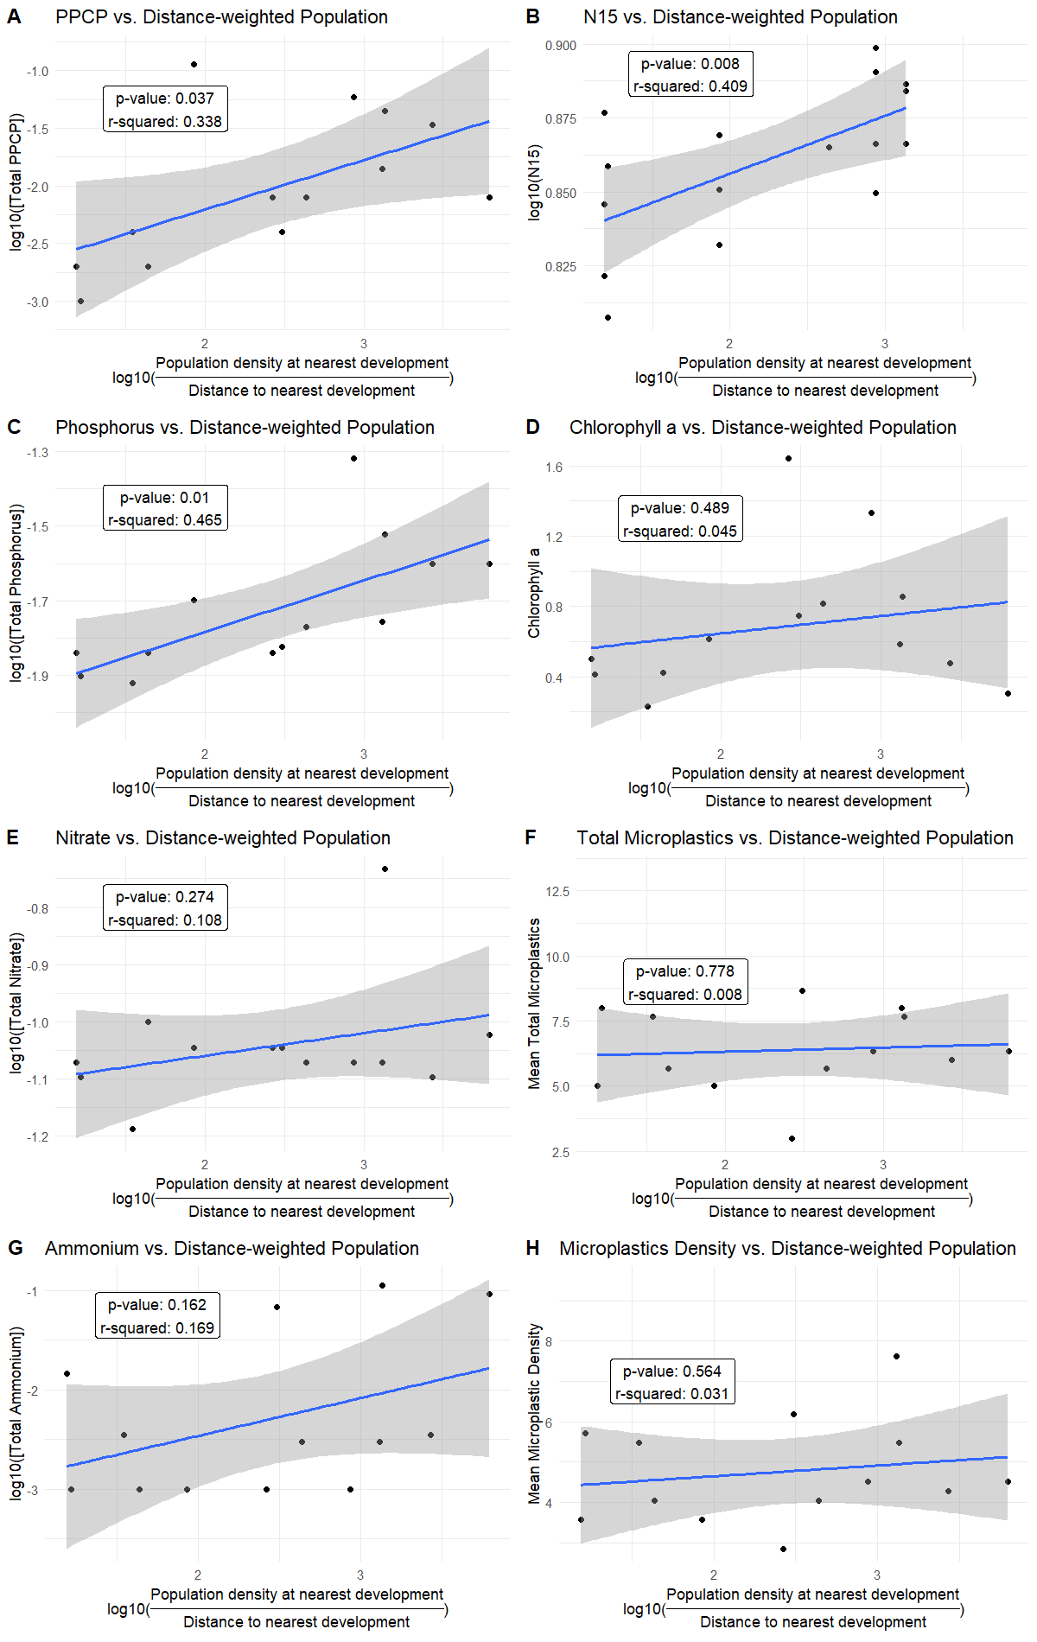

Figure 2: Linear models of total PPCP concentrations (A), N15 (B), phosphorus (C), Chlorophyll a (D), Nitrate (E), Total Microplastics (F), Ammonium (G), and Microplastic Density (H) regressed against log-transformed distance-weighted population. Total PPCP concentrations (A), N15 (B), and phosphorus (C) produced significant models. Chlorophyll a (D), Nitrate (E), Total Microplastics (F), Ammonium (G), and Microplastic Density (H) did not produce significant models.

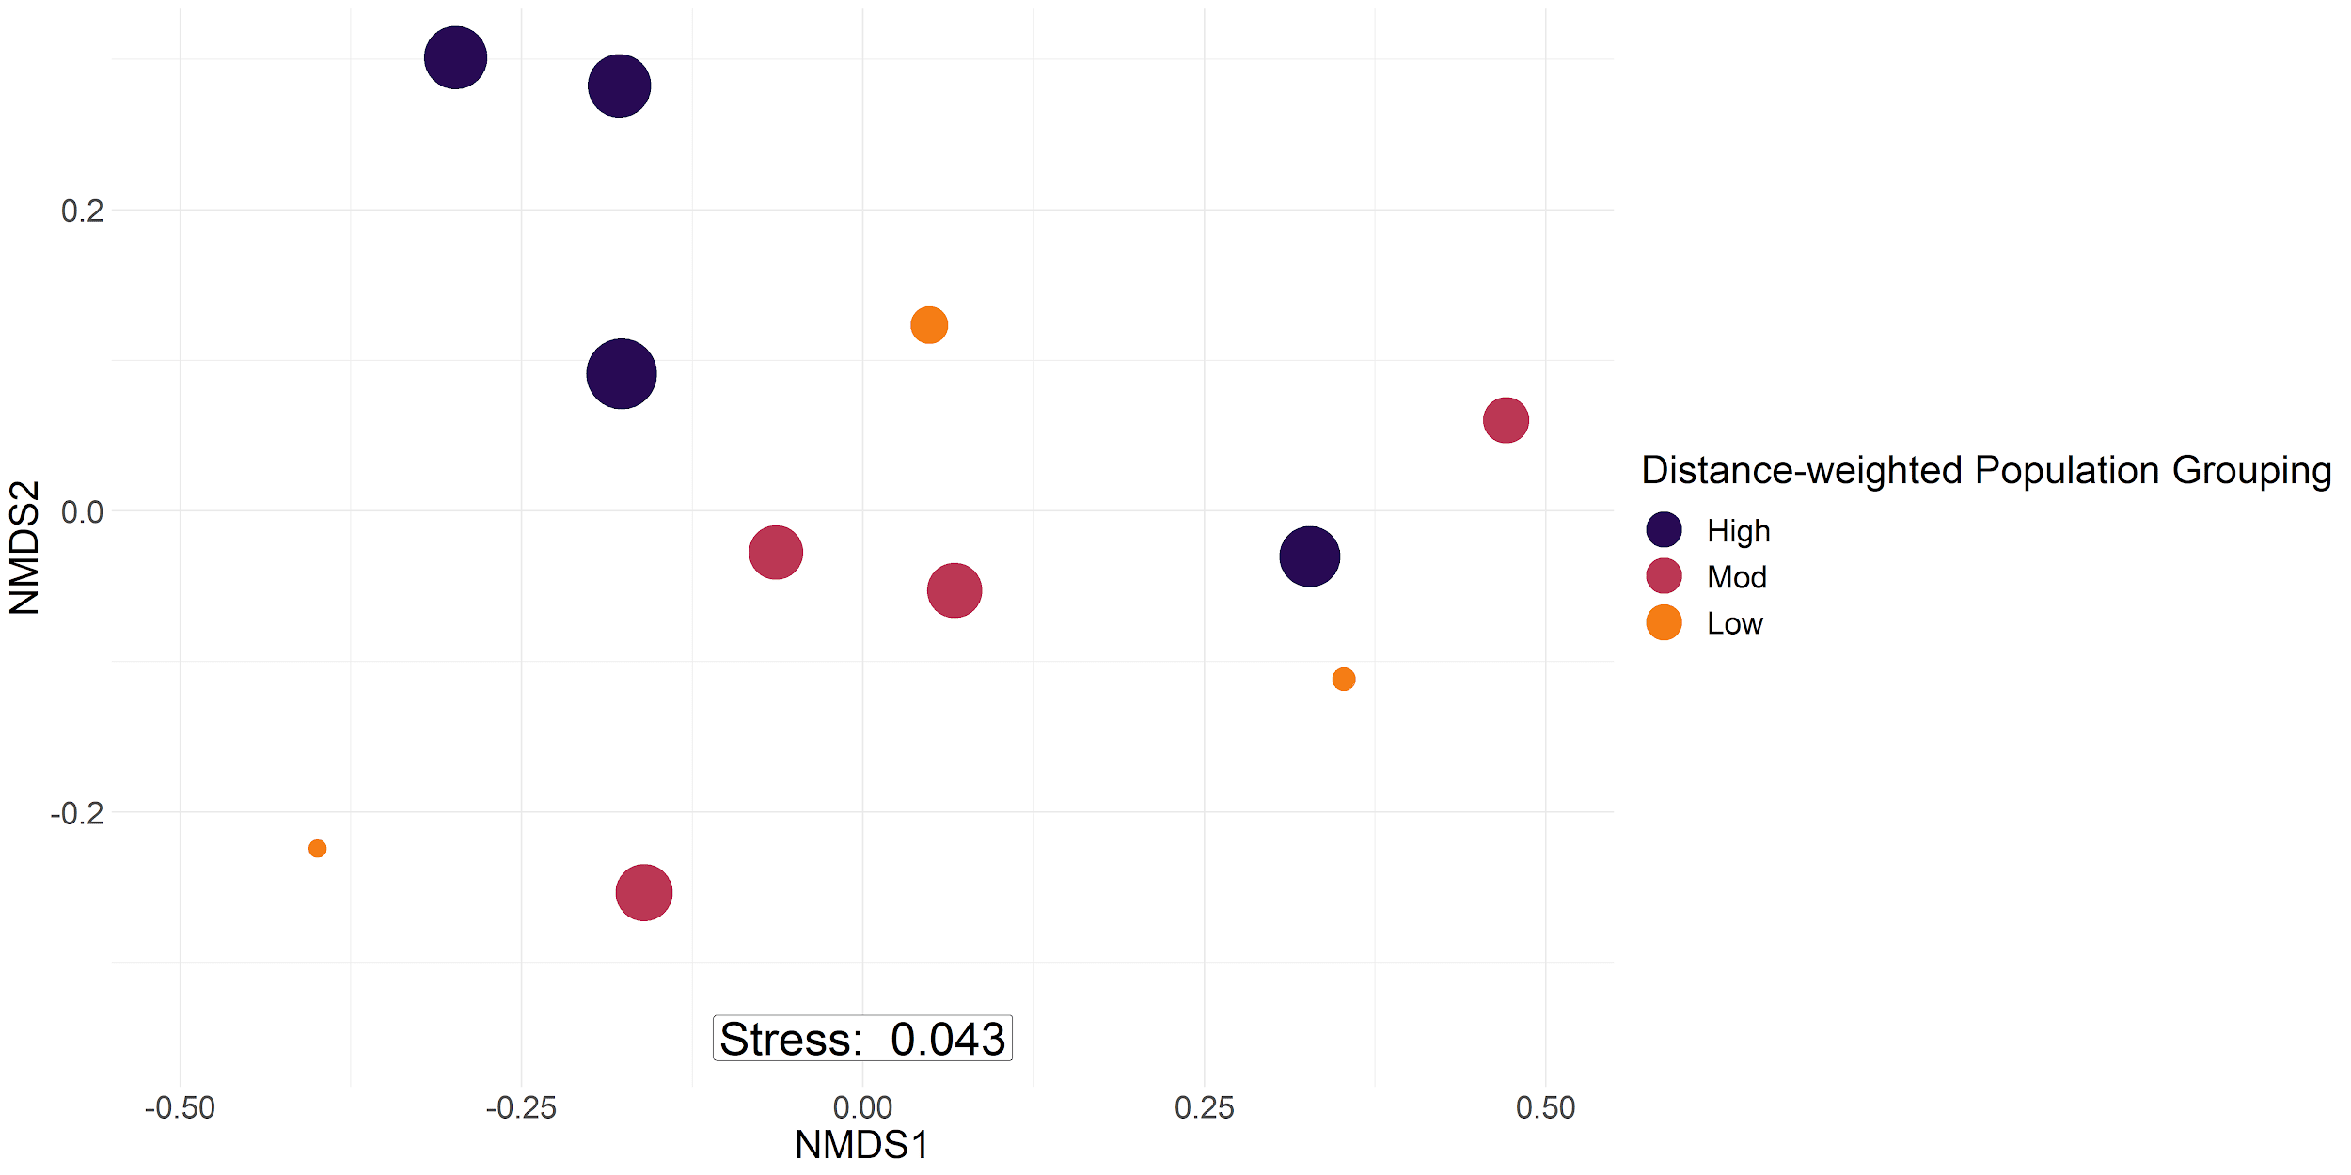

Figure 3: Periphyton abundance NMDS with bray-curtis dissimilarity. Labels are sized by log10 distance-weighted population and colored by sites with high (purple), moderate (pink), and low (orange) distance-weighted population values. PERMANOVA confirmed the three groups to be significantly different (p = 0.023). Sites with a higher distance-weighted population value tended to be more associated with filamentous algal groupings, whereas moderate and low values were more associated with diatom abundance.

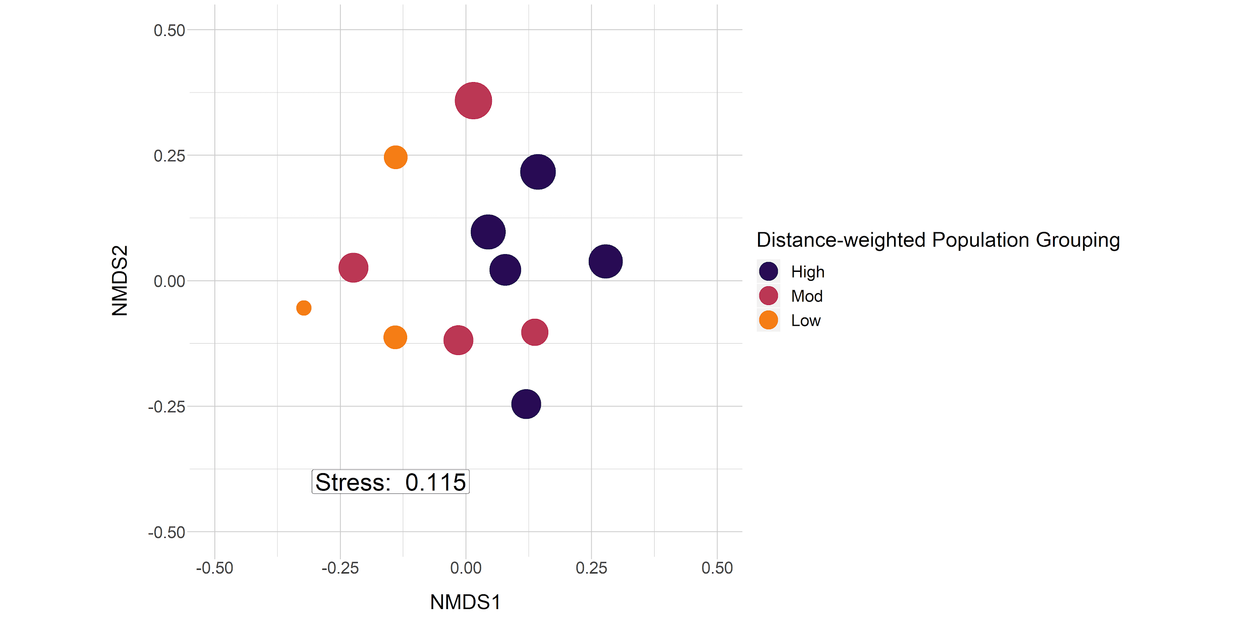

Figure 4: Macroinvertebrate abundance NMDS with bray-curtis dissimilarity. Sampling location labels are sized by log-transformed distance-weighted population with major groups including low (orange), moderate (pink), and high (purple) distance-weighted population. PERMANOVA confirmed the three groups to be significantly different (p = 0.002). Sites with a higher distance-weighted population values tended to be associated with amphipod and leech taxa (see Table 2), whereas sites with lesser distance-weighted population values were more associated with increased mollusc abundance (see Table 2).

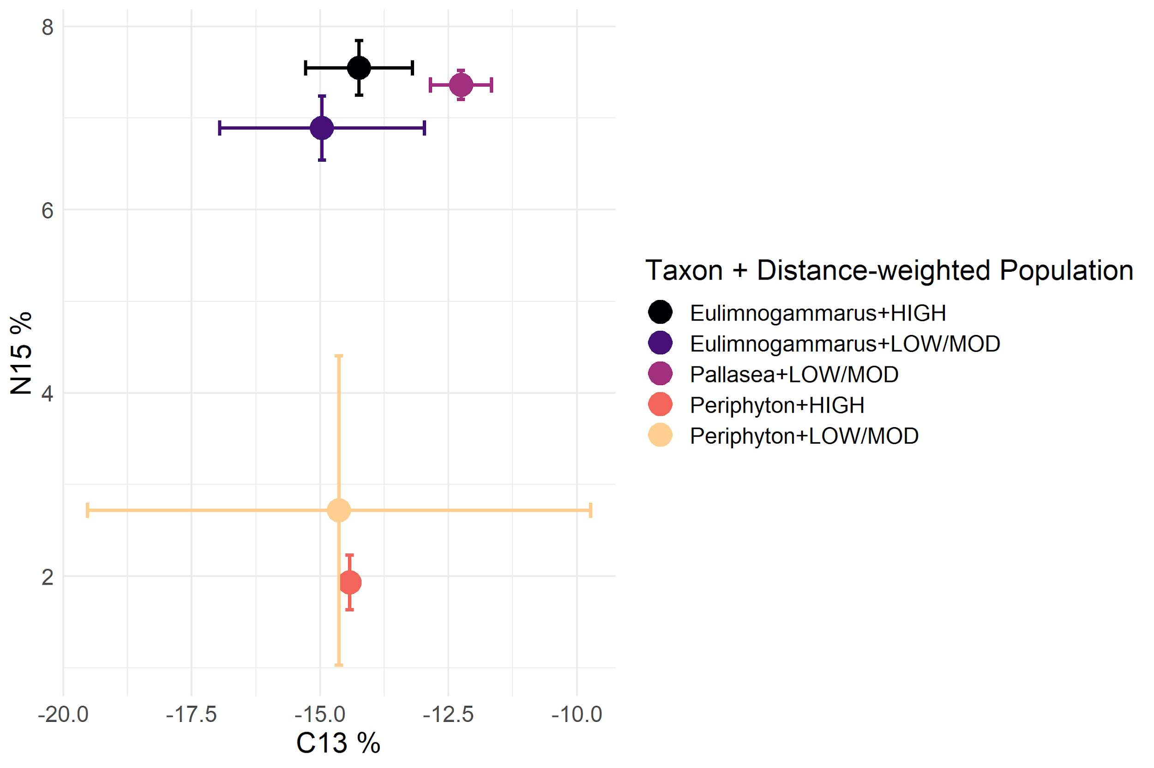

Figure 5: Biplot of mean and standard deviation C13 and N15 stable isotope values for littoral amphipods and periphyton, grouped by categorical distance-weighted population (Table 3). In general, periphyton did not differ in C13 or N15 signatures with increasing distance-weighted population, whereas *Eulimnogammarus* amphipods increased N15 signatures with increasing distance-weighted population. *Pallasea* signatures differed from *Eulimnogammarus* most likely because Pallasea tends to remain in the nearshore area, whereas *Eulimnogammarus* will regularly migrate the deeper zones (Taakhteev & Didorenko, 2015).

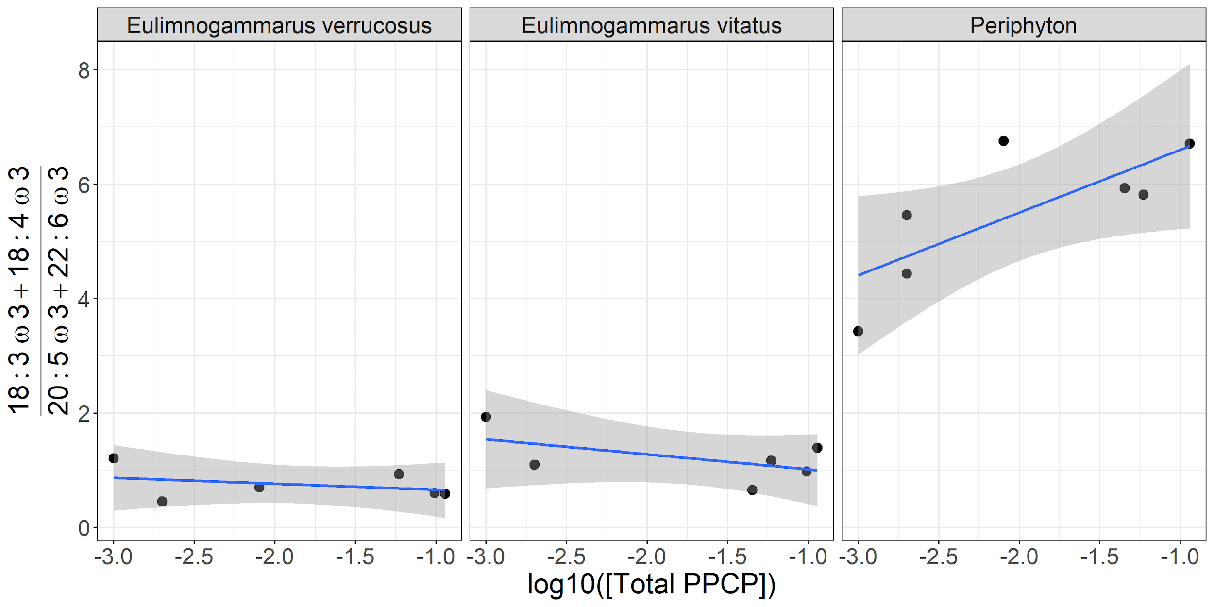

Figure 6: Ratio of 18:3ω3 and 18:4ω3 relative to 20:5ω3 and 20:6ω3 as a function of log -transformed total PPCP concentrations. The fatty acids 18:3ω3, 18:4ω3, 20:5ω3 and 20:6ω3 are all essential fatty acids (EFAs), which are prone to accumulate in organisms and mainly synthesized in primary producers. Because 18:3ω3 and 18:4ω3 are mainly found in filamentous algae whereas 20:5ω3 and 20:6ω3 tend to be associated with diatoms, our ratio also serves as a filamentous:diatom indicator. Periphyton ratios tend to increase with increasing total PPCP concentration, which corroborates our periphyton community abundance results (p = 0.05; Figure 3). Grazing amphipod ratios, however, remain relatively constant over a range of PPCP concentrations, implying two potential causes. First, amphipods could be selectively grazing to maintain a consistent ratio across sewage gradients. This potential cause would also imply that certain periphyton taxa, especially diatoms, would be experiencing increased grazing pressure at higher sewage concentrations. Second, amphipods could graze on filamentous algae and then expend their own energy to upgrade 18:3ω3 and 18:4ω3 to 20:5ω3 and 20:6ω3. In both of these scenarios, amphipods are able to maintain EFAs that are beneficial to living in cold environments despite necessary energetic trade-offs for remaining in areas with higher sewage concentrations.

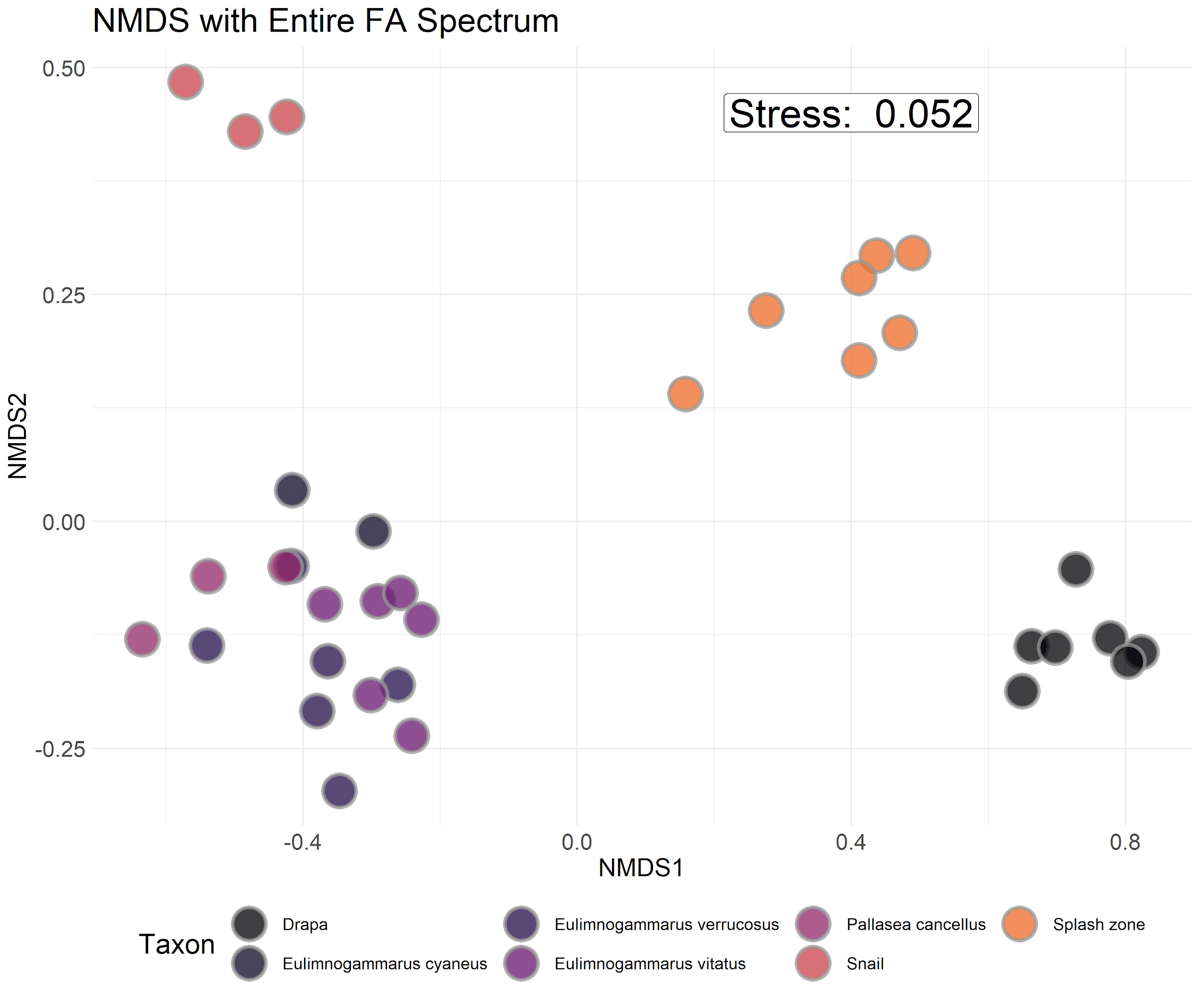

Figure S1: NMDS with bray-curtis dissimilarity of proportional fatty acid compositions for each macroinvertebrate and primary producer collected. Interspecific variation in fatty acid composition tended to be larger than intraspecific variation, implying that fatty acid signatures were largely species-specific and not environmentally driven.

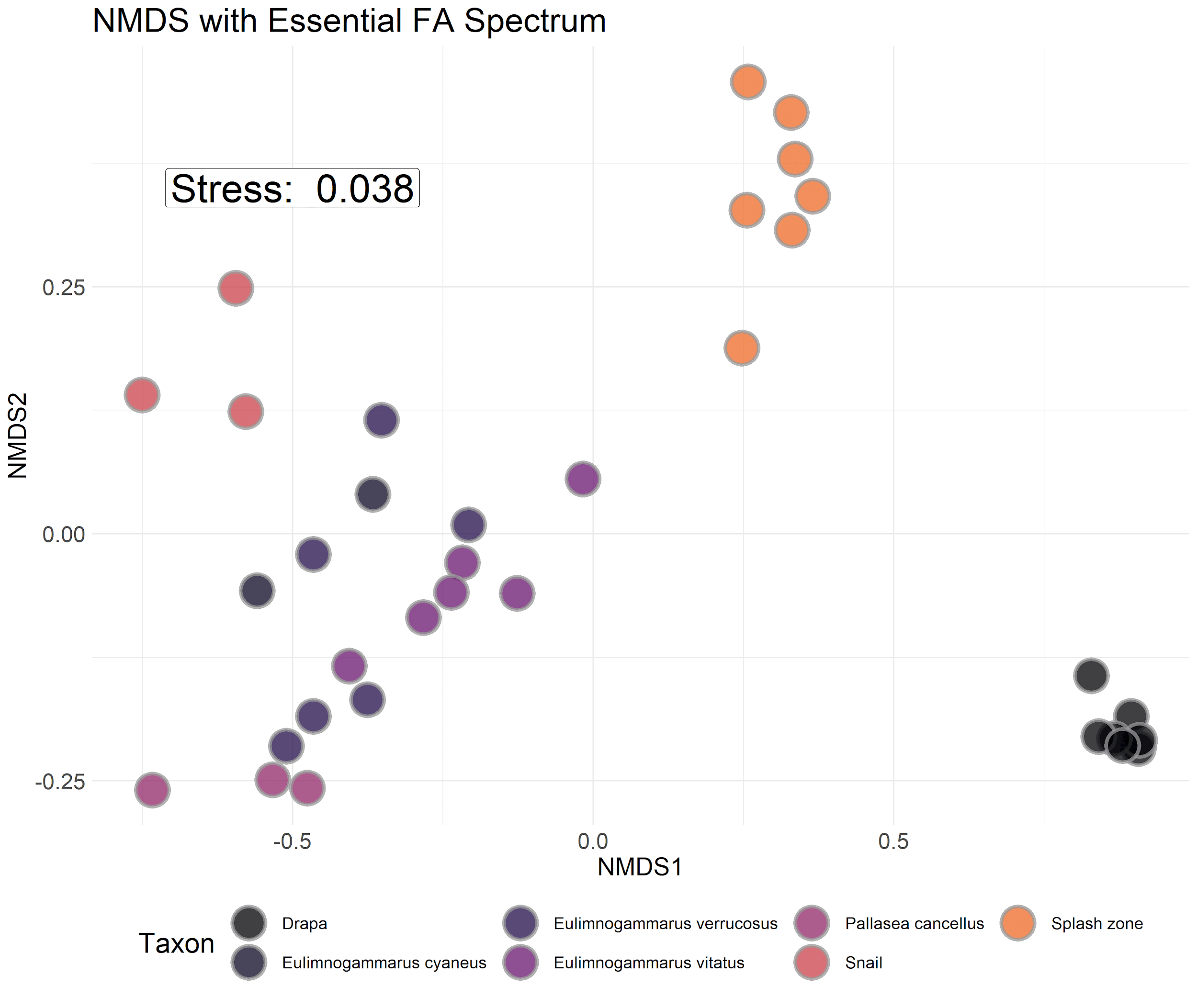

Figure S2: NMDS with bray-curtis dissimilarity of proportional essential fatty acid compositions for each macroinvertebrate and primary producer collected. Interspecific variation in fatty acid composition tended to be larger than intraspecific variation, implying that fatty acid signatures were largely species-specific and not environmentally driven.

|  |  |  |  |  |
| --- | --- | --- | --- | --- |
| Table S1: Metrics for calculating distance-weighted population. All landscape data were measured in google maps, and population data were collected from the 2012 census (IrkuStat, 2012). LI-1 has values of 0 for all variables because it was the southernmost site. | | | | |
| Site | Distance to southern developed site (km) | Population at southern developed site | Shoreline length of southern developed site (km) | Area of southern developed site (km2) |
| BK-1 | 0.22 | 80 | 1.19 | 0.33 |
| BGO-3 | 1.54 | 600 | 1.65 | 2.43 |
| BK-2 | 10.44 | 2000 | 4.61 | 2.03 |
| BK-3 | 0.94 | 80 | 1.19 | 0.33 |
| BGO-1 | 18.61 | 80 | 1.19 | 0.33 |
| BGO-2 | 17.54 | 80 | 1.19 | 0.33 |
| KD-1 | 8.29 | 80 | 1.19 | 0.33 |
| KD-2 | 6.63 | 80 | 1.19 | 0.33 |
| MS-1 | 3.4 | 80 | 1.19 | 0.33 |
| SM-1 | 5.23 | 2000 | 4.61 | 2.03 |
| OS-1 | NA | NA | NA | NA |
| OS-2 | NA | NA | NA | NA |
| EM-1 | 3.34 | 2000 | 4.61 | 2.03 |
| LI-1 | 0 | 0 | 0 | 0 |
| LI-2 | 0.73 | 2000 | 4.61 | 2.03 |
| LI-3 | 1.68 | 2000 | 4.61 | 2.03 |
| OS-3 | NA | NA | NA | NA |