**Effects of spatially heterogeneous lakeside development on nearshore biotic communities in a large, deep, oligotrophic lake (Lake Baikal, Siberia)**

Michael F. Meyer1*

Stephanie E. Hampton2

Ted Ozersky3

Kara H. Woo2

Kirill Shchapov3

Daniel D. Snow4

Emma J. Rosi5

Maxim A. Timofeyev6

Yulia M. Zaitseva7

Dmitry Yu. Karnaukhov6

Nina A. Bondarenko7

Aaron Galloway8

Julie Schram8

Matthew R. Brousil2

1. School of the Environment, Washington State University, Pullman, WA, USA

2. Center for Environmental Research, Education, and Outreach, Washington State University,

Pullman, WA, USA

3. Large Lakes Observatory, University of Minnesota - Duluth, Duluth, MN, USA

4. School of Natural Resources, University of Nebraska-Lincoln, Lincoln, NE, USA

5. Cary Institute of Ecosystem Studies, Millbrook, NY, USA

6. Biological Research Institute, Irkutsk State University, Irkutsk, Irkutsk Oblast, Russia

7. Limnological Institute SB RAS, Irkutsk, Irkutsk Oblast, Russia

8. Oregon Institute of Marine Biology, University of Oregon, Charleston, OR, USA

*corresponding author: michael.f.meyer@wsu.edu

**Keywords**: sewage, PPCP, food webs, community ecology, human disturbance

**Abstract (243/250 words)**

Clustered anthropogenic activity along lake shores can create hot spots of disturbance and ecological degradation. Sewage released from lakeside development is a type of high impact disturbance with effects most immediately observed among littoral biota. For the past decade, Lake Baikal has been experiencing localized sewage pollution from lakeside settlements, near which increasing filamentous algal abundance has suggested that littoral benthic communities are responding. To explicitly link sewage released into Lake Baikal with biological responses, we surveyed a 40-km transect of the southwestern shore for sewage indicators, including pharmaceuticals and personal care products (PPCPs) and microplastics. To examine benthic community responses, periphyton and macroinvertebrate relative abundance as well as indicators of food web structure (stable isotopes and fatty acid composition) were assessed at each littoral site. At all sites, PPCPs including caffeine (up to 60 ng/L) and acetaminophen (up to 40 ng/L) were detected in the nearshore water, and concentrations were related to extent of lakeside development. Periphyton and macroinvertebrate stable isotopes and essential fatty acid compositions suggested that, despite increased filamentous algae presence near developed sites, the food web did not restructure, with amphipods potentially changing behavior or metabolism to compensate for changing periphyton communities. Together, our results suggest that population hot spots can lead to gradients of human disturbance, thereby creating spatial heterogeneity in nearshore, benthic communities. For Lake Baikal, these results are timely, especially considering growing tourism hot spots (~1.2 million tourists annually) may heighten risk for future environmental consequences.

**Introduction**

The release of treated and untreated wastewater into aquatic ecosystems is a common human disturbance that can introduce pollutants and reshape aquatic ecological communities (Hampton et al. 2011). Nitrogen and phosphorus are among the primary pollutants in sewage (Smith et al. 1999). Although often concentrated in wastewater, nutrient can originate from diverse anthropogenic and natural sources, complicating their use as sewage indicators. Regardless of the source, biological processes can further obfuscate sewage detection , such as benthic primary producers in nearshore water assimilating nutrients quickly (e.g., hours), such that deviation in typical water concentrations may not be not observed (Hadwen and Bunn 2005). Because nutrients come from numerous non-sewage sources, certain pollutants and sewage indicators consistently associated with human activity have garnered increasing attention for their usefulness as sewage indicators.

Among the diverse co-contaminants in sewage, enhanced δ15N stable isotope signatures (Costanzo et al. 2001; Camilleri and Ozersky 2019), pharmaceuticals and personal care products (PPCPs) (Rosi-Marshall and Royer 2012) and microplastics (Barnes et al. 2009) have broadly been applied in indicate wastewater inputs. Stable isotopes, such as δ15N, have been frequently used to trace sewage pollution (Gartner et al. 2002), yet their potential to indicate sewage can be obfuscated by complex terrestrial (Craine et al. 2018) and aquatic (Guzzo et al. 2011) processes. PPCP studies from continental (Kolpin et al. 2002; Focazio et al. 2008; Yang et al. 2018) to soil pore water (Yang et al. 2016) scales, have shown that PPCP concentrations tend to be greatest closer to their source and decrease over space (Bendz et al., 2005) and time. Microplastics (plastic debris up to 5 mm in size) also have been used to detect sewage pollution (Li et al. 2018) along gradients of increasing human population density (Klein et al. 2015). Microplastics are resistant to degradation (Barnes et al. 2009), providing a signal over a longer time frame than many PPCPs and nutrients in sewage. Aside from δ15N, PPCP, and microplastic measurements inferring the spatial extent and timing of sewage pollution in an ecosystem, they can also be associated with various biological responses. Although concentrations observed in ecosystems tend not to be lethal, their presence and concentrations can be associated with disrupting ecological processes, such as accelerating dragonfly maturation (Lee et al., 2016) and decreasing primary production in biofilms (Rosi-Marshal et al., 2013).

When entering aquatic environments, the effects of sewage pollution are frequently first seen in nearshore benthic communities where increased nutrients alter algal species composition, abundance, and nutritional quality. Increased filamentous algal abundance, for example, has been frequently observed in areas suspected of sewage pollution (Rosenberger et al. 2008; Hampton et al. 2011), likely due to benthic filamentous algae efficiently taking up nutrients from the water column (Hadwen and Bunn 2005; Andersson and Brunberg 2006). With a changing resource base, grazing macroinvertebrate communities may also shift to include more detritivores or species capable of consuming filamentous algae (Rosenberger et al. 2008). Even though it may be physically difficult for grazers to consume filamentous algae (Mazzella and Russo 1989), filamentous algal taxa tend to contain a different mixture of essential fatty acids (EFAs) in comparison to diatoms (Kelly and Scheibling 2012), which dominate periphyton communities in unimpacted ecosystems. In particular, the EFAs 18:3ω3 and 18:4ω3 are commonly associated with filamentous algae (Taipale et al. 2013), whereas 20:5ω3, and 22:6ω3 are more associated with diatoms (Taipale et al. 2013). While primary producers usually maintain a consistent EFA signature (Taipale et al. 2013), consumers can acquire EFAs by grazing (Dalsgaard et al. 2003) or upgrading EFAs (Sargent and Falk-Petersen 1988; Dalsgaard et al. 2003). In either event, comparing consumer fatty acid compositions to those of potential food sources can be used to infer how grazing patterns change with increasing sewage pollution.

To investigate lake littoral community responses to sewage pollution, we surveyed 40 km of Lake Baikal’s shoreline for indicators of sewage pollution and metrics of benthic community composition and structure. Located in Siberia, Lake Baikal is the oldest, most voluminous, and deepest freshwater lake in the world (Hampton et al. 2018), with the majority of Baikal’s biodiversity occurring in the littoral zone (Kozhova and Izmest’eva 1998). While Lake Baikal’s pelagic zone is generally ultra-oligotrophic (Yoshida et al. 2003; O’Donnell et al. 2017), littoral areas abutting lakeside settlements have recently shown distinct signs of eutrophication (Timoshkin et al. 2016). Much of Lake Baikal’s shoreline lacks human development and Baikal’s watershed is largely roadless and unpopulated (Moore et al. 2009). Despite low levels of human development, increased filamentous algal abundance has been noted throughout the lake since 2010 (Kravtsova et al. 2014; Timoshkin et al. 2016; Volkova et al. 2018). While increased *Ulothrix* spp. abundance historically occurs in late summer (Kozhov 1963; Kozhova and Izmest’eva 1998), recent observations of *Spirogyra* spp. abundance at unprecedented levels are thought to be associated with increased nearshore nutrient concentrations (Volkova et al. 2018; Ozersky et al. 2018). Timoshkin et al. (2016, 2018) present compelling evidence that inadequate wastewater management in lakeside settlements is the main driver of nearshore algal blooms.

Given the growing evidence that Baikal’s nearshore periphyton communities are responding to sewage inputs, our overarching goal was to understand how littoral benthic community composition and structure may likewise be responding. We had three specific objectives:

1. identify areas of sewage pollution using robust indicators,
2. assess the relationship between sewage indicators and littoral benthic periphyton and macroinvertebrate community composition, and
3. evaluate how food webs may restructure with increasing sewage pollution.

We hypothesized that (1) sewage indicators, such as PPCP concentrations, δ15N, and microplastic densities, would increase with increasing population density and proximity of lakeside development; (2) an increasing sewage signal would correlate with increased dominance of filamentous benthic algae; and (3) increasing filamentous algae abundance would result in changes in the abundance of different macroinvertebrate feeding guilds, reflected in community composition and dietary tracers such as carbon and nitrogen stable isotopes and fatty acids.

**Methods**

1. *Site description*

The vast majority of Lake Baikal’s 2,000-km shoreline lacks lakeside development (Moore et al. 2009; Timoshkin et al. 2016). Our study focused on a 40-km section of Baikal’s southwestern shoreline, which included three settlements of different size (Figure 1). From 19 through 23 August 2015, we sampled 14 littoral and 3 pelagic locations along our 40-km transect. Littoral locations were chosen to capture a range of sites with varying degrees of adjacent shoreline development – from “developed” (along the waterfront of human settlements) to “undeveloped” (no adjacent human settlements and complete forest cover) (Figure 1; Figure 2; Table 1). Pelagic sites were located 2 to 5 km offshore from each of the developed sites in water depths of 900 to 1,400 m (Figure 1; Table 1). Littoral sites were sampled at approximately the same depth (~1.25 m) at a distance of 8.9 to 20.75 m from shore (Table 1). At each site, air temperature was measured with a mercury thermometer and photographs were taken of the substrate and the shoreline.

Along our 40-km transect, there were three lakeside settlements. The largest, Listvyanka, is adjacent to Baikal’s only surface outflow. Listvyanka is primarily a tourist town with approximately 1,963 permanent residents, although tourism can contribute significantly to the town’s population with 1.2 million visitors over the course of the year (Interfax-Tourism 2018). The other two settlements are the villages Bolshie Koty and Bolshoe Goloustnoe, which have approximately 80 and 600 permanent residents, respectively. Bolshie Koty is home to two field research stations and several small tourist accommodations. Bolshoe Goloustnoe has several hotels and tourist camps (IrkutskStat, 2012).

*Inverse distance weighted (IDW) population calculation for each sampling location*

We recognized that sewage indicator concentrations at each sampling location may be related to a sampling location’s spatial position relative to the size and proximity of neighboring developments. Therefore, we, created the inverse distance weighted (IDW) population metric to summarize information about human population size, density, and location along the shoreline as well as distance between developed sites and sampling locations. The IDW metric reflects the idea that sewage pollution should be positively related to increasing human density and inversely related with distance from densely populated areas (sensu Bendz et al., 2005). Additionally, Timoshkin et al. (2018) noted that sewage into Baikal’s nearshore largely enters through groundwater-lake connections, implying that locations with more directly adjacent shoreline development should experience higher sewage concentrations in the lake. Acknowledging that nearshore PPCP concentrations were likely positively proportional to a developed location’s shoreline length, we scaled a developed site’s population density by its shoreline length. Scaling a developed site’s population density by its shoreline length also represents the idea that sewage-associated pollutants, such as PPCPs (Karnjanapiboonwong et al., 2010) and nutrients (de Vries, 1972), can be removed via the soil matrix en route to the lake.

Our workflow for calculating IDW population can be described in five main steps. First, we traced polygons and shorelines from satellite imagery for each developed site in Google Earth. Second, polygon and line shapefiles were downloaded from Google Earth as a .kml file. Third, the .kml file was imported into the R statistical environment (R Core Team, 2019), where using the sf package (Pebesma, 2018) we calculated shoreline length, polygon area, and centroid location for each developed site. Fourth, we joined point locations of each sampling site with the spatial polygons to calculate the distance from each sampling location to each developed site’s centroid. Fifth, we calculated IDW population for each location, using formula (1).

(1)

where *I* is the IDW population at sampling location *j*, *P* is the population at each of the three developed sites Listvyanka (LI), Bolshie Koty (BK), Bolshoe Goloustnoe (BGO), *A* is the area of a developed site in km2, *L* is the shoreline length at a developed site in km, and *D* is the distance from developed site *j* to each developed site in km. This formulation implies that all sampling locations are influenced by all three developed sites. Thus, the influence of an individual developed site on each sampling location is positively influenced by the numerical and spatial density of the population and its orientation toward the shoreline, and inversely proportional to a sampling location’s distance from each of the three developed sites.

*2. Water samples*

At both pelagic and littoral sites, water samples were collected for nutrient, chlorophyll, microplastic, and pharmaceutical and personal care product (PPCP) analysis. Samples were collected by hand from 0.75 m depth for each littoral site and with a bucket from aboard the ship for pelagic sites. Each water sample collection procedure is described below.

*2a.* *Nutrients*

Water samples for nutrient analyses were collected at a depth of ~0.75 m in 150 mL glass jars that had been washed with phosphate-free soap and rinsed three times with water from the sampling location. Samples were collected in duplicates and immediately frozen at -20°C until processing at the A.P.Vinogradov Institute of Geochemistry (Siberian Branch of the Russian Academy of Sciences, Irkutsk). Samples were not filtered prior to freezing, meaning that nitrogen and ammonium concentrations may potentially include intracellular nitrogen and therefore be overestimates of nitrogenous forms in the water column.

For each water sample, nitrate, ammonium, phosphate, and total phosphorus concentrations were measured. For ammonium (2016a) and nitrate (2017) concentrations, samples were analyzed with a spectrophotometer following the addition of Nessler’s reagent and disulfuric acid respectively. Phosphate and total phosphorus concentration was measured with a spectrophotometer following the addition of persulfate (2016b). Concentrations are reported in mg/L.

*2b. Chlorophyll a*

Water samples were collected in 1.5 L plastic bottles from a depth of approximately 0.75 m. Within 12 h of collection, three subsamples (up to 150 mL each) were filtered through 25-mm diameter, 0.2 µm pore size nitrocellulose filters. Filters were then placed in a 35 mm petri dish and frozen in the dark until processing.

Chlorophyll samples were processed in a manner similar to that of Parson (1963) and Lorenzen (1967). Nitrocellulose filters were ground in 90% acetone, in which chlorophyll extraction was allowed to proceed overnight. Samples were then centrifuged for 15-20 minutes. After centrifugation, absorbance of the chlorophyll extract was measured in a spectrophotometer at 630, 645, 665, and 750 nm. Concentrations were calculated using the formula: ; where A is the absorbance value of a particular wavelength, V1 is the volume of the filtered water, and V2 is the volume of extract. Concentrations are reported as mg/L.

*2c. PPCPs*

Water samples for PPCP analysis were collected in 250 mL amber glass bottles that were rinsed with either methanol or acetone and then three times with sample water prior to collections. Following collection, samples were refrigerated and kept in the dark until solid phase extraction (SPE).

Within 12 h of collection, samples were filtered directly from the amber glass bottle using a single-stream 25-mm GF/F SPE cartridge setup (Waters Corporation, Milford, MA). Lab personnel wore gloves and face masks to minimize contamination. Prior to filtration, GF/F filters and SPE cartridges were primed with at least 5 mL of either methanol or acetone and then washed with at least 5 mL of sample water. Rate of SPE occurred at approximately 1 drop per second. Extraction proceeded until water could no longer pass through the SPE cartridge or until all collected water was filtered. Cartridges were stored in whirlpacks at -20°C until analysis for PPCPs following methods of Lee et al. (2016).

2d. *Microplastics*

At each location, samples were collected in triplicate using 1.5 L clear plastic bottles that were washed thoroughly with sample water before each collection.

For processing, each sample was vacuum filtered on to a 47-mm diameter GF/F filter. During filtration, aluminum foil was used to cover the filtration funnel to prevent potential contamination from airborne microplastic particles. After filtration, filters were dried under vacuum pressure and then stored in 50-mm petri dishes. Following filtration of all three replicates, the filtrate was collected and then re-filtered through a GF/F filter as a control for contamination.

Microplastic counting involved visual inspection of the entire GF/F according to guidelines proposed in Van Cauwenberghe et al. (2015). Visual enumeration was conducted under a stereo microscope at approximately 100x magnification, and microplastics were classified into one of three categories: fibers, fragments, or beads. For all categories, plastics were defined as observed objects with apparently artificial colors. Fibers were defined as smooth, long plastics with consistent diameters. Fragments were defined as plastics with irregularly sharp or jagged edges. Beads were defined as spherical plastics. During enumeration, GF/Fs remained in the petri dish to minimize potential for contamination from the air. Following enumeration of both experimental and control samples, fibers, fragments, and beads enumerated in the controls were subtracted from the experimental microplastic densities for each plastic type and from each replicate. One location (BK-1) had two control replicates, which were averaged for each plastic type and then subtracted from the experimental samples. Results are reported as the average number of microplastics per liter.

*3. Benthic biological samples*

At each littoral site, periphyton and macroinvertebrates were collected for relative abundance estimates and food web analysis.

*3a. Benthic algal collection*

At each littoral site, we haphazardly selected three rocks representative of local substrate. A plastic stencil was used to define a surface area of each rock from which we scraped a standardized 14.5 cm2 patch of periphyton. Samples were preserved with Lugol’s solution and stored in plastic scintillation vials. Additional periphyton was collected from all collected rocks at each site for fatty acid and stable isotope analysis.

Periphyton taxonomic identification and enumeration was performed by subsampling 10 μL aliquots from each preserved sample. Cells, filaments, and colonies were counted for each taxonomic group until at least a total of 300 cells were identified. For all subsamples, the entire aliquot was counted. In instances where 300 cells were counted prior to completing the aliquot, the entire aliquot was still counted. Taxa were classified into broad categories consistent with Baikal algal taxonomy (Izhboldina, 2007), using coarse groupings to capture general patterns in relative algal abundance. As a result, algal groups consisted of diatoms, *Ulothrix*, *Spirogyra*,and the green algal Order Tetrasporales.

*3b. Benthic invertebrate collection*

At each littoral site, three kick-net samples were collected for assessment of benthic community composition and abundance. Using a D-net, we collected macroinvertebrates by flipping over 1-3 rocks, and then sweeping five times in a left-to-right motion across approximately 1 m. After the series of sweeps, the catch was rinsed into a plastic bucket. For each replicate, bucket contents were concentrated using a 64 μm mesh and placed in glass jars with 40% ethanol (vodka; the only preservative available to us at the time) for preservation and refrigerated at 4°C aboard the research vessel. The 40% ethanol preservative was replaced with ~80% ethanol upon return to the lab within 24 to 48 hours, and samples were stored at ~4°C.

Separate collections were conducted for invertebrate fatty acid and stable isotope analyses. Invertebrates were collected using a D-net in a similar fashion as the community enumeration. Additional invertebrates were also collected by hand. Collected organisms were then live-sorted, identified to species, and frozen at -20°C.

Invertebrate taxonomic identification and enumeration were performed under a stereo microscope. All invertebrates were identified to species with the exception of juveniles (Taakhteev, 2015 for amphipods; Sitnikova, 2012 for molluscs; Table 2). Some samples were not well-preserved and were excluded from further analyses, in order to reduce errors in identification.

*3c. Food web characterization*

To characterize littoral food webs, we analyzed carbon and nitrogen stables isotopes as well as fatty acid profiles for periphyton and macroinvertebrates. Prior to isotopic and fatty acid analysis, periphyton and macroinvertebrate samples were freeze dried for ~24 hours, homogenized to powder, and then weighed.

*Stable isotope analysis*

Measurements of δ15N and δ13C were performed on an elemental analyzer-isotope ratio mass spectrometer (EA-IRMS; Finnigan DELTAplus XP, Thermo Scientific) at the Large Lakes Observatory, University of Minnesota Duluth. The EA-IRMS was calibrated against certified reference materials including L-glutamic acid (NIST SRM 8574), low organic soil and sorghum flour (standards B-2153 and B-2159 from Elemental Micro-analysis Ltd., Okehampton, UK) and in-house standards (acetanilide and caffeine). Replicate analyses of external standards showed a mean standard deviation of 0.06 ‰ and 0.09 ‰, for δ13C and δ15N, respectively.

*Fatty acid analysis*

Fatty acid extractions generally involved three phases: (1) 100% chloroform extraction, (2) chloroform-methanol extraction, and (3) fatty acid methylation. Fatty acid extraction methods were adapted from similar methods developed in Schram et al. (2018).

Following freeze-drying, samples were transferred to 10 mL glass centrifuge vials, and 2 mL of 100% chloroform was added to each under nitrogen gas. Samples were allowed to sit in chloroform overnight at -80°C.

Following overnight chloroform extraction, samples underwent a chloroform-methanol extraction three times. To each sample, we added 1 mL cooled 100% methanol, 1 mL chloroform:methanol solution (2:1), and 0.8 mL 0.9% NaCl solution. Samples were inverted three times and sonicated on ice for 10 minutes. Next, samples were vortexed for 1 minute, and centrifuged for 5 minutes (3,000 rpm) at 4°C. Using a double pipette technique, the lower organic layer was extracted and kept under nitrogen. After the third extraction, samples were allowed to evaporate under nitrogen flow, and resuspended in 1.5 mL chloroform and stored at -20°C overnight.

Once resuspended in chloroform, 1 mL of chloroform extract was transferred to a glass centrifuge tube with a glass syringe. As a standard, 4 μL of 19-carbon fatty acid was added along with 1 mL of toluene and 2 mL of 1% sulfuric acid-methanol. The vial was closed under nitrogen gas and then incubated in 50°C water bath for 16 hours. After incubation, samples were removed from the bath, allowed to reach room temperature and stored on ice. Next, we performed a potassium carbonate-hexane extraction twice. To each sample, we added 2 mL of 2% potassium bicarbonate and 5 mL of 100% hexane, inverting the capped vial so as to mix the solution. Samples were centrifuged for 3 minutes (1,500 rpm) at 4°C. The upper hexane layer was then removed and placed in a vial to evaporate under nitrogen flow. Once almost evaporated, 1 mL of 100% hexane was added and stored in a glass amber autosampler vial for GC/MS quantification. GC/MS quantification was performed with a Shimadzu QP2020 GC/MS in a similar method as described in Schram et al. (2018).

*4. Statistical analyses*

Total phosphorus, nitrate, ammonium, microplastic abundance and density, total PPCP concentration, and δ15N in macroinvertebrate tissues were log-transformed and regressed against log-transformed IDW population using a linear model. Analytically, log-transforming made sites more comparable to one another, as values spanned three orders of magnitude. Physically, we assumed that sewage indicators were likely subject to exponential processes (e.g., mixing, diffusion), and log-transforming the data should linearize the relationships between predictor and response variables. Residuals were assessed for normality and homogeneity of variance.

To assess if benthic community composition was associated with increasing sewage indicators, periphyton and macroinvertebrate abundance data were each analyzed with a consistent multivariate routine. First, replicates where averaged, and taxonomic groups representing less than 1% of the inter-site community were removed from analysis, so as to reduce the influence of rare species on results. Second, community compositions for both periphyton and macroinvertebrates were visualized using non-metric multidimensional scaling (NMDS) with a Bray-Curtis similarity metric. Periphyton community compositions were calculated as relative proportions, whereas invertebrate abundances were grouped at the genus-level and then square-root transformed to minimize influence of more abundant taxa. Visual inspection of the NMDS plot suggested that sites tended to cluster by low, moderate, and high PPCP concentrations and IDW population. Third, we used k-means clustering to identify an optimal number of clusters (Figure S1), for which we iterated through multiple numbers of clusters (i.e., 1 to 10) and calculated the within-group-sum-of-squares (wss). We identified the optimal number of clusters when WSS decreased most markedly (Legendre and Legendre 2012). To assess whether differences between groups were statistically significant, we performed a permutational multivariate analysis of variance (PERMANOVA, (Anderson 2001)) with 999 permutations, where community compositions were treated as a response to the groups identified through k-means clustering. Unlike traditional multivariate analyses of variance (MANOVA), PERMANOVA does not require assumptions of multivariate normality (Anderson 2001). Post-hoc SIMPER analysis (Clarke 1993) was performed following the PERMANOVA to identify which taxonomic groups most influenced cluster differences.

To assess if benthic food webs restructured with increasing sewage indicator concentrations, fatty acid data were analyzed in a manner similar to periphyton and macroinvertebrate abundance data. First, species’ fatty acid profiles were visualized by performing NMDS with Bray-Curtis similarity for all organisms (Figure S2). This technique broadly demonstrated that interspecific variation in fatty acid composition was greater than intraspecific variation. The same pattern was observed for all fatty acids quantified as well as solely essential fatty acids (EFAs; Figure S2). The NMDS plot with species’ EFA profiles suggested that sites differentiated based on sewage indicator concentrations. Among the eight EFAs commonly used in ecological context (Taipale et al. 2013), 18:3ω3, 18:4ω3, 20:5ω3, and 22:6ω3 had the highest coefficients of variation, thus enabling comparisons between sites, and so we focused our analysis on these four compounds. These four EFAs tend to be indicative of green algae (i.e., 18:3ω3 and 18:4ω3) and diatoms (i.e., 20:5ω3 and 22:6ω3). To evaluate how relative EFA abundance may relate to sewage pollution, we regressed filamentous:diatom fatty acid signals (i.e., (18:3ω3% + 18:4ω3%)/(20:5ω3% + 22:6ω3%)) against log-transformed PPCP concentrations using a linear model.

All analyses were conducted in the R statistical environment (R Core Team 2019), using the tidyr (Wickham and Henry 2019), dplyr (Wickham et al. 2019), ggplot2 (Wickham 2016), and vegan (Oksanen et al. 2019) packages. All data, including .kml files used to calculate IDW metric, are publicly available from the Environmental Data Initiative repository (DOI), and all R scripts are available from the GitHub repository of this project’s Open Science Framework account (DOI).

**Results**

*1. Water samples*

Nitrate (R2 = 0.01, p = 0.62), ammonium (R2 = 0.12, p = 0.15), and chlorophyll a (R2 = 0.20, p = 0.11) were not significantly correlated with IDW population (Figure 3). Total phosphorus (R2 = 0.19, p = 0.08) approached significance, and total PPCP (R2 = 0.30, p = 0.02) concentrations were significantly related with IDW population (Figure 3). Within the littoral zone, PPCPs detected included caffeine, 1,7-dimethylxanthine (main human metabolite of caffeine), cotinine (main human metabolite of nicotine), and acetaminophen (Table 3).

Microplastics were detected in samples from both the littoral and pelagic sites. Bead microplastics were only detected near Listvyanka. Fibers (mean = 0.85 microplastics/L, std dev = 1.21 microplastics/L) and fragments (mean = 0.83 microplastics/L, std dev = 1.35 microplastics/L) were the most abundant types of microplastics across all sites, whereas beads were relatively rare (mean = 0.08 microplastics/L, std dev = 0.31 microplastics/L). Total microplastic densities were not significantly correlated with IDW population (R2 = 0.03, p = 0.53; Figure 3), although more types of microplastics were generally observed near areas with higher IDW population values, such as Listvyanka.

*2. Benthic biological samples*

*2a. Periphyton*

Major taxonomic groupings of periphyton consisted of diatoms, *Tetrasporales* spp*.*, *Spirogyra* spp., and *Ulothrix* spp. K-means cluster analysis of periphyton abundance demonstrated three groupings capture most variance, and visual inspection of periphyton community NMDS suggested groupings were related to IDW population values (Figure 4). PERMANOVA results demonstrated that periphyton communities were significantly different based on IDW populations (R2 = 0.55, p = 0.001). Post-hoc SIMPER results suggested that these differences were primarily associated with sites that had higher *Ulothrix* spp. relative abundance. Additionally, sites with high IDW populations had higher diatom relative abundance in comparison to sites with low IDW populations, yet not for sites with moderate IDW populations.

*2b. Macroinvertebrates*

Taxonomic groupings included five amphipod genera: *Eulimnogammarus*, *Poekilogammarus*, *Cryptoropus*, *Brandtia and* *Pallasea*; six mollusc families: Planorbidae, Valvatidae, Baicaliidae, Benedictidae, Acroloxidae, Maackia; flatworms; caddisflies; and leeches (summarized in Table 2). K-means cluster analysis of macroinvertebrate community composition demonstrated 3 major groupings would capture most variance, and visual inspection of NMDS suggested clusters were related to IDW population (Figure 5). PERMANOVA results supported the hypothesis that macroinvertebrate communities significantly differed along a gradient of IDW populations (R2 = 0.19, p = 0.001). Post-hoc SIMPER analyses suggested that *Poekilogammarus*, *Eulimnogammarus*, *Valvatidae*, Caddisflies, *Brandtia*, *Baicaliidae*, and *Panorbidae* contributed the greatest differences between high and moderate/low IDW population groupings.

*3. Food web characterization: stable isotopes and fatty acids*

Among periphyton and amphipod samples, δ 13C values ranged from -19.5 to -9.5% (Figure 6). Among periphyton samples, δ15N values ranged from 0.77 to 3.76, whereas amphipod δ15N values ranged from 6.42 to 7.92.

δ15N significantly increased with IDW population only for grazers (p = 0.008; Figure 3, Figure 6). Periphyton δ15N signatures did not significantly increase with IDW population (p = 0.7). In contrast, δ 13C concentrations were not related with IDW population for either periphyton or macroinvertebrates.

For both periphyton and grazers, our analyses focused mainly on the essential fatty acids (EFAs) 18:3ω3, 18:4ω3, 20:5ω3, and 22:6ω3. For periphyton, the ratio of C18:3ω3 and C18:4ω3 in comparison to C20:5ω3 and C22:6ω3 significantly increased with an increasing PPCP concentration (p = 0.05, Figure 7) but not with an increasing IDW population (p = 0.17). Amphipod fatty acid ratios were not significantly related with either increasing IDW population or increasing PPCP concentrations.

**Discussion**

Our combined results corroborate previous findings (e.g., Timoshkin et al., 2016; 2018) that sewage pollution is entering Lake Baikal’s nearshore area and likely is responsible for changes in nearshore benthic communities. While previous studies have inferred sewage inputs using fecal indicator bacteria (Timoshkin et al., 2016), we incorporate highly specific indicators of sewage pollution and food web structure to show quantitative relationships between human development and ecological responses.

*Relating human settlements to sewage indicator concentrations*

In agreement with our expectations, some sewage pollution indicators in the nearshore of Lake Baikal were associated with size of and distance from human settlements. Total PPCP concentrations, macroinvertebrate δ15N values, and, to some degree, total phosphorus concentrations increased with IDW population. These sewage gradients created by highly localized settlements are noteworthy considering that Baikal’s shoreline is largely free of lakeside development (Moore et al. 2009). Furthermore, the use of sewage-associated micropollutants, such as PPCPs, and enriched δ15N values proved necessary for defining sewage gradients, since nutrients were not correlated with potential sewage inputs. Beyond sewage, melting permafrost in Lake Baikal’s watershed (Anisimov & Reneva, 2006) and the Selenga River (Tornqvist et al., 2014), , and even changing terrestrial plant communities (Moran et al., 2012) have the potential to contribute substantial nutrient loadings. To the best of our knowledge, these are not yet major factors in the Baikal watershed, relative to sewage (Timoshkin et al., 2016, Timoshkin et al., 2018)..

This is the first study to detect PPCPs in Lake Baikal, a voluminous lake in a largely unpopulated watershed. We detected PPCPs in the nearshore but not at our three offshore sites, suggesting that sewage inputs in Baikal may dilute as pollutants diffuse out of the nearshore area. More generally, these results are important for lake monitoring, as PPCPs are robust indicators of sewage pollution. While PPCPs have been found in numerous aquatic systems (Kolpin et al. 2002; Focazio et al. 2008; Rosi et al. 2013), lakes have remained less represented in the PPCP literature in comparison to lotic and subsurface systems (Meyer et al. 2019). While we used PPCPs as indicators of sewage, we do not, however, address how the PPCPs themselves may operate as toxicants themselves and thus influence community dynamics. Previous studies have shown that PPCPs, even in minute concentrations (e.g., ng/L) can elicit biological responses from physiological (e.g., Del Rosario et al., 2015) and behavioral (e.g., Brodin et al. 2013; Dzieweczynski et al., 2016) to food webs (e.g., Lagesson et al., 2016; Richmond et al., 2018) and ecosystems (e.g., Rosi-Marshal et al., 2013). Although our study was not designed to evaluate the toxicological effects of PPCPs themselves, our data do demonstrate that PPCPs can be present in Baikal’s nearshore area to biologically deleterious concentrations. For example, chronic exposure to even 50 ng/L of caffeine can increase oxidative stress in mussels (del Rey et al. 2011). Thus, future studies could usefully address toxicological effects of PPCPs on nearshore Baikal biota.

In contrast to PPCP concentrations and δ15N values, microplastics were not associated with IDW population and may be poor proxies for sewage pollution in Lake Baikal. Additionally, microplastics may originate from non-sewage sources, such as agriculture (Steinmetz et al., 2016) or fragmentation of larger plastics from debris (e.g., fishing nets Eerkes-Medrano et al. 2015). Because of their slow degradation time (Brandon et al. 2016), microplastics may indicate accumulated pollution, which would explain why nearshore and pelagic concentrations were similar. Unlike microplastic concentrations identified in Lake Hovsgol (Free et al. 2014), Lake Superior (Hendrickson et al., 2018), or Lake Erie (Eriksen et al., 2013), microplastic concentrations in Baikal, as quantified by our methods, are poor proxies for capturing pollution from seasonally varying human populations. Since the time of our field sampling, evidence has accumulated that our methods likely dramatically underestimated microplastic abundance (Wang and Wang 2018; Brandon et al. 2020). While we focus here on microplastics as an indicator of sewage pollution, microplastics are increasingly shown to disrupt food web dynamics by altering grazing patterns (Green 2016) and providing carbon substrate for microbial growth (Romera-Castillo et al. 2018). Together these growing uncertainties suggest that microplastic pollution in Baikal deserves increased attention.

*Relating sewage indicators with benthic algal communities*

Congruent with our hypotheses, increasing sewage indicators tended to be associated with higher relative abundance of filamentous taxa in periphyton. Previous studies investigating Baikal’s periphyton composition noted that areas adjacent to human development often had increased abundance of filamentous algae such as *Ulothrix* and *Spirogyra* (Timoshkin et al. 2016, 2018). Lake Baikal’s southwestern shore historically experiences short *Ulothrix* blooms in late August (Kozhov 1963), potentially confounding sewage signals with an annually occurring phenomenon. Our data are consistent with results of Timoshkin et al. (2016) and show that relative abundance of filamentous algae is greatest near areas of higher lakeside development.

While community composition shifted with increasing sewage indicator concentrations, enriched periphyton δ15N values did not differ along our transect. Previous studies in marine (Gartner et al. 2002; Savage and Elmgren 2004; Risk et al. 2009) and freshwater (Wayland and Hobson 2001; Camilleri and Ozersky 2019) systems have highlighted how sewage-associated δ15N can become enhanced in algal samples and even throughout the food web. Like PPCPs in our study, δ15N values tend to be enriched near the source of sewage pollution and decrease over several kilometers (Savage and Elmgren 2004), with concentrations varying based off species-specific uptake rates and advective, dispersive, and diffusive transport (Gartner et al. 2002). While previous studies using δ15N signatures in macroalgae and vascular macrophytes have successfully tracked sewage gradients (Cole et al. 2004), periphyton δ15N as a sewage indicator can be confounded by terrestrial δ15N contributions such as through runoff (Rosenberger et al. 2008; Chang et al. 2012). In our study, periphyton δ15N signatures may be explained by periphyton’s typically high cell turnover rates (e.g., days; Swamikannu and Hoagland 1989) dampening isotopic patterns, δ15N-accumulating algal taxa being grazed more readily by macroinvertebrates (Rosenberger et al. 2008), or co-limitation dynamics between ammonium and nitrate (York et al. 2007; Piñón-Gimate et al. 2009).

In contrast to stable isotopes, fatty acid analyses suggested that changing periphyton community composition altered nutritional quality of periphyton across the pollution gradient. Periphyton essential fatty acid profiles from sites with higher sewage pollution had higher levels of 18:3ω3 and 18:4ω3 relative to C20:5ω3 and C22:6ω3 fatty acids. This pattern likely reflects the higher abundance of green algae relative to diatoms (Iverson et al. 2004; Osipova et al. 2009; Taipale et al. 2013; Galloway and Winder 2015). Together, our periphyton composition and fatty acid results suggest that Baikal’s nearshore periphyton communities near human lakeside developments are becoming more dominated by filamentous green algae, and therefore, likely changing their nutritional content.

Among the array of fatty acids synthesized in algal communities, essential fatty acids (EFAs) are most likely to be taxonomically associated and influenced by changing community composition. EFAs are a subgroup of polyunsaturated fatty acids (PUFAs) that are prone to accumulating in organisms (see Kelly & Scheibling, 2012). Among the eight common EFAs often considered to accumulate in organisms (Taipale et al. 2013), 18:3ω3, 18:4ω3, 20:5ω3, and 22:6ω3 had the highest coefficient of variation between sites. Because these four EFAs demonstrated the greatest variation between sites, our analyses focused on how their relative abundances related to PPCP concentrations and IDW populations. The fatty acids 18:3ω3 and 18:4ω3 have been previously associated with filamentous algae, such as Baikalian *Ulothrix* (Osipova et al. 2009), whereas 20:5ω3 and 22:6ω3 have previously been associated with diatoms (Taipale et al. 2013). Comparing the ratio of (18:3ω3% + 18:4ω3%)/(20:5ω3% + 22:6ω3%) could therefore function as proxy for filamentous:diatom abundance and potentially offer insights into feeding patterns for the grazers.

*Relating sewage indicators with macroinvertebrate feeding guilds*

Our data suggest macroinvertebrate guilds reshape with increasing sewage pollution. Our results suggest Baikalian mollusc abundance tends to decrease with increasing sewage pollution. Decreased mollusc abundance may have several causes, including low tolerance for increased concentrations of PPCPs or other components of sewage (e.g., Hollingsworth et al. 2002, Timoshkin et al. 2016), inability to consume filamentous algae (Mazzella and Russo 1989), or filamentous algae not offering the proper nutrition (Lowe and Hunter 1988). In contrast to molluscs, amphipods were generally prevalent at all littoral sites regardless of sewage indicator concentrations. *Brandtia* spp. was the only species less abundant with sewage indicator signals. This genus tends to be associated with endemic sponges (Taakhteev & Didorenko, 2015), which may also be decreasing in abundance near areas of lakeside development (Timoshkin et al., 2016). *Eulimnogammarus* spp., one of the most speciose Baikal genera (Tachteev & Didorenko, 2015), was prevalent at all sites, and δ15N in its tissue increased slightly but significantly with increasing IDW population. Unlike periphyton, amphipods’ increasing δ15N values may relate to amphipods having longer cellular turnover rates (e.g., weeks; McIntyre and Flecker 2006) relative to periphyton. Consequently, amphipods’ increasing δ15N concentrations suggests that sewage-derived nutrients are being incorporated into the food web. While we did not test amphipod tissues for other sewage indicators such as PPCPs and microplastics, the potential for PPCPs to bioaccumulate and biomagnify in food webs has been demonstrated, with ecological ramifications remaining uncertain (Lagesson et al., 2016; Richmond et al., 2018). These combined results suggest that mollusc abundance and amphipod δ15N concentrations may be longer-term indicators of sewage pollution in Baikal.

In contrast to variation in δ15N concentrations, amphipod fatty acid profiles did not differ markedly between sites (Figure 7). Amphipods from all collected sites expressed consistent 20:5ω3 and 22:5ω3 signatures relative to 18:3ω3 and 18:4ω3. Consumers usually accumulate fatty acids from their food source. Yoshii’s (1999) as well as our own stable isotope data suggest that Baikal’s benthic, littoral amphipods are likely a combination of grazers and omnivores. Because observed fatty acid profiles in amphipods largely reflected fatty acid signatures in periphyton, our data suggest that amphipods likely continue grazing on periphyton, despite the food resource changing in community composition and nutritional content. As a consequence, amphipods may be compensating for the shifting nutritional quality of periphyton through at least two potential mechanisms. First, amphipods may selectively consume diatoms as opposed to filamentous algae, meaning diatom relative abundance could decrease both from increased grazing and lesser efficiency at taking up nutrients relative to filamentous taxa. Second, amphipods themselves (e.g., Desvilettes et al. 1997; Castell et al. 2004) or heterotrophic symbionts (Klein Breteler et al. 1999; Veloza et al. 2006; Hiltunen et al. 2017) may upgrade fatty acids by investing energy to convert C18 fatty acids to C20 and C22 fatty acids. Regardless of the exact mechanism, our data suggest that food web interactions would change with increasing sewage pollution and may imply a net energetic cost through amphipods’ differential grazing patterns.

*Conclusions*

Over the past decade, Lake Baikal has shown signs of nearshore eutrophication, despite the pelagic zone remaining ultra-oligotrophic. While Baikal receives nutrients from multiple sources, our study incorporates sewage-specific indicators to infer sewage pollution as one of the sources. Like Timoshkin et al. (2016, 2018) and Ozersky et al. (2018), our results demonstrate how patchy lakeside development can create gradients in sewage concentrations and ecological responses. Unlike previous studies, our study pairs co-located measurements of sewage pollution (i.e., PPCPs) with dietary tracers (i.e., fatty acids) to assess benthic community and food web consequences of sewage pollution. While sewage pollution may lead to changing resources for macroinvertebrate grazers, Baikal’s amphipods appear to be compensating either (1) by selectively grazing on diatoms or (2) by consuming less desirable food and upgrading fatty acids. In both cases, our results suggest shifting community interactions and may imply a net energetic cost for amphipods, as they expend energy either by foraging selectively for diatoms or by catabolizing certain essential fatty acids.

*Future trajectories: a call for increased nearshore monitoring*

Our results underscore the importance of nearshore monitoring in detecting sewage pollution in large lakes. Lake Baikal is considered ultra-oligotrophic based on pelagic sampling (Yoshida et al. 2003; O’Donnell et al. 2017), but hot spots of eutrophication are developing throughout the lake suggest localized eutrophication (Timoshkin et al. 2016, 2018). While pelagic samples are representative of the lake’s overall status, nearshore sampling aids managers in identifying pollution loading before the entire system is affected (Jacoby et al. 1991; Lambert et al. 2008; Hampton et al. 2011). Beyond Baikal, several large, deep, oligotrophic lakes have likewise experienced localized sewage pollution with nearshore biological responses, despite the pelagic suggesting oligotrophic status (e.g., Jacoby et al. 1991, Rosenberger et al. 2008; Hampton et al., 2011). Once eutrophication of the open water has occurred, mitigation can involve complex socio-economic factors (Carpenter et al. 1999), require system-specific information (Jeppesen et al. 2005), and necessitate long-term strategies (Tong et al. 2020). Because sewage pollution can be confounded with nutrients from other sources, incorporating sewage specific indicators, such as PPCPs, may be necessary. Such work would be especially useful, given that lakes have historically been underrepresented in the PPCP literature (Meyer et al., 2019). PPCP sampling has the potential to not only identify potential sewage inputs but also assess heterogeneities in sewage loading. When PPCP data are paired with co-located benthic community composition and foodweb data, managers can take system-specific actions to mitigate ecological consequences before sewage concentrations are detected throughout the lake. These paired PPCP-biological samples across spatial and temporal scales have potential to offer a synoptic view of the impacts of sewage pollution, enabling regional and local monitoring to coordinate mitigation strategies.

**Works Cited**

Anderson, M. J. 2001. A new method for non-parametric multivariate analysis of variance. Austral Ecology **26**: 32–46. doi:10.1111/j.1442-9993.2001.01070.pp.x

Andersson, E., and A.-K. Brunberg. 2006. Inorganic nutrient acquisition in a shallow clearwater lake – dominance of benthic microbiota. Aquatic Sciences **68**: 172–180. doi:10.1007/s00027-006-0805-x

Barnes, D. K. A., F. Galgani, R. C. Thompson, and M. Barlaz. 2009. Accumulation and fragmentation of plastic debris in global environments. Philos Trans R Soc Lond B Biol Sci **364**: 1985–1998. doi:10.1098/rstb.2008.0205

Brandon, J. A., A. Freibott, and L. M. Sala. 2020. Patterns of suspended and salp-ingested microplastic debris in the North Pacific investigated with epifluorescence microscopy. Limnology and Oceanography Letters **5**: 46–53. doi:10.1002/lol2.10127

Brandon, J., M. Goldstein, and M. D. Ohman. 2016. Long-term aging and degradation of microplastic particles: Comparing in situ oceanic and experimental weathering patterns. Marine Pollution Bulletin **110**: 299–308. doi:10.1016/j.marpolbul.2016.06.048

Camilleri, A. C., and T. Ozersky. 2019. Large variation in periphyton δ13C and δ15N values in the upper Great Lakes: Correlates and implications. Journal of Great Lakes Research **45**: 986–990. doi:10.1016/j.jglr.2019.06.003

Carpenter, S. R., D. Ludwig, and W. A. Brock. 1999. Management of Eutrophication for Lakes Subject to Potentially Irreversible Change. Ecological Applications **9**: 751–771. doi:10.2307/2641327

Castell, J. D., E. J. Kennedy, S. M. C. Robinson, G. J. Parsons, T. J. Blair, and E. Gonzalez-Duran. 2004. Effect of dietary lipids on fatty acid composition and metabolism in juvenile green sea urchins (Strongylocentrotus droebachiensis). Aquaculture **242**: 417–435. doi:10.1016/j.aquaculture.2003.11.003

Chang, H.-Y., S.-H. Wu, K.-T. Shao, and others. 2012. Longitudinal variation in food sources and their use by aquatic fauna along a subtropical river in Taiwan. Freshwater Biology **57**: 1839–1853. doi:10.1111/j.1365-2427.2012.02843.x

Cole, M. L., I. Valiela, K. D. Kroeger, and others. 2004. Assessment of a delta15N isotopic method to indicate anthropogenic eutrophication in aquatic ecosystems. J. Environ. Qual. **33**: 124–132. doi:10.2134/jeq2004.1240

Costanzo, S. D., M. J. O’Donohue, W. C. Dennison, N. R. Loneragan, and M. Thomas. 2001. A New Approach for Detecting and Mapping Sewage Impacts. Marine Pollution Bulletin **42**: 149–156. doi:10.1016/S0025-326X(00)00125-9

Craine, J. M., A. J. Elmore, L. Wang, and others. 2018. Isotopic evidence for oligotrophication of terrestrial ecosystems. Nature Ecology & Evolution **2**: 1735–1744. doi:10.1038/s41559-018-0694-0

Dalsgaard, J., M. St. John, G. Kattner, D. Müller-Navarra, and W. Hagen. 2003. Fatty acid trophic markers in the pelagic marine environment, p. 225–340. *In* Advances in Marine Biology. Elsevier.

Desvilettes, Ch., G. Bourdier, and J. Ch. Breton. 1997. On the occurrence of a possible bioconversion of linolenic acid into docosahexaenoic acid by the copepod *Eucyclops serrulatus* fed on microalgae. J Plankton Res **19**: 273–278. doi:10.1093/plankt/19.2.273

Eerkes-Medrano, D., R. C. Thompson, and D. C. Aldridge. 2015. Microplastics in freshwater systems: A review of the emerging threats, identification of knowledge gaps and prioritisation of research needs. Water Research **75**: 63–82. doi:10.1016/j.watres.2015.02.012

Focazio, M. J., D. W. Kolpin, K. K. Barnes, E. T. Furlong, M. T. Meyer, S. D. Zaugg, L. B. Barber, and M. E. Thurman. 2008. A national reconnaissance for pharmaceuticals and other organic wastewater contaminants in the United States - II) Untreated drinking water sources. SCIENCE OF THE TOTAL ENVIRONMENT **402**: 201–216. doi:10.1016/j.scitotenv.2008.02.021

Free, C. M., O. P. Jensen, S. A. Mason, M. Eriksen, N. J. Williamson, and B. Boldgiv. 2014. High-levels of microplastic pollution in a large, remote, mountain lake. Marine Pollution Bulletin **85**: 156–163. doi:10.1016/j.marpolbul.2014.06.001

Galloway, A. W. E., and M. Winder. 2015. Partitioning the Relative Importance of Phylogeny and Environmental Conditions on Phytoplankton Fatty Acids. PLOS ONE **10**: e0130053. doi:10.1371/journal.pone.0130053

Gartner, A., P. Lavery, and A. J. Smit. 2002. Use of delta N-15 signatures of different functional forms of macroalgae and filter-feeders to reveal temporal and spatial patterns in sewage dispersal. Mar. Ecol.-Prog. Ser. **235**: 63–73. doi:10.3354/meps235063

Green, D. S. 2016. Effects of microplastics on European flat oysters, Ostrea edulis and their associated benthic communities. Environmental Pollution **216**: 95–103. doi:10.1016/j.envpol.2016.05.043

Guzzo, M. M., G. D. Haffner, S. Sorge, S. A. Rush, and A. T. Fisk. 2011. Spatial and temporal variabilities of δ13C and δ15N within lower trophic levels of a large lake: implications for estimating trophic relationships of consumers. Hydrobiologia **675**: 41–53. doi:10.1007/s10750-011-0794-1

Hadwen, W. L., and S. E. Bunn. 2005. Food web responses to low-level nutrient and^ 1^ 5N-tracer additions in the littoral zone of an oligotrophic dune lake. Limnology and Oceanography **50**: 1096.

Hampton, S. E., S. C. Fradkin, P. R. Leavitt, and E. E. Rosenberger. 2011. Disproportionate importance of nearshore habitat for the food web of a deep oligotrophic lake. Marine and Freshwater Research **62**: 350. doi:10.1071/MF10229

Hampton, S. E., S. McGowan, T. Ozersky, and others. 2018. Recent ecological change in ancient lakes. Limnology and Oceanography **63**: 2277–2304. doi:10.1002/lno.10938

Hiltunen, M., M. Honkanen, S. Taipale, U. Strandberg, and P. Kankaala. 2017. Trophic upgrading via the microbial food web may link terrestrial dissolved organic matter to Daphnia. J Plankton Res **39**: 861–869. doi:10.1093/plankt/fbx050

Hollingsworth, R. G., J. W. Armstrong, and E. Campbell. 2002. Caffeine as a repellent for slugs and snails. Nature **417**: 915–916. doi:10.1038/417915a

Interfax-Tourism. 2018. Байкал с января по август 2018 года посетили 1,2 миллиона туристов (1.2 million tourists vistied Baikal from January through August 2018). Interfax-Tourism, October 25

Iverson, S. J., C. Field, W. D. Bowen, and W. Blanchard. 2004. Quantitative Fatty Acid Signature Analysis: A New Method of Estimating Predator Diets. Ecological Monographs **74**: 211–235. doi:10.1890/02-4105

Jacoby, J. M., D. D. Bouchard, and C. R. Patmont. 1991. Response of Periphyton to Nutrient Enrichment in Lake Chelan, WA. Lake and Reservoir Management **7**: 33–43. doi:10.1080/07438149109354252

Jeppesen, E., M. Søndergaard, J. P. Jensen, and others. 2005. Lake responses to reduced nutrient loading – an analysis of contemporary long-term data from 35 case studies. Freshwater Biology **50**: 1747–1771. doi:10.1111/j.1365-2427.2005.01415.x

Kelly, J. R., and R. E. Scheibling. 2012. Fatty acids as dietary tracers in benthic food webs. Marine Ecology Progress Series **446**: 1–22. doi:10.3354/meps09559

Klein Breteler, W. C. M., N. Schogt, M. Baas, S. Schouten, and G. W. Kraay. 1999. Trophic upgrading of food quality by protozoans enhancing copepod growth: role of essential lipids. Marine Biology **135**: 191–198. doi:10.1007/s002270050616

Klein, S., E. Worch, and T. P. Knepper. 2015. Occurrence and Spatial Distribution of Microplastics in River Shore Sediments of the Rhine-Main Area in Germany. Environ. Sci. Technol. **49**: 6070–6076. doi:10.1021/acs.est.5b00492

Kolpin, D. W., E. T. Furlong, M. T. Meyer, E. M. Thurman, S. D. Zaugg, L. B. Barber, and H. T. Buxton. 2002. Pharmaceuticals, Hormones, and Other Organic Wastewater Contaminants in U.S. Streams, 1999−2000: A National Reconnaissance. Environmental Science & Technology **36**: 1202–1211. doi:10.1021/es011055j

Kozhov, M. M. 1963. Lake Baikal and its Life, Springer Science & Business Media.

Kozhova, O. M., and L. R. Izmest’eva. 1998. Lake Baikal: Evolution and Biodiversity, Backhuys Publishers.

Kravtsova, L. S., L. A. Izhboldina, I. V. Khanaev, and others. 2014. Nearshore benthic blooms of filamentous green algae in Lake Baikal. Journal of Great Lakes Research **40**: 441–448. doi:10.1016/j.jglr.2014.02.019

Lambert, D., A. Cattaneo, and R. Carignan. 2008. Periphyton as an early indicator of perturbation in recreational lakes. Can. J. Fish. Aquat. Sci. **65**: 258–265. doi:10.1139/f07-168

Legendre, P., and L. Legendre. 2012. Numerical Ecology, 3rd ed. Elsevier.

Li, J., C. Green, A. Reynolds, H. Shi, and J. M. Rotchell. 2018. Microplastics in mussels sampled from coastal waters and supermarkets in the United Kingdom. Environmental Pollution **241**: 35–44. doi:10.1016/j.envpol.2018.05.038

Lowe, R. L., and R. D. Hunter. 1988. Effect of Grazing by Physa integra on Periphyton Community Structure. Journal of the North American Benthological Society **7**: 29–36. doi:10.2307/1467828

Mazzella, L., and G. F. Russo. 1989. Grazing effect of two Gibbula species (Mollusca, Archaeogastropoda) on the epiphytic community of Posidonia oceanica leaves.

McIntyre, P. B., and A. S. Flecker. 2006. Rapid turnover of tissue nitrogen of primary consumers in tropical freshwaters. Oecologia **148**: 12–21. doi:10.1007/s00442-005-0354-3

Meyer, M. F., S. M. Powers, and S. E. Hampton. 2019. An Evidence Synthesis of Pharmaceuticals and Personal Care Products (PPCPs) in the Environment: Imbalances among Compounds, Sewage Treatment Techniques, and Ecosystem Types. Environ. Sci. Technol. **53**: 12961–12973. doi:10.1021/acs.est.9b02966

Moore, M. V., S. E. Hampton, L. R. Izmest’eva, E. A. Silow, E. V. Peshkova, and B. K. Pavlov. 2009. Climate Change and the World’s “Sacred Sea”-Lake Baikal, Siberia. Bioscience **59**: 405–417. doi:10.1525/bio.2009.59.5.8

O’Donnell, D. R., P. Wilburn, E. A. Silow, L. Y. Yampolsky, and E. Litchman. 2017. Nitrogen and phosphorus colimitation of phytoplankton in Lake Baikal: Insights from a spatial survey and nutrient enrichment experiments. Limnology and Oceanography **62**: 1383–1392. doi:10.1002/lno.10505

Oksanen, J., F. G. Blanchet, M. Friendly, and others. 2019. vegan: Community Ecology Package,.

Osipova, S., L. Dudareva, N. Bondarenko, A. Nasarova, N. Sokolova, L. Obolkina, O. Glyzina, and O. Timoshkin. 2009. Temporal variation in fatty acid composition of Ulothrix zonata (Chlorophyta) from ice and benthic communities of Lake Baikal. Phycologia **48**: 130–135.

Ozersky, T., E. A. Volkova, N. A. Bondarenko, O. A. Timoshkin, V. V. Malnik, V. M. Domysheva, and S. E. Hampton. 2018. Nutrient limitation of benthic algae in Lake Baikal, Russia. Freshwater Science **37**: 472–482. doi:10.1086/699408

Piñón-Gimate, A., M. F. Soto-Jiménez, M. J. Ochoa-Izaguirre, E. García-Pagés, and F. Páez-Osuna. 2009. Macroalgae blooms and δ15N in subtropical coastal lagoons from the Southeastern Gulf of California: Discrimination among agricultural, shrimp farm and sewage effluents. Marine Pollution Bulletin **58**: 1144–1151. doi:10.1016/j.marpolbul.2009.04.004

R Core Team. 2019. R: A Language and Environment for Statistical Computing,.

del Rey, Z. R., E. F. Granek, and B. A. Buckley. 2011. Expression of HSP70 in Mytilus californianus following exposure to caffeine. Ecotoxicology **20**: 855–861. doi:10.1007/s10646-011-0649-6

Risk, M. J., B. E. Lapointe, O. A. Sherwood, and B. J. Bedford. 2009. The use of δ15N in assessing sewage stress on coral reefs. Marine Pollution Bulletin **58**: 793–802. doi:10.1016/j.marpolbul.2009.02.008

Romera-Castillo, C., M. Pinto, T. M. Langer, X. A. Álvarez-Salgado, and G. J. Herndl. 2018. Dissolved organic carbon leaching from plastics stimulates microbial activity in the ocean. Nat Commun **9**: 1–7. doi:10.1038/s41467-018-03798-5

Rosenberger, E. E., S. E. Hampton, S. C. Fradkin, and B. P. Kennedy. 2008. Effects of shoreline development on the nearshore environment in large deep oligotrophic lakes. Freshwater Biology **53**: 1673–1691. doi:10.1111/j.1365-2427.2008.01990.x

Rosi, E. J., D. W. Kincaid, H. A. Bechtold, T. V. Royer, M. Rojas, and J. J. Kelly. 2013. Pharmaceuticals suppress algal growth and microbial respiration and alter bacterial communities in stream biofilms. Ecological Applications **23**: 583–593.

Rosi-Marshall, E. J., and T. V. Royer. 2012. Pharmaceutical Compounds and Ecosystem Function: An Emerging Research Challenge for Aquatic Ecologists. Ecosystems **15**: 867–880. doi:10.1007/s10021-012-9553-z

Sargent, J. R., and S. Falk-Petersen. 1988. The lipid biochemistry of calanoid copepods. Hydrobiologia **167–168**: 101–114. doi:10.1007/BF00026297

Savage, C., and R. Elmgren. 2004. MACROALGAL (FUCUS VESICULOSUS) δ15N VALUES TRACE DECREASE IN SEWAGE INFLUENCE. Ecological Applications **14**: 517–526. doi:10.1890/02-5396

Smith, V. H., G. D. Tilman, and J. C. Nekola. 1999. Eutrophication: impacts of excess nutrient inputs on freshwater, marine, and terrestrial ecosystems. Environmental Pollution **100**: 179–196. doi:10.1016/S0269-7491(99)00091-3

Swamikannu, X., and K. D. Hoagland. 1989. Effects of Snail Grazing on the Diversity and Structure of a Periphyton Community in a Eutrophic Pond. Can. J. Fish. Aquat. Sci. **46**: 1698–1704. doi:10.1139/f89-215

Taipale, S., U. Strandberg, E. Peltomaa, A. W. E. Galloway, A. Ojala, and M. T. Brett. 2013. Fatty acid composition as biomarkers of freshwater microalgae: analysis of 37 strains of microalgae in 22 genera and in seven classes. Aquatic Microbial Ecology **71**: 165–178. doi:10.3354/ame01671

Timoshkin, O. A., M. V. Moore, N. N. Kulikova, and others. 2018. Groundwater contamination by sewage causes benthic algal outbreaks in the littoral zone of Lake Baikal (East Siberia). Journal of Great Lakes Research. doi:10.1016/j.jglr.2018.01.008

Timoshkin, O. A., D. P. Samsonov, M. Yamamuro, and others. 2016. Rapid ecological change in the coastal zone of Lake Baikal (East Siberia): Is the site of the world’s greatest freshwater biodiversity in danger? Journal of Great Lakes Research **42**: 487–497. doi:10.1016/j.jglr.2016.02.011

Tong, Y., M. Wang, J. Peñuelas, and others. 2020. Improvement in municipal wastewater treatment alters lake nitrogen to phosphorus ratios in populated regions. Proc Natl Acad Sci USA **117**: 11566–11572. doi:10.1073/pnas.1920759117

Veloza, A. J., F.-L. E. Chu, and K. W. Tang. 2006. Trophic modification of essential fatty acids by heterotrophic protists and its effects on the fatty acid composition of the copepod Acartia tonsa. Marine Biology **148**: 779–788. doi:10.1007/s00227-005-0123-1

Volkova, E. A., N. A. Bondarenko, and O. A. Timoshkin. 2018. Morphotaxonomy, distribution and abundance of *Spirogyra* (Zygnematophyceae, Charophyta) in Lake Baikal, East Siberia. Phycologia **57**: 298–308. doi:10.2216/17-69.1

Wang, W., and J. Wang. 2018. Investigation of microplastics in aquatic environments: An overview of the methods used, from field sampling to laboratory analysis. TrAC Trends in Analytical Chemistry **108**: 195–202. doi:10.1016/j.trac.2018.08.026

Wayland, M., and K. A. Hobson. 2001. Stable carbon, nitrogen, and sulfur isotope ratios in riparian food webs on rivers receiving sewage and pulp-mill effluents. Can. J. Zool. **79**: 5–15. doi:10.1139/z00-169

Wickham, H. 2016. ggplot2: Elegant Graphics for Data Analysis, Springer-Verlag.

Wickham, H., R. Francois, L. Henry, and K. Mueller. 2019. dplyr: A Grammar of Data Manipulation,.

Wickham, H., and L. Henry. 2019. tidyr: Easily Tidy Data with ‘spread()’ and ‘gather()’ Functions,.

Yang, Y., W. Song, H. Lin, W. Wang, L. Du, and W. Xing. 2018. Antibiotics and antibiotic resistance genes in global lakes: A review and meta-analysis. Environment International **116**: 60–73. doi:10.1016/j.envint.2018.04.011

Yang, Y.-Y., G. S. Toor, P. C. Wilson, and C. F. Williams. 2016. Septic systems as hot-spots of pollutants in the environment: Fate and mass balance of micropollutants in septic drainfields. Science of The Total Environment **566–567**: 1535–1544. doi:10.1016/j.scitotenv.2016.06.043

York, J. K., G. Tomasky, I. Valiela, and D. J. Repeta. 2007. Stable isotopic detection of ammonium and nitrate assimilation by phytoplankton in the Waquoit Bay estuarine system. Limnology and Oceanography **52**: 144–155. doi:10.4319/lo.2007.52.1.0144

Yoshida, T., T. Sekino, M. Genkai-Kato, and others. 2003. Seasonal dynamics of primary production in the pelagic zone of southern Lake Baikal. Limnology **4**: 53–62. doi:10.1007/s10201-002-0089-3

2016a. Methods for determination of nitrogen-containing matters (with corrections) (Методы определения азотсодержащих веществ (с Поправками)).

2016b. Methods for determination of phosphorus-containing matters (with corrections) (Методы определения фосфорсодержащих веществ).

2017. Nitrate concentration in waters: Photometric methods with Giress reagent following stabilization in a cadmium reducer (Массовая концентрация нитратного азота в водах: Методика измерений фотометрическим методом с реактивом Грисса после восстановления в камиевом редукторе).

**Acknowledgments**

We would like to thank the faculty, students, staff, and mariners of the Irkutsk State University’s Biological Research Institute Biostation for their expert field, taxonomic, and laboratory support; Marianne Moore and Bart De Stasio for helpful advice; the researchers and students of the Siberian Branch of the Russian Academy of Sciences Limnological Institute for expert taxonomic and logistical assistance; Stephen M. Powers, Stephanie G. Labou, Stephen L. Katz, Brian P. Lanouette, John R. Loffredo, Alex K. Fremier, Erica J. Crespi, Daniel L. Preston, and Jim J. Elser for offering insights throughout the development of this project. Funding was

provided by the National Science Foundation (NSF-DEB-1136637) to S.E.H., a Fulbright Fellowship to M.F.M., a NSF Graduate Research Fellowship to M.F.M. (NSF-DGE-1347973), and the Russian Ministry of Education and Science Research Project (No. GR 01201461929; 1354-2014/51). This work serves as one chapter of M.F.M.’s doctoral dissertation in Environmental and Natural Resource Sciences at Washington State University.

|  |  |  |  |  |  |  |  |
| --- | --- | --- | --- | --- | --- | --- | --- |
| Table 1: Location, depth, temperature and population information for each of the 17 sampling stations. “OS” refers to pelagic locations (i.e., “Offshore”), whereas other site abbreviations refer to littoral sampling locations. | | | | | | | |
| Site | Latitude | Longitude | Depth (m) | Distance to shore (m) | Air Temperature (C) | Surface Temperature (C) | Adjacent Population |
| BK-1 | 51.90316 | 105.07404 | 0.7 | 10 | 18 | 14 | 56 |
| BK-2 | 51.90365 | 105.069 | 0.9 | 17.5 | 19 | 13 | 56 |
| BK-3 | 51.90536 | 105.0957 | 0.8 | 10 | 18 | 14 | 56 |
| BGO-1 | 52.02693 | 105.40102 | 0.9 | 18 | 20 | 13 | 0 |
| BGO-2 | 52.0197 | 105.37707 | 1.1 | 14 | 19 | 14 | 600 |
| BGO-3 | 52.02649 | 105.43577 | 0.7 | 21 | 18 | 16 | 600 |
| OS-1 | 51.98559 | 105.47237 | 900 | NA | 15 | NA | NA |
| KD-1 | 51.92646 | 105.24504 | 0.8 | 20.75 | 23 | NA | 0 |
| KD-2 | 51.91807 | 105.21456 | 0.9 | 14.5 | 23 | 16 | 0 |
| MS-1 | 51.89863 | 105.15017 | 0.6 | 10.5 | 21 | 17 | 0 |
| SM-1 | 51.87152 | 104.98006 | 0.9 | 11.5 | 21 | 15 | 0 |
| LI-1 | 51.86825 | 104.83042 | 0.6 | 8.9 | 19 | 14 | 2000 |
| LI-2 | 51.84626 | 104.87356 | 0.8 | 9.4 | 21 | 15 | 2000 |
| LI-3 | 51.85407 | 104.86216 | 0.7 | 9.25 | 19.5 | 15 | 2000 |
| EM-1 | 51.86005 | 104.93999 | 0.7 | 15.5 | 24.5 | 14 | 0 |
| OS-2 | 51.8553 | 104.8148 | 1300 | NA | 21 | NA | NA |
| OS-3 | 51.859108 | 105.0769 | 1400 | 5000 | NA | 14.5 | NA |

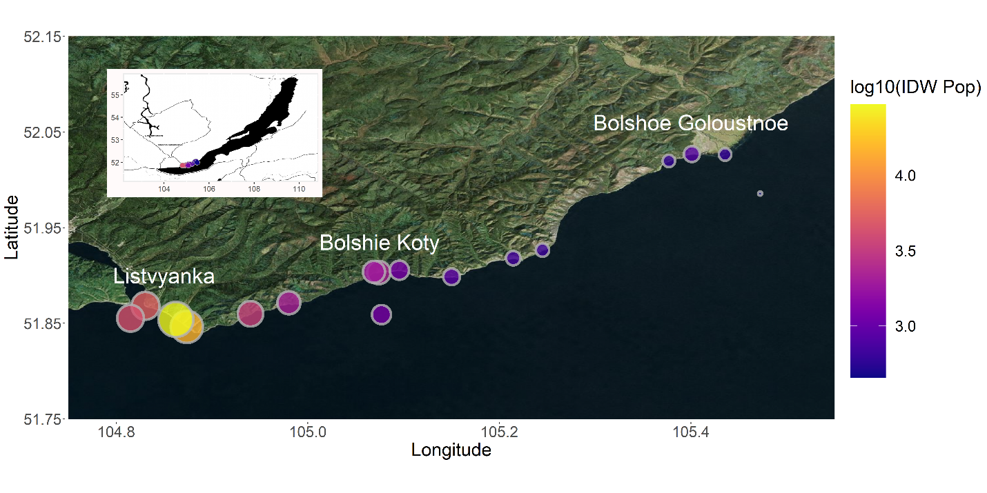

Figure 1: Map of all sampling locations with sites sized and colored by log-transformed IDW population. IDW population was log-transformed so as to make IDW populations across three degrees of magnitude more comparable. The entire transect included three developed sites (i.e., Listvyanka, Bolshie Koty, Bolshoe Goloustnoe). Three offshore samples were also collected to compare pelagic sewage signals to those in the littoral.

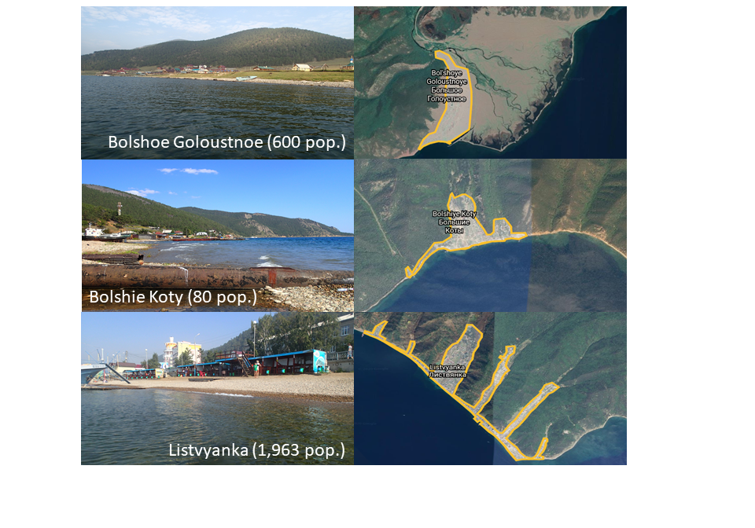

Figure 2: Photographs and Google Earth imagery of each developed area. Photographs were taken by Kara H. Woo and Michael F. Meyer.

|  |  |  |
| --- | --- | --- |
| Table 2: Macroinvertebrate taxonomic groupings for abundance estimates. Amphipod taxa were defined as in Taakhteev & Didorenko, 2015; Mollusc taxa were defined as in Sitnikova, 2012. | | |
| **Amphipoda** | **Mollusca** | **Other** |
| *Brandtia latissima intermida* (Dorogostaiskii 1930) | Acroloxidae | Asellidae |
| *Brandtia latissima lata* (Dybowsky 1874) | Baicaliidae | Caddisflies |
| *Brandtia latissima latior* (Dybowsky 1874) | Benedictidate | Hirudinea |
| *Brandtia latissima latissima* (Gerstfeldt 1858) | Maackia | Planaria |
| *Brandtia parasitica parasitica* (Dybowsky 1874) | Planorbidae |  |
| *Cryptoropus inflatus* (Dybowsky 1874) | Valvatidae |  |
| *Cryptoropus pachytus* (Dybowsky 1874) |  |  |
| *Cryptoropus rugosus* (Dybowsky 1874) |  |  |
| *Eulimnogammarus capreolus* (Dybowsky 1874) |  |  |
| *Eulimnogammarus cruentes* (Dorogostaiskii 1930) |  |  |
| *Eulimnogammarus cyaneus* (Dybowsky 1874) |  |  |
| *Eulimnogammarus grandimanus* (Bazikalova 1945) |  |  |
| *Eulimnogammarus maacki* (Gerstfeldt 1858) |  |  |
| *Eulimnogammarus marituji* (Bazikalova 1945) |  |  |
| *Eulimnogammarus verucossus* (Gerstfeldt 1858) |  |  |
| *Eulimnogammarus viridis viridis* (Dybowsky 1874) |  |  |
| *Eulimnogammarus vittatus* (Dybowsky 1874) |  |  |
| *Pallasea brandtia brandita* (Dybowsky 1874) |  |  |
| *Pallasea brandtii tenera* (Sovinskii 1930) |  |  |
| *Pallasea cancelloides* (Gerstfeldt 1858) |  |  |
| *Pallasea cancellus* (Pallas 1776) |  |  |
| *Pallasea viridis* (Garjajev 1901) |  |  |
| *Poekilogammarus crassimus* (Sovinskii 1915) |  |  |
| *Poekilogammarus ephippiatus* (Dybowsky 1874) |  |  |
| *Poekilogammarus megonychus perpolitus* (Takhteev 2002) |  |  |
| *Poekilogammarus pictus* (Dybowsky 1874) |  |  |

|  |  |  |  |  |  |  |  |  |  |  |  |  |
| --- | --- | --- | --- | --- | --- | --- | --- | --- | --- | --- | --- | --- |
| Table 3: Average sewage indicator concentrations and densities per sampling location | | | | | | | | | | | | |
| Site | NH4+ (mg/L) | NO3- (mg/L) | TP (mg/L) | Caffeine (ng/L) | Acetaminophen  (ng/L) | Paraxanthine  (ng/L) | Cotinine  (ng/L) | Fragment density (MPs/L) | Fiber density (MPs/L) | Bead density (MPs/L) | IDW population | Categorical IDW population |
| BK-1 | 0.003 | 0.085 | 0.054 | 0.011 | 0.001 | 0.002 | 0 | 0 | 0.000833 | 0 | 2304.039 | High |
| BK-2 | 0.003 | 0.085 | 0.052 | 0.007 | 0.001 | 0 | 0 | 0.000952 | 0.000476 | 0 | 1891.558 | Mod |
| BK-3 | 0.068 | 0.09 | 0.045 | 0.003 | 0.001 | 0 | 0 | 0.003095 | 0.00119 | 0 | 1231.234 | Mod |
| BGO-1 | 0.0145 | 0.085 | 0.044 | 0 | 0.002 | 0 | 0 | 0.00119 | 0 | 0 | 838.5385 | Low |
| BGO-2 | 0.001 | 0.08 | 0.0385 | 0 | 0.001 | 0 | 0 | 0.000238 | 0.001905 | 0 | 611.91 | Low |
| BGO-3 | 0.001 | 0.09 | 0.044 | 0.005 | 0.003 | 0 | 0 | 0 | 0 | 0 | 624.455 | Low |
| OS-1 | 0.001 | 0.085 | 0.061 | 0 | 0.001 | 0 | 0.001 | 0.002381 | 0 | 0 | 455.7733 | Low |
| KD-1 | 0.0035 | 0.065 | 0.0375 | 0.003 | 0.001 | 0 | 0 | 0 | 0.000476 | 0 | 662.4151 | Low |
| KD-2 | 0.001 | 0.1 | 0.0445 | 0.001 | 0.001 | 0 | 0 | 0.000714 | 0.001905 | 0 | 720.5484 | Low |
| MS-1 | 0.001 | 0.09 | 0.061 | 0.064 | 0.035 | 0.015 | 0 | 0 | 0.000238 | 0 | 903.6733 | Low |
| SM-1 | 0.001 | 0.085 | 0.1475 | 0.042 | 0.012 | 0.005 | 0 | 0 | 0.001667 | 0 | 2146.218 | Mod |
| LI-1 | 0.004 | 0.08 | 0.0385 | 0.05 | 0.04 | 0.006 | 0.002 | 0.00381 | 0.000238 | 0.000714 | 5403.209 | High |
| LI-2 | 0.091 | 0.095 | 0.0775 | 0.001 | 0.007 | 0 | 0 | 0.001429 | 0.00119 | 0 | 14792.51 | High |
| LI-3 | 0.0035 | 0.08 | 0.077 | 0.027 | 0.002 | 0.002 | 0.003 | 0.000476 | 0 | 0.000714 | 29511.73 | High |
| EM-1 | 0.1125 | 0.185 | 0.092 | 0.029 | 0.014 | 0.002 | 0 | 0 | 0.000238 | 0 | 3389.949 | High |
| OS-2 | 0.001 | 0.08 | 0.078 | 0.033 | 0.001 | 0.004 | 0.003 | 0.000238 | 0.001905 | 0 | 4340 | High |
| OS-3 | 0.001 | 0.08 | 0.0795 | 0.001 | 0.001 | 0 | 0 | 0 | 0.002143 | 0 | 1221.424 | Mod |

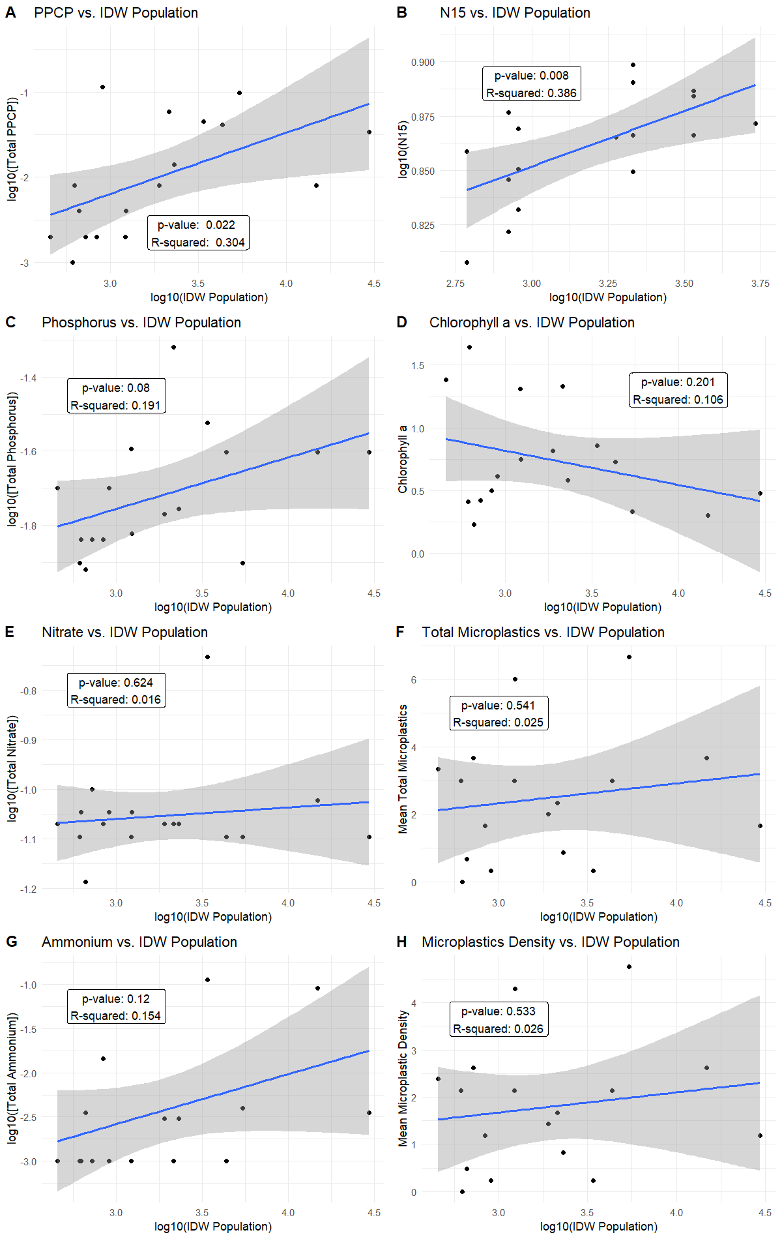

Figure 3: Linear models of total PPCP concentrations (A), δ15N (B), phosphorus (C), Chlorophyll a (D), Nitrate (E), Total Microplastics (F), Ammonium (G), and Microplastic Density (H) regressed against log-transformed IDW population. Total PPCP concentrations (A), δ15N (B), and phosphorus (C) produced significant models. Chlorophyll a (D), Nitrate (E), Total Microplastics (F), Ammonium (G), and Microplastic Density (H) did not produce significant models.

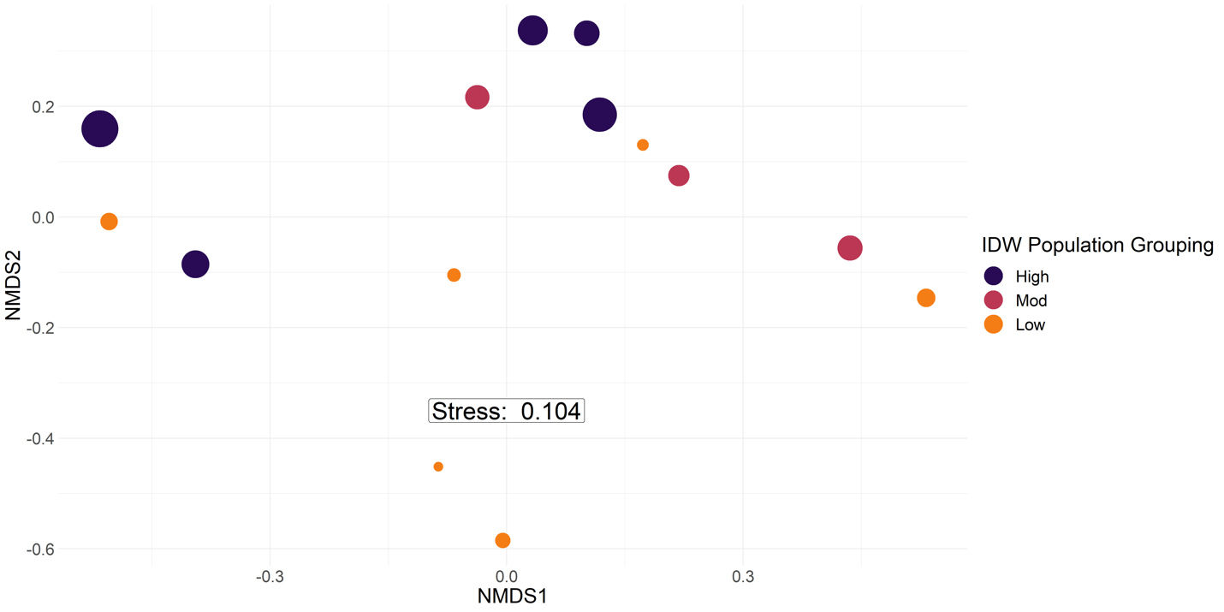

Figure 3: Periphyton abundance NMDS with Bray-Curtis dissimilarity. Labels are sized by log10 IDW population and colored by sites with high (purple), moderate (pink), and low (orange) IDW population values. and separate from sites with IDW population , which PERMANOVA confirmed the three groups to be significantly different (p = 0.023).

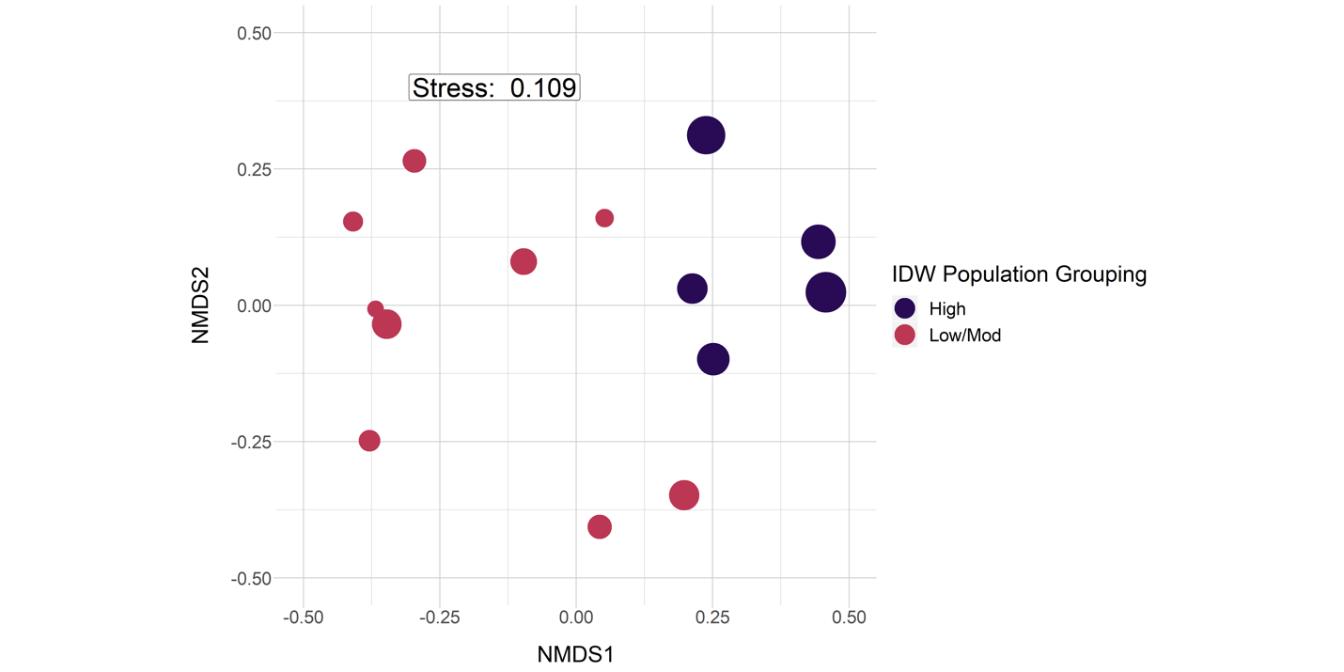

Figure 5: Macroinvertebrate abundance NMDS with Bray-Curtis dissimilarity. Sampling location labels are sized by log-transformed IDW population with major groups including low (orange), moderate (pink), and high (purple) IDW population. PERMANOVA confirmed the three groups to be significantly different (p = 0.002). Sites with a higher IDW population values tended to be associated with amphipod and leech taxa (see Table 2), whereas sites with lesser IDW population values were more associated with increased mollusc abundance (see Table 2).

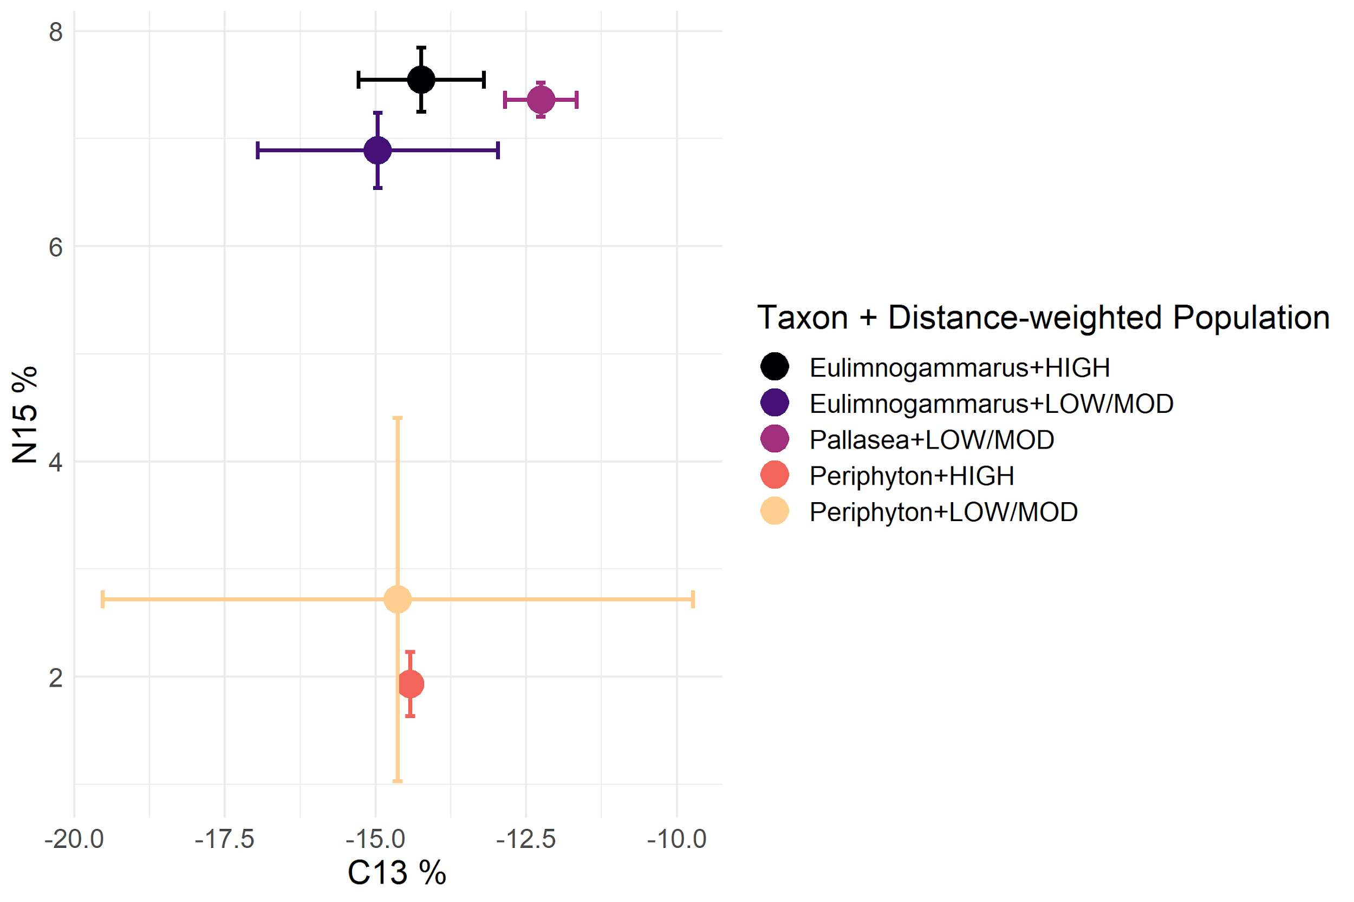

Figure 6: Biplot of mean and standard deviation δ13C and δ15N stable isotope values for littoral amphipods and periphyton, grouped by categorical IDW population (Table 3). In general, periphyton did not differ in δ13C or δ15N signatures with increasing IDW population, whereas *Eulimnogammarus* amphipods increased in δ15N signatures with increasing IDW population. *Pallasea* signatures differed from *Eulimnogammarus* most likely because *Pallasea* tends to remain in the nearshore area, whereas *Eulimnogammarus* will regularly migrate to deeper zones (Taakhteev & Didorenko, 2015).

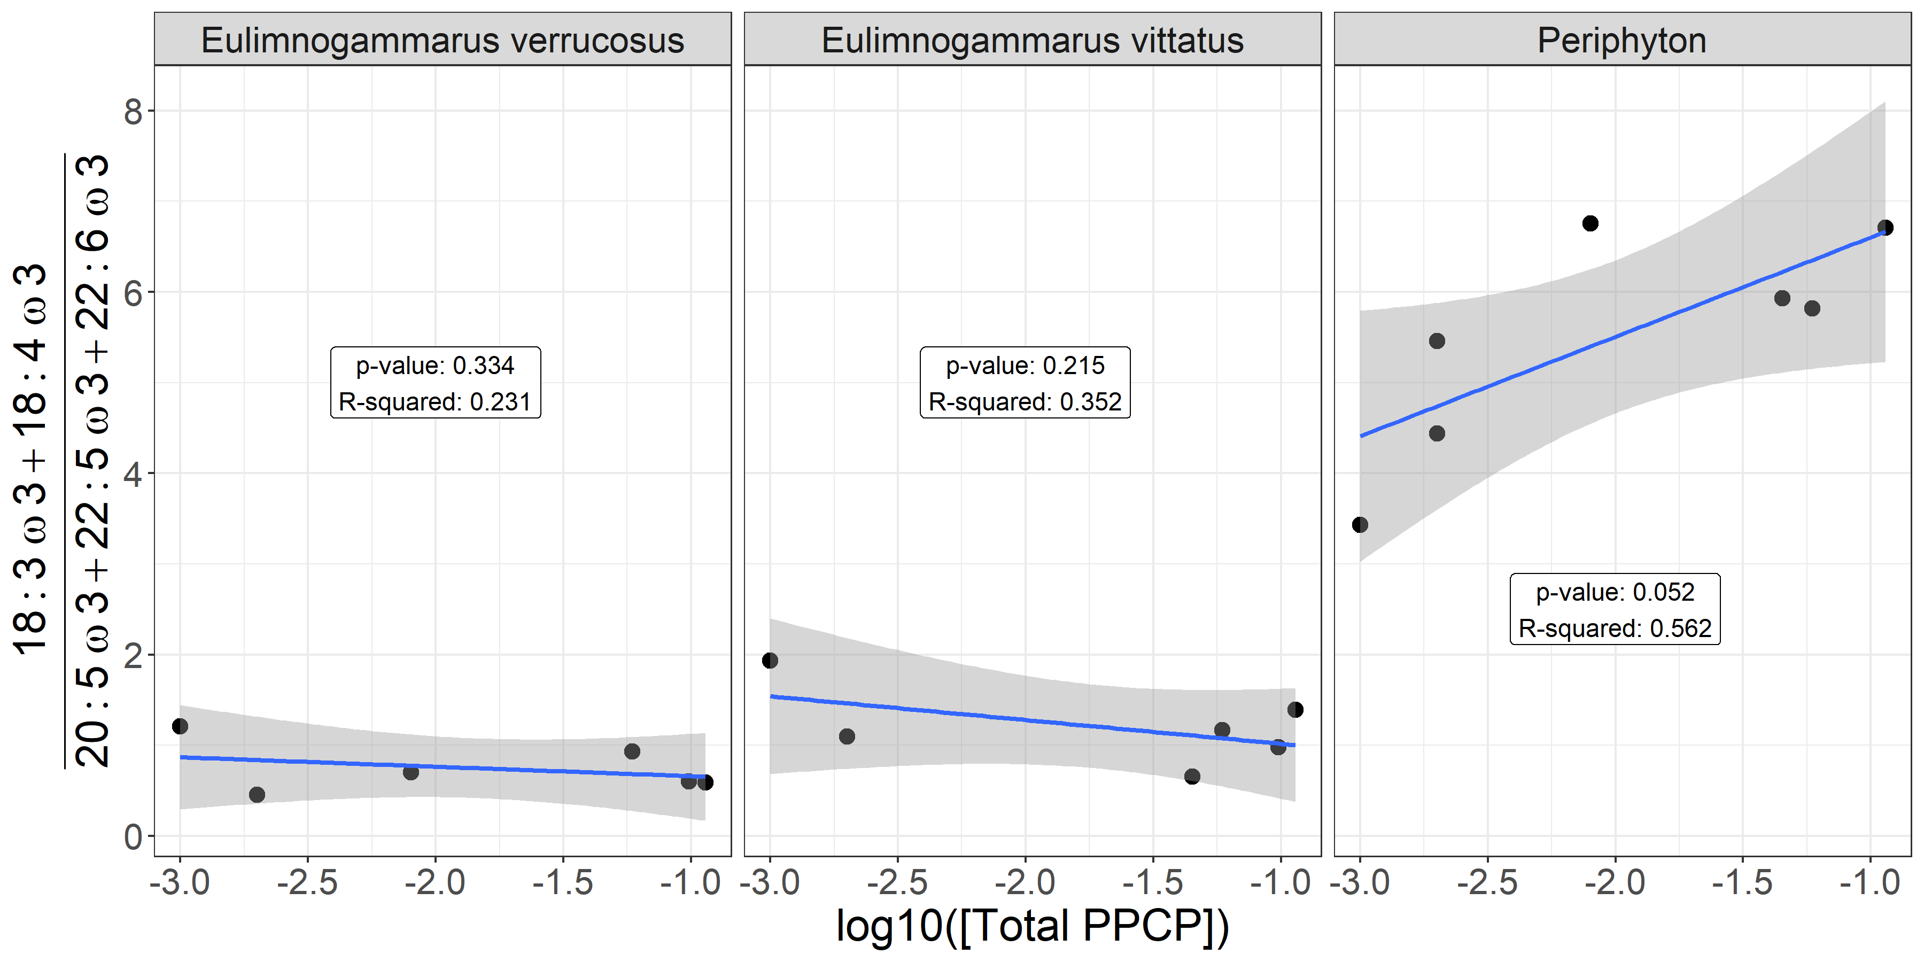

Figure 7: Ratio of 18:3ω3 and 18:4ω3 relative to 20:5ω3 and 20:6ω3 as a function of log -transformed total PPCP concentrations. The fatty acids 18:3ω3, 18:4ω3, 20:5ω3 and 20:6ω3 are all essential fatty acids (EFAs), which are prone to accumulate in organisms and mainly synthesized in primary producers. Because 18:3ω3 and 18:4ω3 are mainly found in filamentous algae whereas 20:5ω3 and 20:6ω3 tend to be associated with diatoms, our ratio also serves as a filamentous:diatom indicator. Periphyton ratios tend to increase with increasing total PPCP concentration, which corroborates our periphyton community abundance results (p = 0.05; Figure 4). Grazing amphipod ratios, however, remain relatively constant over a range of PPCP concentrations.

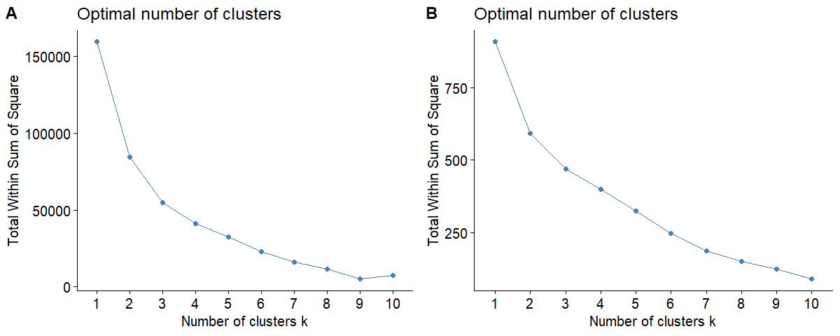

Figure S1: WSS for increasing number of clusters for periphyton (A) and invertebrate (B) community data. In the case of periphyton data, WSS decreases most markedly with three clusters, whereas invertebrate community abundance is best described by two clusters.

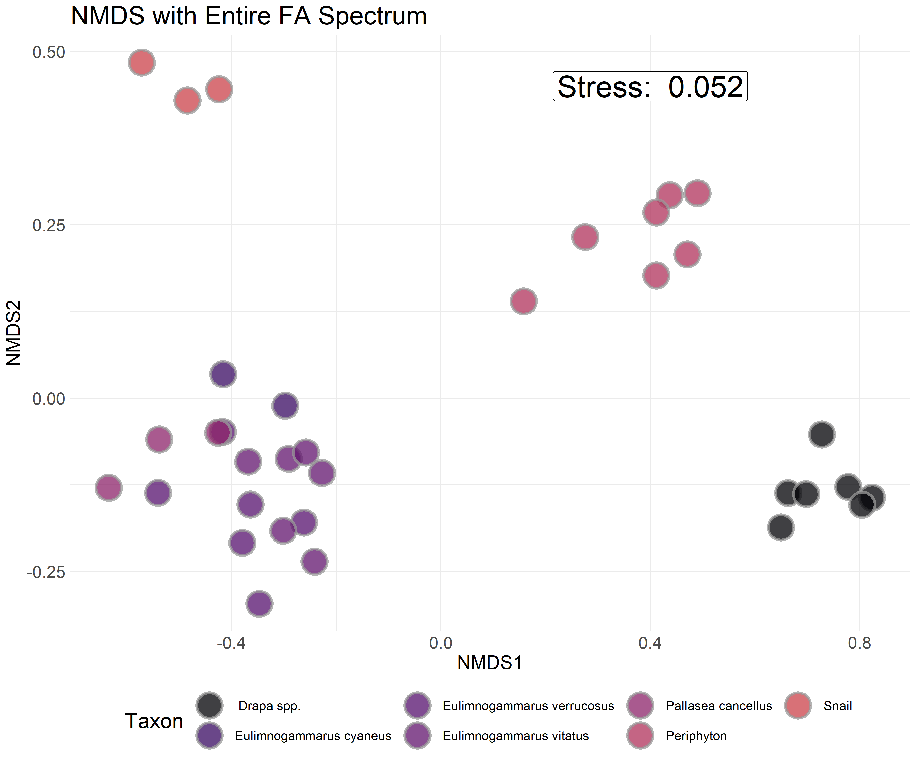

Figure S2: NMDS with Bray-Curtis dissimilarity of proportional fatty acid compositions for each macroinvertebrate and primary producer collected. *Eulimnogammarus* and *Pallasea* are endemic amphipod genera. *Drapa* are endemic filamentous algae that are large and form very dense mats easily collected where it occurs. *Drapa* occurred in large, visible colonies, allowing us to sample and analyze just the *Drapa* fatty acids. Because *Drapa* fatty acids were dominated by 18:3ω3 more so than periphyton, they formed their own cluster. Snails were not identified to species prior to fatty acid analysis. Interspecific variation in fatty acid composition tended to be larger than intraspecific variation, implying that fatty acid signatures were largely species-specific and not environmentally driven.

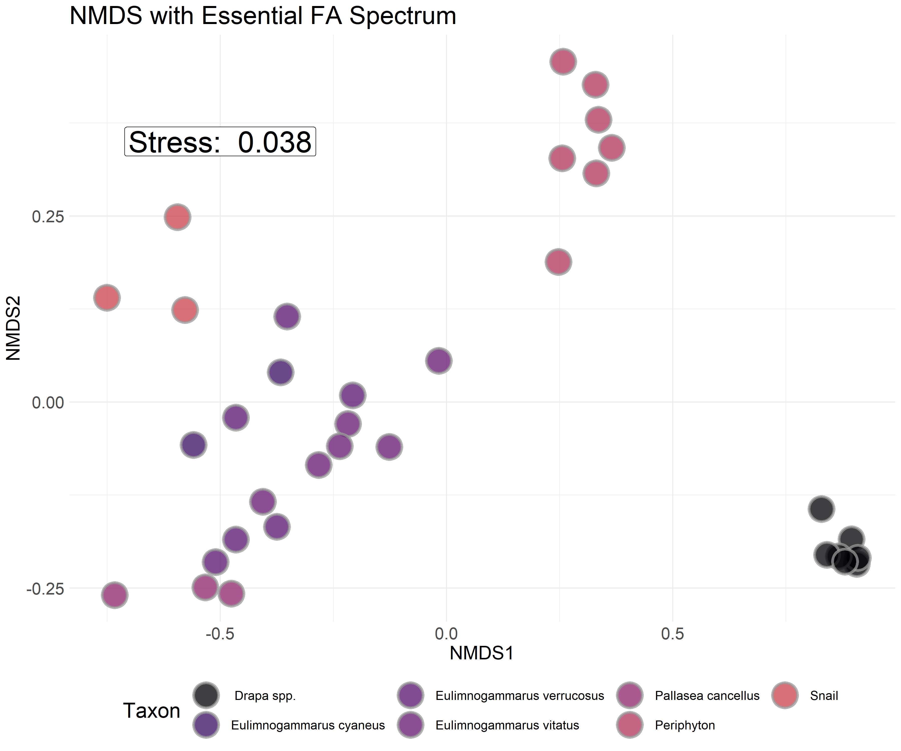

Figure S3: NMDS with Bray-Curtis dissimilarity of proportional biologically essential fatty acid compositions for each macroinvertebrate and primary producer collected. *Eulimnogammarus* and *Pallasea* are endemic amphipod genera. *Drapa* are endemic filamentous algae that are large and form very dense mats easily collected where it occurs. *Drapa* occurred in large, visible colonies, allowing us to sample and analyze just the *Drapa* fatty acids. Because *Drapa* fatty acids were dominated by 18:3ω3 more so than periphyton, they formed their own cluster. Snails were not identified to species prior to fatty acid analysis. Interspecific variation in fatty acid composition tended to be larger than intraspecific variation, implying that fatty acid signatures were largely species-specific and not environmentally driven.