FOOD WEB IMPLICATIONS OF SPATIO-TEMPORALLY HETEROGENEOUS LAKESIDE

HUMAN DISTURBANCE ON NEARSHORE PERIPHYTON COMMUNITIES

IN FLATHEAD LAKE (MONTANA, UNITED STATES)

Michael F. Meyer1*

Shawn P. Devlin2

Aaron W.E. Galloway3

Julie B. Schram3

Bradley T. Luff1

Matthew R. Brousil4

Stephanie E. Hampton4

1School of the Environment, Washington State University, Pullman WA USA

2Flathead Lake Biological Station, University of Montana, Polson MT USA

3Oregon Institute of Marine Biology, University of Oregon, Charleston OR USA

4Center for Environmental Research, Education, & Outreach, Washington State University, Pullman WA USA

**Keywords**: PPCPs, fatty acids, stoichiometry, chlorophyte, cyanobacteria

**Abstract (236 of 250 words)**

Nutrients from lakeside developments can reshape aquatic ecosystems. Algal communities, especially in oligotrophic lakes, can rapidly remove nutrients from the water column, causing increased biomass and altered resources for grazers. However, associating times and locations of nutrient loading with biological responses can be complicated, as spatio-temporal heterogeneities in nutrient loading and biological succession can obfuscate patterns. To evaluate how variation in nutrient addition may be associated with algal succession and nutritional quality, we sampled 15 littoral sites in Flathead Lake (Montana U.S.) from June through September 2017, when tourism dynamics may create variation in nutrient influx. As indicators of anthropogenic nutrient additions, pharmaceutical and personal care product (PPCPs) concentrations were measured fortnightly. Periphyton community composition, stoichiometry, and fatty acids were assessed monthly. PPCPs, including caffeine, nicotine, and warfarin, were detected, and PPCP concentrations as well as periphyton-associated branched- and odd-chain fatty acid abundance varied with seasonal tourist activity. Locations near centralized treatment had significantly lower periphyton C:N ratios, suggesting altered nutrition available to grazers. Further, results suggested that locations near decentralized treatment had more temporally transient periphyton community composition and nutrition, trending toward increased relative cyanobacteria as well as 20-carbon polyunsaturated fatty acids over time although these changes were not statistically significant. Overall, our results suggest that sewage treatment techniques and seasonal human activity can create hot spots and hot moments for nutrient addition, thereby reshaping algal community compositions and available nutrition to the food web.

**Introduction**

Pollutants in wastewater released from lakeside developments are a common human disturbance that can alter biological communities and reshape food webs. In particular, nutrients, such as nitrogen and phosphorus, in treated and untreated wastewater can increase biomass and eventually lead to system-wide changes in algal community composition and production (Edmondson 1970) with potential consequences for higher trophic levels (Edmondson 1994; Hampton et al. 2006; Galloway and Winder 2015). Although nutrients in sewage have been shown to alter aquatic ecosystems, explicitly linking increased nutrient concentrations and biological responses to sewage can be challenging, as nutrients can originate from disparate anthropogenic and natural environmental sources. For example, agriculture (Powers et al. 2016), melting permafrost (Turetsky et al. 2000), wildfires (Gould et al. 2016), and changing terrestrial plant communities (Goldman 1961; Moran et al. 2012) can all contribute nutrients to aquatic systems, potentially obfuscating sewage signals. In addition, biological processes can further confound sewage signals. Benthic primary producers, especially those in oligotrophic systems (Rosenberger et al. 2008; Hampton et al. 2011; Oleksy et al. 2020; Atkins et al. 2021), can remove nutrients quickly from the water column (e.g., hours; Hadwen and Bunn 2005), such that deviations in nutrient concentrations may not be detectable in water samples.

Because nutrients come from numerous non-sewage sources, indicators consistently associated with wastewater pollution, such as pharmaceuticals and personal care products (PPCPs) (Rosi-Marshall and Royer 2012; Meyer et al. 2019) as well as bacterial biomarkers (Seguel et al. 2001) have garnered attention for their usefulness as sewage indicators. PPCPs, such as caffeine, acetaminophen, and sulfamethoxazole, have been used to identify spatially and temporally heterogeneous sewage pollution in surface (Bendz et al. 2005) and subsurface (Yang et al. 2016) aquatic systems. Because biota seem not to actively uptake most PPCPs (Bai and Acharya 2017), their concentrations within the water column tend to be directly proportionate to increasing human population and inversely proportionate with distance from population centers (Meyer et al.; Bendz et al. 2005). Microbial and bacterial biomarkers, such as branched- and odd-chain fatty acids, also can be useful for defining areas and times of sewage loading (Seguel et al. 2001). In contrast to PPCPs, bacteria-associated fatty acids can be less specific sewage indicators, as bacteria can originate from numerous non-sewage sources. Thus, tracking the changes in relative bacterial abundance (vs. simply total bacterial abundance) can be a more reliable indicator of spatial and temporal patterns in sewage loading for both freshwater (Templar et al. 2016; Booncharoen et al. 2018) and marine systems (Abaya et al. 2018; Booncharoen et al. 2018). Together, the combined use of PPCP and bacterial biomarker measurements may provide more robust, multi-proxy information to infer the spatial extent and timing of sewage pollution into an ecosystem.

The effects of wastewater pollution are often first observed among littoral benthic communities, where increased nutrients, especially in oligotrophic systems, can alter algal community succession through increased chlorophyte abundance relative to diatoms and cyanobacteria (Meyer et al.; Rosenberger et al. 2008; Hampton et al. 2011; Timoshkin et al. 2016; Bondarenko et al. 2021; Atkins et al. 2021). Similar to patterns observed with phytoplankton succession (Sommer et al. 1986, 2012), benthic algal communities follow consistent successional patterns over the course of a growing season. In particular, bacterial and diatom taxa tend to first colonize substrates by producing extracellular, carbon-rich, mucous matrices for adhering to substrate (Hoagland et al., 1982). As temperatures increase and nutrients, such as silica, nitrogen, and phosphorus, become limiting, benthic algal communities typically increase in chlorophyte abundance over the course of a growing season and then eventually decrease in chlorophyte abundance relative to diatoms and cyanobacteria (Hoagland et al. 1982; McCormick and Stevenson 1991; Stevenson et al. 1996; Azim et al. 2005). Transitions between algal groups occur when access to light, space, and nutrients become limiting for many taxa, with taxa in the canopy of the biofilm representing the most photosynthetically active and nutrient-rich members (Aloi et al. 1988). In the case of sustained wastewater inputs, consistent and elevated nutrient influxes can allow for benthic chlorophyte taxa to remain dominant within the community (Timoshkin et al. 2016, 2018; Volkova et al. 2018), potentially due to increased chlorophyte abundance as well as increased temperatures being associated with higher nutrient uptake efficiency (Oleksy et al. 2021). In the case of intermittent wastewater inputs, inconsistent nutrient addition can allow for chlorophyte taxa to episodically increase in relative abundance in response to temporally punctuated nutrient inputs, but then become displaced as smaller diatoms and cyanobacteria outcompete chlorophytes for resources (McCormick and Stevenson 1991; Marks and Lowe 1993; Stevenson et al. 1996). These two disturbance regimes where temporal nutrient additions are either consistent or transient, therefore, present two similar yet diverging scenarios, where sustained nutrient addition can allow chlorophytes to remain consistently abundant and hinder cyanobacteria from establishing towards the end of the growing season.

By driving community compositional shifts, nutrients from wastewater can also influence nutritional quality of the periphyton, with consequences for higher trophic levels. Key elements of algal nutritional quality include fatty acid composition (Iverson et al. 2004; Kelly and Scheibling 2012) and C:N:P stoichiometric ratios (Elser et al. 2000), based on fundamental metabolic needs of the algal cells themselves as well as aquatic grazers. Fatty acids reflect changing nutritional content as a function of altered community composition, where chlorophyte, cyanobacteria, and diatoms each contain taxon-specific multivariate fatty acid signatures (Kelly and Scheibling 2012; Taipale et al. 2013; Galloway and Winder 2015). In particular, the essential fatty acids (EFAs) are where these groups diverge the most, with diatoms associated with 20:5ω3, chlorophytes associated with 18:3ω3 and 18:2ω6, and cyanobacteria usually containing negligible EFAs (Taipale et al. 2013; Galloway and Winder 2015). Similarly, stoichiometric C:N:P ratios can also define nutritional content within periphyton for higher trophic levels (Kahlert et al. 2002; Fink et al. 2006), where lower C:N:P ratios indicate increased nutrition via increased nitrogen and phosphorus content. Unlike fatty acids, stoichiometric analysis does not allow inference of community taxonomic composition. Rather, algal stoichiometric ratios can be plastic (Thrane et al. 2017) and significantly influenced by environmental conditions such as light and nutrient availability (Frost and Elser 2002). Even so, these ratios may be modified by taxon-specific traits. Taxa that are associated with high nutrient uptake, such as chlorophytes, can decrease a community’s overall C:N:P ratios (Frost and Elser 2002) and potentially increase food quality for grazers. In the context of sewage-associated nutrient pollution, both periphyton stoichiometric ratios and fatty acid profiles can be useful for inferring taxonomic and environmental aspects of algal nutritional content. Thus, sewage loading that drives successional shifts from diatom-dominated to chlorophyte-dominated communities may be expected to decrease 20-Carbon EFAs and increase less nutritious 18-Carbon EFAs; simultaneously, these communities may become more nutritious (i.e. decreased C:N and C:P ratios) from a stoichiometric perspective, as communities with more chlorophytes exhibit higher nutrient uptake rates (Nydick et al. 2004; Oleksy et al. 2021).

To investigate how sewage-associated nutrient addition can alter nearshore periphyton community composition, and thus standing nutritional resources for higher level consumers, we surveyed 15 littoral locations in Flathead Lake (Montana, United States) throughout the tourism season for indicators of sewage pollution and metrics of periphyton community abundance and nutritional content. Flathead Lake is a large, deep, oligotrophic lake in western Montana (Young 1935; Ellis et al. 2011). With Glacier National Park covering approximately one third of the lake’s watershed, Flathead Lake’s catchment is largely unpopulated, despite gradual increases in permanent and seasonal human population throughout the previous century (Stanford et al. 1994a). Within Flathead Lake’s watershed, areas with intensive development have shown distinct signs of sewage pollution, evidenced by pharmaceutical and personal care product (PPCPs) and volatile organic compounds detected in subsurface waters although not yet in the lake (Tappenbeck and Ellis 2010, 2011). As locations with dense human population are generally located away from the lake, (e.g., > 20 km), Flathead’s pelagic is broadly oligotrophic, likely due to the lake’s exceptionally low hydraulic residence time (~3 years; Stanford et al. 1983) relative to its size (Messager et al. 2016). While the human population in Flathead Lake’s watershed is low, the littoral areas with adjacent lakeside development have been suspected of localized sewage pollution (Stanford et al. 1994a), evidenced by sustained increases in periphyton biomass since the 1980s. In particular, littoral sites without adjacent centralized wastewater treatment infrastructure (e.g., sewage treatment plants) have demonstrated signs of nonpoint nutrient addition, which could be contributed from decentralized forms of wastewater management, such as improperly functioning septic systems (Stanford et al. 1994a; Makepeace and Mladenich 1996; Moore et al. 2003; Withers et al. 2014). These same lakeside developments also experience large tourism activity throughout the summer, where a reliance on decentralized sewage treatment could create moments of increased nutrient loading during the tourism season followed by reduced sewage loading after the tourism season. Similarly, littoral areas near locations with centralized sewage treatment also experience increased tourism during the summer, but as these areas tend to have larger, less transient human populations, these adjacent nearshore locations also likely experience consistent but elevated wastewater-associated nutrient loading relative to nearshore communities with adjacent decentralized infrastructure.

Given prior evidence that Flathead’s periphyton communities may be responding to external nutrient loading, our goal was to understand how spatially and temporally heterogeneous nutrient addition from seasonal tourism may alter algal community composition and, thus, the available nutrition to the food web. This goal can be divided into three specific objectives:

1. identify areas and periods of wastewater-associated nutrient loading using sewage-specific indicators,
2. assess the relationship between sewage-specific indicators and periphyton community composition
3. evaluate how periphyton community compositional shifts may correspond with altered nutritional quality.

We hypothesized that human sewage pollution is altering periphyton community composition and creating heterogeneity around the perimeter of Flathead Lake. We predicted that (1) sewage-specific indicators, such as PPCP concentration as well as branched- and odd-chain fatty acids characteristic of bacteria, would increase near areas with increased population density and proximity to lakeside development as well as during periods of increased human activity; (2) an elevated sewage signal would correspond with increased abundance of benthic chlorophyte algae; (3) increased chlorophyte abundance should be associated with increased stoichiometric nutrition but decreased essential fatty acid nutrition of the periphyton community; and (4) sites with consistent sewage indicators (i.e., those near centralized wastewater treatment) would correspond with less temporal fluctuation in periphyton community composition and nutritional content relative to sites with temporally fluctuating sewage indicators (i.e., sites near decentralized wastewater treatment systems).

**Methods**

*Site Description*

Most of Flathead Lake’s 260-km shoreline contains some degree of lakeside development, but the vast majority of Flathead’s basin is unpopulated and roadless (Stanford et al. 1994a; Makepeace and Mladenich 1996). Located approximately 23 km from the lake, the city of Kalispell is the largest human population center within the basin with approximately 23,000 residents (U.S. Census, 2019). The Flathead River runs through Kalispell and is the main surface input to Flathead Lake. The Flathead River is Flathead Lake’s only surface outlet, where the river flows into Flathead Lake in the northeast region near the town of Bigfork with approximately 4,700 residents and exits in the southwest near the town of Polson with approximately 4,900 residents (U.S. Census, 2019). The Swan River is the second largest surface input into Flathead Lake. Unlike the Flathead River, the Swan River originates within Glacier National Park and does not run through large population centers. Both the Flathead and Swan Rivers contribute phosphorus loadings into Flathead Lake, but these loadings are particularly concentrated in mid-to-late May, when the snowmelt freshet leads to a spike of inorganic phosphorus (Stanford et al. 1983). Snowmelt is also responsible for raising lake levels to their annual peaks. With two dams on the lower Flathead River, the lake’s only outflow, lake levels remain high throughout the summer and autumn, and then decrease in late winter (Stanford et al. 1983). The spring freshet is also responsible for generating lateral currents in Flathead Lake, where incoming flows from the northeast generally travel along the lake’s western shoreline and to the southern basin (Stanford et al. 1983). A strong Coriolis effect likewise aids in circulating the northern basin in a counterclockwise direction, whereas the southern basin circulates in a clockwise pattern (Stanford et al. 1983).

While larger human population centers are concentrated away from Flathead’s shoreline, there are several small lakeside population centers that host annual summertime tourists. Each of these main tourist towns have different permanent population sizes and infrastructures for handling human population fluctuations, ranging from centralized wastewater treatment plants with subsequent tertiary treatment to septic systems. Previous studies have noted increased nutrient concentrations and periphyton abundance near these lakeside developments with decentralized wastewater treatment (Stanford et al. 1994a) and implicated sewage-associated nutrient loading as the source (Makepeace and Mladenich 1996). The lakeside town of Bigfork (HO, WF; Figure 1) as well as the Flathead Lake Biological Station (FLBS, YB) on the eastern shore rely on centralized forms of wastewater treatment, whereas the remaining sampling locations with adjacent development rely on septic treatment. The sampling site at Ducharme (DU) has no adjacent lakeside development but was included because of its proximity to other developments within the southern basin (Figure 1). To expand on these previous works by specifically identifying sewage-associated nutrient loading and tracking co-located periphyton responses, our study focused on 15 littoral sampling locations throughout the lake from the middle of June through late September 2017. All sampling sites were chosen to represent a range of lakeside development sizes - spanning from sites with centralized sewage treatment and housing for permanent residents to seasonally occupied developments with septic systems. Many sampling locations were located within Montana State Parks, which ensured consistent access to sampling locations throughout the course of a summer. To evaluate potential sewage contributions from Kalispell, one sampling site was located in the Flathead River, upstream of the town of Bigfork. Sampling occurred at a depth of approximately 0.75-1.25 m, depending on wave activity and periphyton accessibility, such that sampling locations ranged 0.5-8.0 m from shore. During each sampling event, we recorded air and surface water temperature with an alcohol thermometer, qualitative wave intensity (e.g., mild, moderate, strong waves), and whether or not tourists were present at time of sampling.

**Temporally-Scaled Inverse Distance Weighted (TSIDW) Population Calculation**

We recognized that sewage indicator presence was likely spatially related to the human population density of and distance from lakeside developments, as well as temporally related with the tourism season. Therefore, we created a metric that would represent both the human population density at a given sampling site as well as how that population might vary throughout a summer. Additionally, Makepeace and Mladenich (1996) suggested that anthropogenic nutrient loading into Flathead Lake was driven by subsurface flows, meaning that the length of development’s shoreline (or the size of a development's interface with the lake) was likely directly proportionate to the amount of wastewater that could enter the lake. Building on techniques described in Meyer et al (Under Revision, Chapter 2) and concepts expressed in Bendz et al (2005), we created a temporally-scaled inverse distance weighted (TSIDW) population metric, which considers that sewage indicator levels are likely directly related to population density, a lakeside development’s shoreline length, and level of tourism as well as inversely related to a sampling location’s distance from lakeside developments.

The TSIDW population metric is meant to capture both spatial and temporal variation of human activity at each sampling location. The formulation of TSIDW population can be broken into two main components: (1) the static inverse distance weighted (IDW) population and (2) a temporal scalar of how much the lakeside human population changes through time. First, the static IDW population can be calculated in five main steps (Meyer et al, Under Revision, Chapter 2). Municipality boundary and shoreline geometries were drawn using Google Earth and census delineations for five main lakeside municipalities. Shapefiles were then exported from Google Earth as a .kml file, and then imported into the R Statistical Environment (R Core Team 2019), in which shoreline length as well as municipality area and centroid were calculated using the sf package (Pebesma 2018). Static IDW population was then calculated by summing the distance-weighted, shoreline length-scaled population density to each sampling location relative to each of the five lakeside municipalities. Second, the static IDW population was scaled by the average monthly temporal change in human population. In this case, State Park visitation records were used to track changes in the human population relative to pre-tourism visitation levels. To track how the lakeside human population may change spatially and temporally, we collected data on visitor passes issued at each of the five State Parks around the lake (Figure 1). These data aggregated both day-visitor as well as overnight-visitor passes purchased within a month, thereby representing the total number of visitors to each of the five lakeside Parks. To estimate a deviation in human population due to tourism, we normalized each Park’s monthly visitors by the number of visitors to the same Park in May, and as such this calculation assumes that the number of visitors in May is characteristic of the pre-tourism season. Because each State Park was not necessarily located within or adjacent to the five main lakeside developments, we weighted temporal scalars by the distance of a given sampling location from the centroid of each State Park. Lastly, we averaged monthly temporal scalars across Parks. Averaging the temporal scalars in a given month helped us account for populations that may not be visiting a local Park or correct for populations may have been dispersed when one of the Parks (FI; Figure 1) was closed near the end of the tourism season. TSIDW population (I) is expressed by equation 1:

where the left summation is the temporal scalar formulation and the right summation is the spatial IDW population formulation. The equation represents the TSIDW population *I* at site *i* in month *m*. The IDW formulation considers the population size *P*, area *A*, and shoreline length *L* at development site *j* and weights the shoreline population by the distance from *i* to *j*. The temporal scalar formulation considers the number of visitor passes sold *n* in a month *m* at Park *q* relative to the number of passes sold in May at Park *q* and weights this ratio by the distance of sampling site *i* from Park *q*. When multiplied, the TSIDW population is meant to capture the temporal change and spatial position of human population around the lake’s perimeter, where sites with large populations but low tourism retain a high TSIDW population throughout the summer whereas sites with a smaller static population that experiences waves of tourism increase in TSIDW population at the beginning of the tourism season and then decrease in TSIDW population at the end of the tourism season.

**Pharmaceuticals and Personal Care Products (PPCPs)**

Water column Pharmaceutical and Personal Care Product (PPCP) samples were collected in duplicate fortnightly at a depth of approximately 0.5 m at each sampling location. Samples were collected in 1-L amber glass bottles that had been rinsed with lake water prior to collection. Samples were kept on ice and out of direct sunlight in a cooler while in the field and then placed in a refrigerator at ~4℃ upon return to the lab. While in the field, personnel collecting samples refrained from caffeine, nicotine, and other non-prescription PPCPs on the days of sample collection to avoid potential contamination.

Within 96 h of collection, samples underwent a solid phase extraction (SPE). Samples were filtered directly from the amber glass bottle using an in-line Teflon filter holder with glass microfiber GMF (1.0 µm pore size, WhatmanGrad 934-AH) in tandem with a solid phase extraction (SPE) cartridge (200 mg HLB, Waters Corporation, Milford, MA) connected to a 4-liter vacuum flask. Lab personnel wore gloves and face masks when handling samples in the lab to minimize potential for contamination. Prior to filtration, SPE cartridges were primed with at least 5 mL of either methanol or acetone and then washed with at least 5 mL of sample water. Rate of extraction was maintained at approximately 1 drop per second. Extraction proceeded until water could no longer pass through the SPE cartridge or until all collected water was filtered. Cartridges were stored in Whirlpacks at -20°C until analysis for 11 PPCP residues using high performance liquid chromatography tandem mass spectrometry (HPLC-MS) following methods of Furlong et al. (2008), Lee et al. (2016), and D’Alessio et al (2018). PPCP residues included cotinine, acetaminophen/paracetamol, 1,7-dimethylxanthine/paraxanthine, caffeine, codeine, trimethoprim, thiabendazole, sulfamethoxazole, diphenhydramine, carbamazepine, and warfarin. These specific PPCPs were chosen due to their historical frequency of occurrence within the PPCP literature (Meyer et al., 2019) and their capacity to be measured within one water sample, allowing more samples to be processed with a constrained range of PPCP compounds. During the mass spectrometry sample processing, blank samples with methanol as well as a 20 µg/L standard were processed after every tenth sample. This step was added as a quality assurance protocol to flag instances of and correct for cross-sample contamination as well as peak drift when running samples over multiple hours. Regardless of detection thresholds, we manually integrated all PPCP peaks observed in the chromatogram and corrected for cross-sample contamination in post-processing. Samples were processed at the Water Environmental Research Laboratory at Washington State University.

**Nutrients**

Water column nutrient samples were collected at all 15 sampling locations during the August and September PPCP sample collection that occurred with periphyton sample collection (i.e., second fortnightly PPCP sampling campaign within a month). Samples were collected in 0.5-L plastic Nalgene bottles that had been rinsed with lake water prior to collection. Samples were kept on ice and out of direct sunlight in a cooler while in the field and then placed in a refrigerator at ~4°C upon return to the lab. Prior to freezing, samples intended for phosphorus analysis were transferred directly to a clear 60-mL HDPE Nalgene bottle. Samples intended for nitrate/nitrite analysis were first filtered through a 0.45 µm nitrocellulose filter to remove intracellular nitrogenous species. Samples were processed using a spectrophotometer. Detection limits were estimated to be 1.5 µg/L-N for nitrogen samples and 0.8 µg/L-P for phosphorus samples. When concentrations were estimated as below detection limits, we replaced values with a random number between 0 and half of the respective minimal detection limit.

**Periphyton Sample Collection**

Periphyton samples were collected at 13 of the 15 sampling locations approximately every four weeks (i.e., second fortnightly sampling campaign within a month). Two sampling locations (Holt and Ducharme) were largely characterized by clay and silt sediments, making standardized, systematic periphyton collection difficult. The remaining 13 locations were comparable with respect to the substrate, which could be characterized as a mix of large, oblate rocks and gravel. As such, we do not include data from HO and DU in our analysis.

At each of the periphyton sampling locations, nine rocks were haphazardly collected and placed into plastic, Ziplock bags within the field. Within 18 h of collection, a plastic stencil was used to define a surface area of each rock from which we scraped a standardized 1.61 cm2 patch of periphyton with a firm bristled toothbrush. Individual samples from three rocks were transferred to 50 mL plastic falcon tubes for abundance estimates. Glutaraldehyde (0.2% final volume) was added to each falcon tube as a preservative. Individual samples from four other rocks were transferred to GF/Fs for ash free dry mass estimates. Following standardized area scrapes, all remaining periphyton on each of the nine rocks was scraped from the rock and into an aluminum tray. The composite periphyton mixture for a given site and sampling time was then placed into 50 mL plastic falcon tubes, which were centrifuged at ~750 rpm for 20 minutes to concentrate periphyton at the bottom of the tube. Using a 5-mL transfer pipette, visibly compacted periphyton and sediment were removed from falcon tubes and transferred to 1.5-mL Eppendorf tubes until a maximum of 10 Eppendorf tubes were filled with periphyton and sediment. These composite periphyton samples were then placed in a -80℃ freezer until processing for stoichiometry and fatty acids. Periphyton abundance samples collected in June degraded during preservation and were not counted to prevent spurious results. Periphyton abundance during June was also too low to secure enough biomass for reliable stoichiometric and fatty acid analysis, meaning that periphyton stoichiometric and fatty acids data only reflect samples collected in July, August, and September.

**Benthic Algal Abundance**

Periphyton taxonomic identification and enumeration was performed by subsampling 30-μL aliquots from each preserved sample using a compound light microscope. For all 30-μL aliquots, cells and filaments were counted, for the entire subsample, until at least 300 cells were identified for a given sampling replicate. If the first aliquot contained fewer than 300 cells, we counted additional subsamples until we reached at least 300 cells in total. In instances when 300 cells were counted before finishing a subsample, we still counted the entire aliquot. Taxa were classified into broad categories consistent with periphyton algal taxonomy (Biggs and Kilroy 2000), using coarse groupings to capture general patterns in relative algal abundance. As a result, algal groups consisted of diatoms, chlorophytes, cryptophytes, chrysophytes, and cyanobacteria. For consistency, all samples were processed by one person (MFM) to reduce cross-observer error.

**Ash Free Dry Mass**

GF/Fs were removed from whirlpacks, placed on aluminum foil, and transferred to a drying oven at ~96°C overnight. Samples were then relocated to a desiccator for at least 24 h. After samples were dry, samples were weighed to the nearest 0.0001 g, and then placed in a muffle furnace at 550°C for ~1.5 h. After cooling for ~30 minutes, samples were massed again, and pre- and post-ignition were differenced. Samples were processed at the Water Environmental Research Laboratory at Washington State University.

**Periphyton Stoichiometry**

Two 1.5-mL Eppendorf tubes of concentrated periphyton for each sampling location and time were transferred to a foil pan and allowed to thaw and dry in a drying oven at 60°C overnight. Samples were then homogenized and placed in a desiccator for at least one hour prior to weighing.

Two subsamples of completely dried periphyton were transferred to two glass scintillation vials and covered with foil. Particulate carbon and nitrogen measurements could be processed together and required at least 50 mg of tissue, whereas particulate phosphorus required a separate instrument and no more than 5 mg of tissue for analysis. Frozen samples were thawed at 102-105°C in a drying oven for at least 24 h. Particulate carbon and nitrogen were estimated using a Leco CN628 analyzer. Particulate phosphorus was estimated using an Astoria Pacific, A2 segmented flow analyzer with an Astoria Pacific models 311 XYZ autosampler. The method detection limits were estimated to be 2 μg/L-P. Samples were processed at the Freshwater Research Laboratory at Flathead Lake Biological Station.

**Periphyton Fatty Acid Analysis**

All collected periphyton samples in 1.5-mL Eppendorf tubes that were not used for stoichiometric assessment were allocated to fatty acid analysis. Samples were allowed to freeze-dry overnight. Following freeze-drying, samples were transferred to 10 mL glass centrifuge vials, and 2 mL of 100% chloroform was added to each under nitrogen gas. Samples remained in chloroform overnight at -80°C. Fatty acid extractions generally involved three phases: (1) 100% chloroform extraction, (2) chloroform-methanol extraction, and (3) fatty acid methylation. Fatty acid extraction methods were adapted from Schram et al. (2018).

After overnight chloroform extraction, samples underwent a chloroform-methanol extraction three times. To each sample, we added 1 mL cooled 100% methanol, 1 mL chloroform:methanol solution (2:1), and 0.8 mL 0.9% NaCl solution. Samples were inverted three times and sonicated on ice for 10 minutes. Next, samples were vortexed for 1 minute, and centrifuged for 5 minutes (3,000 rpm) at 4°C. Using a double pipette technique, the lower organic layer was removed and kept under nitrogen. After the third extraction, samples were evaporated under nitrogen flow, and resuspended in 1.5 mL chloroform and stored at -20°C overnight.

Once resuspended in chloroform, 1 mL of chloroform extract was transferred to a glass centrifuge tube with a glass syringe as well as an internal standard of 4 μL of 19-carbon fatty acid. Samples were then evaporated under nitrogen, and then 1 mL of toluene and 2 mL of 1% sulfuric acid-methanol was added. The vial was closed under nitrogen gas and then incubated in a 50°C water bath for 16 hours. After incubation, samples were removed from the bath, allowed to reach room temperature and stored on ice. Next, we performed a potassium carbonate-hexane extraction twice. To each sample, we added 2 mL of 2% potassium bicarbonate and 5 mL of 100% hexane, inverting the capped vial to mix the solution. Samples were centrifuged for 3 minutes (1,500 rpm) at 4°C. The upper hexane layer was then removed and placed in a vial to evaporate under nitrogen flow. Once almost evaporated, 1 mL of 100% hexane was added and stored in a glass amber autosampler vial for GC/MS quantification. GC/MS quantification was performed with a Shimadzu QP2020 GC/MS following Schram et al. (2018). Samples were processed at the Community Trophic Ecology Laboratory at the Oregon Institute for Marine Biology.

**Statistical Analysis**

To evaluate how lakeside development and tourism season may be associated with human activity and sewage indicator abundance, we tested whether total PPCP concentration, abundance of branched- and odd-chain fatty acids as indicators of bacteria, nitrogen and phosphorus concentrations, as well as ash free dry mass changed across sites and timepoints using a linear model, where sewage indicators were regressed against log-transformed TSIDW populations. Recognizing that significant variation in human population distribution, wastewater infrastructure and maintenance, as well as complex mixing dynamics may not be captured by TSIDW models, we also grouped sites by whether they were associated with centralized (HO, WF, FLBS, YB; Figure 1) and decentralized (WB, BD, BB, FI, BO, SJ, SA, DA, WS, DA; Figure 1) sewage treatment and whether a sample was collected during or following the tourism season. This framework allowed us to create ANOVA models with sewage treatment technique (i.e., decentralized or centralized), tourism season (i.e., in-season, out-of-season), and their interaction as predictors. To characterize patterns, we averaged a given site’s sewage indicator values observed in and out of the tourism season. Total PPCP and nutrient concentrations were log-transformed prior to analysis, as we assumed these variables were likely subject to non-linear physical processes, such as mixing and diffusion. Branched- and odd-chain fatty acid proportions were arcsine-square root-transformed prior to analysis to meet assumptions of normality. “In Season” samples were defined as samples collected in June, July, or August, and “Out of Season” samples were defined as samples collected in September. Months were classified as “In Season” or “Out of Season” based on the number of visitor passes sold in a particular month relative to the number sold in May, which we assume as being either before or at least at the beginning of the tourism season. Predictors in ANOVA models were treated as fixed effects. Results should be viewed cautiously due to the potential for spatial and temporal autocorrelation. Because the sampling design was unbalanced, we used a Type II SS formulation (Langsrud 2003). Raw data as well as model residuals were assessed for normality and homogeneity of variance.

To determine how spatial and temporal variation in lakeside development and human activity may influence periphyton community composition, we first performed a non-metric multidimensional scaling (NMDS) with Bray-Curtis similarity, and then visualized the NMDS in two-dimensional space. Because chrysophytes and cryptophytes were rare (i.e., < 2% of the intersite abundance), we omitted these taxa from analysis and visualization. To test differences among relative abundance of diatoms, chlorophytes, and cyanobacteria, we performed a permutational multivariate analysis of variance (PERMANOVA; Anderson 2001) with 4,999 permutations, where sewage treatment technique (i.e., decentralized or centralized) and tourism season (i.e., in-season, out-of-season) were predictors of relative periphyton community abundance. Unlike traditional multivariate analyses of variance (MANOVA), PERMANOVA does not require assumptions of multivariate normality (Anderson 2001). When significant differences were identified, post-hoc SIMPER analysis (Clarke 1993) was performed to identify which taxonomic groups most influenced site separation.

To assess variation in periphyton nutritional content, we performed ANOVAs with sewage treatment technique, tourism season, and their interaction as predictors of periphyton stoichiometric ratios and relative fatty acid abundances. For stoichiometry, we assessed Carbon:Nitrogen, Carbon:Phosphorus, and Nitrogen:Phosphorus ratios. For fatty acids, we evaluated relative saturated (SAFA), monounsaturated (MUFA), and polyunsaturated (PUFA) fatty acid abundance, where proportions were arcsine-square root-transformed to improve normality. Results should be viewed cautiously, given the potential for autocorrelation.

To understand how sewage treatment technique and the tourism season may influence multivariate essential fatty acid signatures, we performed NMDS with Bray-Curtis similarity of all essential fatty acids constituting more than 1% of intersite proportions, and then visualized the NMDS in two-dimensional space. To test for differences between relative essential fatty acid abundance in samples, we performed a PERMANOVA with 4,999 permutations, where sewage treatment technique and tourism season were predictors of the entire essential periphyton fatty acid profile. When significant differences were identified, post-hoc SIMPER analysis was performed to identify which fatty acids most influenced site separation.

All data aggregation routines and statistical analyses were performed using the R Statistical Environment (R Core Team 2019) with the tidyverse (Wickham et al. 2019), vegan (Oksanen et al. 2019), car (Fox and Weisberg 2019), lubridate (Grolemund and Wickham 2011), stringi (Gagolewski 2020), janitor (Firke 2020), ggpubr (Kassambara 2019), ggrepel (Slowikowski 2019), viridis (Garnier 2018), rnaturalearth (South 2017), ggspatial (Dunnington 2021), ggstar (Xu 2021), cowplot (Wilke 2019), and sf (Pebesma 2018) packages. All R code can be accessed from this project’s GitHub Repository (https://github.com/mishafredmeyer/flathead_sewage), and all associated data can be found on this project’s Open Science Framework portal (Meyer et al. 2021). All R scripts were written by one person (MFM) and then independently reviewed by a data manager (M.R. Brousil) to assess scripts for accuracy, reproducibility, and clarity of comments.

**Results**

*Temporally Scaled Inverse Distance Weighted (TSIDW) Population*

Visual assessment of Figure 2 suggests that TSIDW tends to fluctuate through space and time in a way that reflected static and transient human populations across the tourism season. Spatially, TSIDW population appeared higher in the northeastern part of the lake, which is likely due to the town of Bigfork being a larger population center (Figure 2). Temporally, TSIDW population highlighted fluctuations in human population in the southernmost portion of Flathead Lake, near the town of Polson (Figure 2). Generally, TSIDW population values tended to decrease with the tourism season more than across sewage treatment technique (Figure 5A).

*Water Samples*

In general, water column nutrient concentrations did not differ across sites and timepoints. When assessed with a linear model, nutrients were not significantly related to TSIDW (Figure 3), with the exception of total phosphorus, which tended to decrease significantly with an increasing TSIDW population (R2 = 0.208, p = 0.019; Figure 3E). When evaluated with an ANOVA model, nitrate/nitrite and total nitrogen did not differ significantly with sewage treatment technique, tourism season, or the interaction between site and tourism season (summarized in Table S1, S3). Soluble reactive phosphorus (SRP), ammonia concentrations, and total phosphorus showed some differences approaching statistical significance (Table S1, S3). SRP concentrations tended to be higher at sites with centralized sewage treatment relative to those near decentralized wastewater treatment (Table S1), but neither sewage treatment technique (F1,24 = 3.313, p = 0.081; Table S3), tourism season (F1,24 = 0.009, p = 0.923; Table S3), nor the interaction between them (F1,24 = 0.114, p = 0.739; Table S3) were statistically significant. Ammonia (as nitrogen) concentrations likewise were higher at sites near centralized treatments relative to those near sites with decentralized treatment (Table S1), although neither sewage treatment (F1,24 = 3.347, p = 0.080; Table S3), tourism season (F1,24 = 0.454, p = 0.507; Table S3), nor the interaction between them (F1,24 = 1.040, p = 0.318; Table S3) were statistically significant. Total phosphorus concentrations appeared to be higher following the tourism season relative to concentrations observed during the tourism season (Table S1), although neither sewage treatment technique (F1,24 = 2.10, p = 0.160; Table S3), tourism season (F1,24 =3.282, p = 0.083; Table S3), nor the interaction between them (F1,24 = 0.148, p = 0.704; Table S3) were statistically significant. Notably, a large majority of water column SRP concentrations (82% of samples) were below detection limits (< 0.8 µg/L). In comparison to SRP, 27% of nitrate/nitrite, 20% of total phosphorus, and 3% of ammonia (as nitrogen) samples were below detection limits. No total nitrogen samples were below detection limits.

PPCPs detected within the water column included caffeine, paraxanthine/1,7-dimethylxanthine, acetaminophen/paracetamol, cotinine, cimetidine, and warfarin. PPCPs not detected included carbamazepine, codeine, diphenhydramine, sulfamethoxazole, thiabendazole, and trimethoprim. As with nutrients, total PPCP concentrations were not related to TSIDW population when using a linear model (R2 = 0, p = 0.92; Figure 3H). When evaluated with an ANOVA model (Table S1), total PPCP concentrations tended to be higher during the tourism season (F1,26 = 3.915, p = 0.059), although this result was not statistically significant (i.e., p < 0.05; see Table S4). Neither sewage treatment technique (F1,26 = 0.649, p = 0.428) nor the interaction between sewage treatment and tourism season (F1,26 = 2.085, p = 0.161) were significant predictors of total PPCP concentration (summarized in Table S4).

*Periphyton Community Composition*

Periphyton community composition largely consisted of chlorophytes, cyanobacteria, and diatoms (Figure 6; Table S2), with cyanobacteria abundance being generally higher at sites with decentralized wastewater treatment. NMDS suggested differentiation of chlorophyte and diatom abundance along the horizontal axis that potentially reflects temporal patterns, such as tourism season and community succession. In vertical space on the NMDS biplot, relative cyanobacteria abundance helped differentiate sites as well, potentially reflecting sewage treatment technique, as sites near centralized sewage treatment tended to cluster (Figure 7). PERMANOVA results, however, suggested that groupings based on sewage treatment technique (F1,30 = 1.554, p = 0.160) and tourism season (F1,30 = 1.930, p = 0.098) were not statistically different (summarized in Table S5).

*Periphyton Stoichiometry*

Periphyton C:N, C:P, and N:P molar ratios varied widely across sites and timepoints. Most values were above stoichiometric ratios for sustained periphyton growth (119:17:1; Hillebrand and Sommer 1999). Neither C:P nor N:P ratios differed based on sewage treatment technique, tourism season, or interactions between tourism season and sewage treatment technique (Figure 8B, 8C; summarized in Table S2, S6). C:N ratios were significantly lower at sites with centralized wastewater treatment in comparison to decentralized wastewater treatment (F1,29 = 5.830, p = 0.022; Figure 8A; Table S2, S6) but did not differ with tourism season (F1,29 = 0.015, p = 0.904; Figure 8A; Table S2, S6) nor interactions between tourism season and sewage treatment technique (F1,29 = 0.051, p = 0.823; Figure 8A; Table S2, S6).

*Periphyton Fatty Acids*

To characterize benthic bacterial communities, our samples contained 15- and 17-Carbon saturated as well as 15-Carbon branched fatty acids. ANOVA results suggested that relative abundance of branched and odd-chain fatty acids was higher during the tourism season than outside of the tourism season (F1,21 = 4.565, p = 0.045; Figure 5; Table S1, S4). There was no difference in relative branched and odd-chain fatty acids based on sewage treatment technique (F1,21 = 0.307, p = 0.585; Table S1, S4) nor the interaction of sewage treatment technique and tourism season (F1,21 = 0.353, p = 0.559; Table S1, S4).

Other fatty acid groups, such as saturated (SAFA), monounsaturated (MUFA), and polyunsaturated (PUFA) fatty acids, also varied across timepoints, but not between sewage treatment techniques or interactions between sewage treatment techniques and time (Figure 9; Table S2, S7). In particular, PUFAs increased in relative abundance following the tourism season (F1,29 = 14.470, p = 0.001; Table S2, S7) but did not change between types of sewage treatment (F1,29 = 0.160, p = 0.692; Table S2, S7) nor the interaction of sewage treatment and tourism season (F1,29 = 0.256, p = 0.617; Table S2, S7). Likewise, SAFAs decreased following the tourism season (F1,29 = 20.529, p < 0.001; Table S2, S7) and did not differ between types of sewage treatment (F1,29 = 0.070, p = 0.793; Table S2, S7) nor with interactions of sewage treatment and tourism season (F1,29 = 1.618, p = 0.214; Table S2, S7). MUFAs remained consistent across sewage treatment types (F1,29 = 0.046, p = 0.832; Table S2, S7), throughout the tourist season (F1,29 = 1.016, p = 0.322; Table S2, S7), and between interactions of sewage treatment and tourism season (F1,29 = 0.249, p = 0.622; Table S2, S7).

Deviations in PUFA abundance were largely driven by changes in essential fatty acid (EFA) relative abundance, which were likely reflective of differences in periphyton community composition. Among the EFAs, 18:3ω3, 18:2ω6, and 20:5ω3 appeared especially variable (Table S2). Periphyton EFAs at sites with centralized sewage treatment visually appeared to have more consistent proportions through time, whereas sites with decentralized treatment visually appeared to have higher proportions of 20-Carbon EFAs, particularly the EFA 20:5ω3. When analyzed in a multivariate framework (Figure 11), visual inspection of the NMDS suggested that fatty acids more associated with chlorophytes (i.e., 18:2ω6, and 18:3ω3) and fatty acids more associated with diatoms (i.e., 20:5ω3) tended to separate in the horizontal dimension while temporal changes in EFA composition, such those potentially occurring throughout the tourism season, were more apparent along the vertical axis. PERMANOVA results (summarized in Table S5) suggested tourism season as statistically significant in discriminating groups (F1,30 = 2.775, p = 0.006), but sewage treatment technique was not statistically significant (F1,30 = 0.726, p = 0.676). Post-hoc SIMPER analyses suggested 20:5ω3 as the most influential discriminating fatty acid (Cumulative Variance = 37.6%, p = 0.04). Together, 20:5ω3, 18:2ω6, and 18:3ω3 accounted for more than 85% of the total variance.

**Discussion**

Our combined results corroborate previous findings (e.g., Makepeace and Mladenich 1996) that sewage pollution is entering Flathead Lake’s nearshore area which could alter nearshore periphyton community composition and nutritional content. Unlike previous studies in Flathead Lake (Stanford et al. 1994a; Makepeace and Mladenich 1996), we incorporated highly specific indicators of sewage pollution as well as periphyton nutritional content to describe how sewage pollution entering Flathead Lake may influence periphyton stoichiometry and fatty acid composition. Thus, our results provide multiple lines of evidence that sewage entering Flathead Lake could ultimately alter nutrition available to the lake’s food web.

*Relating Human Population with Sewage Indicators*

Contrary to our prediction, TSIDW population was not a significant predictor of nutrient or sewage indicator concentrations. Stanford et al (1994) suggested that sewage pollution entering Flathead’s nearshore is likely related to wastewater treatment infrastructure, where septic systems from lakeside developments throughout the lake can contribute nutrients and stimulate periphyton production. These patterns have the potential to create non-linear interactions between human geography, placement of infrastructure, and hydrodynamic physical processes, such as the timing of spring freshet and Coriolis effect-driven circulation patterns. However, several sewage indicators (PPCPs and branched- and odd-chain fatty acids) were significantly higher during the tourism season, when lakeside human populations were larger. The temporal correspondence of increased human populations, PPCP concentration, and branched- and odd-chain fatty acids together suggest that more sewage entered the lake when tourism pressure was higher. These cumulative results are noteworthy as Flathead’s watershed is largely unpopulated, but permanent and seasonal human populations have been growing since the 1950s (U.S. Census, 2020). However, finer scale patterns of temporal change across the two sewage treatment types were largely elusive; our sampling frequency may not have been adequate to characterize patterns given the high variance in sewage indicators across space and time.

Patterns in nutrient concentrations alone were not fully reflective of patterns observed with more specific sewage indicators such as PPCPs (Figure 3). These incongruencies may be due to nutrients originating from non-sewage sources as well as nutrients being actively removed from and released into the water column through physicochemical and biochemical processes. For example, allochthonous nutrients can originate from fertilizers applied in directly adjacent lakeside orchards (Stanford et al. 1994a), pollen from conifers (Graham et al. 2006), and forest fires (Gould et al. 2016) or atmospheric deposition more broadly (Elser et al. 2009). Throughout the course of our sampling campaign, wildfires, significant pollen deposition, and lakeside agriculture all occurred and likely contributed some nutrients to Flathead’s nearshore communities, but these are currently not known to contribute significant nutrient loadings in Flathead Lake relative to sewage and the spring freshet that can contribute inorganic phosphorus into Flathead Lake’s pelagic zone (Stanford et al. 1983).

To our knowledge, this is the first study to detect PPCPs in Flathead Lake, a high-volume lake with a short hydraulic residence time relative to its size (Messager et al. 2016) and located in a largely unpopulated and undeveloped watershed (Stanford et al. 1994a). Previous investigations of sewage pollution into groundwater near Kalispell, Montana (the watershed’s most populous city with ~23,000 people; U.S. Census) have highlighted the potential for PPCPs to occur within the groundwater in Flathead’s watershed but from distal developments and at concentrations higher than those observed in this study (Tappenbeck and Ellis 2010, 2011). Furthermore, unknown factors include: (1) how subsurface PPCP concentrations within Flathead’s basin may enter surface flows through groundwater-surface water connections or (2) how PPCPs contributed from Kalispell may affect subsurface, hyporheic, and nearshore biota, such as stonefly larvae (Stanford et al. 1994b; Stewart 2002; Malison et al. 2020). Our sampling scheme included one location within the Flathead River (HO; Figure 1), which runs through Kalispell and is the main surface input into Flathead Lake. Although we detected PPCPs at this site, concentrations were generally lower than those observed near the lakeside development of Bigfork, implying that concentrations observed in Flathead Lake likely originated from adjacent lakeside settlements rather than the river.

These data and results are important for understanding PPCP prevalence in lakes and sewage contributions from decentralized wastewater treatment, which is present throughout the Flathead watershed and a common form of sewage treatment worldwide (Withers et al. 2014). Despite rapid growth in the PPCP literature over the past three decades globally, both lakes and forms of decentralized sewage treatment have remained far less represented in the literature relative to lotic environments and centralized forms of wastewater treatment (Meyer et al., 2019). These imbalances may be important for shaping our understanding of PPCPs in the environment. Lakes tend to have longer hydraulic residence times relative to lotic systems, meaning that pollutants within sewage may concentrate and elicit stronger biological responses. Likewise, decentralized wastewater treatment can contribute significant nutrient (Moore et al. 2003; Rosenberger et al. 2008; Hampton et al. 2011; Withers et al. 2014) and micropollutant (Meyer et al.; Bendz et al. 2005) loadings to proximal aquatic systems. Adding to this complexity, PPCPs contributed from septic systems have demonstrated complex transport dynamics that may influence their residence time, where some PPCPs, such as caffeine, can pulse through subsurface systems and enter into surface flows, yet others, such as acetaminophen, can sorb to proximal colloidal materials, thereby creating PPCP hotspots (Yang et al. 2016). Considering that more than half of the world’s population utilizes some form of decentralized wastewater treatment (Withers et al. 2014), the current uncertainties around PPCP prevalence, PPCPs’ potential to accumulate and create pollution hot spots, and PPCPs’ often uncertain biological effects, our data underscore the potential for PPCP concentrations to vary spatially and temporally in lakes and highlight the need for continued study of the biophysical processes influencing their abundance.

While our study focused on using PPCPs as indicators of sewage, PPCPs themselves can cause deleterious ecological consequences, even at concentrations we observed in Flathead (e.g., < 10 ng/L; Feijão et al. 2020). Biotic responses can include physiological (del Rey et al. 2011) and behavioral (Brodin et al. 2013) consequences as well as food web (Meador et al. 2016; Lagesson et al. 2016; Richmond et al. 2018) and ecosystem (Rosi-Marshall et al. 2013) alterations. Although our study was neither designed to evaluate ecotoxicological effects of PPCPs on periphyton communities nor higher trophic levels, future studies could build on this study as well as the empirical results of others to address how wastewater treatment infrastructure and variation in human population can create diverse mixtures of PPCPs that may affect biological communities differently across various spatial and temporal scales.

*Relating Human Population with Periphyton Community Composition*

Contrary to our predictions, diatom, chlorophyte, and cyanobacteria relative abundance did not differ significantly across sites or through time; however, when viewed in both univariate (Figure 6) and multivariate (Figure 7) space, visual patterns suggest some compositional changes may have occurred among chlorophytes and cyanobacteria. Chlorophytes appeared to be more associated with times and places with higher sewage pressure (Figures 6-7), particularly but not significantly near locations and at times with increased human population, PPCP concentrations, and bacterial-associated fatty acids (Figures 5-7; Table S1-5). Previous studies have noted patterns of increased filamentous chlorophytes in the nearshore of other large, deep, oligotrophic lakes, such as Lake Baikal (Meyer et al.; Timoshkin et al. 2016, 2018; Volkova et al. 2018), Lake Crescent (Rosenberger et al. 2008; Hampton et al. 2011), Lake Pend Oreille and Priest Lake (Rosenberger et al., 2008), and Lake Tahoe (Naranjo et al. 2019; Atkins et al. 2021). In addition to sewage inputs providing increased nutrients, chlorophyte abundance in Flathead may also be responding to nutrient co-limitation dynamics (Marks and Lowe 1993), seasonal shifts in light availability (Marks and Lowe 1993), and increasing surface temperatures (Thrane et al. 2017; Pilla et al. 2020), all of which could produce similar periphyton patterns to those we observed. For example, increasing epilimnion temperatures in tandem with increasing nitrogen concentrations have been associated with increased chlorophyte abundance and increased nutrient uptake efficiencies in oligotrophic mountain systems (Oleksy et al. 2021). While much understanding of algal successional patterns is based on phytoplankton dynamics (Sommer et al. 1986, 2012), periphyton appear to undergo similar phenological shifts from spring through autumn in response to shifting availability of nutrients and competition for light and space (McCormick and Stevenson 1991; Stevenson et al. 1996; Azim et al. 2005). Visual patterns in our results (Figures 6-7) also suggested increases in cyanobacteria over time at decentralized but not centralized sewage treatment locations, implying that assemblages at sites near decentralized treatment were more likely to shift in algal composition in comparison to sites near centralized treatment. In contrast, sites near centralized wastewater treatment tended toward a more consistent assemblage of chlorophytes and diatoms throughout the growing season, implying that consistent sewage loading may have created more temporally stable community compositions.

Beyond algal community composition, relative abundance of branched- and odd-chain fatty acids, which are highly specific indicators of bacterial communities were significantly higher during the tourism season relative to those observed after the tourism season (Table S1, S4). These patterns in bacterial indicators were similar to those observed for total PPCP concentrations. Bacteria are core constituents of biofilm communities (Azim et al. 2005), and bacterial relative abundance can be useful for inferring sewage pollution (Seguel et al. 2001; Rocchetta et al. 2014). While branched- and odd-chain fatty acids can suggest bacterial abundance (Seguel et al. 2001; Rocchetta et al. 2014), the diversity of branched- and odd-chain fatty acids observed in our data could not identify specific taxonomic groups. These periods of increased heterotroph abundance may be consequential for autotrophic and heterotrophic productivity. Rosi-Marshall et al. (2013), for example, demonstrated how caffeine can act as generalist toxicant and reduce community respiration by reducing abundance of the entire community, whereas diphenhydramine can act as a specialist toxicant and reduce community respiration by reducing certain taxa’s relative abundance. In the context of our study, patterns in periphyton branched- and odd-chain fatty acids underscore the potential for heterogeneities in sewage loading to influence benthic bacterial communities. Our data, in addition to the uncertainties in how sewage may influence heterotroph composition and productivity in lotic and lentic systems (e.g., Rosi-Marshall et al. 2013; Shaw et al. 2015), suggest that non-autotrophic responses to sewage pollution warrant increased research emphasis.

*Relating Human Population with Periphyton Nutritional Content*

Fatty acid analyses suggested that changes in periphyton community composition altered periphyton nutritional quality across time, although no significant differences existed between treatment types (Table S5, S7). Periphyton fatty acid profiles at sites tended to show a tradeoff of SAFAs and PUFAs throughout the course of the summer, where SAFAs decreased and PUFAs increased in relative abundance (Figure 9). This tradeoff appeared more pronounced near decentralized sewage treatment sites, although there were no significant interactions in the statistical models. Shifts in fatty acids are likely reflective of changes in the periphyton community composition, as algal taxa tend to have strongly differentiated multivariate fatty acid signatures (Taipale et al. 2013; Galloway and Winder 2015).

Increased PUFA abundance following the tourism season was likely driven by increases in diatom-associated essential fatty acids (EFAs). EFAs comprise a subgroup of PUFAs that accumulate in organisms, are mainly synthesized by primary producers, and can provide vital nutrition to higher trophic levels (Iverson et al. 2004; Kelly and Scheibling 2012). Among the eight common essential fatty acids, 18:3ω3, 18:2ω6, and 20:5ω3 appeared especially variable (Table S2). Both 18:3ω3 and 18:2ω6 are associated with chlorophytes; 20:5ω3 is consistently associated with diatoms (Taipale et al. 2013; Galloway and Winder 2015). Comparing taxonomic compositions with fatty acid profiles, the increased diatom presence relative to chlorophytes following the tourism season was likely responsible for increased 20:5ω3 abundance (Figure 6,9). Together, our analysis of sewage indicators, periphyton composition, and fatty acid results suggest that Flathead’s nearshore periphyton communities near centralized sewage treatment may experience more temporally consistent sewage loading that likely supports a more consistent assemblage of chlorophytes and diatoms relative to those near decentralized treatment, and therefore, these sites maintain a more temporally consistent fatty acid signature. In contrast, these same results suggest that Flathead’s nearshore periphyton communities near decentralized sewage treatment tend to experience a more inconsistent sewage loading that likely allows for tradeoffs in chlorophyte, cyanobacteria, and diatom relative abundance. Therefore, these sites may maintain a temporally inconsistent fatty acid signature. In particular, sites with decentralized treatment tended to experience increased PUFA abundance, especially 20:5ω3, following the tourism season (Figure 9), which could provide necessary nutrition to higher trophic levels as they prepare to overwinter. However, this interpretation must be viewed cautiously, given that tourism season was the only significant predictor of periphyton fatty acid characteristics (Table S5, S7), and this factor is confounded with other temporal dynamics affecting seasonal succession for periphyton.

Among each of the stoichiometric ratios considered, C:N was the only ratio that differed between sewage treatment types, whereas none differed significantly with season. C:N ratios were significantly lower at sites with centralized treatment than those at sites with decentralized treatment (Figure 7; Table S2, S6), suggesting higher nutritional quality near centralized treatment from a stoichiometric perspective. Unlike fatty acids, periphyton stoichiometric ratios do not to map as consistently to community composition and can be influenced by ambient water column nutrient concentrations (Frost and Elser 2002), production of extracellular matrices or mucilage tubes (Frost et al. 2005), and variable nutrient uptake rates (Oleksy et al. 2021). All ratios were approximately in the range of values observed in other oligotrophic systems, such as Lake Constance (Fink et al. 2006). The lack of differences between sites and timepoints for C:P and N:P ratios is not necessarily surprising, as phosphorus is usually a limiting element in oligotrophic Flathead (Axler and Reuter 1996).

Although differences in periphyton fatty acids and stoichiometries appear to tell diverging narratives about periphyton nutritional content in response to spatio-temporally heterogeneous sewage loading, each interpretation can be valid when considering the grazer guilds that might be consuming the periphyton. Through a stoichiometric lens, our results suggest that stoichiometric measures of nutrition vary more in space than in time. Sites near centralized wastewater treatment tended to have consistently higher ammonia and SRP water column concentrations, and temporally consistent, low C:N periphyton that largely contained chlorophytes and diatoms. This periphyton assemblage may favor generalist grazers capable of consuming chlorophytes, including filamentous taxa that frequently respond to nearshore nutrient loading in oligotrophic lakes (e.g. Jacoby et al. 1991), as well as detritivores capable of consuming decomposing algal tissue. Because these low C:N ratios and periphyton community compositions appear to remain consistent throughout a growing season, these resources are likely to be reliable for consumer guilds throughout a summer. Through a fatty acid lens, our results suggest that fatty acid markers of nutrition vary more in time than in space. Following the tourism season, increased EFA abundance, particularly increased 20:5ω3 abundance at sites near decentralized wastewater treatment, was likely associated with increased diatom and decreased chlorophyte abundance. This periphyton assemblage may support grazers that require higher order PUFAs that are specifically associated with diatoms, which can be crucial for maintaining membrane fluidity (Nichols et al. 1993) and increase reproductive success (Brett and Müller‐Navarra 1997) as grazers prepare to overwinter. Because increased diatoms and 20:5ω3 tended to co-occur with decreased sewage indicator levels, these resources may be temporally transient and potentially vulnerable to prolonged or enhanced sewage loading that could arise through an extended tourism season or increased lakeside development.

**Conclusions**

Over the past century, Flathead Lake’s watershed has experienced consistent growth in its permanent and seasonal human population (U.S. Census 2019). Although Flathead’s depth, volume, and short hydraulic residence time have likely aided in keeping the pelagic waters oligotrophic, there are distinct signs of eutrophication in the nearshore, particularly near areas with larger human populations. While Flathead receives nutrients from multiple sources, our repeated sampling of sewage specific indicators and co-located biological data throughout the lake implicate wastewater pollution as one of the nutrient sources. Our results corroborate previous work by Makepeace and Mladenich (1996), demonstrating how hot spots and hot moments of sewage pollution can occur within Flathead Lake’s nearshore. Unlike previous studies, our work pairs human population, highly specific sewage indicator, periphyton community composition, fatty acid, and stoichiometric data to understand how differences in human disturbance are associated with differences in algal community structure as well as nutrition available to the lake’s food web. While our data do not include higher trophic levels’ response to changing resources, our data do suggest that grazing macroinvertebrate communities would need to compensate for shifting nutrition in their resources, either by individuals migrating to where nutritious resources may be more abundant or through changes in community composition to include more generalist or detritivorous grazers. In either event, our results suggest grazers requiring nutrition from diatom assemblages may be more vulnerable to increasing sewage pollution, especially in cases when tourism seasons may be extended or lakeside developments increase in size.

**Beyond Flathead: A Case for Increased Nearshore Monitoring**

Our results stress the importance of nearshore monitoring for detecting sewage inputs in large lakes. Flathead Lake’s pelagic is considered oligotrophic (Ellis et al. 2011), but increased tourism and development along the shoreline and within the watershed may increase potential for eutrophication hot spots or hot moments within the nearshore. While pelagic samples are useful for describing the lake’s overall status, nearshore sampling can aid managers in identifying pollution sources before the entire system is affected. Flathead’s large volume, short hydraulic residence time, and general lack of concentrated development likely buffer the system from abrupt perturbations. However, once eutrophication of the pelagic has started, mitigation and restoration can be complex (Jeppesen et al. 2005) and require system-specific interventions (Jacoby et al. 1991) with long term strategies (Tong et al. 2020). Several other large, deep, oligotrophic lakes, such as Baikal (Timoshkin et al 2016; 2018; Bondarenko et al. 2021; Meyer et al, Under Revision), Tahoe (Njora et al., 2019; Atkins et al., 2021), and Superior (Camillieri & Ozerky, 2019), have likewise experienced localized eutrophication in the nearshore. Many of these cases implicated sewage as a source of increased nutrient concentrations and chlorophyte abundance. However, incorporating sewage specific indicators, such as PPCPs as well as branched- and odd-chain fatty acids, may be necessary to directly associate ecological consequences with sewage pollution. As observed in Flathead Lake, repeated PPCP sampling throughout the lake has the potential to define times of greatest concern, especially in instances where temporal swings in human population may vary. Furthermore, our results highlight that traditional approaches to assessing periphyton response based on algal abundance may not be sufficiently sensitive indicators of ecological response to sewage pollution. Rather, metrics that characterize a range of periphyton nutritional qualities, such as stoichiometric ratios and fatty acid profiles, may reveal more nuanced periphyton responses, which would also be directly consequential for higher trophic levels. By pairing human population and sewage indicator data with co-located, contemporaneous biological data, managers can better contextualize and mitigate ecological consequences before they affect the entire lake. When compared across lakes, these same data can be useful tools to synthesize ramifications of sewage pollution, thereby enabling coordination between local, regional, and national management efforts.

**Acknowledgements**

We would like to thank the faculty, research scientists, and staff of the Flathead Lake Biological Research Station at the University of Montana for their expert field and laboratory support; Adam Baumann, Sydni Racki, John Ranieri, James Craft, Tyler Tappenbeck, Diane Whited, and James J. Elser for lending their time, patience, and expertise in helping us develop both this study and a historical understanding of Flathead Lake’s limnology and ecology. We appreciate the constructive feedback from Alexander K. Fremier, Ted Ozersky, Erica J. Crespi, Stephanie G. Labou, Alli N. Cramer, Stephen M. Powers, Nicholas B. Engdahl, and Tyler Fouty for helping develop the clarity and vision of this project from its inception through the finalized analyses. Funding was provided by a National Science Foundation Graduate Research Fellowship to M.F.M. (NSF-DGE-1347973). This work serves as one chapter of M.F.M.’s doctoral dissertation in Environmental and Natural Resource Sciences at Washington State University. The authors declare no conflicts of interest.

**References**

Abaya, L. M., T. N. Wiegner, S. L. Colbert, J. P. Beets, K. M. Carlson, K. L. Kramer, R. Most, and C. S. Couch. 2018. A multi-indicator approach for identifying shoreline sewage pollution hotspots adjacent to coral reefs. Marine Pollution Bulletin **129**: 70–80. doi:10.1016/j.marpolbul.2018.02.005

Aloi, J. E., S. L. Loeb, and C. R. Goldman. 1988. Temporal and Spatial Variability of the Eulittoral Epilithic Periphyton, Lake Tahoe, California-Nevada. Journal of Freshwater Ecology 4: 401–410. doi:10.1080/02705060.1988.9665189

Anderson, M. J. 2001. A new method for non-parametric multivariate analysis of variance. Austral Ecology **26**: 32–46. doi:10.1111/j.1442-9993.2001.01070.pp.x

Atkins, K. S., S. H. Hackley, B. C. Allen, S. Watanabe, J. E. Reuter, and S. G. Schladow. 2021. Variability in periphyton community and biomass over 37 years in Lake Tahoe (CA-NV). Hydrobiologia. doi:10.1007/s10750-021-04533-w

Axler, R. P., and J. E. Reuter. 1996. Nitrate uptake by phytoplankton and periphyton: Whole-lake enrichments and mesocosm-δ15N experiments in an oligotrophic lake. Limnology and Oceanography **41**: 659–671.

Azim, M. E., M. C. J. Verdegem, A. A. van Dam, and M. C. M. Beveridge. 2005. Periphyton: Ecology, Exploitation and Management, CABI.

Bai, X., and K. Acharya. 2017. Algae-mediated removal of selected pharmaceutical and personal care products (PPCPs) from Lake Mead water. Science of The Total Environment **581–582**: 734–740. doi:10.1016/j.scitotenv.2016.12.192

Bendz, D., N. A. Paxéus, T. R. Ginn, and F. J. Loge. 2005. Occurrence and fate of pharmaceutically active compounds in the environment, a case study: Höje River in Sweden. Journal of Hazardous Materials **122**: 195–204. doi:10.1016/j.jhazmat.2005.03.012

Biggs, B., and C. Kilroy. 2000. Stream periphyton monitoring manual. New Zealand Ministry for the Environment/NIWA.

Bondarenko, N. A., I. V. Tomberg, A. A. Shirokaya, and others. 2021. *Dolichospermum lemmermannii* (Nostocales) bloom in world’s deepest Lake Baikal (East Siberia): abundance, toxicity and factors influencing growth. Limnology and Freshwater Biology **1**: 1101–1110. doi:10.31951/2658-3518-2021-A-1-1101

Booncharoen, N., S. Mongkolsuk, and K. Sirikanchana. 2018. Comparative persistence of human sewage-specific enterococcal bacteriophages in freshwater and seawater. Appl Microbiol Biotechnol **102**: 6235–6246. doi:10.1007/s00253-018-9079-1

Brett, M., and D. Müller‐Navarra. 1997. The role of highly unsaturated fatty acids in aquatic foodweb processes. Freshwater Biology 38: 483–499. doi:10.1046/j.1365-2427.1997.00220.x

Brodin, T., J. Fick, M. Jonsson, and J. Klaminder. 2013. Dilute Concentrations of a Psychiatric Drug Alter Behavior of Fish from Natural Populations. Science **339**: 814–815. doi:10.1126/science.1226850

Clarke, K. R. 1993. Non-parametric multivariate analyses of changes in community structure. Australian Journal of Ecology **18**: 117–143. doi:https://doi.org/10.1111/j.1442-9993.1993.tb00438.x

D’Alessio, M., S. Onanong, D. D. Snow, and C. Ray. 2018. Occurrence and removal of pharmaceutical compounds and steroids at four wastewater treatment plants in Hawai’i and their environmental fate. Science of The Total Environment **631–632**: 1360–1370. doi:10.1016/j.scitotenv.2018.03.100

Dodds, W. K., B. J. F. Biggs, and R. L. Lowe. 1999. Photosynthesis-irradiance patterns in benthic microalgae: variations as a function of assemblage thickness and community structure. Journal of Phycology **35**: 42–53. doi:10.1046/j.1529-8817.1999.3510042.x

Dunnington, D. 2021. ggspatial: Spatial Data Framework for ggplot2.

Edmondson, W. T. 1970. Phosphorus, nitrogen, and algae in Lake Washington after diversion of sewage. Science **169**: 690–691.

Edmondson, W. T. 1994. Sixty years of Lake Washington: A Curriculum Vitae. Lake and Reservoir Management **10**: 75–84. doi:10.1080/07438149409354178

Ellis, B. K., J. A. Stanford, D. Goodman, and others. 2011. Long-term effects of a trophic cascade in a large lake ecosystem. Proceedings of the National Academy of Sciences **108**: 1070–1075. doi:10.1073/pnas.1013006108

Elser, J. J., T. Andersen, J. S. Baron, and others. 2009. Shifts in lake N:P stoichiometry and nutrient limitation driven by atmospheric nitrogen deposition. Science **326**: 835–837. doi:10.1126/science.1176199

Elser, J. J., R. W. Sterner, E. Gorokhova, and others. 2000. Biological stoichiometry from genes to ecosystems. Ecology Letters **3**: 540–550.

Feijão, E., R. Cruz de Carvalho, I. A. Duarte, and others. 2020. Fluoxetine arrests growth of the model diatom *Phaeodactylum tricornutum* by increasing oxidative stress and altering energetic and lipid metabolism. Front Microbiol **11**. doi:10.3389/fmicb.2020.01803

Fink, P., L. Peters, and E. Von Elert. 2006. Stoichiometric mismatch between littoral invertebrates and their periphyton food. Archiv für Hydrobiologie 145–165. doi:10.1127/0003-9136/2006/0165-0145

Firke, S. 2020. janitor: Simple Tools for Examining and Cleaning Dirty Data.

Fox, J., and S. Weisberg. 2019. An R Companion to Applied Regression, Third. Sage.

Frost, P. C., and J. J. Elser. 2002. Effects of light and nutrients on the net accumulation and elemental composition of epilithon in boreal lakes. Freshwater Biology **47**: 173–183. doi:10.1046/j.1365-2427.2002.00796.x

Frost, P. C., H. Hillebrand, and M. Kahlert. 2005. Low algal carbon content and its effect on the C : P stoichiometry of periphyton. Freshwater Biology **50**: 1800–1807. doi:10.1111/j.1365-2427.2005.01449.x

Furlong, E. T., S. L. Werner, B. D. Anderson, and J. D. Cahill. 2008. Determination of human-health pharmaceuticals in filtered water by chemically modified styrene-divinylbenze resin-based solid-phase extraction and high-performance liquid chromatograph/mass spectrometry. Techniques and Methods 5-B5. Techniques and Methods 5-B5 US Geological Survey.

Gagolewski, M. 2020. R package stringi: Character string processing facilities.

Galloway, A. W. E., and M. Winder. 2015. Partitioning the relative importance of phylogeny and environmental conditions on phytoplankton fatty acids. PLOS ONE **10**: e0130053. doi:10.1371/journal.pone.0130053

Garnier, S. 2018. viridis: Default Color Maps from “matplotlib.”

Goldman, C. R. 1961. The contribution of alder trees (*Alnus tenuifolia*) to the primary productivity of Castle Lake, California. Ecology **42**: 282–288. doi:10.2307/1932080

Gould, G. K., M. Liu, M. E. Barber, K. A. Cherkauer, P. R. Robichaud, and J. C. Adam. 2016. The effects of climate change and extreme wildfire events on runoff erosion over a mountain watershed. Journal of Hydrology **536**: 74–91. doi:10.1016/j.jhydrol.2016.02.025

Graham, M. D., R. D. Vinebrooke, and M. Turner. 2006. Coupling of boreal forests and lakes: Effects of conifer pollen on littoral communities. Limnology and Oceanography **51**: 1524–1529. doi:10.4319/lo.2006.51.3.1524

Grolemund, G., and H. Wickham. 2011. Dates and Times Made Easy with lubridate. Journal of Statistical Software **40**: 1–25.

Hadwen, W. L., and S. E. Bunn. 2005. Food web responses to low-level nutrient and δ15N-tracer additions in the littoral zone of an oligotrophic dune lake. Limnology and Oceanography **50**: 1096.

Hampton, S. E., S. C. Fradkin, P. R. Leavitt, and E. E. Rosenberger. 2011. Disproportionate importance of nearshore habitat for the food web of a deep oligotrophic lake. Marine and Freshwater Research **62**: 350. doi:10.1071/MF10229

Hampton, S. E., M. D. Scheuerell, and D. E. Schindler. 2006. Coalescence in the Lake Washington story: Interaction strengths in a planktonic food web. Limnology and Oceanography **51**: 2042–2051. doi:10.4319/lo.2006.51.5.2042

Hillebrand, H., and U. Sommer. 1999. The nutrient stoichiometry of benthic microalgal growth: Redfield proportions are optimal. Limnology and Oceanography **44**: 440–446. doi:10.4319/lo.1999.44.2.0440

Hoagland, K. D., S. C. Roemer, and J. R. Rosowski. 1982. Colonization and community structure of two periphyton assemblages, with emphasis on the diatoms (bacillariophyceae). American Journal of Botany **69**: 188–213. doi:10.1002/j.1537-2197.1982.tb13249.x

Hogan, E. J., S. McGowan, and N. J. Anderson. 2014. Nutrient limitation of periphyton growth in arctic lakes in south-west Greenland. Polar Biology **37**: 1331–1342. doi:10.1007/s00300-014-1524-8

Iverson, S. J., C. Field, W. D. Bowen, and W. Blanchard. 2004. Quantitative fatty acid signature analysis: A new method of estimating predator diets. Ecological Monographs **74**: 211–235. doi:10.1890/02-4105

Jacoby, J. M., D. D. Bouchard, and C. R. Patmont. 1991. Response of periphyton to nutrient enrichment in Lake Chelan, WA. Lake and Reservoir Management **7**: 33–43. doi:10.1080/07438149109354252

Jeppesen, E., M. Søndergaard, J. P. Jensen, and others. 2005. Lake responses to reduced nutrient loading – an analysis of contemporary long-term data from 35 case studies. Freshwater Biology **50**: 1747–1771. doi:10.1111/j.1365-2427.2005.01415.x

Kahlert, M., A. T. Hasselrot, H. Hillebrand, and K. Pettersson. 2002. Spatial and temporal variation in the biomass and nutrient status of epilithic algae in Lake Erken, Sweden. Freshwater Biology **47**: 1191–1215. doi:10.1046/j.1365-2427.2002.00844.x

Kassambara, A. 2019. ggpubr: “ggplot2” Based Publication Ready Plots.

Kelly, J. R., and R. E. Scheibling. 2012. Fatty acids as dietary tracers in benthic food webs. Marine Ecology Progress Series **446**: 1–22. doi:10.3354/meps09559

Lagesson, A., J. Fahlman, T. Brodin, J. Fick, M. Jonsson, P. Byström, and J. Klaminder. 2016. Bioaccumulation of five pharmaceuticals at multiple trophic levels in an aquatic food web - Insights from a field experiment. Science of The Total Environment **568**: 208–215. doi:10.1016/j.scitotenv.2016.05.206

Langsrud, Ø. 2003. ANOVA for unbalanced data: Use Type II instead of Type III sums of squares. Statistics and Computing **13**: 163–167. doi:10.1023/A:1023260610025

Lee, S. S., A. M. Paspalof, D. D. Snow, E. K. Richmond, E. J. Rosi-Marshall, and J. J. Kelly. 2016. Occurrence and potential biological effects of amphetamine on stream communities. Environmental Science & Technology **50**: 9727–9735. doi:10.1021/acs.est.6b03717

Lepori, F., and J. Robin. 2014. Nitrogen limitation of the phytobenthos in Alpine lakes: results from nutrient-diffusing substrata. Freshwater Biology **59**: 1633–1645. doi:10.1111/fwb.12370

Makepeace, S., and B. Mladenich. 1996. Contribution of Nearshore Nutrient Loads to Flathead Lake.

Malison, R. L., B. K. Ellis, A. G. DelVecchia, and others. 2020. Remarkable anoxia tolerance by stoneflies from a floodplain aquifer. Ecology **101**: e03127. doi:10.1002/ecy.3127

Marks, J. C., and R. L. Lowe. 1993. Interactive effects of nutrient availability and light levels on the periphyton composition of a large oligotrophic lake. Canadian Journal of Fisheries and Aquatic Sciences **50**: 1270–1278.

McCormick, P. V., and R. J. Stevenson. 1991. Mechanisms of benthic algal succession in lotic environments. Ecology **72**: 1835–1848. doi:10.2307/1940982

Meador, J. P., A. Yeh, G. Young, and E. P. Gallagher. 2016. Contaminants of emerging concern in a large temperate estuary. Environmental Pollution **213**: 254–267. doi:10.1016/j.envpol.2016.01.088

Messager, M. L., B. Lehner, G. Grill, I. Nedeva, and O. Schmitt. 2016. Estimating the volume and age of water stored in global lakes using a geo-statistical approach. Nature Communications **7**: 13603. doi:10.1038/ncomms13603

Meyer, M., S. Devlin, A. W. E. Galloway, J. Schram, B. Luff, M. R. Brousil, and S. Hampton. 2021. Flathead Lake Nearshore Communities.

Meyer, M. F., T. Ozersky, K. H. Woo, and others. Effects of spatially heterogeneous lakeside development on nearshore biotic communities in a large, deep, oligotrophic lake (Lake Baikal, Siberia).

Meyer, M. F., S. M. Powers, and S. E. Hampton. 2019. An evidence synthesis of pharmaceuticals and personal care products (PPCPs) in the environment: Imbalances among compounds, sewage treatment techniques, and ecosystem types. Environ. Sci. Technol. **53**: 12961–12973. doi:10.1021/acs.est.9b02966

Moore, J. W., D. E. Schindler, M. D. Scheuerell, D. Smith, and J. Frodge. 2003. Lake eutrophication at the urban fringe, Seattle region, USA. AMBIO: A Journal of the Human Environment **32**: 13–18.

Moran, P. W., S. E. Cox, S. S. Embrey, R. L. Huffman, T. D. Olsen, and S. C. Fradkin. 2012. Sources and Sinks of Nitrogen and Phosphorus in a Deep, Oligotrophic Lake, Lake Crescent, Olympic National Park, Washington. US Geological Survey.

Naranjo, R. C., R. G. Niswonger, D. Smith, D. Rosenberry, and S. Chandra. 2019. Linkages between hydrology and seasonal variations of nutrients and periphyton in a large oligotrophic subalpine lake. Journal of Hydrology **568**: 877–890. doi:10.1016/J.JHYDROL.2018.11.033

Nichols, D. S., P. D. Nichols, and T. A. McMeekin. 1993. Polyunsaturated fatty acids in Antarctic bacteria. Antartic science **5**: 149–160. doi:10.1017/S0954102093000215

Nydick, K. R., B. M. Lafrancois, J. S. Baron, and B. M. Johnson. 2004. Nitrogen regulation of algal biomass, productivity, and composition in shallow mountain lakes, Snowy Range, Wyoming, USA. Can. J. Fish. Aquat. Sci. **61**: 1256–1268. doi:10.1139/f04-085

Oksanen, J., F. G. Blanchet, M. Friendly, and others. 2019. vegan: Community Ecology Package.

Oleksy, I. A., J. S. Baron, and W. S. Beck. 2021. Nutrients and warming alter mountain lake benthic algal structure and function. Freshwater Science. doi:10.1086/713068

Pebesma, E. 2018. Simple Features for R: Standardized Support for Spatial Vector Data. The R Journal **10**: 439–446. doi:10.32614/RJ-2018-009

Pilla, R. M., C. E. Williamson, B. V. Adamovich, and others. 2020. Deeper waters are changing less consistently than surface waters in a global analysis of 102 lakes. Sci Rep **10**: 20514. doi:10.1038/s41598-020-76873-x

Powers, S. M., T. W. Bruulsema, T. P. Burt, and others. 2016. Long-term accumulation and transport of anthropogenic phosphorus in three river basins. Nature Geoscience **9**: 353–356. doi:10.1038/ngeo2693

R Core Team. 2019. R: A Language and Environment for Statistical Computing.

del Rey, Z. R., E. F. Granek, and B. A. Buckley. 2011. Expression of HSP70 in *Mytilus californianus* following exposure to caffeine. Ecotoxicology **20**: 855–861. doi:10.1007/s10646-011-0649-6

Richmond, E. K., E. J. Rosi, D. M. Walters, J. Fick, S. K. Hamilton, T. Brodin, A. Sundelin, and M. R. Grace. 2018. A diverse suite of pharmaceuticals contaminates stream and riparian food webs. Nature Communications **9**: 4491. doi:10.1038/s41467-018-06822-w

Rocchetta, I., M. Y. Pasquevich, H. Heras, M. del C. Ríos de Molina, and C. M. Luquet. 2014. Effects of sewage discharges on lipid and fatty acid composition of the Patagonian bivalve *Diplodon chilensis*. Marine Pollution Bulletin **79**: 211–219. doi:10.1016/j.marpolbul.2013.12.011

Roemer, S. C., K. D. Hoagland, and J. R. Rosowski. 1984. Development of a freshwater periphyton community as influenced by diatom mucilages. Can. J. Bot. **62**: 1799–1813. doi:10.1139/b84-244

Rosenberger, E. E., S. E. Hampton, S. C. Fradkin, and B. P. Kennedy. 2008. Effects of shoreline development on the nearshore environment in large deep oligotrophic lakes. Freshwater Biology **53**: 1673–1691. doi:10.1111/j.1365-2427.2008.01990.x

Rosi-Marshall, E. J., D. W. Kincaid, H. A. Bechtold, T. V. Royer, M. Rojas, and J. J. Kelly. 2013. Pharmaceuticals suppress algal growth and microbial respiration and alter bacterial communities in stream biofilms. Ecological Applications **23**: 583–593. doi:10.1890/12-0491.1

Rosi-Marshall, E. J., and T. V. Royer. 2012. Pharmaceutical compounds and ecosystem function: An emerging research challenge for aquatic ecologists. Ecosystems **15**: 867–880. doi:10.1007/s10021-012-9553-z

Schram, J. B., J. N. Kobelt, M. N. Dethier, and A. W. E. Galloway. 2018. Trophic transfer of macroalgal fatty acids in two urchin species: Digestion, egestion, and tissue building. Front. Ecol. Evol. **6**. doi:10.3389/fevo.2018.00083

Seguel, C. G., S. M. Mudge, C. Salgado, and M. Toledo. 2001. Tracing sewage in the marine environment: Altered signatures in Concepción Bay, Chile. Water Research **35**: 4166–4174. doi:10.1016/S0043-1354(01)00146-4

Shaw, L., C. Phung, and M. Grace. 2015. Pharmaceuticals and personal care products alter growth and function in lentic biofilms. Environmental Chemistry **12**: 301. doi:10.1071/EN14141

Slowikowski, K. 2019. ggrepel: Automatically Position Non-Overlapping Text Labels with “ggplot2.”

Sommer, U., R. Adrian, L. De Senerpont Domis, and others. 2012. Beyond the Plankton Ecology Group (PEG) Model: Mechanisms driving plankton succession. Annual Review of Ecology, Evolution, and Systematics **43**: 429–448. doi:10.1146/annurev-ecolsys-110411-160251

Sommer, U., Z. Maciej Gleiwicz, W. Lampert, and A. Duncan. 1986. The PEG-model of seasonal succession of planktonic events in fresh waters. Archiv Fur Hydrobiologie **106**: 433–471.

South, A. 2017. rnaturalearth: World Map Data from Natural Earth.

Stanford, J. A., B. K. Ellis, D. G. Carr, G. C. Poole, J. A. Craft, and D. W. Chess. 1994a. Diagnostic Analysis of Annual Phosphorus Loading and Pelagic Primary Production in Flathead Lake, Montana. FLBS Open File Report 132-94. FLBS Open File Report 132-94.

Stanford, J. A., T. J. Stuart, and B. K. Ellis. 1983. Limnology of Flathead Lake. Flathead River Basin Environmental Impact Study Open File Report 076-83. Open File Report 076-83 U.S. Environmental Protection Agency.

Stanford, J. A., J. V. Ward, and B. K. Ellis. 1994b. 14 - Ecology of the Alluvial Aquifers of the Flathead River, Montana, p. 367–390. *In* J. Gibert, D.L. Danielopol, and J.A. Stanford [eds.], Groundwater Ecology. Academic Press.

Stevenson, R. J., M. L. Bothwell, and R. L. Lowe, eds. 1996. Algal Ecology: Freshwater Benthic Ecosystem, Academic Press.

Stewart, K. W. 2002. Nymphs of North American Stonefly Genera, 2nd edition. The Caddis Press.

Taipale, S., U. Strandberg, E. Peltomaa, A. W. E. Galloway, A. Ojala, and M. T. Brett. 2013. Fatty acid composition as biomarkers of freshwater microalgae: analysis of 37 strains of microalgae in 22 genera and in seven classes. Aquatic Microbial Ecology **71**: 165–178. doi:10.3354/ame01671

Tappenbeck, T. H., and B. K. Ellis. 2010. Assessment of Groundwater Pollutants and Contaminants in the Shallow Aquifer of the Flathead Valley, Kalispell, Montana: Phase I. FLBS Report 206-10. FLBS Report 206-10 Flathead Basin Commission.

Tappenbeck, T. H., and B. K. Ellis. 2011. Assessment of Groundwater Pollutants and Contaminants in the Shallow Aquifer of Flathead Valley, Kalispell, Montana: Phase II. FLCS Report 207-11. FLCS Report 207-11 Flathead Basin Commission.

Templar, H. A., D. K. Dila, M. J. Bootsma, S. R. Corsi, and S. L. McLellan. 2016. Quantification of human-associated fecal indicators reveal sewage from urban watersheds as a source of pollution to Lake Michigan. Water Research **100**: 556–567. doi:10.1016/j.watres.2016.05.056

Thrane, J.-E., D. O. Hessen, and T. Andersen. 2017. Plasticity in algal stoichiometry: Experimental evidence of a temperature-induced shift in optimal supply N:P ratio. Limnology and Oceanography **62**: 1346–1354. doi:10.1002/lno.10500

Timoshkin, O. A., M. V. Moore, N. N. Kulikova, and others. 2018. Groundwater contamination by sewage causes benthic algal outbreaks in the littoral zone of Lake Baikal (East Siberia). Journal of Great Lakes Research. doi:10.1016/j.jglr.2018.01.008

Timoshkin, O. A., D. P. Samsonov, M. Yamamuro, and others. 2016. Rapid ecological change in the coastal zone of Lake Baikal (East Siberia): Is the site of the world’s greatest freshwater biodiversity in danger? Journal of Great Lakes Research **42**: 487–497. doi:10.1016/j.jglr.2016.02.011

Tong, Y., M. Wang, J. Peñuelas, and others. 2020. Improvement in municipal wastewater treatment alters lake nitrogen to phosphorus ratios in populated regions. Proc Natl Acad Sci USA **117**: 11566–11572. doi:10.1073/pnas.1920759117

Turetsky, M. R., R. K. Wieder, C. J. Williams, and D. H. Vitt. 2000. Organic matter accumulation, peat chemistry, and permafrost melting in peatlands of boreal Alberta. Écoscience **7**: 115–122. doi:10.1080/11956860.2000.11682608

Vadeboncoeur, Y., M. V. Moore, S. D. Stewart, and others. 2021. Blue waters, green bottoms: Benthic filamentous algal blooms are an emerging threat to clear lakes worldwide. BioScience. doi:10.1093/biosci/biab049

Volkova, E. A., N. A. Bondarenko, and O. A. Timoshkin. 2018. Morphotaxonomy, distribution and abundance of *Spirogyra* (Zygnematophyceae, Charophyta) in Lake Baikal, East Siberia. Phycologia **57**: 298–308. doi:10.2216/17-69.1

Wickham, H., M. Averick, J. Bryan, and others. 2019. Welcome to the tidyverse. Journal of Open Source Software **4**: 1686. doi:10.21105/joss.01686

Wilke, C. O. 2019. cowplot: Streamlined Plot Theme and Plot Annotations for “ggplot2.”

Withers, P. J., P. Jordan, L. May, H. P. Jarvie, and N. E. Deal. 2014. Do septic tank systems pose a hidden threat to water quality? Frontiers in Ecology and the Environment **12**: 123–130. doi:10.1890/130131

Xu, S. 2021. ggstar: Multiple Geometric Shape Point Layer for “ggplot2.”

Yang, Y.-Y., G. S. Toor, P. C. Wilson, and C. F. Williams. 2016. Septic systems as hot-spots of pollutants in the environment: Fate and mass balance of micropollutants in septic drainfields. Science of The Total Environment **566–567**: 1535–1544. doi:10.1016/j.scitotenv.2016.06.043

Young, R. T. 1935. The Life of Flathead Lake, Montana. Ecological Monographs **5**: 1–163. doi:10.2307/1948521

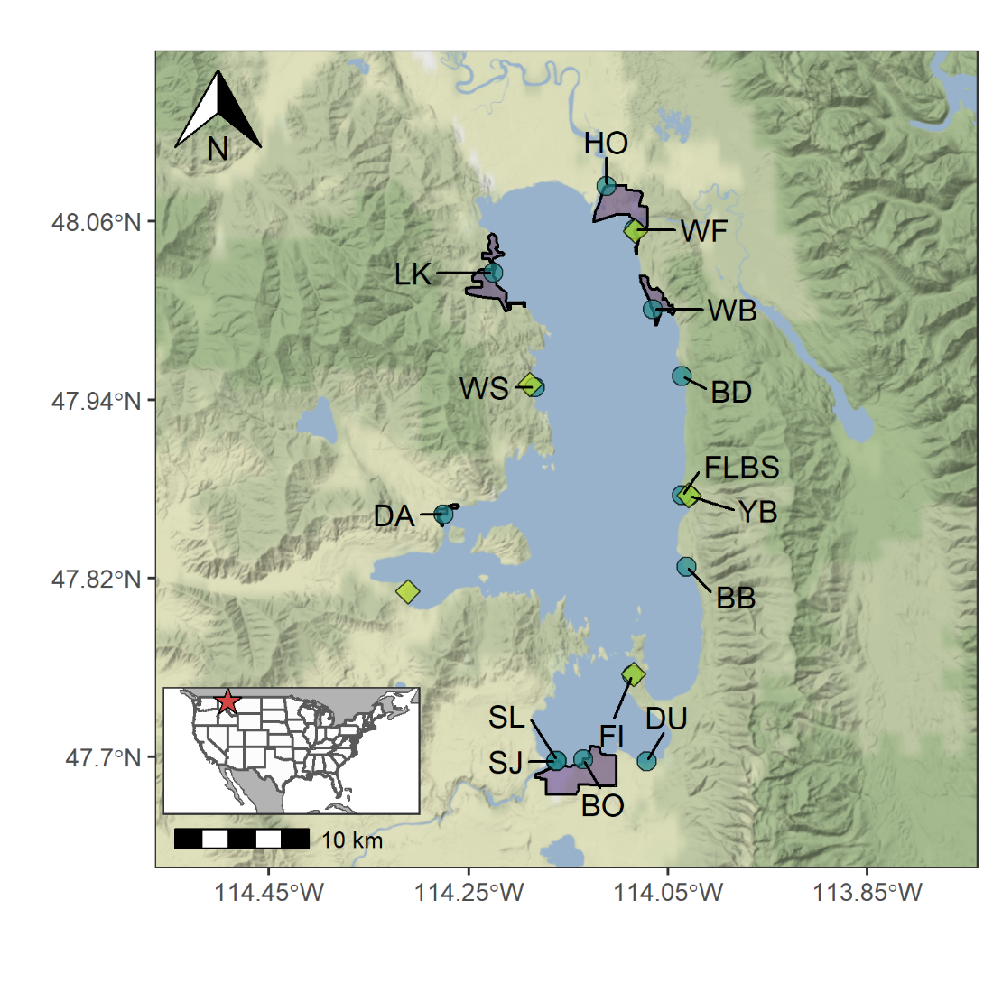

Figure 1: Map of sampling locations, State Parks, and major lakeside developments. Sampling locations are denoted by the blue circles and are labeled with the site name. HO and DU were considered reference sites, where HO was sampled within the Flathead River before it enters Flathead Lake and DU was sampled where there was no adjacent lakeside development. Green diamonds correspond to locations of five State Parks, from which we gather monthly data on visitor passes sold. Many sampling locations (blue circles) and State Parks (green diamonds) are co-located, and their respective symbols may overlap. Purple polygons refer to area delineated for five major lakeside developments (Bigfork, Lakeside, Wood’s Bay, Dayton, and Polson).

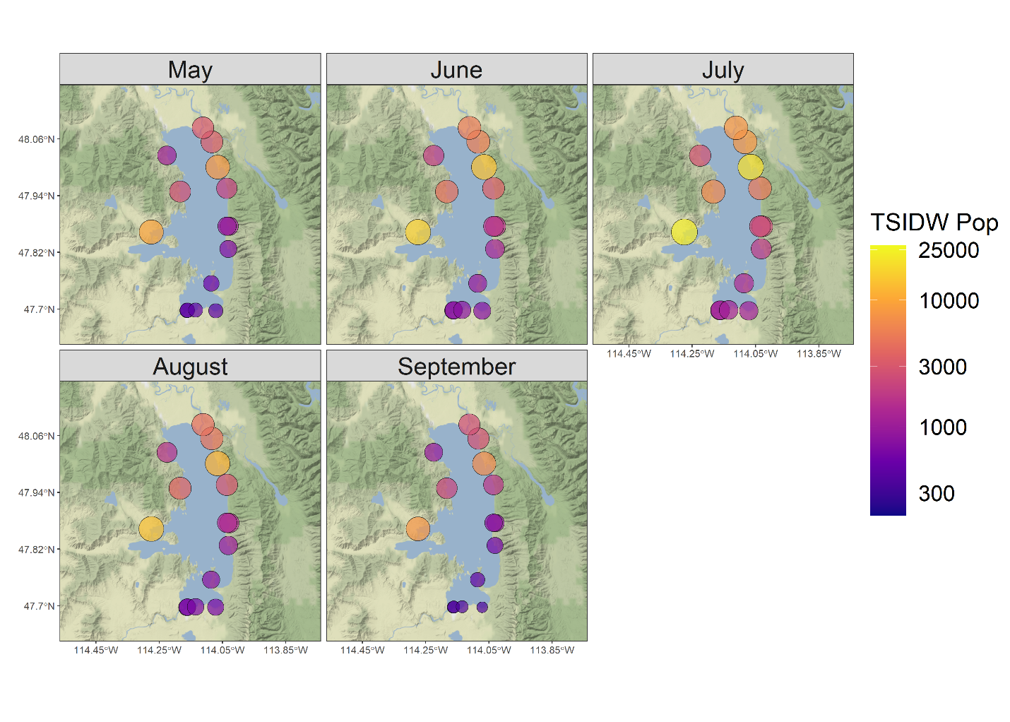

Figure 2: Temporally scaled inverse distance weighted (TSIDW) population for each sampling location and month. Larger, yellow points indicate sites with high TSIDW populations. Smaller, more purple points represent sites with lower TSIDW populations. Spatially, TSIDW population tended to be highest in the northeast portion of the lake, near the towns of Bigfork and Wood’s Bay. Temporally, TSIDW population tended to be highest in July.

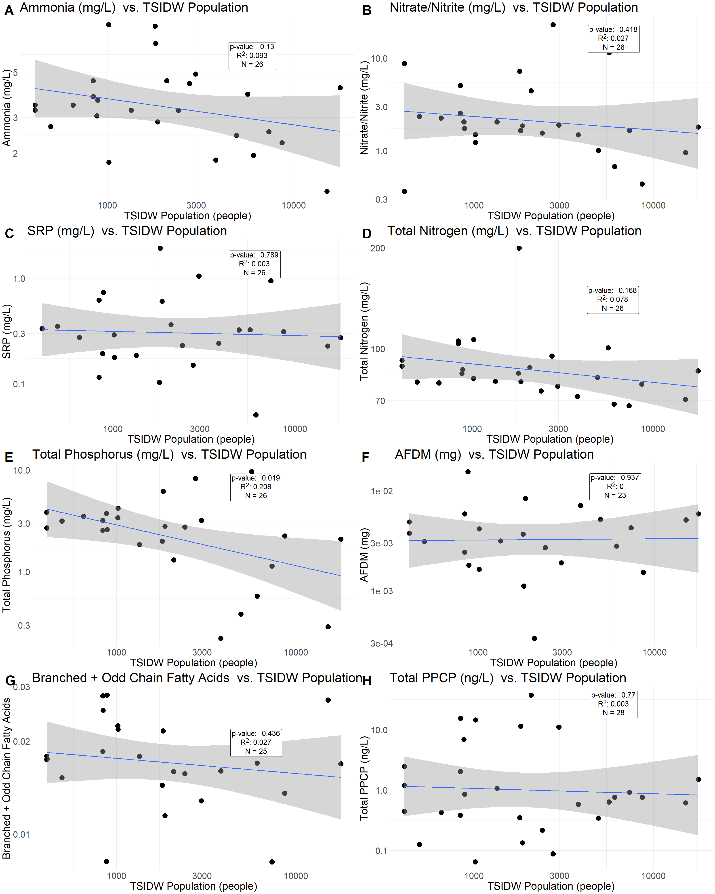

Figure 3: Regressions of TSIDW human population against nutrient concentrations (A-E), ash free dry mass (F), branched- and odd-chain fatty acid abundance (G), and total PPCP concentrations (H). With the exception of total phosphorus, none of these regressions were statistically significant, suggesting that TSIDW population was not a powerful predictor of sewage indicator concentrations in Flathead Lake’s nearshore area.

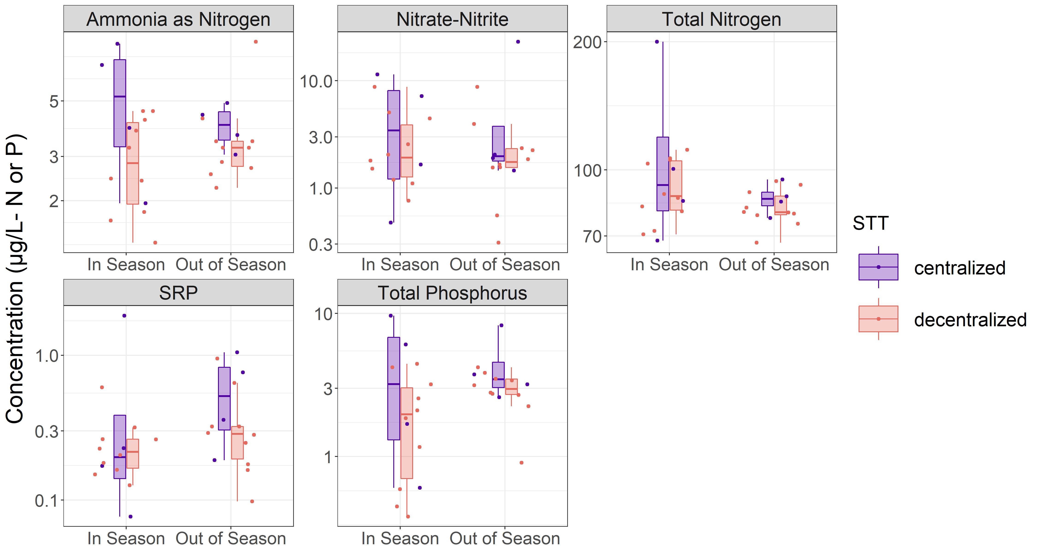

Figure 4: Littoral water column nutrient concentrations observed at each of the sampling locations. Concentrations are visualized on a log-scaled y-axis. While most nutrient concentrations were consistent between sewage treatment techniques and timepoints, SRP and Ammonia were often higher near sites with centralized sewage treatment in comparison to decentralized sewage treatment, although this may be a product of detection limits. When nutrient concentrations were below minimal detection limits (1.5 µg/L for ammonia, nitrate/nitrite, and total phosphorus; 25 µg/L for total nitrogen; and 0.8 µg/L for SRP), we assigned a random value between zero and half of the minimal detection limit.

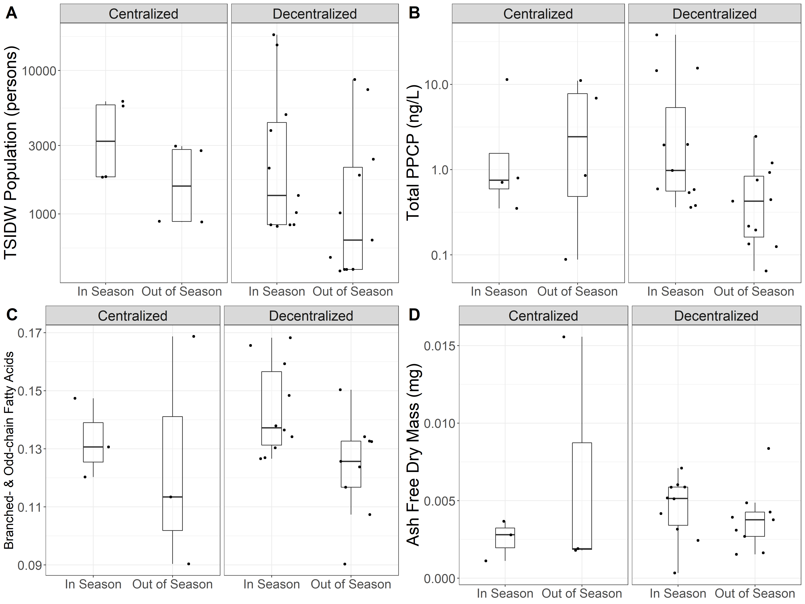

Figure 5: Boxplots of TSIDW population (A), total PPCP concentration (B), relative abundance of branched- and odd-chain fatty acids (C), and ash free dry mass (D) in response to tourism season (x-axis) and sewage treatment technique (faceted axis). To characterize overarching patterns, values are averaged within a sewage treatment technique and season for a given site. TSIDW Population (A) generally was higher at sites with centralized wastewater treatment and also decreased following the tourism season both for sites with centralized and decentralized wastewater treatment. Total PPCP concentrations (B) were often higher at sites with decentralized wastewater treatment during the tourism season than at those same sites following the tourism season. Periphyton branched- and odd-chain fatty acids (C) were higher during tourism season both for sites with centralized and decentralized wastewater treatment. These fatty acids are indicative of bacterial communities, which would be expected to be more abundant during times and at locations of increased wastewater loading. Ash free dry mass (D), a proxy for periphyton productivity and detritus biomass, was consistent between sites in relation to sewage treatment technique and tourism season.

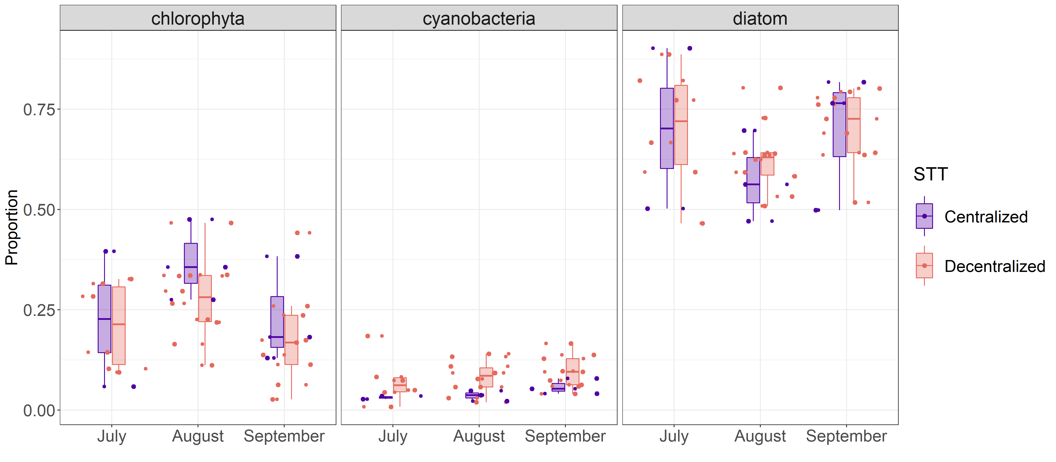

Figure 6: Boxplots of algal taxonomic group proportional abundance throughout the course of a summer. Sites with centralized wastewater treatment were generally dominated by chlorophyte and diatoms, whereas sites with decentralized treatment tended to have a higher cyanobacteria abundance that gradually increased over the course of a summer. As periphyton collections in June degraded during storage, we do not include June proportional abundance data in this analysis.

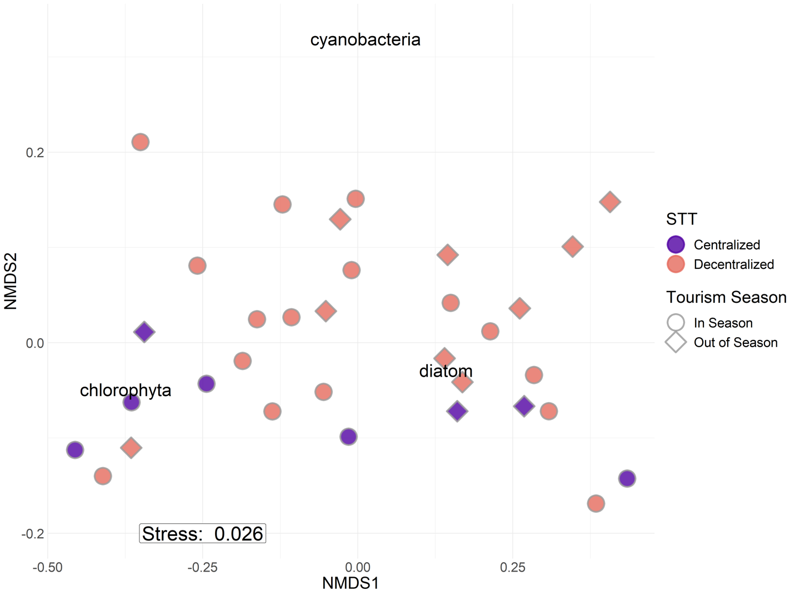

Figure 7: NMDS with Bray-Curtis similarity of relative periphyton abundance. The NMDS biplot suggested that sites did not separate based on multivariate patterns in algal community composition. Rather, sites with centralized wastewater treatment tended to cluster at the lower end of NMDS2, which likely was driven by these sites having lower relative cyanobacterial abundance. This same pattern was observed in the univariate analysis of each taxon’s relative abundance (Figure 6).

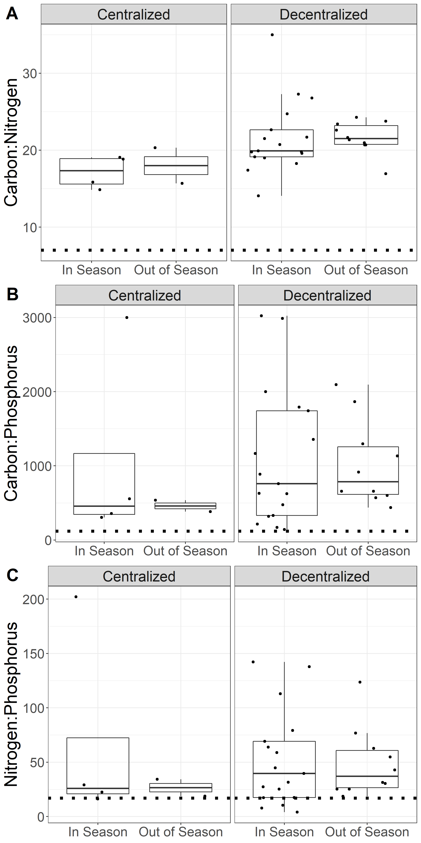

Figure 8: Molar Carbon:Nitrogen (A), Carbon:Phosphorus (B), and Nitrogen:Phosphorus (C) ratios for periphyton with samples groups by whether sites were located near centralized or decentralized wastewater treatment, or samples were collected during or following the tourism season. As periphyton collections in June did not yield enough biomass for reliable measurements, “In Season” denotes samples collected during July or August, whereas “Out of Season” denotes samples collected in September. Dotted lines in each plot reflect the empirically derived stoichiometric ratios for non-nutrient limited growth of periphyton communities (i.e., 119:17:1; Hillebrand and Sommer 1999).

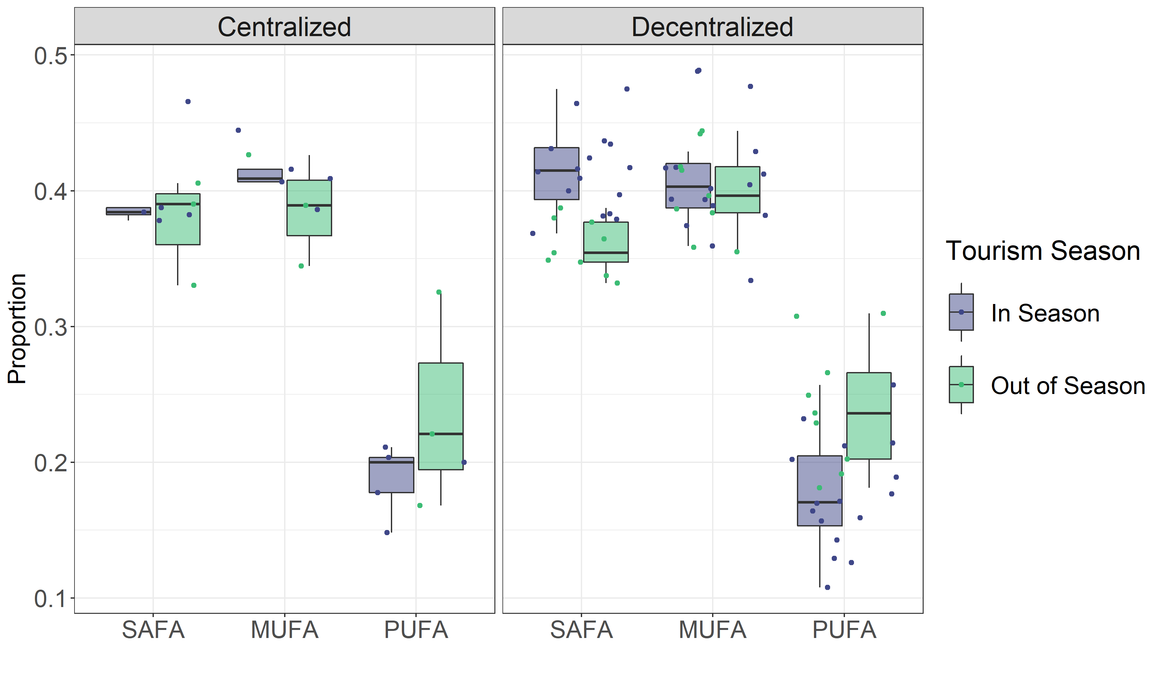

Figure 9: Relative concentrations of saturated (SAFA), monounsaturated (MUFA), and polyunsaturated (PUFA) fatty acids in periphyton with samples groups by whether sites were located near centralized or decentralized wastewater treatment or samples were collected during or following the tourism season. As periphyton collections in June did not yield enough biomass for reliable measurements, “In Season” denotes samples collected during July or August, whereas “Out of Season” denotes samples collected in September.

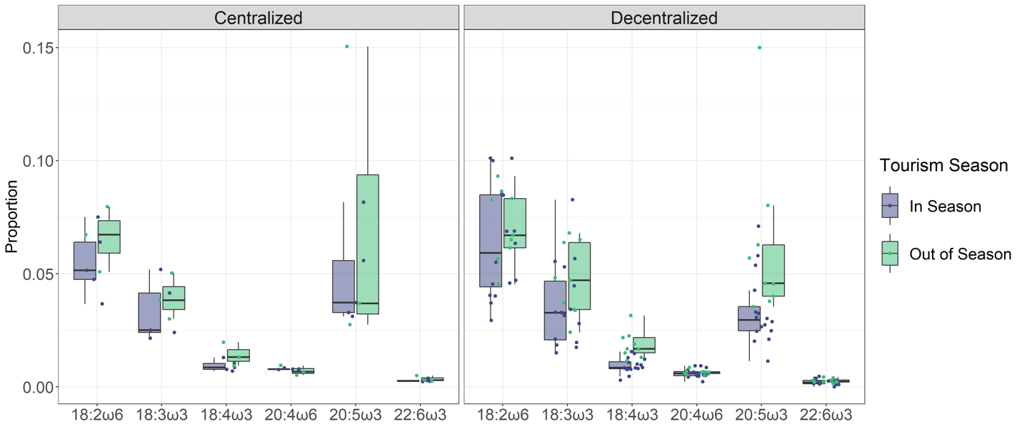

Figure 10: Relative concentrations of essential fatty acids (EFAs) in periphyton with samples groups by whether sites were located near centralized or decentralized wastewater treatment or samples were collected during or following the tourism season. As periphyton collections in June did not yield enough biomass for reliable measurements, “In Season” denotes samples collected during July or August, whereas “Out of Season” denotes samples collected in September. EFAs are considered highly nutritious fatty acids for higher trophic levels and are primarily synthesized by primary producers. Greatest differences in EFAs between locations and timepoints occurred at sites with decentralized sewage treatment, which contained increased 20:5ω3 following the tourism season. Because fatty acids tend to map to algal community compositions, this increased 20:5ω3 signature was likely related with increased diatom abundance (Figure 6).

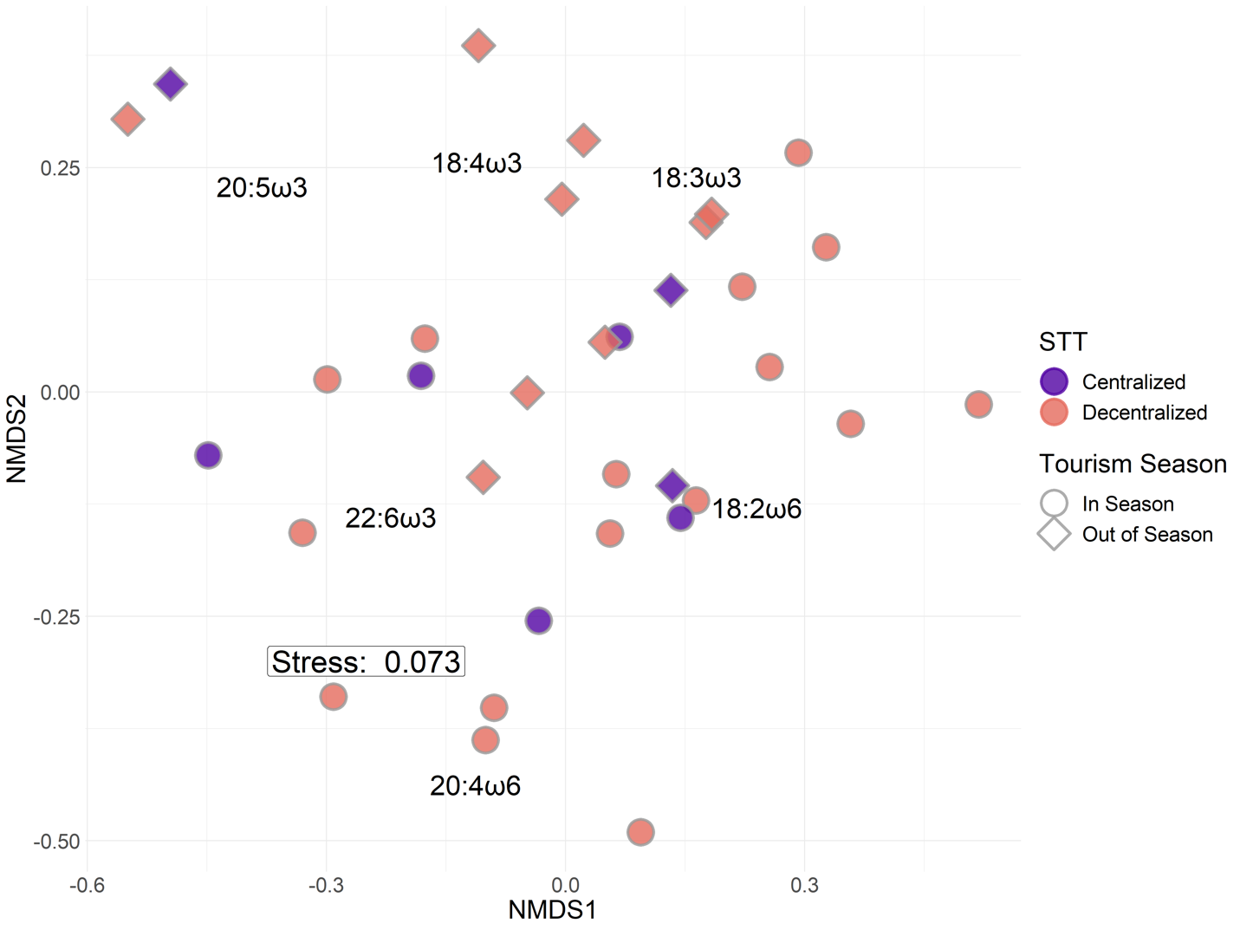

Figure 11: NMDS with Bray-Curtis similarity based on EFA relative abundance. The NMDS biplot suggested that sites separated by differences in tourism season (circles and diamonds). Post hoc SIMPER analyses suggested 20:5ω3 relative abundance as the most influential EFA in driving point separation, which was likewise supported by the univariate analysis of EFA abundance (Figure 9).

|  |  |  |  |
| --- | --- | --- | --- |
| **Analyte** | **Tourist Season** | **Centralized Mean**  **(St Dev)** | **Decentralized Mean**  **(St Dev)** |
| Ammonia (mg/L) | In Season | 5.313 (2.934) | 3.014 (1.215) |
| Out of Season | 4.000 (0.815) | 3.660 (1.825) |
| Nitrate/Nitrite (mg/L) | In Season | 5.244 (5.037) | 2.933 (2.482) |
| Out of Season | 7.186 (10.576) | 2.465 (2.429) |
| Soluble Reactive Phosphorus (mg/L) | In Season | 0.604 (0.897) | 0.287 (0.141) |
| Out of Season | 0.532 (0.436) | 0.387 (0.228) |
| Total Nitrogen (mg/L) | In Season | 113.275 (59.167) | 90.515 (15.078) |
| Out of Season | 85.763 (7.343) | 81.525 (8.114) |
| Total Phosphorus (mg/L) | In Season | 4.598 (4.120) | 2.056 (1.555) |
| Out of Season | 4.450 (2.576) | 2.973 (0.871) |
| AFDM (mg) | In Season | 0.003 (0.001) | 0.005 (0.002) |
| Out of Season | 0.006 (0.008) | 0.004 (0.002) |
| Branched & Odd-Chain Fatty Acids (µg/mg) | In Season | 0.018 (0.004) | 0.021 (0.005) |
| Out of Season | 0.016 (0.010) | 0.015 (0.004) |
| PPCP (ng/L) | In Season | 4.179 (6.248) | 7.486 (12.242) |
| Out of Season | 6.268 (5.123) | 0.676 (0.733) |

Table S1: Mean and standard deviations of water column analytes across sewage treatment techniques and periods in the tourism season.

|  |  |  |  |
| --- | --- | --- | --- |
| Analyte | Tourist Season | Centralized Mean  (St Dev) | Decentralized Mean  (St Dev) |
| Chlorophyte (proportion) | In Season | 0.312 (0.159) | 0.251 (0.106) |
| Out of Season | 0.232 (0.134) | 0.180 (0.123) |
| Cyanobacteria (proportion) | In Season | 0.034 (0.010) | 0.078 (0.047) |
| Out of Season | 0.058 (0.019) | 0.095 (0.041) |
| Diatom (proportion) | In Season | 0.627 (0.176) | 0.656 (0.118) |
| Out of Season | 0.693 (0.171) | 0.705 (0.094) |
| MUFA (proportion) | In Season | 0.412 (0.021) | 0.410 (0.044) |
| Out of Season | 0.387 (0.041) | 0.400 (0.033) |
| PUFA (proportion) | In Season | 0.188 (0.026) | 0.176 (0.041) |
| Out of Season | 0.238 (0.080) | 0.241 (0.047) |
| SAFA (proportion) | In Season | 0.400 (0.037) | 0.414 (0.030) |
| Out of Season | 0.375 (0.040) | 0.359 (0.019) |
| 18:2ω6c (proportion) | In Season | 0.055 (0.015) | 0.063 (0.025) |
| Out of Season | 0.066 (0.014) | 0.071 (0.016) |
| 18:3ω3 (proportion) | In Season | 0.033 (0.013) | 0.036 (0.018) |
| Out of Season | 0.040 (0.010) | 0.047 (0.016) |
| 18:4ω3 (proportion) | In Season | 0.009 (0.002) | 0.009 (0.003) |
| Out of Season | 0.014 (0.005) | 0.019 (0.006) |
| 20:4ω6 (proportion) | In Season | 0.008 (0.000) | 0.006 (0.002) |
| Out of Season | 0.007 (0.002) | 0.006 (0.001) |
| 20:5ω3 (proportion) | In Season | 0.048 (0.021) | 0.034 (0.015) |
| Out of Season | 0.072 (0.068) | 0.062 (0.036) |
| 22:6ω3 (proportion) | In Season | 0.003 (0.001) | 0.002 (0.001) |
| Out of Season | 0.003 (0.001) | 0.003 (0.001) |
| C:N | In Season | 17.145 (2.124) | 21.603 (4.755) |
| Out of Season | 17.995 (3.284) | 21.627 (2.104) |
| C:P | In Season | 1054.715 (1301.646) | 1095.483 (928.905) |
| Out of Season | 459.828 (109.753) | 1023.074 (572.281) |
| N:P | In Season | 67.505 (89.876) | 52.364 (43.839) |
| Out of Season | 26.552 (10.945) | 49.195 (32.148) |

Table S2: Mean and standard deviations of periphyton analytes across sewage treatment techniques and periods in the tourism season.

|  |  |  |  |  |
| --- | --- | --- | --- | --- |
| 1. **Ammonia** | | | | |
|  | Sum of Squares | Degrees of Freedom | F value | P value |
| STT | 0.121 | 1 | 3.347 | 0.080 |
| Tourist Season | 0.016 | 1 | 0.454 | 0.507 |
| STT:Tourist Season | 0.038 | 1 | 1.040 | 0.318 |
| Residuals | 0.866 | 24 |  |  |
|  |  |  |  |  |
| 1. **Nitrate/Nitrite** | | | | |
|  | Sum of Squares | Degrees of Freedom | F value | P value |
| STT | 0.255 | 1 | 1.058 | 0.314 |
| Tourist Season | 0.059 | 1 | 0.243 | 0.627 |
| STT:Tourist Season | 0.125 | 1 | 0.517 | 0.479 |
| Residuals | 5.793 | 24 |  |  |
|  |  |  |  |  |
| 1. **SRP** | | | | |
|  | Sum of Squares | Degrees of Freedom | F value | P value |
| STT | 0.378 | 1 | 3.313 | 0.081 |
| Tourist Season | 0.001 | 1 | 0.009 | 0.923 |
| STT:Tourist Season | 0.013 | 1 | 0.114 | 0.739 |
| Residuals | 2.741 | 24 |  |  |
|  |  |  |  |  |
| 1. **Total Nitrogen** | | | | |
|  | Sum of Squares | Degrees of Freedom | F value | P value |
| STT | 0.011 | 1 | 1.374 | 0.253 |
| Tourist Season | 0.020 | 1 | 2.554 | 0.123 |
| STT:Tourist Season | 0.003 | 1 | 0.316 | 0.579 |
| Residuals | 0.191 | 24 |  |  |
|  |  |  |  |  |
| 1. **Total Phosphorus** | | | | |
|  | Sum of Squares | Degrees of Freedom | F value | P value |
| STT | 0.256 | 1 | 2.101 | 0.160 |
| Tourist Season | 0.400 | 1 | 3.282 | 0.083 |
| STT:Tourist Season | 0.018 | 1 | 0.148 | 0.704 |
| Residuals | 2.922 | 24 |  |  |

Table S3: ANOVA tables for nutrient concentrations in response to sewage treatment technique (STT) and tourist season.

|  |  |  |  |  |
| --- | --- | --- | --- | --- |
| 1. **PPCPs** | | | | |
|  | Sum of Squares | Degrees of Freedom | F value | P value |
| STT | 0.290 | 1 | 0.649 | 0.428 |
| Tourist Season | 1.750 | 1 | 3.915 | 0.059 |
| STT:Tourist Season | 0.932 | 1 | 2.085 | 0.161 |
| Residuals | 11.624 | 26 |  |  |
|  |  |  |  |  |
| 1. **Branched- and Odd-Chain Fatty Acids** | | | | |
|  | Sum of Squares | Degrees of Freedom | F value | P value |
| STT | < 0.001 | 1 | 0.307 | 0.585 |
| Tourist Season | 0.002 | 1 | 4.565 | 0.045 |
| STT:Tourist Season | < 0.01 | 1 | 0.353 | 0.559 |
| Residuals | 0.008 | 21 |  |  |
|  |  |  |  |  |
| 1. **Ash Free Dry Mass** | | | | |
|  | Sum of Squares | Degrees of Freedom | F value | P value |
| STT | < 0.001 | 1 | 0.039 | 0.845 |
| Tourist Season | < 0.001 | 1 | 0.096 | 0.760 |
| STT:Tourist Season | < 0.001 | 1 | 2.558 | 0.125 |
| Residuals | < 0.001 | 21 |  |  |

Table S4: ANOVA tables for sewage indicator values in response to sewage treatment technique (STT) and tourist season.

|  |  |  |  |  |
| --- | --- | --- | --- | --- |
| 1. **Periphyton Community Composition** | | | | |
|  | Sum of Squares | Degrees of Freedom | F value | P value |
| STT | 0.127 | 1 | 0.127 | 0.127 |
| Tourist Season | 0.158 | 1 | 0.158 | 0.158 |
| Residuals | 2.459 | 30 |  |  |
|  |  |  |  |  |
| 1. **Fatty Acids** | | | | |
|  | Sum of Squares | Degrees of Freedom | F value | P value |
| STT | 0.082 | 1 | 0.726 | 0.667 |
| Tourist Season | 0.311 | 1 | 2.775 | 0.008 |
| Residuals | 3.367 | 30 |  |  |

Table S5: PERMANOVA tables for periphyton community and multivariate fatty profiles in response to sewage treatment technique (STT) and tourist season.

|  |  |  |  |  |
| --- | --- | --- | --- | --- |
| 1. **Carbon:Nitrogen** | | | | |
|  | Sum of Squares | Degrees of Freedom | F value | P value |
| STT | 85.606 | 1 | 5.830 | 0.022 |
| Tourist Season | 0.215 | 1 | 0.015 | 0.904 |
| STT:Tourist Season | 0.752 | 1 | 0.051 | 0.823 |
| Residuals | 425.863 | 29 |  |  |
|  |  |  |  |  |
| 1. **Carbon:Phosphorus** | | | | |
|  | Sum of Squares | Degrees of Freedom | F value | P value |
| STT | 233756.454 | 1 | 0.310 | 0.582 |
| Tourist Season | 204497.198 | 1 | 0.271 | 0.606 |
| STT:Tourist Season | 300369.615 | 1 | 0.399 | 0.533 |
| Residuals | 21848264.461 | 29 |  |  |
|  |  |  |  |  |
| 1. **Nitrogen:Phosphorus** | | | | |
|  | Sum of Squares | Degrees of Freedom | F value | P value |
| STT | 25.980 | 1 | 0.012 | 0.915 |
| Tourist Season | 728.571 | 1 | 0.328 | 0.571 |
| STT:Tourist Season | 1570.836 | 1 | 0.707 | 0.407 |
| Residuals | 64403.453 | 29 |  |  |

Table S6: ANOVA tables for periphyton stoichiometric ratios in response to sewage treatment technique (STT) and tourist season.

|  |  |  |  |  |
| --- | --- | --- | --- | --- |
| 1. **PUFA** | | | | |
|  | Sum of Squares | Degrees of Freedom | F value | P value |
| STT | < 0.001 | 1 | 0.160 | 0.692 |
| Tourist Season | 0.044 | 1 | 14.470 | 0.001 |
| STT:Tourist Season | 0.001 | 1 | 0.256 | 0.617 |
| Residuals | 0.089 | 29 |  |  |
|  |  |  |  |  |
| 1. **SAFA** | | | | |
|  | Sum of Squares | Degrees of Freedom | F value | P value |
| STT | < 0.001 | 1 | 0.070 | 0.793 |
| Tourist Season | 0.019 | 1 | 20.519 | < 0.001 |
| STT:Tourist Season | 0.001 | 1 | 1.618 | 0.213 |
| Residuals | 0.026 | 29 |  |  |
|  |  |  |  |  |
| 1. **MUFA** | | | | |
|  | Sum of Squares | Degrees of Freedom | F value | P value |
| STT | < 0.001 | 1 | 0.046 | 0.832 |
| Tourist Season | 0.002 | 1 | 1.016 | 0.322 |
| STT:Tourist Season | < 0.001 | 1 | 0.249 | 0.622 |
| Residuals | 0.044 | 29 |  |  |

Table S7: ANOVA tables for periphyton relative fatty acid abundance in response to sewage treatment technique (STT) and tourist season. Prior to analysis, values were arcsine-square root transformed to normalize proportional data.