Evaluating Medicare prescribing practices in North Carolina, 2018-2023
High antibiotic prescribing can lead to increased antimicrobial resistance. Before we even assess appropriateness of antibiotic prescribing, we need to establish what high volume prescribing looks like in North Carolina. How do we evaluate what drives antibiotic prescribing practices in the North Carolina Medicare population? Who is prescribing the most? Is prescribing regional or dependent on specialty? What is the best model to use? Here I explain a modeling approach to analyzing antibiotic claim rate by both population density where the provider is located and by practice specialty type. This adds a further level of analysis to current literature which has been limited to single-predictor models. See here for an example: https://www.cdc.gov/mmwr/volumes/71/wr/pdfs/mm7106a3-H.pdf
Using Medicare claims data from 2018-2023 and only prescribers who have greater than ten antibiotic claims per year, we can evaluate prescribing volume based on rate of claims per 1,000 beneficiaries.
Step 0, establish what we want to evaluate.
Before any analysis is conducted, let’s look at our rural and non-rural distribution of antibiotic claim rate among providers submitting more than 10 antibiotic prescription claims each year from 2018 to 2023:
Fig 1.
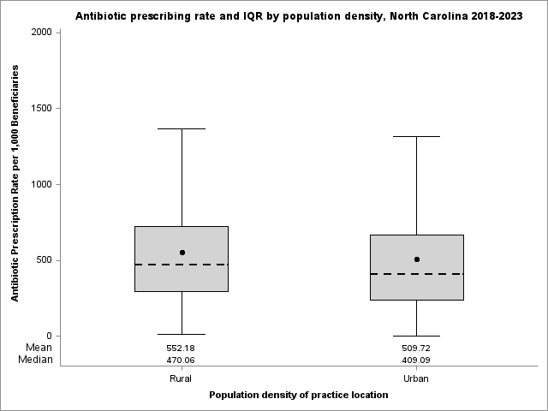
Visually, we can see a higher mean and median in rural provider antibiotic claim rate. Does this matter? Is it significant? How do we determine if this is influenced by specialty type?

Step 1, determine significance.
Fig 2.
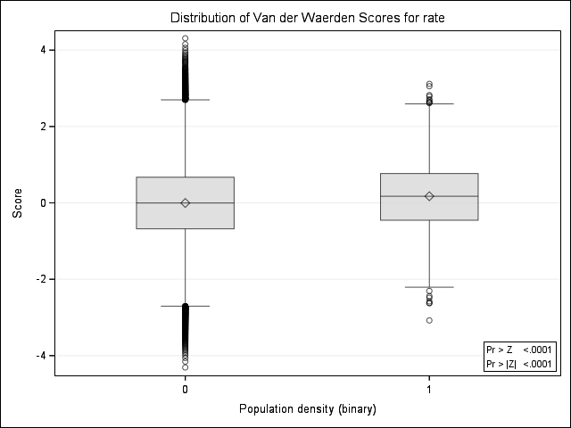
Table 1. Rank sum one-way chi sq. and significance
Data Scores One-Way Analysis
Chi-Square | DF | Pr > ChiSq
36.8201 | 1 | <.0001

Do we even have a relationship? The traditional way to evaluate the differences in prescribers by cohort is a rank sum test like the Wilcoxon (Mann-Whitley; two comparisons not Kruskal-Wallis for more granular 3+ population density groups blah blah blah statistics that I maybe understand) test. In our case, rural versus non-rural are our cohorts. Building off figure 1, we can compare , ranks, and “score” the median rate of prescribing among both groups. If those medians are different, we can say the median prescribing rate of rural providers is higher than the median prescribing rate of non-rural providers. In our example we use the Wilcoxon rank sum test, which measures the median values of each group and compares them against each other in a one and two-sided test. In this case, we confirm what we saw in Fig 1, the median (50th percentile) of prescribers in rural areas have a higher median antibiotic claims rate as compared to their non-rural counterparts AND that difference is statistically significant (p<.0001). We can visualize this in a box and whisker plot displaying Van der Waerden Scores (Fig 2). Don’t worry about understanding scoring, we simply use that as a test of significance in this instance (red box and table 1.).
However, now we run into a problem. Some specialties prescribe more. Could specialty differences drive differences in antibiotic claims trends by population density? Look how much higher dentistry claim rate is when compared to other specialties. Same with urologists, their mean and median prescribing rates are higher than others. How can we assess claims AND account for specialty type?
Fig 3.
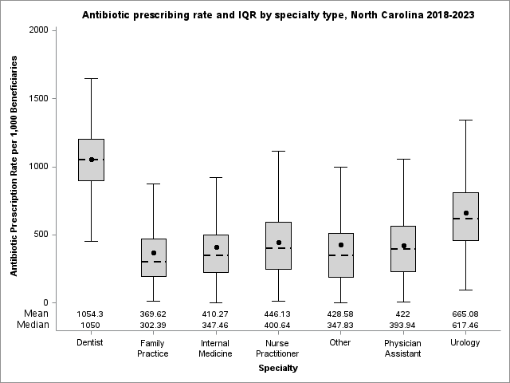

Step 2, get more granular.
Fig 4. Difference in antibiotic prescribing claims per 1,000 beneficiaries among rural providers compared to non-rural providers, North Carolina 2018- 2023
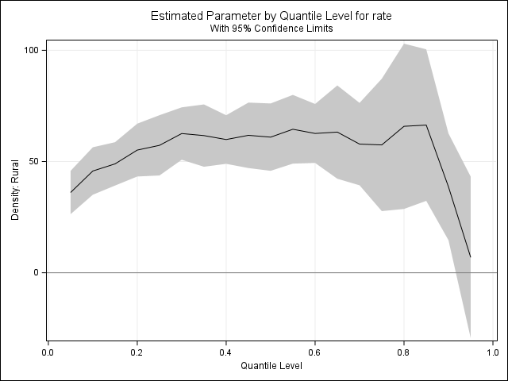
Rank sum testing used the median rate of prescribing in our example. That means we are comparing the 50th percentile of rural prescribers to the 50th percentile of urban prescribers. That’s great, it tells us a lot, but we can ask even more questions. Different levels of prescribers may prescribe at different rates. That is to ask questions like: do rural prescribers in the bottom 10% of antibiotic claim submitters by rate prescribe more than their non-rural counterparts? Using quantile regression analysis helps us get more information out of our data.
Figure 4 shows the difference in antibiotic prescribing claim rate when comparing rural providers to urban providers by level, or quantile, of prescribing. From prescribing quantiles 5 to 90, rural providers submit significantly more claims than their non-rural counterparts. For example, a provider in a rural area that falls in the 10th percentile of antibiotic prescription claims among all providers within their rural cohort will file more antibiotic prescription claims than a non-rural provider in the 10th percentile of their cohort. However, at the top 5% of each cohort the difference between rural and non-rural provider claims decreases and is not significant. The interpretation here is that very high prescribers are prescribing about the same amount regardless of where they are located. In other words, higher rural antibiotic prescription claims are not exclusively driven by the highest prescribers.
Looking at each quantile is all well and good, but it doesn’t answer our last question. How do we determine if this is influenced by specialty type? We already know from figure 3 that some specialties prescribe at higher rates than others, let’s determine if this influences our rural versus non-rural prescribing.

Step 3, multiple predictors.
How can we assess claims AND account for specialty type? Rank sum tests like the Wilcoxon are great for looking at a single predictor: population density, high-volume prescriber, or specialty type. However, rank sum tests are limited when explaining different independent variables. To overcome the limitations of rank sum we can utilize the quantile regression model seen in figure 4 while adding specialty as an additional predictor.
Fig 5. Difference in antibiotic prescribing claims per 1,000 beneficiaries among rural providers compared to non-rural providers accounting for specialty type, North Carolina 2018- 2023
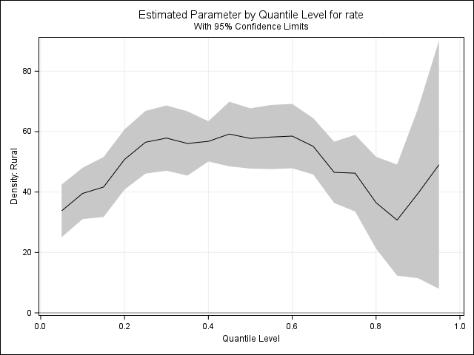
“High tail”
Let’s look at our results, they aren’t all that different from our single predictor model… until we reach the 90th percentile. The “high tail” moves the opposite direction as our prior model when including specialty as a predictor! The top 10% of antibiotic claims submitters by rate shift from closing the gap between rural and non-rural in our initial model (Fig. 4) to expanding the gap between prescribing rates. How do we interpret this outcome? Rural providers appear to have higher claim rates at every quantile 5-95 than their non-rural counterparts AND those differences are significant AND we have accounted for specialty type. Further, while the gap between prescribing rates closes as we approach the 90th percentile, or highest 10% of prescribers, it widens again among our highest antibiotic claim submitters by rate. It’s worth nothing that our rate difference, the y-axis, is a little bit condensed. Our range of rate-of-claims is slightly smaller when adding specialty as an additional predictor.
Step 4, what does this all mean?
Medicare data can provide valuable insight into the prescribing practices of different specialties and their locations. We can evaluate claim rate volume and make inferences based on our results. However, we must use caution. Volume does not equate to inappropriate use of antibiotics in every case. While there may be associations between high volume and higher levels of antibiotic prescribing, we did NOT evaluate those relationships here. In a nutshell, we have expanded on prior literature by adding specialty and rural versus non-rural provider location as predictors when evaluating prescribing practices in North Carolina.
In a concluding sentence we can say: Rural North Carolina Medicare providers submitted a significantly higher rate of antibiotic claims per 1,000 beneficiaries when compared to their non-rural counterparts when including specialty as predictor of claim rate from 2018-2023.

Step 5 (added later), but wait, there’s more!
2018-2023 is a big range. Some studies have looked at multiple-year ranges, for example: Antibiotic prescribing to Kentucky Medicaid children,2012-2017: Prescribing is higher in rural areas. However, Medicare-specific studies have generally been a single year study, particularly the one we are basing this evaluation off: Identifying Higher-Volume Antibiotic Outpatient Prescribers Using Publicly. Further, providers are more aware of antimicrobial stewardship and the implications over-prescribing can have on antibiotic resistance 2019 Antibiotic resistance threats and some updated numbers in 2024. Programs including North Carolina specific antimicrobial awareness week and CDC based programs supporting Antibiotic Stewardship at the facility level.
So, do programs raising awareness, informing best practices, and increased surveillance affect antibiotic stewardship, particularly with health equity in mind?
Fig 6. Difference in antibiotic prescribing claims per 1,000 beneficiaries among rural providers compared to non-rural providers accounting for specialty type, North Carolina 2023
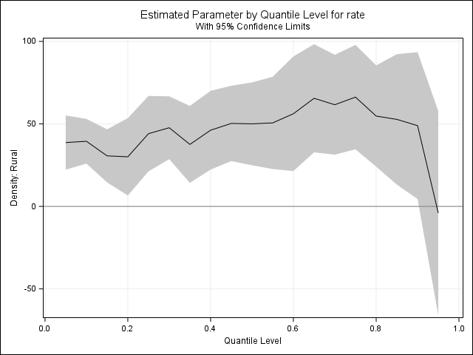
Look at this! When we confine our evaluation and analysis to 2023 only, our “high tail” we talked about in Fig. 5 completely changes. How can we interpret this visual? In simple terms, the median prescribing rate among the highest prescribers (95th percentile) is not significantly different among rural and non-rural providers. Based on this singular analysis, we may have closed the gap in high prescriber differences by population density when accounting for specialty. The remaining providers falling between the 5th and 90th percentiles still have a significant discrepancy in antibiotic claim rate; rural providers prescribe at a higher rate compared to non-rural providers.
Let’s do one more comparison just so we can visualize what we’re implying.
Let’s run a view of each quantile of prescriber by year, so comparing each year from 2018-2022 to 2023. We would expect to see prior years generally higher, especially in the highest volume prescribers.
Fig 7. Difference in antibiotic prescribing claims per 1,000 by year compared to 2023, North Carolina 2018-2023
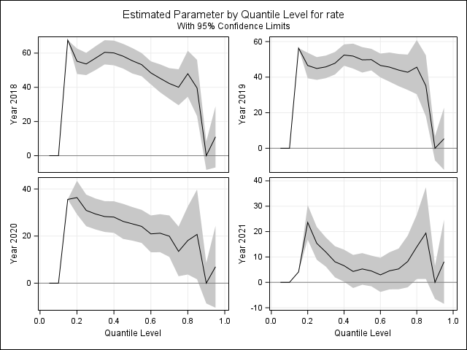
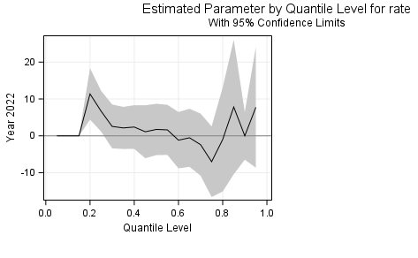
So we do see that when comparing years to 2023, we generally see a higher antibiotic claim rate (Fig. 7). This visual is a bit trickier to interpret so lets unpack it in bullet points.
- 2023 is our reference year.
- Each graph shows the median prescribing claim rate difference of the year identified in the y-axis label when compared to 2023.
- Year is the only predictor, we just want to see what effect year has on each level of prescriber from lowest percentile (5th) to highest (95th).
Visually, each graph gets closer to the 0 difference in antibiotic claim rate line and more of our confidence intervals cross the 0-line showing less significance year over year. In a sentence we can say antibiotic claim rates per 1,000 beneficiaries were the most different in 2018 when compared to 2023. To further help visualize claims by year, we can map predicted claims using the previous model, but in a maybe clearer way. The figure below shows the median rate of prescriptions among providers while removing our reference groups. Essentially, we will be showing what is driving the visual decrease in antibiotic prescribing claims.

Fig 8. Median predicted claims per 1,000 by year, North Carolina 2018-2023
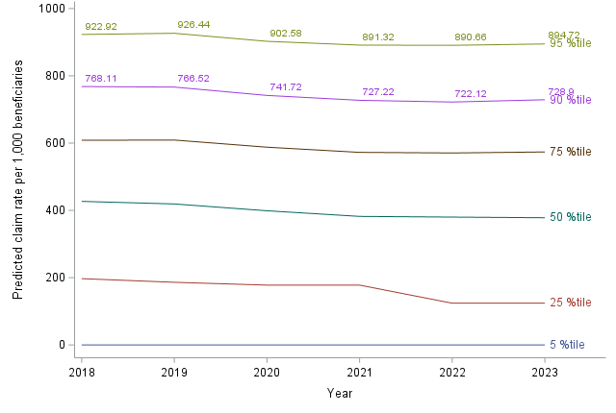
Here we can visualize the decrease and range between selected percentiles of prescribers and their predicted median claim rate from 2018 - 2023. The key observation here is the 95th and 90th percentile of prescribers. Both highest volume prescribers have shown a small, but visible decrease in predicted median number of antibiotic prescriptions claims since 2018. We can see this reflected in our yearly graphs as well (Fig 7.), but it may be easier to comprehend in the line-style visual. Each line shows the median predicted antibiotic claim rate per year, for a rural, non-reference group specialty (I used internal medicine) for quantiles 5, 25, 50, 75, 90 and 95. For example, a rural but not internal medicine provider in the 25th percentile could be expected to claim about 200 antibiotics per 1,000 beneficiaries in 2018 and closer to 150 in 2023. Figure 8 does not have the number of providers comprising each quantile (we know many more providers fall on the lower end of the data, hence our right-skew).
Let’s make one more leap and add year into our full model (see appendices for annual models). When we add year into our model (Fig. 9). We can say that year appears to be a predictor of higher antibiotic claim rate along with population density and specialty type. Are antibiotic stewardship interventions working in rural areas? Are rural providers more aware of antimicrobial resistance? We cannot definitively say any of this, however we can summarize our findings to North Carolina Medicare Part D providers submitting antibiotic claims.
Fig 9. Difference in antibiotic prescribing claims per 1,000 beneficiaries among rural providers compared to non-rural providers accounting for specialty type, year, North Carolina 2018- 2023
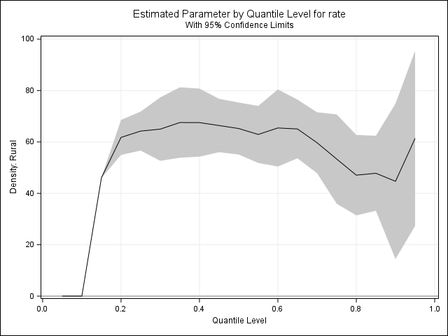

Final thought:
Rural North Carolina Medicare Part D providers submitted a significantly higher rate of Medicare Part D antibiotic claims per 1,000 beneficiaries when compared to their non-rural counterparts when including specialty and year as predictors of claim rate from 2018-2023. We may be seeing a reduction in discrepancy over time in North Carolina high-volume Medicare Part D prescribers in rural areas as compared to providers in non-rural areas from 2018 - 2023.

