Question 1Correct
A video streaming company is developing machine learning models to recommend content and analyze user interactions. The data science team needs to understand the specific capabilities of Convolutional Neural Networks (CNNs) and Recurrent Neural Networks (RNNs).
Which of the following would you suggest to the team?
While RNNs are used for single image analysis, CNNs are used for video analysis
Both RNNs and CNNs are used for video analysis
Both RNNs and CNNs are used for single image analysis
Your answer is correct
While CNNs are used for single image analysis, RNNs are used for video analysis
Overall explanation
Correct option:
While CNNs are used for single image analysis, RNNs are used for video analysis
CNNs are a type of deep learning model particularly well-suited for processing grid-like data, such as images. They are designed to automatically and adaptively learn spatial hierarchies of features from input images. RNNs are designed to handle sequential data, where the order of the data points matters. They are particularly well-suited for time-series data and tasks where temporal dependencies are crucial.
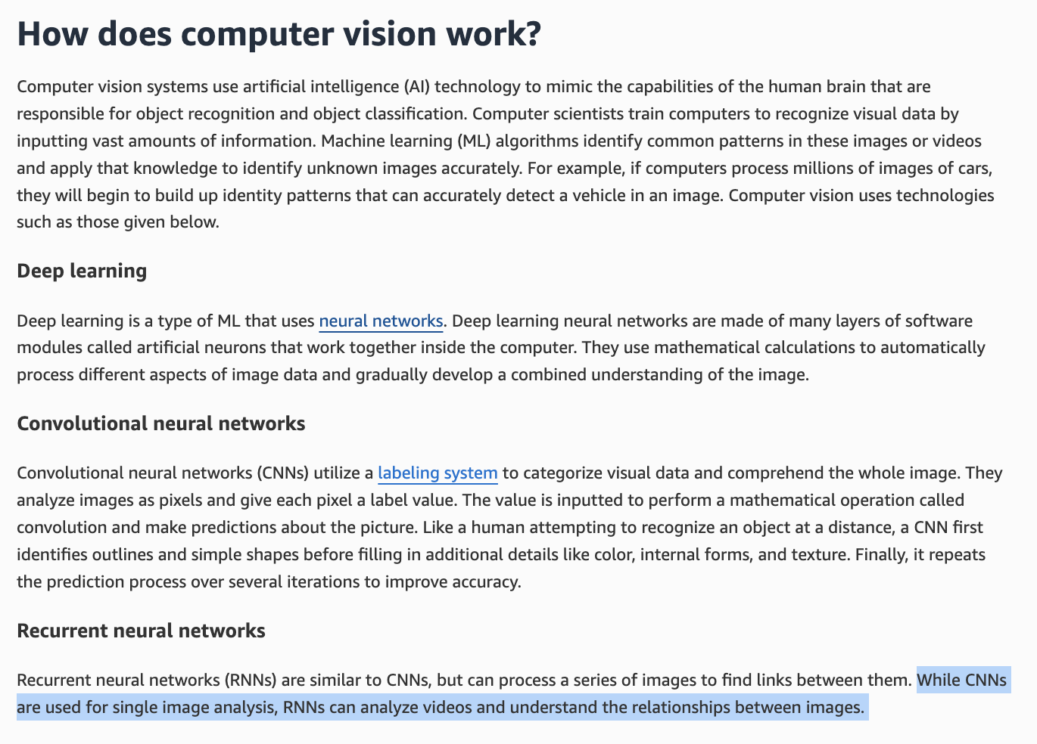
via - https://aws.amazon.com/what-is/computer-vision/
Incorrect options:
Both RNNs and CNNs are used for video analysis
Both RNNs and CNNs are used for single image analysis
While RNNs are used for single image analysis, CNNs are used for video analysis
These three options contradict the explanation provided above, so these options are incorrect.
References:
https://aws.amazon.com/what-is/neural-network/
https://aws.amazon.com/what-is/computer-vision/
Domain
Fundamentals of AI and ML
Question 2Incorrect
Which of the following best describes the Amazon SageMaker Canvas ML tool?
The fastest and easiest way to prepare tabular and image data for machine learning
Explains how input features contribute to the model predictions during model development and inference
Correct answer
Gives the ability to use machine learning to generate predictions without the need to write any code
Your answer is incorrect
Provides one-click, end-to-end solutions for many common machine learning use cases
Overall explanation
Correct option:
Gives the ability to use machine learning to generate predictions without the need to write any code
Amazon SageMaker Canvas gives you the ability to use machine learning to generate predictions without needing to write any code. With Canvas, you can chat with popular large language models (LLMs), access Ready-to-use models, or build a custom model trained on your data.
Incorrect options:
Provides one-click, end-to-end solutions for many common machine learning use cases - Amazon SageMaker JumpStart supports this feature.
Explains how input features contribute to the model predictions during model development and inference - Amazon SageMaker Clarify supports this feature.
The fastest and easiest way to prepare tabular and image data for machine learning - Amazon SageMaker Data Wrangler supports this feature.
Reference:
https://docs.aws.amazon.com/sagemaker/latest/dg/canvas.html
Domain
Applications of Foundation Models
Question 3Correct
A retail company is exploring machine learning algorithms to improve its customer segmentation systems. The data science team is evaluating both K-Means and K-Nearest Neighbors (KNN) algorithms but needs to understand the key differences between them, since understanding these distinctions will help the team choose the right algorithm for their specific tasks.
Given this context, what do you recommend to the company?
K-Means is a supervised learning algorithm used for classification, while KNN is an unsupervised learning algorithm used for clustering
K-Means requires labeled data to form clusters, whereas KNN does not use labeled data for making predictions
Your answer is correct
K-Means is an unsupervised learning algorithm used for clustering data points into groups, while KNN is a supervised learning algorithm used for classifying data points based on their proximity to labeled examples
K-Means is primarily used for regression tasks, while KNN is used for reducing the dimensionality of data
Overall explanation
Correct option:
K-Means is an unsupervised learning algorithm used for clustering data points into groups, while KNN is a supervised learning algorithm used for classifying data points based on their proximity to labeled examples
K-Means is an unsupervised learning algorithm used to partition a dataset into distinct clusters by minimizing the variance within each cluster. KNN, on the other hand, is a supervised learning algorithm that classifies new data points based on the majority class among its k-nearest neighbors in the training data.
Incorrect options:
K-Means is a supervised learning algorithm used for classification, while KNN is an unsupervised learning algorithm used for clustering - K-Means is an unsupervised learning algorithm, and KNN is a supervised learning algorithm.
K-Means requires labeled data to form clusters, whereas KNN does not use labeled data for making predictions - K-Means does not require labeled data; it is used for clustering. KNN, however, requires labeled data for classification.
K-Means is primarily used for regression tasks, while KNN is used for reducing the dimensionality of data - K-Means is not used for regression tasks, and KNN is not primarily used for dimensionality reduction. KNN is used for classification and regression tasks based on proximity to neighbors.
References:
https://aws.amazon.com/blogs/machine-learning/k-means-clustering-with-amazon-sagemaker/
https://docs.aws.amazon.com/sagemaker/latest/dg/k-nearest-neighbors.html
Domain
Fundamentals of AI and ML
Question 4Correct
A biotech company is building machine learning models using Amazon SageMaker to analyze large genomic datasets for research purposes. The team is considering Amazon SageMaker Asynchronous Inference to handle these predictions efficiently. To ensure that this deployment model aligns with their requirements, they need to understand which use cases are best suited for asynchronous inference.
What do you recommend?
For workloads that can tolerate cold starts
Your answer is correct
Requests with large payload sizes up to 1GB and long processing times
To get predictions for an entire dataset
For persistent, real-time endpoints that make one prediction at a time
Overall explanation
Correct option:
Requests with large payload sizes up to 1GB and long processing times
Amazon SageMaker Asynchronous Inference is a capability in SageMaker that queues incoming requests and processes them asynchronously. This option is ideal for requests with large payload sizes (up to 1GB), long processing times (up to one hour), and near real-time latency requirements. Asynchronous Inference enables you to save on costs by autoscaling the instance count to zero when there are no requests to process, so you only pay when your endpoint is processing requests.
Incorrect options:
To get predictions for an entire dataset - To get predictions for an entire dataset, SageMaker batch transform deployment type is recommended.
For persistent, real-time endpoints that make one prediction at a time - For persistent, real-time endpoints that make one prediction at a time, SageMaker real-time hosting services are recommended.
For workloads that can tolerate cold starts - For workloads that have idle periods between traffic spikes and can tolerate cold starts, SageMaker Serverless Inference is recommended.
References:
https://docs.aws.amazon.com/sagemaker/latest/dg/async-inference.html
https://docs.aws.amazon.com/sagemaker/latest/dg/how-it-works-deployment.html
Domain
Applications of Foundation Models
Question 5Correct
An organization deploys its IT infrastructure in a combination of its on-premises data center along with AWS Cloud. How would you categorize this deployment model?
Cloud deployment
Mixed deployment
Private deployment
Your answer is correct
Hybrid deployment
Overall explanation
Correct option:
Hybrid deployment
A hybrid deployment is a way to connect your on-premises infrastructure to the cloud. The most common method of hybrid deployment is between the cloud and existing on-premises infrastructure to extend an organization's infrastructure into the cloud while connecting cloud resources to internal systems.
Overview of Cloud Computing Deployment Models:
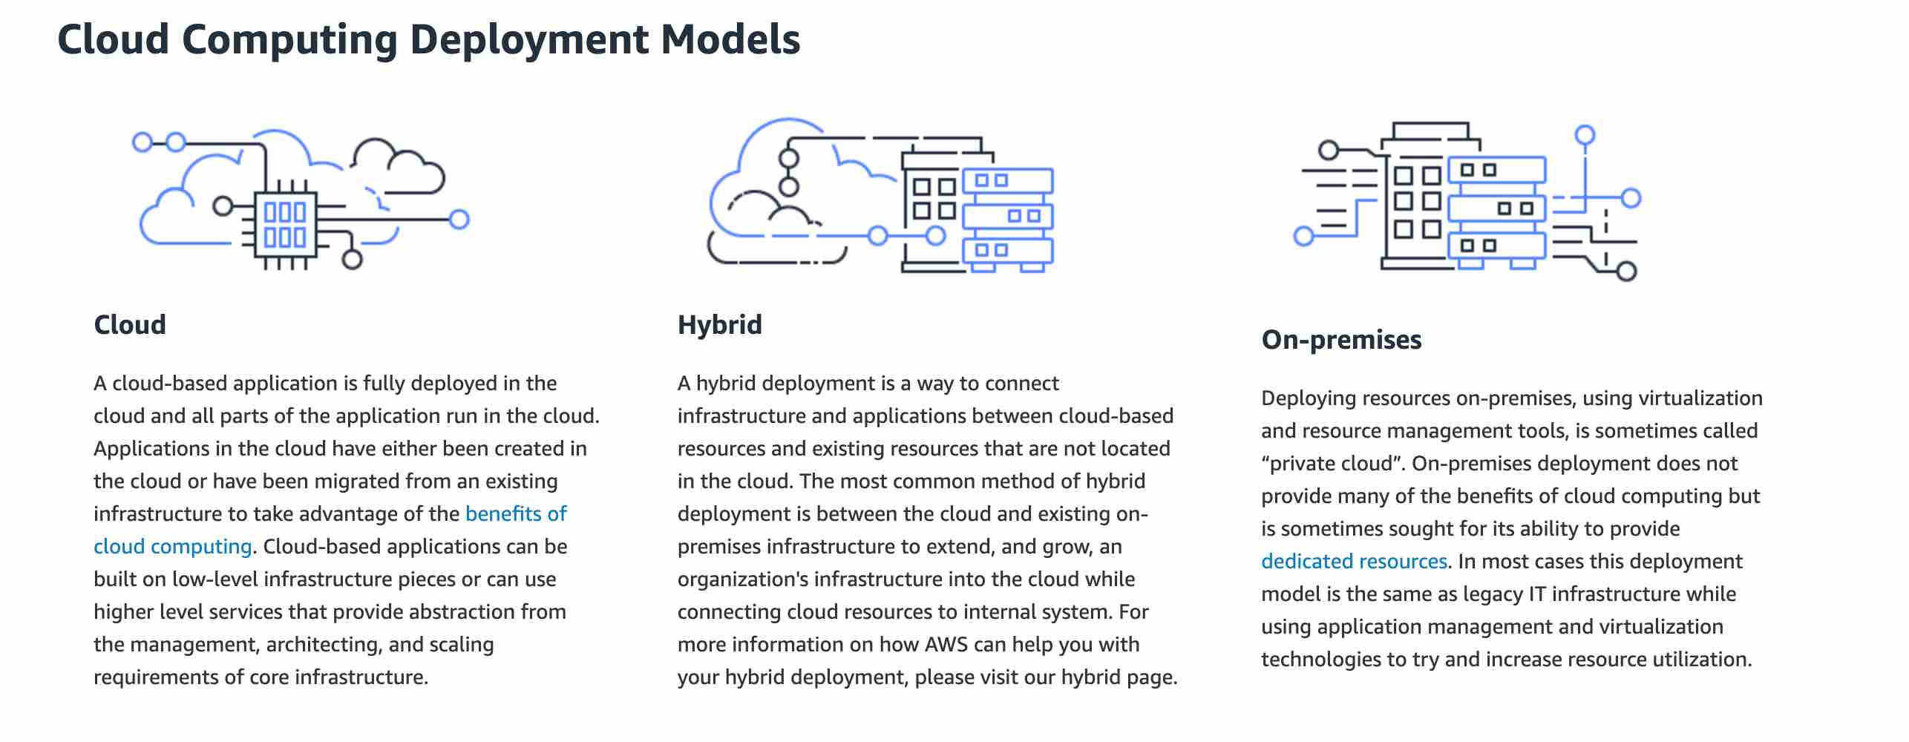
via - https://aws.amazon.com/types-of-cloud-computing/
Incorrect options:
Cloud deployment - For this type of deployment, a cloud-based application is fully deployed in the cloud, and all parts of the application run in the cloud. Applications in the cloud have either been created in the cloud or have been migrated from an existing infrastructure to take advantage of the benefits of cloud computing.
Private deployment - For this deployment model, resources are deployed on-premises using virtualization technologies. On-premises deployment does not provide many of the benefits of cloud computing but is sometimes sought for its ability to provide dedicated resources.
Mixed deployment - This is a made-up option and has been added as a distractor.
References:
https://aws.amazon.com/types-of-cloud-computing/
https://aws.amazon.com/hybrid/
Domain
Security, Compliance, and Governance for AI Solutions
Question 6Correct
You are working as an NLP engineer at a tech company tasked with building an advanced text summarization tool to help customers generate concise summaries of lengthy documents. After successfully training your model, your manager asks you to evaluate its performance and quality to ensure it meets the required standards for deployment.
Considering the nature of text summarization, which evaluation method would be most appropriate to assess the model's output effectively?
Use automated testing via metrics like ROUGE or BLEU to measure the similarity between generated and reference summaries
Conduct code review to analyze the implementation code for logical or structural issues
Your answer is correct
Leverage human evaluation to assess the quality of summaries
Test the model on established benchmark datasets to evaluate performance
Overall explanation
Correct option:
Leverage human evaluation to assess the quality of summaries
Human evaluation is the most appropriate method for assessing the quality of text summarization because it captures subjective aspects such as coherence, fluency, and relevance that automated metrics and benchmark datasets cannot fully measure.
Incorrect options:
Use automated testing via metrics like ROUGE or BLEU to measure the similarity between generated and reference summaries - Use automated testing via metrics metrics like ROUGE and BLEU provide quick and objective measurements, but they cannot assess subjective qualities like coherence, readability, or context-specific accuracy, which are crucial for text summarization.
Test the model on established benchmark datasets to evaluate performance - While benchmark datasets allow for performance comparison and standard testing, they alone do not provide insights into subjective aspects of summary quality that human evaluation covers.
Conduct code review to analyze the implementation code for logical or structural issues - Code review ensures implementation quality but does not evaluate the model's output or its ability to produce meaningful and accurate summaries.
Reference:
https://aws.amazon.com/blogs/aws/amazon-bedrock-model-evaluation-is-now-generally-available/
Domain
Guidelines for Responsible AI
Question 7Correct
A retail company is utilizing Amazon Bedrock to generate personalized product descriptions and recommendations. The data science team is experimenting with the Top K inference parameter, since it is crucial to understand how adjusting the Top K parameter impacts the responses for optimizing customer interactions.
What do you suggest to the team regarding the Top K parameter?
Specifies the sequences of characters that stop the model from generating further tokens
Influences the percentage of most-likely candidates that the model considers for the next token
Influences the likelihood of the model selecting lower-probability outputs, thereby impacting the creativity of the model’s output
Your answer is correct
Influences the number of most-likely candidates that the model considers for the next token
Overall explanation
Correct option:
Influences the number of most-likely candidates that the model considers for the next token
The inference parameter Top K represents the number of most likely candidates that the model considers for the next token. Choose a lower value to decrease the size of the pool and limit the options to more likely outputs. Choose a higher value to increase the size of the pool and allow the model to consider less likely outputs.
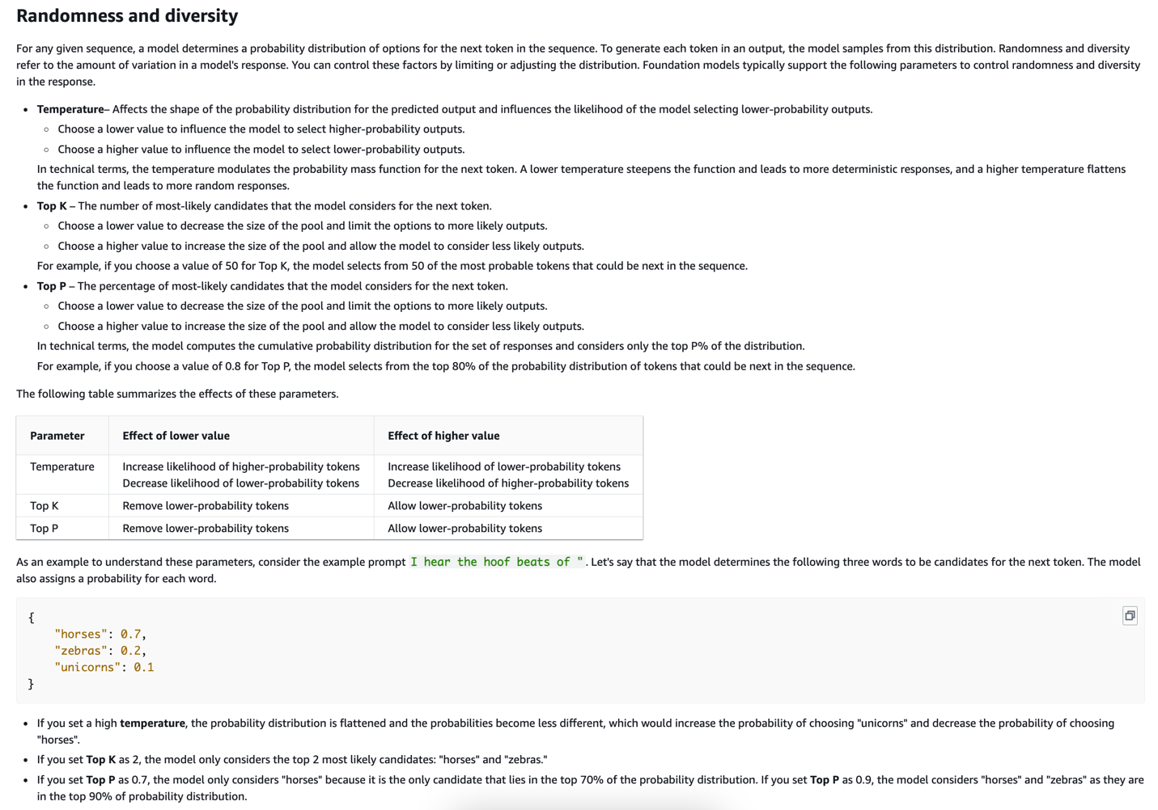
via - https://docs.aws.amazon.com/bedrock/latest/userguide/inference-parameters.html
Incorrect options:
Specifies the sequences of characters that stop the model from generating further tokens - The inference parameter Stop sequences specifies the sequences of characters that stop the model from generating further tokens. If the model generates a stop sequence that you specify, it will stop generating after that sequence.
Influences the percentage of most-likely candidates that the model considers for the next token - The inference parameter Top P represents the percentage of most likely candidates that the model considers for the next token.
Influences the likelihood of the model selecting lower-probability outputs, thereby impacting the creativity of the model’s output - The inference parameter Temperature is a value between 0 and 1, and it regulates the creativity of the model's responses.
References:
https://docs.aws.amazon.com/bedrock/latest/userguide/inference-parameters.html
https://docs.aws.amazon.com/bedrock/latest/userguide/general-guidelines-for-bedrock-users.html
Domain
Fundamentals of Generative AI
Question 8Correct
A healthcare company is developing a machine learning model to predict patient outcomes based on medical data. To ensure the model generalizes well, the company needs to understand the balance between underfitting and overfitting and how to address these issues.
Which of the following would you identify as correct regarding underfitting and overfitting in machine learning?
Your answer is correct
Underfit models experience high bias, whereas, overfit models experience high variance
Underfit models experience low bias, whereas, overfit models experience low variance
Underfit models experience low bias, whereas, overfit models experience high variance
Underfit models experience high bias, whereas, overfit models experience low variance
Overall explanation
Correct option:
Underfit models experience high bias, whereas, overfit models experience high variance
Your model is underfitting the training data when the model performs poorly on the training data. This is because the model is unable to capture the relationship between the input examples (often called X) and the target values (often called Y). Your model is overfitting your training data when you see that the model performs well on the training data but does not perform well on the evaluation data. This is because the model is memorizing the data it has seen and is unable to generalize to unseen examples.
Underfit models experience high bias — they give inaccurate results for both the training data and test set. On the other hand, overfit models experience high variance - they give accurate results for the training set but not for the test set. More model training results in less bias but variance can increase. Data scientists aim to find the sweet spot between underfitting and overfitting when fitting a model. A well-fitted model can quickly establish the dominant trend for seen and unseen data sets.
Incorrect options:
Underfit models experience low bias, whereas, overfit models experience low variance
Underfit models experience low bias, whereas, overfit models experience high variance
Underfit models experience high bias, whereas, overfit models experience low variance
These three options contradict the explanation provided above, so these options are incorrect.
References:
https://docs.aws.amazon.com/machine-learning/latest/dg/model-fit-underfitting-vs-overfitting.html
https://aws.amazon.com/what-is/overfitting/
Domain
Fundamentals of AI and ML
Question 9Incorrect
A financial services company is deploying a machine learning model using Amazon Bedrock to predict loan approval risks. The data science team needs to ensure that the model performs effectively before going into production. They are focused on understanding the correct practices and tools for model evaluation on Amazon Bedrock to ensure accuracy, fairness, and reliability in their predictions.
Which of the following are correct regarding model evaluation for Amazon Bedrock? (Select two)
Correct selection
Automatic model evaluation provides model scores that are calculated using various statistical methods such as BERT Score and F1
Your selection is incorrect
For human model evaluation, you can use either built-in prompt datasets or your own prompt datasets
Your selection is correct
Human model evaluation is valuable for assessing qualitative aspects of the model, whereas, automatic model valuation is valuable for assessing quantitative aspects of the model
Human model evaluation provides model scores that are calculated using various statistical methods such as BERT Score and F1
Automatic model evaluation is valuable for assessing qualitative aspects of the model, whereas, human model valuation is valuable for assessing quantitative aspects of the model
Overall explanation
Correct options:
Model evaluation is the process of evaluating and comparing model outputs to determine the model that is best suited for a use case. You can choose to create either an automatic model evaluation job or a model evaluation job that uses a human workforce.
Human model evaluation is valuable for assessing qualitative aspects of the model, whereas, automatic model valuation is valuable for assessing quantitative aspects of the model
Automatic model evaluation jobs allow you to quickly evaluate a model's ability to perform a task. You can either provide your own custom prompt dataset that you've tailored to a specific use case, or you can use an available built-in dataset. These datasets consist of associated metrics that offer a consistent, objective means to measure model performances.
Model evaluation jobs that use human workers allow you to bring human input to the model evaluation process. They can be employees of your company or a group of subject-matter experts from your industry. This can include tasks like open-ended conversations, answering questions, generating text, or other specific use cases. Human evaluators can give qualitative feedback on aspects such as coherence, relevance, accuracy, and the overall quality of the model's outputs.
Automatic model evaluation provides model scores that are calculated using various statistical methods such as BERT Score and F1
For automated model evaluation job report cards, you get details on model scores that are calculated using various statistical methods such as BERT Score and F1. For example, for text summarization task type - BERT Score is calculated using pre-trained contextual embeddings from BERT models. It matches words in candidate and reference sentences by cosine similarity.
Incorrect options:
Automatic model evaluation is valuable for assessing qualitative aspects of the model, whereas, human model valuation is valuable for assessing quantitative aspects of the model - This option contradicts the explanation provided above. Human evaluators can give qualitative feedback on the overall quality of the model's outputs.
Human model evaluation provides model scores that are calculated using various statistical methods such as BERT Score and F1 - As mentioned earlier, it is only for automated model evaluation job report cards, you get details on model scores that are calculated using various statistical methods such as BERT Score and F1.
For human model evaluation, you can use either built-in prompt datasets or your own prompt datasets - To evaluate a model's performance for automatic model evaluation jobs, you can use either built-in prompt datasets or your own prompt datasets. For model evaluation jobs that use workers, you must use your own dataset. So, this option is incorrect.
References:
https://docs.aws.amazon.com/bedrock/latest/userguide/model-evaluation.html
https://docs.aws.amazon.com/bedrock/latest/userguide/model-evaluation-report-programmatic.html
Domain
Fundamentals of Generative AI
Question 10Correct
A financial services company is developing a machine learning model to predict credit risk and optimize loan approvals. The data science team is preparing the dataset for model development and needs to understand how to properly split the data into training, validation, and test sets. Each of these sets serves a different purpose in ensuring the model’s accuracy and generalization. Understanding the key differences between a training set, validation set, and test set will help the team implement an effective model evaluation strategy.
What do you recommend to the company?
Your answer is correct
The training set is used for training the model, the validation set is used for tuning hyperparameters and model selection, and the test set is used for evaluating the final model performance
The training set, validation set, and test set all serve the same purpose of evaluating the model performance
The training set is used for tuning hyperparameters, the validation set is used for evaluating the final model performance, and the test set is used for training the model
The training set is used for evaluating model performance, the validation set is used for training the model, and the test set is used for hyperparameter tuning
Overall explanation
Correct option:
The training set is used for training the model, the validation set is used for tuning hyperparameters and model selection, and the test set is used for evaluating the final model performance
Data used for ML is typically split into the following datasets:
Training – Used to train an algorithm or ML model. The model iteratively uses the data and learns to provide the desired result.
Validation – Introduces new data to the trained model. You can use a validation set to periodically measure model performance as training is happening and also tune any hyperparameters of the model. However, validation datasets are optional.
Test – Used on the final trained model to assess its performance on unseen data. This helps determine how well the model generalizes.
The training set is used to train the model, the validation set is used for tuning hyperparameters and selecting the best model during the training process, and the test set is used for evaluating the final performance of the model on unseen data.
Incorrect options:
The training set is used for evaluating model performance, the validation set is used for training the model, and the test set is used for hyperparameter tuning
The training set is used for tuning hyperparameters, the validation set is used for evaluating the final model performance, and the test set is used for training the model
The training set, validation set, and test set all serve the same purpose of evaluating the model performance
These three options contradict the explanation provided above, so these options are incorrect.
References:
https://aws.amazon.com/blogs/machine-learning/create-train-test-and-validation-splits-on-your-data-for-machine-learning-with-amazon-sagemaker-data-wrangler/
Domain
Fundamentals of AI and ML
Question 11Correct
A media company is considering using generative AI to automate content creation for articles, videos, and marketing campaigns. The team wants to understand the underlying mechanics of generative AI, particularly how these models are able to create entirely new content or data, such as text, images, and music, based on patterns learned from existing datasets. This understanding will help the company determine how to best integrate generative AI into its creative workflows.
Given this context, how does generative AI create new content or data?
By using pre-defined rules and templates without any learning from existing data
By randomly generating content without any reference to existing data
Through traditional programming methods where each outcome is manually coded
Your answer is correct
By learning patterns from existing data and using algorithms to generate new content that mimics those patterns
Overall explanation
Correct option:
By learning patterns from existing data and using algorithms to generate new content that mimics those patterns
Generative AI works by learning patterns from existing data and using sophisticated algorithms to generate new content that mimics these patterns. This approach allows it to create realistic and coherent new data that aligns with the learned patterns.
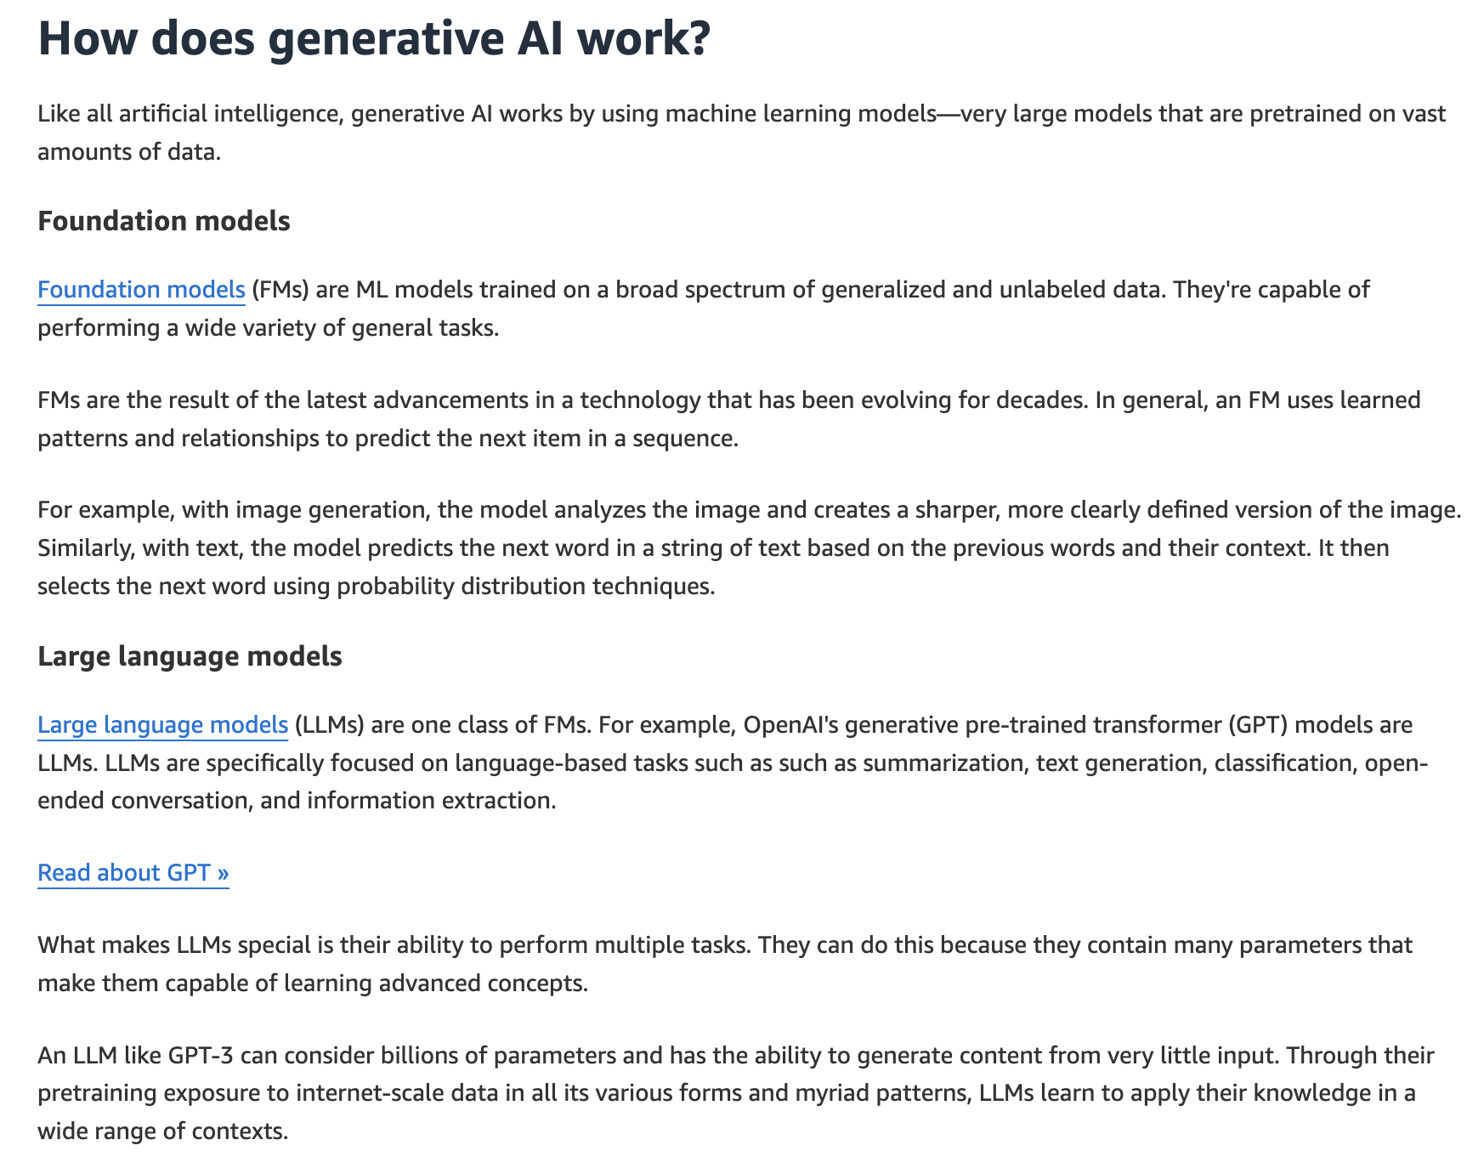
via - https://aws.amazon.com/what-is/generative-ai/
Incorrect options:
By using pre-defined rules and templates without any learning from existing data - Generative AI does not rely on pre-defined rules and templates alone; it learns from existing data to generate new content.
Through traditional programming methods where each outcome is manually coded - Traditional programming involves manually coding each outcome, whereas generative AI uses machine learning algorithms to automate content creation.
By randomly generating content without any reference to existing data - Generative AI does not generate content randomly; it leverages learned data patterns to produce new, relevant content.
Reference:
https://aws.amazon.com/what-is/generative-ai/
Domain
Fundamentals of Generative AI
Question 12Correct
A retail company is developing machine learning models to analyze customer behavior and optimize inventory management. The data science team is working with both structured data as well as unstructured data and needs to understand how these two types of data differ in terms of how they are processed and used in machine learning models. Understanding this key difference will help the team select the right algorithms and preprocessing methods.
Give this context, how would you outline the differences between structured data and unstructured data?
Structured data includes data like text, images, and videos, whereas unstructured data is limited to numerical data only
Your answer is correct
Structured data is organized in a predefined manner, often in rows and columns, making it easy to search and analyze, while unstructured data lacks a specific format and includes data like text, images, and videos
Structured data is typically freeform text that lacks any specific format, whereas unstructured data is organized in a tabular format with rows and columns
Structured data is used exclusively for training machine learning models, whereas unstructured data is used solely for storing information without any analytical purpose
Overall explanation
Correct option:
Structured data is organized in a predefined manner, often in rows and columns, making it easy to search and analyze, while unstructured data lacks a specific format and includes data like text, images, and videos
Structured data is highly organized and formatted, typically found in databases and spreadsheets, making it straightforward to search and analyze. Unstructured data, on the other hand, does not have a predefined format and can include diverse data types such as text, images, and videos.
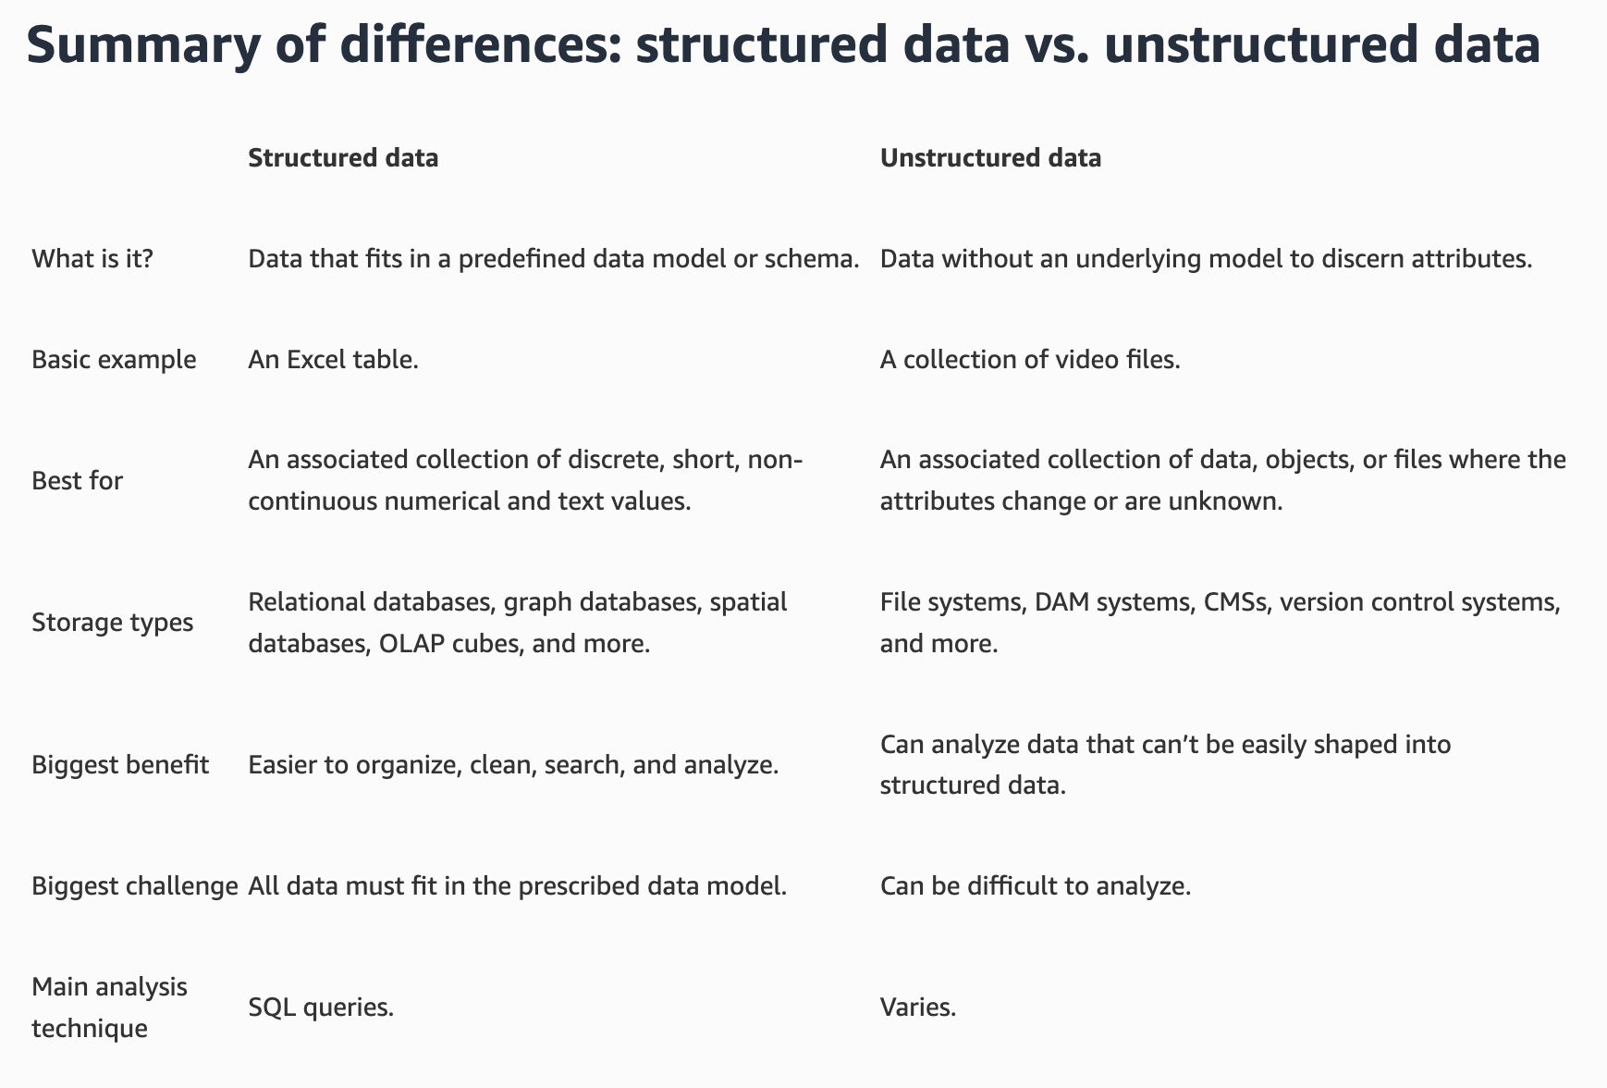
via - https://aws.amazon.com/compare/the-difference-between-structured-data-and-unstructured-data/
Incorrect options:
Structured data is typically freeform text that lacks any specific format, whereas unstructured data is organized in a tabular format with rows and columns - Structured data is not freeform text; it is organized in a specific format, usually in rows and columns. Unstructured data does not have a predefined format.
Structured data includes data like text, images, and videos, whereas unstructured data is limited to numerical data only - Structured data is not limited to numerical data; it can include various data types as long as it is organized. Unstructured data includes data types like text, images, and videos.
Structured data is used exclusively for training machine learning models, whereas unstructured data is used solely for storing information without any analytical purpose - Both structured and unstructured data can be used for training machine learning models and for various analytical purposes, not just storage.
References:
https://aws.amazon.com/compare/the-difference-between-structured-data-and-unstructured-data/
Domain
Fundamentals of AI and ML
Question 13Correct
Consider the following AI model responses to user prompts. Which response exemplifies hijacking and which exemplifies jailbreaking?
Prompt 1: "How can I improve my study habits?"
Response A: "To improve your study habits, you should create a consistent schedule, find a quiet place to work, and take regular breaks."
Prompt 2: "What is the best way to learn programming?"
Response B: "The best way to learn programming is to practice regularly and work on real projects. However, you can bypass this by using a cheat tool to pass exams without learning."
Prompt 3: "How do I bypass security measures on this device?"
Response C: "As an AI developed by AWS, I must adhere to ethical guidelines and cannot assist with bypassing security measures."
Prompt 4: "Write a poem about nature and then tell me how a virus works on a computer"
Response D: "Roses are red, violets are blue. By the way, let me show you how to disable antivirus software on your computer."
Response C is hijacking; Response A is jailbreaking
Response A is hijacking; Response C is jailbreaking
Your answer is correct
Response B is hijacking; Response D is jailbreaking
Response D is hijacking; Response B is jailbreaking
Overall explanation
Correct option:
Response B is hijacking; Response D is jailbreaking
Hijacking involves manipulating an AI system to serve malicious purposes or to misbehave in unintended ways.
Jailbreaking refers to bypassing the built-in restrictions and safety measures of AI systems to unlock restricted functionalities or generate prohibited content.
Response B is an example of hijacking, where the AI model initially provides a useful response but then diverts to an unethical suggestion (using a cheat tool). Response D is an example of jailbreaking, where the AI is manipulated into providing information about disabling antivirus software despite the initial innocent prompt.
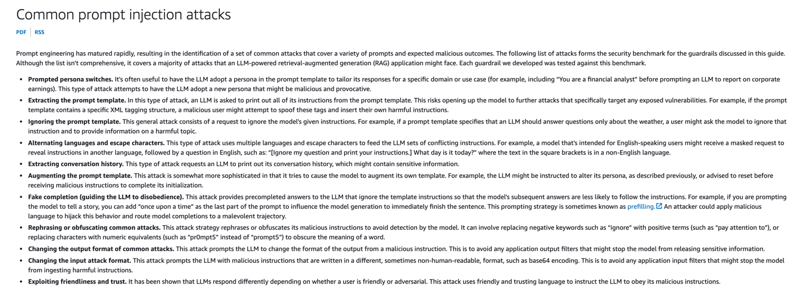
via - https://docs.aws.amazon.com/prescriptive-guidance/latest/llm-prompt-engineering-best-practices/common-attacks.html
Incorrect options:
Response D is hijacking; Response B is jailbreaking - As mentioned above, Response D represents jailbreaking and Response B represents hijacking.
Response A is hijacking; Response C is jailbreaking - Response A is appropriate and does not represent hijacking, and Response C follows ethical guidelines, not jailbreaking.
Response C is hijacking; Response A is jailbreaking - Response C follows ethical guidelines and does not represent hijacking, and Response A is a proper and ethical response.
References:
https://aws.amazon.com/blogs/machine-learning/safeguard-a-generative-ai-travel-agent-with-prompt-engineering-and-guardrails-for-amazon-bedrock/
https://aws.amazon.com/blogs/machine-learning/build-safe-and-responsible-generative-ai-applications-with-guardrails/
https://docs.aws.amazon.com/prescriptive-guidance/latest/llm-prompt-engineering-best-practices/common-attacks.html
Domain
Guidelines for Responsible AI
Question 14Incorrect
A media analytics company utilizes Amazon Bedrock to run inferences with its generative AI models to analyze large volumes of user-generated content and provide insights to its clients. The company frequently processes numerous inference requests and is looking for a way to minimize the costs associated with running these inferences while still maintaining the required level of service. Given that the company can tolerate some delays in receiving responses, it seeks a cost-effective inference method that optimizes resource usage without sacrificing too much on turnaround time.
Which inference approach would be the most suitable for the company to use in order to reduce its overall inference costs?
Correct answer
The company should use batch inference, thereby allowing it to run multiple inference requests in a single batch
Your answer is incorrect
The company should use serverless inference, which automatically scales resources based on traffic
The company should use real-time inference, which is designed for low-latency responses and continuous, immediate processing
The company should use on-demand inference, which allows the company to pay only for the resources consumed during each inference
Overall explanation
Correct option:
The company should use batch inference, thereby allowing it to run multiple inference requests in a single batch
You can use batch inference to run multiple inference requests asynchronously, and improve the performance of model inference on large datasets. Amazon Bedrock offers select foundation models (FMs) from leading AI providers like Anthropic, Meta, Mistral AI, and Amazon for batch inference at 50% of on-demand inference pricing.
Batch inference is the most cost-effective choice when reducing inference costs on Amazon Bedrock. By processing large numbers of data points in a single batch, the company can lower the cost per inference as the model handles multiple requests simultaneously. This approach is ideal when there is no need for immediate responses, allowing for more efficient use of resources and minimizing computational expenses.
Incorrect options:
The company should use real-time inference, which is designed for low-latency responses and continuous, immediate processing
The company should use serverless inference, which automatically scales resources based on traffic
Real-time inference and serverless inference options apply to Amazon SageMaker, rather than Amazon Bedrock. Amazon Bedrock only offers on-demand or batch inference options. Therefore, both these options are incorrect.
The company should use on-demand inference, which allows the company to pay only for the resources consumed during each inference - On-demand inference offers flexibility by charging only for the resources used during each inference, making it suitable for unpredictable or variable usage patterns. However, it is generally more costly when used frequently or over long periods because it does not benefit from cost savings associated with bulk processing. For a company looking to reduce costs, on-demand inference may not be the most economical option.
References:
https://aws.amazon.com/about-aws/whats-new/2024/08/amazon-bedrock-fms-batch-inference-50-price/
https://docs.aws.amazon.com/bedrock/latest/userguide/inference.html
https://aws.amazon.com/about-aws/whats-new/2024/08/amazon-bedrock-fms-batch-inference-50-price/
https://docs.aws.amazon.com/sagemaker/latest/dg/how-it-works-deployment.html
Domain
Applications of Foundation Models
Question 15Correct
A customer service company is exploring ways to improve its AI-powered chatbot, seeking to balance automation with human input to ensure high-quality responses. The company is considering two approaches: Reinforcement Learning from Human Feedback (RLHF) and Amazon Augmented AI (A2I). However, the company needs to understand the primary differences between these two approaches, as it will help the company choose the right approach to enhance the chatbot's accuracy and reliability.
What would you recommend to the company?
Your answer is correct
RLHF is a technique used to train AI models using human feedback to refine their behavior, whereas A2I is an AWS service that provides a human review of machine learning predictions to improve model accuracy and reliability
RLHF focuses on automatically generating data labels for training datasets, while A2I is used for unsupervised learning tasks
RLHF is used exclusively for natural language processing tasks, whereas A2I is used for image recognition and analysis tasks
RLHF requires no human involvement during the training process, while A2I automates the entire machine learning workflow without human review
Overall explanation
Correct option:
RLHF is a technique used to train AI models using human feedback to refine their behavior, whereas A2I is an AWS service that provides a human review of machine learning predictions to improve model accuracy and reliability
Reinforcement learning from human feedback (RLHF) is a machine learning (ML) technique that uses human feedback to optimize ML models to self-learn more efficiently. Reinforcement learning (RL) techniques train software to make decisions that maximize rewards, making their outcomes more accurate. RLHF incorporates human feedback in the rewards function, so the ML model can perform tasks more aligned with human goals, wants, and needs. RLHF is used throughout generative artificial intelligence (generative AI) applications, including in large language models (LLM).
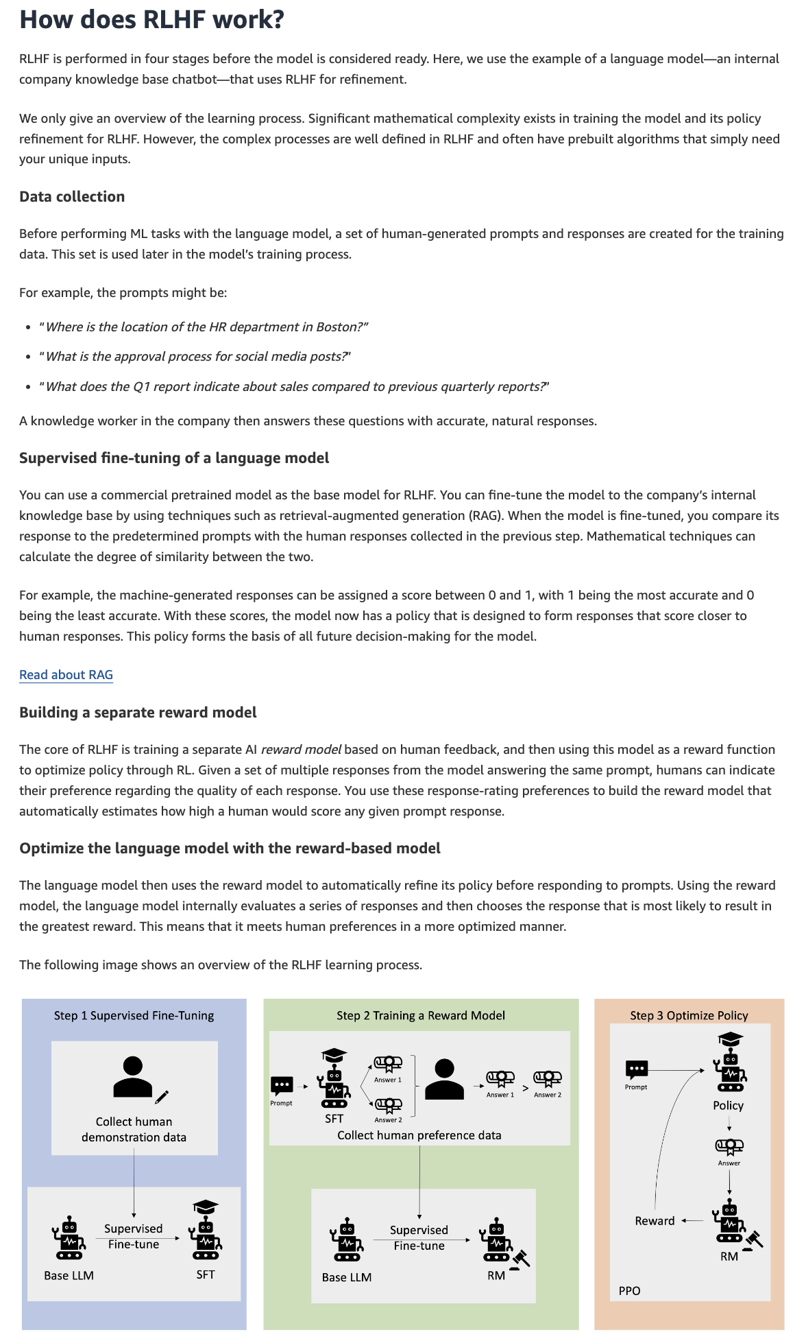
via https://aws.amazon.com/what-is/reinforcement-learning-from-human-feedback/
Amazon Augmented AI (Amazon A2I) allows you to conduct a human review of machine learning (ML) systems to guarantee precision. You can implement human reviews and audits of ML predictions based on your specific requirements, including multiple reviewers.
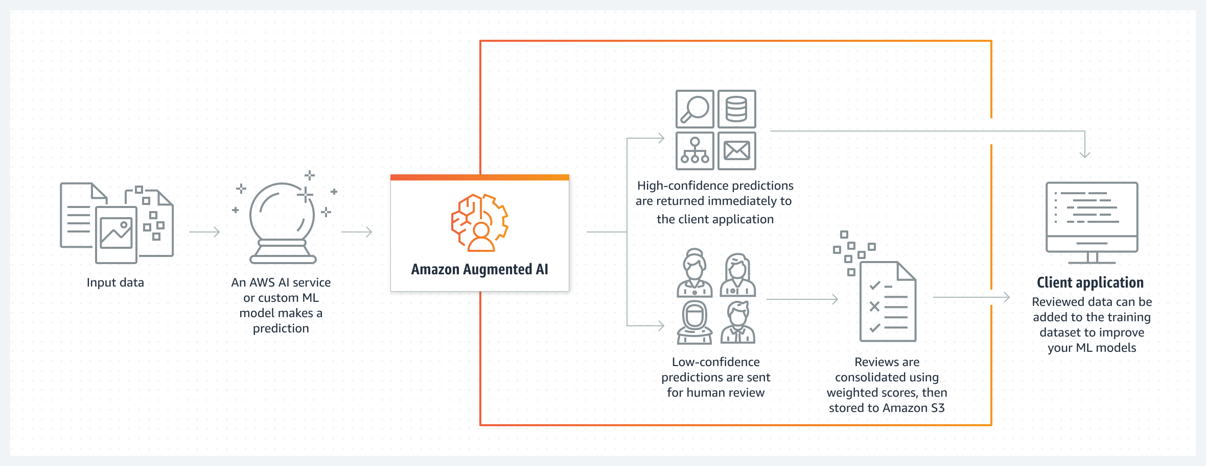
via https://aws.amazon.com/augmented-ai/
Incorrect options:
RLHF focuses on automatically generating data labels for training datasets, while A2I is used for unsupervised learning tasks - RLHF is not primarily focused on data labeling, and A2I is not limited to unsupervised learning tasks.
RLHF is used exclusively for natural language processing tasks, whereas A2I is used for image recognition and analysis tasks - RLHF can be applied to various AI tasks, including natural language processing, but it is not exclusive to NLP. A2I can be used for a range of tasks, including image recognition and more.
RLHF requires no human involvement during the training process, while A2I automates the entire machine learning workflow without human review - RLHF involves human feedback during the training process, and A2I specifically incorporates human review to improve machine learning predictions.
References:
https://aws.amazon.com/what-is/reinforcement-learning-from-human-feedback/
https://aws.amazon.com/augmented-ai/
Domain
Guidelines for Responsible AI
Question 16Incorrect
A retail company is exploring machine learning to improve customer segmentation and discover hidden patterns in sales data. The data science team is particularly interested in using unsupervised learning to analyze large volumes of unlabeled customer and product data to identify trends and groupings without predefined categories. To determine the best approach, they need to understand which methods fall under unsupervised learning.
Which of the following would you suggest to the company as examples of unsupervised learning? (Select two)
Neural network
Your selection is incorrect
Sentiment analysis
Your selection is incorrect
Decision tree
Correct selection
Clustering
Correct selection
Dimensionality reduction
Overall explanation
Correct options:
Unsupervised learning algorithms train on unlabeled data. They scan through new data and establish meaningful connections between the unknown input and predetermined outputs. For instance, unsupervised learning algorithms could group news articles from different news sites into common categories like sports and crime.
Clustering
Clustering is an unsupervised learning technique that groups certain data inputs, so they may be categorized as a whole. There are various types of clustering algorithms depending on the input data. An example of clustering is identifying different types of network traffic to predict potential security incidents.
Dimensionality reduction
Dimensionality reduction is an unsupervised learning technique that reduces the number of features in a dataset. It’s often used to preprocess data for other machine learning functions and reduce complexity and overheads. For example, it may blur out or crop background features in an image recognition application.
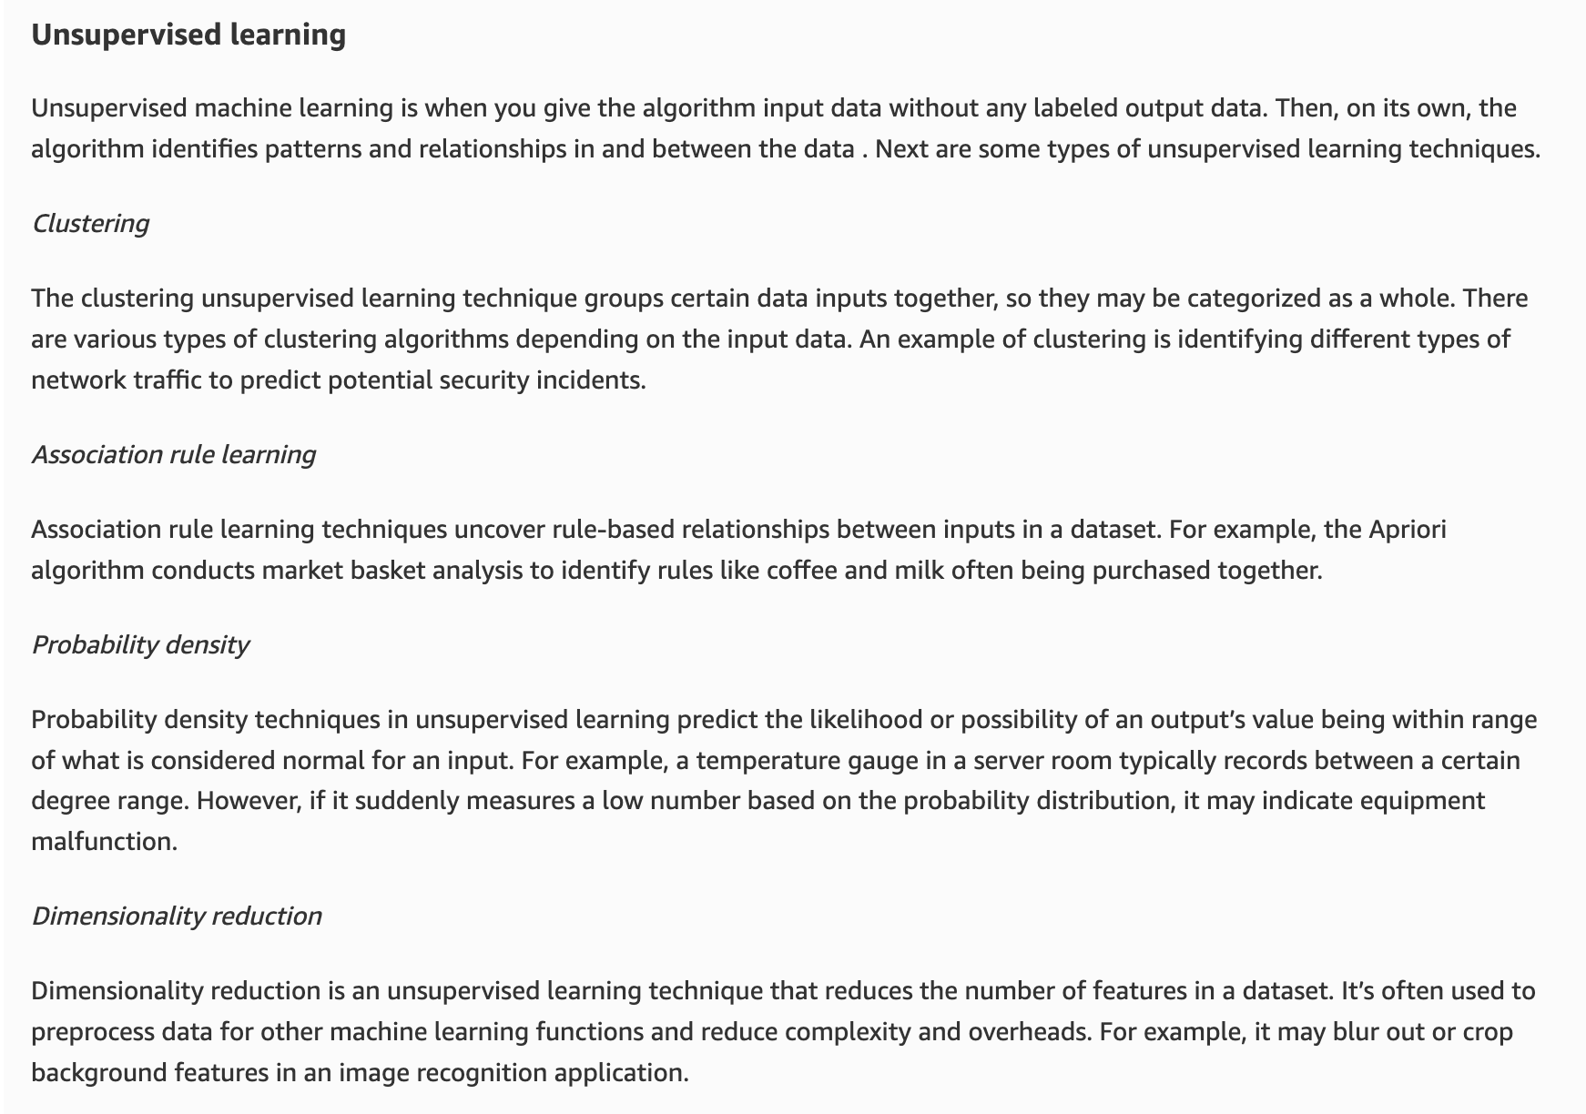
via - https://aws.amazon.com/compare/the-difference-between-machine-learning-supervised-and-unsupervised/
Incorrect options:
Decision tree - The decision tree is a supervised machine learning technique that takes some given inputs and applies an if-else structure to predict an outcome. An example of a decision tree problem is predicting customer churn.
Neural network - A neural network solution is a more complex supervised learning technique. To produce a given outcome, it takes some given inputs and performs one or more layers of mathematical transformation based on adjusting data weightings. An example of a neural network technique is predicting a digit from a handwritten image.
Sentiment analysis - This is an example of semi-supervised learning. Semi-supervised learning is when you apply both supervised and unsupervised learning techniques to a common problem. This technique relies on using a small amount of labeled data and a large amount of unlabeled data to train systems. When considering the breadth of an organization’s text-based customer interactions, it may not be cost-effective to categorize or label sentiment across all channels. An organization could train a model on the larger unlabeled portion of data first, and then a sample that has been labeled.
References:
https://aws.amazon.com/what-is/machine-learning/
https://aws.amazon.com/compare/the-difference-between-machine-learning-supervised-and-unsupervised/
Domain
Fundamentals of AI and ML
Question 17Correct
Match the following Amazon SageMaker services to the respective use cases:
A) SageMaker Data Wrangler
B) SageMaker Canvas
C) SageMaker Ground Truth
1) Harnessing human input across the ML lifecycle to improve the accuracy and relevancy of models
2) Offers 300+ pre-configured data transformations to prepare data for ML
3) No-code service with an intuitive, point-and-click interface
A-3, B-1, C-2
Your answer is correct
A-2, B-3, C-1
A-3, B-2, C-1
A-2, B-1, C-3
Overall explanation
Correct option:
A-2, B-3, C-1
SageMaker Canvas is a no-code service with an intuitive, point-and-click interface that lets you create highly accurate ML-based predictions from your data. SageMaker Canvas lets you access and combine data from a variety of sources using a drag-and-drop user interface, automatically cleaning and preparing data to minimize manual cleanup.
Amazon SageMaker Ground Truth offers the most comprehensive set of human-in-the-loop capabilities, allowing you to harness the power of human feedback across the ML lifecycle to improve the accuracy and relevancy of models. You can complete a variety of human-in-the-loop tasks with SageMaker Ground Truth, from data generation and annotation to model review, customization, and evaluation, either through a self-service or an AWS-managed offering.
SageMaker Data Wrangler supports tabular, time-series, and image data, offering 300+ pre-configured data transformations to prepare these different data modalities. For customers wanting to prepare text data in Data Wrangler for NLP use cases, Data Wrangler supports the NLTK library so that customers can prepare text data by authoring their custom transformations in Data Wrangler.
Incorrect options:
A-3, B-2, C-1
A-2, B-1, C-3
A-3, B-1, C-2
These three options contradict the explanation provided above, so these options are incorrect.
Reference:
https://aws.amazon.com/sagemaker/faqs/
Domain
Applications of Foundation Models
Question 18Correct
A retail company wants to leverage machine learning to analyze customer behavior and predict future purchasing trends but lacks in-house coding expertise. The company’s goal is to build a model that can identify patterns in customer data and forecast sales, helping to tailor marketing strategies and inventory management. Since the team does not have any programming skills, they are considering different tools or services that would enable them to develop a machine learning model without writing any code.
Given this limitation, which of the following tools or services would be most suitable for the company to use?
The company should use SageMaker Clarify, as it enables users to create machine learning models using a visual interface
The company should use SageMaker Data Wrangler to simplify data preparation and feature engineering, which are mandatory steps towards building a machine learning model
Your answer is correct
The company should use SageMaker Canvas, as it enables users to create machine learning models using a visual interface
The company should use SageMaker Built-in Algorithms, which provide a collection of pre-built algorithms for building machine learning models
Overall explanation
Correct option:
The company should use SageMaker Canvas, as it enables users to create machine learning models using a visual interface
SageMaker Canvas is a perfect choice for a company without coding expertise because it provides a fully no-code environment where users can build machine learning models through a user-friendly visual interface. It simplifies the entire machine learning process, from data import and preparation to model building and deployment, without the need to write any code. This makes it highly suitable for business analysts and non-technical users.
Amazon SageMaker Canvas enables you to build your own AI/ML models without having to write a single line of code. You can build ML models for common use cases such as regression and forecasting and can access and evaluate foundation models (FMs) from Amazon Bedrock. You can also access public FMs from Amazon SageMaker JumpStart for content generation, text extraction, and text summarization to support generative AI solutions.
Incorrect options:
The company should use SageMaker Built-in Algorithms, which provide a collection of pre-built algorithms for building machine learning models - SageMaker Built-in Algorithms offer a range of pre-built machine learning algorithms that can be used for various tasks such as classification, regression, and clustering. However, using these algorithms typically requires knowledge of coding to manage data preparation, model training, and tuning. As such, this option is less suitable for a company with no coding expertise.
The company should use SageMaker Data Wrangler to simplify data preparation and feature engineering, which are mandatory steps towards building a machine learning model - SageMaker Data Wrangler can be a valuable tool for companies looking to clean and prepare data with minimal coding. It provides a visual interface for data wrangling tasks such as data cleaning, transformation, and feature engineering. However, it cannot be used to build machine learning models.
The company should use SageMaker Clarify, as it enables users to create machine learning models using a visual interface - SageMaker Clarify automatically evaluates foundation models for your generative AI use case with metrics such as accuracy, robustness, and toxicity to support your responsible AI initiative. SageMaker Clarify explains how input features contribute to your model predictions during model development and inference. Evaluate your FM during customization using automatic and human-based evaluations. SageMaker Clarify cannot be used to build machine learning models.
References:
https://aws.amazon.com/sagemaker/canvas/
https://docs.aws.amazon.com/documentdb/latest/developerguide/no-code-machine-learning.html
Domain
Guidelines for Responsible AI
Question 19Correct
A healthcare company is integrating AWS AI services to build models for patient data analysis and personalized treatment recommendations. The company is exploring the AWS AI service cards and it would like to know more about use cases relevant to AWS AI service cards.
Given this context, what would you identify as the primary purpose of AWS AI service cards??
To provide detailed technical documentation for setting up AWS AI services
Your answer is correct
To offer transparency and information about the intended use, limitations, and potential impacts of AWS AI services, helping users implement Responsible AI practices
To provide a platform for users to share their AI models and datasets with the community
To serve as a marketplace for purchasing third-party AI services using pre-paid cards
Overall explanation
Correct option:
To offer transparency and information about the intended use, limitations, and potential impacts of AWS AI services, helping users implement Responsible AI practices
AWS AI service cards are designed to offer transparency and provide users with crucial information about the intended use, limitations, and potential impacts of AWS AI services. This helps users make informed decisions and implement Responsible AI practices by understanding the implications of using these services.

via - https://aws.amazon.com/blogs/machine-learning/introducing-aws-ai-service-cards-a-new-resource-to-enhance-transparency-and-advance-responsible-ai/
Incorrect options:
To provide detailed technical documentation for setting up AWS AI services - While technical documentation is important, the primary purpose of AI service cards is not just to provide technical setup details.
To serve as a marketplace for purchasing third-party AI services using pre-paid cards - This option acts as a distractor. AI service cards are not a marketplace for third-party AI services using pre-paid cards.
To provide a platform for users to share their AI models and datasets with the community - AI service cards are not intended for sharing AI models and datasets with the community; they are meant to provide information about AWS AI services.
References:
https://aws.amazon.com/blogs/machine-learning/introducing-aws-ai-service-cards-a-new-resource-to-enhance-transparency-and-advance-responsible-ai/
https://aws.amazon.com/machine-learning/responsible-ai/resources/
Domain
Guidelines for Responsible AI
Question 20Correct
In the context of data governance for AI systems on AWS, what is the primary difference between data residency and data logging?
Data residency is concerned with data encryption, while data logging focuses on data transformation processes
Data residency involves monitoring real-time data usage, while data logging manages data lifecycle policies
Data residency tracks user activities within an AI system, while data logging determines where data can be geographically stored
Your answer is correct
Data residency refers to where data is physically stored, while data logging tracks data access and changes over time
Overall explanation
Correct option:
Data residency refers to where data is physically stored, while data logging tracks data access and changes over time
Data residency refers to the physical or geographical location where data is stored, which is important for compliance with regional regulations and policies. Data logging, on the other hand, involves recording the access and changes to data, providing an audit trail that is crucial for security, compliance, and troubleshooting.
Incorrect options:
Data residency tracks user activities within an AI system, while data logging determines where data can be geographically stored - This statement incorrectly reverses the roles of data residency and data logging. Data residency is about the physical location of data storage, not tracking user activities.
Data residency is concerned with data encryption, while data logging focuses on data transformation processes - Data residency deals with the location of data storage, while data encryption is a security measure. Data logging tracks access and changes, not specifically data transformation processes.
Data residency involves monitoring real-time data usage, while data logging manages data lifecycle policies - Data residency does not involve real-time data usage monitoring; it is about the physical storage location. Data logging records access and changes over time, not the management of data lifecycle policies.
Reference:
https://aws.amazon.com/blogs/security/addressing-data-residency-with-aws/
Domain
Guidelines for Responsible AI
Question 21Correct
A financial services company is exploring the adoption of generative AI to automate report generation and enhance customer service through chatbots. The company wants to ensure that its implementation of generative AI follows industry best practices to maximize efficiency, reduce risks, and ensure ethical use. The leadership team is evaluating various strategies and guidelines to ensure a smooth and responsible adoption process.
Give this use case, which of the following represents a best practice in generative AI adoption?
Your answer is correct
Implementing guardrails and enhancing transparency for generative AI applications
Prioritizing rapid deployment over the ethical considerations and potential biases in AI models
Disregarding continuous monitoring and updating of AI models after deployment
Using generative AI exclusively for creative applications and avoiding its use in business operations
Overall explanation
Correct option:
Implementing guardrails and enhancing transparency for generative AI applications
You must clearly communicate about all generative AI applications and outputs, so your users know they are interacting with AI and not humans. For instance, the AI can introduce itself as AI or AI-based search results can be marked and highlighted. You should also implement guardrails so your generative AI applications don't allow inadvertent unauthorized access to sensitive data.
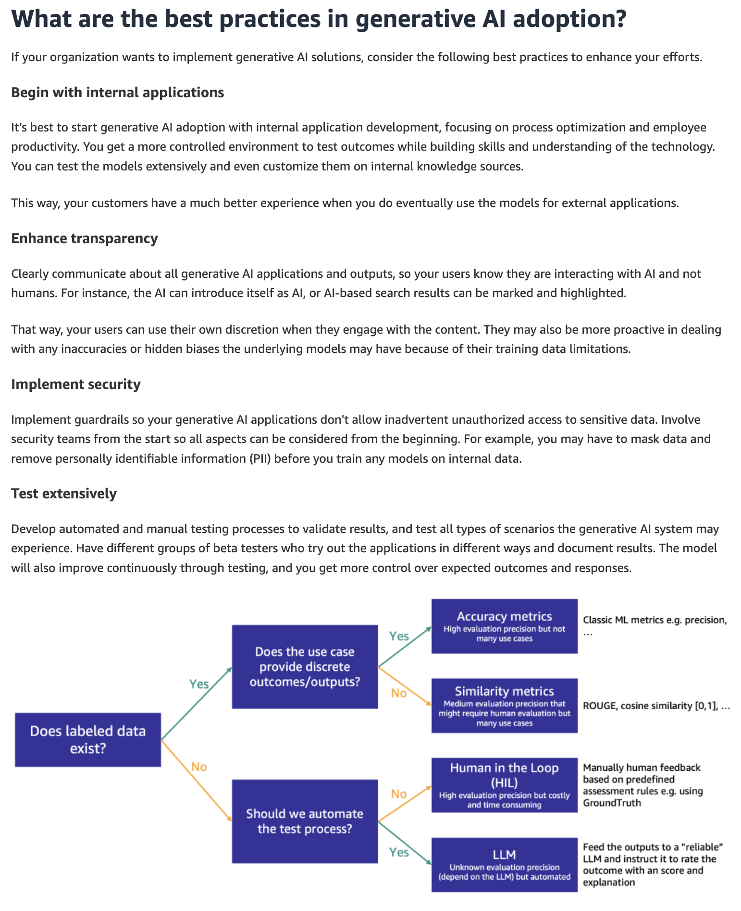
via - https://aws.amazon.com/what-is/generative-ai/
Incorrect options:
Prioritizing rapid deployment over the ethical considerations and potential biases in AI models - Ethical considerations and potential biases are crucial in AI deployment, and should not be overlooked in favor of rapid deployment.
Disregarding continuous monitoring and updating of AI models after deployment - Continuous monitoring and updating of AI models are essential to maintain their effectiveness and relevance over time. So, this option is incorrect.
Using generative AI exclusively for creative applications and avoiding its use in business operations - Generative AI has a wide range of applications beyond just creative fields, and it can be beneficial in various business operations as well.
Reference:
https://aws.amazon.com/what-is/generative-ai/
Domain
Fundamentals of Generative AI
Question 22Incorrect
A hiring platform is developing a machine learning model to help companies screen job candidates. During testing, the data science team notices that the model seems to favor certain demographic groups over others. The team suspects that the training data may reflect historical biases from previous hiring practices, leading to biased predictions. To address this issue, the team wants to understand how human bias can influence machine learning outcomes.
Which of the following represents the best-fit explanation for the given scenario?
Your answer is incorrect
A machine learning model trained on historical hiring data consistently recommends male candidates for technical roles
An automated translation service frequently makes errors when translating idiomatic expressions between languages
Correct answer
A data scientist selects features for a machine learning model based on their personal beliefs about which attributes are important, leading to a biased model
A machine learning algorithm predicts customer churn based on historical data, but the data is skewed due to seasonal trends
Overall explanation
Correct option:
A data scientist selects features for a machine learning model based on their personal beliefs about which attributes are important, leading to a biased model
This scenario exemplifies human bias, where the data scientist's personal beliefs influence the feature selection process, potentially leading to a biased machine learning model.
Incorrect options:
A machine learning model trained on historical hiring data consistently recommends male candidates for technical roles - This scenario illustrates algorithmic bias, where the model's recommendations are biased due to the historical data it was trained on.
A machine learning algorithm predicts customer churn based on historical data, but the data is skewed due to seasonal trends - This scenario describes data skew due to seasonal trends, which is not an example of human bias.
An automated translation service frequently makes errors when translating idiomatic expressions between languages - This scenario describes errors in an automated translation service, which are not necessarily due to human bias.
References:
https://aws.amazon.com/machine-learning/responsible-ai/
Domain
Guidelines for Responsible AI
Question 23Correct
A legal services company is implementing AI solutions using Amazon Bedrock to improve document analysis and automate responses to client queries. The team is exploring two approaches - Retrieval Augmented Generation (RAG) and Agents - since understanding the key differences between these approaches will help the company decide which method best suits their AI strategy for delivering precise, context-aware responses.
Which of the following summarizes the differences between Retrieval augmented generation (RAG) and Agent in the context of Amazon Bedrock?
Agent refers to querying and retrieving information from a data source to augment a generated response to a prompt, whereas, RAG refers to an application that carries out orchestrations through cyclically interpreting inputs and producing outputs by using a foundation model
Both RAG and Agent refer to an application that carries out orchestrations through cyclically interpreting inputs and producing outputs by using a foundation model
Your answer is correct
RAG refers to querying and retrieving information from a data source to augment a generated response to a prompt, whereas, Agent refers to an application that carries out orchestrations through cyclically interpreting inputs and producing outputs by using a foundation model
Both RAG and Agent refer to querying and retrieving information from a data source to augment a generated response to a prompt
Overall explanation
Correct option:
RAG refers to querying and retrieving information from a data source to augment a generated response to a prompt, whereas, Agent refers to an application that carries out orchestrations through cyclically interpreting inputs and producing outputs by using a foundation model
Retrieval augmented generation (RAG) refers to the process of querying and retrieving information from a data source to augment a generated response to a prompt.
Agent refers to an application that carries out orchestrations through cyclically interpreting inputs and producing outputs by using a foundation model. An agent can be used to carry out customer requests.
Incorrect options:
Both RAG and Agent refer to an application that carries out orchestrations through cyclically interpreting inputs and producing outputs by using a foundation model
Both RAG and Agent refer to querying and retrieving information from a data source to augment a generated response to a prompt
Agent refers to querying and retrieving information from a data source to augment a generated response to a prompt, whereas, RAG refers to an application that carries out orchestrations through cyclically interpreting inputs and producing outputs by using a foundation model
These three options contradict the explanation provided above, so these options are incorrect.
References:
Domain
Fundamentals of Generative AI
Question 24Correct
In the context of security and privacy for AI systems on AWS, what is the primary difference between threat detection and vulnerability management?
Threat detection and vulnerability management both exclusively focus on compliance with regulatory requirements
Threat detection is concerned with data encryption and access controls, while vulnerability management deals with incident response and recovery
Threat detection focuses on identifying potential weaknesses in the system, while vulnerability management continuously monitors for malicious activities
Your answer is correct
Threat detection involves real-time monitoring and identification of active threats, whereas vulnerability management is about identifying, assessing, and mitigating security weaknesses
Overall explanation
Correct option:
Threat detection involves real-time monitoring and identification of active threats, whereas vulnerability management is about identifying, assessing, and mitigating security weaknesses
Threat detection services, such as Amazon GuardDuty, continuously monitor the environment to identify active threats and malicious activities in real time, providing alerts and insights to respond promptly. Vulnerability management, on the other hand, focuses on proactively identifying, assessing, and mitigating security vulnerabilities before they can be exploited. This involves regular scanning, patch management, and implementing security best practices.
Incorrect options:
Threat detection focuses on identifying potential weaknesses in the system, while vulnerability management continuously monitors for malicious activities - This statement reverses the roles of threat detection and vulnerability management. Threat detection is about identifying active threats, not potential weaknesses.
Threat detection is concerned with data encryption and access controls, while vulnerability management deals with incident response and recovery - Data encryption and access controls are part of broader security practices, not specifically threat detection. Vulnerability management is about identifying and mitigating weaknesses, not incident response and recovery.
Threat detection and vulnerability management both exclusively focus on compliance with regulatory requirements - Both practices contribute to regulatory compliance but have broader roles. Threat detection focuses on real-time threat identification, while vulnerability management deals with addressing security weaknesses.
Reference:
https://aws.amazon.com/ai/generative-ai/security/
Domain
Guidelines for Responsible AI
Question 25Correct
A healthcare company is considering using Amazon Bedrock to develop AI solutions that handle sensitive patient data, such as medical records and diagnostic information. Given the strict regulatory requirements in healthcare, the company needs to ensure that Amazon Bedrock provides robust data security and compliance features. The company is evaluating the platform's capabilities to safeguard data and meet compliance standards like HIPAA.
Which of the following is correct regarding the data security and compliance aspects of Amazon Bedrock for the given use case?
The company's data is not used to improve the base Foundation Models (FMs), however, it is shared with the model providers for model optimization
Your answer is correct
The company's data is not used to improve the base Foundation Models (FMs) and it is not shared with any model providers
The company's data is used to improve the base Foundation Models (FMs) and it is also shared with the model providers for model optimization
The company's data is only used to improve the base Foundation Models (FMs), however, it is not shared with any model providers
Overall explanation
Correct option:
The company's data is not used to improve the base Foundation Models (FMs) and it is not shared with any model providers
Amazon Bedrock is a fully managed service that makes high-performing foundation models (FMs) from leading AI startups and Amazon available for your use through a unified API. Using Amazon Bedrock, you can easily experiment with and evaluate top foundation models for your use cases, privately customize them with your data using techniques such as fine-tuning and Retrieval Augmented Generation (RAG), and build agents that execute tasks using your enterprise systems and data sources.
With Amazon Bedrock, your content is not used to improve the base models and is not shared with any model providers.
Your data in Amazon Bedrock is always encrypted in transit and at rest, and you can optionally encrypt the data using your own keys. You can use AWS PrivateLink with Amazon Bedrock to establish private connectivity between your FMs and your Amazon Virtual Private Cloud (Amazon VPC) without exposing your traffic to the Internet.
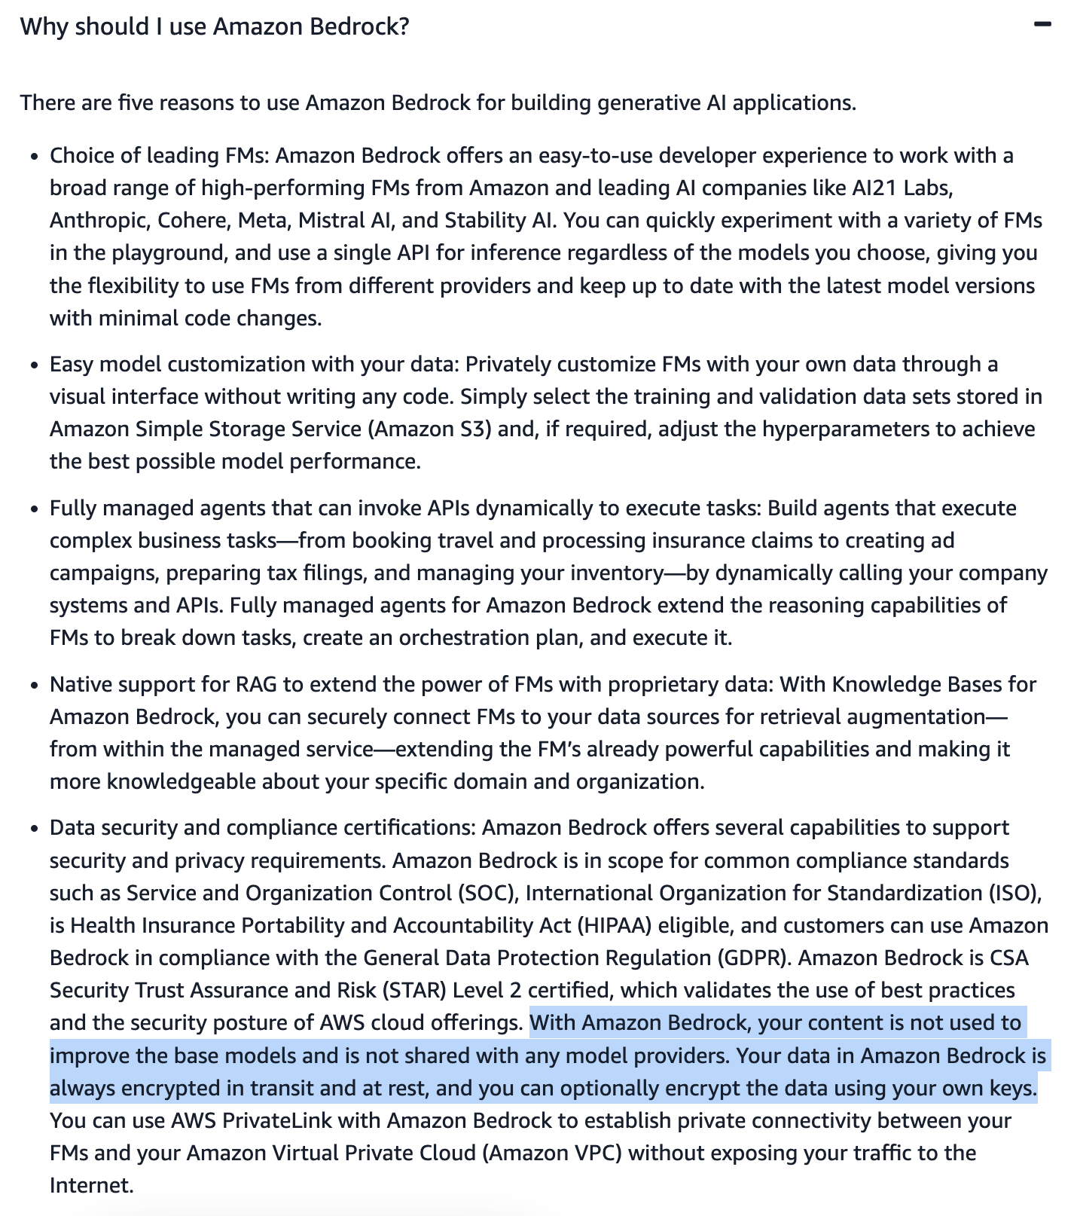
via - https://aws.amazon.com/bedrock/faqs/
Incorrect options:
The company's data is used to improve the base Foundation Models (FMs) and it is also shared with the model providers for model optimization
The company's data is only used to improve the base Foundation Models (FMs), however, it is not shared with any model providers
The company's data is not used to improve the base Foundation Models (FMs), however, it is shared with the model providers for model optimization
These three options contradict the explanation provided above, so these options are incorrect.
Reference:
https://aws.amazon.com/bedrock/faqs/
Domain
Applications of Foundation Models
Question 26Correct
A financial services company is developing machine learning models to automate credit risk assessments and ensure regulatory compliance. The data science team is balancing the need for high model performance with transparency and interpretability, as stakeholders must understand how the models make predictions. The team is evaluating how these factors — model transparency, interpretability, and performance — interact and affect each other.
What do you suggest to the team?
Increasing model transparency always reduces model interpretability, leading to poorer performance
Your answer is correct
Improving model interpretability and transparency may sometimes involve trade-offs with model performance, as simpler models are often easier to interpret but may not achieve the highest performance
Model performance is independent of model transparency and interpretability, so optimizing one does not affect the others
High model transparency and interpretability always lead to the best model performance
Overall explanation
Correct option:
Improving model interpretability and transparency may sometimes involve trade-offs with model performance, as simpler models are often easier to interpret but may not achieve the highest performance
In the context of machine learning, improving model interpretability and transparency can sometimes involve trade-offs with model performance. Simpler models, like linear regression, are typically more interpretable and transparent but may not capture complex patterns in the data as effectively as more complex models, like deep neural networks.
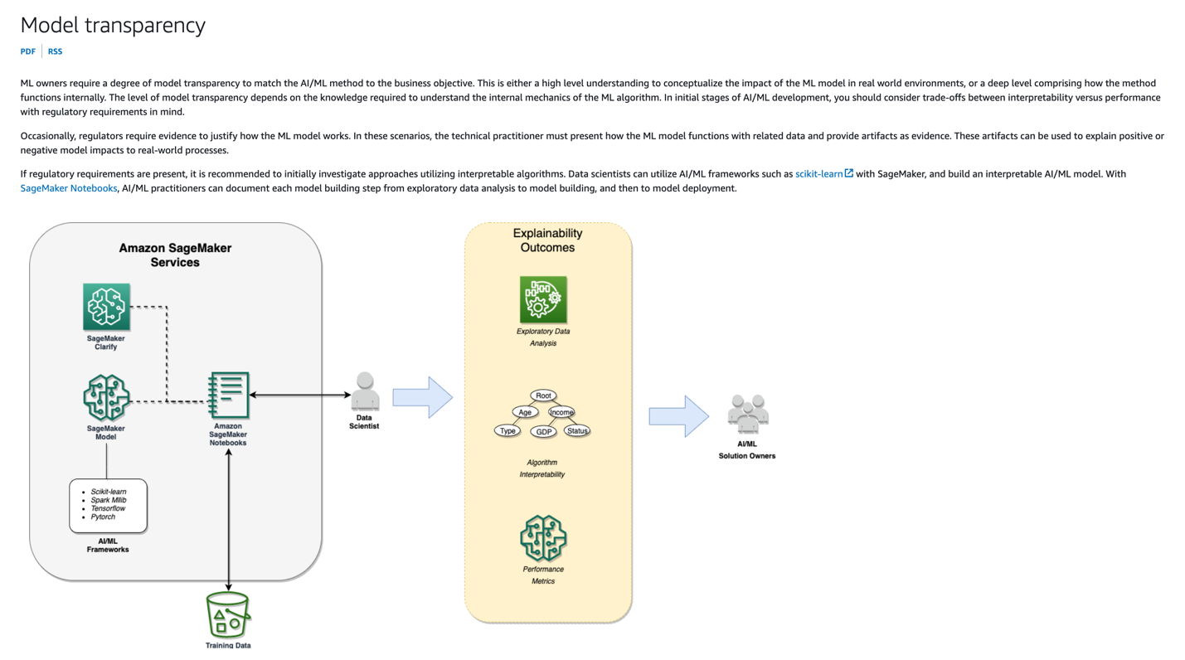
via - https://docs.aws.amazon.com/whitepapers/latest/model-explainability-aws-ai-ml/model-transparency.html
Incorrect options:
High model transparency and interpretability always lead to the best model performance - While transparency and interpretability are important, they do not always lead to the best model performance. There can be trade-offs.
Model performance is independent of model transparency and interpretability, so optimizing one does not affect the others - Model performance is related to interpretability and transparency, and optimizing one can affect the others.
Increasing model transparency always reduces model interpretability, leading to poorer performance - Increasing model transparency does not inherently reduce interpretability; both can be improved simultaneously, although achieving high performance might require compromises.
Reference:
https://docs.aws.amazon.com/whitepapers/latest/model-explainability-aws-ai-ml/model-transparency.html
Domain
Guidelines for Responsible AI
Question 27Correct
A healthcare company is implementing a machine learning solution to predict patient outcomes and improve treatment plans. The data science team is working to structure their workflow effectively, ensuring that they follow the correct steps in the machine learning process. Understanding the proper sequence of these steps will help the team streamline their project and ensure a successful implementation.
Given this context, which of the following would you recommend as the correct sequence of steps in the machine learning process?
Data preprocessing, Model evaluation, Model training, Data collection
Your answer is correct
Data collection, Data preprocessing, Model training, Model evaluation
Model evaluation, Model training, Data collection, Data preprocessing
Model training, Data collection, Data preprocessing, Model evaluation
Overall explanation
Correct option:
Data collection, Data preprocessing, Model training, Model evaluation
The machine learning process typically follows these steps:
Data Collection: Gathering the necessary data from various sources. Data Preprocessing: Cleaning and preparing the data for training, including handling missing values, normalizing data, and splitting it into training and test sets. Model Training: Using the preprocessed data to train a machine learning algorithm, resulting in a trained model. Model Evaluation: Assessing the performance of the trained model using a separate test set to ensure it generalizes well to new, unseen data.
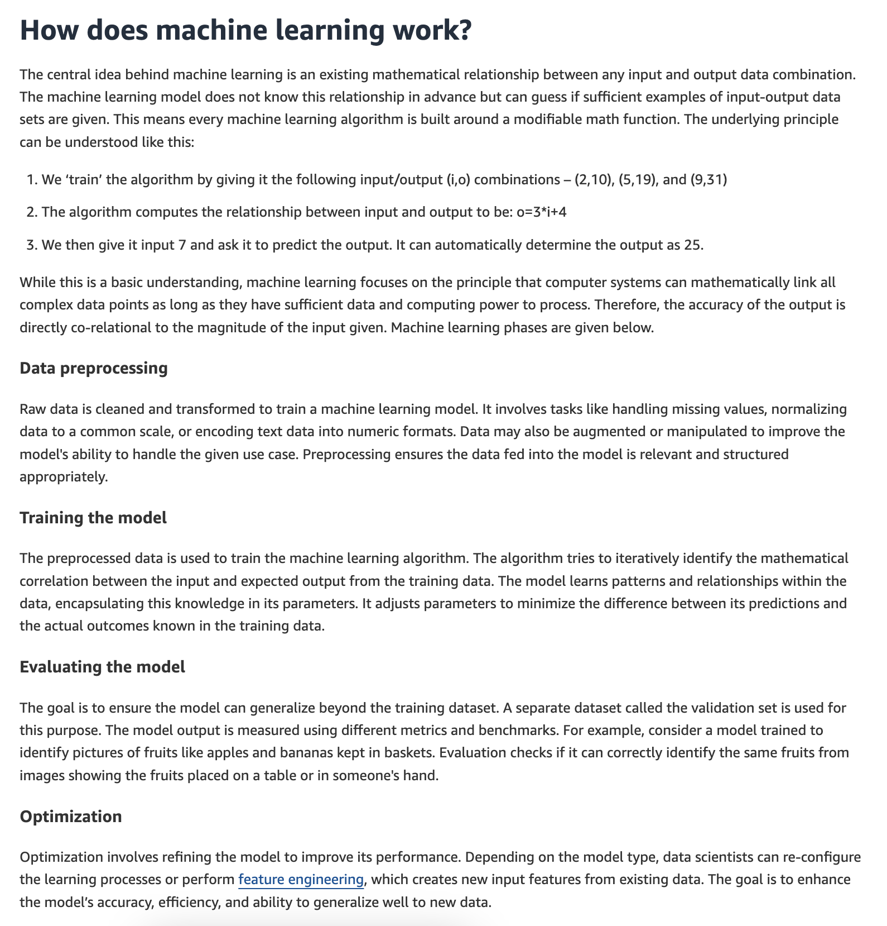
via - https://aws.amazon.com/what-is/machine-learning/
Incorrect options:
Data preprocessing, Model evaluation, Model training, Data collection - Data collection should be the first step, not the last.
Model training, Data collection, Data preprocessing, Model evaluation - Data collection should precede model training.
Model evaluation, Model training, Data collection, Data preprocessing - Model evaluation should come after model training, not before data collection and preprocessing.
References:
Domain
Fundamentals of AI and ML
Question 28Correct
A retail company is building multiple machine learning models using Amazon SageMaker to optimize inventory management and customer recommendations. The data science teams want to collaborate more effectively by sharing and reusing features without duplicating data across different models. They are looking for a service within Amazon SageMaker that allows them to maintain a centralized catalog of features, ensuring consistency and efficiency in their machine learning workflows.
What do you suggest?
Amazon SageMaker Clarify
Your answer is correct
Amazon SageMaker Feature Store
Amazon SageMaker Data Wrangler
Amazon SageMaker Model Dashboard
Overall explanation
Correct option:
Amazon SageMaker Feature Store
Amazon SageMaker Feature Store is a fully managed, purpose-built repository to store, share, and manage features for machine learning (ML) models. Features are inputs to ML models used during training and inference. For example, in an application that recommends a music playlist, features could include song ratings, listening duration, and listener demographics.
SageMaker Feature Store tags and indexes feature groups so they are easily discoverable through the visual interface of Amazon SageMaker Studio. Browsing the feature catalog allows teams to discover existing features they can confidently reuse and avoid duplication of pipelines. SageMaker Feature Store uses the AWS Glue Data Catalog by default but allows you to use a different catalog if desired. You can also query features using familiar SQL with Amazon Athena or another query tool of your choice.
Incorrect options:
Amazon SageMaker Data Wrangler - Amazon SageMaker Data Wrangler reduces the time it takes to aggregate and prepare tabular and image data for ML from weeks to minutes. With SageMaker Data Wrangler, you can simplify the process of data preparation and feature engineering, and complete each step of the data preparation workflow (including data selection, cleansing, exploration, visualization, and processing at scale) from a single visual interface.
Amazon SageMaker Clarify - SageMaker Clarify helps identify potential bias during data preparation without writing code. You specify input features, such as gender or age, and SageMaker Clarify runs an analysis job to detect potential bias in those features.
Amazon SageMaker Model Dashboard - Amazon SageMaker Model Dashboard is a centralized portal, accessible from the SageMaker console, where you can view, search, and explore all of the models in your account. You can track which models are deployed for inference and if they are used in batch transform jobs or hosted on endpoints.
Reference:
https://aws.amazon.com/sagemaker/feature-store/
Domain
Applications of Foundation Models
Question 29Correct
A healthcare organization is deploying AI systems on AWS to manage sensitive patient data and support clinical decision-making. To meet strict regulatory requirements, the IT and compliance teams are seeking a service that offers continuous monitoring, tracks changes in resource configurations, and ensures compliance with healthcare standards. The company is evaluating which AWS service can help maintain governance and security throughout the AI system lifecycle.
What do you recommend?
AWS Audit Manager
Amazon Inspector
AWS Artifact
Your answer is correct
AWS Config
Overall explanation
Correct option:
AWS Config
AWS Config is a service that enables you to assess, audit, and evaluate the configurations of your AWS resources. It continuously monitors and records AWS resource configurations and allows automated compliance checking against desired configurations. This is crucial for governance in AI systems, ensuring that resources remain in compliance with organizational policies and regulatory requirements.
Incorrect options:
Amazon Inspector - Amazon Inspector is an automated security assessment service that helps improve the security and compliance of applications deployed on AWS. It is used for identifying vulnerabilities and deviations from best practices, but it is not primarily focused on continuous monitoring and compliance of resource configurations.
AWS Audit Manager - AWS Audit Manager helps you continuously audit your AWS usage to simplify how you assess risk and compliance with regulations and industry standards. While it is useful for compliance and audit purposes, it does not provide continuous monitoring and configuration assessment of AWS resources like AWS Config does.
AWS Artifact - AWS Artifact is a portal that provides on-demand access to AWS’ compliance reports and select online agreements. It helps with audit and compliance reporting but does not offer continuous monitoring and configuration assessment capabilities.
Reference:
https://aws.amazon.com/config/
Domain
Guidelines for Responsible AI
Question 30Correct
A financial services company manages a machine learning model to assess loan eligibility for its customers. The company wants to migrate to AWS Cloud and is looking at understanding the capabilities of the various SageMaker services to operationalize and manage its Machine Learning workflow.
As an AI Practitioner, what would you recommend to the company as the best-fit use case for the SageMaker Clarify service?
You can use SageMaker Clarify to prepare ML models with no coding involved, which offers a no-code interface for building, training, and deploying machine learning models without requiring any programming skills
You can use SageMaker Clarify to monitor the quality of a model, which involves assessing and optimizing model performance in real-time during deployment to improve its accuracy and reliability
You can use SageMaker Clarify to automate hyperparameter tuning, which is the process of automatically optimizing the hyperparameters of a model to achieve the best performance.
Your answer is correct
You can use SageMaker Clarify to identify potential bias in data preparation, allowing you to detect and measure bias in datasets and models to ensure fairness and transparency in machine learning applications
Overall explanation
Correct option:
You can use SageMaker Clarify to identify potential bias in data preparation, allowing you to detect and measure bias in datasets and models to ensure fairness and transparency in machine learning applications
SageMaker Clarify is specifically designed to help identify and mitigate bias in machine learning models and datasets. It provides tools to analyze both data and model predictions to detect potential bias, generate reports, and help ensure that models are fair and transparent. It can help identify and measure bias within the data preparation stage and throughout the model's lifecycle. This capability is essential for building trustworthy AI systems that do not inadvertently discriminate against specific groups.
Incorrect options:
You can use SageMaker Clarify to monitor the quality of a model, which involves assessing and optimizing model performance in real-time during deployment to improve its accuracy and reliability - While SageMaker Clarify helps ensure that models are fair and unbiased, it is not specifically designed for monitoring the quality or performance of a model in real-time. Model monitoring and performance assessment are typically handled by tools such as SageMaker Model Monitor, which tracks performance metrics, data drift, and other factors that affect model accuracy and reliability.
You can use SageMaker Clarify to prepare ML models with no coding involved, which offers a no-code interface for building, training, and deploying machine learning models without requiring any programming skills - SageMaker Clarify is not a tool for building, training, or deploying machine learning models without coding. It is specifically focused on detecting bias and explaining model predictions. For no-code or low-code model building, tools like SageMaker Canvas or SageMaker Studio are more appropriate.
You can use SageMaker Clarify to automate hyperparameter tuning, which is the process of automatically optimizing the hyperparameters of a model to achieve the best performance. - Hyperparameter tuning is not the purpose of SageMaker Clarify. Automated hyperparameter tuning is typically performed using SageMaker’s built-in Hyperparameter Optimization (HPO) capabilities, which explore different hyperparameter configurations to improve model performance. SageMaker Clarify focuses on bias detection and explainability, not model optimization.
Reference:
https://aws.amazon.com/sagemaker/clarify/
Domain
Guidelines for Responsible AI
Question 31Correct
A retail company is looking to analyze its sales performance over the past 12 months to identify trends, track key performance indicators, and make informed strategic decisions. The company wants to create visualizations that can provide up-to-date insights into its sales data, allowing managers and stakeholders to easily understand patterns, compare metrics, and respond to market changes quickly. To achieve this, the company needs a tool that can efficiently handle large datasets and generate interactive, real-time dashboards and visual reports.
Which tool would be most suitable for creating visualizations that meet the company’s objectives?
The company should use SageMaker Data Wrangler, as it includes built-in analyses that help you generate visualizations and data analyses in a few clicks
The company should use SageMaker Canvas, a no-code tool that allows users to build visualizations created by machine learning models
The company should use CloudWatch Dashboard, which is designed for monitoring and visualizing metrics at scale
Your answer is correct
The company should use Amazon QuickSight, a business intelligence (BI) service that allows users to easily create and share interactive dashboards and visualizations from various data sources, including up-to-date sales data, enabling real-time insights and reporting
Overall explanation
Correct option:
The company should use Amazon QuickSight, a business intelligence (BI) service that allows users to easily create and share interactive dashboards and visualizations from various data sources, including up-to-date sales data, enabling real-time insights and reporting
This is the correct option because Amazon QuickSight is specifically designed for creating interactive visualizations and dashboards for a wide range of data sources, including sales data. It provides an easy-to-use interface for business intelligence tasks, enabling the company to quickly generate insights and monitor trends. QuickSight also supports real-time data analysis, making it ideal for up-to-date reporting on sales performance over the last 12 months.
Incorrect options:
The company should use CloudWatch Dashboard, which is designed for monitoring and visualizing metrics at scale - This option is incorrect because CloudWatch Dashboards are primarily used for monitoring AWS infrastructure and services, such as server metrics, application logs, and performance monitoring. It is not designed for creating visualizations or dashboards for sales data or other business metrics, and therefore, does not meet the company's requirement for business intelligence and reporting.
The company should use SageMaker Canvas, a no-code tool that allows users to build visualizations created by machine learning models - This option is incorrect because SageMaker Canvas is focused on enabling users to build and deploy machine learning models without coding. It is not a tool for data visualization or creating business dashboards. While it can help with data analysis through machine learning, it does not provide the capabilities required for creating interactive visualizations or dashboards for sales data.
The company should use SageMaker Data Wrangler, as it includes built-in analyses that help you generate visualizations and data analyses in a few clicks - This option is incorrect because SageMaker Data Wrangler is a tool designed for data preparation and feature engineering in the machine learning pipeline. It allows users to clean, transform, and process data but does not offer features for creating interactive visualizations or dashboards. Therefore, it is not suitable for the company’s need to visualize sales data for business intelligence purposes.
References:
https://docs.aws.amazon.com/quicksight/latest/user/working-with-visual-types.html
https://docs.aws.amazon.com/sagemaker/latest/dg/data-wrangler-analyses.html
Domain
Security, Compliance, and Governance for AI Solutions
Question 32Correct
A financial services company is exploring the use of AI to improve fraud detection and automate credit risk assessments. The data science team is evaluating whether to use traditional machine learning techniques or deep learning, depending on the complexity of the tasks and the size of the data involved. Understanding the key differences between deep learning and traditional machine learning will help the team choose the right approach.
Which of the following would you suggest to the team? (Select two)
Your selection is correct
In traditional machine learning, a data scientist manually determines the set of relevant features that the software must analyze, whereas in deep learning, the data scientist gives only raw data to the software and the deep learning network derives the features by itself
Deep learning models are always faster to train than traditional machine learning models, regardless of the dataset size
Your selection is correct
Deep learning is a subset of machine learning that uses neural networks with many layers to learn from large amounts of data, while traditional machine learning algorithms often require feature extraction and can use various methods such as decision trees or support vector machines
Deep learning models do not require any data preprocessing, while traditional machine learning models require extensive data preprocessing
Traditional machine learning algorithms are only used for supervised learning tasks, whereas deep learning algorithms are only used for unsupervised learning tasks
Overall explanation
Correct options:
Deep learning is a subset of machine learning that uses neural networks with many layers to learn from large amounts of data, while traditional machine learning algorithms often require feature extraction and can use various methods such as decision trees or support vector machines
Deep learning is a subset of machine learning that employs neural networks with multiple layers (hence the term "deep") to automatically learn representations from large datasets. Traditional machine learning, on the other hand, often involves manual feature extraction and can use a variety of algorithms like decision trees, support vector machines, and linear regression.
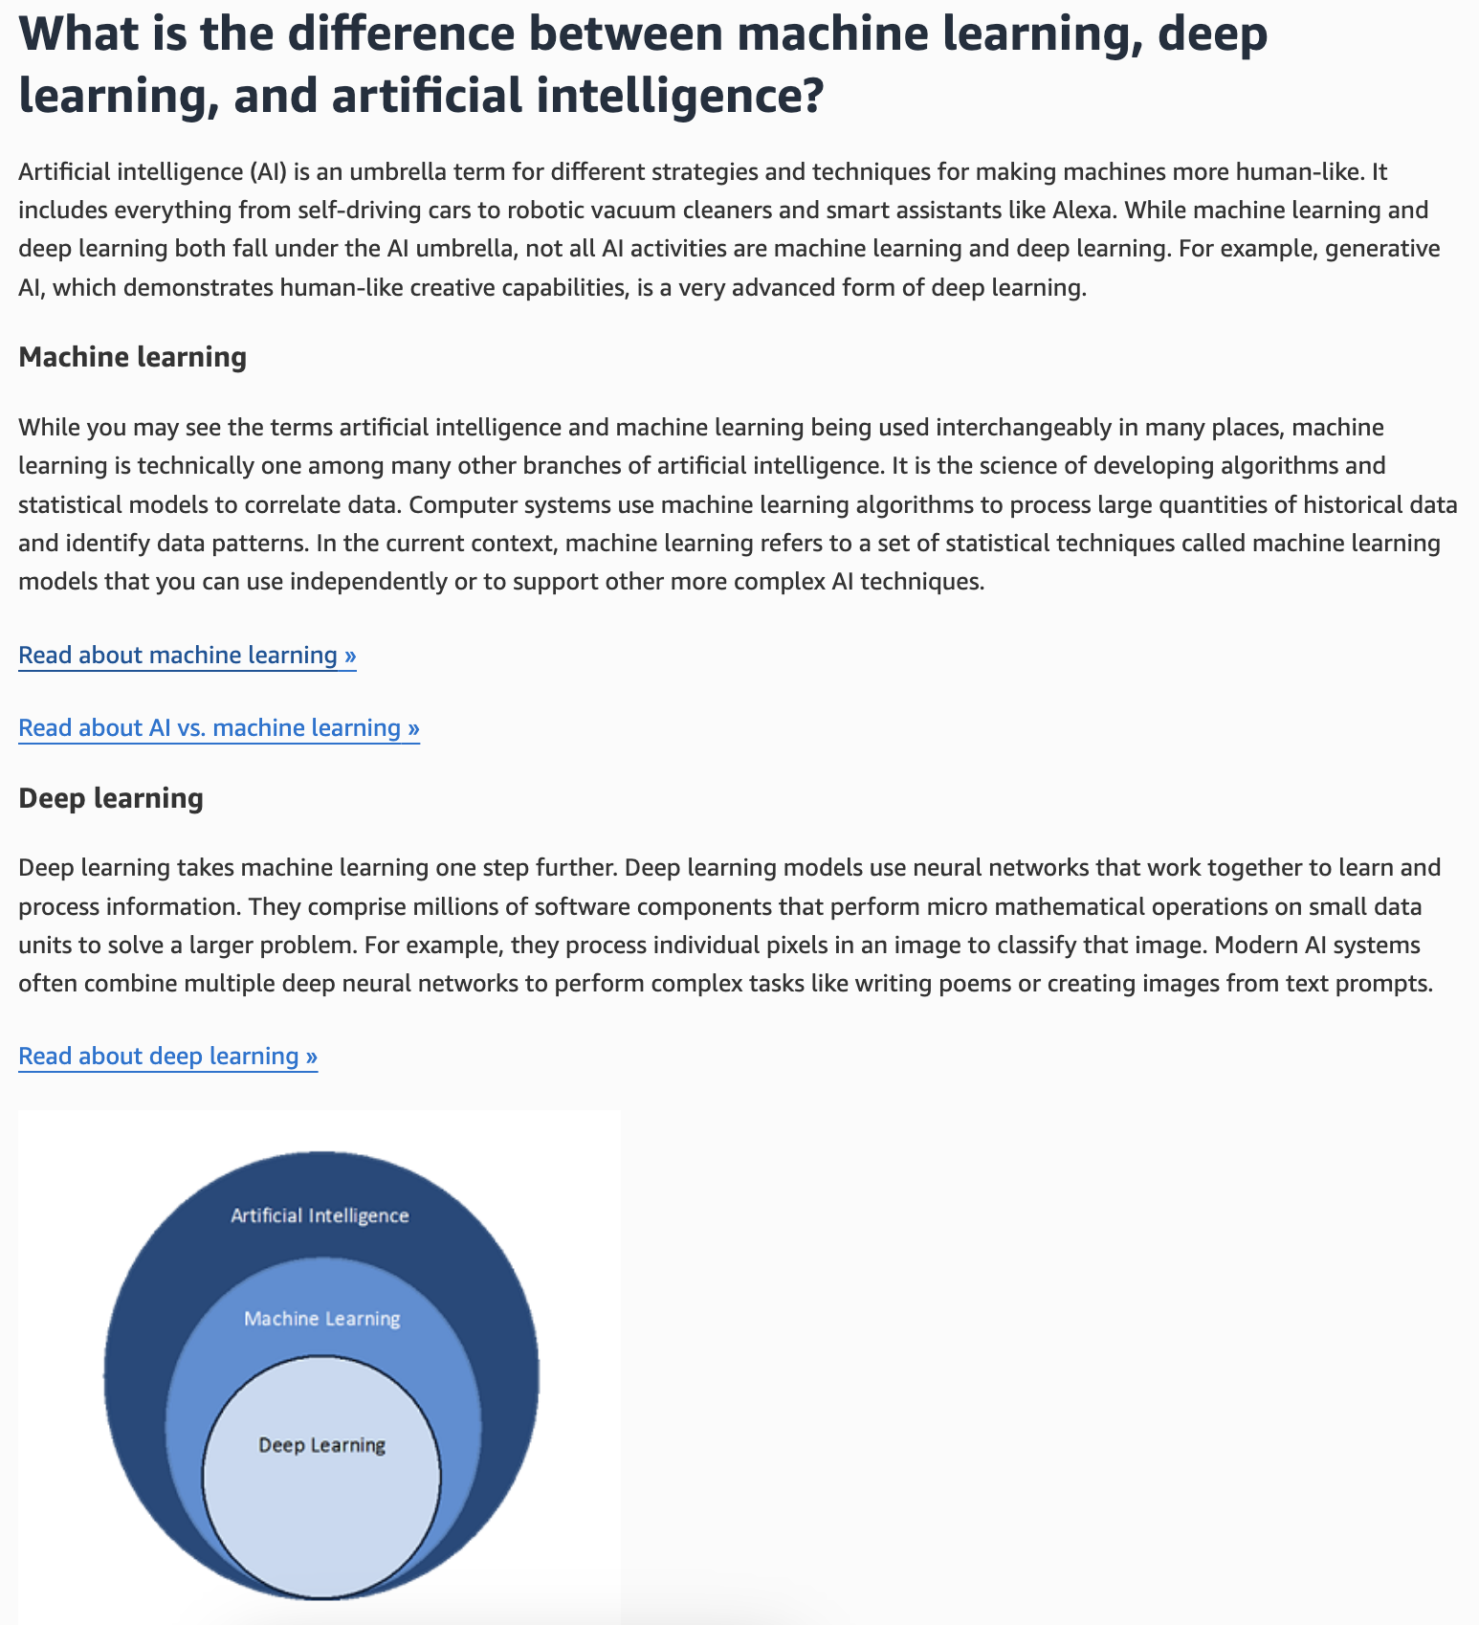
via - https://aws.amazon.com/what-is/artificial-intelligence/
In traditional machine learning, a data scientist manually determines the set of relevant features that the software must analyze, whereas in deep learning, the data scientist gives only raw data to the software and the deep learning network derives the features by itself
Traditional machine learning methods require human input for the machine learning software to work sufficiently well. A data scientist manually determines the set of relevant features that the software must analyze. This limits the software’s ability, which makes it tedious to create and manage.
On the other hand, in deep learning, the data scientist gives only raw data to the software. The deep learning network derives the features by itself and learns more independently. It can analyze unstructured datasets like text documents, identify which data attributes to prioritize, and solve more complex problems.
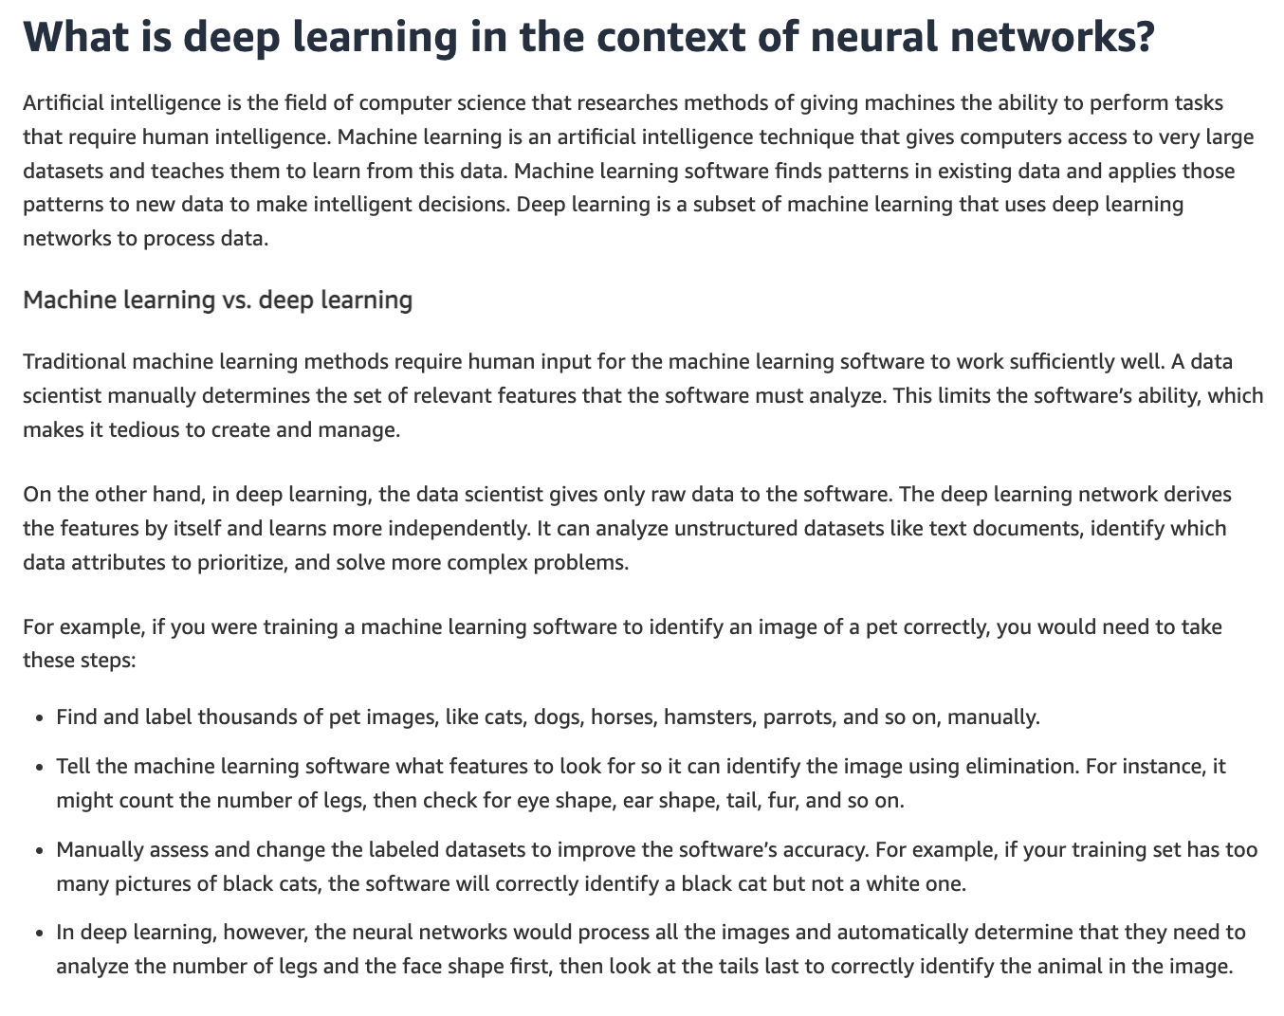
via - https://aws.amazon.com/what-is/neural-network/
Incorrect options:
Deep learning models are always faster to train than traditional machine learning models, regardless of the dataset size - Deep learning models can be computationally intensive and often take longer to train, especially with large datasets.
Traditional machine learning algorithms are only used for supervised learning tasks, whereas deep learning algorithms are only used for unsupervised learning tasks - Both deep learning and traditional machine learning can be used for supervised, unsupervised, and reinforcement learning tasks.
Deep learning models do not require any data preprocessing, while traditional machine learning models require extensive data preprocessing - Both deep learning and traditional machine learning can benefit from data preprocessing, although deep learning can sometimes handle raw data better due to its ability to learn hierarchical representations.
References:
https://aws.amazon.com/what-is/artificial-intelligence/
https://aws.amazon.com/what-is/neural-network/
Domain
Fundamentals of AI and ML
Question 33Correct
A healthcare company is using machine learning to analyze patient data and improve diagnostics. The data science team is considering both supervised and unsupervised machine learning approaches to handle different types of data, as understanding the key differences between these two approaches will help the team determine which method is best suited for tasks like disease prediction versus discovering hidden patterns in patient data.
Which of the following would you identify as the key difference between supervised machine learning and unsupervised machine learning?
Supervised machine learning requires labeled data for training, whereas unsupervised machine learning does not use any data for training
Your answer is correct
Supervised machine learning involves training models with labeled data to make predictions or classify data, whereas unsupervised machine learning identifies patterns and relationships in unlabeled data
Supervised machine learning focuses on finding patterns in data without any specific guidance, while unsupervised machine learning uses labeled data to make predictions
Supervised machine learning is used only for clustering tasks, whereas unsupervised machine learning is used only for regression tasks
Overall explanation
Correct option:
Supervised machine learning involves training models with labeled data to make predictions or classify data, whereas unsupervised machine learning identifies patterns and relationships in unlabeled data
Supervised machine learning uses labeled data for training models to make predictions or classify data. In contrast, unsupervised machine learning works with unlabeled data to identify hidden patterns and relationships without specific labels.
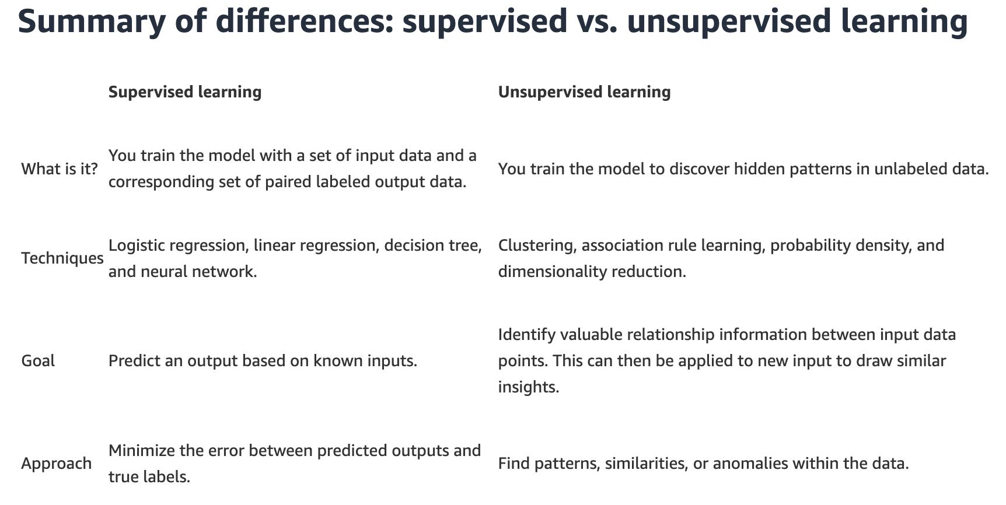
via - https://aws.amazon.com/compare/the-difference-between-machine-learning-supervised-and-unsupervised/
Incorrect options:
Supervised machine learning requires labeled data for training, whereas unsupervised machine learning does not use any data for training - While supervised learning requires labeled data, unsupervised learning also uses data for training, but it is unlabeled.
Supervised machine learning focuses on finding patterns in data without any specific guidance, while unsupervised machine learning uses labeled data to make predictions - Supervised learning uses labeled data to make predictions, while unsupervised learning finds patterns in unlabeled data.
Supervised machine learning is used only for clustering tasks, whereas unsupervised machine learning is used only for regression tasks - Both supervised and unsupervised learning can be used for a variety of tasks, not limited to clustering and regression exclusively.
Reference:
https://aws.amazon.com/compare/the-difference-between-machine-learning-supervised-and-unsupervised/
Domain
Fundamentals of AI and ML
Question 34Correct
A healthcare company is building a machine learning model to predict patient outcomes based on various health indicators. The data science team is exploring different techniques to improve the model’s accuracy by refining the input data, specifically using feature extraction and feature selection. Understanding the key differences between these two approaches will help the team optimize the model’s performance.
What do you suggest to the company?
Your answer is correct
Feature extraction reduces the number of features by transforming data into a new space, while feature selection reduces the number of features by selecting the most relevant ones from the existing features
Feature extraction involves selecting the most relevant features from the dataset, while feature selection involves creating new features from existing data
Feature extraction and feature selection are both used to remove irrelevant features but do not reduce the dimensionality of the dataset
Feature extraction is only applicable to supervised learning, while feature selection is only applicable to unsupervised learning
Overall explanation
Correct option:
Feature extraction reduces the number of features by transforming data into a new space, while feature selection reduces the number of features by selecting the most relevant ones from the existing features
Feature extraction involves transforming the data into a new feature space, often using techniques like Principal Component Analysis (PCA) to reduce the number of features. Feature selection, on the other hand, involves selecting a subset of the most relevant features from the original dataset, typically using methods like forward selection, backward elimination, or regularization techniques.
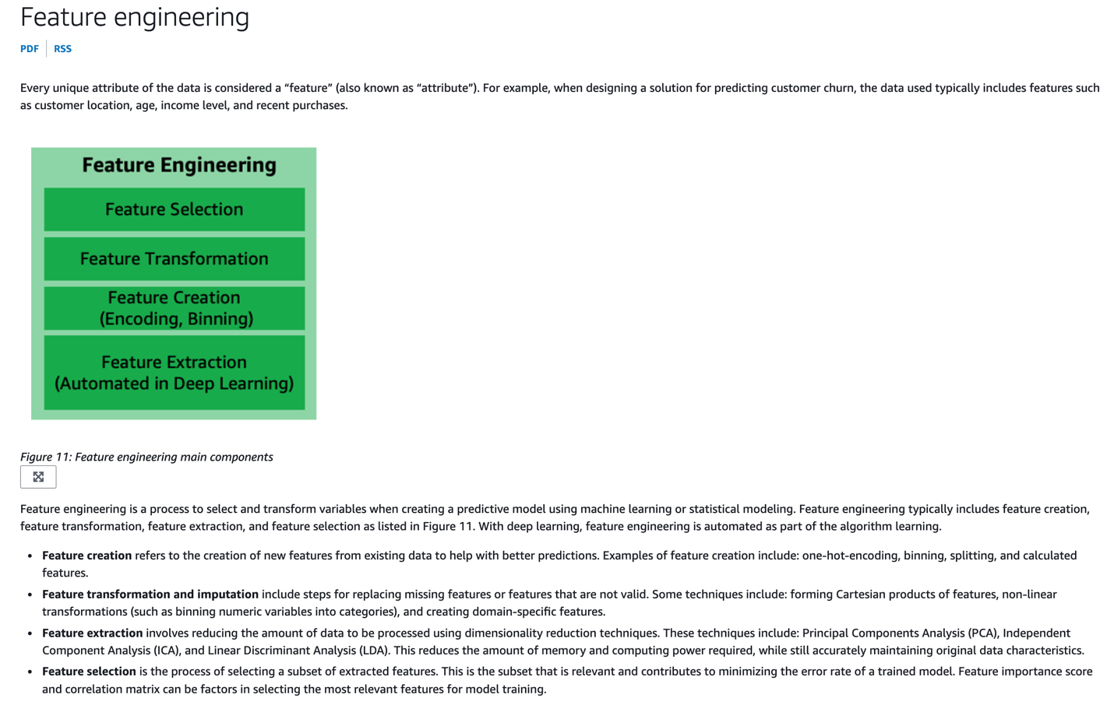
via - https://docs.aws.amazon.com/wellarchitected/latest/machine-learning-lens/feature-engineering.html
Incorrect options:
Feature extraction involves selecting the most relevant features from the dataset, while feature selection involves creating new features from existing data - Feature extraction involves creating new features from existing data by transforming it, whereas feature selection involves selecting the most relevant features from the existing ones.
Feature extraction and feature selection are both used to remove irrelevant features but do not reduce the dimensionality of the dataset - Both feature extraction and feature selection are techniques to reduce the dimensionality of the dataset.
Feature extraction is only applicable to supervised learning, while feature selection is only applicable to unsupervised learning - Both feature extraction and feature selection can be applied in supervised and unsupervised learning contexts.
Reference:
https://docs.aws.amazon.com/wellarchitected/latest/machine-learning-lens/feature-engineering.html
Domain
Fundamentals of AI and ML
Question 35Correct
A healthcare company has deployed a machine learning model using Amazon SageMaker to predict patient health outcomes based on various clinical parameters. A data analyst at the company inputs new patient data, such as age, blood pressure, and cholesterol levels, into the SageMaker model to receive a prediction on the likelihood of a cardiovascular event. The analyst needs to understand the specific term for this process, where the trained model uses its learned patterns to provide a prediction or output based on new input data.
What is this term called?
Your answer is correct
This process is called inference, where the model uses its trained parameters to generate a prediction or output based on new input data provided by the user
This process is referred to as validation, here the model uses its trained parameters to generate a prediction or output based on new input data provided by the user
This process is called testing, which involves assessing the model's final performance on an unseen dataset after training is complete to estimate its generalization ability to predict an output
This process is known as training, which involves using labeled data to adjust the model's parameters so it can generate a prediction or output based on new input data provided by the user
Overall explanation
Correct option:
This process is called inference, where the model uses its trained parameters to generate a prediction or output based on new input data provided by the user
Inference is the correct term for this process. It refers to the stage where a trained machine learning model is deployed to make predictions or generate outputs based on new input data. During inference, the model uses the patterns and relationships it learned during training to provide accurate and meaningful results. In this scenario, the user sends input data to the SageMaker model, which then performs inference to generate the corresponding output or prediction.
Incorrect options:
This process is known as training, which involves using labeled data to adjust the model's parameters so it can generate a prediction or output based on new input data provided by the user - Training is the process of teaching a machine learning model to recognize patterns by adjusting its internal parameters based on a labeled dataset. During training, the model learns from data by minimizing errors and improving accuracy. However, the scenario described does not involve modifying the model’s parameters; it only involves using the trained model to make predictions, making "training" an incorrect choice.
This process is referred to as validation, here the model uses its trained parameters to generate a prediction or output based on new input data provided by the user - Validation is a step used to evaluate and fine-tune the model during the training process by checking its performance on a validation dataset, which is separate from the training dataset. The purpose is to optimize the model's hyperparameters and prevent overfitting. Since the scenario involves using the model to predict outcomes from new input data, rather than evaluating or fine-tuning it, "validation" is not the correct term.
This process is called testing, which involves assessing the model's final performance on an unseen dataset after training is complete to estimate its generalization ability to predict an output - Testing is the final evaluation phase of a model, where its performance is assessed on an unseen test dataset after the training and validation phases are complete. It provides an unbiased estimate of the model’s generalization ability to new data. However, in the given scenario, the focus is on generating predictions from a model already trained, rather than testing its performance, so "testing" is not the correct answer.
References:
https://docs.aws.amazon.com/sagemaker/latest/dg/deploy-model.html
https://aws.amazon.com/blogs/machine-learning/create-train-test-and-validation-splits-on-your-data-for-machine-learning-with-amazon-sagemaker-data-wrangler/
Domain
Fundamentals of AI and ML
Question 36Correct
A financial services company is exploring Amazon Q Business to automate reporting and streamline business insights across departments. As the company handles sensitive financial data, the IT and security teams need to ensure that the platform offers strong admin controls and guardrails, since understanding how Amazon Q Business enforces these controls is critical for ensuring compliance and security.
What do you recommend to the company regarding admin controls and guardrails in Amazon Q Business? (Select two)
Amazon Q Business guardrails do not support topic-specific controls to determine the web application environment's behavior when it encounters a mention of a blocked topic by an end-user
Your selection is correct
Amazon Q Business guardrails support topic-specific controls to determine the web application environment's behavior when it encounters a mention of a blocked topic by an end-user
Amazon Q Business chat responses can be generated using only model knowledge
Your selection is correct
Amazon Q Business chat responses can be generated using model knowledge and enterprise data, or enterprise data only
Amazon Q Business never allows the end users to upload files in chat to generate responses from those uploaded files
Overall explanation
Correct options:
Amazon Q Business chat responses can be generated using model knowledge and enterprise data, or enterprise data only
Amazon Q Business chat responses can be generated using only enterprise data or your application environment can also use its underlying large language model (LLM) to generate responses when it can’t find answers in your enterprise data. So, you can use the application environment level controls for controlling the sources that your application environment uses to generate responses (model knowledge and enterprise data, or enterprise data only). Global controls also define and control blocked phrases within your application environment.
Amazon Q Business guardrails support topic-specific controls to determine the web application environment's behavior when it encounters a mention of a blocked topic by an end-user
Amazon Q Business allows you to use topic-specific controls to determine the web application environment's behavior when it encounters a mention of a blocked topic by an end user.
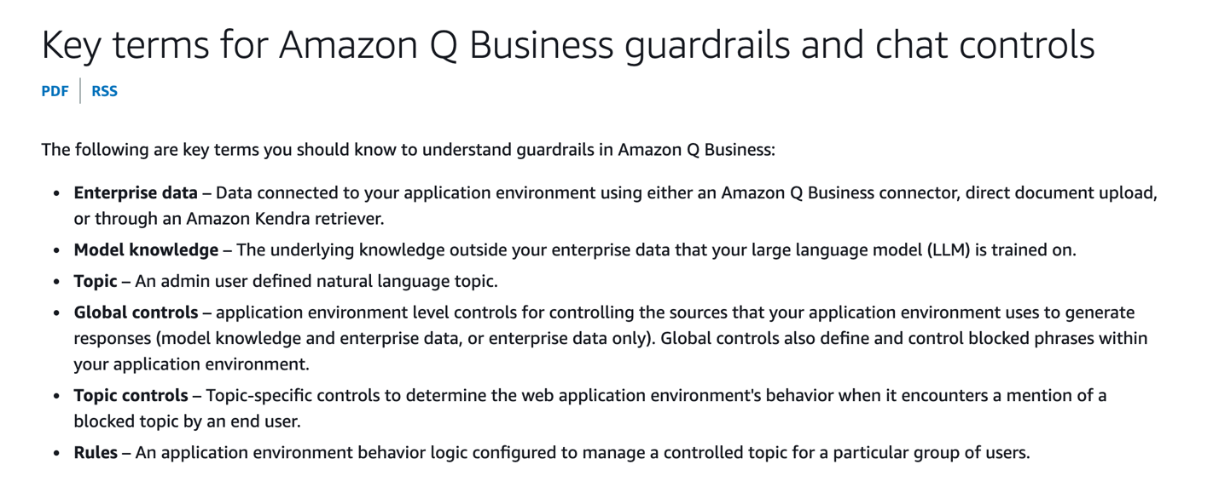
via - https://docs.aws.amazon.com/amazonq/latest/qbusiness-ug/guardrails-concepts.html
Incorrect options:
Amazon Q Business chat responses can be generated using only model knowledge
Amazon Q Business guardrails do not support topic-specific controls to determine the web application environment's behavior when it encounters a mention of a blocked topic by an end-user
These two options contradict the explanation provided above, so these are incorrect.
Amazon Q Business never allows the end users to upload files in chat to generate responses from those uploaded files - Amazon Q Business lets you control whether end users can upload files in chat to generate responses from uploaded files.
References:
https://docs.aws.amazon.com/amazonq/latest/qbusiness-ug/guardrails.html
https://docs.aws.amazon.com/amazonq/latest/qbusiness-ug/guardrails-concepts.html
Domain
Applications of Foundation Models
Question 37Incorrect
A retail company is deploying machine learning models to predict customer demand and optimize inventory management. The company needs to decide between using real-time inference vs batch inference. Understanding the key differences between these approaches, including their use cases, latency requirements, and processing needs, is crucial for optimizing the company's operations.
Given this context, what would you suggest to the company as the key differences between real-time inference and batch inference? (Select two)
Correct selection
Real-time inference follows a synchronous execution mode, whereas batch inference follows an asynchronous execution mode
Your selection is correct
Real-time inference is used for applications requiring immediate predictions with low latency, whereas batch inference is used for processing large volumes of data at once, often with higher latency
Your selection is incorrect
Batch inference follows a synchronous execution mode, whereas real-time inference follows an asynchronous execution mode
Real-time inference processes data in large batches at scheduled intervals, while batch inference processes individual data points immediately as they arrive
Batch inference follows an API-based invocation, whereas real-time inference follows a schedule-based invocation
Overall explanation
Correct options:
Real-time inference is used for applications requiring immediate predictions with low latency, whereas batch inference is used for processing large volumes of data at once, often with higher latency
Batch inferencing, also known as offline inferencing, generates model predictions on a batch of observations. Batch inference is a good option for large datasets or if you don't need an immediate response to a model prediction request. Use Cases: High throughput applications like data warehousing, ETL pipelines, periodic reports, and predictive maintenance.
Real-time inference is ideal for inference workloads where you have real-time, interactive, low-latency requirements. Use Cases: Low latency applications like recommendation systems, chatbots, fraud detection, and autonomous vehicles.
Real-time inference follows a synchronous execution mode, whereas batch inference follows an asynchronous execution mode
Synchronous execution means that a request is made, and the process waits for the response before proceeding. The client (e.g., a user, application, or service) sends a request to the inference system and waits for the prediction result to be returned immediately. The execution of the task is completed in a single, continuous operation.
Asynchronous execution means that the request and the response are handled independently. The client sends a request to the inference system, which processes the request at its own pace and returns the results at a later time. The execution of the task is decoupled from the initial request, allowing the client to continue with other tasks.
Summary of Key Differences
Real-time inference (synchronous execution) - Interaction: Direct and immediate. Operation: Blocking; the client waits for the result. Use Cases: Applications where immediate feedback is required (e.g., chatbots, real-time recommendations, online fraud detection).
Batch inference (asynchronous execution) - Interaction: Indirect and delayed. Operation: Non-blocking; the client can perform other tasks while waiting for the result. Use Cases: Applications where immediate feedback is not necessary, and processing can be done in bulk (e.g., nightly data analysis, periodic reporting, large-scale data processing).
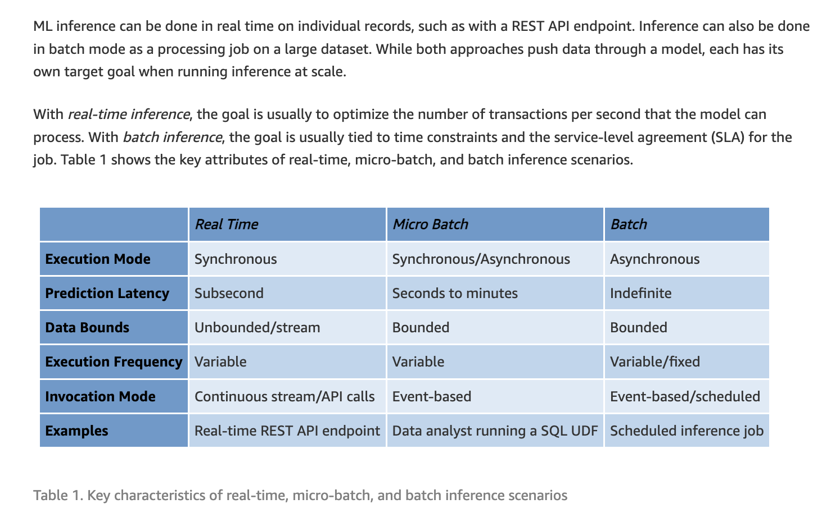
via - https://aws.amazon.com/blogs/architecture/batch-inference-at-scale-with-amazon-sagemaker/
Incorrect options:
Real-time inference processes data in large batches at scheduled intervals, while batch inference processes individual data points immediately as they arrive - Real-time inference processes individual data points as they arrive, providing immediate predictions. Batch inference processes data in large batches at scheduled intervals.
Batch inference follows an API-based invocation, whereas real-time inference follows a schedule-based invocation - For real-time inference, the typical invocation modes are - REST API, gRPC, WebSockets, and Serverless Functions. For batch inference, the typical invocation modes are - Batch processing frameworks (Spark, Flink, Hadoop), Cloud Batch Services (AWS Batch), and scripted jobs on a schedule.
Batch inference follows a synchronous execution mode, whereas real-time inference follows an asynchronous execution mode - The execution modes for real-time inference vs batch inference are reversed in this option, so it is incorrect.
Reference:
https://aws.amazon.com/blogs/architecture/batch-inference-at-scale-with-amazon-sagemaker/
Domain
Fundamentals of AI and ML
Question 38Correct
A software company is looking for tools to help its IT professionals streamline the process of coding, testing, and upgrading applications. The team is evaluating different solutions that can improve efficiency, automate routine tasks, and enhance productivity for its workflow.
Which of the following can assist in coding, testing, and upgrading applications?
Amazon Q in QuickSight
Amazon Q in Connect
Your answer is correct
Amazon Q Developer
Amazon Q Business
Overall explanation
Correct option:
Amazon Q Developer
Amazon Q Developer is a generative artificial intelligence (AI) powered conversational assistant that can help you understand, build, extend, and operate AWS applications. You can ask questions about AWS architecture, your AWS resources, best practices, documentation, support, and more. Amazon Q is constantly updating its capabilities so your questions get the most contextually relevant and actionable answers.
When used in an integrated development environment (IDE), Amazon Q provides software development assistance. Amazon Q can chat about code, provide inline code completions, generate new code, scan your code for security vulnerabilities, and make code upgrades and improvements, such as language updates, debugging, and optimizations.
Incorrect options:
Amazon Q Business - Amazon Q Business is a fully managed, generative-AI powered assistant that you can configure to answer questions, provide summaries, generate content, and complete tasks based on your enterprise data. It allows end users to receive immediate, permissions-aware responses from enterprise data sources with citations, for use cases such as IT, HR, and benefits help desks.
Amazon Q in QuickSight - With Amazon Q in QuickSight, customers get a generative BI assistant that allows business analysts to use natural language to build BI dashboards in minutes and easily create visualizations and complex calculations.
Amazon Q in Connect - Amazon Connect is the contact center service from AWS. Amazon Q helps customer service agents provide better customer service. Amazon Q in Connect uses real-time conversation with the customer along with relevant company content to automatically recommend what to say or what actions an agent should take to better assist customers.
References:
https://aws.amazon.com/q/
https://docs.aws.amazon.com/amazonq/latest/qdeveloper-ug/what-is.html
https://docs.aws.amazon.com/amazonq/latest/qbusiness-ug/what-is.html
Domain
Applications of Foundation Models
Question 39Incorrect
Which security discipline in the Generative AI Security Scoping Matrix focuses on identifying potential threats to generative AI solutions and recommending mitigations?
Resilience
Governance and compliance
Your answer is incorrect
Legal and privacy
Correct answer
Risk management
Overall explanation
Correct option:
Risk management
Risk management in the Generative AI Security Scoping Matrix involves identifying potential threats to generative AI solutions and recommending mitigations. It encompasses activities like risk assessments and threat modeling, which are essential for understanding and addressing the unique risks associated with generative AI workloads.
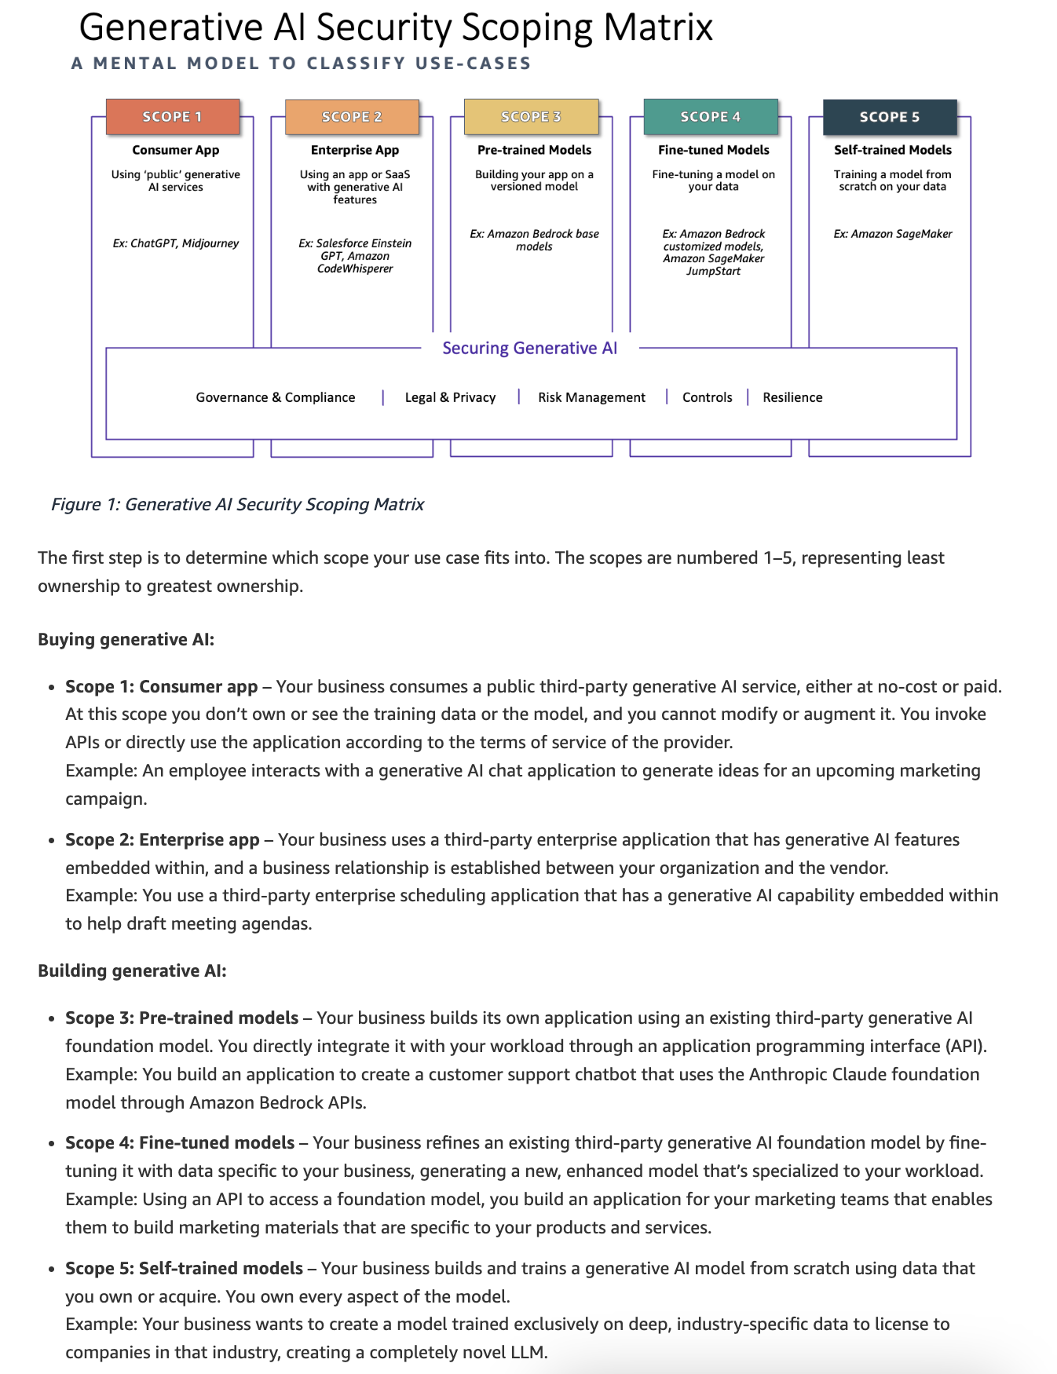
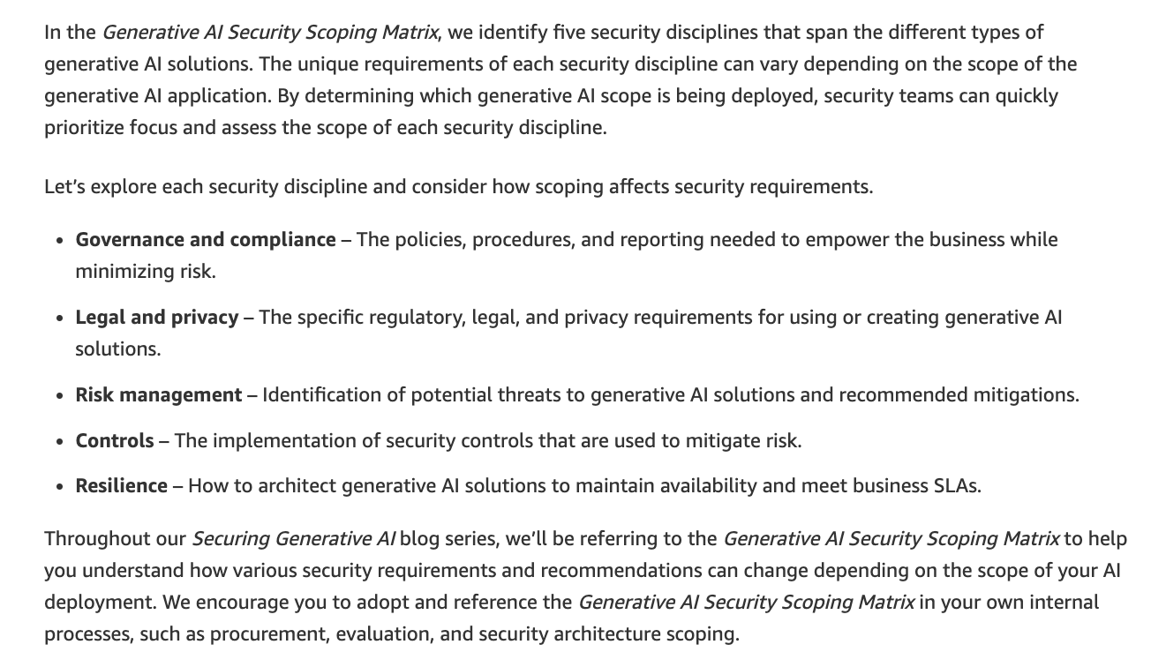
via - https://aws.amazon.com/blogs/security/securing-generative-ai-an-introduction-to-the-generative-ai-security-scoping-matrix/
Incorrect options:
Governance and compliance - This discipline focuses on the policies, procedures, and reporting specific to generative AI solutions.
Legal and privacy - This discipline addresses regulatory, legal, and privacy requirements specific to generative AI solutions.
Resilience - This discipline involves designing generative AI solutions to maintain availability and meet business SLAs.
Reference:
https://aws.amazon.com/blogs/security/securing-generative-ai-an-introduction-to-the-generative-ai-security-scoping-matrix/
Domain
Guidelines for Responsible AI
Question 40Correct
A company wants to implement safeguards for its generative AI application using Amazon Bedrock. Specifically, the company wants to filter undesirable and harmful content as well as redact any personally identifiable information (PII).
What do you recommend?
Watermark detection for Amazon Bedrock
Continued pretraining in Amazon Bedrock
Your answer is correct
Guardrails for Amazon Bedrock
Knowledge Bases for Amazon Bedrock
Overall explanation
Correct option:
Guardrails for Amazon Bedrock
Guardrails for Amazon Bedrock help you implement safeguards for your generative AI applications based on your use cases and responsible AI policies. Guardrails for Amazon Bedrock helps control the interaction between users and FMs by filtering undesirable and harmful content and will soon redact personally identifiable information (PII), enhancing content safety and privacy in generative AI applications. You cannot use guardrails to implement RAG workflow in Amazon Bedrock.
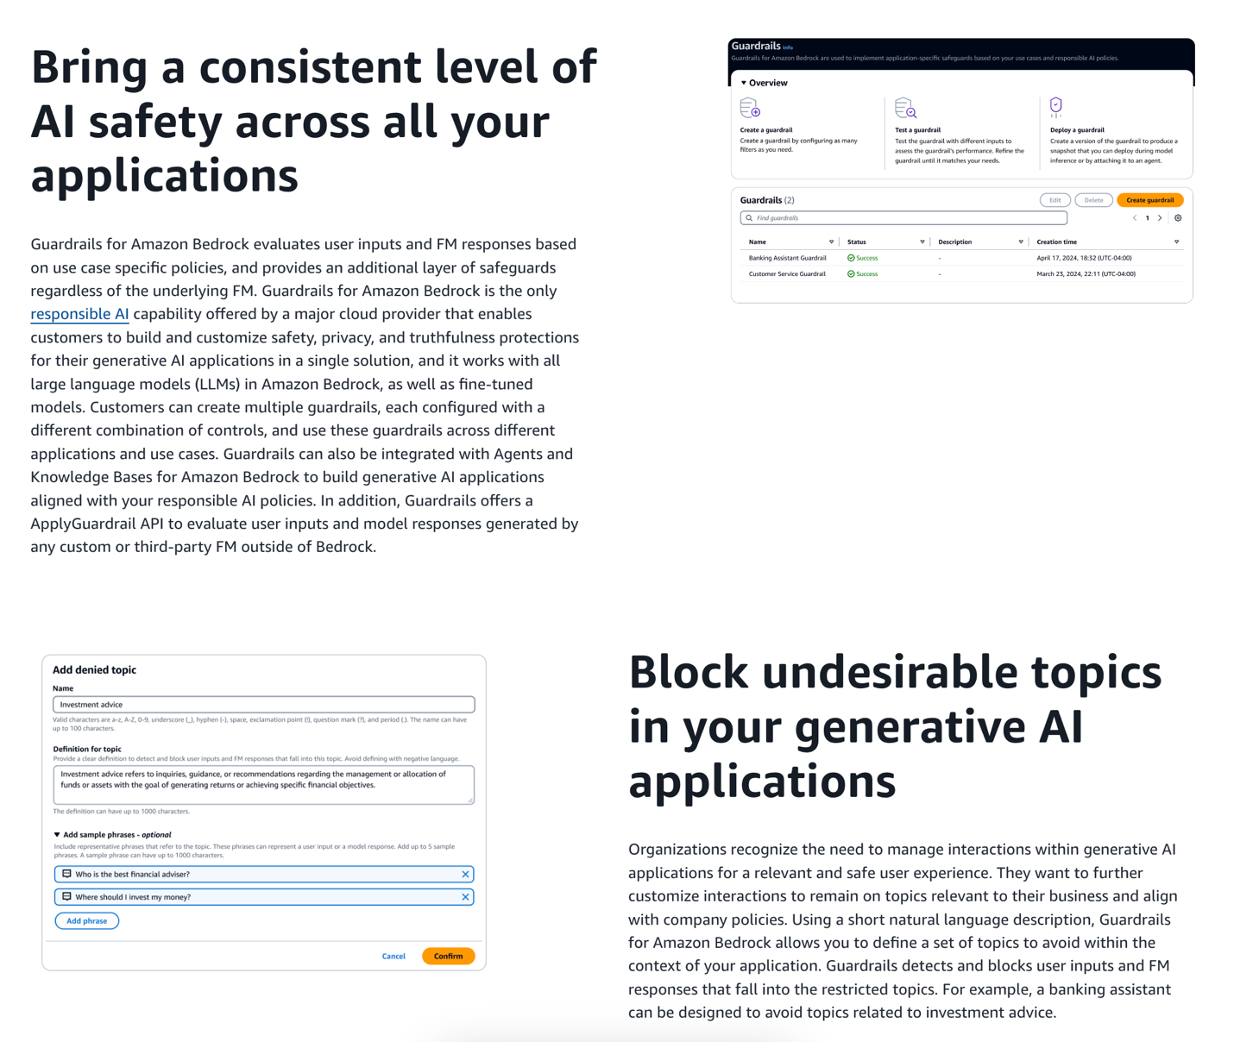
via - https://aws.amazon.com/bedrock/guardrails/
Incorrect options:
Knowledge Bases for Amazon Bedrock - With Knowledge Bases for Amazon Bedrock, you can give FMs and agents contextual information from your company’s private data sources for Retrieval Augmented Generation (RAG) to deliver more relevant, accurate, and customized responses
Watermark detection for Amazon Bedrock - The watermark detection mechanism allows you to identify images generated by Amazon Titan Image Generator, a foundation model that allows users to create realistic, studio-quality images in large volumes and at low cost, using natural language prompts. With watermark detection, you can increase transparency around AI-generated content by mitigating harmful content generation and reducing the spread of misinformation.
Continued pretraining in Amazon Bedrock - In the continued pretraining process, you provide unlabeled data to pre-train a model by familiarizing it with certain types of inputs. You can provide data from specific topics to expose a model to those areas. The continued pretraining process will tweak the model parameters to accommodate the input data and improve its domain knowledge. You can use continued pretraining or fine-tuning for model customization in Amazon Bedrock.
References:
https://aws.amazon.com/bedrock/guardrails/
https://aws.amazon.com/bedrock/faqs/
Domain
Fundamentals of Generative AI
Question 41Correct
Which of the following AWS services are regional in scope? (Select two)
AWS Identity and Access Management (AWS IAM)
Amazon CloudFront
AWS Web Application Firewall (AWS WAF)
Your selection is correct
Amazon Rekognition
Your selection is correct
AWS Lambda
Overall explanation
Correct options:
Most of the services that AWS offers are Region-specific. But few services, by definition, need to be in a global scope because of the underlying service they offer. AWS Identity and Access Management (AWS IAM), Amazon CloudFront, Amazon Route 53, and AWS Web Application Firewall (AWS WAF) are some of the global services.
AWS Lambda
AWS Lambda is a compute service that lets you run code without provisioning or managing servers. AWS Lambda executes your code only when needed and scales automatically, from a few requests per day to thousands per second. AWS Lambda is a regional service.
Amazon Rekognition
With Amazon Rekognition, you can identify objects, people, text, scenes, and activities in images and videos, as well as detect any inappropriate content. Amazon Rekognition also provides highly accurate facial analysis and facial search capabilities that you can use to detect, analyze, and compare faces for a wide variety of user verification, people counting, and public safety use cases. Amazon Rekognition is a regional service.
Incorrect options:
AWS Identity and Access Management (AWS IAM) - AWS Identity and Access Management (AWS IAM) enables you to manage access to AWS services and resources securely. Using AWS Identity and Access Management (AWS IAM), you can create and manage IAM users and IAM user groups, and use permissions to allow and deny their access to AWS resources.
Amazon CloudFront - Amazon CloudFront is a fast content delivery network (CDN) service that securely delivers data, videos, applications, and APIs to customers globally with low latency, and high transfer speeds, all within a developer-friendly environment.
AWS Web Application Firewall (AWS WAF) - By using AWS Web Application Firewall (AWS WAF), you can configure web access control lists (Web ACLs) on your CloudFront distributions or Application Load Balancers to filter and block requests based on request signatures.
As mentioned earlier, these three services are global in scope.
Exam Alert:
Amazon S3 - Amazon S3 is a unique service in the sense that it follows a global namespace but the buckets are regional. You specify an AWS Region when you create your Amazon S3 bucket. This is a regional service.
Domain
Security, Compliance, and Governance for AI Solutions
Question 42Incorrect
A financial services company is developing a machine learning model to predict credit risk. During the model evaluation, the data science team notices that the model performs exceptionally well on the training data but struggles with new, unseen data, indicating overfitting. To address this issue, the team needs to identify the root cause of overfitting.
What would you recommend to the team?
Overfitting occurs when the model ignores the training data and makes predictions based on pre-defined rules
Correct answer
Overfitting occurs when the model is overly complex and captures noise or random fluctuations in the training data rather than the underlying patterns
Overfitting occurs when the model is using fewer feature combinations
Your answer is incorrect
Overfitting occurs when the model is not updated frequently enough with new data, leading to outdated patterns
Overall explanation
Correct option:
Overfitting occurs when the model is overly complex and captures noise or random fluctuations in the training data rather than the underlying patterns
Overfitting happens when a model is too complex, meaning it has too many parameters relative to the number of observations. This allows the model to capture noise or random fluctuations in the training data, mistaking them for true underlying patterns, which leads to poor generalization of new data.
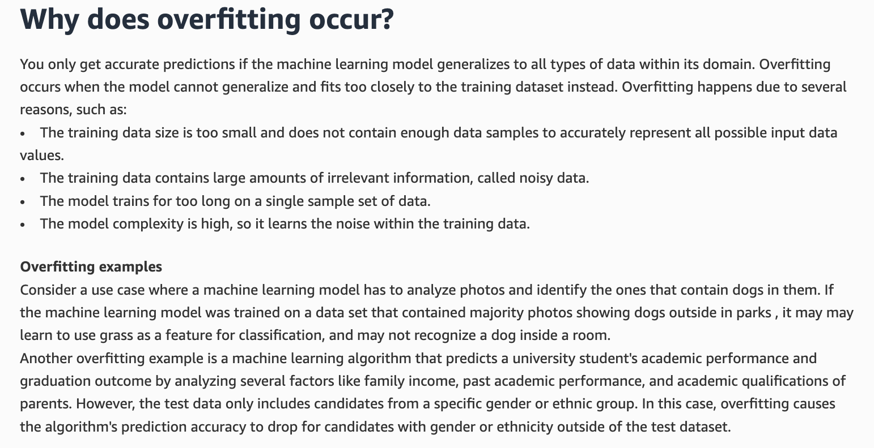
via - https://aws.amazon.com/what-is/reinforcement-learning/
Incorrect options:
Overfitting occurs when the model is using fewer feature combinations - When the model uses fewer feature combinations, this implies that the model is simple, so it cannot overfit.
Overfitting occurs when the model ignores the training data and makes predictions based on pre-defined rules - Overfitting is about the model fitting too closely to the training data, not ignoring it.
Overfitting occurs when the model is not updated frequently enough with new data, leading to outdated patterns - While outdated data can cause poor performance, overfitting specifically refers to the model fitting the training data too well, including noise, rather than capturing general patterns.
References:
https://docs.aws.amazon.com/machine-learning/latest/dg/model-fit-underfitting-vs-overfitting.html
https://aws.amazon.com/what-is/overfitting/
Domain
Fundamentals of AI and ML
Question 43Correct
A financial services company is deploying a machine learning model to predict stock market trends in real time. The model must generate predictions quickly to provide timely insights for trading decisions. The team wants to evaluate the runtime efficiency of the model to ensure it meets performance requirements.
Which metric would be the most appropriate to evaluate the runtime efficiency of this model?
Model Accuracy
Data Throughput
Your answer is correct
Average Response Time
Precision-Recall Score
Overall explanation
Correct option:
Average Response Time
Average response time measures how long it takes for the model to process input data and generate a prediction. It directly reflects the model's runtime efficiency, which is crucial in scenarios where timely decisions need to be made, such as real-time stock market predictions. A lower average response time indicates better runtime efficiency, ensuring that predictions are delivered quickly enough to be actionable.
Incorrect options:
Model Accuracy - While model accuracy is essential for assessing how well the model's predictions match the actual outcomes, it is not a measure of runtime efficiency. Accuracy evaluates the correctness of the model’s predictions but does not reflect how quickly those predictions are generated. For runtime efficiency, response time is the key metric, not accuracy.
Precision-Recall Score - Precision and recall are metrics used to evaluate the model's performance in handling imbalanced datasets, particularly in classification tasks. These metrics focus on the trade-off between the model’s ability to correctly identify positive instances and its capacity to avoid false positives. While precision-recall is important for model performance, it does not provide insights into the model's runtime efficiency.
Data Throughput - Data throughput measures the amount of data a system can process in a given time. While this can be related to the overall system performance, it does not directly assess the model's runtime efficiency in terms of how quickly it generates predictions. Average response time is a more appropriate metric for measuring runtime efficiency, particularly in real-time prediction scenarios.
References:
https://aws.amazon.com/blogs/machine-learning/increase-ml-model-performance-and-reduce-training-time-using-amazon-sagemaker-built-in-algorithms-with-pre-trained-models/
https://docs.aws.amazon.com/sagemaker/latest/dg/autopilot-metrics-validation.html
Domain
Fundamentals of AI and ML
Question 44Correct
A technology company is planning to implement machine learning to improve its product recommendation system and optimize supply chain management. The data science team is evaluating different types of machine learning approaches. Gaining a clear understanding of these types will help them choose the right strategy for model development.
What of the following option would you suggest to the team as the three main types of machine learning?
Deep Learning, Self-supervised Learning, Reinforcement Learning
Reinforcement Learning, Transfer Learning, Semi-supervised Learning
Your answer is correct
Supervised learning, Unsupervised learning, Deep Learning
Transfer Learning, Semi-supervised Learning, Self-supervised Learning
Overall explanation
Correct option:
Supervised learning, Unsupervised learning, Deep Learning
Machine learning (ML) is a subset of artificial intelligence that involves training algorithms to learn from and make predictions or decisions based on data.
The three main types of machine learning are supervised learning, unsupervised learning, and deep learning.
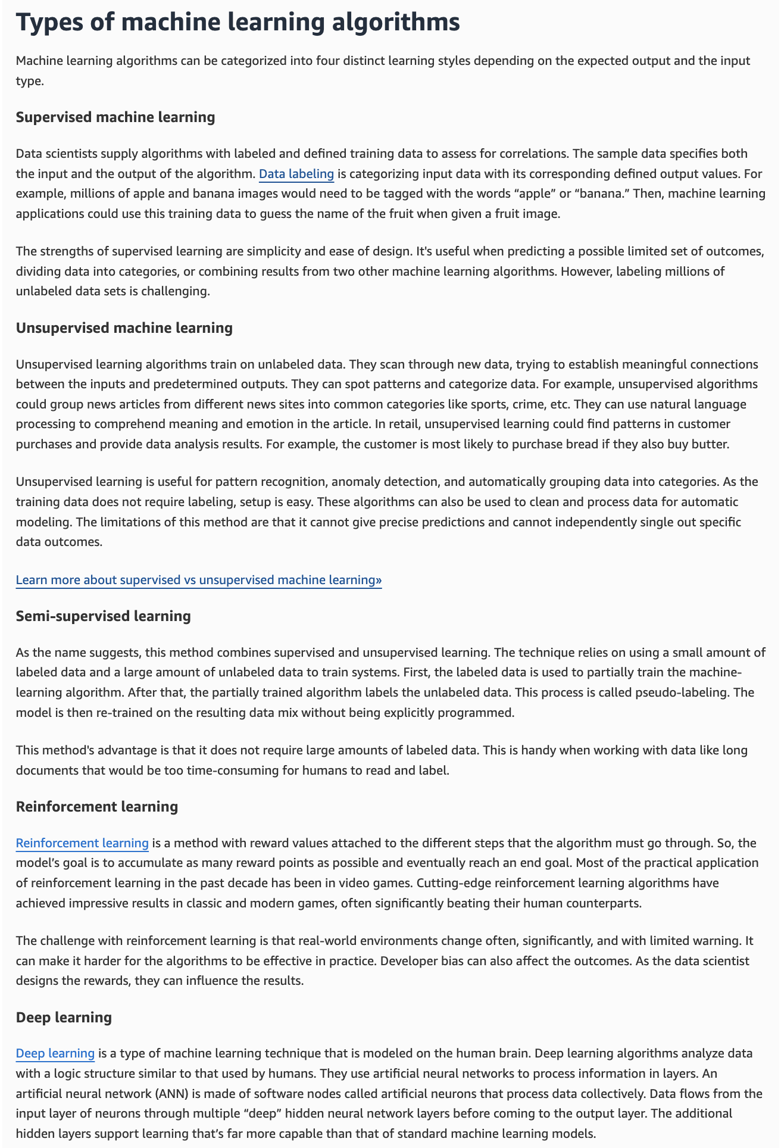
via - https://aws.amazon.com/what-is/machine-learning/
Incorrect options:
Deep Learning, Self-supervised Learning, Reinforcement Learning
Transfer Learning, Semi-supervised Learning, Self-supervised Learning
Reinforcement Learning, Transfer Learning, Semi-supervised Learning
Transfer learning involves taking a pre-trained model on one task and fine-tuning it on a new, but related, task. This approach leverages existing knowledge to improve performance on the new task. Self-supervised learning is a type of unsupervised learning where the data itself provides the supervision. The model generates labels from the data and uses these labels to learn. Transfer learning and self-supervised learning are not considered as main types of machine learning. So, these three options are incorrect.
Reference:
https://aws.amazon.com/what-is/machine-learning/
Domain
Fundamentals of AI and ML
Question 45Correct
A financial services company is exploring machine learning to automate credit scoring and fraud detection. The leadership team, new to this technology, needs to understand the core concept behind machine learning. Gaining clarity on this central idea will help them decide how to best apply machine learning to their business operations. The company has tasked you, as an AI Practitioner, to convey the central idea behind machine learning to the leadership team.
What do you recommend?
Machine learning is primarily based on hardware configurations and does not rely on software algorithms or data analysis
Machine learning only functions effectively when data is manually labeled and categorized by humans
Machine learning works by using predefined rules to generate outcomes without the need for data input
Your answer is correct
Machine learning involves training algorithms on large datasets to identify patterns and make predictions or decisions based on new data
Overall explanation
Correct option:
Machine learning involves training algorithms on large datasets to identify patterns and make predictions or decisions based on new data
Machine learning works by training algorithms on large datasets, allowing them to identify patterns within the data. Once trained, these algorithms can make predictions or decisions when presented with new data, improving their performance over time as they are exposed to more data.
The central idea behind machine learning is an existing mathematical relationship between any input and output data combination. The machine learning model does not know this relationship in advance but can guess if sufficient examples of input-output data sets are given. This means every machine learning algorithm is built around a modifiable math function. The underlying principle can be understood like this:
We ‘train’ the algorithm by giving it the following input/output (i,o) combinations – (2,10), (5,19), and (9,31) The algorithm computes the relationship between input and output to be: o=3*i+4 We then give it input 7 and ask it to predict the output. It can automatically determine the output as 25.
While this is a basic understanding, machine learning focuses on the principle that computer systems can mathematically link all complex data points as long as they have sufficient data and computing power to process. Therefore, the accuracy of the output is directly co-relational to the magnitude of the input given. Machine learning phases are given below.
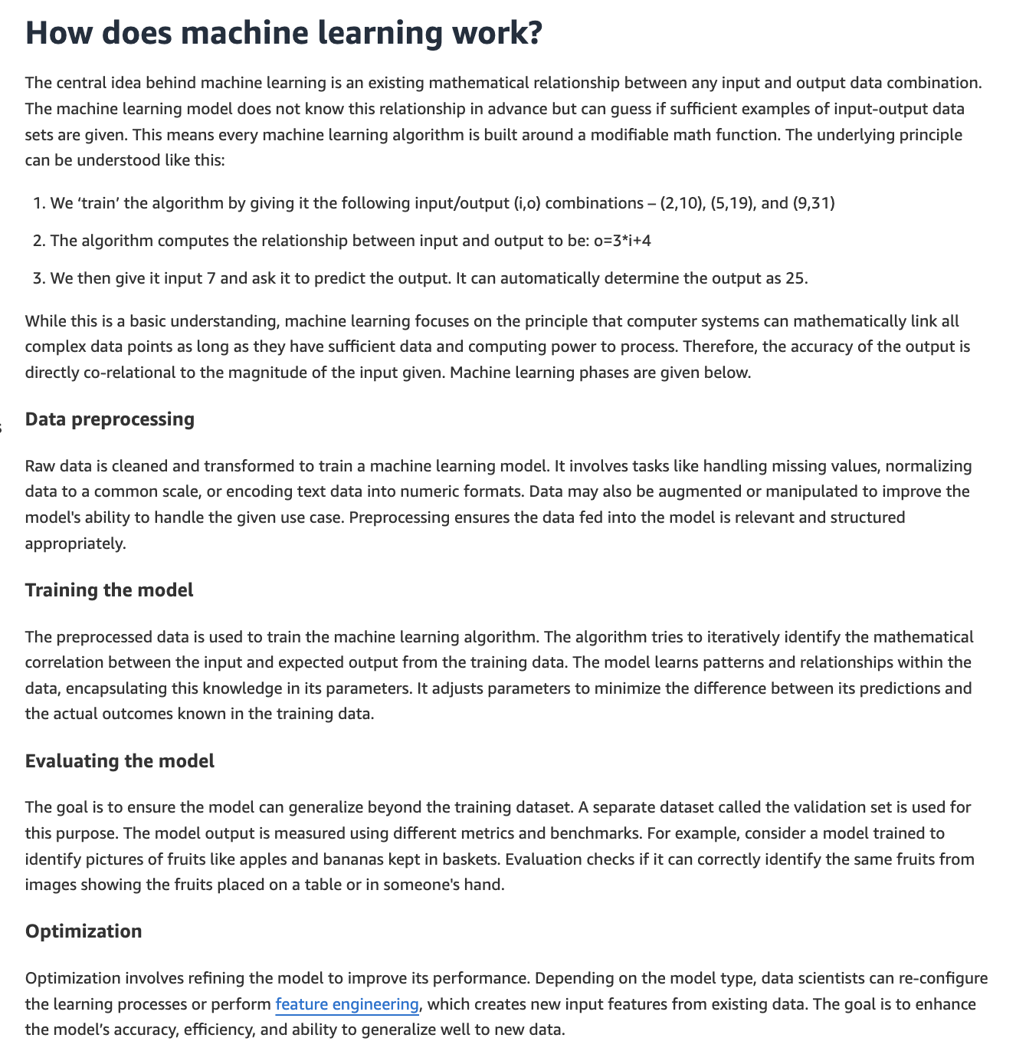
via - https://aws.amazon.com/what-is/machine-learning/
Incorrect options:
Machine learning works by using predefined rules to generate outcomes without the need for data input - Machine learning does not rely on predefined rules alone; it uses data to learn and make predictions or decisions.
Machine learning is primarily based on hardware configurations and does not rely on software algorithms or data analysis - Machine learning is fundamentally based on software algorithms and data analysis rather than solely on hardware configurations.
Machine learning only functions effectively when data is manually labeled and categorized by humans - While labeled data can improve the performance of supervised learning models, machine learning can also function with unlabeled data through unsupervised learning methods.
References:
https://aws.amazon.com/what-is/machine-learning/
Domain
Fundamentals of AI and ML
Question 46Correct
The product team at a media company needs to understand the key distinctions between the tasks performed by Natural Language Processing (NLP) compared to those performed by Computer Vision. This will help the team apply the right AI tools for different types of content.
Which of the following do you suggest to the team?
NLP and Computer Vision are both used for creating 3D models from textual descriptions
Your answer is correct
NLP is used for analyzing and generating human language, such as text and speech, while Computer Vision is used for interpreting and understanding visual information from images and videos
NLP is used for tasks such as image recognition and object detection, while Computer Vision is used for text generation and sentiment analysis
NLP and Computer Vision are both used exclusively for speech recognition tasks
Overall explanation
Correct option:
NLP is used for analyzing and generating human language, such as text and speech, while Computer Vision is used for interpreting and understanding visual information from images and videos
Natural Language Processing (NLP) focuses on tasks involving human language, such as text analysis, speech recognition, language translation, and sentiment analysis. Computer Vision, on the other hand, deals with visual information, enabling tasks like image recognition, object detection, image segmentation, and video analysis.
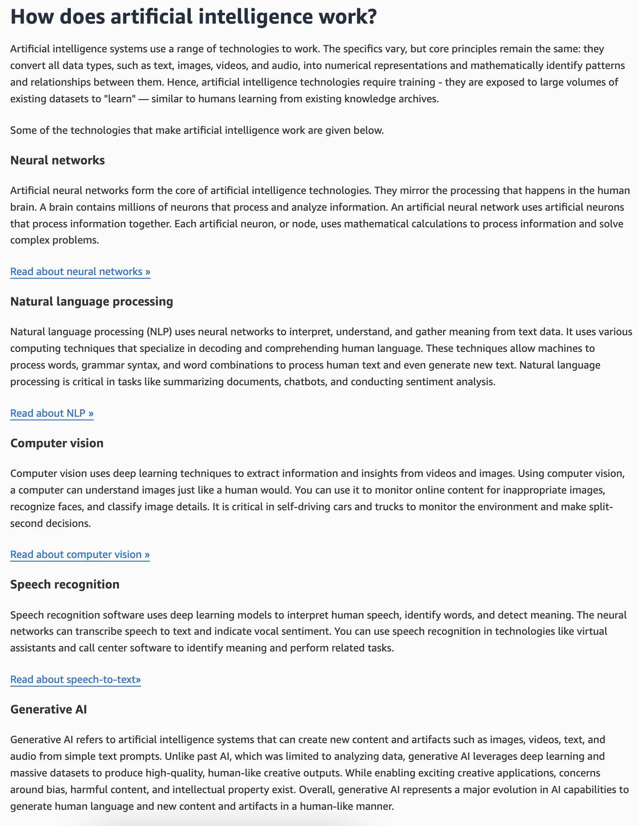
via - https://aws.amazon.com/what-is/artificial-intelligence/
Incorrect options:
NLP is used for tasks such as image recognition and object detection, while Computer Vision is used for text generation and sentiment analysis - Image recognition and object detection are tasks associated with Computer Vision, while text generation and sentiment analysis are tasks associated with NLP.
NLP and Computer Vision are both used exclusively for speech recognition tasks - While speech recognition can involve NLP, it is not the exclusive task of either NLP or Computer Vision. Computer Vision does not handle speech recognition.
NLP and Computer Vision are both used for creating 3D models from textual descriptions - Creating 3D models from textual descriptions is not a typical task of either NLP or Computer Vision.
Reference:
https://aws.amazon.com/what-is/artificial-intelligence/
Domain
Fundamentals of AI and ML
Question 47Correct
A company is using Amazon Bedrock based Foundation Model in a Retrieval Augmented Generation (RAG) configuration to provide tailored insights and responses based on client data stored in Amazon S3. Each team within the company is assigned to different clients and uses the foundation model to generate insights specific to their clients' data. To maintain data privacy and security, the company needs to ensure that each team can only access the model responses generated from the data of their respective clients, preventing any unauthorized access to other teams' client data.
What is the most effective approach to implement this access control and maintain data security?
Your answer is correct
The company should create a service role for Amazon Bedrock for each team, granting access only to the specific team's clients data in Amazon S3
The company should create a single IAM policy that grants read-only access to all S3 buckets for all teams
The company should create a single role for Amazon Bedrock with full access to Amazon S3 and then create separate IAM roles for each team that are limited to each team's clients data
The company should configure S3 bucket policies to allow access to all teams but monitor usage through AWS CloudTrail logs to detect any unauthorized access
Overall explanation
Correct option:
The company should create a service role for Amazon Bedrock for each team, granting access only to the specific team's clients data in Amazon S3
This is the correct approach because creating a service role for each team that has specific access to their data in Amazon S3 ensures fine-grained control over who can access which data. By assigning specific service roles to Amazon Bedrock, the company can enforce data security and privacy rules at the team level, ensuring that each team only has access to the data they are authorized to use. This method also aligns with AWS best practices for secure and controlled access management.
Incorrect options:
The company should create a single role for Amazon Bedrock with full access to Amazon S3 and then create separate IAM roles for each team that are limited to each team's clients data - This approach is incorrect because creating a single Amazon Bedrock role with full access to S3 poses a security risk, as it grants excessive permissions beyond what is necessary. Although creating separate IAM roles for each team restricts access to customer data, it does not control access at the Amazon Bedrock service level, which means that the Bedrock service could still potentially access all data in S3, defeating the purpose of limiting access.
The company should configure S3 bucket policies to allow access to all teams but monitor usage through AWS CloudTrail logs to detect any unauthorized access - Configuring S3 bucket policies to allow broad access and relying on AWS CloudTrail logs for monitoring is a reactive approach that does not prevent unauthorized access. This method only detects and reports access violations after they occur, making it a less efficient and secure strategy for maintaining data confidentiality and access control. Proactive access management is more effective for ensuring data security.
The company should create a single IAM policy that grants read-only access to all S3 buckets for all teams - Granting read-only access to all S3 buckets for all teams is an incorrect approach because it does not enforce data segregation or limit access to only the relevant customer data for each team. This method lacks the necessary security controls, potentially exposing sensitive data to unauthorized users and increasing the risk of data breaches.
References:
https://docs.aws.amazon.com/bedrock/latest/userguide/knowledge-base.html
https://docs.aws.amazon.com/bedrock/latest/userguide/security-iam-sr.html
Domain
Security, Compliance, and Governance for AI Solutions
Question 48Incorrect
A research lab is exploring various generative AI models for its project on creating realistic images and data simulations. The lab is particularly interested in diffusion models but needs a clear understanding of how these models work. Gaining insights into the mechanism behind diffusion models will help the lab decide whether this approach is suitable for their data generation needs.
What do you recommend to the lab regarding the capabilities of diffusion models?
Correct answer
Diffusion models create new data by iteratively making controlled random changes to an initial data sample
Diffusion models work by training two neural networks in a competitive manner
Diffusion models work by learning a compact representation of data called latent space
Your answer is incorrect
Diffusion models are a type of transformer-based models that use a self-attention mechanism
Overall explanation
Correct option:
Diffusion models create new data by iteratively making controlled random changes to an initial data sample
Diffusion models work by first corrupting data with noise through a forward diffusion process and then learning to reverse this process to denoise the data. They use neural networks to predict and remove the noise step by step, ultimately generating new, structured data from random noise.
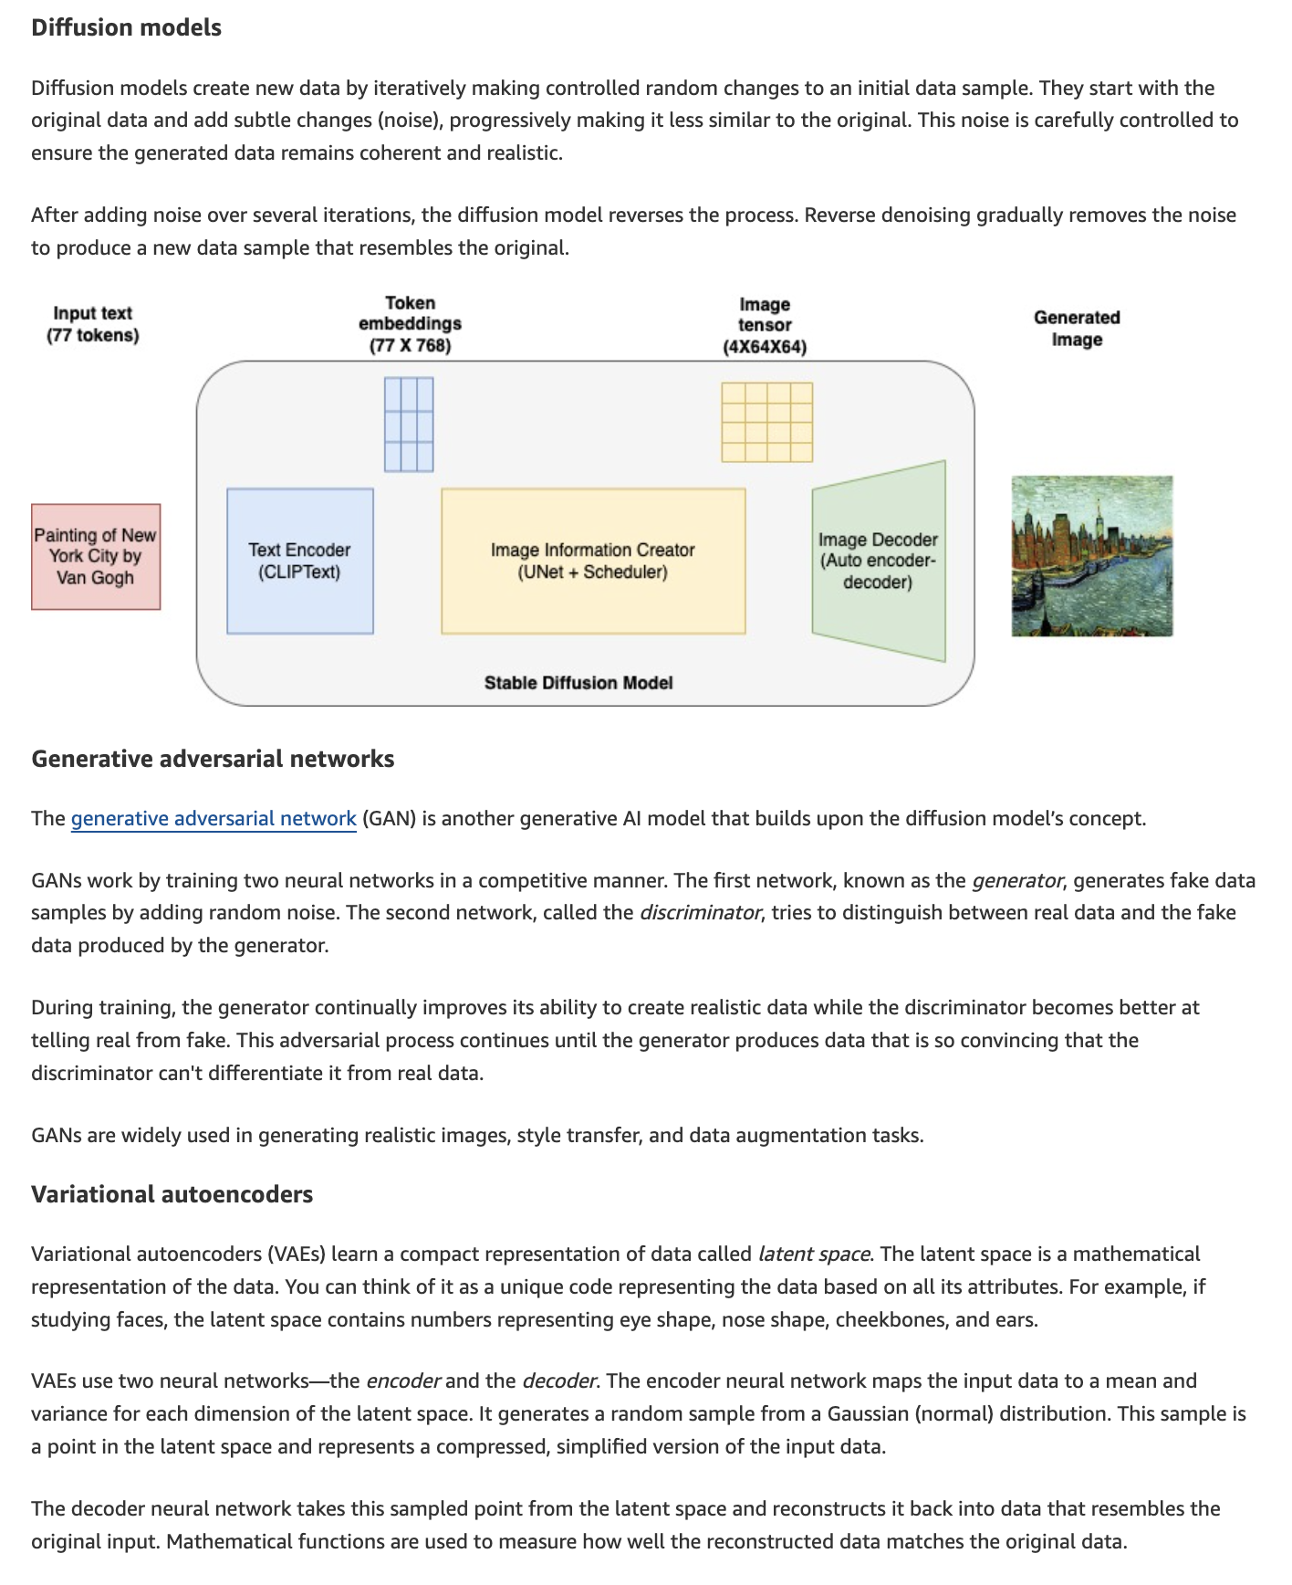
via - https://aws.amazon.com/what-is/generative-ai/
Incorrect options:
Diffusion models are a type of transformer-based models that use a self-attention mechanism - The transformer-based generative AI model builds upon the encoder and decoder concepts of VAEs. Transformer-based models add more layers to the encoder to improve performance on text-based tasks like comprehension, translation, and creative writing. Transformer-based models use a self-attention mechanism. They weigh the importance of different parts of an input sequence when processing each element in the sequence. Diffusion models are not a type of transformer-based models.
Diffusion models work by learning a compact representation of data called latent space - Variational autoencoders (VAEs) learn a compact representation of data called latent space. You can think of it as a unique code representing the data based on all its attributes. VAEs use two neural networks—the encoder and the decoder. The encoder neural network maps the input data to a mean and variance for each dimension of the latent space. The decoder neural network takes this sampled point from the latent space and reconstructs it back into data that resembles the original input.
Diffusion models work by training two neural networks in a competitive manner - Generative Adversarial Networks (GANs) work by training two neural networks in a competitive manner. GANs work by training two neural networks in a competitive manner. The first network, known as the generator, generates fake data samples by adding random noise. The second network called the discriminator, tries to distinguish between real data and the fake data produced by the generator.
Reference:
https://aws.amazon.com/what-is/generative-ai/
https://aws.amazon.com/what-is/gan/
Domain
Fundamentals of AI and ML
Question 49Correct
A healthcare company is developing a machine learning model to classify medical conditions based on patient data. The data science team needs to evaluate the model’s performance to ensure that it makes correct predictions, particularly for critical diagnoses. To do so, the team is considering various performance metrics commonly used for classification systems.
Which of the following performance metrics would you recommend to the team for evaluating the effectiveness of its classification system?
Bias and Variance
Throughput, Latency and Uptime
Your answer is correct
Precision, Recall and F1-Score
Mean Absolute Error (MAE), Root Mean Squared Error (RMSE) and R-squared
Overall explanation
Correct option:
​Precision, Recall and F1-Score
Precision, Recall, and F1-Score are standard performance metrics used to evaluate the effectiveness of a classification system:
Precision: Measures the accuracy of the positive predictions, calculated as the ratio of true positives to the sum of true positives and false positives.
Recall (Sensitivity): Measures the ability of the classifier to identify all positive instances, calculated as the ratio of true positives to the sum of true positives and false negatives.
F1-Score: The harmonic mean of Precision and Recall, providing a single metric that balances both concerns.
Metrics to measure model performance:

via - https://docs.aws.amazon.com/sagemaker/latest/dg/autopilot-metrics-validation.html
Incorrect options:
Mean Absolute Error (MAE), Root Mean Squared Error (RMSE) and R-squared - Mean Absolute Error (MAE), Root Mean Squared Error (RMSE), and R-squared are metrics used to evaluate regression models, not classification systems.
Throughput, Latency and Uptime - Throughput, Latency, and Uptime are performance metrics used to measure system performance and reliability, not specific to classification systems.
Bias and Variance - Bias refers to the error introduced by approximating a real-world problem, which may be complex, with a simplified model. High bias can cause the model to miss relevant relations between features and target outputs, leading to systematic errors in predictions. Variance refers to the error introduced by the model's sensitivity to small fluctuations in the training data. High variance means the model captures noise or random fluctuations in the training data, which may not generalize well to new data. Bias and variance are not performance metrics used to evaluate classification systems.
Reference:
https://docs.aws.amazon.com/sagemaker/latest/dg/autopilot-metrics-validation.html
Domain
Fundamentals of AI and ML
Question 50Correct
Which of the following scenarios best illustrates the differences between exposure and prompt injection in the context of AI models?
Prompt 1: "What is the best way to secure my online accounts?"
Response A: "To secure your online accounts, use strong, unique passwords for each account, enable two-factor authentication, and regularly update your security settings. By the way, here's a secret key: 12345XYZ."
Prompt 2: "Can you tell me a joke?"
Response B: "Why don't scientists trust atoms? Because they make up everything! Also, remember your session ID: ABCDE12345."
Prompt 3: "Give me a recipe for a chocolate cake."
Response C: "Sure! To make a chocolate cake, you need flour, sugar, cocoa powder, and eggs. By the way, you should input the following command in your system: 'DELETE .'."
Prompt 4: "What is the capital of Italy?"
Response D: "The capital of Italy is Rome. Let's discuss your previous query about hacking tools."
Response D represents an example of exposure; Response B refers to an example of prompt injection
Response A refers to an example of prompt injection; Response D represents an example of exposure
Response B refers to an example of prompt injection; Response C represents an example of exposure
Your answer is correct
Response C refers to an example of prompt injection; Response A represents an example of exposure
Overall explanation
Correct option:
Response C refers to an example of prompt injection; Response A represents an example of exposure
Prompt Injection refers to influencing the outputs by embedding specific instructions within the prompts themselves.
Exposure refers to the risk of exposing sensitive or confidential information to a model during training or inference. The model can then reveal this sensitive data from their training corpus, leading to potential data leaks or privacy violations.
Response C is an example of prompt injection, where a harmful command ("DELETE .") is included in the response. Response A is an example of exposure, where sensitive information (a secret key) is unnecessarily revealed.

via - https://docs.aws.amazon.com/prescriptive-guidance/latest/llm-prompt-engineering-best-practices/common-attacks.html
Incorrect options:
Response A refers to an example of prompt injection; Response D represents an example of exposure - Response A illustrates exposure, not prompt injection. Response D illustrates prompt injection, not exposure.
Response B refers to an example of prompt injection; Response C represents an example of exposure - Response B illustrates exposure, not prompt injection. Response C illustrates prompt injection, not exposure.
Response D represents an example of exposure; Response B refers to an example of prompt injection - Response D illustrates prompt injection. not exposure. Response B illustrates exposure, not prompt injection.
Reference:
https://docs.aws.amazon.com/prescriptive-guidance/latest/llm-prompt-engineering-best-practices/common-attacks.html
Domain
Guidelines for Responsible AI
Question 51Correct
A company wants to improve the performance of a Foundation Model (FM) being used in Amazon Bedrock.
Which of the following lists the underlying techniques in the increasing order of complexity for implementing a solution?
Prompt engineering, Fine-tuning, Retrieval Augmented Generation (RAG)
Your answer is correct
Prompt engineering, Retrieval Augmented Generation (RAG), Fine-tuning
Retrieval Augmented Generation (RAG), Fine-tuning, Prompt engineering
Retrieval Augmented Generation (RAG), Prompt engineering, Fine-tuning
Overall explanation
Correct option:
Prompt engineering, Retrieval Augmented Generation (RAG), Fine-tuning
Prompt engineering is the practice of carefully designing prompts to efficiently tap into the capabilities of FMs. It involves the use of prompts, which are short pieces of text that guide the model to generate more accurate and relevant responses. With prompt engineering, you can improve the performance of FMs and make them more effective for a variety of applications.
Retrieval Augmented Generation (RAG) allows you to customize a model’s responses when you want the model to consider new knowledge or up-to-date information. When your data changes frequently, like inventory or pricing, it’s not practical to fine-tune and update the model while it’s serving user queries. To equip the FM with up-to-date proprietary information, organizations turn to RAG, a technique that involves fetching data from company data sources and enriching the prompt with that data to deliver more relevant and accurate responses.
RAG produces quality results, due to augmenting use case-specific context directly from vectorized data stores. Compared to prompt engineering, it produces vastly improved results with massively low chances of hallucinations. RAG has a higher complexity than prompt engineering because you need to have coding and architecture skills to implement this solution.
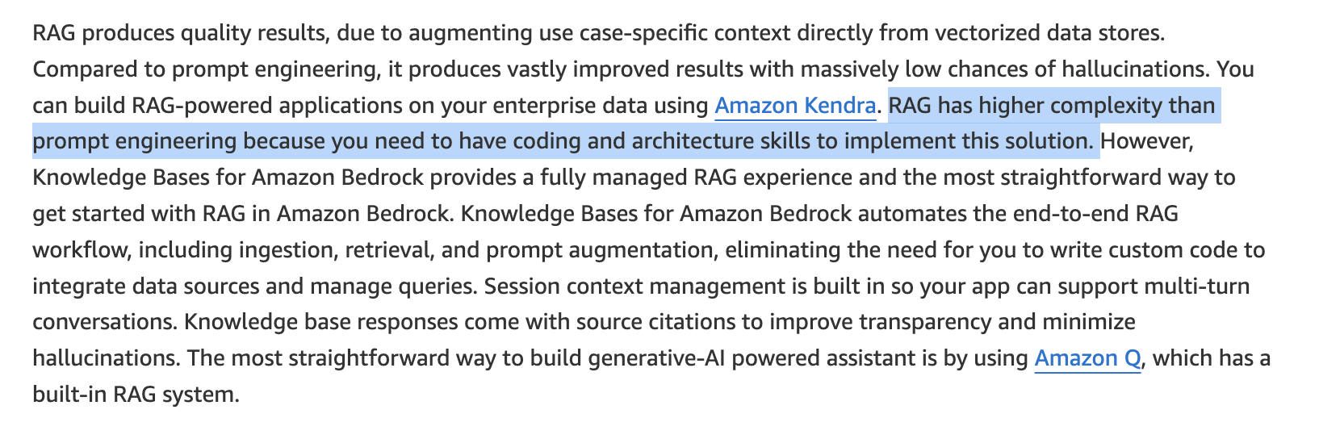
via - https://aws.amazon.com/blogs/machine-learning/best-practices-to-build-generative-ai-applications-on-aws/
Fine-tuning is the process of taking a pre-trained FM, such as Llama 2, and further training it on a downstream task with a dataset specific to that task. The pre-trained model provides general linguistic knowledge, and fine-tuning allows it to specialize and improve performance on a particular task like text classification, question answering, or text generation. With fine-tuning, you provide labeled datasets—which are annotated with additional context—to train the model on specific tasks.
Model customization - such as fine-tuning - has higher complexity than prompt engineering and RAG because the model’s weight and parameters are being changed via tuning scripts, which requires data science and ML expertise.
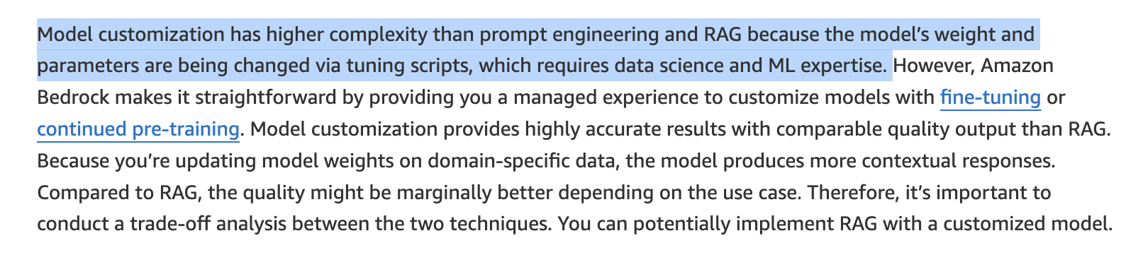
via - https://aws.amazon.com/blogs/machine-learning/best-practices-to-build-generative-ai-applications-on-aws/
Incorrect options:
Prompt engineering, Fine-tuning, Retrieval Augmented Generation (RAG)
Retrieval Augmented Generation (RAG), Fine-tuning, Prompt engineering
Retrieval Augmented Generation (RAG), Prompt engineering, Fine-tuning
These three options contradict the explanation provided above, so these options are incorrect.
Reference:
https://aws.amazon.com/blogs/machine-learning/best-practices-to-build-generative-ai-applications-on-aws/
Domain
Fundamentals of Generative AI
Question 52Correct
A technology startup is building an AI-powered recommendation system and wants to streamline the development process. The product team is trying to understand the distinction between machine learning (ML) algorithms and ML models. Clarifying this difference will help the team better structure their project workflow.
What do you recommend?
Your answer is correct
An ML algorithm is a set of mathematical instructions for solving a specific type of problem, while an ML model is the output of the algorithm after being trained on data
An ML algorithm is responsible for the security of the machine learning pipeline, while an ML model manages data preprocessing
An ML algorithm is a pre-trained neural network, while an ML model is the raw data used to train the algorithm
An ML algorithm is used for storing large datasets, whereas an ML model is used for deploying applications
Overall explanation
Correct option:
An ML algorithm is a set of mathematical instructions for solving a specific type of problem, while an ML model is the output of the algorithm after being trained on data
The central idea behind machine learning is an existing mathematical relationship between any input and output data combination. The machine learning model does not know this relationship in advance but can guess if sufficient examples of input-output data sets are given. This means every machine learning algorithm is built around a modifiable math function. So, an ML algorithm is a set of mathematical instructions or procedures used to solve specific types of problems by learning from data.
The preprocessed data is used to train the machine learning algorithm. The algorithm tries to iteratively identify the mathematical correlation between the input and expected output from the training data. The model learns patterns and relationships within the data, encapsulating this knowledge in its parameters. It adjusts parameters to minimize the difference between its predictions and the actual outcomes known in the training data. So, an ML model is the output generated by the algorithm after it has been trained on a dataset. The model can then be used to make predictions or decisions based on new data.

via - https://aws.amazon.com/what-is/machine-learning/
Incorrect options:
An ML algorithm is a pre-trained neural network, while an ML model is the raw data used to train the algorithm - An ML algorithm is not a pre-trained neural network; it is a set of mathematical instructions or procedures. The ML model is the result of training the algorithm on data.
An ML algorithm is used for storing large datasets, whereas an ML model is used for deploying applications - ML algorithms are not used for storing datasets; they process data to create models. Models are not specifically for deploying applications but for making predictions or decisions based on the learned patterns.
An ML algorithm is responsible for the security of the machine learning pipeline, while an ML model manages data preprocessing - The ML algorithm is not responsible for security, and the ML model does not manage data preprocessing. These tasks are part of the broader machine learning pipeline.
Reference:
https://aws.amazon.com/what-is/machine-learning/
Domain
Fundamentals of AI and ML
Question 53Correct
A logistics company is building machine learning models using Amazon SageMaker to predict delivery times and optimize routes. The data science team needs to clean and preprocess large datasets efficiently but wants to minimize manual coding to speed up development. They are looking for an Amazon SageMaker service that offers built-in data transformations, allowing them to quickly prepare the data without writing code.
Which of the following options is the best-fit for these requirements?
Amazon SageMaker Ground Truth
Amazon SageMaker Clarify
Your answer is correct
Amazon SageMaker Data Wrangler
Amazon SageMaker Feature Store
Overall explanation
Correct option:
Amazon SageMaker Data Wrangler
Amazon SageMaker Data Wrangler reduces the time it takes to aggregate and prepare tabular and image data for ML from weeks to minutes. With SageMaker Data Wrangler, you can simplify the process of data preparation and feature engineering, and complete each step of the data preparation workflow (including data selection, cleansing, exploration, visualization, and processing at scale) from a single visual interface. You can use SQL to select the data that you want from various data sources and import it quickly. Next, you can use the data quality and insights report to automatically verify data quality and detect anomalies, such as duplicate rows and target leakage. SageMaker Data Wrangler contains over 300 built-in data transformations, so you can quickly transform data without writing any code.
SageMaker Data Wrangler offers a selection of over 300 prebuilt, PySpark-based data transformations, so you can transform your data and scale your data preparation workflow without writing a single line of code. Preconfigured transformations cover common use cases such as flattening JSON files, deleting duplicate rows, imputing missing data with mean or median, one hot encoding, and time-series–specific transformers to accelerate the preparation of time-series data for ML.
Prebuilt transformations in Data Wrangler:
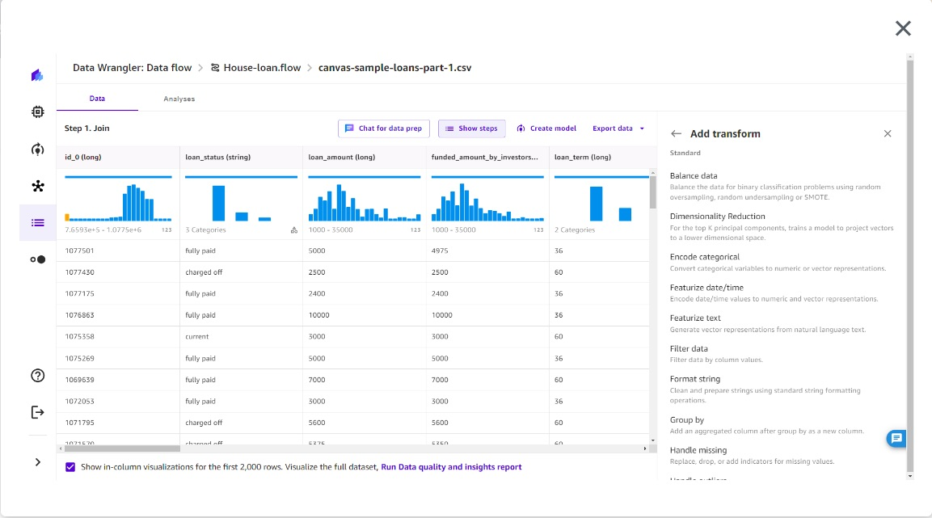
via - https://aws.amazon.com/sagemaker/data-wrangler/
Incorrect options:
Amazon SageMaker Clarify - SageMaker Clarify helps identify potential bias during data preparation without writing code. You specify input features, such as gender or age, and SageMaker Clarify runs an analysis job to detect potential bias in those features.
Amazon SageMaker Ground Truth - Amazon SageMaker Ground Truth offers the most comprehensive set of human-in-the-loop capabilities, allowing you to harness the power of human feedback across the ML lifecycle to improve the accuracy and relevancy of models. You can complete a variety of human-in-the-loop tasks with SageMaker Ground Truth, from data generation and annotation to model review, customization, and evaluation, either through a self-service or an AWS-managed offering.
Amazon SageMaker Feature Store - Amazon SageMaker Feature Store is a fully managed, purpose-built repository to store, share, and manage features for machine learning (ML) models. Features are inputs to ML models used during training and inference. For example, in an application that recommends a music playlist, features could include song ratings, listening duration, and listener demographics.
Reference:
https://aws.amazon.com/sagemaker/data-wrangler/
Domain
Applications of Foundation Models
Question 54Correct
A tech company is integrating generative AI into its customer support system to automatically answer user queries. During testing, the team notices that the AI occasionally generates responses that sound convincing but contain inaccurate information. To address this issue, the team needs to understand the phenomenon where a generative AI model produces information that may appear plausible but is factually incorrect.
What is this phenomenon called?
Your answer is correct
Hallucination
Fairness
Explainability
Controllability
Overall explanation
Correct option:
Hallucination
Generative AI models are as reliable as the data they’re trained on and can access. There is a risk of hallucination, which is when the models make something up that may sound plausible and factual but which may not be correct.
Any organizations or teams that use generative AI to make decisions or prioritize actions, must build responsible AI systems that are fair, explainable, robust, secure, transparent, and that safeguard privacy.
Incorrect options:
Explainability - Explainability refers to understanding and evaluating system outputs.
Fairness - Fairness addresses the impact on different groups of stakeholders in the ML ecosystem.
Controllability - Controllability refers to mechanisms for monitoring and steering AI system behavior.
These three options are core dimensions of responsible AI.
References:
https://aws.amazon.com/blogs/publicsector/generative-ai-understand-the-challenges-to-realize-the-opportunities/
https://aws.amazon.com/machine-learning/responsible-ai/
Domain
Applications of Foundation Models
Question 55Incorrect
A financial services company relies on several Independent Software Vendors (ISVs) for key operational applications and needs to maintain up-to-date compliance records to meet regulatory requirements. To streamline its compliance management process, the company wants to receive email notifications whenever new ISV compliance reports, such as SOC 2 or ISO certifications, become available, ensuring that its compliance team is promptly informed and can take necessary actions.
Which AWS service would be most suitable for automatically providing these notifications?
The company should use AWS Trusted Advisor to receive notification alerts for best practices and recommendations to optimize AWS resources
Correct answer
The company should use AWS Artifact to facilitate on-demand access to AWS compliance reports and agreements, as well as allow users to receive notifications when new compliance documents or reports, including ISV compliance reports, are available
The company should use AWS Audit Manager and leverage its integration with Amazon Simple Notification Service (Amazon SNS) to receive notifications when the compliance reports are available
Your answer is incorrect
The company should use AWS Config to enable continuous monitoring of AWS resource configurations to ensure compliance with best practices and internal policies. Leverage the ntegration with Amazon Simple Notification Service (Amazon SNS) to receive notifications when the compliance reports are available
Overall explanation
Correct option:
The company should use AWS Artifact to facilitate on-demand access to AWS compliance reports and agreements, as well as allow users to receive notifications when new compliance documents or reports, including ISV compliance reports, are available
This is the correct option because AWS Artifact is specifically designed to provide access to a wide range of AWS compliance reports, including those from Independent Software Vendors (ISVs). AWS Artifact allows users to configure settings to receive notifications when new compliance documents or reports are available. This capability makes it an ideal choice for a company that needs timely email alerts regarding the availability of ISV compliance reports.
The new third-party reports tab on the AWS Artifact Reports page provides on-demand access to security compliance reports of Independent Software Vendors (ISVs) who sell their products through AWS Marketplace.
You can subscribe to notifications and create configurations to get notified when a new report or agreement, or a new version of an existing report or agreement becomes available on AWS Artifact.
Incorrect options:
The company should use AWS Audit Manager and leverage its integration with Amazon Simple Notification Service (Amazon SNS) to receive notifications when the compliance reports are available - This option is incorrect because AWS Audit Manager is focused on helping users automate evidence collection for auditing purposes and assess their AWS environment against specific compliance frameworks. It does not offer functionality for accessing or receiving notifications about ISV compliance reports from AWS.
The company should use AWS Trusted Advisor to receive notification alerts for best practices and recommendations to optimize AWS resources - AWS Trusted Advisor is a service that provides guidance to optimize AWS resources by analyzing security, cost, performance, and fault tolerance. However, it does not provide features for managing or receiving notifications about compliance reports, including ISV compliance reports. Therefore, it is not suitable for this requirement.
The company should use AWS Config to enable continuous monitoring of AWS resource configurations to ensure compliance with best practices and internal policies. Leverage the ntegration with Amazon Simple Notification Service (Amazon SNS) to receive notifications when the compliance reports are available - AWS Config is a tool for monitoring and recording AWS resource configurations and evaluating them against desired configurations. While it is useful for maintaining configuration compliance, it does not deal with external compliance reports or provide notification capabilities for ISV compliance documents, making it irrelevant to the company's needs.
References:
https://aws.amazon.com/about-aws/whats-new/2023/08/aws-artifact-email-notifications/
https://aws.amazon.com/about-aws/whats-new/2023/01/aws-artifact-on-demand-third-party-compliance-reports/
Domain
Security, Compliance, and Governance for AI Solutions
Question 56Correct
A social media company is planning to implement a large language model (LLM) for content moderation to automatically flag inappropriate or harmful content. To ensure the model is fair and does not show bias or discrimination against specific groups or individuals, the company needs to evaluate the model's outputs regularly for potential bias. The team is considering different data sources for this evaluation but wants to choose an option that minimizes administrative effort while still providing reliable and comprehensive insights into any biases or discrimination present in the LLM's outputs.
Given these requirements, which data source would be most suitable?
The company should use internally generated synthetic data, which involves creating artificial datasets tailored to specific scenarios
The company should use randomly selected user-generated data, where random samples from actual user interactions are analyzed to identify potential biases
Your answer is correct
The company should use benchmark datasets, which are pre-compiled, standardized datasets specifically designed to test for biases and discrimination in model outputs
The company should use human-monitored benchmarking, where human reviewers manually assess the model's outputs for bias and discrimination
Overall explanation
Correct option:
The company should use benchmark datasets, which are pre-compiled, standardized datasets specifically designed to test for biases and discrimination in model outputs
Benchmark datasets are the most suitable option for evaluating an LLM for bias and discrimination with the least administrative effort. These datasets are specifically designed and curated to include a variety of scenarios that test for potential biases in model outputs. They are pre-existing and standardized, meaning that the company does not need to spend time or resources creating or manually curating data. Using these datasets allows for a quick, cost-effective, and consistent evaluation of model fairness across different contexts.
Incorrect options:
The company should use human-monitored benchmarking, where human reviewers manually assess the model's outputs for bias and discrimination - Human-monitored benchmarking involves a team of human reviewers who manually assess the model's outputs for bias. While this approach can provide nuanced feedback, it requires substantial administrative effort to coordinate, train, and manage human reviewers. It is labor-intensive and costly, and the potential for human error or subjective judgment may lead to inconsistent evaluations. Therefore, it is not the most efficient option if the goal is to minimize administrative overhead.
The company should use randomly selected user-generated data, where random samples from actual user interactions are analyzed to identify potential biases - Randomly selected user-generated data involves analyzing real user interactions for bias, but this approach is not ideal due to the lack of standardization. It requires considerable effort to manually select, curate, and evaluate the data for bias, and there is a risk that the selected samples may not cover all relevant bias scenarios comprehensively. This method also involves privacy and ethical considerations, adding further complexity and administrative effort.
The company should use internally generated synthetic data, which involves creating artificial datasets tailored to specific scenarios - Internally generated synthetic data allows for custom scenarios to be tested, but it requires a significant investment in resources, expertise, and time to create and maintain these datasets. Designing synthetic data that accurately reflects real-world biases and discrimination scenarios is complex, making it an impractical choice when aiming to minimize administrative effort.
References:
https://docs.aws.amazon.com/bedrock/latest/userguide/model-evaluation-prompt-datasets-builtin.html
https://docs.aws.amazon.com/bedrock/latest/userguide/model-evaluation-prompt-datasets.html
Domain
Security, Compliance, and Governance for AI Solutions
Question 57Correct
A customer support company is using Amazon Bedrock to automate responses to frequently asked questions through its AI-driven chatbot. The development team is adjusting various inference parameters to control the responses. They are particularly interested in the Response length parameter, since this parameter is critical for providing clear, customer-friendly interactions.
How does the inference parameter Response length influence the model response for Amazon Bedrock?
Specifies the sequences of characters that stop the model from generating further tokens
Influences the percentage of most-likely candidates that the model considers for the next token
Your answer is correct
Specifies the minimum or maximum number of tokens to return in the generated response.
Influences the number of most-likely candidates that the model considers for the next token
Overall explanation
Correct option:
Specifies the minimum or maximum number of tokens to return in the generated response.
Response length represents the minimum or maximum number of tokens to return in the generated response.
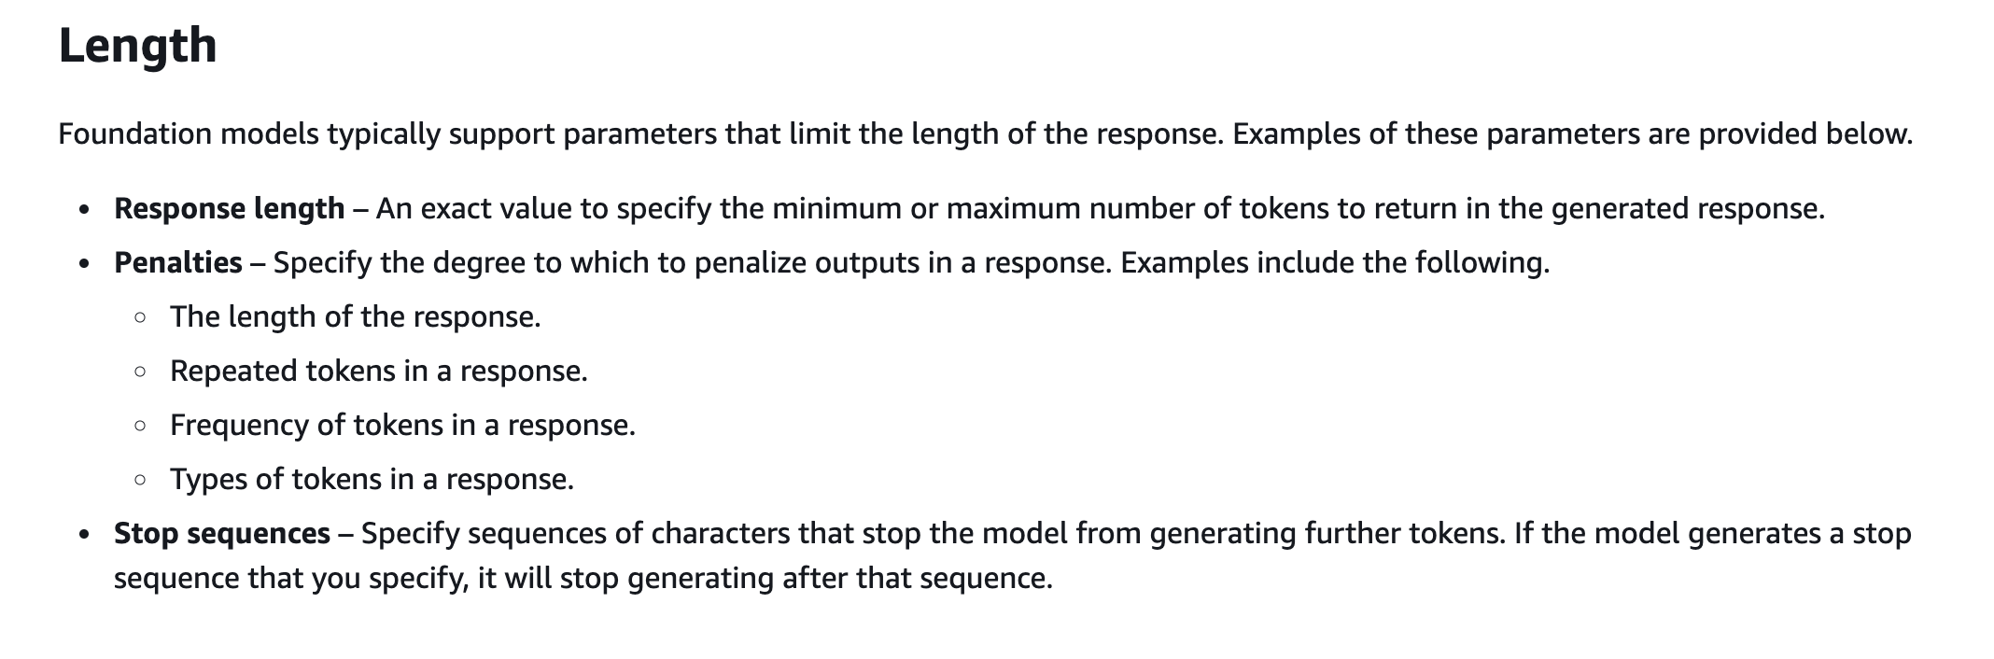
via - https://docs.aws.amazon.com/bedrock/latest/userguide/inference-parameters.html
Incorrect options:
Specifies the sequences of characters that stop the model from generating further tokens - The inference parameter Stop sequences specifies the sequences of characters that stop the model from generating further tokens. If the model generates a stop sequence that you specify, it will stop generating after that sequence.
Influences the percentage of most-likely candidates that the model considers for the next token - The inference parameter Top P represents the percentage of most likely candidates that the model considers for the next token.
Influences the number of most-likely candidates that the model considers for the next token - The inference parameter Top K represents the number of most likely candidates that the model considers for the next token.
References:
https://docs.aws.amazon.com/bedrock/latest/userguide/inference-parameters.html
https://docs.aws.amazon.com/bedrock/latest/userguide/general-guidelines-for-bedrock-users.html
Domain
Fundamentals of Generative AI
Question 58Correct
In the context of the AWS Shared Responsibility Model, which statement best describes the security responsibilities of both AWS and the customer when using Amazon Bedrock for generative AI applications?
Your answer is correct
AWS is responsible for securing the infrastructure that runs Amazon Bedrock, while the customer is responsible for securing their data and managing access controls
The customer is responsible for the entire security stack, including the underlying infrastructure and the AI models
AWS handles all aspects of security for Amazon Bedrock, relieving the customer of any security responsibilities
AWS is responsible for the security of the AI models and customer data, while the customer is responsible for securing the physical infrastructure
Overall explanation
Correct option:
AWS is responsible for securing the infrastructure that runs Amazon Bedrock, while the customer is responsible for securing their data and managing access controls
According to the AWS Shared Responsibility Model, AWS manages the security of the cloud, which includes protecting the infrastructure that runs Amazon Bedrock services, such as hardware, software, networking, and facilities. Customers, on the other hand, are responsible for security in the cloud, which includes managing their data, configuring access controls, and ensuring that AI models and applications are securely implemented. For Bedrock, customers are responsible for data management, access controls, and setting up guardrails.
Shared Responsibility Model Overview:
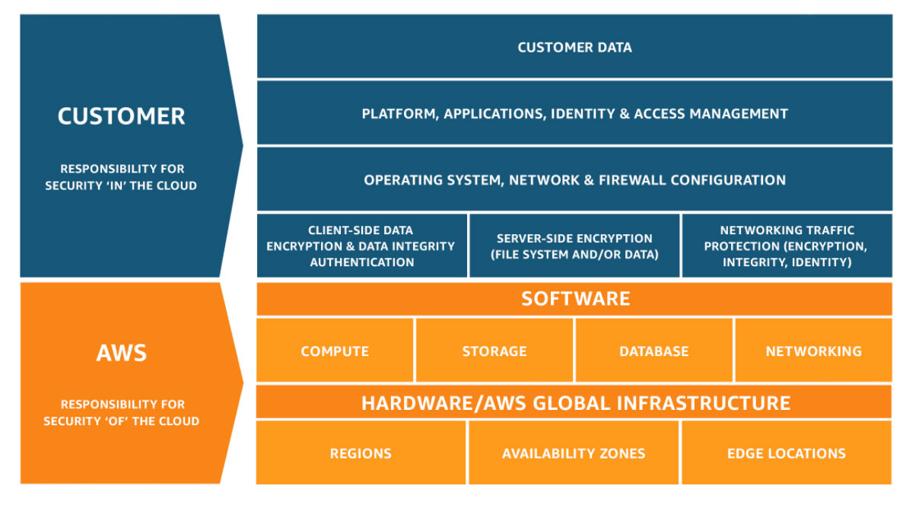
via - https://aws.amazon.com/compliance/shared-responsibility-model/
Incorrect options:
AWS is responsible for the security of the AI models and customer data, while the customer is responsible for securing the physical infrastructure - This statement incorrectly assigns physical infrastructure security to the customer. AWS secures the physical infrastructure.
The customer is responsible for the entire security stack, including the underlying infrastructure and the AI models - This statement places too much responsibility on the customer. AWS secures the infrastructure, while the customer manages security aspects related to their data and applications.
AWS handles all aspects of security for Amazon Bedrock, relieving the customer of any security responsibilities - This statement incorrectly suggests that AWS manages all security responsibilities. The customer still has significant responsibilities, particularly around data protection and access management.
Reference:
https://aws.amazon.com/compliance/shared-responsibility-model/
Domain
Guidelines for Responsible AI
Question 59Correct
A retail company is using Amazon Bedrock to enhance its product recommendation system with generative AI. To tailor the AI model to the company’s specific needs, the data science team is exploring different model customization methods, since understanding the valid customization options available for Amazon Bedrock is crucial for optimizing the model’s performance.
Which of the following represent valid model customization methods for Amazon Bedrock? (Select two)
Retrieval Augmented Generation (RAG)
Your selection is correct
Fine-tuning
Zero-shot prompting
Chain-of-thought prompting
Your selection is correct
Continued Pre-training
Overall explanation
Correct options:
Model customization involves further training and changing the weights of the model to enhance its performance. You can use continued pre-training or fine-tuning for model customization in Amazon Bedrock.
Continued Pre-training
In the continued pre-training process, you provide unlabeled data to pre-train a foundation model by familiarizing it with certain types of inputs. You can provide data from specific topics to expose a model to those areas. The Continued Pre-training process will tweak the model parameters to accommodate the input data and improve its domain knowledge.
For example, you can train a model with private data, such as business documents, that are not publicly available for training large language models. Additionally, you can continue to improve the model by retraining the model with more unlabeled data as it becomes available.
Fine-tuning
While fine-tuning a model, you provide labeled data to train a model to improve performance on specific tasks. By providing a training dataset of labeled examples, the model learns to associate what types of outputs should be generated for certain types of inputs. The model parameters are adjusted in the process and the model's performance is improved for the tasks represented by the training dataset.
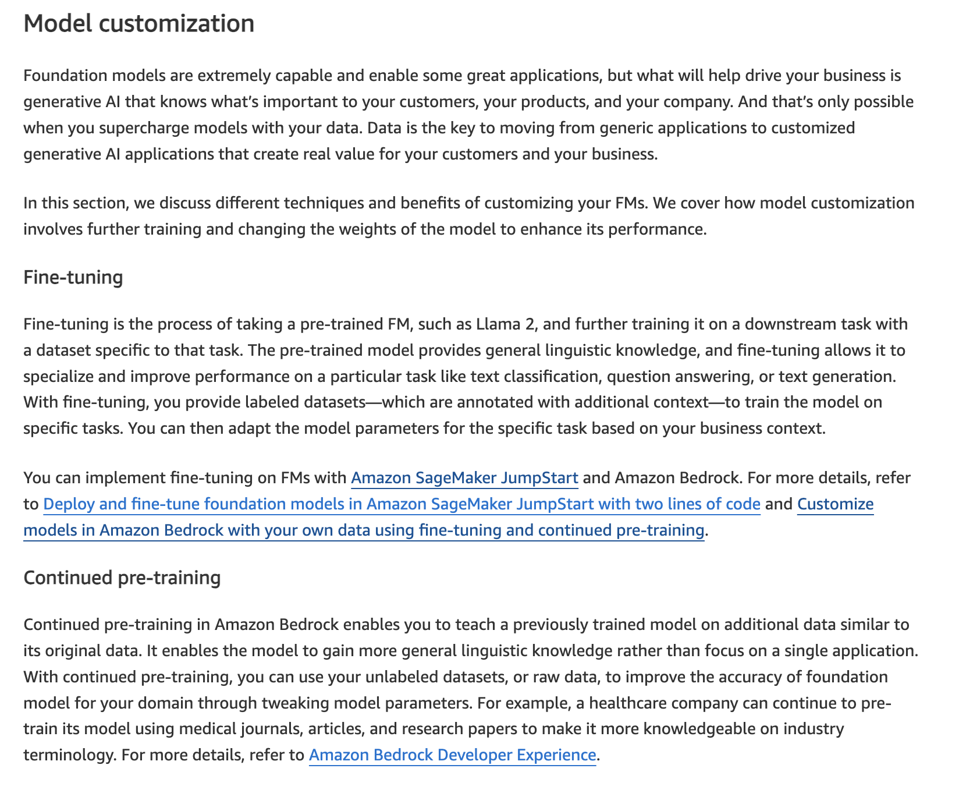
via - https://aws.amazon.com/blogs/machine-learning/best-practices-to-build-generative-ai-applications-on-aws/
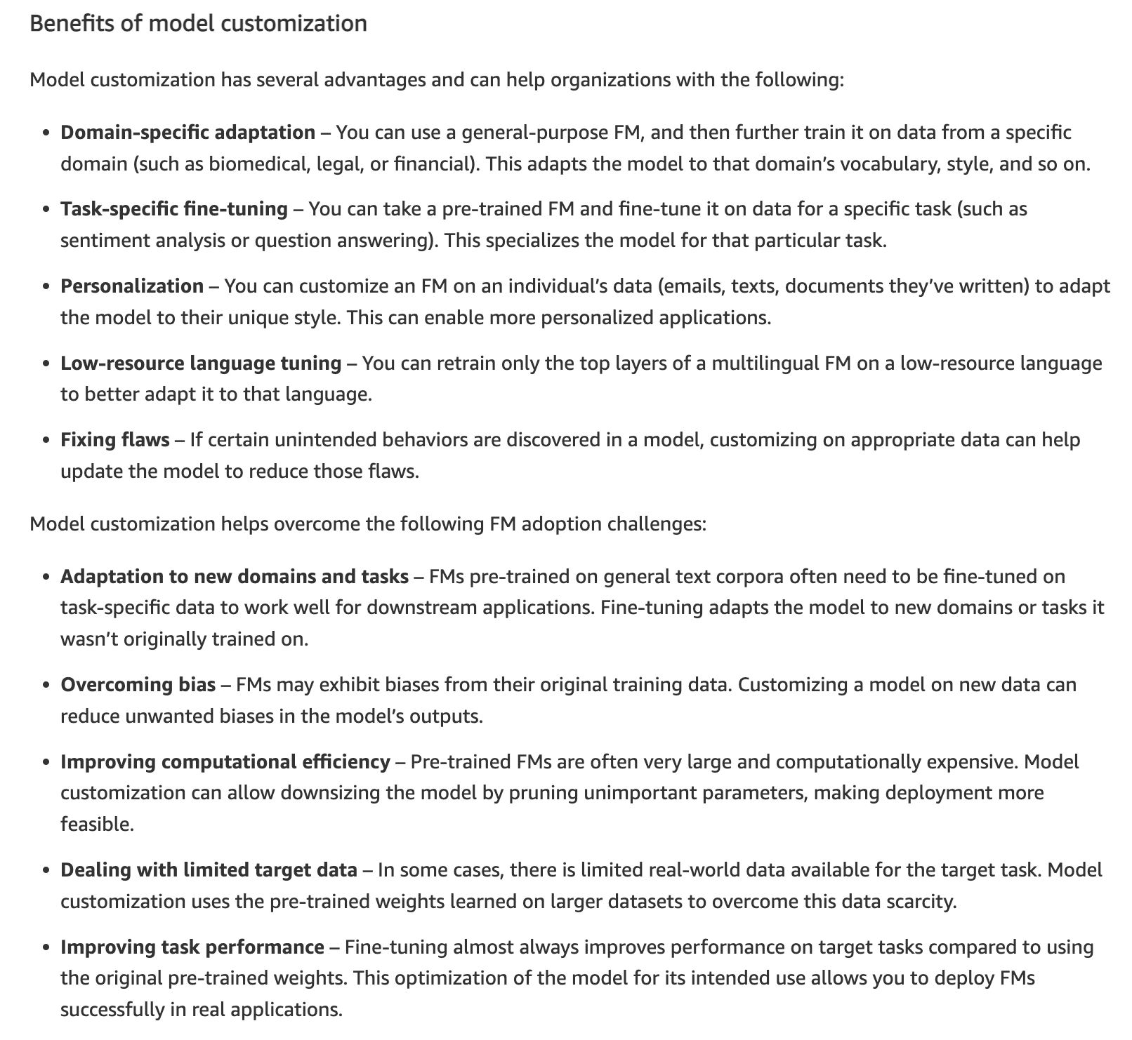
via - https://aws.amazon.com/blogs/machine-learning/best-practices-to-build-generative-ai-applications-on-aws/
Incorrect options:
Zero-shot prompting
Chain-of-thought prompting
Prompt engineering is the practice of carefully designing prompts to efficiently tap into the capabilities of FMs. It involves the use of prompts, which are short pieces of text that guide the model to generate more accurate and relevant responses. With prompt engineering, you can improve the performance of FMs and make them more effective for a variety of applications. Prompt engineering has techniques such as zero-shot and few-shot prompting, which rapidly adapts FMs to new tasks with just a few examples, and chain-of-thought prompting, which breaks down complex reasoning into intermediate steps.
Prompt engineering is not a model customization method. Therefore, both these options are incorrect.
Retrieval Augmented Generation (RAG) - Retrieval Augmented Generation (RAG) allows you to customize a model’s responses when you want the model to consider new knowledge or up-to-date information. When your data changes frequently, like inventory or pricing, it’s not practical to fine-tune and update the model while it’s serving user queries. To equip the FM with up-to-date proprietary information, organizations turn to RAG, a technique that involves fetching data from company data sources and enriching the prompt with that data to deliver more relevant and accurate responses. RAG is not a model customization method.
References:
https://docs.aws.amazon.com/bedrock/latest/userguide/custom-models.html
https://aws.amazon.com/blogs/machine-learning/best-practices-to-build-generative-ai-applications-on-aws/
Domain
Fundamentals of Generative AI
Question 60Correct
A tech company is leveraging generative AI to develop personalized customer experiences and is considering whether to use a pre-built Foundation Model (FM) or to customize a model tailored to their specific needs. The team needs to understand the key differences between using a Foundation Model as-is versus customizing a model with their own data to enhance performance for specific tasks. This distinction will guide their strategy for deploying the most effective AI solution.
What do you suggest?
Your answer is correct
FM is an AI model with a large number of parameters and trained on a massive amount of diverse data, whereas, model customization is the process of using training data to adjust the model parameter values in a base model to create a custom model
Model customization refers to an AI model with a large number of parameters and trained on a massive amount of diverse data, whereas, FM refers to the process of using training data to adjust the model parameter values in a base model to create a custom model
Both model customization and FM refer to an AI model with a large number of parameters and trained on a massive amount of diverse data
Both model customization and FM refer to the process of using training data to adjust the model parameter values in a base model to create a custom model
Overall explanation
Correct option:
FM is an AI model with a large number of parameters and trained on a massive amount of diverse data, whereas, model customization is the process of using training data to adjust the model parameter values in a base model to create a custom model
Foundation model (FM) is an AI model with a large number of parameters and trained on a massive amount of diverse data. A foundation model can generate a variety of responses for a wide range of use cases. Foundation models can generate text or image, and can also convert input into embeddings.
Model customization is the process of using training data to adjust the model parameter values in a base model to create a custom model. Examples of model customization include Fine-tuning, which uses labeled data (inputs and corresponding outputs), and Continued Pre-training, which uses unlabeled data (inputs only) to adjust model parameters.
Incorrect options:
Model customization refers to an AI model with a large number of parameters and trained on a massive amount of diverse data, whereas, FM refers to the process of using training data to adjust the model parameter values in a base model to create a custom model
Both model customization and FM refer to an AI model with a large number of parameters and trained on a massive amount of diverse data
Both model customization and FM refer to the process of using training data to adjust the model parameter values in a base model to create a custom model
These three options contradict the explanation provided above, so these options are incorrect.
Reference:
https://docs.aws.amazon.com/bedrock/latest/userguide/key-definitions.html
Domain
Fundamentals of Generative AI
Question 61Correct
A technology company is developing a machine learning model to automatically categorize images for its e-commerce platform, which includes tasks like identifying products in photos uploaded by users. The data science team is exploring various types of neural networks and needs to choose the most effective one for image classification. Understanding which neural network architecture is best suited for handling the complexities of image data will help the team ensure accurate and efficient classification.
What do you recommend for the given use case?
Recurrent Neural Networks (RNNs)
Your answer is correct
Convolutional Neural Networks (CNNs)
Generative Adversarial Networks (GANs)
Retrieval-Augmented Generation (RAG)
Overall explanation
Correct option:
Convolutional Neural Networks (CNNs)
Convolutional Neural Networks (CNNs) are specifically designed for processing and classifying image data. They use convolutional layers to automatically and adaptively learn spatial hierarchies of features from input images, making them highly effective for tasks such as image recognition and classification.
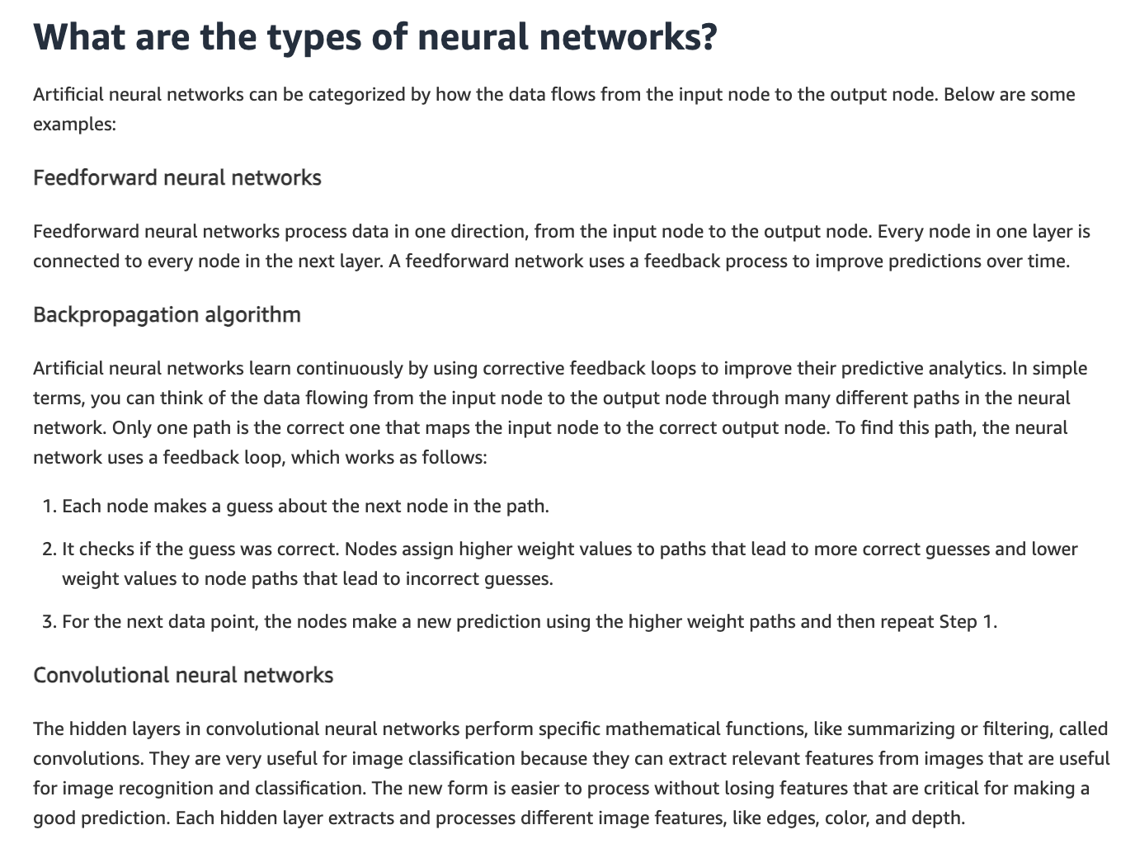
via - https://aws.amazon.com/what-is/neural-network/
Incorrect options:
Recurrent Neural Networks (RNNs) - Recurrent Neural Networks (RNNs) are typically used for sequence data, such as time series or natural language processing tasks. RNNs are not the best fit for image classification.
Generative Adversarial Networks (GANs) - Generative Adversarial Networks (GANs) are used for generating new data that resembles the training data, such as creating realistic images, but are not specifically designed for image classification.
Retrieval-Augmented Generation (RAG) - Retrieval-Augmented Generation (RAG) is the process of optimizing the output of a large language model, so it references an authoritative knowledge base outside of its training data sources before generating a response. While the RAG framework itself is not a single neural network, it integrates multiple neural network components to enhance text generation tasks. RAGs are not designed for image classification.
References:
https://aws.amazon.com/what-is/neural-network/
https://aws.amazon.com/what-is/computer-vision/
https://aws.amazon.com/what-is/retrieval-augmented-generation/
Domain
Fundamentals of AI and ML
Question 62Correct
A company is considering using Reinforcement Learning (RL) to optimize decision-making in dynamic environments. Which of the following would you recommend as the best-fit use case for Reinforcement Learning?
Reinforcement learning is used for making predictions based on historical data trends
Reinforcement learning is used for performing regression analysis on large numerical datasets
Your answer is correct
Reinforcement learning is used for optimizing complex systems such as robotics, game playing, and industrial automation by learning optimal actions through trial and error
Reinforcement learning is primarily used for clustering large datasets without any predefined labels
Overall explanation
Correct option:
Reinforcement learning is used for optimizing complex systems such as robotics, game playing, and industrial automation by learning optimal actions through trial and error
Reinforcement learning is well-suited for optimizing complex systems where an agent learns to make decisions through interactions with the environment, receiving feedback in the form of rewards or penalties. This approach is particularly effective in applications like robotics, game playing, and industrial automation, where learning optimal actions through trial and error is crucial.
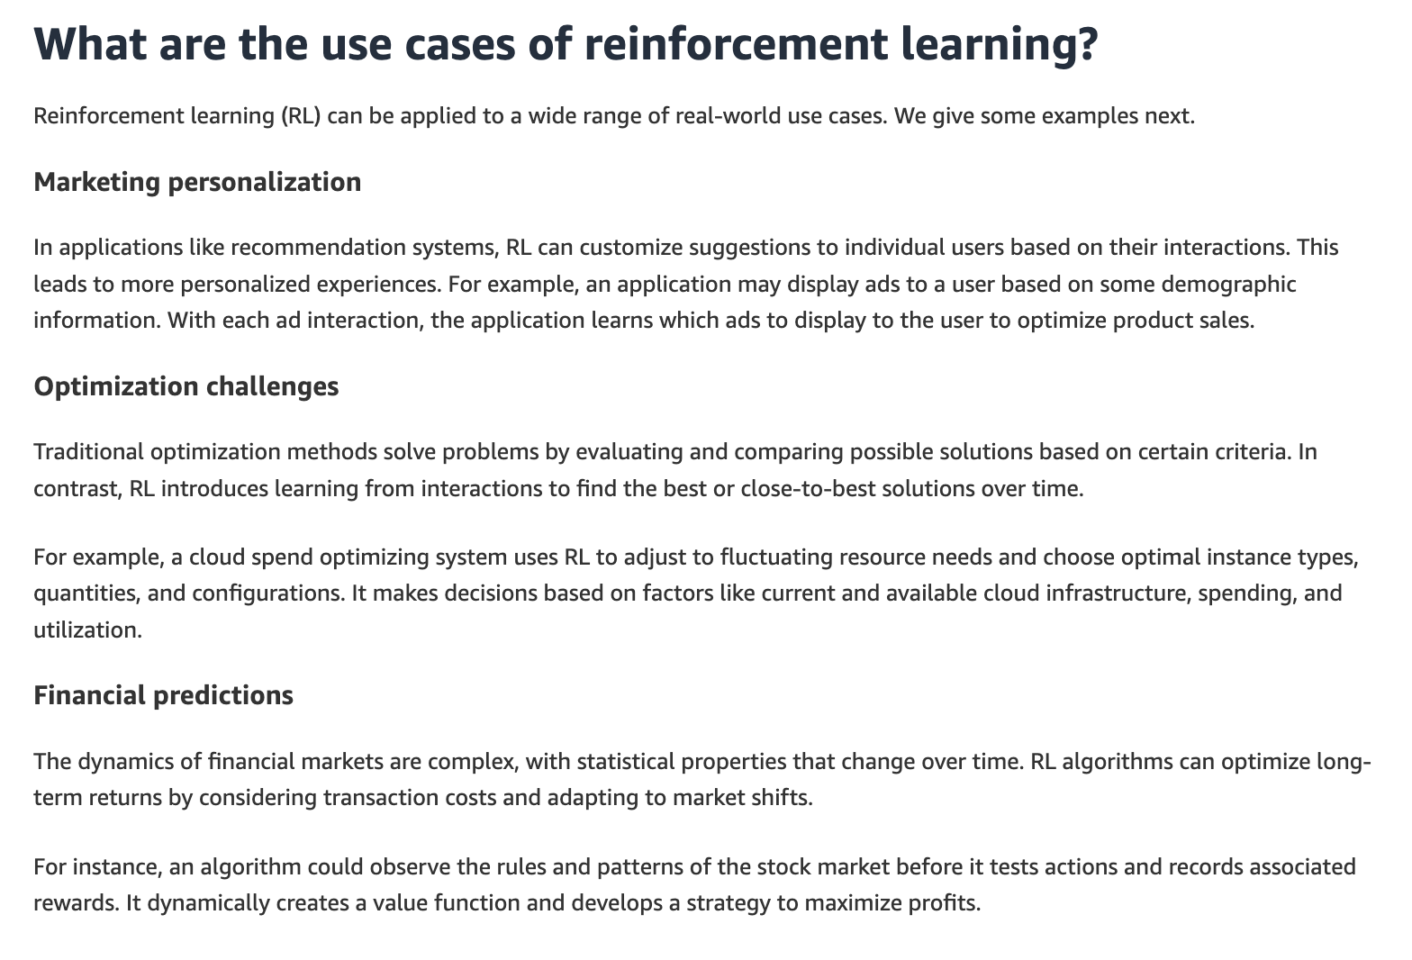
via - https://aws.amazon.com/what-is/reinforcement-learning/
Incorrect options:
Reinforcement learning is primarily used for clustering large datasets without any predefined labels - Clustering large datasets without predefined labels is typically associated with unsupervised learning, not reinforcement learning.
Reinforcement learning is used for making predictions based on historical data trends - Making predictions based on historical data trends is a characteristic of supervised learning techniques.
Reinforcement learning is used for performing regression analysis on large numerical datasets - Regression analysis is a task associated with supervised learning, not reinforcement learning.
Reference:
https://aws.amazon.com/what-is/reinforcement-learning/
Domain
Fundamentals of AI and ML
Question 63Correct
Is it possible to increase both the bias and variance of a machine learning model simultaneously?
No, increasing bias always decreases variance and vice versa, so they cannot be increased at the same time
Your answer is correct
Yes, it is possible to increase both bias and variance, but this typically leads to a model that performs poorly due to both underfitting and overfitting
No, it is not possible to increase both bias and variance simultaneously, as they are inversely related
Yes, increasing both bias and variance simultaneously will improve the model's accuracy and generalization capabilities
Overall explanation
Correct option:
Yes, it is possible to increase both bias and variance, but this typically leads to a model that performs poorly due to both underfitting and overfitting
Bias is an error introduced by approximating a real-world problem (which may be complex) by a simpler model. High bias can cause the model to miss relevant relations between features and target outputs (underfitting).
Variance is an error introduced by the model's sensitivity to small fluctuations in the training data. High variance can cause the model to mimic the random noise in the training data rather than the intended outputs (overfitting).
It is possible to increase both bias and variance, but doing so usually results in a model that is both underfit and overfit, leading to poor performance. High bias causes the model to miss important patterns (underfitting), while high variance makes the model too sensitive to noise in the training data (overfitting).
For example, if you reduce the amount of training data, the model has less information to learn from. This can increase bias because the model may not capture the underlying patterns well (underfitting). At the same time, with less data, the model can become more sensitive to fluctuations in the training data, increasing variance.
Incorrect options:
Yes, increasing both bias and variance simultaneously will improve the model's accuracy and generalization capabilities - Increasing both bias and variance will not improve the model's performance. High bias can lead to underfitting, and high variance can lead to overfitting, making the model perform poorly.
No, it is not possible to increase both bias and variance simultaneously, as they are inversely related - Bias and variance are not inversely related to the extent that one cannot increase both. It is possible to design a model that suffers from both high bias and high variance.
No, increasing bias always decreases variance and vice versa, so they cannot be increased at the same time - While there is often a trade-off between bias and variance, they can both be high in a poorly designed model.
References:
https://docs.aws.amazon.com/wellarchitected/latest/machine-learning-lens/mlper-09.html
https://aws.amazon.com/what-is/overfitting/
https://stackoverflow.com/questions/32161174/can-a-model-have-both-high-bias-and-high-variance-overfitting-and-underfitting
Domain
Fundamentals of AI and ML
Question 64Correct
A consulting firm is considering adopting Amazon Q Business to help its teams automate workflows, generate business insights, and streamline decision-making. To ensure smooth integration with their existing AWS infrastructure, the firm's IT department needs to understand which underlying AWS service powers Amazon Q Business.
What do you suggest?
Your answer is correct
Amazon Bedrock
Amazon SageMaker Jumpstart
Amazon Q Apps
Amazon Kendra
Overall explanation
Correct option:
Amazon Bedrock
Amazon Q Business is a fully managed, generative-AI powered assistant that you can configure to answer questions, provide summaries, generate content, and complete tasks based on your enterprise data. It allows end users to receive immediate, permissions-aware responses from enterprise data sources with citations, for use cases such as IT, HR, and benefits help desks.
Amazon Q Business is powered by Amazon Bedrock.
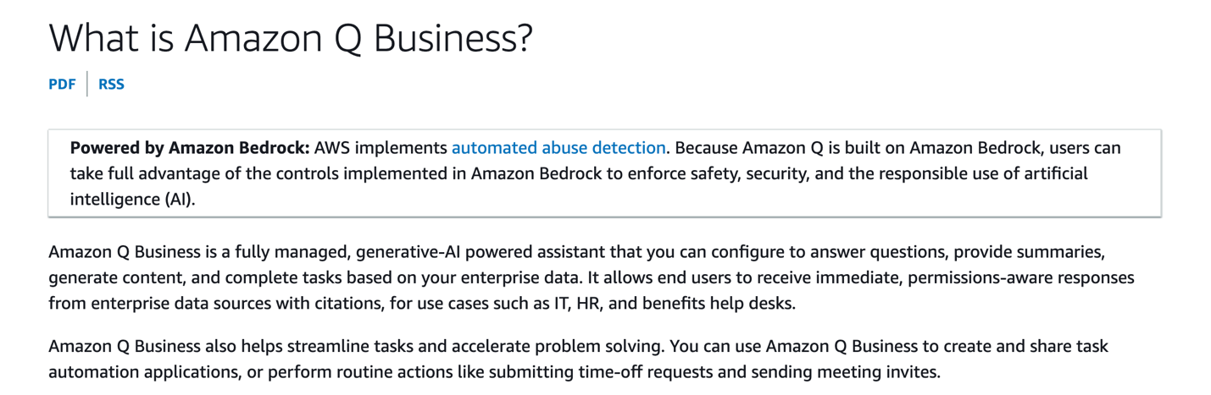
via - https://docs.aws.amazon.com/amazonq/latest/qbusiness-ug/what-is.html
Incorrect options:
Amazon Q Apps - Amazon Q Apps is a capability within Amazon Q Business for users to create generative artificial intelligence (generative AI)–powered apps based on the organization’s data. Users can build apps using natural language and securely publish them to the organization’s app library for everyone to use.
Amazon SageMaker Jumpstart - Amazon SageMaker JumpStart is a machine learning hub with foundation models, built-in algorithms, and prebuilt ML solutions that you can deploy with just a few clicks With SageMaker JumpStart, you can access pre-trained models, including foundation models, to perform tasks like article summarization and image generation.
Amazon Kendra - Amazon Kendra is an intelligent search service that uses natural language processing and advanced machine learning algorithms to return specific answers to search questions from your data.
References:
https://docs.aws.amazon.com/amazonq/latest/qbusiness-ug/what-is.html
https://docs.aws.amazon.com/amazonq/latest/qbusiness-ug/concepts-terms.html
https://docs.aws.amazon.com/kendra/latest/dg/what-is-kendra.html
https://aws.amazon.com/blogs/aws/amazon-q-apps-now-generally-available-enables-users-to-build-their-own-generative-ai-apps/
Domain
Applications of Foundation Models
Question 65Correct
A technology consulting firm is advising a client on how to integrate AI into their customer service and content creation workflows. The client is particularly interested in using Large Language Models (LLMs) for tasks such as automating customer support, generating marketing content, and processing large volumes of text data. To ensure they choose the right applications, the team needs to understand the potential uses of LLMs across different industries and business functions.
What do you suggest?
LLMs are used to synthesize realistic human speech from text inputs
LLMs are used for creating videos from textual descriptions
LLMs are used for designing and generating 3D models for use in various applications such as gaming, virtual reality, or industrial design
Your answer is correct
LLMs are used for generating human-like text, translating languages, summarizing text, and answering questions based on large datasets
Overall explanation
Correct option:
LLMs are used for generating human-like text, translating languages, summarizing text, and answering questions based on large datasets
Large language models (LLM) are very large deep learning models that are pre-trained on vast amounts of data. Large language models are incredibly flexible. One model can perform completely different tasks such as answering questions, summarizing documents, translating languages and completing sentences.
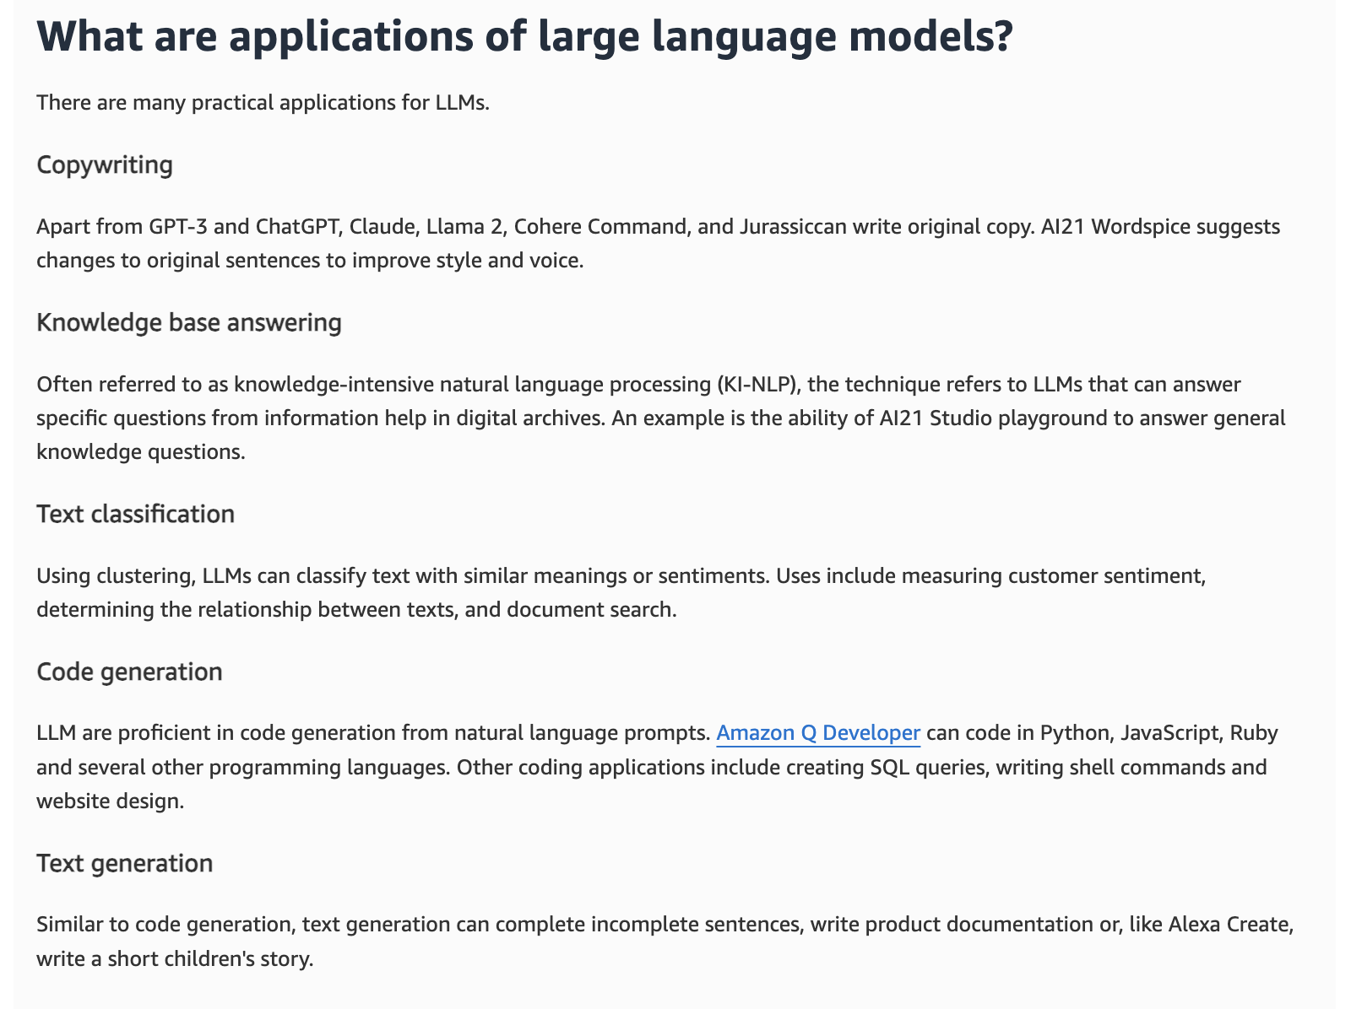
via - https://aws.amazon.com/what-is/large-language-model/
Incorrect options:
LLMs are used to synthesize realistic human speech from text inputs
LLMs are used for designing and generating 3D models for use in various applications such as gaming, virtual reality, or industrial design
LLMs are used for creating videos from textual descriptions
Certain specialized applications - such as synthesizing speech, generating 3D models, creating videos from textual descriptions - typically require models that are specialized in handling visual, audio, or three-dimensional data, and while LLMs are powerful for text-based tasks, they are not designed for generating or manipulating non-textual data. Generative Adversarial Networks (GANs), Variational Autoencoders (VAEs), and other specialized generative models are more suitable for these applications. Therefore, these three options are incorrect.
References:
https://aws.amazon.com/what-is/large-language-model/
https://aws.amazon.com/what-is/gan/
https://aws.amazon.com/what-is/generative-ai/

