Gusset Weld Verification
(Octave FEM Codes)

Author: Mishal Mohanlal
Date:15/04/202

Contents
1. Summary 1
2. Finite Element Models 2
3. Results 2
4. Conclusion 4

Summary
This report will cover the verification of the program developed on Octave called “Gusset (R3)” which uses a custom-built toolbox to develop Finite Element models, the program has been developed to assess stresses in welds. The custom-built finite element functions and “Gusset (R3)” program will not be discussed.

Two models will be developed, one using the “Gusset (R3)” program and another on Strand7, the same loads will be applied to both models and the reaction forces will be compared. The Octave program uses the reaction forces to formulate weld stresses, this will not be checked against Strand7 as this constitutes as post processing the reactions forces, if the reactions forces are comparable then the use those results will also be comparable.

Finite Element Models
The Finite Element model has been developed using the following points which make up a polygon:
- P1, (0,0)
- P2, (0,291)
- P3, (284,291)
- P4, (91,0)
A load of 9500N has been applied in both the X and Y direction at P3 with the vertical and horizontal edges along the X and Y axis have been restrained against translation as presented by Figure 1 (left). Figure 1 (right) presents the mesh developed using Octave. The material properties are based on Grade S0355JR steel which is 16mm thick.
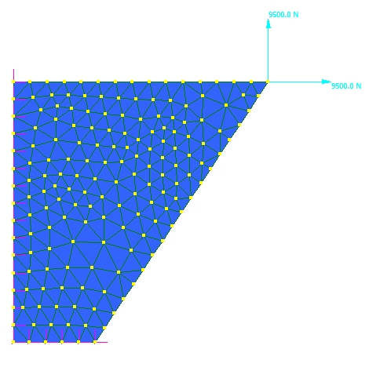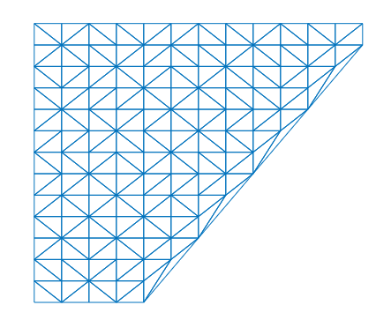
Y
Figure 1: Finite element models, left Strand7, right Octave
X

Results
Figure 2 and Figure 3 present the D(X) displacement results for the Strand7 and Octave model, respectively. From the results presented there are differences, however these differences can be considered small. Strand7 presents a far more detailed displacement plot which can be attributed to its complex extrapolation algorithms. The results from Octave can be considered accurate, the same holds true for the D(Y) displacement results.
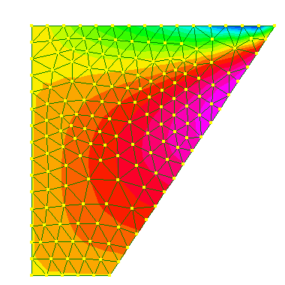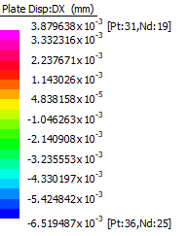
Figure 2: Strand7 D(X) displacement results
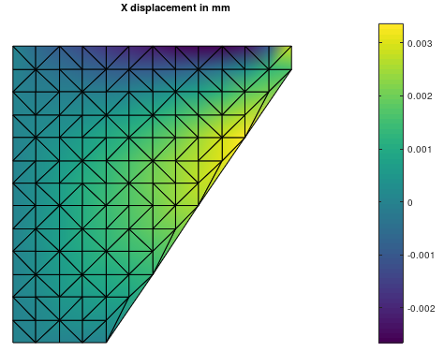
Figure 3: Octave D(X) displacement results

The reaction forces at the nodes have been plotted using P1 as point 1. The results are presented in Figure 4 and Figure 5. The vertical restraints present reactions that are similar, while there is a deviance in results with regards to the horizontal restraints, the deviance is not large. The deviance from the Octave results to Strand7 can be attributed to the poor mesh quality and aspect ratio of elements near the restraints.

Figure 4: Reaction forces on vertical restraints

Figure 5: Reaction forces on the horizontal restraints

Conclusion
Based on the presented results it can be concluded that the Octave formulations are comparable to Strand7 thus making the results accurate. The results have been compared with a meshes that have the same amount of elements on each edge, thus the accuracy of results only pertains to numerical values and not of the quality of results. The quality of results can be altered by using an adequate mesh.

