Part A: Know Your Hardware
CPU (Processor):
• Model Name: 12th Gen Intel(R) Core(TM) i5-12450H
• Number of Cores:8
• Logical Processors: 12
RAM (Memory):
• Total RAM:32.0 GB DDR4
• RAM Speed (MHz): 3200 MT/s
Storage (Disk):
• Disk Type (HDD/SSD): SSD
• Total Disk Size: 477 GB
GPU (Graphics):
• GPU Name: NVIDIAGeForceRRT 2050
• Dedicated Memory : 0

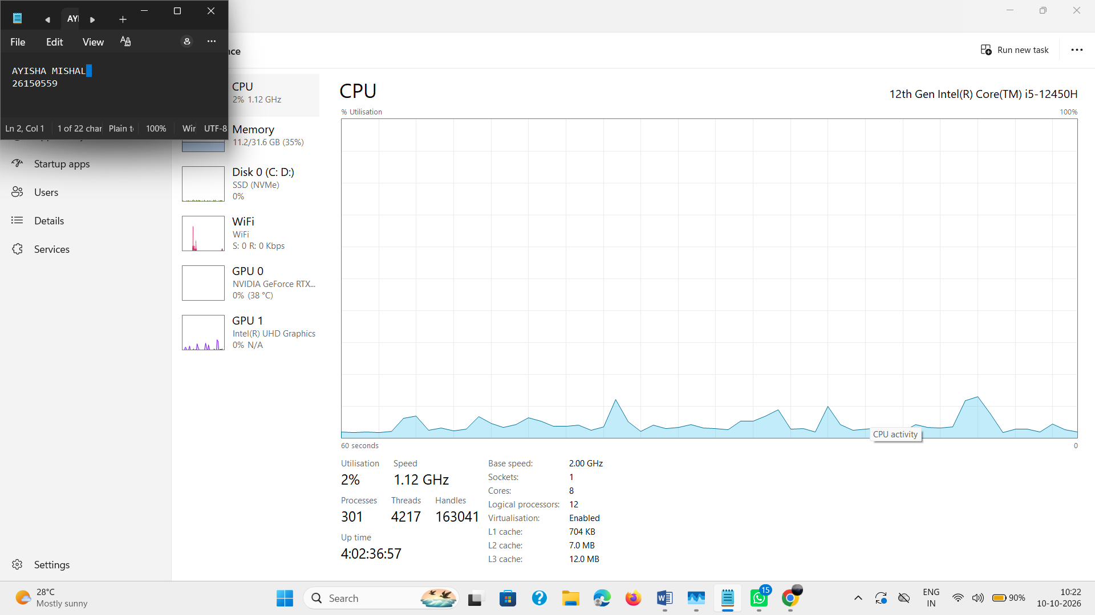

Part B: Windows System Information
• BIOS Version/Date:AMI F.18, 21-08-2024
• OS Name: Microsoft Windows 11 Home Single Language
• OS Version: 10.0.26200 Build 26200
• OS Build: Microsoft Corporation
• System Manufacturer: HP
• System Model: Victus by HP Gaming Laptop 15-fa1xxx

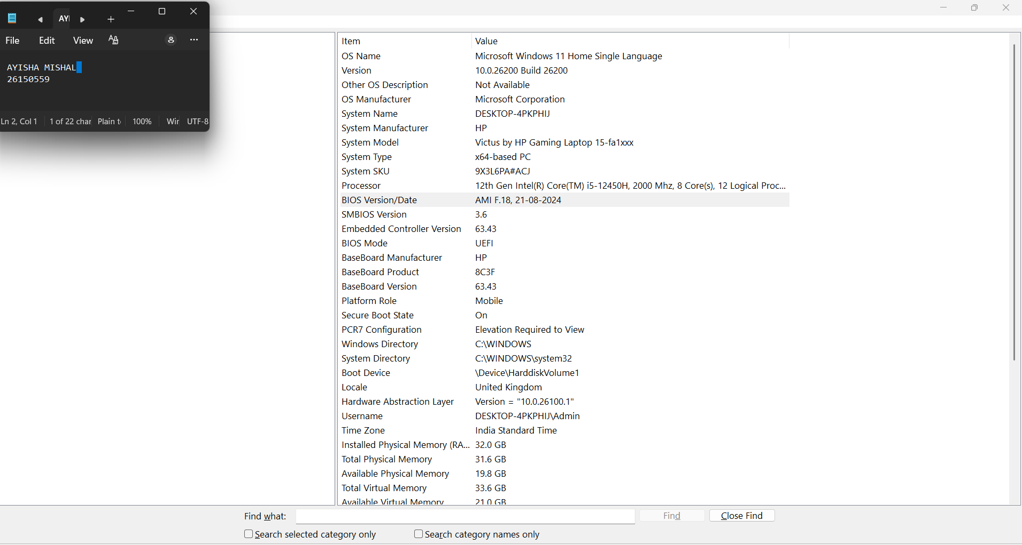

Part C: Windows Command Prompt Commands (5 marks)
What is Command Prompt?
Command Prompt (CMD) is a text-based interface for Windows.
Instead of clicking, you type commands.
1. whoami
• output: desktop-4pkphij\admin
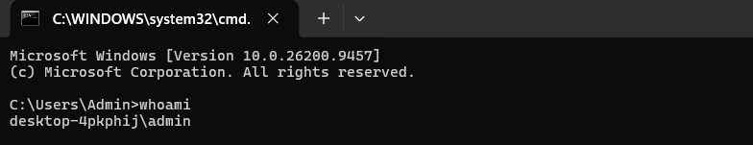

2. ipconfig
• IP Address: 10.243.136.147
• Your Default Gateway: fe80::9c1c:1cff:fe06:8ade%5
10.243.136.52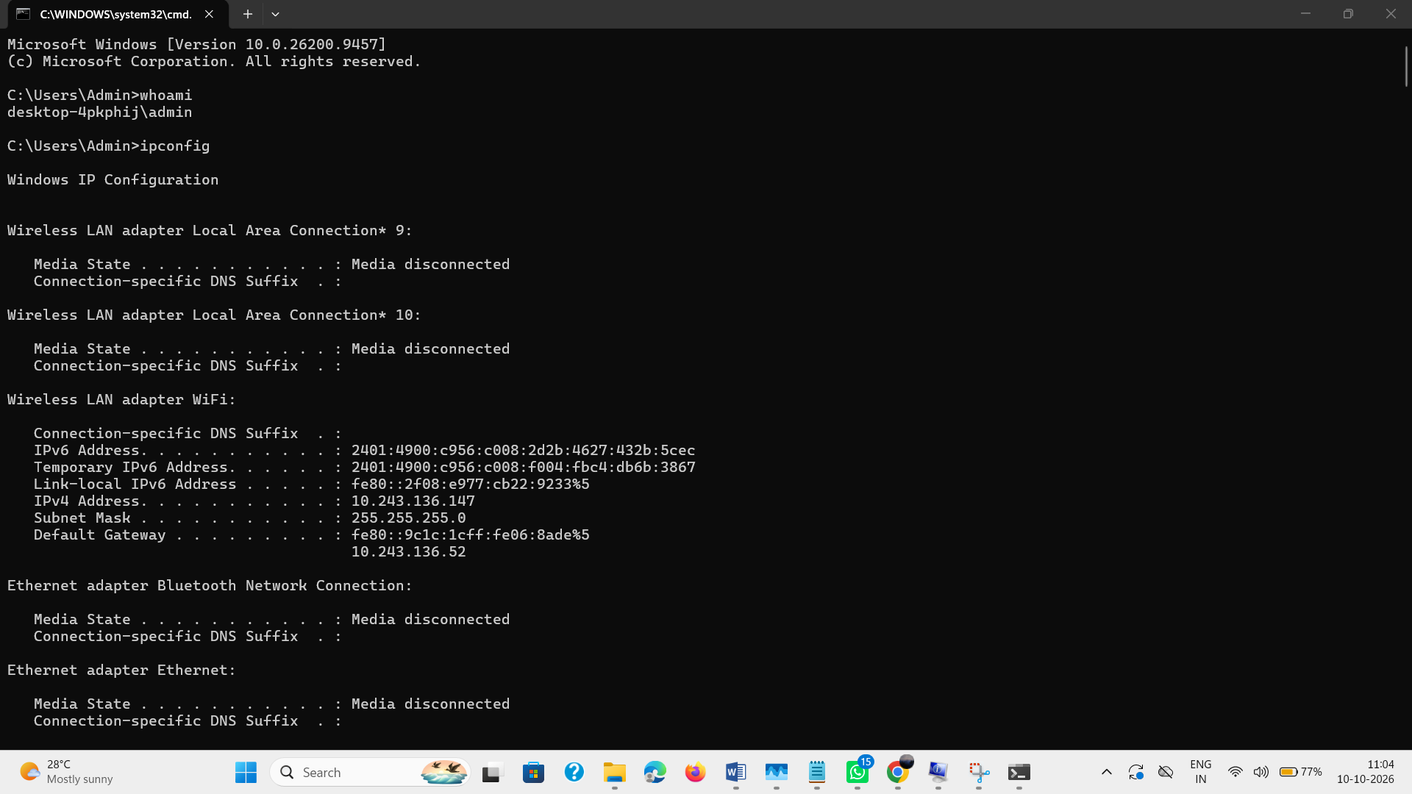

3. dir
• Record 3 folders: cache, copilot, docker
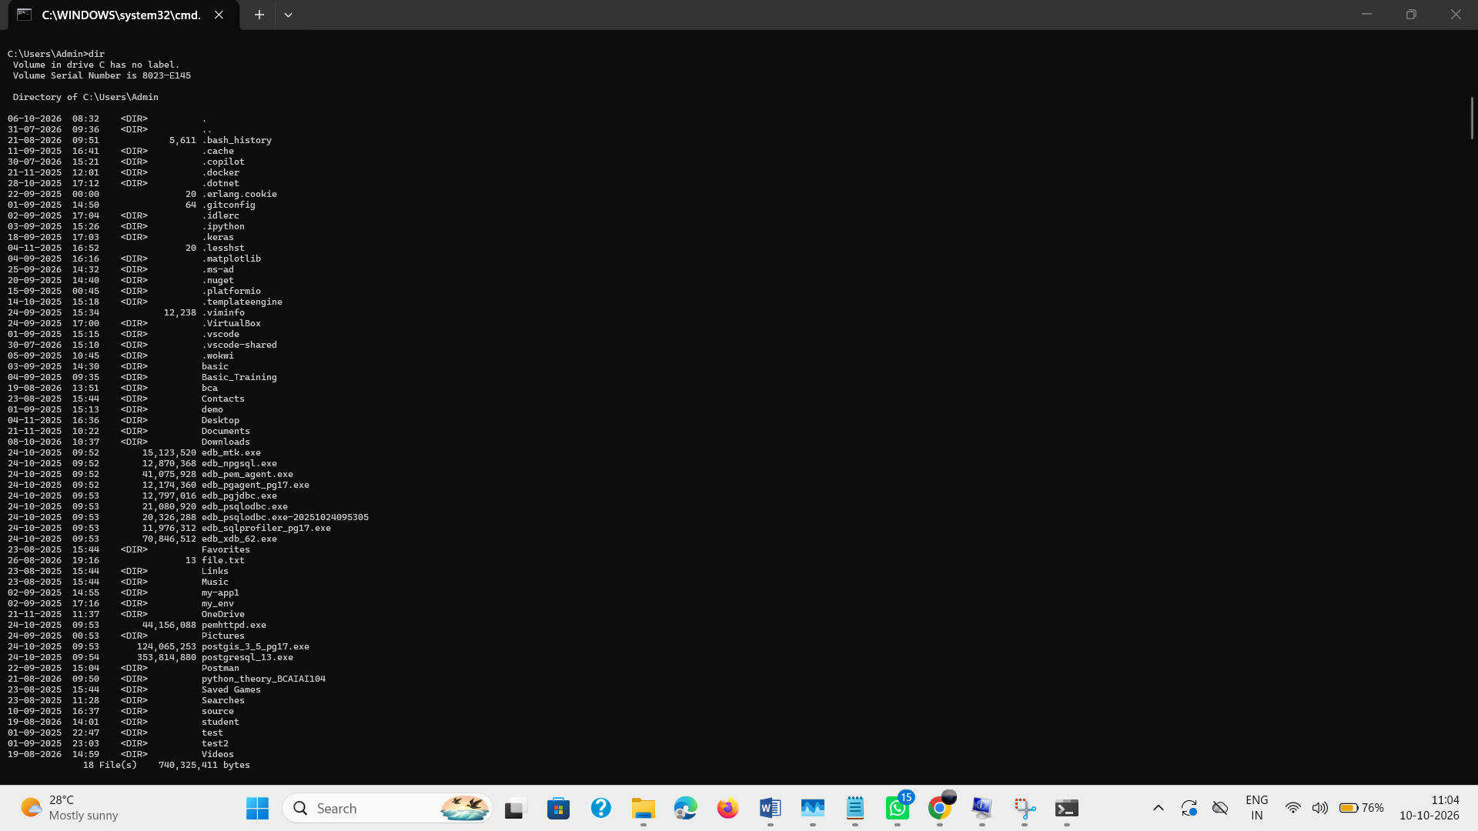

4. mkdir BCA_Test
• What it does: Creates a new folder named "BCA_Test"
• Verify by typing: dir
• Did you see "BCA_Test" folder created? Yes
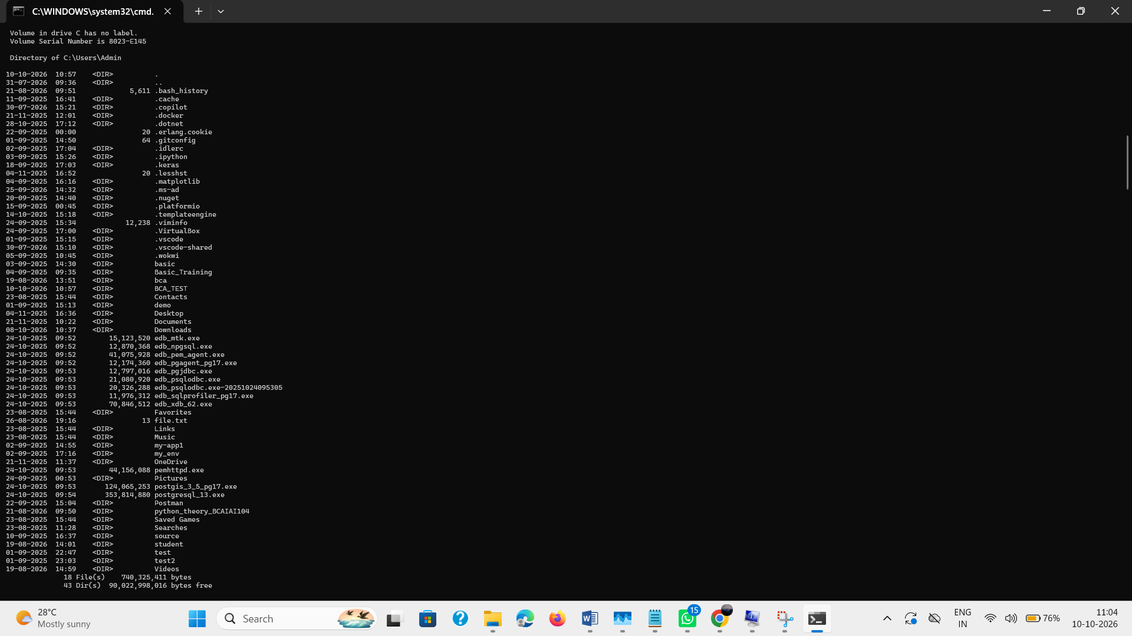

5. tasklist
• What it does: Lists all running programs
• Record 5 running processes: System Idle Process, System, Secure System, Registry, smss.exe

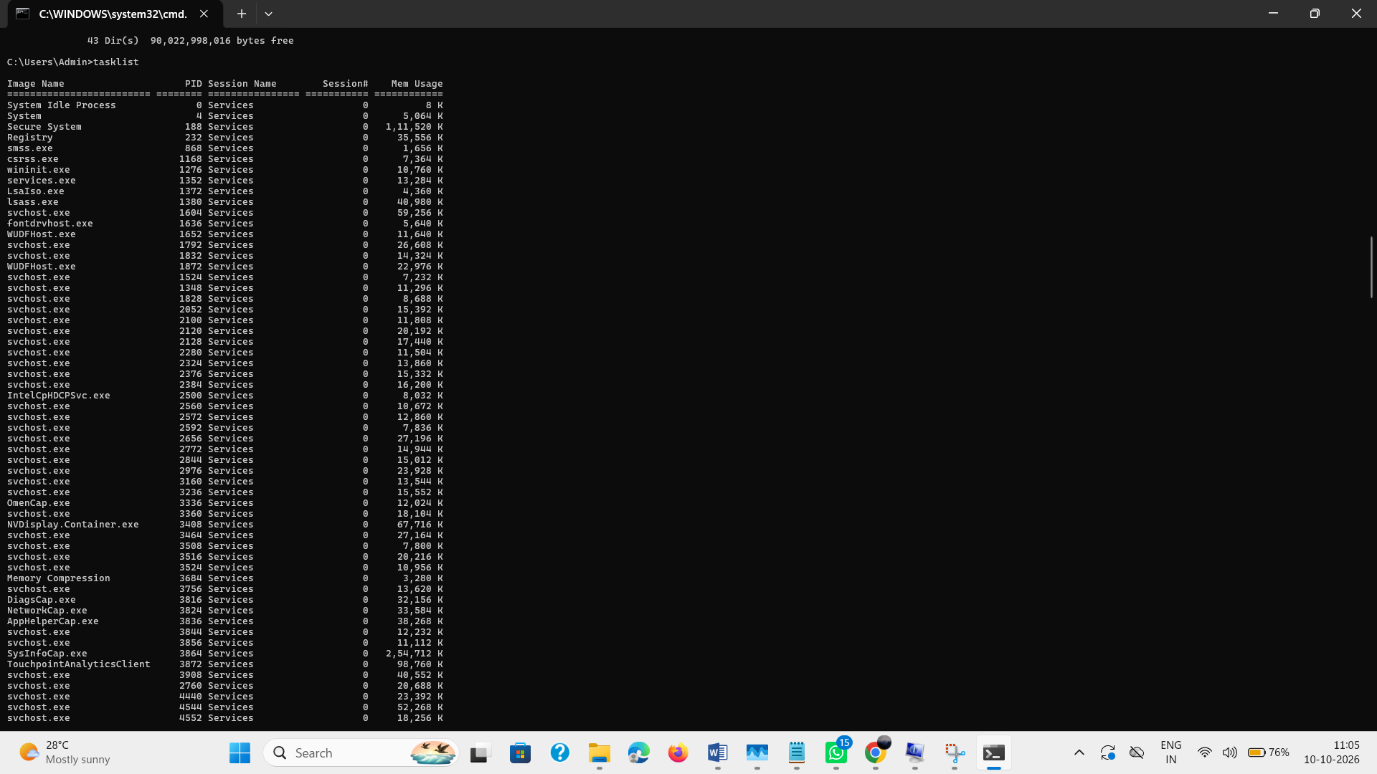

6. systeminfo
• What it does: Shows detailed Windows system information
• Record your Processor:[01]: Intel64 Family 6 Model 154 Stepping 3 GenuineIntel ~2000 Mhz
• Record your Total Physical Memory: 32,409 MB
