Seychelles national chapter test

Mishal

13 March 2018

## Background to the bleaching event

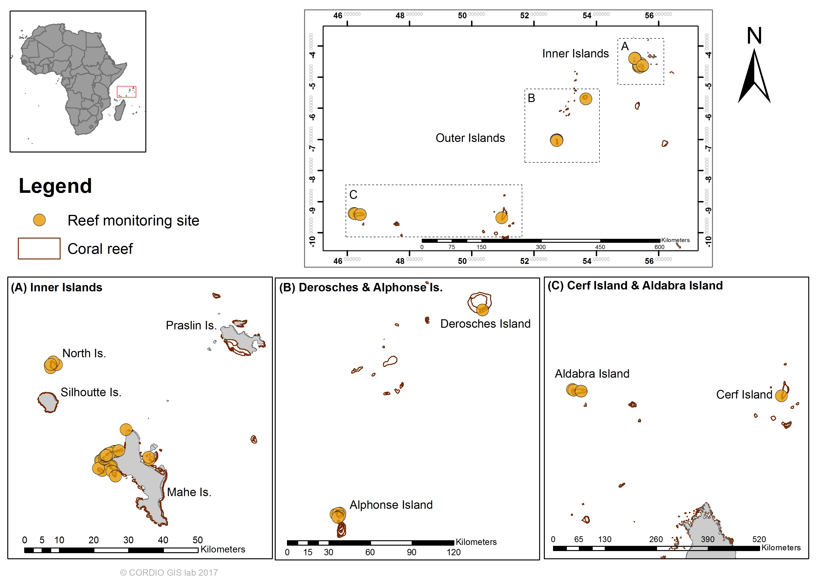

Coral reef monitoring stations in Seychelles for which data was included in this study

## Trends in hard coral cover and algae

Seychelles hard coral cover plot with station lines

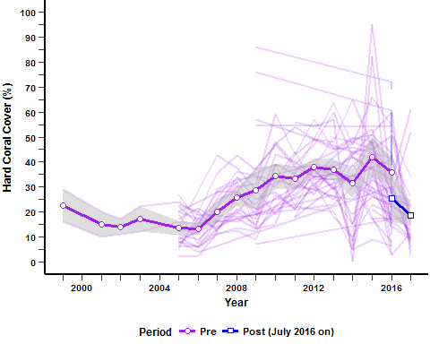

Seychelles trend line for coral cover and fleshy algae

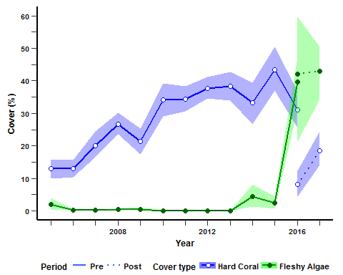

Trends in fleshy algae (green line, closed circles) and hard coral cover (blue line, open-circles) in the Seychelles before (solid line) and after (dotted line) the 2016 bleaching event. Shaded areas represent the 95% confidence limit. Only stations with data for both periods and with both fleshy-algae and hard coral cover were included in the analysis (n=32). The post-bleaching period from July 2016 onwards.

Seychelles bar plot HC and FA pre vs post

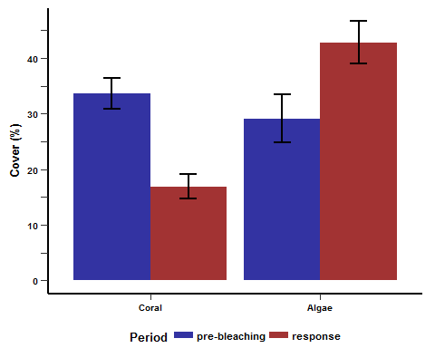

figure caption.

Seychelles sub-national analysis

