Kenya WIO post-bleaching national chapter test version

Mishal

12 March 2018

## Trends in hard coral cover and algae

Kenya hard coral cover plot with station lines

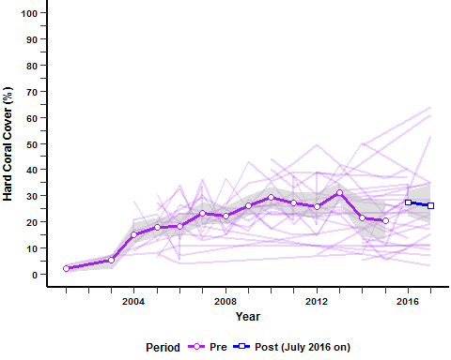

Kenya trend line for coral cover and fleshy algae

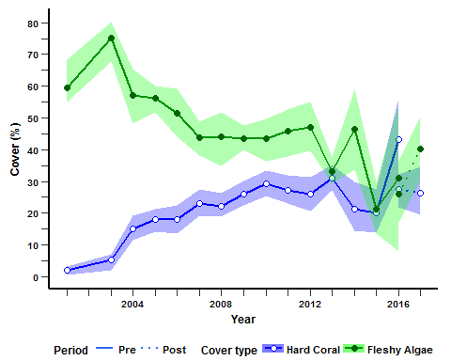

figure caption.